AN INTRODUCTION

Construction is a vital part in this industry, although the music industry sider of it is more fast paced. Stage managers and designers may have to repair mistakes ort inconveniences. Nothing has to be perfect as you can learn from previous mistakes.

MATERIALS

-3 x 1” and 3 x 2” rough saw wood, PAR
-2 x 1”, 6 x 1”, 8 x 1” plywood sheets, commonly red and white layered bit others can be used, like birch, which is more expensive due to the weight. Plywood can de-laminate which means it pulls itself apart over time. 8ft and 18ml thick is standard issue. You can get thinner quality plywood, but the quality gets worse the thinner it gets.
-2440 x 1220 hardwood. This is more rigid and expensive than plywood but can splinter more.
-MDF (medium density fibreboard). This causes asbestos if exposed to it for long periods of time. MDF is banned in half of the USA. It mainly has a flat finish but is incredibly dusty so if you are handling it, be sure to wear a filtration mask.

TOOLS (Brand – Festool)

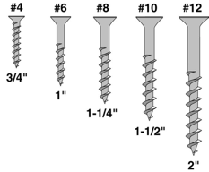

DRILLS – There are two modes for drills, drilling holes and screws. These have different bits that size up in millimetres. To drill holes, you would need a regular drill bit and for screws, a screwdriver bit. On festool drills, to drill a screw, a series of numbers from 1-12 correspond to the size, thickness, and length, of the screw. There are three types of drill bit. Spiky ends are for wood, ends that look like ^ are for metal and wood and ends that look like a house silhouette are commonly more for masonry, stonework, and brickwork. REMEMBER – NEVER DRILL AT AN ANGLE. Before you drill anything, always check of the bit is correct. When drilling a piece of wood that seems unsteady, you can clamp or screw it to the work surface to minimise movement. If you have to drill pilot hole screws, make sure that the holes are not too close to the edge of the wood or corners as this can cause the wood to split and you will have to redo the entire side.

SCREW SIZES – The most common screw size for theatre use is either 3 1/2 x 40 or 3 ½ x 50. But you can also have 5 x 30 or 4 x 20.

^ 4 – 20mm, 6 – 25mm, 8 – 32mm,
10 – 38mm, 12 – 50mm
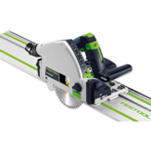
TRACK SAW – More commonly known as a rail saw as it has tracks to slide on when cutting wood. There are foam rectangles to stop the rails from sliding around. When setting the depth of the cut, it is important to add the rail width to ensure the section of wood is cut all the way through. When using the track saw, always make sure to have a good grip on the handle and don’t force the blade. Let it go on its own. There is also a slot that the saw will slide in, making it easy to move.

If you are working in a group, it helps to have another person to hold the dust extractor hose as it gets in the way easily. Always remember to start the saw first before using it to cut anything and do not hold the wood. This can result in the loss of a few fingers. The lengths for the rails can vary from 800mm,400mm and 2.5m.
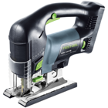
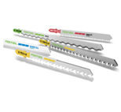
JIGSAW – A jigsaw is commonly used for freehand cutting and curved edges. There is a speed setting (1 – slow, 6 – fast) and an automatic speed, which is easier to use. The dust extraction is exactly the same mechanism as the rail saw. There are different blades, and the teeth point either up or down. The teeth on the specific blades for kitchens will always point up. They are delicate so only use them on softer materials. They have a bayonetted fitting so be sure to fit it in the jigsaw whilst the power is disconnected.
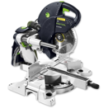
CHOP SAW – When handling the chop saw, it is always important to start the saw before dropping it and cutting wood. Make sure you wear ear protection and safety goggles and go slowly. There are laser lines to help with cutting. There is also a speed setting from 1 – 6 like the jigsaw.

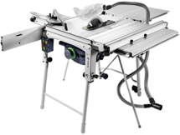
TABLE SAW – Don’t use tape measures for this as they could get stuck or caught. Be sure to measure the length you want from the blade to the end of the table. The table saw has saw stop technology, meaning if someone or something hits the blade, it will stop and retract. There are square jigs to help with moving the edge of the wood through the saw to insure it cuts all the way through.

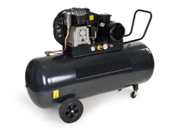
COMPRESSOR – Green: OFF, red: ON. The valve on the compressor is always closed unless air needs to be let out. There are air hoses that attach to wither staple guns or wiggle pin guns to secure wood for flats together.

FIRST INITIAL THOUGHTS – After trying the tools for the first time, I was surprised to find how easy it was to handle them. It could have been because I thought some of the saw tools felt secure. The only tool I did not enjoy handling was the jigsaw because it felt so freehand, and I didn’t really know if I could handle it well because I felt unsecure and unsupported.

CONSTRUCTING FLATS

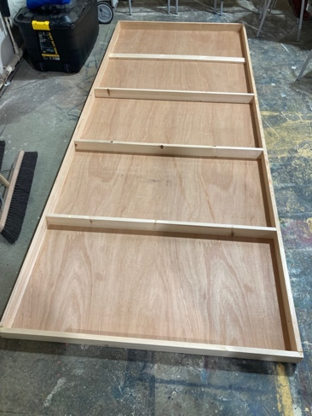
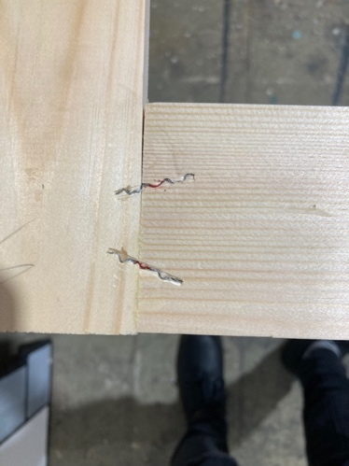
The first thing to know about building flats is that it takes time. You must remember to measure twice before cutting any measurements. Scenery should always be lightweight as you could be transporting it around a lot if you are part of a touring company. Broadway flats tend to take up less space, yet they are wider than Hollywood flats, which are screwed and stapled together. Broadway flats use wood glue and corrugated fasteners (wiggle pins) instead of staples. They also have corner plates installed for more stability, made from thin plywood, and attached with staples and wood glue. It is important to always use wood glue before permanently securing parts together, using a set square to keep things parallel and straight. This gives you the opportunity to move things around slightly if they are not flush together.

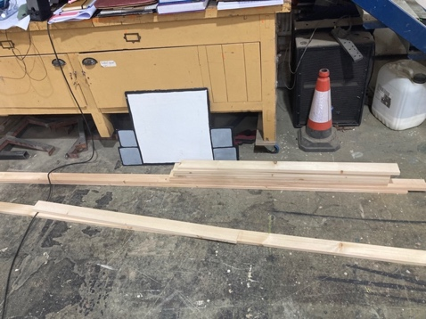
CUTTING LIST – When you make a cutting list, you need to include all your measurements. For Hollywood flats you would need the width of your frame, overall. You would also need the top and bottom (rails), vertical sides (styles) and the middle sections (toggles).

Broadway flats are cut to eventually be 8ft high (2440mm). The toggles are cut the same way, but the top and bottom rails are cut to the full width.
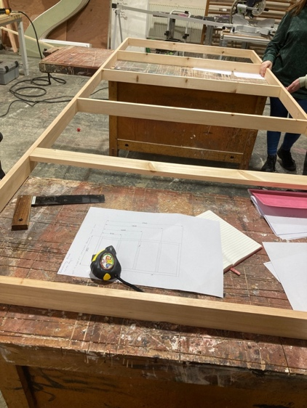
PROCESS
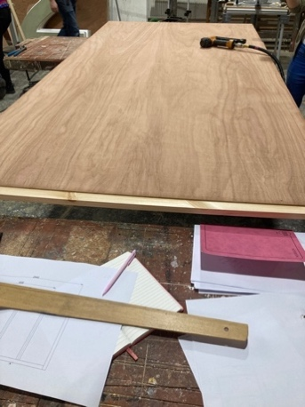
HOLLYWOOD – We started by screwing together the rails and styles to act as the mainframe of the flat. We then screwed the toggles to the frame to strengthen it. For this we used 2 x 4 wood lengths, the chop saw to cut the lengths down to size and a drill to put it together. For the top of the flats, we used a plywood sheet and the table saw to cut it to size. We then glued and stapled it to the frame in order for it to be secure.

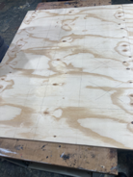
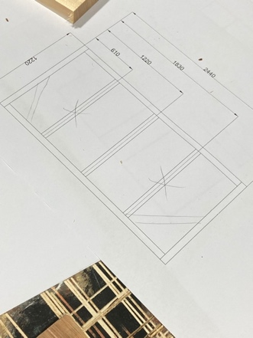
BROADWAY – Putting Broadway flats together uses a similar technique, except instead of using a drill to attach the frame, we used a wiggle pin gun to affix each piece together. They fasten across the wood joins to keep them secure. Before using them, we also glued the pieces to stop them from moving around. To strengthen the corners, we cut plywood triangles with the chop saw and affixed them with staples.
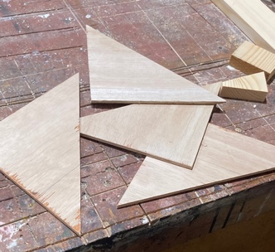
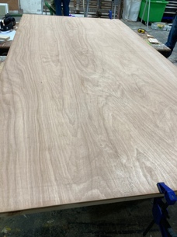

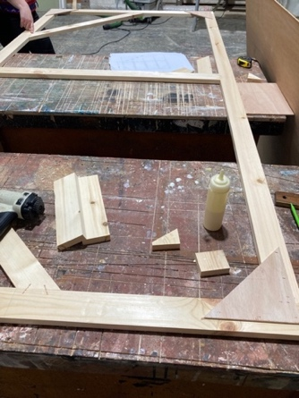

THOUGHTS – Looking back on this project, I know I preferred making the Hollywood flats as I found them easier to handle and there were less elements to interact with which made it easier for me to focus on one thing. The things I disliked were using the wiggle pin gun as it took me by surprise when using it and it was incredibly loud. I am happy with the end product, and I definitely think I did a good job with using the tools as I felt more confident using some of them, as opposed to before.

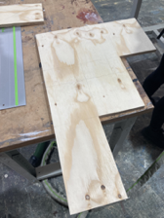
CONSTRUCTING TREADS

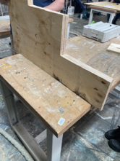
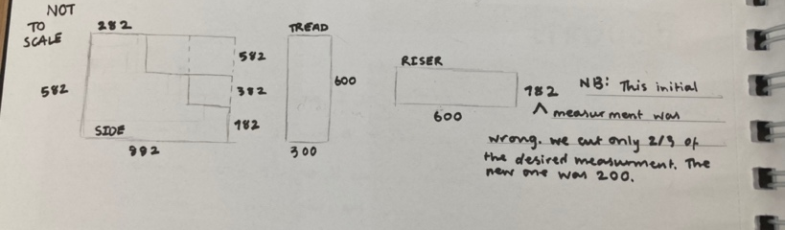
Before we began to construct the treads, we were given a 1:25 scale drawing. To make it easier to find out the measurements we needed, we used our scale rulers and were able to translate them into 1:1 scale. Our chosen material was 18mm thick, soft sheet plywood. This is ideal as it is cheaper to buy, the layers don’t pull apart as easily and there are no holes filled with concrete which is very common. After finding out each measurement, we noticed that the thickness of the plywood would affect how the final outcome of the treads would look like, so we had to subtract 18mm from our findings.

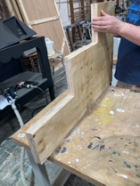
We tackled each section individually, starting with the sides. We used the rail saw and jigsaw to get into the corners and make sure it was precise. Cutting out the risers and treads was easier, only using the table saw to cut them out.

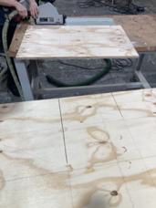

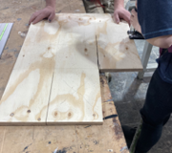
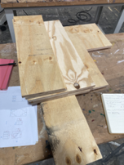
INITIAL THOUGHTS – Initially, I went into this project feeling nervous about having to use the machinery that I was not confident using. However, I now know that I have to keep using these tools to gain the confidence and experience I need for future projects. I knew that this project would need me to use my strengths more as we would be going into more detail with painting them in the future.

PUTTING THE TREADS TOGETHER

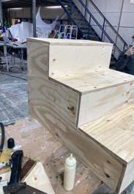
When putting the pieces together, we used wood glue, screws, and staples. In order to make them stronger, we had to include support beams. These were cut from 3 x 2 and measured at 564mm. These were also screwed to the structure to make them more secure and stable. This was to firmly assure someone could use them as treads.
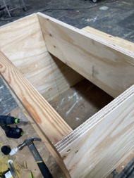
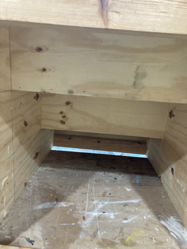
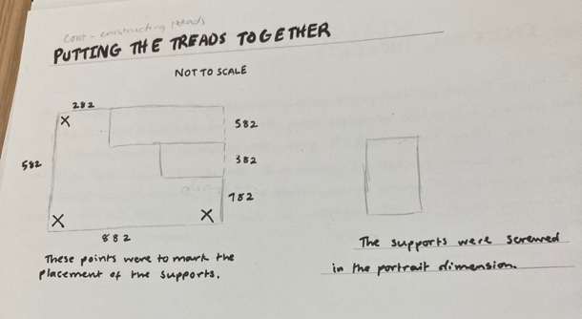

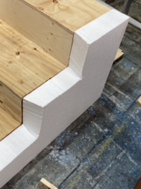
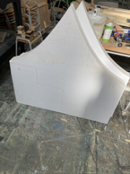
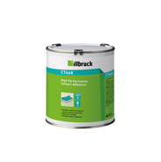
ADDING POLYSTYRENE – To keep in line with the set criteria we were given, we had to add polystyrene to the treads and use it to create a rock-wall texture. To achieve this easily, we traced around the tread siders to get the correct shape. In order to cut them out, we used the jigsaw, and a specific blade used to cut softer materials like polystyrene. It was definitely easier cutting these shapes as the polystyrene was more forgiving as a material.

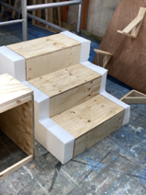
We used a specific polystyrene contact cement to glue the pieces to the sides of the treads. The brand was Illbruck industrial contact adhesive. We applied this to both surfaces around the edges, waited for it to get tacky then precisely stuck them together as it bonds very quickly if enough pressure is applied.

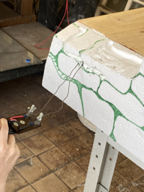
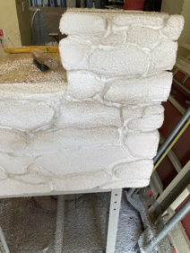
CREATING A STONEWALL EFFECT – To create the desired stonewall texture and effect, we used a picture reference and drew stone-like shapes, ready to be carved out later. To shape the sides, we used a hot wire tool to add dimension, depth, and realism. We had to be quite delicate as we were free handing each shape, but I think we handled it well. To add texture, we used wire brushes and smaller carving tools to achieve the desired effect we wanted.

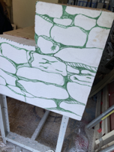
I am confident in knowing that I can take these skills further in future projects and can continue to learn from my mistakes and past actions. I believe that this is the easiest way to progress forward with learning new skills and strengthening older ones. I know that I will come back to using these skills in the future as I enjoyed becoming more confident with them.

CONSTRUCTING A CIRCULAR ROSTRUM

For this project, we were given the task to create a circular platform that had to be 2.4m in diameter. We used a wood sheet and 3 x 2 strips for supports. Their measurements were 1185mm and 101mm.
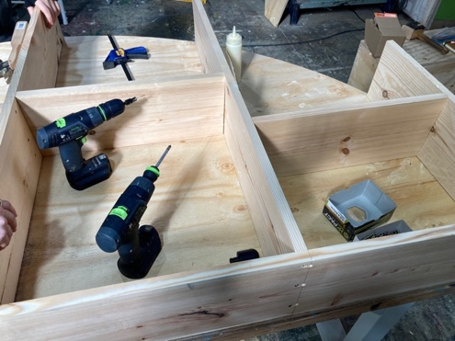
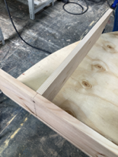
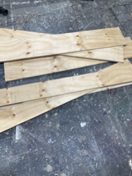

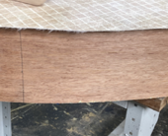
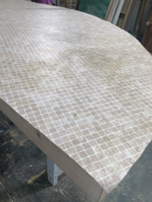

PROCESS - To construct the rostra, we thought to have two semi-circles bolted together. We used the jigsaw to make the rounded edge and the chop saw to cut the supports to the right size. After screwing in the supports to the structure, we decided to add further support to make the entire rostrum stronger. We did staple some parts down but had to use the angle grinder to correct our mistakes. I found this helpful as I learned how to use it correctly and gain more confidence with the tools.

After securing all the supports, we used thin plywood sheets to cover the rounded edge, but before we could staple it down, we had to smooth out the supports, so everything was nice and neat. For that, we used the Festool EHL 65 EQ. We were able to add lino to the top using contact adhesive around both perimeters.
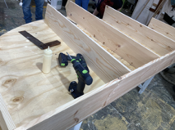

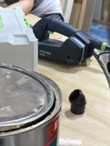
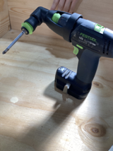
THOUGHTS – This project really pushed me to use the skills I have and additionally allowed me to try new things and try to build my confidence using tools I may not be confident using. I know that doing all these projects and tasks is a learning experience and I am eager to be able to build on and develop my skills in construction.

INERESTING SETS

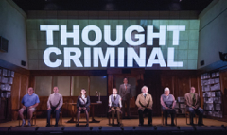
1984 – Duncan Macmillan and Robert Icke
The set for Headlong’s production of 1984 felt very filmic as it was a realistic office setting with chairs and tables to give the look of a conference room. At the back of the stage, there was a set of double doors with windows to see actors walking across the back. There were also large projection screens and LED strip lights along the sides of the stage.

In contrast to the office setting, room 101 was completely bare, save for a chair, small table, and pink beach umbrella. The walls liked like they were made of the material people use for building renovations. I really liked how they kept the audience in suspense and how they gradually took the set away when room 101 was revealed to everyone.
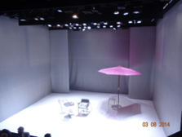
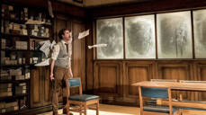

The Twilight Zone – Anne Washburn

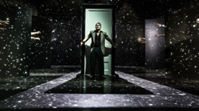

The twilight zone is a play based on the episodic TV series by Rod Sterling, so the nature of the entire production was very whimsical and dream-like. The set pieces were all individual, one was a bar in the style of the 50s era, another being a bed and a door secured to a low theatre wagon. These would have to have been easy to move and lightweight as none of the set was on the stage for the entire time, and because of this, the play felt episodic.


There were also hidden doors built into the walls on the sides of the set box, which had been painted to look like the opening of the TV series. I really liked how stylised everything was. It was like I was watching the proper series from the 50s.

Superliminal – Pillow Castle
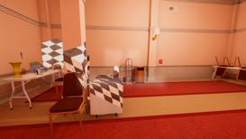

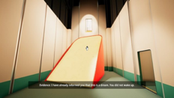
Superliminal is a puzzle game using the trope of “object sizes can change by interacting and perceiving it differently”. The plot to the game is that the player is learning about dream therapy technology aiming to help with the problems of not perceiving the inconveniences of their life. The experiment goes wrong and we, the player must navigate our mind to find a way to wake up in our reality again.

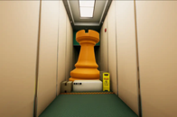
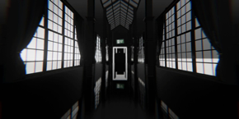
I really like how the developers of Superliminal play on the elements of perspective, reality, and dreams. At first, the look of the game is entirely normal bit changes throughout the progression of the game. In some areas, there are Broadway flats depicted, further hinting at the themes of deception and whether we are dreaming or experiencing reality.

SCAFFOLDING
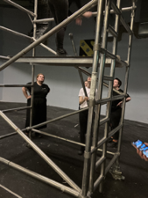
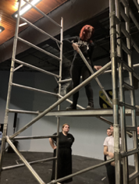
Scaffolding is mainly used to aid in setting up lights, set or any other scenery props or dressings. However, many theatre companies and set designers choose to use scaffolding or a structure similar in look as the set. This is beneficial for any industrial looking production or using it to support scenery in front of the structure.

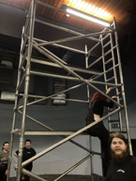
Scaffolding also poses as a health and safety hazard, with both setting it up and working at height. Whenever you use scaffolding, you have to ensure that the structure is sturdy enough to prevent someone from falling. Before working on the structure, it is important to assess all the risks and decide on any precautions.

CAD (COMPUTER AIDED DESIGN)
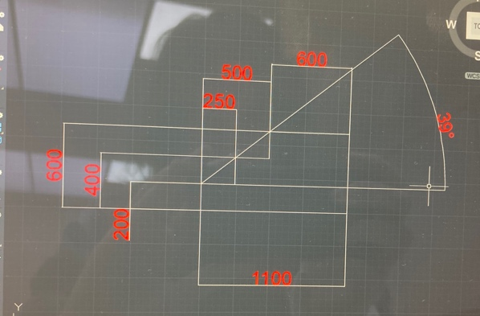
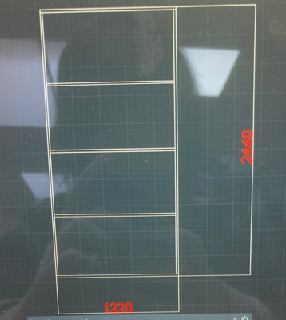
CAD is the industry standard for drawing props, set, technical drawings, plans, technical costume (for example, articulated wings), grand plans and festivals. As well as the theatre field, CAD is used in engineering, architecture, and entertainment. Vector works are more for scenic construction and lighting specialists as well as including 3D visualisation. Within CAD, you can draw in real scale then print it in a smaller scale, however, it doesn’t need to be too accurate.
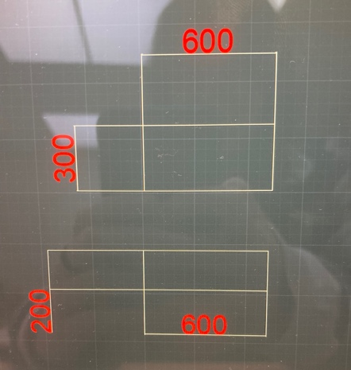
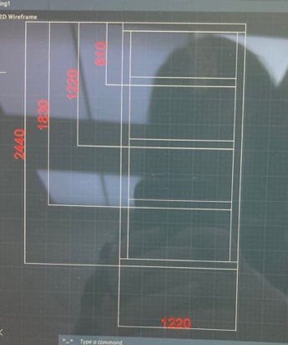
If you are given an illustration without measurements, you will have to work it out, but it’s a lot easier if the designer has given measurements for you to work off. Layers are another important thing to use as you can separate different sections and elements into their own separate layer. The dimensions are not included or inside of the drawings. That is only for doorways and windows.

CONSTRUCTING SHELVES
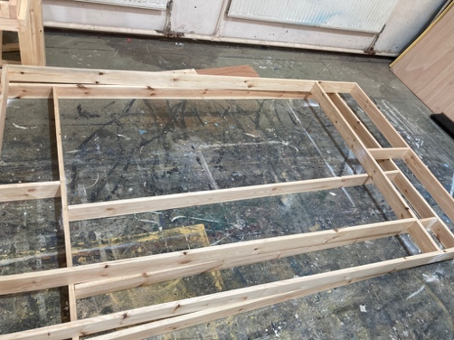
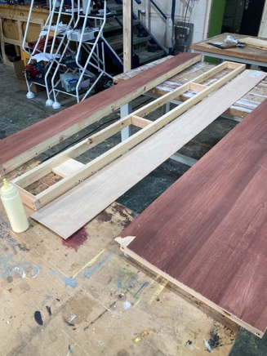
For this project, we used 4 x 2 planks for the shelves. This was for a production of Patience from the Charles Court Opera. We also added cladding to one side, which is the wood that goes on a flat. We also used thin plywood sheets on the back of the shelves.

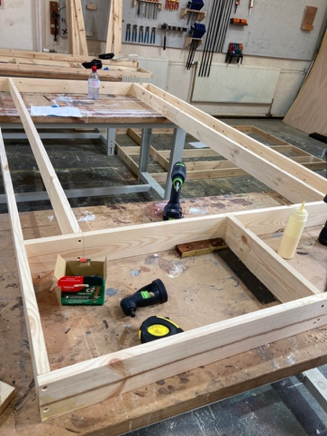
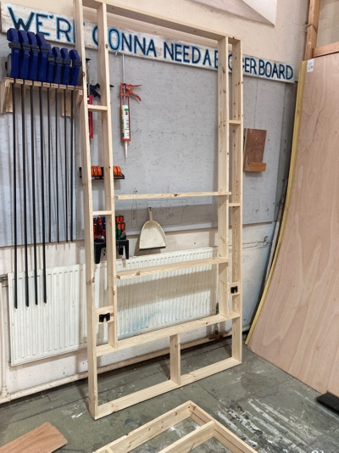
Our cutting list was:
- 2x 2040mm
- 2x 2020mm
- 2x 1510mm
- 1x 1470mm

When constructing the shelving, we noticed that the wood was slightly cupped, which meant that it curved in a semi-circle shape. This would have been not ideal if we had not noticed before screwing the shelves in, as the prop bottles that are used in the production would have rolled off. To combat this, we screwed in these wood bits so the curve was cup side up so the props would at least have a chance of staying on.

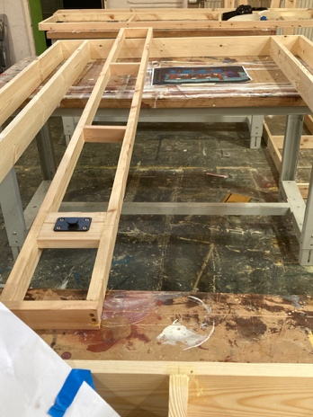
THOUGHTS – I was eager to improve my skills with this project but thought we needed to be cleaner and more precise as this was for a theatre company. I’m glad that we ran into a few problems as that helped with my problem-solving skills and allowed me to think on my feet quickly and efficiently.
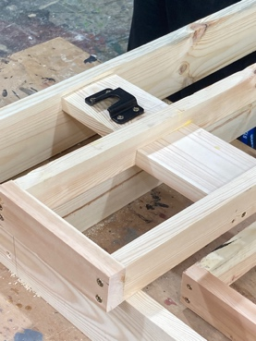

CONSTRUCTING A BOX
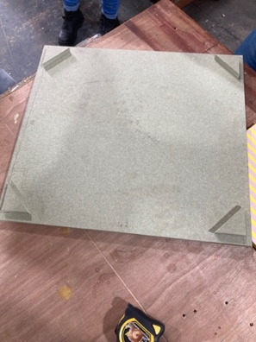
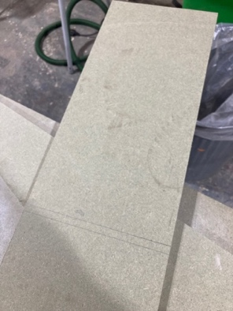
We constructed this box for the 200 project out of green MDF. It was for the lighting control box The thickness was 12mm, so we had to take that into account. The cutting list proved to be difficult as we were not given any prior measurements and had to figure it out all by ourselves. It was difficult but a good challenge to work out.

Our final cutting list came out as:
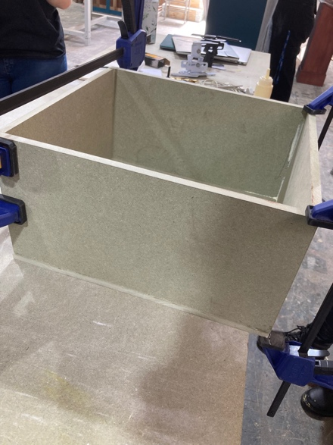
- 2x 354 x 206
- 2x 420 x 206
- 2x 420 x 384

To cut the MDF, we used the rail saw for the sides and top, and the staple gun loaded with pins to attach it all together. To add stability to the top, we added 4 50mm x 50 mm triangles to stop the top lid from moving around. The top would also be hinged to add more security, and the back would have an opening for the wires from the box to come out of.

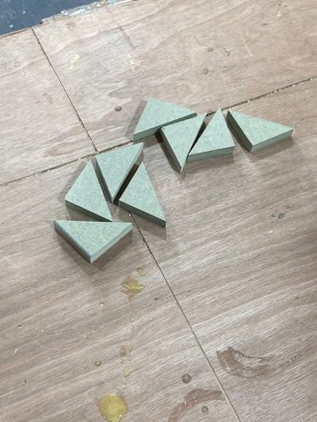
THOUGHTS – Initially, I thought this project would be very easy, but I was quickly proved wrong with how many times we had to re-measure the sides and re cut the MDF. It definitely gave me a glimpse of what happens when things go wrong and how to rectify it quickly. With the end product though, I am glad about how it turned out, and how we were able to learn from our mistakes.
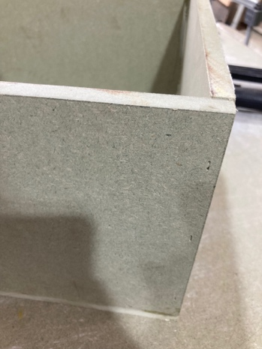
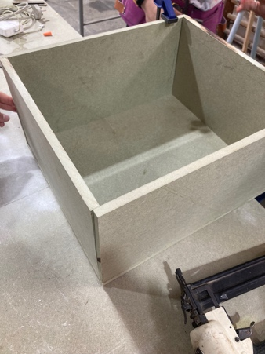

STUDY TASKS

HOW ARE TREADS MADE FOR THEATRE?

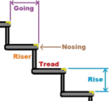
Most treads are made of plywood; however, some are constructed from lumber. Before building, you must take into account the hazards. Are they wide or deep enough for performers? You have to make them strong enough to support that weight. Some treads include cleats which attach to the stage, then attach to the treads. This is to ensure they will not move around too much during a performance. If a set of treads has three or more risers, then a handrail is recommended. The correct angle for treads to be safe would be between 30-35 degrees. However, some treads can be at angles of 20 to 50 degrees.

WHAT IS A ROSTRA IN THEATRE?

Rostras are like blocks. They are used when a portion of the stage needs to be raised or a production needs a platform. They can be different shapes and sizes. Temporary rostras are used in music production, particularly festivals and concerts. For this sort of staging, you must take instruments, amps, speakers, and lighting into account. Drummers and percussionists are given a separate rostra with rubber matting to prevent low frequency vibrations. Rostras can also be used to modify a staging arrangement or to fix any awkward patches of staging.
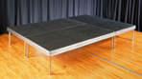

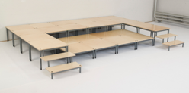
You can get modular staging systems which are mostly used for school systems. They include frames, tie plates and decks for the top. They offer a range of levels. Tiered staging is normally easy to store and put together, whereas other rostra are more difficult, but that could be because some are sturdier than others.
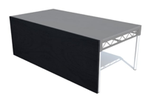

WHAT ARE THEATRE TRUCKS

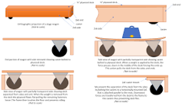
A truck is a wheeled platform that can be used on scenery (often in education). They are also sometimes called wagons and can be moved either manually or via an automated system. Trucks can support and move scenery onto and off the stage. Casters are used as breaks to stop the truck from moving around during a scene.

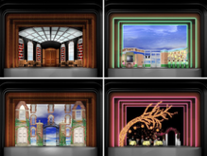
One production that has trucks to aid in moving set pieces around, was the Broadway production of Legally Blonde: The Musical in 2006. The designer, David Rockwell mapped each piece onto a flat surface before attaching them to low trucks to make them easy to move.
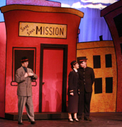

WHAT ARE REVOLVES IN THEATRE?

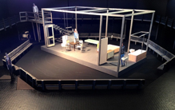
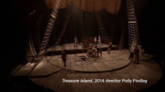
A revolve is a turntable within the stage or a round floor that spins on a central pivot. Some notable productions that have revolves built into the stage are the 2016 production of Hamilton and The National Theatre’s Treasure Island from 2014. They are controlled by automation. If a production has a revolve as a part of the set design, the actors will use it in rehearsal to get used to the feeling and movement. There are examples of entire sets being on a revolve such as The National Theatre’s production of A Streetcar Named Desire.

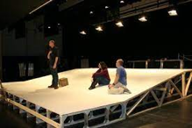
If the stage was not very steep, you could add a revolve but you would have to adapt it to the particular staging you want. You wouldn’t want the revolve to be too fast as the actors could fly off and injure themselves. You also have to take into account if the revolve is higher than the stage. If so, them a small ramp could help with movement.
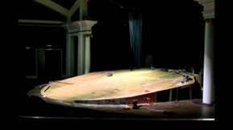

USING METAL TO BUILD SCENERY
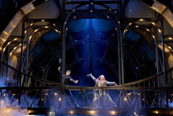
Using metal in scenery is beneficial as it is incredibly strong, durable and increases safety. Metal is also less flammable and weather resistant. Scenery can last longer if in an indoor environment. Metal is also more versatile, being beneficial in many projects due to being cut into different shapes and sizes. There are also a variety of different types of metal to choose from.

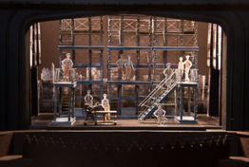
Metal allows scenery to become stronger. It can also create scenery and set to have a specific look or feel (for example, steampunk or Victorian). Some examples of productions that uses a lot of metal in their set are the RSC’s The Magician’s Elephant and the Broadway production of Newsies. It can act as a good skeleton to build on if a particular set piece needed to be more fleshed out.

FOUR WAYS FLATS CAN BE JOINED TOGETHER

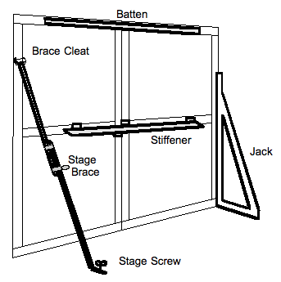
Four ways flats can be joined together are with pin hinges, cleats, jacks, and battens. Battens are normally 1 x 3 or 1 x 4 boards that are screwed to the frame. Cleats are metal brackets attached at the back of a flat. You can tie rope to it and attach it to a stage brace which further helps to stabilise the flat. Pin hinges are screwed to adjoining flats to be held securely. When taking down the flats, you remove the pins, and they will come apart. A jack is a triangular wooden frame that attaches to the back of a flat, usually with attached hinges to secure it to the flat and even ones for the floor. Alternatively, you could use a weight or sandbag to stabilise the jack on the floor and to counter the flat’s weight.

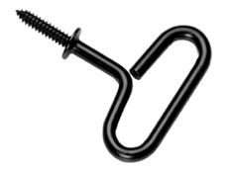
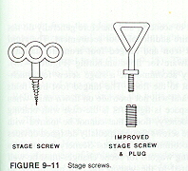
Stage screws are used to normally affix whatever is supporting the flat to the floor. The two types are traditional and improved. The traditional screw is affixed by hand into a hole in the floor, but, if the set needs to move for any particular reason, then a new hole will need to be made. An improved stage screw is designed to overcome this problem. It includes a square thread instead of the tapered one the traditional screw has, and an insert. To insert the screw into the floor, you must drill a pilot hole with a brace and a specific drill bit, then you screw the improved stage screw into the insert. It does, however, take more effort to do and leaves a smaller hole in the floor but it will not damage it as much.

WHAT IS WELDING AND METALWORK IN THEATRE
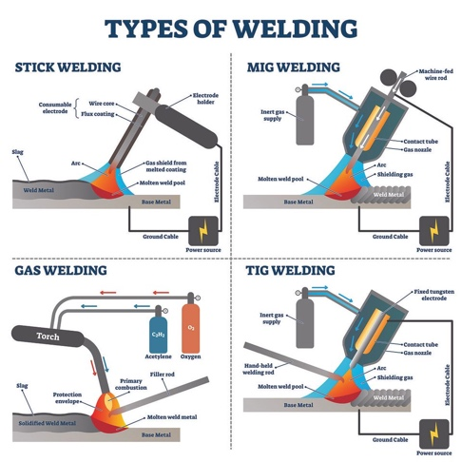
There are four types of welding used in construction. MIG, TIG, stick and flux cored. MIG, or gas metal arc welding is commonly used in vehicle repair and building work. It is the most universal welding type. It uses a continuous wire, or electrode as well as a shielding gas to protect yourself from contamination. TIG, or gas tungsten arc welding uses a tungsten electrode that is very strong and will not burn out or dissipate. This method also uses an external gas stock such as helium. It is used in the industrial line of work and can be useful to farmers with any machinery.

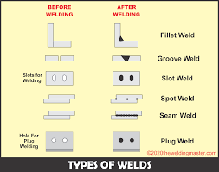
Stick welding (shielded metal arc welding) is portable and is used in construction, maintenance, industrial fabrication, and underwater pipes. The electrode is protected, and it softens and compiles metal by heating an arc between the electrode and metal piece. As it melts, the protected layer comes away, shielding the area from any gases in the air. Flux cored (flux cored arc welding) is akin to MIC as they both have continuous power and wire. But flux cored combines the electrode with a base metal. The electrode is hollow, and flux gets poured in through the gun and into the weld pool. This is more ideal for outdoor working as the shield is weather resistant. Flux cored is used in machinery as it is suited for thicker metals.

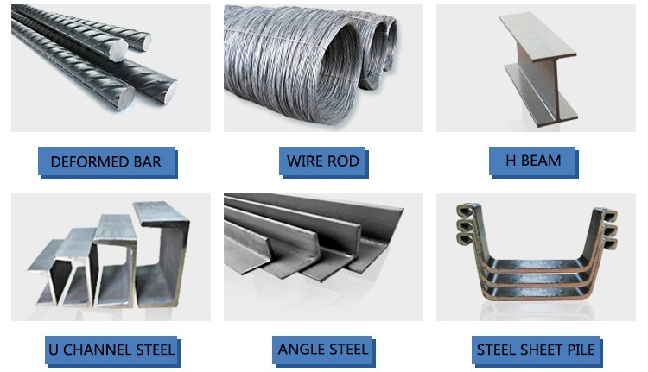
You are able to buy lengths of metal up to 4 metres long. They can range from aluminium, steel, stainless steel, brass, and copper. The pricing would differ based on the metal type and how much you want. However, wood is cheaper than metal, but this can change due to the nature of construction you want to achieve and possible shipping payments.

CONSTRUCTING A TREE THAT NEEDS TO BE CLIMBED ON
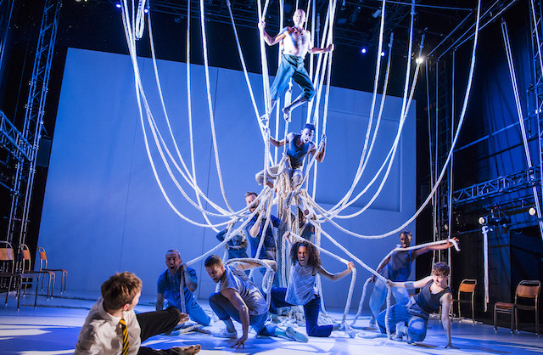
To first tackle this project, if I was given it, I would start by looking into how normal tree props would be made, then build on how I could make it sturdier in order for actors to climb on it. One of the most notable examples of this idea would be The National Theatre’s production of A Monster Calls. The set designer, Michael Vale, thought of the idea of having a large collection of thick exercise ropes in the centre of the stage to represent the yew tree. This was beneficial as it could easily be tucked to the side of the stage if it was not needed. Apart from that and chairs for the rest of the acting company, the stage was bare. This was a very prominent, bold choice but the fact that it could be hung back on hooks made it not too overwhelming and it didn’t overpower the rest of the stage.


I really liked this concept as it creates such a large impact on the audience and can be open to interpretation. However, the only slight downside is that whoever was climbing on the tree, had to be in a harness for safety reasons, but the rest of the company would help stabilise the ropes to stop them from moving so much. This would have probably been a safety choice, but I would like to think that it was also a creative choice. However, a lot of the production used circus elements like stilts to create impact.

If I were to construct a tree in the same way as The National Theatre, 15m x 5cm of exercise rope is roughly £75 on Amazon. I think this depends on the designer’s choice of how “full” they would want the tree to look and whether they want bits hanging down from it, or extra support. I would then have to research how to tie a strong enough knot for all the rope to be secure, guaranteeing that it would not unravel halfway through a run-through of whatever play this is for.

WHAT IS CLADDING
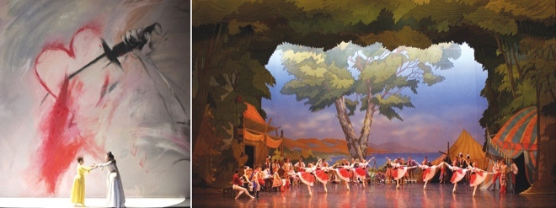
Cladding is to protect the framework and to present a cleaner side of the flats that can be added to with scenery props or design. The most basic way of cladding is to use scenery canvas or any other thick cloth. If you do choose to use canvas, it should be fire retardant so you should use durably flame-retardant fabric as the starting point. This type of canvas has been treated with specific chemicals to prevent fires and can be washed up to two times before it starts to lose those properties. To get the best results, you should look into inherently flame-retardant fabric as this has better results and requires no treatment. The upside to using canvas for cladding is that you can paint scenes onto it so more space will be allocated to the stage.

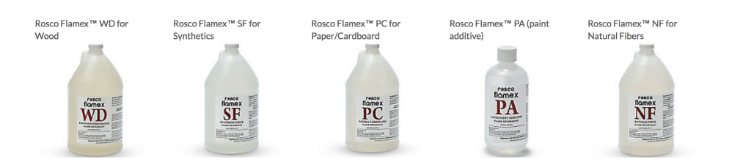
There are quite a few things that can go wrong when using fire resistant products on your canvas. The first being the obvious, use the right product before you start painting just in case you use the wrong one and have to start again. If you get confused, you can look up the properties of the product. Another point is to not be too stingy with the product. If you put too little on there, it’s at a larger risk of catching on fire if one does occur. One more point is that you shouldn’t assume that the fabric will pass the flame test. All fabrics should be tested before going on stage.

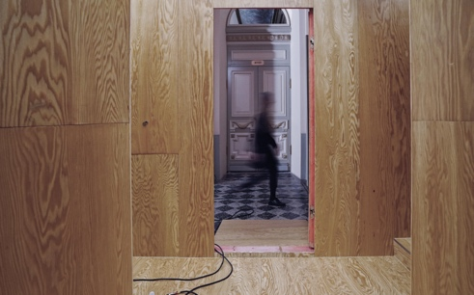
Alternatively, you can also use hardboard or thin plywood. Hardboard is the cheapest alternative but definitely not the best, as it damages easily, it is not extremely durable, can bow over time quickly and is quite heavy. A 3mm sheet that is roughly 2.4m x 1.2m is 9.53kg. Plywood is more expensive but more durable and easier to attach to flats. It is also lighter with a 3mm sheet with the same dimensions can weigh 7.4kg. Woods such as MDF are unsuitable for cladding due to them being too thick.

LITTLE REVOLUTION (3RD YEAR SHOW)

In the construction side of the third-year show, Little Revolution, there was some influence from street graffiti and alleyways with the white, grey, and black colour palette. Most of the material used was metal sheeting and chains that held posters with collaged pictures of protests and riots, seemingly spanning many years. These posters also had plastic acetate in the middle, where the actors can see through and were chained to the ceiling. The whole performance was played with an immersive audience, with wooden boxes that were spray-painted to fit with the theme of the rest of the set. The only other set props included a metal trolley on wheels, dressed with shards of metal sheeting wire mesh, and spray-painted with black and white colours. The other prop was a wooden newsagent’s billboard to fit the story. Overall, it was quite a minimal set, which I liked as it made me focus more on the acting and storyline.

EVALUATION

Over the time I have spent doing this module, I think I have become more confident in myself using different tools in the workshop. At first, I was really nervous to use them as I thought I’d mess up or possibly injure myself whilst using one. Looking back now, I have decided that I am more confident and comfortable using tools and how to use them in the right circumstances. I really liked the treads project as I was able to use skills, I had learned prior, and adopt new skills, such as carving polystyrene. I know I didn’t like first using the tools, but that was expected as I hadn’t used some before.

It was reassuring that I could recognise some tools and knew how they worked even if I wasn’t confident. The main thing I have taken away from this module is that if I am needed to help with any kind of set building or construction, I can help because of the skills I have gained and developed.

REFERNCES

Alderson, M. (2010). Stage Carpentry. [online] www.ia470.com. Available at: https://www.ia470.com/primer/scenery.htm.
BBC (2020). Temporary Stages and Rostra. [online] www.bbc.co.uk. Available at: https://www.bbc.co.uk/safety/resources/aztopics/temporary-stages-and-rostras/.
Finger, A. (2006). Legally Blonde: The Musical. [online] Adam Finger. Available at: https://www.adamfinger.com/legally-blonde.
Forum Theatre (2022). How to Join Theatre Flats? Forum Theatre | Accessible, affordable, and Entertaining Theater | DC Metro Area. [online] forum-theatre.com. Available at: https://forum-theatre.com/how-to-join-theatre-flats/ [Accessed 17 May 2022].
HSE (2015a). Construction - Assessing all work at height - HSE. [online] www.hse.gov.uk. Available at: https://www.hse.gov.uk/construction/safetytopics/assess.htm.
HSE (2015b). Construction - Scaffold checklist - HSE. [online] Hse.gov.uk. Available at: https://www.hse.gov.uk/construction/safetytopics/scaffoldinginfo.htm.
IVCCD (2021). What are the 4 Types of Welding? [online] Iowa Valley Community College District. Available at: https://www.iavalley.edu/blog/2021/03/11/what-are-the-4-types-of-welding/#:~:text=There%20are%20four%20main%20types.
Megan, B. (2012). Quick guide to strange theatre terms. [online] www.mtc.com.au. Available at: https://www.mtc.com.au/discover-more/mtc-now/quick-guide-to-strange-theatre-terms/.
Paperclip (2012). TSM Project 2008 - Raked Revolve - paperclip. [online] Rcs.ac.uk. Available at: https://paperclip.rcs.ac.uk/index.php/TSM_Project_2008_-_Raked_Revolve.
Point, H. (2020). Uses For Indoor Scaffolding. [online] Hi Point Access. Available at: https://hi-pointscaffolding.co.uk/blog/some-indoor-uses-for-scaffolding/ [Accessed 16 May 2022].
Powers, A. (2018). 7 Ways to Screw-up Your Flame Retarding. [online] Guild of Scenic Artists. Available at: https://www.scenicguild.org/2018/12/7-ways-to-screw-up-your-flame-retarding/ [Accessed 17 May 2022].
Primrose, J. (2016). Flats - Types and Methods. [online] Theatrecrafts.com. Available at: https://www.theatrecrafts.com/pages/home/topics/scenic-stage-design/flats-types-methods/.
Saxby, K. (2020). How does a revolve work? [online] www.mtc.com.au. Available at: https://www.mtc.com.au/discover-more/mtc-now/how-does-a-revolve-work/#:~:text=A%20standard%20revolve%20is%20a.
Stage Systems (2017a). Modular Staging. [online] Stage Systems. Available at: https://www.stagesystems.co.uk/modular-staging/ [Accessed 16 May 2022].
Stage Systems (2017b). Tiered Staging - Q-Plus & Q-Stand Seating. [online] Stage Systems. Available at: https://www.stagesystems.co.uk/staging/tiered-staging/ [Accessed 16 May 2022].
Teague, B. (2004). How to Build Theater Stairs - An Illustrated Guide. [online] Available at: https://inspectapedia.com/hazmat/Theatre_Stairs_Teague.pdf.
The Old Vic (2018a). A Monster Calls | Official Trailer. [online] www.youtube.com. Available at: https://www.youtube.com/watch?v=Jrc_hrygT8M&t=14s [Accessed 17 May 2022].
The Old Vic (2018b). A MONSTER CALLS TEACHING RESOURCES. [online] Available at: https://cdn.oldvictheatre.com/uploads/2018/07/A-MONSTER-CALLS-TEACHING-RESOURCE-UPDATED-ARTWORK-.pdf [Accessed 17 May 2022].
TheatreCrafts (2021). Automation (Scenic). [online] Theatrecrafts.com. Available at: https://www.theatrecrafts.com/pages/home/topics/automation.
TVTropes (2019). Superliminal (Video Game). [online] TV Tropes. Available at: https://tvtropes.org/pmwiki/pmwiki.php/VideoGame/Superliminal [Accessed 16 May 2022].
Valle, G. (2022). Pros and Cons of Using Steel in Construction Projects - BuilderSpace. [online] www.builderspace.com. Available at: https://www.builderspace.com/pros-and-cons-of-using-steel-in-construction-projects.

