University of Wales Trinity Saint David London

BMSK4004- Problem Solving and Decision Making

Student’s Name: Jebunnessa Zorna
Student’s ID: 1705789

Lecturer’s Name: Renuga Jayakumar

Contents
Introduction: 1
LO1 Describing a problem, its scope, nature and impact on the workplace 1
LO2 gathering and analyzing information for solving a problem 3
LO3 Evaluation of options for aiding in decision making 8
LO4 Planning, monitoring and reviewing implementation and communication of decisions. 10
Conclusion: 14
References 15

Introduction:
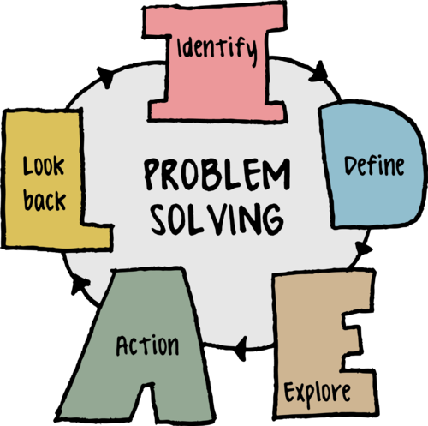
Problems and challenges are integral parts of any organization. The resources available within any organization are utilized in order to tackle the detrimental effects of the problem by minimizing the dynamics involved with them. Problem solving is the activity of analyzing the available data relevant to a problem to produce useful information which can consequently help in solving the problem. In order to do so it is necessary to be able to make significant decisions which might have immediate or potential impacts on the organization (Reed & Learning, 2014). This report is focused on identifying a workplace problem and describing its characteristics and impacts on the organization. It will also gather relevant information on a particular problem from the learner’s past working experience and attempt to solve the problem using various techniques and methods. Finally the report will focus on evaluating different options for approaching the solution of the problem followed by a addressing the complete process involved in addressing the problem which will include planning, monitoring, communication and reviewing the decisions made for solving the problems. The report will be prepared based on the information gathered from the work experience of the learner acquired from Bright horizons Family solutions. This is one of the leaders in the child care service industry in UK. They provide employer funded childcare. In other words, corporate individuals can avail their services via their employers. They operate with corporate accounts as well as individual accounts. They have over 300 nurseries all over UK (Brighthorizons, 2018). Along with child care they also provided preschool education and a good environment for children to spend their time while their guardians are working. They have also provided employment to over 10,000 employees across their outlets.

LO1 Describing a problem, its scope, nature and impact on the workplace
The learner worked in Bright Horizons as a Manager. She was in charge of managing the operations of a branch in London. The roles and responsibilities mainly included the following:
i) Ensuring that the service users are provided with necessary services
ii) Employing compassionate and competent individuals
iii) Coordinating with the maintenance staff for maintain hygiene and safety.
iv) Collaborating with child care brands for promoting services
v) Managing performance
vi) Providing information to the upper management for making critical decisions.
While working many problems arose in the workplace. Most of them were quite simple and could be addressed by making small changes and decisions within the boundaries of the authority granted to the learner. But some issues were quite complex and required involvement of the top management for complete mitigation or removal. In the following segment, one of the major complex problems will be discussed in terms of its nature, scope and impact on Bright horizons.
Problem:
In the childcare industry it is crucial that the employees are invested and enthusiastic with the work as the target audience encompasses children who might be difficult to deal with at times. Even though the employees were invested in the work, the performance of that particular branch of bright horizons in which the learner worked as a manager, had very low performance scores. It was found that the children were irritated most of the time after leaving the care home and some parents also reported instances of their children being affected with rashes and illnesses which was not present prior to the visit in the care home. This resulted in decreased rate of return. 70% of the parents didn’t return for service after 1 or 2 months. The employees were also affected by this and remuneration was a challenge. It was quite difficult to promote employees as the outlet itself was doing very poorly. This might have been caused due to the varying expectation and the lack of understanding of the tasks which was induced by the very short training module of 1 week provided to all care providers before employment. A general training regime is conducted throughout all the outlets which might have been ineffective in addressing the needs of specific demography and region in which the outlets are operating in. moreover, the short term training might have been too overwhelming for the employees to even sustain the knowledge and apply them practically (Cadle et al., 2014).
According to the Honey-Mumford learning style theory there are four types of learners namely, pragmatist learning style which involves various case studies and analyzing practical implications, reflector style involves adherence to examples and information, theorist learning style involves significant adherence to theories which is backed up with adequate background information and lastly activist learning style involves doing particular tasks to understand the process and learn from the experience. All these aspects might not have been considered in the training regime as a linear program was provided for all employees.
Nature and Scope of the problem:
The problem was quite severe as it was ruining the reputation of Bright horizons as a whole for that particular community. And as child care is quite sensitive for the society, the social advocacy was also working against the services of Bright horizons.
The children were facing problems quite often and parents would complaint at least 3- 4 times a week. Such intensity and repetition had dented the reputation of the branch. One of the worst case scenario was when a child was found to have chopped of his hair with a sharp object. Allegations were filed in regards to unsupervised sessions.
Impact:
The most affected group was the employees as it was becoming difficult to keep them employed and they had to find new jobs. This happened because unskilled employees would further cause the incidents that are not desirable. The organization also suffered from a dented reputation. The team morale was also decreased rendering the whole workplace to be inefficient and unwilling to work effectively.
By solving the problem, the performance level will be increased. This would rejuvenate the organizations reputation which would intrigue more individuals to avail their services. Finally, increased employment opportunity will be ensured. If no actions are taken on the other hand, then the branch might close down and the whole organization might lose the loyalty of their existing customers due to the fear of possibility of reenactment of the issues in other branches.

LO2 gathering and analyzing information for solving a problem
The first and foremost condition of solving a problems is to recognize the existence of the problem. This recognition requires gathering some information related to the problem and the workplace in which the problem is existent. In the following segment the relevant information will be gathered in order to solve the aforementioned problem.
Difference between data and information.

Data is simply the observed facts and figures which when analyzed and interpreted in an organized fashion, produces information. This information when analyzed properly produces knowledge. The context for data is provided by information. An analogy might be used in this regards, data is to information as paint is to paintings. A collection of relevant and organized data formulates information. For solving the aforementioned problem, some information is required. These include SWOT analysis, PESTLE analysis etc. In the following segment the information is gathered from analyzing different aspects of the organization (Blais, 2012).
PESTLE:
PESTLE analysis is used to analyze the external environmental factors to assess their impacts on an organization. PESTLE stands for political, economic, social, technological legal factors. These factors are analyzed in regards to the operations of Bright horizons in the following segment.
Political:
The political situation is quite unstable in UK. Due to Brexit, many organizations had to suffer loss of human resources. Bright horizons also had to suffer due to the limited pool if employees. It is also quite expensive to operate as a child care organization because many stake holders and legislative bodies are involved in monitoring. If the standards are not met then penalties are put into action. If the situation remains as such then future ventures of Bright horizons might produce difficulties for them. Moreover, all the employees working under them might also suffer from decreased employment and career development opportunities.
Economic:
The particular branch of bright horizons in which the learner worked was in south London. The area is quite flourished and has many corporate entities both in small and large scale. The employment rate of that region is also very high. Consequently the average income of the household is quite high and adequate for maintaining a proper living standard. So, the individuals are able to afford expensive services regarding child care and in many cases they can avail private child care assistants. At this juncture, the choice becomes subjective to the quality and value for money that different entities provide. As organizations have certified individuals in child care, it is more likely that they will be inclined towards them irrespective of the cost. Moreover, there are over 10 other child care services present in that area which renders the competition to be quite challenging.
Social:
The individuals of the south London, have a high performance culture embedded in their practices. Most of the employed individuals are pursuing ambitious career paths which have adequate scope for making progress and moving up the ladder. This high performance culture has rendered them unable to stay at home and care for their children in working hours. As a result, the need for child care services is persistent and growing. Under such circumstances the individuals have to be inclined and completely reliant on the services of these child care services for the safety and care of their children. And due to the increased social awareness, it is easy for them to identify flaws associated with the services. They are vigilant about the quality of services and are willing and capable to move to the ones who are able provided better services than others. The individuals also rely on other social entities for making such decisions. So social advocacy plays a great role in influencing decisions (Carlberg, 2010).
Technological:
South London is quite flourished in case of technology. Almost all the public places have free internet. This enables all the individuals to be constantly connected to the internet and to their social circles via social media. The aforementioned problems can be rapidly posted on the internet and customer feedback comments can be posted on the organization’s website. These evidences and comments influences the decisions of potential customers. Moreover, they can make alternative choices instantly by searching for them on the internet. So, it is easy for Bright horizons to acquire customers and it is easier for them to lose them via negative advocacy.
Legal:
There are many legislations which have direct impact on the operations of Bright horizons. One of the most significant legislations is the child care act, 1991. According to this act child care providing organizations must maintain standards and adhere to proper codes in order to provide the necessary care for children. Failure to comply with the codes makes them vulnerable to penalties and lawsuits by the aggrieved.
Environmental:
Hosting so many children can produce significant waste. And as a industrial district, the individuals of the society are quite aware of the importance and necessity of keeping their environment clean. Under these circumstances, Bright horizons must adhere to proper waste management practices and should perform corporate social responsibilities in order to gain favor of the society. Moreover, the workplace must be kept free of any hazardous or potentially dangerous element that might affect the health of the children.
SWOT analysis.
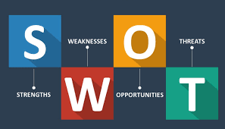
SWOT analysis is basically the analysis of internal strengths and weaknesses which can be manipulated to utilize opportunities and avoid weaknesses respectively. In the following segment the SWOT analysis of Bright horizons is conducted.
Strengths:
The main strength of Bright Horizon is that they have flat organizational structure which enables them to implement decisions rapidly. This makes the organization quite flexible to changes and can show promising results swiftly. On the other hand, the organization also has patronage of many corporate entities which adds to their portfolio for mitigating trust issues.
Weaknesses:
The main weakness of Bright horizons is their inability to develop a training program that suits the capabilities of all employees. As different employees have different learning styles and different learning curves, it is difficult to certify them as professionals under one linear training regime (Frisendal, 2014).
Opportunities:
The employment rate of South London is quite high, which results in increased number of families living in that area. In other words, the population of that area is high as there are more opportunities available in comparison to neighboring areas. This results in accumulation of more children which eventually increases the need for professional child care services. If organizations can prove their worth through their services then they can expand to several branches in that area for mitigating the local need.
Threats:
The main threat is increasing competition. One of the other aspects which facilitates the threat is increased exposure of individual to the internet and social media which can spread negative reviews like wildfire.
Ways to recognize, define, investigate and analyze problems.
The problem of low performance was first recognized when parents were filing increasing number of complaints on a regular basis. The second indicator was the decreased rate of recurring visits. Moreover, rate of new client visits were reduced by 60%. Both immediate and far reaching impacts were indicative of the problem.
The problem was investigated by determining the reason from employee and client surveys. The employee survey clearly indicated the lack of proper knowledge within employees. The client survey provided information on the incompetence of the care providers. Digging deeper, it was found that removing the employees who were accused of poor performance didn’t solve the problem. From this it was deduced that the training regime is at fault.
The problem was analyzed by addressing the core which is the training regime. The training regime was analyzed in respect to its effectiveness in reaching learners with different learning styles. It was found that the training only included reading materials and some written tests. No provision for application or practical work was found. The individuals were not provided with practical workplace examples.
Reasons for organizational change:
Organizational change is important, because the cause of the problem is not in the employees or the individuals running the branches but in the company policy and procedure of training. Changes is leaderships is required to ensure buy in form employees for making them committed to the learning process and help build the organizations reputation for efficient outcomes. The technological aspects should also be changed for better communication and increased level of accuracy in tasks which do not require human input (Howell & Teichroew, 2013).

LO3 Evaluation of options for aiding in decision making
The problem needs to be solved by making proper decisions. The decision has to be made at the top level of the organization as it would affect the whole organization. So the decision has little room for changes once made as it would cost huge amount of resources to implement changes to the whole organization in a repetitive manner. So the options are needed to be considered and the most viable options should be selected.
How to evaluate options:
Evaluating the options is very important as the potential performance of the whole organization rests on the decision made. To evaluate the options some aspects were kept under consideration.
First of all, the decision making phase was not delayed. The information gathering, formulating possible options began as soon as the problems were identified.

Secondly, the negative comments and reviews posted by aggrieved customers were not taken personally, rather they were taken as constructive criticism and options were evaluated based on their ability to address the mentioned issues.
Thirdly, an expert opinion was sought. Business analyst and child care specialists were hired to deliberate on the issues and provide there takes on how to approach them. The advices were then evaluated against the available resources and capabilities (Curwin et al., 2013).
The data collection for solving the problem was done with utmost sincerity so that the exact information can be acquired. This would enable in choosing the most objective options.

The importance of adequate and relevant information for effective decision-making:
Relevant information helps to identify the real scenario and objectively determine the factors which influence the whole problem. If the acquired information is not relevant and adequate then the decisions made based on those information would be misdirected and ineffective in solving the problem. As a result resources will be wasted and the problem will take more severe form. Under such situation the organizational might become unable to address the problem again due to shortage of resources which might result in closure
Adequate information relevant to the problem, helps to identify the problem at its core. The decision made based on this information has significant impact on the whole organization and is able to make proper improvements in mitigating the causes of the problems.
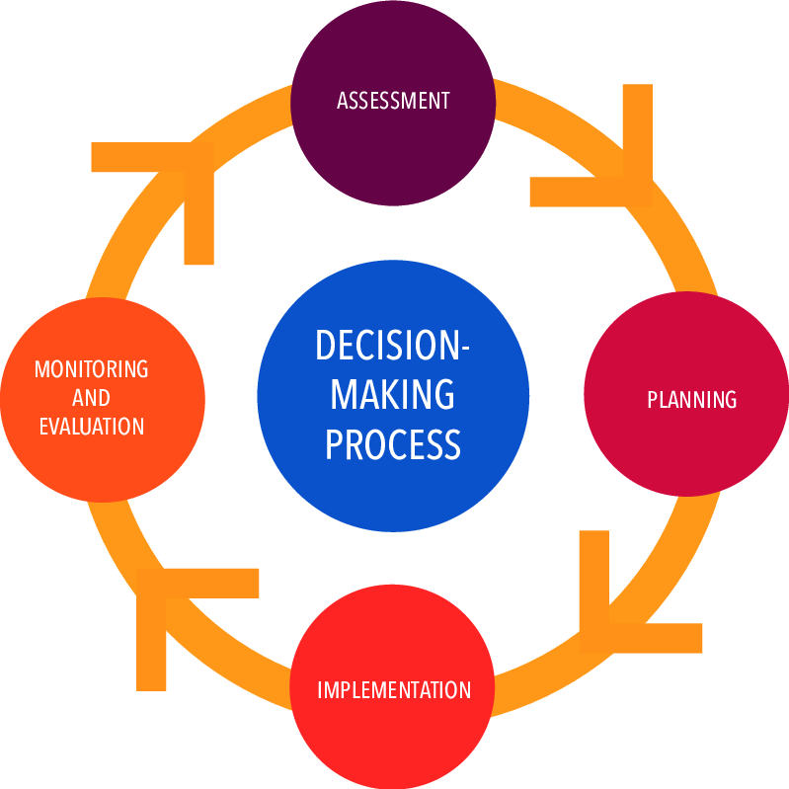
Decision making techniques:
There are many decision making techniques and models which are effective in different scenarios. These techniques include, multiple criteria decision analysis, analytical hierarchy process, influence diagram etc. For this particular scenario the pro/con technique has been adopted for choosing the best decisions among the available options. In this technique the pros and cons of all the available options are evaluated. The ones with the most pros and least cons are selected.

The main options were as follows:
i) Change the whole training regime and extend it to be a month long program.
ii) Employ professionals to provide on the job training for individuals for the first two months
iii) Provide dynamic training regimes for different branches based on the external and internal environmental dynamics.
It was found form the pro con analysis that the third decision had the most pros. The pros were, dynamic training regimes can objectively fulfill the requirements of the local workforce in terms of skill development as opposed to a generalized training regime which would feed excessive information which might make the process overwhelming. The decision also allowed to delegate the task of training the employees to the branches and the manager which reduced the load form central authority. Lastly, the decision provided opportunity for innovative training design and enabled proof of concept for several training regimes at a time which can be utilized later for different branches with similar environmental dynamics (Koku, 2016).

LO4 Planning, monitoring and reviewing implementation and communication of decisions.
Objective setting in relation to problem.
The objective of the problem solving activity was to increase client satisfaction and help to redeem the lost reputation. This can only be done by solving the problems from their origin. The whole process is discussed in the following segment
Planning:
The initial plan of implementing the decision involved some activities over a period of 8 weeks. These activities are:
i) Collecting data on the problem
ii) Analyzing the information
iii) Identifying the flaws
iv) Consulting professionals and discussing possible options
v) Evaluating options
iv) Implementing the decision to the whole organization.
The plan is represented in a Gantt chart in the following segment:
 | Week 1 | Week 2 | Week 3 | Week 4 | Week 5 | Week 6 | Week 7 | Week 8
Collection of data
Analyzing the data
Identifying flaws
Consulting professionals for determining options
Evaluation of options
Implementing decisions

Monitoring and review techniques:
The monitoring was done by using various tools like Critical path analysis. The results were assessed against the speculated outcomes by a third party for unbiased report. Decisions were made to mitigate the shortcomings while the process was being executed (Lloyd, 2011).
The review was done based on some key performance indicators. For example, the consultation phase was associated with an indicator which required generation of at least three viable options relevant to solving the problem with in the capabilities of the organization. The data collection phase was reviewed based on the objectivity of the information acquired which justifies the problem.
Brainstorming, problem solving and creative thinking techniques:
The brainstorming techniques which was used to select appropriate decision was pros and cons technique. A step by step process form initiation to formulation of solution was used as a technique for solving the problem. Lastly, for creative thinking, the force field analysis was used (Mina, 2009).
Interpretation of charts and diagrams.

Here it is seen that the complaint rate is speculated to be minimized significantly almost to a non-existent state. The client return rate is significantly increased and the customer acquisition cost drops down drastically.
Presentation of a case:
The main problem was ineffective training regimes which did not prepare the employees of south London to perform at the expected level. By taking the decision for providing dynamic training regimes to the branches, the employees were trained in the manner which was best suited for meeting the needs of that area and the learning needs of the employees involved. The decision was objective and effective for the particular scenario and was speculated to be completed within the capabilities of the organization.
Importance of involving people to facilitate effective change:
The change is important because the existing system is not working properly. In order to facilitate the change to ensure its full potential, individuals are also required to be invested in the process. Individuals ranging from the training coordinators to the ones on the receiving end, should be willing and active in developing their skills for facilitating the operations of the organization. Moreover, a high learning culture should also be induced for intriguing individuals to take active measures towards learning and implementing their knowledge (Rao, 2013).
Implications of change and principles of change management.
The benefits of changes are improved efficiency in workforce, increased rate of returning clients, decreased rate of complaints, increased revenue stream and positive reputation for Bright horizons. The main principles of managing to lead by examples, cultural influence and engagement in hands on activity.
Tools for planning change.
The main tools to manage change in Bright horizons is, readiness assessment which determines how capable are the employees and the organization to cope to new dynamics in the workplace. This helps to modify the decision implementing process to resonate with the pace of the involved stake holders.
Feasibility and viability of the change for stakeholders.

The change can effectively address the issue. When the issues are addressed the employers of Bright Horizons can experience increased revenue stream and growth in market share. The employees will also be able to pursue higher levels in their career and can utilize their skills in more ambitious ventures if required. But most importantly, the clients will have the peace of mind to work with utmost efficiency when they will know that they children are in safe hands (Reed & Learning, 2014).

Factors involving resistance to change:
The main factors which can resist the change are employees and the monetary resources. The employees can be resistant because they might find the new training regime to be intimidating and complex which involves more practical application than study. On the other hand, the dynamism of the decision might incur varying costs. The existing monetary resources might hinder the process for the lack of allocation in due time (Whimbey et al., 2013).

Conclusion:
The report has identified different techniques to solve problems and has provided a full process of solving a problem via the example of Bright horizons. The report first analyzed the problem and discussed about its nature and scope, them all the relevant information was gathered which helped in formulating probable options for making decisions. Then the most appropriate and value adding decision was selected and finally the whole process was discussed.

References
Blais, S. (2012). Business analysis. Hoboken, N.J.: Wiley.
Brighthorizons.com. (2018). Bright Horizons Child Care | Preschool & Early Education Programs | Bright Horizons®. [Online] Available at: https://www.brighthorizons.com/ [Accessed 17 Aug. 2018].
Cadle, J., Paul, D. and Yeates, D. (2014). Business analysis. Swindon, U.K: BCS.
Carlberg, C. (2010). Business analysis. [Place of publication not identified]: Que.
Curwin, J., Slater, R. and Eadson, D. (2013). Quantitative methods for business decisions. Andover: Cengage Learning.
Frisendal, T. (2014). Design Thinking Business Analysis. Berlin: Springer Berlin.
Howell, J. and Teichroew, D. (2013). Mathematical analysis for business decisions. Whitefish, Mont.: LiteraryLicensing.com.
Koku, P. (2016). Decision making in marketing and finance. [Place of publication not identified]: Palgrave Macmillan.
Lloyd, C. (2011). Data-driven business decisions. Oxford: Wiley.
Mina, E. (2009). 101 boardroom problems and how to solve them. New York: American Management Association.
Rao, R. (2013). Decision making in manufacturing environment using graph theory and fuzzy multiple attribute decision making methods. London: Springer.
Reed, C. and Learning, B. (2014). Problem Solving. Chicago: Britannica Digital Learning.
Whimbey, A., Lochhead, J. and Narode, R. (2013). Problem solving and comprehension. New York: Routledge.

