Callum Cresser (2006263)

Business Inquiry and RESEARCH – BMSP5007,
Roisin Mullins

Table of Contents Part 1
2. Introduction
3. Research
4. Procedure
6. Interview Findings
10. Conclusion
23. Bibliography

Introduction
This study was undertaken in order to establish whether online advertising has an affect on the spending habits of consumers. The present social and economic atmosphere has facilitated the adoption of internet advertising as a part of daily life. Even while performing the most basic actions online, individuals are subjected to a barrage of advertising (Graham, 2021). As the volume of advertisements is increasing it is important to be aware of the impacts that this will have on consumers. This is an area that is relevant to my field within business management, as the results will indicate whether using this method of advertising is beneficial. Advertising is a key part of any business and understanding how to best utilise this tool can allow a company to survive. In 2019, there are 4.3 billion internet users. This opens the door to a vast array of potential clients. By utilising online advertising, the business may reach a larger audience. Businesses require exposure in order to attract clients, and the internet market is the most effective method to do this. When a business is mentioned, people want to learn more about it. If individuals can't locate what they're looking for online, they're likely to abandon their purchase (Ocampos, 2020). The data was collected using semi structured interviews with three participants. This is a qualitative method of collecting information. A varying demographic was important in order to provide a range of opinions across different age ranges. The interviews will question the impact of online advertising on the participants as well as their views on whether they feel the current level of advertising is acceptable.

Research
Qualitative research was chosen over quantitative in this scenario as it will allow the participants to offer their views on the subject. It will allow for more detail to be captured during the interviews. Qualitative research is a method for analysing an event in its context and is particularly beneficial for examining complex topics. Interviews are a good method to use in order to gain good information on this topic. D. Silverman notes that interviews are an excellent method for obtaining qualitative data because they enable participants to share their stories and reveal sentiments and views influenced by their own experiences, increasing our understanding of human behaviour and the social environment (2010). By utilising interviews, it will allow the participants to use personal experience in order to give the best possible answers. The methodology used for analysing the data is phenomenology. Researchers use phenomenological research designs to understand a phenomenon’s universal nature by exploring the views of those who have experienced it. This approach is popularly used to study lived experience, gain a deeper understanding of how human beings think, and expand a researcher’s knowledge about a phenomenon (Groenewald, 2004). In order to obtain the best results, the phenomenon chosen for the interviews is the impact of online advertising on spending habits.

Procedure
Thematic analysis has been selected as the method for analysing the interviews. Thematic analysis is a qualitative data analysis technique. It is most frequently used to refer to a collection of texts, such as an interview or transcripts. Thematic analysis was selected as the most suitable method of analysing the interviews that were conducted. Thematic analysis is especially beneficial for summarising significant characteristics of a large data collection, since it requires the researcher to take a systematic approach to data management, resulting in a more structured final report (King, 2004).
In order to achieve the best results from the interviews as well as creating a fair and comfortable environment it is important to have a clear process.
• The questions were created to be related to the subject matter. For the purpose of gathering thorough information for analysis, open questions were utilised. Almost all of the queries were on the influence of online advertising on consumers' spending habits.
• A diverse group of individuals was selected in order to provide a varied set of outcomes. This is necessary in order to acquire outcomes from a varied group of people.
• A semi-structured interview technique was adopted since it enables for more in-depth responses to be provided. It is possible for interviewees to provide more detailed responses while employing semi structured interviews, as opposed to when using a more structured technique. All interviews were conducted in the same setting in order to ensure that all interviewees are treated equally.
It is important to record all relevant answers to the questions posed to the interviewees. Subjects' responses were recorded during the interviews and were subsequently transcribed into a word document. During this part, no personal information or names were recorded.
Analysing the Data
To clearly present the recorded information, a table using three sections was produced. The first column contained the responses of participants. The second section contained the interpretations of the researcher, with the third including the concepts or themes that were recognized amongst the answers.

Interview Findings
The participants are numbered 1, 2 and 3 in the left-hand column of the table below alongside the researchers’ interpretations or each individual participant. The themes and concepts are in the right-hand column.
Participants Answers | Researchers Interpretations of Answers | Concepts and Themes Within the Answers
- When I see adverts online I am sometimes likely to look into buying the items. I will only buy things that I need or already want. If the advert isn’t for something I’m interested in I won’t pay any attention to it. | Adverts alone are not enough to convince the participant to purchase the goods. There needs to be an existing reason as to why the goods would be useful. | - Online adverts that are not relevant to the consumer do not influence spending habits.  - People are more likely to use pre established apps to purchase goods.
- Most adverts I see don’t have anything I want. When I buy things online it’s usually from website’s I already know and use. | Adverts are mostly not relevant therefore not useful.  People use already established sites to purchase goods from.
- If the advert is of something I’m interested in then I sometimes will go and buy it. I always see clothing adverts online and then I usually go to that website to have a look. They usually advertise deals that they have on. I do spend more money because of adverts. | Adverts draw people’s attention to deals and offers which lead to more spending.  Increased spending due to online adverts.  More relevant advertisements lead to more engagement from customers.

One theme that can be identified from the finding is that online advertisements that are not relevant to the specific person will not influence the spending of that individual. By tailoring adverts to show relevant and interesting topics the likelihood of interaction increases.
Participants Answers | Researchers Interpretations of Answers | Concepts and Themes Within the Answers
- I think online adverts can be annoying when they interrupt something you’re trying to do. When they’re just on my online feed I don’t mind them. | Advertisements sometimes get in the way of other tasks online. | - Adverts can get in the way of online activities.  - Frustrating when adverts are constantly interrupting.  - The numbers of advertisements are constantly increasing.
- I feel like they are everywhere, no matter what app I use there are always loads of adverts. When they pop up during a video I’m watching online they annoy me. I know why companies use them, but I feel like they get in the way. | Hard to avoid online.  Can be frustrating to deal with when they interrupt activities online without a choice.  Understand why they are used.  Can be overused.
- I think adverts can benefit my life when they show things I’m interested in. I don’t see the difference between adverts during videos and adverts on TV.  Neither bother me. | Can be beneficial to customers when relevant.  No difference between TV and online advertisements in terms of volume.

The participants opinions on advertisements online varied however themes throughout the interviews saw that adverts can interrupt a person’s activities. This can become frustrating. The sheer number of adds is also a theme of this question.
Participants Answers | Researchers Interpretations of Answers | Concepts and Themes Within the Answers
- If the adverts were more suited to my interests I would be more likely to purchase items from them. | More relevant advertisements would be beneficial. | - If the level of advertisements continues to rise it will negatively effect spending habits.  - More relevant adverts would likely increase spending habits.
- If adverts did not interrupt my life online so often I would be more likely to use them. | The volume of advertisements is off-putting for some.
- As long as the adverts don’t continue to increase in numbers I will be happy to see them when I’m online. | The number of adverts is at an optimal level currently. Any higher would affect spending habits.

There participants indicated that an increase in the relevance of the online advertisements would see more interaction and an increase in their spending habits. It was also indicated that the volume of advertisements is optimal currently and an increase in the volume could have a negative effect on consumer spending habits.

Conclusion
Online advertisements have emerged as the most dominant form of advertisements. The growth of social media and online platforms have created an environment in which they can reach a massive audience. The data collected has indicated that online advertisements do impact the spending habits of consumers. Although, people are more likely to interact with adverts that are more relevant. It was noted that despite providing people with information on deals and offers from different companies, the volume of adverts should not be increased further than it is. It is also discussed that adverts are beginning to interrupt the most basic tasks online; this can have a negative effect on the spending habits of consumers.

Table of Contents Part 2
12. Introduction
13. Method for Capturing Information
14. Analysing the Data
15. Procedure for Capturing Data
16. Presenting the Data
22. Conclusion
23. Bibliography

Introduction
This report will look to gain a further insight into the impact that online advertisements have on consumer spending habits. The current global climate has been transformed over the last decade. Increasing access to the internet has allowed more people to purchase goods and services online as opposed to travelling into shops and supermarket. The COVID pandemic created a necessity for non-contact purchases and the online market is ideal in that regard. Due to the closure of main street stores, the report also revealed that UK internet shopping sales increased by 48 percent to roughly £113 billion in 2020, up from £76.1 billion the previous year. The websites of food and beverage merchants had the greatest boost in sales - up 82% from 2019 levels. From September until the end of 2020, clothes and footwear sales topped £1 billion per month (Gausden, 2021). While the online spending habits have been impacted by the pandemic, it is important to investigate other factors. Online advertising has developed into a hugely important aspect for businesses to utilise.
This has been selected for further research as it is a vitally important aspect of business, and the increasing use of social media allows an even greater platform for online advertising to be used. Investigating the impact of online advertising on consumer spending habits can lead to useful information for businesses to use.

Method for Capturing Information
The method used for capturing data for this report is a quantitative method. This will be conducted using an online survey through Google Forms. Quantitative research seeks to create general principles of behaviour and phenomena that apply to a variety of settings/contexts. Research is utilised to put a hypothesis to the test and finally confirm or deny it. It includes the processing of statistical, computational, or mathematical approaches to collect observable data in order to answer a research issue. It is frequently seen as more precise or valuable than qualitative research, which is concerned with the collection of non-numerical data. Quantitative research necessitates an in-depth understanding of experimental design and the capacity of anybody to duplicate both the test and the results. This increases the reliability of the data you collect and makes it less susceptible to criticism (Devault, 2020). This approach was chosen since it can be given to a wide number of individuals and produces accurate and fair results. After that, the findings may be conveniently analysed.

Analysing the Data
The quantitative method of capturing data is transferred into numbers to be analysed. Statistics aid in the conversion of quantitative data into meaningful knowledge that aids in decision making. Analysts can summarise data by describing patterns, correlations, and links. Statistics are either descriptive or inferential in nature. Descriptive statistics assist us in synthesising our data (Mcleod, 2008).
In order to analyse the data recorded by the survey cross tabulation will be used. Cross-tabulation analysis, sometimes referred to as contingency table analysis, is frequently used to analyse categorical data. Cross-tabulations are represented visually as data tables that contain the responses of the complete group of respondents as well as those of subgroups of respondents. They enable you to investigate relationships within the data that may be missed when examining merely the overall number of survey replies. Cross tabulation is advantageous when categorical variables or data, such as information, can be classified into mutually exclusive categories (Qualtrics, 2018).

Procedure for Data Capture
An online survey will be used in order to capture the data. The survey will contain 10 questions and will be released online to obtain a high number of responses. This will ensure that there is a good base in order to statistically analyse the results. This also is more convenient for the participants as they can complete the survey when it is suitable to them.
The questions within the survey were designed to understand the public opinion of online advertising. The survey also looks to discover whether the online advertisements have an impact on their spending habits. Also, within the survey are designed to determine the demographic of people that are participating. This enables the ability to identify themes and groups within the responses. The data was processed, and patterns identified using IBM's Statistical Package for Social Sciences. Numbers were assigned to multiple choice responses in order to easily apply the results within SPSS. Variables were input and assigned a numerical value, a scale value, or an ordinal value.

Presenting the Data
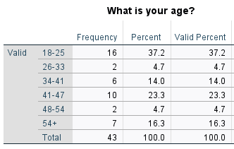
The table above shows the variable range of ages in the participants of the survey. The ages vary from 18 to 54+ and the total number of participants was 43. The highest percentage of representation came within the age range of 18-25 which accumulated 37% of the total. The lowest representation came from the age ranges of 26-33 and 48-54.
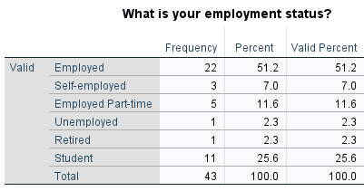
The second question focussed on the employment status of the participant. This was used in order to understand the spending power of the particular person may have. Employed was the most common among the answer with 51.2% of participants selecting this answer. Unemployed and retired were the lowest values with both only accounting for 1% of the contributors. There was a high percentage of students that completed the survey, accounting for 25.6% of the total.
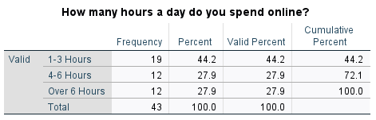
The third question looked at the total amount of time spent online during a day. This is useful as it will show how exposed a personal may be to online advertisements. This may have an effect on whether their online spending habits as a result. The majority of participants spent between one and three hours online a day, with 19 of 43 people selecting this option. Both 4-6 hours and over 6 hours had 27.9% of the answers. This shows that there is a high percentage of people that use the internet for over 4 hours a day.
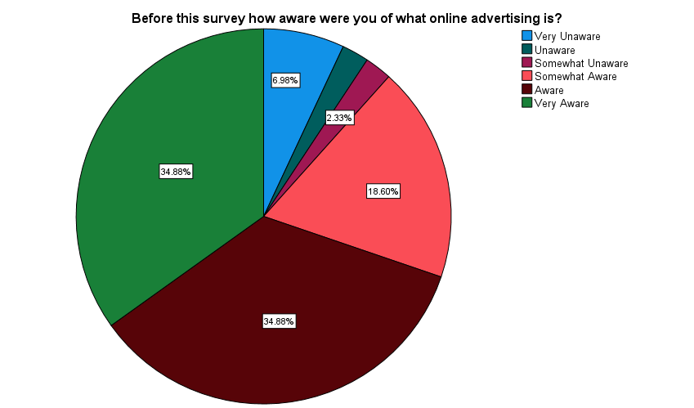
The chart above represents the awareness of online advertisements before the start of the survey. The majority of participants were either aware or very aware of what online adverts are. Both options saw 34.88% of the votes, showing a good level of awareness within the participants of what online advertisements are.

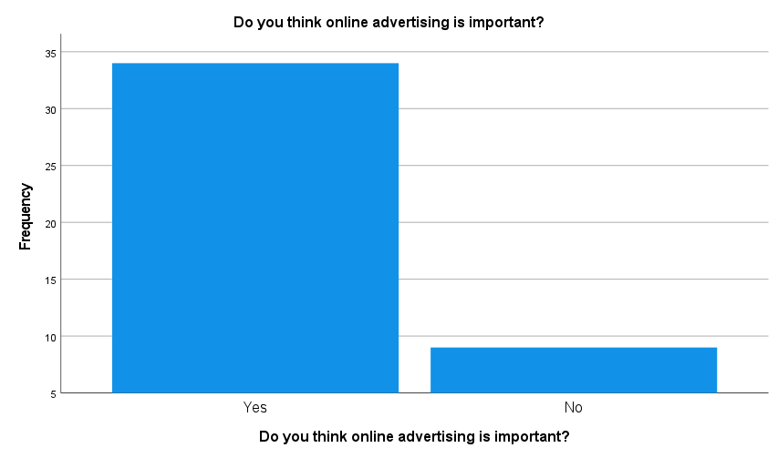
Question 5 enquired as to whether the participants feel that online advertising is important for businesses. Of the 43 participants involved, 34 believed that is was an important aspect with 9 believing that it was unimportant.
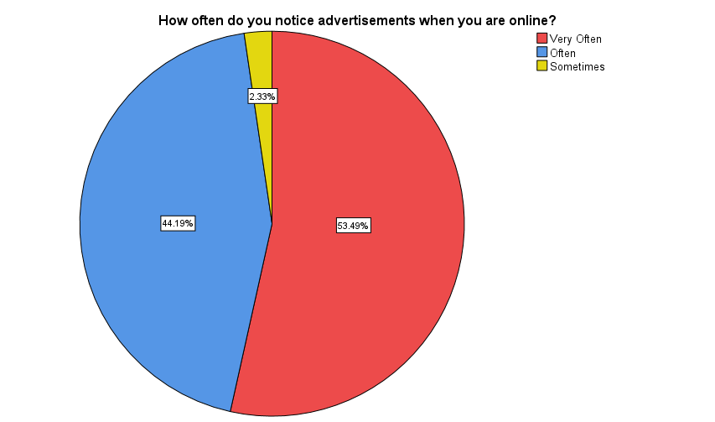
Question 6 looked into how often participants noticed online advertisements. More than half of the participants noted that they notice advertisements very often making up 53%. 44% of people said that they noticed them often. No participants noted that they rarely notice online advertisements.
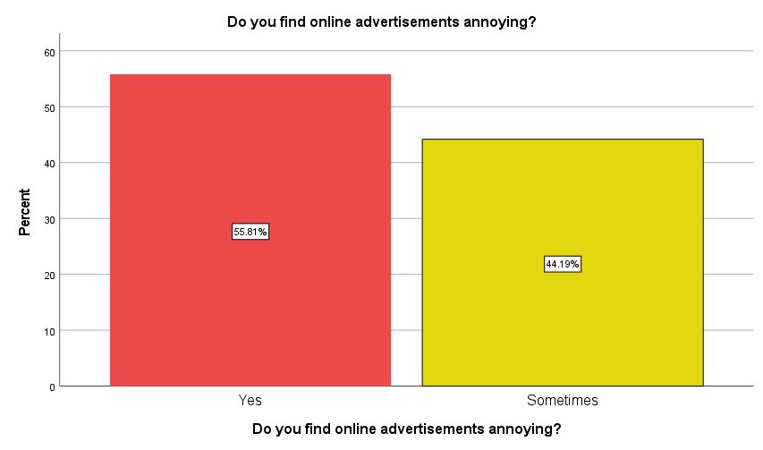
The following question investigated the public opinions on online advertisements. 56% of participants noted that they found online adverts to be annoying, with 44% noting that they sometimes do. There were no people that said that they do not find the advertisements annoying despite this being an option in the survey. It is clear that online adverts have increased to a point where they are seen to be annoying.

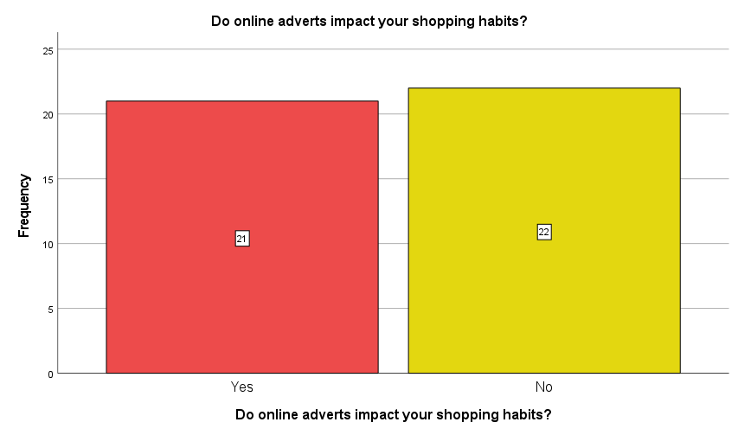Question 8 directly queries whether online advertisements impact the shopping habits of the participants. 21 of the 43 participants noted that online advertisements do have a direct impact on how they shop online. This shows that there is a high percentage of people that online advertisements influence.
Despite 21 participants noting that online advertisements do impact their shopping habits the following table shows that the impacts may not be positive for businesses.
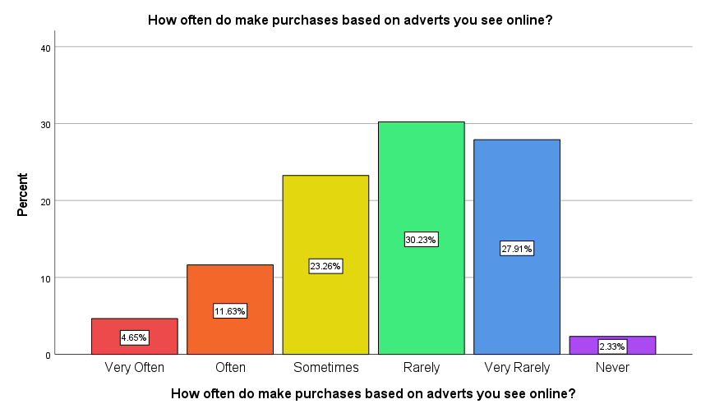
Question 9 investigates how often that people make purchases based on adverts they see online. 30% of participants noted that they rarely make purchases based on advertisements and 27% of people note that they very rarely make purchases. Only 17% of participants say that online adverts either often or very often influence them to make purchases online.
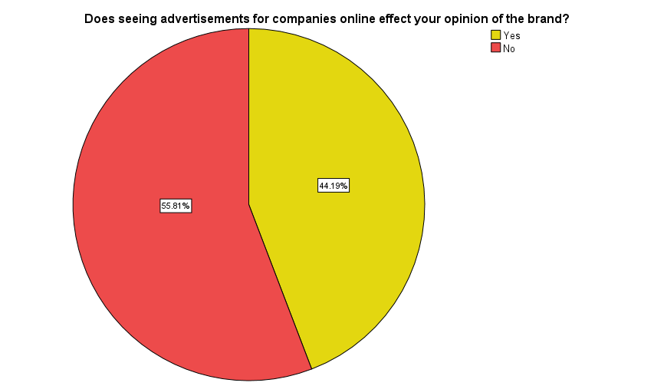

The final question examines whether seeing online advertisements impacts a person’s opinion of the brand. 55% of the participants of the survey noted that when subjected to online adverts it does impact on their opinion of the brand in question. This result indicates that businesses must be aware when advertising online that it can have a detrimental effect on the public opinion of their brand.

Conclusion
The volume of online advertisements is ever increasing in the modern age due to demand and access to the internet becoming normalised. The majority of people in the current day find that they are aware of what an online advertisement is. While many feel advertising online advertising is important for businesses there is also a feeling that the volume of adverts can be annoying to witness. The advertisements do have an impact on the shopping habits of consumers however it is not necessarily a positive impact. A number of people noted that they are influenced by online adverts however they rarely, or very rarely make purchases online. It is important to note that the data collected may not be an accurate representation of the full population as the sample size is small. Also, the questions can be limiting in certain areas therefore in future a pilot survey may be beneficial in order to correct those issues. There is no doubt that online advertising is quickly becoming the dominant form of advertising for businesses. The reach of online advertising is massive however, it is important for businesses to be self-aware and to not over advertise online. This could have a damaging effect on the success of the business.

Bibliography
Caulfield, J. (2019, September 6). How to Do Thematic Analysis | A Step-by-Step Guide & Examples. Retrieved from Scribbr.com: https://www.scribbr.com/methodology/thematic-analysis/
Graham, M. (2021, December 6). Advertising Market Keeps Growing Much Faster Than Expected, Forecasters Say. Retrieved from The Wall Street Journal : https://www.wsj.com/articles/advertising-market-keeps-growing-much-faster-than-expected-forecasters-say-11638784800
Groenewald, T. (2004). A Phenomenological Research Design Illustrated.
King, N. (2004). Essential Guide to Qualitative Methods in Organizational Research. London: Sage.
Ocampos, J. (2020, March 17). WHY DIGITAL MARKETING IS IMPORTANT FOR BUSINESSES? Retrieved from mmmaters.com: https://www.mmmatters.com/blog/why-digital-marketing-is-important-for-businesses
Silverman, D. (2010). Qualitative Research. Sage.
Simpson, J. (2017, August 25). Finding Brand Success In The Digital World. Retrieved from Forbes: https://www.forbes.com/sites/forbesagencycouncil/2017/08/25/finding-brand-success-in-the-digital-world/?sh=19d73a5c626e

