
UWTSD
Comparison of Digital Modulation Methods
Digital Signal Processing & Communications (M2X8518)
James Thomas (1708737)
12-14-2017

Declaration

The work of this report completed under the supervision of Professor Ian Wells declare that this report is the product of my own work and is not being submitted for any other degree etc.

Sign the declaration
James Thomas

Table of Content

Figure 1 Simulink block diagram, Basic ASK. 7
Figure 2 Scope results of a basic ASK 7
Figure 3 Simulink block diagram, Basic PSK. 8
Figure 4 Scope results of a basic PSK 8
Figure 5 Simulink block diagram, Basic FSK. 9
Figure 6 Scope results of a basic PSK 10
Figure 7 Simulink block diagram, ASK. 12
Figure 8 Scope Results of an ASK 12
Figure 9 Simulink block diagram, ASK with AWGN. 13
Figure 10 Scope Results of an ASK with AWGN 13
Figure 11 Simulink block diagram, PSK. 14
Figure 12 Scope Results of a PSK 14
Figure 13 Simulink block diagram, PSK with AWGN 15
Figure 14 Scope Results of a PSK with AWGN 15
Figure 15 Simulink block diagram, FSK. 16
Figure 16 Scope Results of a FSK 16
Figure 17 Simulink block diagram, FSK with AWGN 17
Figure 18 Scope Results of an FSK with AWGN 17
Figure 19 Even Parity System 22

Table 1 ASK 17
Table 2 PSK 17
Table 3 FSK 17

Graph 1 Error Rate 17
Graph 2 Error Detected 18

Abstract

This report will cover comparison of digital modulation methods. It will be looking at the different methods of digital modulation. Which one has less errors when noise is added? What is digital modulations and how each method work, also analysis on the methods. What is error control will be covered in this report, how it works? Why we use it? Also what types are out there?

Contents
Digital Signal Processing & Communications (M2X8518) 0
Declaration 1
Table of Content 2
Abstract 3
1.0. Introduction 7
2.0. Amplitude Shift Keying (ASK) 8
3.0. Phase Shift Keying (PSK) 9
4.0. Frequency Shift Keying (FSK) 10
5.0. Simulink 11
5.1. Stage 1 11
5.2. Stage 2 11
5.3. Stage 3 11
5.4. Stage 4 11
6.0. Additive white Gaussian noise (AWGN) 12
Additive 12
Gaussian 12
White Noise 12
6.1. ASK 13
13
13
6.2. PSK 15
6.3. FSK 17
6.4. Analysis 19
7.0. Error Control 21
Types of Errors 21
Error-Detecting codes 21
Error-Correcting codes 21
7.1. Hamming code 22
23
8.0. Conclusion 24
References 25

Introduction

Digital modulation are now widely used in today world. There all a lot of different types such as amplitude shift keying, phase shift keying and frequency shift keying. This report talk about each one, how it works with and without noise added. Additive white gaussian noise (AWGN) is the channel I used in Simulink. Think report explains noise and how it effects data when being transferred. Error control is commonly used to correct and detect an error when data is being transmitted. Later in this report explains why use it.

Amplitude Shift Keying (ASK)

What is ASK? ASK stands for Amplitude Shift Keying. ASK is one of many methods of Amplitude Modulation and then this symbolises the binary data in the form of variations in the amplitude of a signal. [1] [2]

When it comes to modulated signals it has a high frequency carrier. The binary signal, at a zero value it a low input while it offers the carrier output for high input and this for ASK modulated. [1] [2]

The following figure show ASK block diagram produced on Simulink. Figure 2 shows the input and output of an ASK modulated waveform.

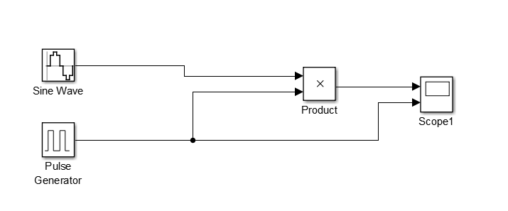
Figure 1 Simulink block diagram, Basic ASK.
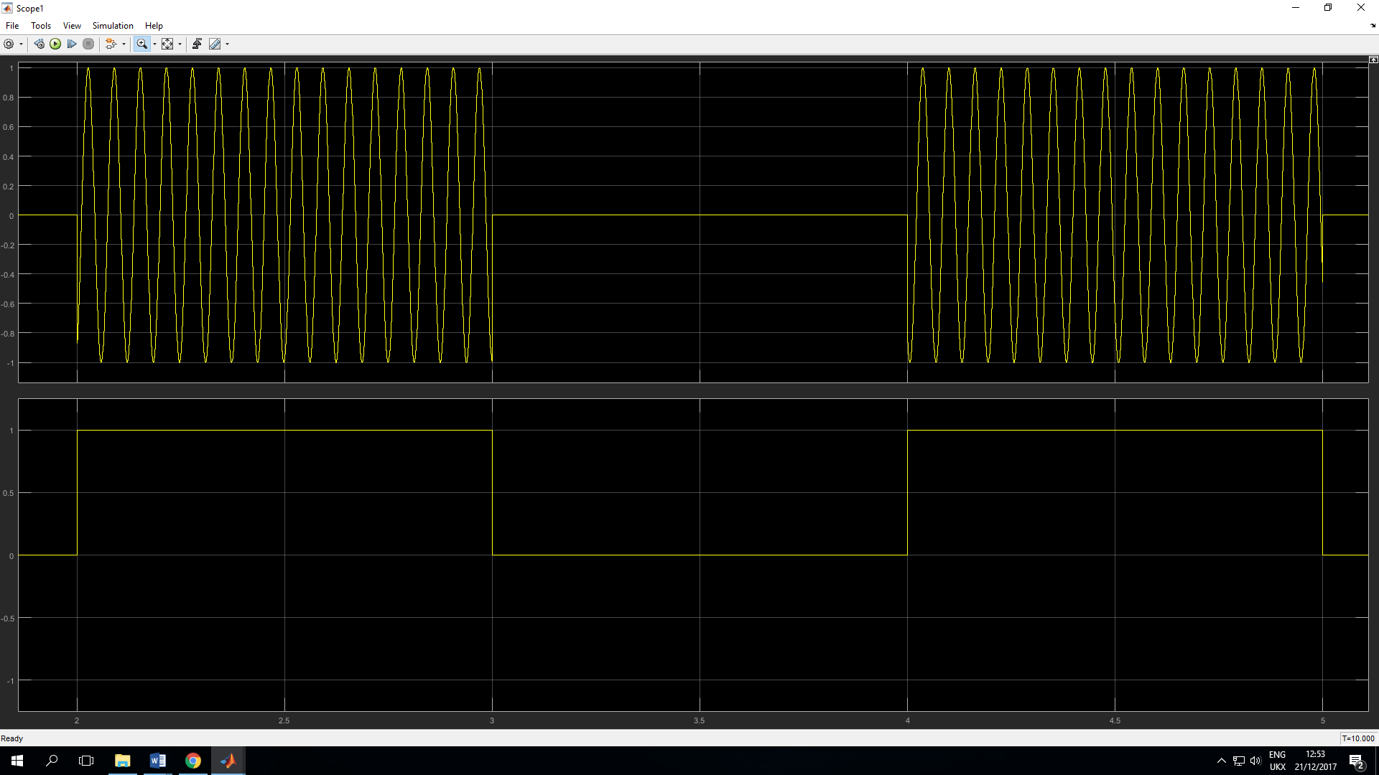
Figure 2 Scope results of a basic ASK

Phase Shift Keying (PSK)

Another methods of digital modulation is PSK, which is Phase Shift Keying. When it come to this digital modulation technique is where the phase of the carrier, changes the signal and this from a variable of the sine and cosine inputs at a given time. PSK technique is widely used in the world and commonly seen in wireless LANs, bio-metric, contactless operations, along with RFID and Bluetooth communications. [1] [2]
The following figure 3 show PSK block diagram produced on Simulink. Figure 4 shows the input and output of a PSK modulated waveform.

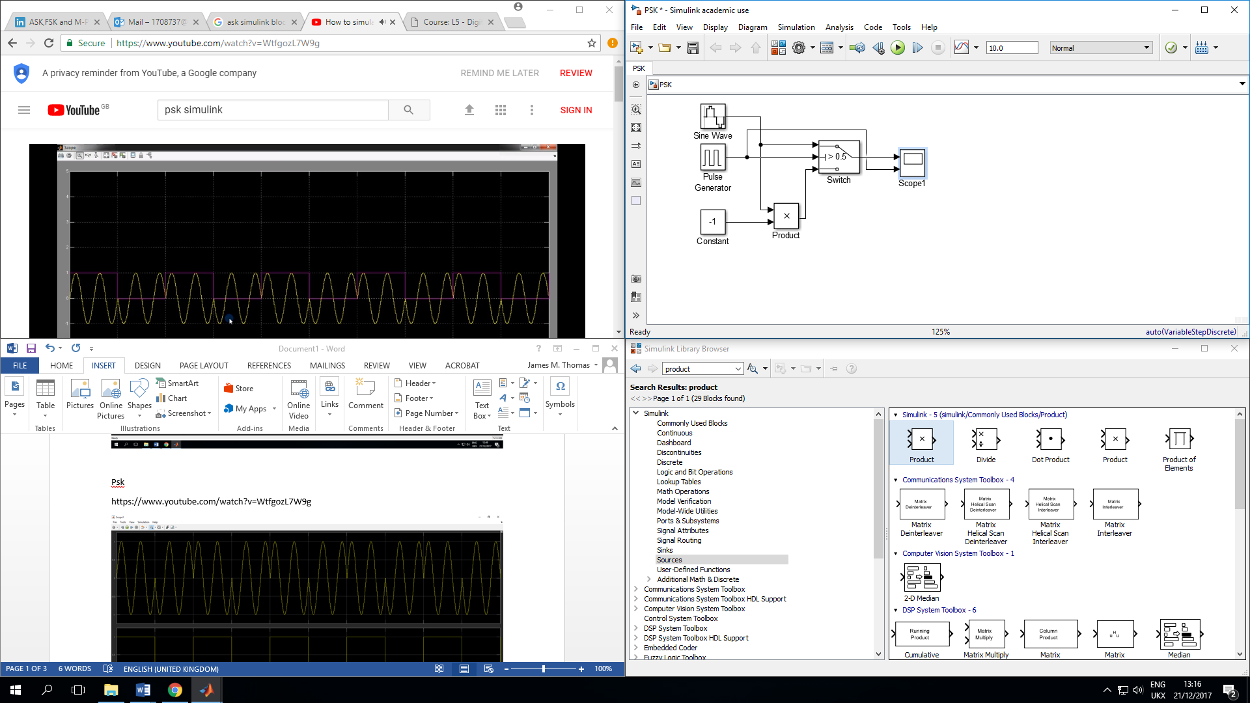
Figure 3 Simulink block diagram, Basic PSK.
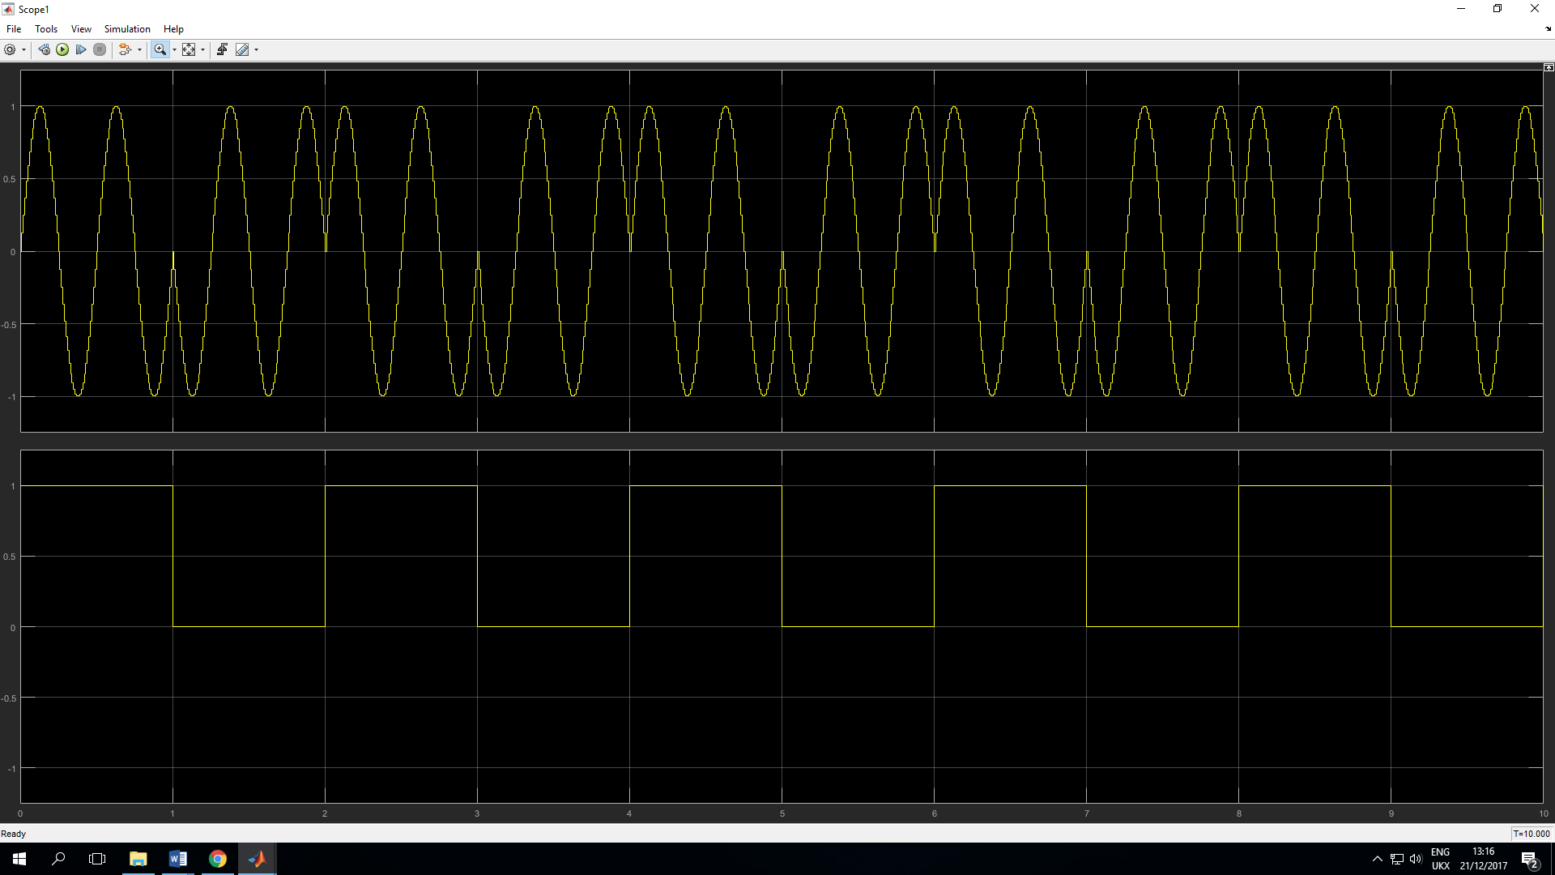
Figure 4 Scope results of a basic PSK

Frequency Shift Keying (FSK)

Another form of digital modulation is FSK, which stands for Frequency Shift Keying. This digital modulation technique which involves the frequency of the carrier signal, the frequency differs conferring to the digital signal changes. Frequency Shift Keying is a order of frequency modulation. [1] [2]

When it comes to FSK modulated the wave is high in frequency as an output, the input is a binary High and when the frequency is low the input has a binary Low. Mark and Space frequencies are the binary 1s and 0s. [1] [2]

The following figure 5 show PSK block diagram produced on Simulink. Figure 6 shows the input and output of a PSK modulated waveform. [1]
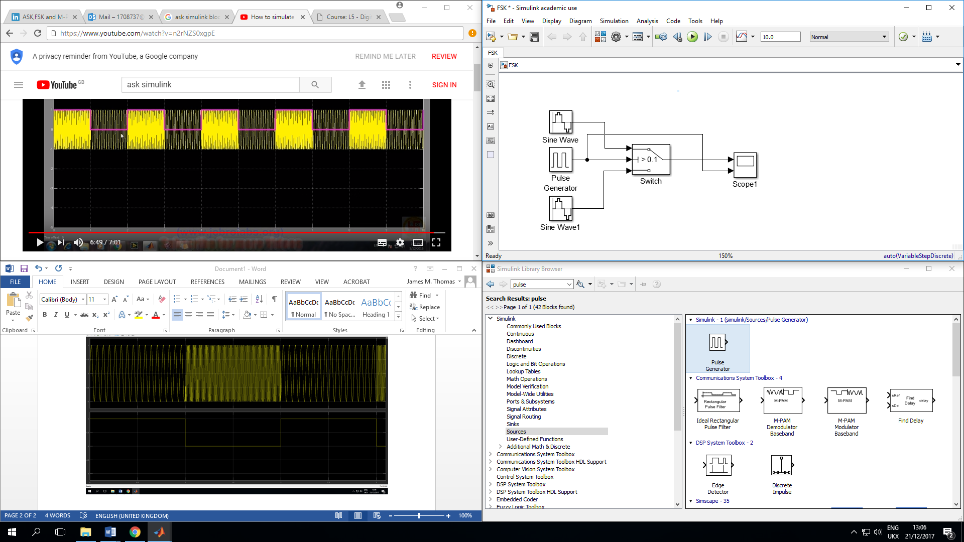
Figure 5 Simulink block diagram, Basic FSK.

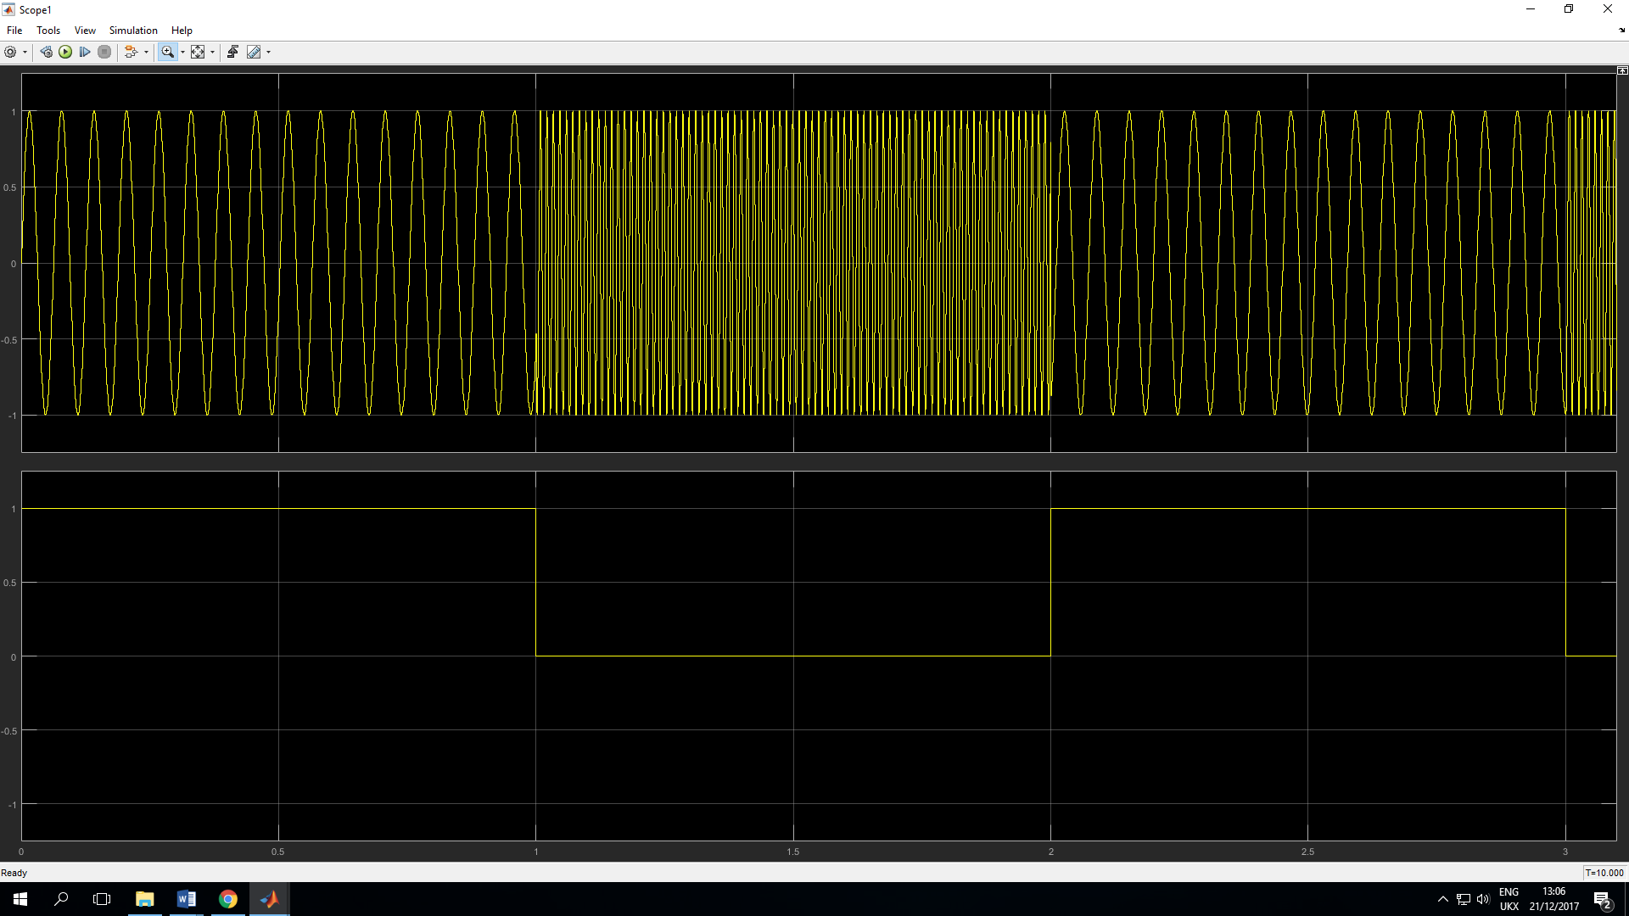
Figure 6 Scope results of a basic PSK

Simulink

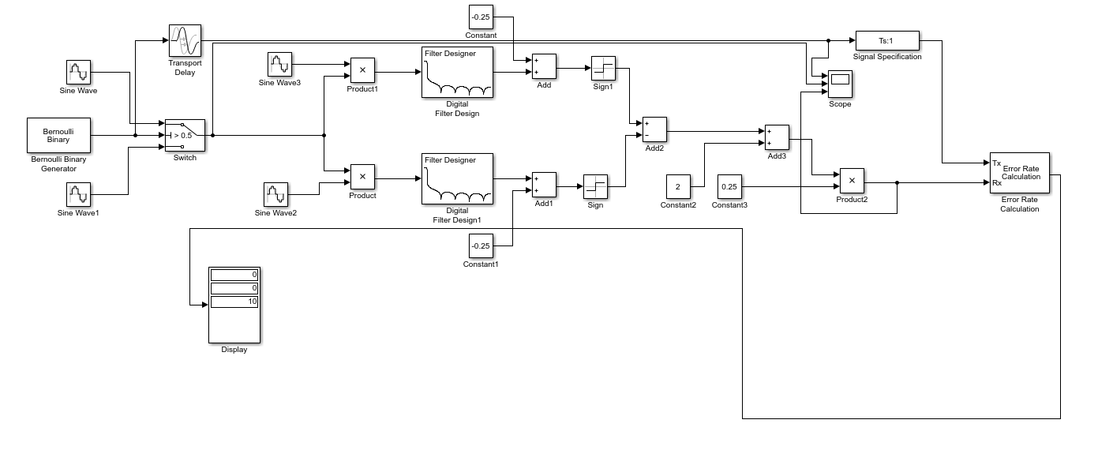
Stage4
Stage3
Stage1
Stage2

Stage 1

This stage is the Bernoulli binary generator. This produces random numbers (binary) using a Bernoulli distribution.

Stage 2

This stage involves a modulator. Modulation is the addition of information to data. This uses a carrier signal with a steady waveform that has constant amplitude and frequency.

Stage 3

This stage involves a demodulator and as show there are two paths both have a digital filter. This is used to recover the original input signal from the modulated wave. Demodulator can be called a detector too.

Stage 4

This stage is using the math operation in Simulink. Changing the signal in the correct form compare to the input signal and also this stage is scaling the output wave in the same scale as the input.

Additive white Gaussian noise (AWGN)

Additive white Gaussian noise, also known as AWGN is one of many noise mode but it is a simple noise mode. We tend to use AWGN to simulator the effect of random process that can occur in nature and this for Information theory. Specific characteristics denoted from the modifiers: Additive because it gets added to every noise that might be essential to the information system in question. [3] [4]

Additive

Additive means you are adding the noise rather than multiplying it. For example when receiving a noise it shown in a simple equation, a(t) = b(t) + c(t) , let x(t) by the original clean transmitted signal, and let n(t) be the noise. [3] [4]

Gaussian

Gaussian is thermal noise and in nature it is random, obviously noise can't be deterministic or else you would take away the deterministic noise from a(t) straight away when receive a(t). Gaussian distribution with 0 mean (variance as the Noise power) is random thermal noise. Variance of Gaussian is great it’s not good but increase the power of b(t) or be contented with having a higher probability of error. When talking about 0 mean it is also to expected the value c(t) during any time interval T is 0. Another way to say it is on average c(t) will income 0 value, meaning that the probability of c(t) = 0. This will be the highest and probability fast drops as you rise the magnitude of c(t). [3] [4]

White Noise

White meaning in this occasion is the amount of all the colours. Another way to look at it is, same power for all frequencies involved. Then this will mean that any noise in this process is the same with all present that have the same power no matter their frequencies. Frequency domain, Noise level is even throughout at every frequency. [3] [4]

ASK

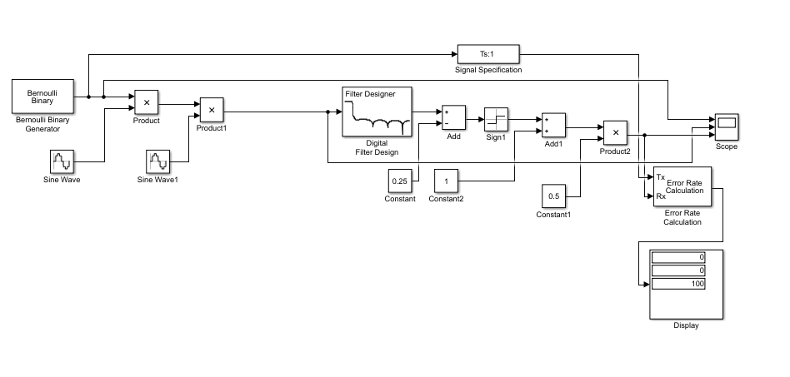
Figure 7 Simulink block diagram, ASK.

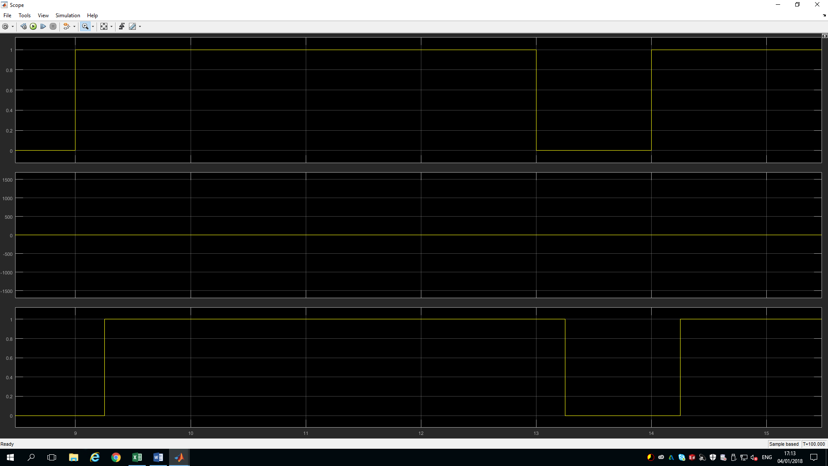
Figure 8 Scope Results of an ASK

Figure 7 Show an amplitude modulation in form of ASK that I had built on Simulink without AWGN. Then Figure 8 show the input and output signal are the same, meaning that the circuit I had built is correct. The output digital signal is out of phase but not by much. I could have correct this by using a transport delay block, I would of need to put the time valve it is out of phase by.
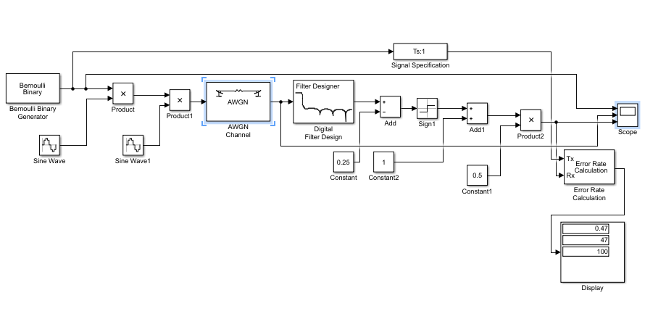
Figure 9 Simulink block diagram, ASK with AWGN.
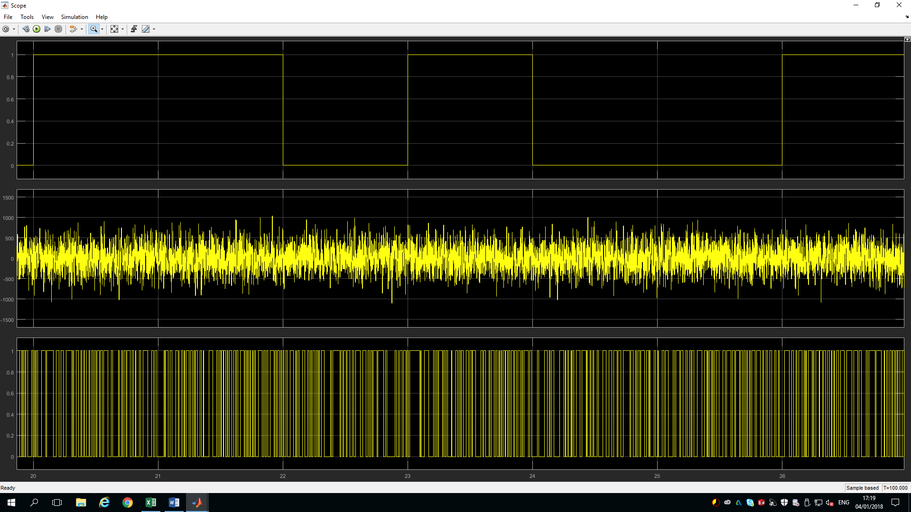
Figure 10 Scope Results of an ASK with AWGN
Figure 9 shows my block diagram of an ASK with AWGN added to it. Then Figure 10 shows that the input and output digital signal aren’t the same, meaning that the AWGN has affected my signal with a lot of errors, making my output signal non-recognizable to my input signal.

PSK

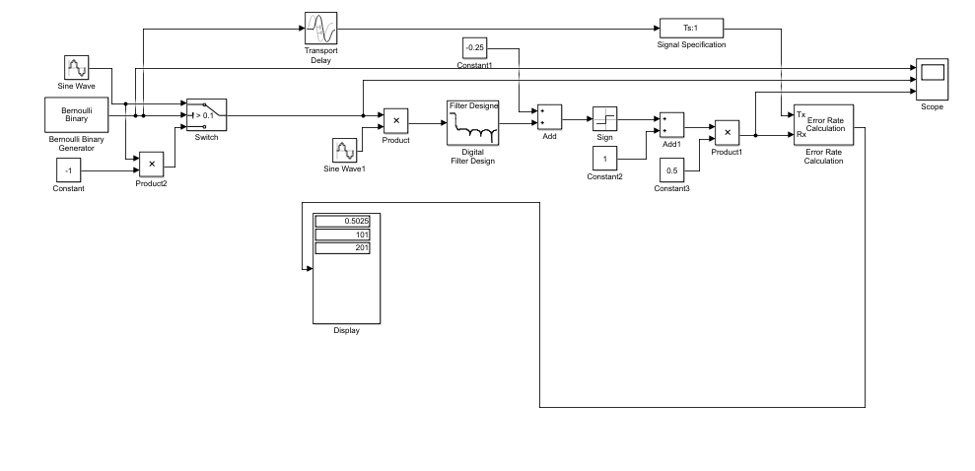
Figure 11 Simulink block diagram, PSK.

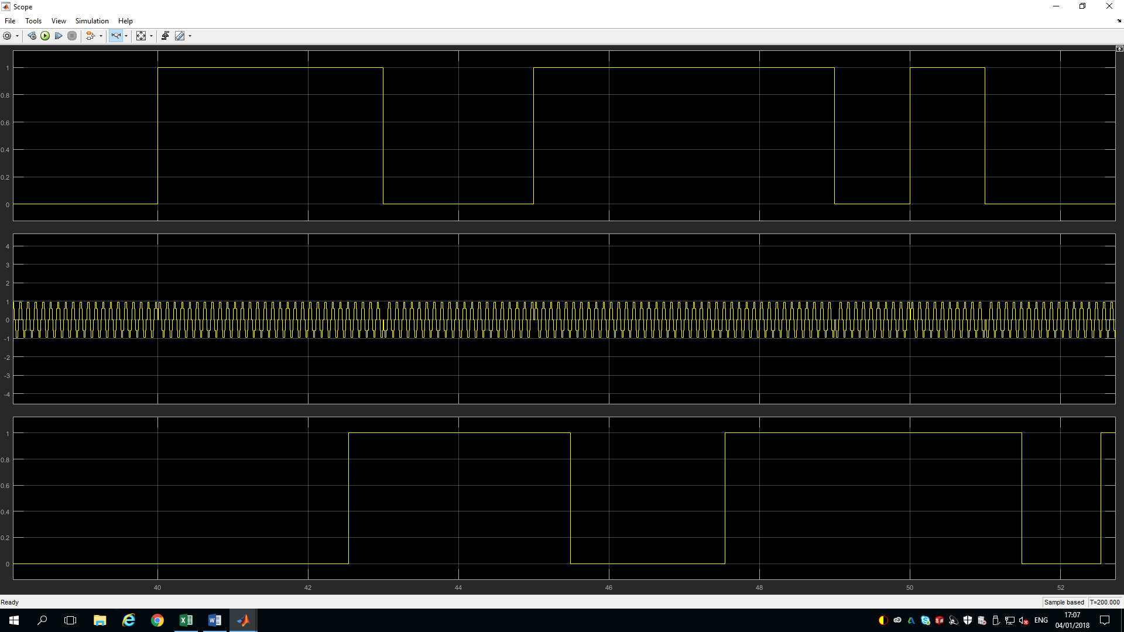Figure 12 Scope Results of a PSK
Figure 11 Show a Phase modulation in the form of PSK that I had built on Simulink without AWGN.. Then Figure 12 show the input and output signal are the same, meaning that the circuit I had built is correct. The output digital signal is out of phase. I tried using transport delay block to correct this, I found it very tricky and the value it was out but was very small and couldn’t seem to get perfect.

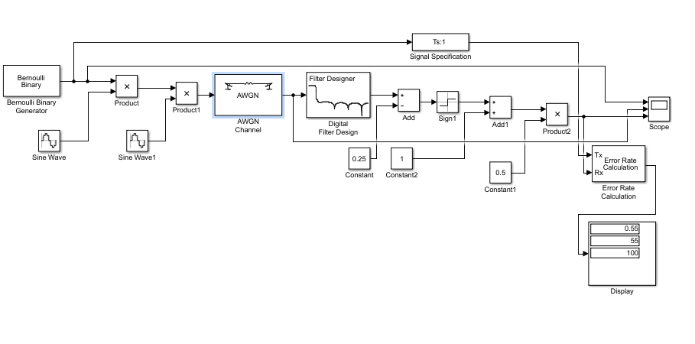
Figure 13 Simulink block diagram, PSK with AWGN

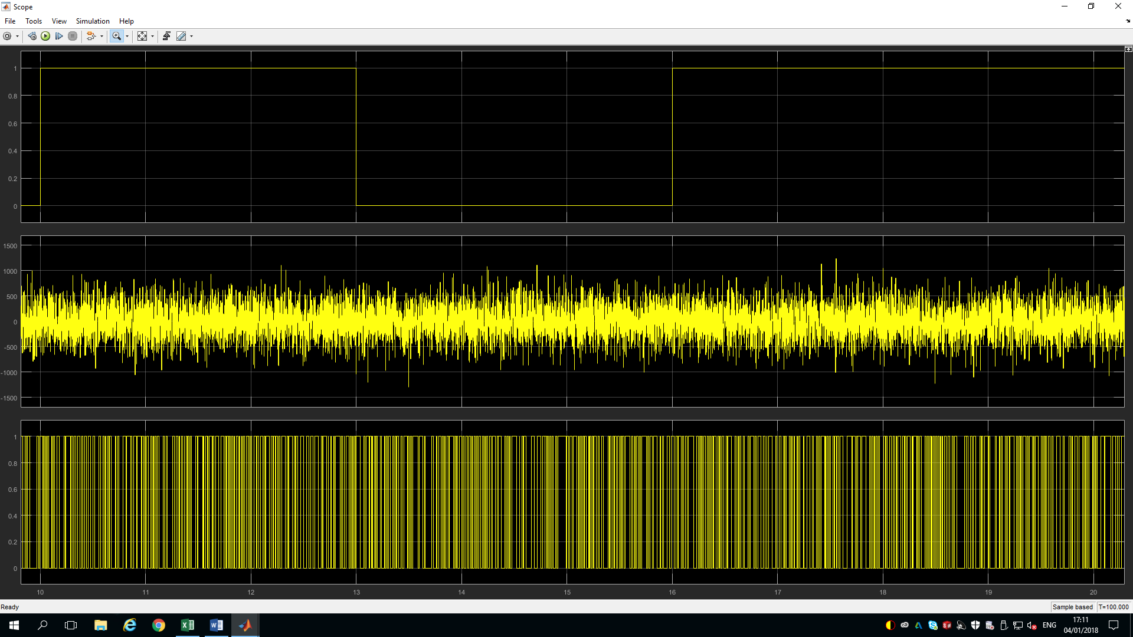Figure 14 Scope Results of a PSK with AWGN

Figure 13 shows my block diagram of a PSK with AWGN added to it. Figure 14 shows that the input and output digital signal aren’t the same, again meaning that the AWGN has affected my signal with a lot of errors, making my output signal non-recognizable to my input signal.

FSK

Figure 15 Simulink block diagram, FSK.
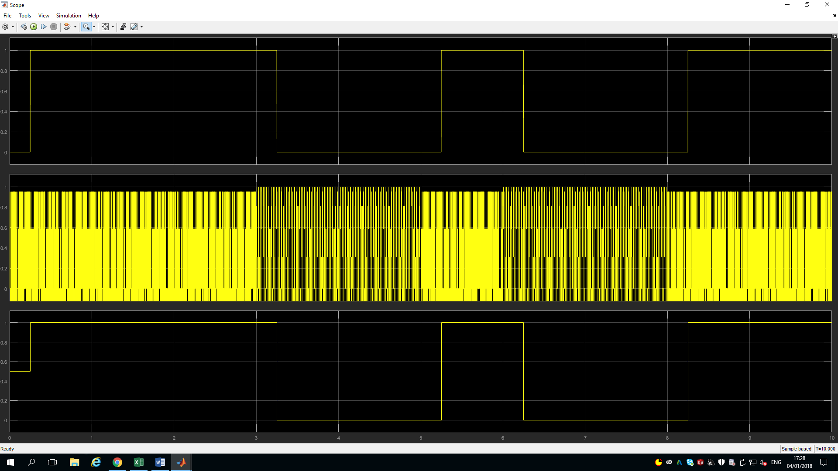
Figure 16 Scope Results of a FSK

Figure 15 Show a frequencies modulation in the form of FSK that I had built on Simulink without AWGN.. Then Figure 12 show the input and output signal are the same, again meaning that the circuit I had built is correct. The output and input digital signal are in phase in this one. By using transport delay block to correct this.

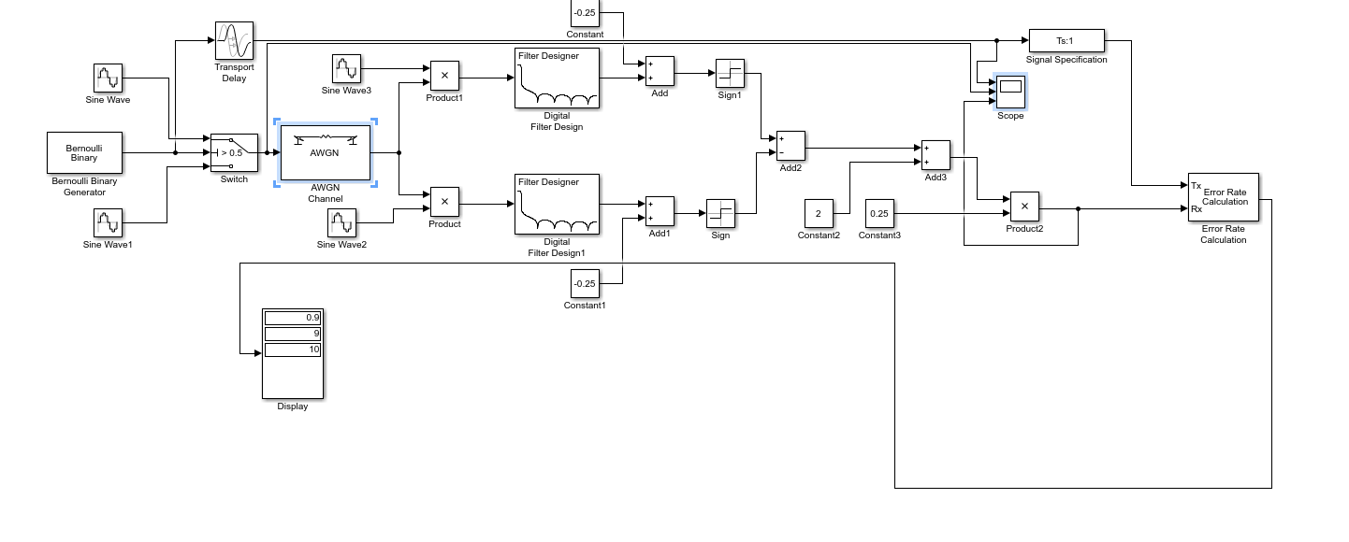
Figure 17 Simulink block diagram, FSK with AWGN
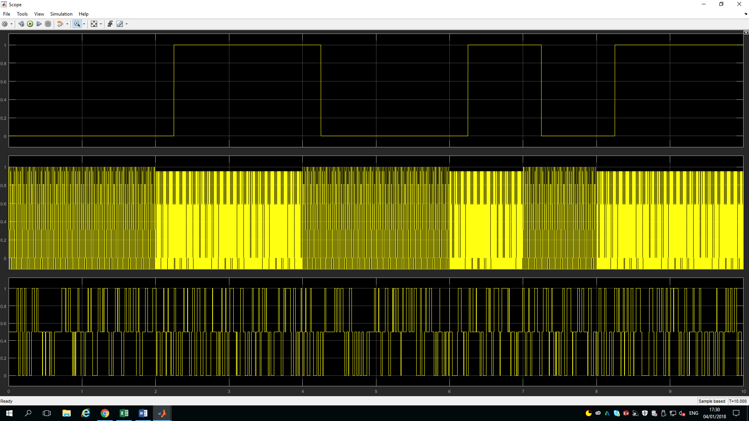
Figure 18 Scope Results of an FSK with AWGN

Figure 17 shows my block diagram of a FSK with AWGN added to it. Again Figure 18 shows that the input and output digital signal aren’t the same. Like ASK and PSK, AWGN has affected my signal with a lot of errors, making my output signal non-recognizable to my input signal.

Analysis

SNR (dB) | Error Rate | Error Detected | Number of symbols Transmitted
-50 | 0,46 | 46 | 100
-40 | 0.61 | 61 | 100
-30 | 0.49 | 49 | 100
-20 | 0.45 | 45 | 100
-10 | 0.39 | 39 | 100
0 | 0.17 | 17 | 100
10 | 0.01 | 1 | 100
Table 1 ASK

SNR (dB) | Error Rate | Error Detected | Number of symbols Transmitted
-50 | 0.5274 | 106 | 201
-40 | 0.4876 | 98 | 201
-30 | 0.4478 | 90 | 201
-20 | 0.4129 | 83 | 201
-10 | 0.2537 | 51 | 201
0 | 0.0796 | 16 | 201
10 | 0 | 0 | 201
Table 2 PSK
SNR (dB) | Error Rate | Error Detected | Number of symbols Transmitted
-50 | 0.9 | 9 | 10
-40 | 0.7 | 7 | 10
-30 | 0.8 | 8 | 10
-20 | 0.7 | 7 | 10
-10 | 0.5 | 5 | 10
0 | 0 | 0 | 10
10 | 0 | 0 | 10
Table 3 FSK

The 3 tables above show the information I have collected from each modulation when AWGN has been added. The range being used in SNR which stands for Signal-to-noise ration and it’s a measurement of a signal strength to comparative background noise. The SNR range I am using is -50 to 10 dBs A negative value in SNR range means higher the noise to a positive value.

Graph 1 Error Rate

Graph 2 Error Detected

From Graph 1 and 2 the data form this shows the more noise being added the errors increase with all 3 modulations which I would expect. PSK is very complex modulations, it has a low error probability, also its noise immunity is low and it’s better than the two others, making this suitable for high bit rates. FSK is moderately complex modulations, it also has a high error probability that’s shown in my result but I would expected it to be as low as ASK but not higher than PSK, also its noise immunity seems to be high and not what I expected. FSK from my results seems to show that it’s the worse out of them all but I would expect FSK to be in the middle of the PSK and ASK because they tend to be used up to 1200 bits/secs (bit rate). ASK is a simple modulations, it has a low error probability, also its noise immunity is low and better than FSK but again I would expect this to be the worse out of the lot because normally the bit rate they are tend to be used for is anything up to 100 bits/sec.

Error Control

Data gets transferred from one device to another device. When transferring data as of a transmitting application to a receiving application, it will do this in a few steps and this can cause an error. Because of this error control is needed in the process, because when transferring date it should be identical at both ends. When transferring data it become corrupted during transmission. When doing this process reliable communication is key so errors must be detected and corrected. [5] [6]

Detecting and correcting is error control is the process. It detecting and correcting both the bit level and packet level errors. [6]

Types of Errors

One type of error you will come across will be single bit error. This means that out all the bits in the data only one will change from 1 to 0 and 0 to 1. [5] [6]
Another type of error is burst error. This means out of all the bits being transmitted two or more can be changed. Packet data is also Burst error, where errors like packet loss, duplication, reordering. [5] [6]

Error-Detecting codes

When transmitting data, it is possible for it to get messed up by noise or data even corrupted. A way to avoid this is using error-detecting codes. Error-detecting codes are additional data added to the original data to find if there any errors when it getting transmitted. One example is parity while using error-detecting code. [6]

Error-Correcting codes

Error-correcting code are also added, this is used to pass some data to find what the original message was and that’s from the corrupt message that was received. Error-correcting codes use same technique as error-detecting codes but additionally, this codes will find the exact position of the corrupt bit. [6]

Error-correcting codes also use parity check and the way it does it a simple way. It will detect errors alongside with a sophisticated mechanism to govern the corrupt bit location. When a corrupt bit is found, the value of the bit is reverted either from 0 to 1 or 1 to 0 and this will get the original message. [6]

Hamming code

What is hamming coding? It is bunch of error-correction codes. This error-correction codes tend to be used to detect bit errors and when found it will correct them. As talked about before, errors can occur when data is transferred or stored. Hamming code is named for R. W. Hamming of Bell Labs. [6] [7]

Hamming codes is one of many error-correction codes but just like other methods, it will use the model of parity and parity bits. These are bits that are added to data so that the data in question can be checked. When more than one parity bit is being used. When using this type of error-correction code it can identify a single bit error, but also it can find the point where the error is in the data. [6] [7]

Forward error correction (FEC) is the ability correct data in a receiving station and thus is in data transmission. This can rise throughput on a data link when amount of noise present. For this to work, a station is add and this called a transmitting station. A transmitting station adds additional data called error correction bits. The problem with this maybe than the correction might not every time signify a cost saving over that of basic resending the information. Hamming codes make FEC minus expensive to implement through the use of a block parity mechanism. [6] [8]

Computing parity counts the amount of ones in section of data, this is either adding a zero or a one and this called a parity bit adding a zero or a one is to make the count odd for odd parity or even for even parity. Figure 19 on the next page shows an example of this. When an even parity calculate is needed, the XOR operator is used and when an odd parity calculate is needed, the XNOR operator is used. When Single bit errors are detected the parity count will show the amount of ones that are incorrect, showing the data bit has been overturned by noise, which would have been in the line. By using more than one parity bit like hamming codes, it detect two bit errors, each of which is figured on different mixtures of bits in the data. [6] [9]

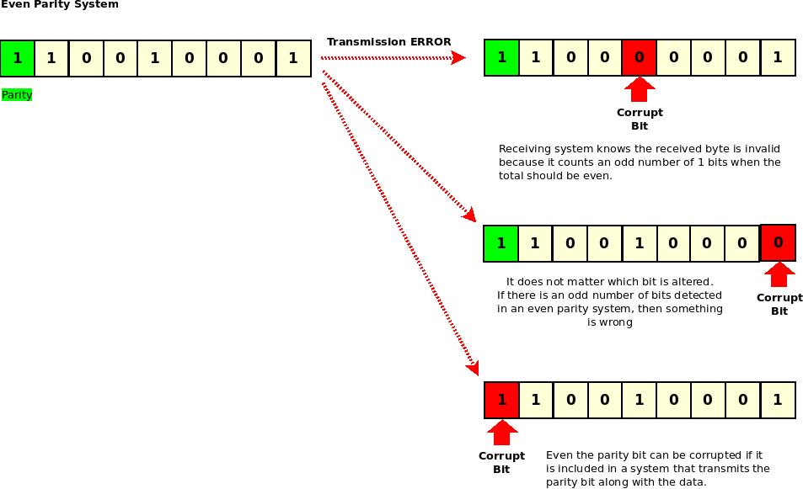
Figure 19 Even Parity System
[10]

Conclusion

This report has shown that noise does effect modulations and it effect on different methods are different. Amplitude shift Keying is a simple modulations, when phase shift keying is complex and frequency shift keying being very complex when building them in Simulink. When simulating this modulation with noise the errors increased when the noise did, they way to stop this or limited is to use error control. Error control uses a detector to find the errors and then uses a corrector to get rid of these errors.

Form the data I collected and shown in the graphs above. PSK has a low error probability, also its noise immunity is low compared to the others. FSK has a high error but I would expected it to be as low as ASK but not as high as PSK, also its noise immunity seems to be high. ASK has a low error probability, also its noise immunity is low and better than FSK but again I would expect this to be the worse out the two other modulations.

References

[1] | Slideshare, “ASK, FSK and M-PSK,” Amirah Nadrah Ghazali, p. 17, 2014.
[2] | Srmuniv , “44,” [Online]. Available: http://www.srmuniv.ac.in/sites/default/files/files/comm_lab_manual_final.pdf. [Accessed 07 01 2018].
[3] | S. Raman, “What is an Additive White Gaussian Noise channel in terms of digital communication?,” 22 11 2014 . [Online]. Available: https://www.quora.com/What-is-an-Additive-White-Gaussian-Noise-channel-in-terms-of-digital-communication. [Accessed 19 12 2017].
[4] | Wikipedia, “Additive white Gaussian noise,” [Online]. Available: https://en.wikipedia.org/wiki/Additive_white_Gaussian_noise. [Accessed 18 22 2017].
[5] | Wiki Books, “Communication Networks/Error Control, Flow Control, MAC,” [Online]. Available: https://en.wikibooks.org/wiki/Communication_Networks/Error_Control,_Flow_Control,_MAC. [Accessed 24 12 2017].
[6] | Tutorials Poinrt, “Error Detection & Correction,” [Online]. Available: https://www.tutorialspoint.com/computer_logical_organization/error_codes.htm. [Accessed 04 01 2018].
[7] | Gaussian Waves, Hamming Codes – How it works, Mathuranathan , 2008.
[8] | SearchMobileComputing, “forward error correction (FEC),” [Online]. Available: http://searchmobilecomputing.techtarget.com/definition/forward-error-correction. [Accessed 06 01 2018].
[9] | PC Mag, “RAID parity,” [Online]. Available: https://www.pcmag.com/encyclopedia/term/60364/raid-parity. [Accessed 06 01 2018].
[10] | DelightlyLinux, [Online]. Available: https://delightlylinux.files.wordpress.com/2015/03/parity071.png. [Accessed 07 01 2018].
[11] | Cengage Learning, “Simulink Tutorial on Digital,” 2013.
[12] | Ques10, “Compare ASK , PSK & FSK systems.,” [Online]. Available: http://www.ques10.com/p/3619/compare-ask-psk-fsk-systems-1/. [Accessed 06 01 2018].
[13] | Math Works, [Online]. Available: https://uk.mathworks.com/help/comm/ref/bernoullibinarygenerator.html. [Accessed 09 01 2018].

