School of Engineering

Connecting Rod Dynamic Forces Report.

Robert Morse
1806186

Abstract
This report will investigate the forces acting upon a connecting rod in an internal combustion engine.
Two engines will be compared with different design aspects, these aspects will be compared to demonstrate the impact they have on connecting rod forces.
Engine measurements have been input into a spreadsheet to calculate velocity and forces, these have demonstrated how mass and acceleration can affect the tensile forces acting upon the connecting rod.
Multiple engine design characteristics have been discussed of how to improve engine design.

Contents
Abstract 2
List of Figures 4
Introduction 5
The Connecting Rod. 5
Method 6
Engine Data. 7
Calculated Data 8
Velocity. 9
Acceleration and Tensile Force 10
Connecting Rod Failures. 11
Conclusion 12
References 13

List of Figures

Table 1 - Ford Zetec Imperial Measurements 7

Table 2 - Ford Zetec Metric Measurements 7

Table 3 - VAG PD Metric Measurements 7

Table 4 - Connecting Rod Height During Engine Operation 8

Table 5 - Velocity 9

Table 6 - Acceleration and Tensile Force Zetec Engine 10

Table 7 - Acceleration and Tensile Force PD Engine 11

Introduction

This report will investigate the forces acting on a connecting rod in an internal combustion engine.
Different engines will be assessed to observe how various characteristics such as the mass of the components effect the forces acting upon the connecting rod at a range of engine speeds.
The different parameters will be input into an excel spreadsheet to calculate the forces being produced, this information will be presented in various graphs to compare the impact of different engine design characteristics on con rod load.
The engine specifications will be taken from manufacturer’s information.

The Connecting Rod.

The connecting rod is a key component within an internal combustion engine it is submitted to high forces throughout the four stroke cycle. The connecting rod transfers the forces acting upon the piston though to the crankshaft changing reciprocating motion into rotary motion. The forces acting upon the con rod vary from each stroke, it is compressed during the power and compression strokes and stretched on the induction and exhaust strokes due to the piston velocity having to be stopped at top dead center.
Due to the forces acting upon it the con rod must be made of a material that is very strong but also light so that it does not have an adverse effect on the rotating mass within the engine. The material commonly used in production of con rods is steel, however in performance applications other materials such as aluminum alloys and titanium are being used to cope with the extra stress demands.

“Connecting rods are nearly always made from steel forgings, accurately machined where necessary. In high performance engines they are often machined all over to reduce weight to the minimum and polished to remove surface scratches, which might lead to fatigue or failure.
Some exotic and expensive alloys or steels are now used in high performance and racing engines; these material provide reduced weight with increased strength but at a high cost”
(Hillier and Coombes, 2004,p.58)

The two main parts that make up a connecting rod are the small end and the big end, the small end has the Gudgeon pin inserted through it linking the con rod and the piston. The big end is constructed in two parts and is clamped around the crankshaft. The construction of the big end section of the con rod has been altered multiple times to try and gain the best mate between the big end cap and the connecting rod, the most common design in modern engines is to construct the con rod as one piece and then crack the big end into two pieces. This manufacturing process gives a perfect joint between the cap and the connecting rod, this reduces any tolerance between the two surfaces.

Method

Research will be conducted into engine specifications and manufacturers data to gain the information needed to calculate the con rod load. Measurements of components such as the crankshaft radius, con rod length and piston mass will be input into the excel spreadsheet shown below to collate the information.
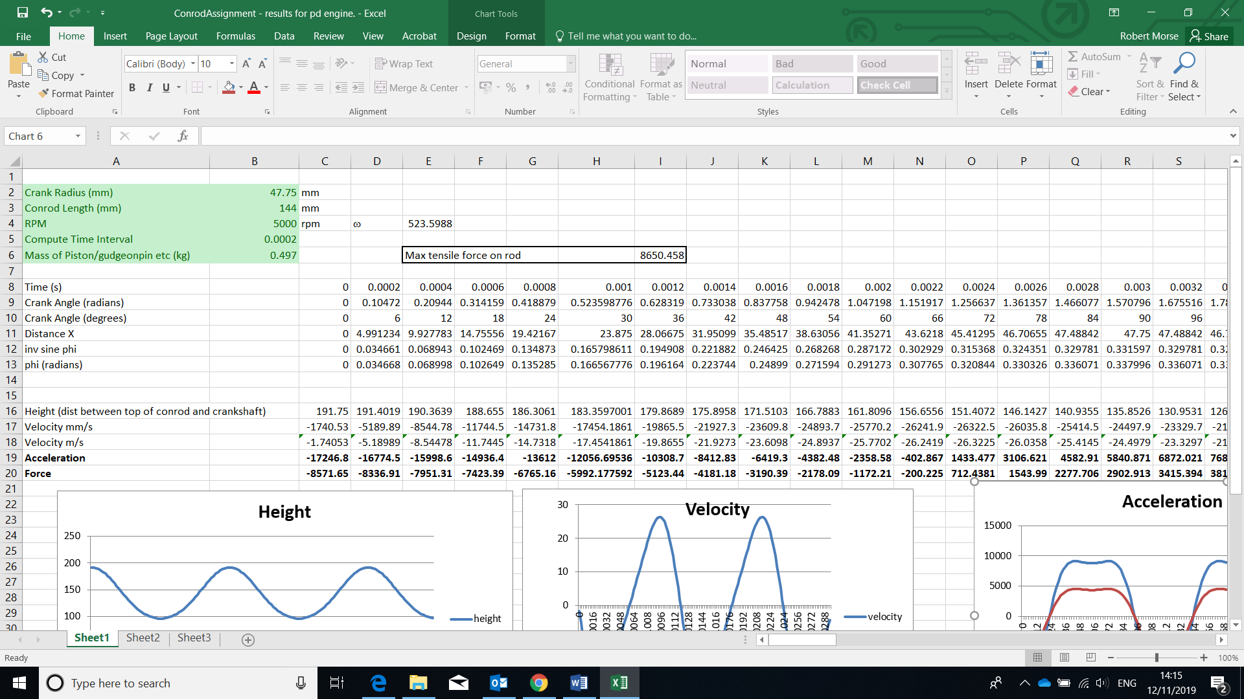
Engine Specifications to change.

When adjustments are made to the engine measurements the spreadsheet will output data in multiple formats such as graphs and maximum load figures. This information can be used to compare the data across different engines or used to influence engine design.

Engine Data.

Table 1 - Ford Zetec Imperial Measurements
Crank Radius (inches) | 1.675 (Stroke = 3.350)
Con rod Length (inches) | 5.230
Max RPM | 6800
Piston / Gudgeon Pin Mass (Kg) | 0.380

Inches to mm conversion.

Crank Radius.
$$1.675 x 25.4= 42.545$$

Con Rod.
$$5.230 x 25.4=132.842$$

Table 2 - Ford Zetec Metric Measurements
Crank Radius (mm) | 41.875
Con rod Length (mm) | 132.842
Max RPM | 6800
Piston / Gudgeon Pin Mass (Kg) | 0.380

Table 3 - VAG PD Metric Measurements
Crank Radius (mm) | 47.75
Con rod Length (mm) | 144
Max RPM | 5000
Piston / Gudgeon Pin Mass (Kg) | 0.497

Calculated Data

Table 4 - Connecting Rod Height During Engine Operation

The height represents the distance between the crankshaft and the top of the con rod, as can be seen from the graph this varies on crankshaft position. Due to the engine design this variation will be limited to double the crank radius, this distance is known as the stroke. If an engine is designed with a longer stroke it will result in a slower maximum RPM due to the distance the piston has to travel. This will however give greater torque output due to the longer crank radius acting around the center point of the crank. Some engine designs where high torque is not a necessity such as motorcycle engines will have a shorter stroke allowing for much higher engine RPM.
Demonstrated in the above graph the PD engine has a larger crank radius therefore the distance between the crank center and the top of the con rod is larger than the Zetec engine. The effects of this can be seen when looking at the max RPM figures with the Zetec engines max RPM at 6800 and the PD engine at 5000.

Velocity.

Table 5 - Velocity

As can be seen in the graph above the velocity varies between acceleration and deceleration dependent upon engine position. The piston will be accelerated throughout the strokes but they have to be stopped at the end of each stroke, this creates not only compression forces on the con rod but also stretching forces when it is being slowed. The two main factors that can effect these forces are the weight of the piston and the engine speed. As stated in Newton’s second law:
The Relationship between force, mass and acceleration is given in the following equation:
$$F=ma$$
Where F = force in newton’s, m = mass in kg, a = acceleration in m/s²
(Bonnick, 2008, p.115)
As engine speed is normally a desired aspect for performance engines, engine designers have looked to reduce weight in components such as pistons and con rods to reduce the forces acting upon them. Pistons have been redesigned to remove mass as well as different lighter materials being used.
Pistons and rods are actually under some of the most extreme stress at TDC during changeover between exhaust and intake strokes, where there’s little resistance to the upward motion of the piston from pressure in the chamber, and the piston is suddenly changing direction as the motion of the crank starts to yank it back down the bore.
Huizenga (2018)
The Graph above shows the calculated velocity of the two engines that were looked at during this investigation, the peak velocity of the Zetec engine is higher than the PD due to the higher maximum RPM.
Acceleration and Tensile Force.
Table 6 - Acceleration and Tensile Force Zetec Engine

As can be seen in the above graph the forces acting upon the con rod follow the trend of the acceleration due to the force being directly related to the acceleration. The maximum tensile force measured on the connecting rod 10580.04 N.
Table 7 - Acceleration and Tensile Force PD Engine

The Maximum tensile force acting upon the connecting rod of the PD Engine is 8650.458N this force is lower than the forces on the Zetec engine because the maximum RPM is lower.
To further compare the results I changed the mass of the piston on the Zetec engine to the same mass as the PD Engine, this resulted in the maximum tensile force acting upon the rod reaching 13838.09N. This confirms that to allow the engine RPM to be higher the piston mass must be reduced.

Connecting Rod Failures.

Connecting rod failure can be caused by many different things however the main cause of rod failure is the forces acting upon it exceed the forces it was designed to handle. These forces can be increased by things such as increasing the maximum engine RPM, it is a common modification to have the engine rev limiter removed without upgrading any other engine components. This is obviously going to increase the forces acting upon the connecting rod, the only modification to maintain the forces with higher RPM is to reduce the mass being accelerated.

“The Tensile Strength of a material is the maximum tensile stress that the material can bear before breaking “
$$Tensile strength= \frac{maximum load }{original cross sectional of the material }$$
The tensile strength of a connecting rod should never be reached during normal engine operation, there should always be a safe tolerance to work within.
(Bonnick, 2008, p.73)

“In order to preserve the strength and working properties of a component, the maximum load to which a material is subjected is restricted to a figure which is below the tensile strength of the material. This maximum working load gives rise to the allowable working stress and it is a fraction of the tensile strength of the material”
(Bonnick, 2008, p.74)

Conclusion

In conclusion, it is clear to see from the calculated results that piston mass and velocity have a clear impact on the forces acting upon the connecting rod. As seen in the research the lower the tensile forces acting upon the con rod the less likely it is for the component to fail.
It is a balance for engine manufacturers to ensure reliability, performance and cost. In an ideal situation expensive materials should be used to lower the piston mass and make the con rod stronger, however this will increase production costs in most cases unnecessarily.
Calculations that were carried out in this investigation are key in engine design to ensure the optimum balance between cost and suitable components to reach the desired end result.

References

Hillier, V.A.W and Coombes, P. (2004) Hilliers Fundamentals of Motor Vehicle Technology. 5th edn. Cheltenham: Nelson Thornes Ltd.

Bonnick, A. (2008) Automotive Science and Mathematics. 1st edn. Oxon: Routledge.

Huizenga, P. (2018) How To Make Pistons Lighter. Available at: http://blog.wiseco.com/how-to-make-pistons-lighter (Accessed: 24 November 2019)

