DAV20857440 (George Davies)

REPORT ON THE STATISTICAL ANALYSIS OF RETAIL STORE PERFORMANCE

Contents
Introduction 1
Section A 1
Q1 1
A 1
B 2
C 3
Q2 4
A 4
B 4
C 5
Section B 5
Q3 5
A 5
B 6
C 6
Q4 7
A 7
B 7
C 7
Q5 8
A 8
B 9
Bibliography 10

Introduction
Conducting a sales analysis for a retail company can greatly help them calculate the performance of each of their stores [1], while also helping them make better informed business decisions. By using different statistical analysis techniques on the data provided, there are many conclusions we can make about how the company is performing.
The company has collected data on 5 of its different stores while giving data for each of them. It has included the following data:
- Product Category
- Daily Sales (in thousands of pounds)
- Average Customer Rating (on a scale of 1 to 5)
- Location (Rural or Urban)
With the data that the company has provided, this document will provide a statistical analysis of the data that has been provided and information that will help the business increase its performance.

Section A

Q1

A

By calculating each the mean, median and mode, there was a lot of information about each of the stores that I discovered. To begin with, the mean of each store was different. The highest mean daily sales were store 5 with 23.83 daily sales, while store 3 only had 13, showing both the strongest and weakest areas of the company. Using the mean of all the stores shows that that stores that have an average of over 16.9 daily are performing well when compared to the rest of the data, showing that Store 1 and Store 5 are showing the best overall performance when compared to Store 2, 3 and 4.
The median also showed results varying from the mean, with Store 4 having the lowest median, while store 5 again had the highest. Looking at the data and the median, this shows me that although Store 4 has a higher mean than Store 3, it’s median is lower meaning it has more days where it made less profit than store 3. This also shows once again that overall store 5 has the most successful days compared to other stores.
Throughout the stores, only Store 1 has a median which is 20. This data may show that there is not much consistency throughout the patterns of daily sales in stores besides store 1.

B

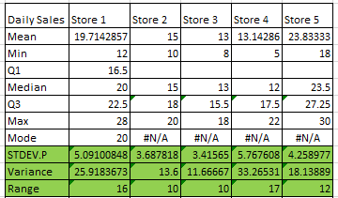
From the table, it shows that Store 4 has the highest standard deviation which shows that sales typically have a large gap from the mean, showing more unpredictable sale patterns. The data also shows that Store 3 has the lowest standard deviation, showing that out of all the stores, Store 3 consists of the most predictable sale patterns compared to other stores which are less predictable.
The range of the data shows me that Store 4 has the highest range, showing me that overall Store 4 has more diversified daily sales, having a large difference between the highest and lowest. The data also shows me that both Store 2 and Store 3 has the lowest range, indicating they have the most consistent results out of all the stores.
Store 4 having the highest variance shows me that overall Store 4 has the biggest difference in daily sales, having a much higher dispersion in the results. Store 3 however has the lowest variance, showing it has the least disparity between results, making it the most consistent store in terms of sales.
Each of these measures provide different information about the data that has been provided, with the methods used capturing the inconsistency of some stores such as Store 4 with a high range and variance, and the consistency of other stores such as Store 3 with a much lower range and lower variance.

C

Using the Q1 and Q3 of the data provided, outlier detection in the data becomes a much easier process. Anything lower than Q1 and greater than Q3 can be considered an outlier, which is shown in the table below highlighted in red.
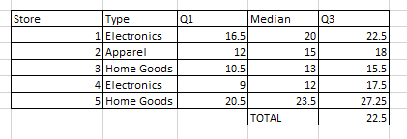
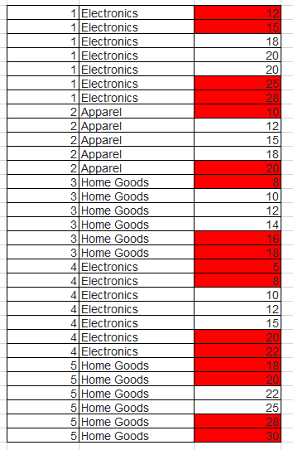

Q2

A
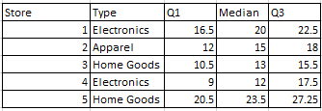

Calculating the 75th percentile showed that the sales of store 5 overall had a better sales performance overall than the other stores, making more money above the Q3 range. This also showed that store 3 were overall performing negatively with a lower Q3 of 15.5, showing that a large majority of results of the store are lower on average. Utilising the Q3 of data is significant since it allows comparison between stores, showing how much better each store is performing compared to the other stores.

B
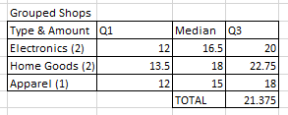
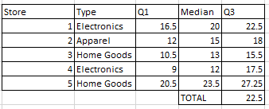
By grouping the stores and calculating the quartile ranges for them, the stores that are performing well are clearly highlighted after being compared to the third quartile. In electronics, store 1 is performing better than store 3 with its Q3 being higher by 5, showing a much larger amount of revenue in store 1. Store 3 also has a much lower Q3 compared to the grouped Q3 of the stores, showing its performance is subpar compared to the other electronic store.
In home goods, Store 5 is performing better than Store 3 by 11.75, showing a huge difference between the sales of the two stores. Store 3 also falls below the grouped Q3 of home good stores by 7.25, a significant difference showing a lower number of sales from the store compared to other sales of home goods.
Apparel only has one store worth of data to be measured so the Q3 is the same regardless. This can be a problem when comparing data of sales since other stores were giving a higher sample size which affected results greatly, meaning any statistical analysis made on store 2 could be inaccurate when compared to other measurements.

C
Finding the Q3 shows many things about the company sales strategy. Since the Q3 can be used to compare the different stores and display the better performing one, the company can use this to effectively figure out which stores are not performing adequately. This can help the company’s sales strategy as they can focus on improving their sales for the store that isn’t performing well enough. One of the main causes of stores having lower quartiles may have to do with their location, as from the data gathered, I can see that both store 4 and 3 which are the stores with the lowest Q3 are both located in a rural area. This indicates that stores in a rural area are not as effective as stores built in an urban area, which may mean that the company should focus on ensuring stores are built in urban areas compared to rural ones. The company sale strategy may also be focused more on their Home Goods department as their grouped Q3 is higher than any of the other departments, possibly indicating the company primarily focusing on a singular department. Apparel only having one store location however may cause an issue with the results of the Q3 calculations, which also may indicate that the company is less focused on their apparel department compared to the others.

Section B

Q3

A
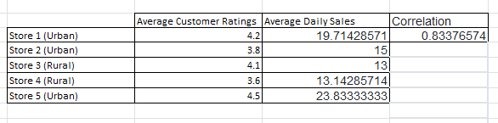
This table shows each of the store’s average customer ratings, as well as the average daily sales for each of the stores. The correlation value being 0.8 represents the correlation between both average daily sales and average customer ratings, and since it is very close to 1, the value indicates a positive correlation.

B

The graph that was created using average daily sales and average customer sales shows all the stores plotted based off their performance. The graph shows a positive correlation between the average customer rating and the average daily sales as the correlation line is on an upwards trend, which shows that the higher the customer rating is, the higher the daily sales are. The line is also very steep which shows a much stronger positive trend, meaning that the rating of the store greatly affects the daily sales.

C
Based off the data found, I can see that most stores have a larger average daily sales count when their average customer rating is higher, compared to other stores with lower average customer ratings. Based off this, it is in the best interest of the company to improve shopper’s experience in the stores that are not performing as well as the others. One way to do this may be to invest in the design of the store as this is shown to increase sales due to customers being more likely to visit the store for its atmosphere alone [2]. Another method to increase customer rating may be to train employees to offer better customer service, as this may lead to people being more likely to visit the store again [3]. An additional way to increase customer reviews may be to offer them an incentive to return to the same store again such as a loyalty system like points. This will encourage customers to frequently shop at the same place, therefore increasing their opinion of the company as they have been given a reason to prefer it [4].

Q4

A
The null hypothesis of the data is that there is no difference between the earnings of Rural locations and Urban locations. The alternative hypothesis is that there is a significant difference between the earnings of the Urban locations and the Rural locations.

B
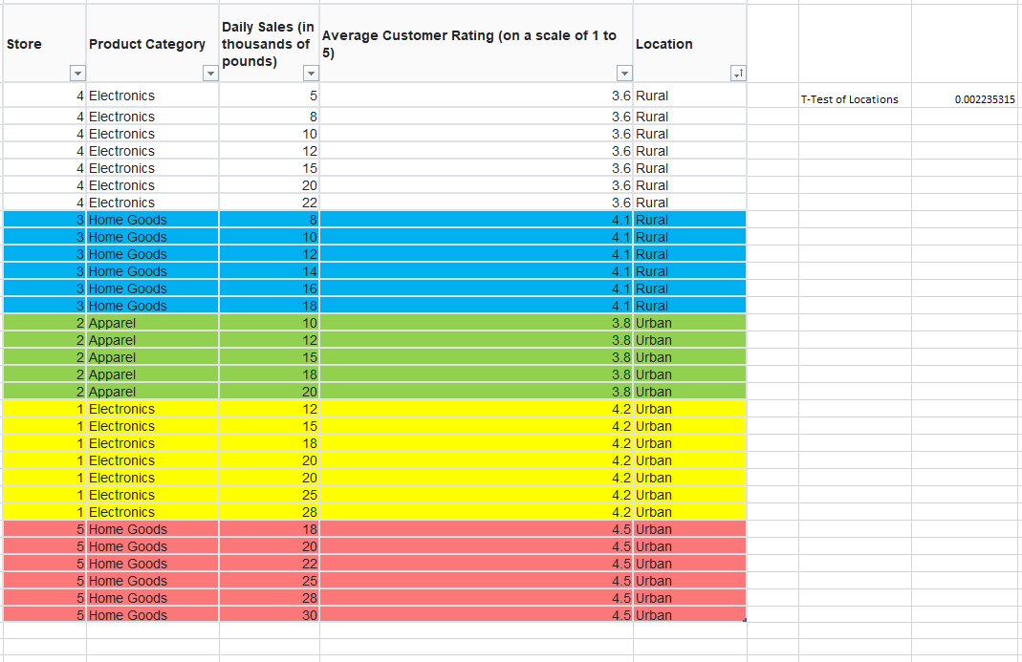
Using data sorted by location, the t-test came up as 0.002235315. Comparing this data to the p-values 0.01, 0.05 and 0.1 as well as using degrees of freedom 80%, 95% and 99% shows that in all comparison scenarios, the t-test gave a number much smaller than the p-value. This shows strong evidence that the null hypothesis is incorrect, meaning that the alternative hypothesis was correct. This means that there was a difference between the sales of stores based in Rural Areas compared to stores based in Urban areas, with the Urban areas having a much greater number of sales, meaning the null hypothesis is rejected.

C
Based off the findings of sales performance and customer ratings, I believe that to improve sales performance, stores need to be based more in Urban areas as this is the place where the sales performance is best. It is also apparent that both rural stores have the lowest ratings out of the 5 stores, showing that these stores may not be being taken care of enough or other in-store reasons. A way that the performance of these stores could be improved is by using loyalty programs, such as earning points for purchasing items which make customers more likely to come back to the store [5]. Another way that the issue of rural stores having less sales can be solved is by giving customers incentives to visit the rural locations instead of the urban ones, such as advertising sales in select locations to encourage people to visit them [3].

Q5

A

The stacked bar chart shows the difference in product categories by location. This graph shows that the Rural store locations and the Urban locations share the same amount of both Electronic and Home Goods stores. However, the chart also shows that the Urban location has an apparel store while the Rural location does not.

B

This scatter plot shows the distribution of average customer ratings and the daily sales of the store.

Bibliography

[1] | H.-H. W. Jiunn-I Shieh, “Applying importance-performance analysis to compare the changes of a convenient store,” Spriner Link, vol. 43, pp. 391-400, 2007.
[2] | K. Moore, “7 Ideas for How To Attract Customers To Your Store (2024),” 3 August 2021. [Online]. Available: https://www.shopify.com/uk/retail/ideas-to-bring-customers-in-store. [Accessed 18 January 2024].
[3] | Forbes, “10 Simple Strategies To Draw Customers Back To Your Brick-And-Mortar Store,” 10 September 2021. [Online]. Available: https://www.forbes.com/sites/theyec/2021/09/10/10-simple-strategies-to-draw-customers-back-to-your-brick-and-mortar-store/?sh=199cce34380d. [Accessed 18 January 2024].
[4] | Swift Local Solutions, “7 Ways You Can Improve Your Customer's Shopping Experience (and Increase Sales!) Without Spending a Bunch of Money,” [Online]. Available: https://www.swiftlocalsolutions.com/blog/6-ways-you-can-improve-your-customers-shopping-experience-and-increase-sales-without-spending-a-bunch-of-money. [Accessed 18 January 2024].
[5] | C. J. Louise O'Brien, “Harvard Business Review,” [Online]. Available: https://hbr.org/1995/05/do-rewards-really-create-loyalty. [Accessed 17 January 2024].

