

Application of Computer-Aided Engineering Processes

Author: Joshua Luke Evans (2011912)
Course: BEng Ordnance, Munitions, and Explosives – Level 5 Computer-Aided Engineering (ACDB5007)
Faculty of Architecture, Computing and Engineering
Date of Submission: 18th July 2024
Word Count: 4686 (excluding references)

Executive Summary
A study has been conducted on the applications of computer-aided engineering (CAE) practices across the engineering and scientific sectors. To draw out the key benefits and limitations of CAE, a prosthetic leg was designed in Solidworks and later tested in Ansys as an example case study. The case study included the geometry creation, identification and sourcing of appropriate and accurate material properties, generating a suitable mesh for accurate analysis, performing two structural analyses, and validating the results using theoretical engineering calculations.
The case study of the sprinter’s prosthetic leg demonstrates CAE’s potential in modern engineering, enabling virtual prototyping and detailed simulations of real-world conditions. Accurate CAD models, material selection, and meshing are crucial for reliable CAE analyses. While CAE tools offer significant time and cost savings, the quality of input data, computational power, and user competency in modelling and the specific engineering field are critical for accurate simulations.

Contents
Executive Summary 2
Table of Figures 4
1. Introduction 5
2. Case Study 5
2.1. Geometry 5
2.2. Material Selection 7
2.3. Meshing 7
2.3.1. Importance of Meshing 7
2.3.2. Types of Meshes 7
2.3.3. Impact of Mesh Quality and Alterations 8
2.3.4. Pros and Cons of Meshing in CAE 8
2.4. Results 9
2.4.1. Static Structural Analysis 9
2.4.2 Eigenvalue Buckling Analysis 10
3. Validation 12
4. Discussion 16
5. Conclusion 18
References 20

Table of Figures
Figure 1 - Example of a runner's prosthetic [2] 6
Figure 2 - Blade (top-left), Socket (top-right), Bracket (bottom-left) and Foot (bottom-right) components for prosthetic leg case study 6
Figure 3 – Comparison between default mesh (left) and adjusted mesh (right) coloured by mesh quality 8
Figure 4 - Total deformation (left) and von Mises stress (right) of prosthetic leg under 2746.8N load 9
Figure 5 - Eigenvalue buckling modes – default mesh 11
Figure 6 - Eigenvalue Buckling Modes – Finer Mesh 12
Figure 7 - Buckling example schematic [2] 13
Figure 8 - Euler Buckling example geometry created in Solidworks 14
Figure 9 - Eigenvalue Buckling modes 1, 2, and 10 (from left to right, respectively) for the validation test piece 15
Figure 10 - Gathering height/base values in Ansys for the moment of inertia calculation 15
Figure 11 - Stress on the prosthetic blade 17

Table of Tables
Table 1 - Equivalent stress and total deformation of prosthetic leg under loads 10
Table 2 – Buckling modes and associated critical loads from Eigenvalue buckling analysis with default mesh 11
Table 3 - Buckling modes and associated critical loads from Eigenvalue buckling analysis with finer mesh 12
Table 4 - Critical load values for the Eigenvalue Buckling test analysis 16

Introduction
The Computer-Aided Engineering (CAE) module at the University of Wales, Trinity Saint David, is designed to equip students with the essential knowledge and skills for proficient use of Computer-Aided Design (CAD) and Finite Element Analysis (FEA) tools. This module enables students to develop their skills in critically analysing and evaluating structural and fluid dynamics problems using CAE software. Additionally, it fosters competence in applying appropriate software packages to investigate engineering issues and enhances cognitive skills in formulating and solving problems within their chosen engineering specialism.
CAE is a transformative tool across numerous sectors, offering substantial efficiency and cost savings benefits. Enlyft [1] has data on 17,775 companies using Ansys alone, including Fujitsu and Infosys Ltd. By facilitating the analysis of design concepts, CAE tools empower companies to refine their products precisely, conserving essential resources. However, leveraging CAE to its full potential demands proficiency in the modelling software and the scientific principles underlying the analysis. Missteps in either domain can result in inaccuracies that, if unchecked, can lead to flaws. These mistakes are particularly critical in high-stakes fields such as aviation, medicine, and defence, where errors can lead to loss of life. Therefore, CAE simulations must be complemented by empirical testing at all stages of product development, from conceptualisation through to design and evaluation.
This report aims to illuminate CAE's practical applications and potential by examining a sprinter's prosthetic leg. Utilising Ansys, a leading CAE tool, a series of analyses will be conducted within a single environment to investigate the interplay of internal and external factors critical to the product's design and functionality. By doing so, the report aims to highlight the benefits and limitations of CAE in modern engineering.

Case Study

Geometry
Solidworks 2023 was selected as the Computer-Aided Design (CAD) package to produce the geometry for the case study. Solidworks is a robust CAD software for creating 3D models and technical drawings. It offers a user-friendly interface, making geometry generation relatively simple for users already adept in other CAD packages. It also contains simulation and analysis modules but does not employ the same breadth or depth of analyses that can be achieved by dedicated FEA or Computational Fluid Dynamics (CFD) packages.
The prosthetic selected for the case study is specialised for professional track runners [2] (see Figure 1). It is a design consisting of four main components: The socket, the blade, the foot, and the fixing bracket (Figure 2). The socket serves as the interface between the residual limb and the prosthetic. It is custom-moulded to ensure a secure and comfortable fit, effectively transferring the user's body weight and movements to the prosthetic components [3]. The blade is a specially engineered curved component typically made from carbon fibre, designed to provide high energy return and flexibility, mimicking the natural movement of a human leg during running and sprinting. The foot is the lower part of the prosthetic, designed to provide stability, traction, and additional shock absorption, enhancing the overall performance and comfort during dynamic activities. The fixing bracket securely attaches the blade to the socket, encapsulating a metal block to ensure robust and reliable connections, allowing the bolts to be fastened without compromising the integrity of the composite materials. These components create a highly efficient and responsive prosthetic leg tailored for high-performance athletic activities.
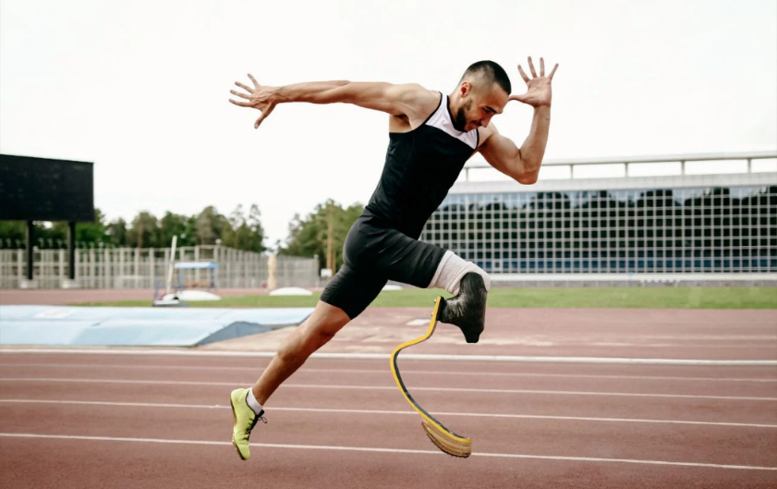
Figure 1 - Example of a runner's prosthetic [2]
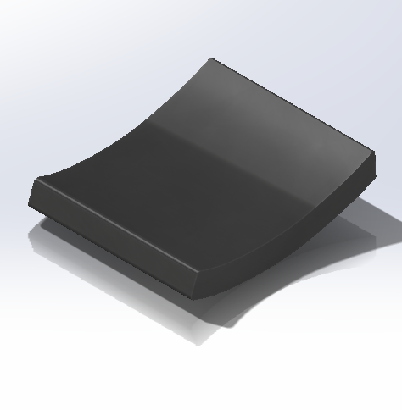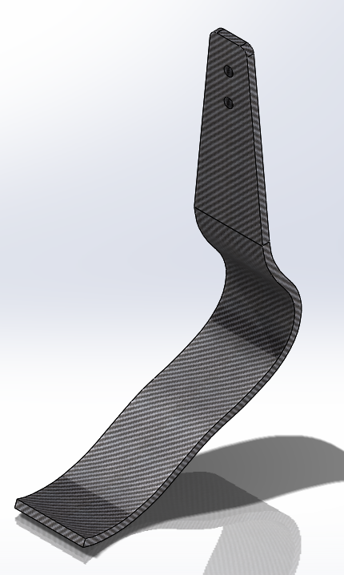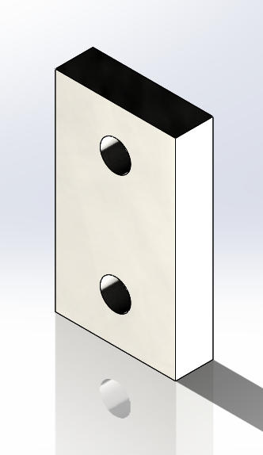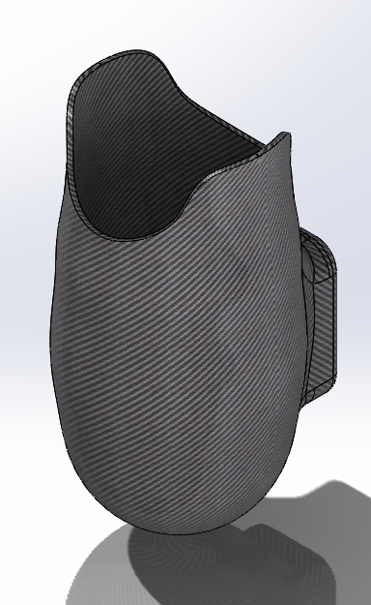
Figure 2 - Blade (top-left), socket (top-right), bracket (bottom-left) and foot (bottom-right) components for prosthetic leg case study

Material Selection
The selection of materials plays a pivotal role in FEA in understanding the ability of components/systems to withstand the loads acting upon them and the resulting stresses and strains being exhibited. The materials selected for the static analysis of the prosthetic leg were a high-strength, epoxy matrix carbon fibre for the blade and socket components. The bracket was made from AISI 1015 carbon steel, whilst the foot was made from polyurethane rubber.
The material properties for this selection were sourced using Ansys Granta. This software package provides data for metals, plastics, composites, and more. It has an extensive database of materials and various grades, allowing users to find appropriate material properties for their analyses.
The analyses being conducted on the prosthetic leg are both linear methods. The key characteristics of linear analysis methods are: [4]
- Stress is directly proportional to strain.
- They assume deformations are small enough that the original geometry does not change significantly.
- They assume that materials follow Hooke's Law.
- They are generally more straightforward problems, requiring less computational effort.
Due to these methods being employed in the case study, Ansys only requires basic engineering data such as isotropic elasticity properties (e.g., Young's modulus, Poisson's ratio, etc.) and yield and ultimate strength characteristics.

Meshing
Meshing is critical in the CAE process, particularly in Finite Element Analysis (FEA). It involves dividing a complex geometry into smaller, simpler elements that can be individually analysed. The quality and type of mesh can significantly influence the analysis's accuracy, convergence, and computational efficiency. In the context of the prosthetic leg, careful consideration of meshing is essential to ensure reliable results.

2.3.1. Importance of Meshing
- Representation of Geometry: Meshing helps accurately represent the geometry of the prosthetic leg. A finer mesh can capture more details of complex shapes, leading to more precise analysis.
- Boundary Conditions and Loads: Accurate meshing ensures that boundary conditions and applied loads are correctly represented in the model, which is crucial for realistic simulation outcomes.

2.3.2. Types of Meshes
- Structured Meshes consist of regular grid-like elements (e.g., hexahedral). They are easier to generate and solve but may not conform to complex geometries.
- Unstructured Meshes use irregularly shaped elements (e.g. tetrahedral), which can better conform to intricate geometries like those found in a prosthetic leg. However, they can be more computationally intensive.
- Hybrid Meshes combine structured and unstructured elements, balancing accuracy and computational efficiency.
An unstructured hexahedral mesh was applied to the assembly for this case study. The prosthetic leg consists of curves and thin-walled components unsuited to structured mesh types.

2.3.3. Impact of Mesh Quality and Alterations
- Element Size and Density: Smaller elements increase the mesh density, which can improve the accuracy of the results but at the cost of higher computational resources. For a prosthetic leg, areas with high-stress concentrations, such as joints and attachment points, might require a finer mesh to capture the forces acting upon these areas more accurately.
- Element Shape: Poorly shaped elements (e.g., highly skewed or distorted) can lead to numerical inaccuracies and convergence issues. Ensuring good element quality is essential for reliable results.
- Adaptive Meshing: This technique involves refining the mesh in regions of interest (e.g., high-stress or deformation areas) during analysis. Adaptive meshing can enhance accuracy without excessively increasing computational costs.
- Mesh Independence Study: Conducting a mesh independence study involves analysing the results using different mesh densities to ensure that the mesh size does not significantly affect the results. This step is crucial to confirm that the simulation outcomes for the prosthetic leg are robust and reliable.
Ansys allows users to view geometry using mesh quality (as shown in Figure 3). This view provides users with an indication of the suitability of the mesh that has been generated. This view would allow users to identify poorly shaped or otherwise unoptimised elements for the simulation. In this study, the mesh quality view indicated that the default mesh assigned by the software had a relatively poor mesh quality. As seen in the left image of Figure 3, many elements are coloured yellow and orange. On the right of Figure 3, it can be seen that the mesh quality improved significantly by adjusting the element size on the blade and the socket geometries. Some further improvements could have been made to the socket geometry. However, it was determined that a finer mesh quality may increase the computational resource requirements for the simulation.
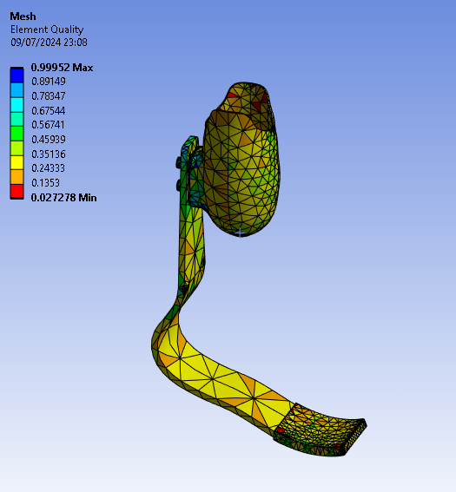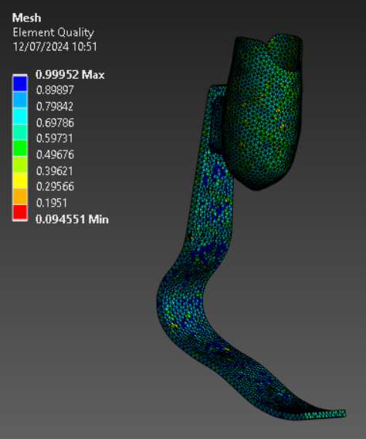
Figure 3 – Comparison between default mesh (left) and adjusted mesh (right) coloured by mesh quality

2.3.4. Pros and Cons of Meshing in CAE
- Pros:
  - Accuracy: High-quality meshing can significantly improve the accuracy of the simulation results, providing a better prediction of the prosthetic leg's performance.
  - Detail Representation: A well-defined mesh can capture detailed prosthetic leg features, leading to more realistic simulations.
  - Optimisation: Adaptive meshing and mesh refinement techniques can optimise the computational resources, focusing efforts on critical areas.
- Cons:
  - Computational Cost: Finer meshes require more computational power and time, which can be a limitation for complex models like prosthetic legs.
  - Complexity: Creating an optimal mesh can be complex and time-consuming, requiring expertise and experience.
  - Numerical Issues: Poor mesh quality can lead to numerical inaccuracies and convergence problems, potentially compromising the reliability of the results.

Results

Static Structural Analysis
For the static structural analysis, four load conditions were looked at to assess the performance of the prosthetic leg. The load conditions correspond to several weight classes (70 kg, 80 kg, and 90 kg); one dynamic loading represents a person sprinting (70 kg plus ground reactive force – 9.81 m/s multiplied by 4). Table 1 displays the max equivalent stresses and total deformation exhibited by the prosthetic leg under these loading conditions.
Table 1 - Equivalent stress and total deformation of prosthetic leg under loads
Load (N) | Equivalent Stress (Pa) | Total Deformation (m)
2746.8 (70kg + ground reactive force) | 239.46e+006 | 0.023263
882.9 (90kg) | 76.97e+006 | 0.016504
784.8 (80kg) | 68.417e+006 | 0.016208
686.7 (70kg) | 59.865e+006 | 0.015867
Figure 4 shows the total deformation and von Mises stresses, respectively. The total deformation showed that the upper portion of the blade and the socket deformed the most in the study. The highest stresses were found on the blade: A large area at the apex of the blade, towards the foot, and another small localised area of stress below the mounting position of the socket.
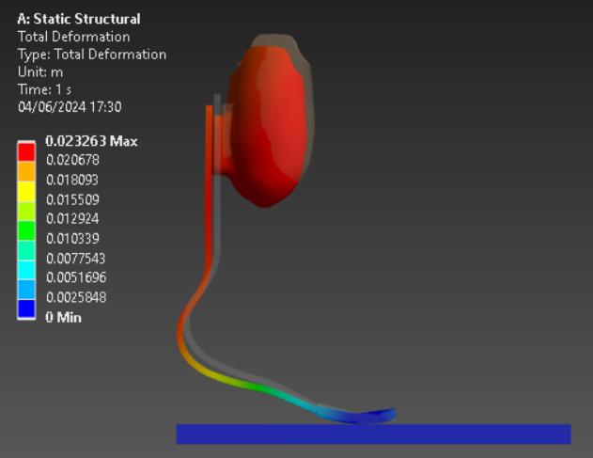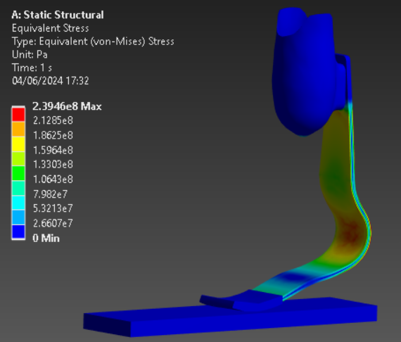
Figure 4 - Total deformation (left) and von Mises stress (right) of prosthetic leg under 2746.8N load

2.4.2 Eigenvalue Buckling Analysis
The Eigenvalue Buckling analysis was performed with the default and altered mesh sizing in Section 2.3.3. Tables 2 and 3 list the critical load values of the prosthetic leg, whilst Figures 5 and 6 display the visual representation of these loads. The smallest critical loads were associated with a compressive force at the front of the socket (mode 5 in Table 2 and Figure 5, mode 4 in Table 3 and Figure 6), seemingly failing the prosthetic leg at the joint between the socket and the blade. There is a significant difference of 10.335 kN between the default and finer meshes, with the finer mesh having a smaller critical load. Across the ten buckling modes, the default mesh returned higher critical loads than the finer mesh for the same failure modes.
Note that the negative and positive values in the tables below correspond to the direction of the load.
Table 2 – Buckling modes and associated critical loads from Eigenvalue buckling analysis with default mesh
Mode | Critical Load (N) | Notes
1 | -1.2377e+006 | Compressive force (downwards)
2 | -1.0607e+006 | Rotational force
3 | -224.71e+003 | Compressive (downwards) and rotational force
4 | -64.736e+003 | Compressive (downwards) and rotational force
5 | 25.178 e+003 | Compressive force (backwards)
6 | 50.334e+003 | Compressive force (sideways)
7 | 257.45e+003 | Tensile force (upwards)
8 | 647.48e+003 | Rotational force
9 | 745.47e+003 | Rotational force
10 | 1.0182e+006 | Tensile force (upwards)

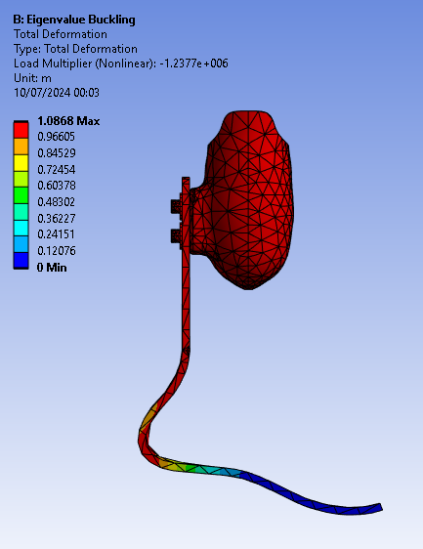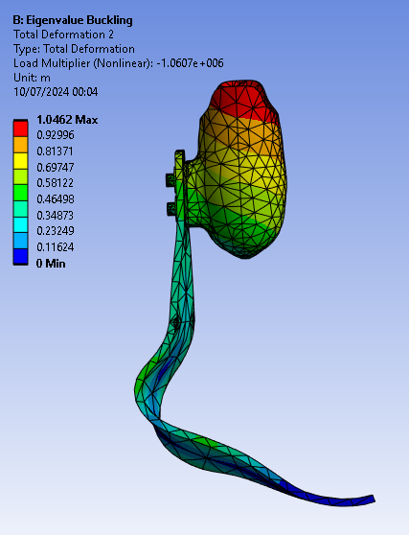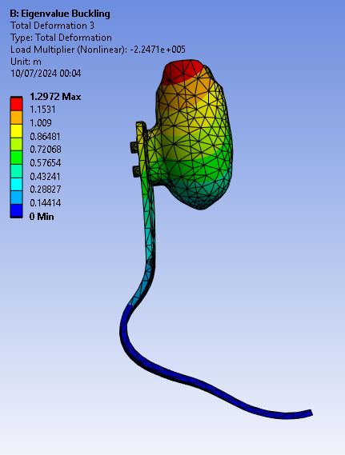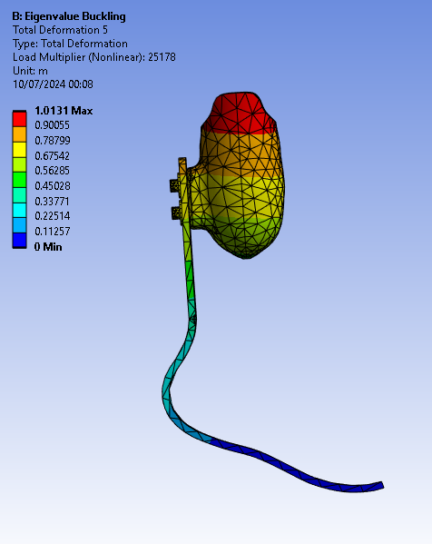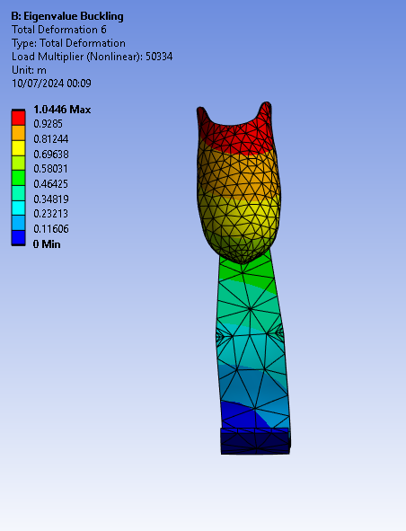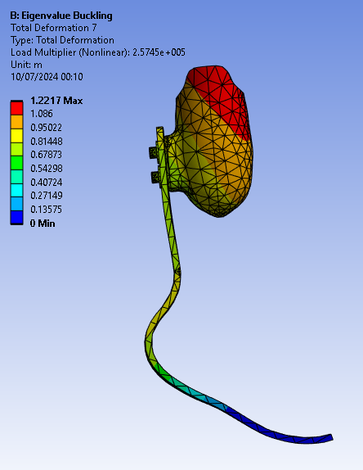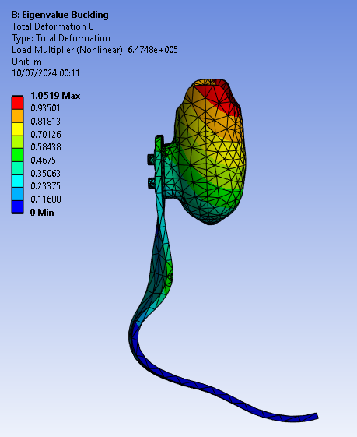
1
2
3 & 4
5
6
7
8
Figure 5 - Eigenvalue buckling modes – default mesh
Table 3 - Buckling modes and associated critical loads from Eigenvalue buckling analysis with finer mesh
Mode | Critical Load (N) | Notes
1 | -581.12e+003 | Rotational force
2 | -296.28e+003 | Compressive force (backwards)
3 | -201.77e+003 | Rotational force
4 | 14.843e+003 | Compressive force (backwards)
5 | 28.852e+003 | Compressive force (sideways)
6 | 162.56e+003 | Tensile force (upwards)
7 | 413.5e+003 | Rotational force
8 | 433.11e+003 | Tensile force (upwards)
9 | 687e+003 | Tensile force (upwards)
10 | 889.17e+003 | Rotational force

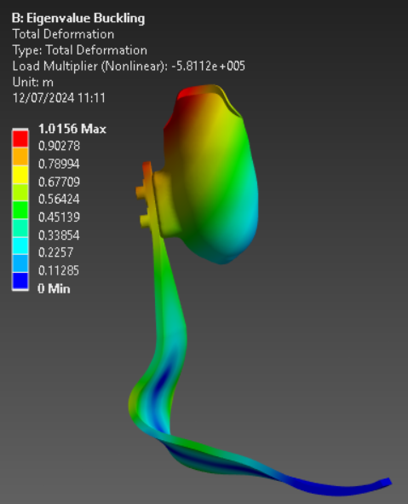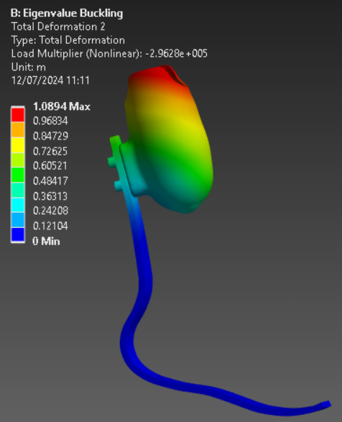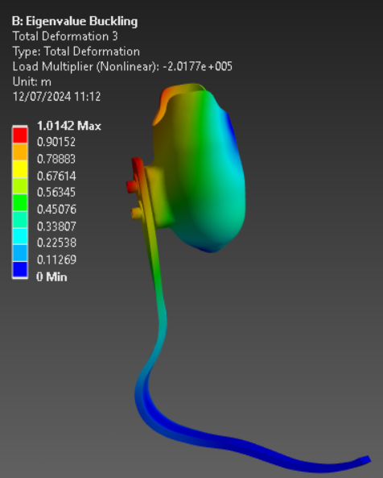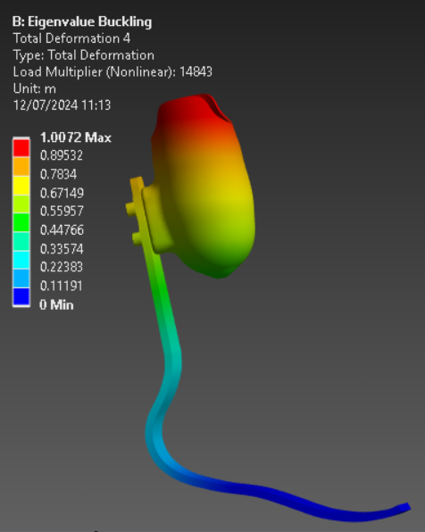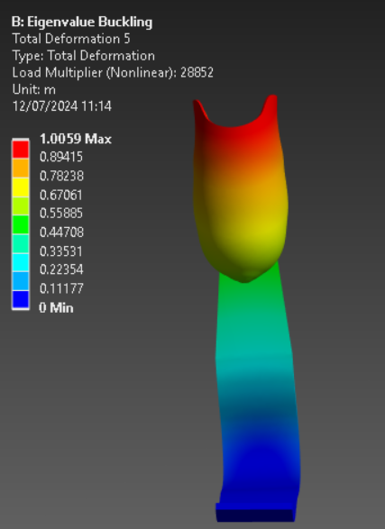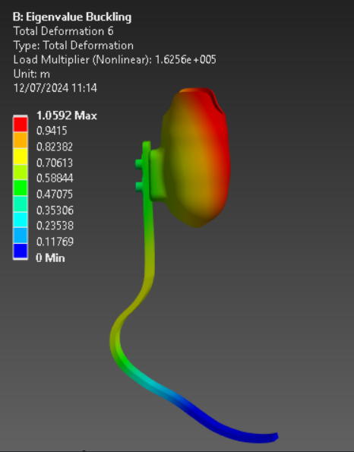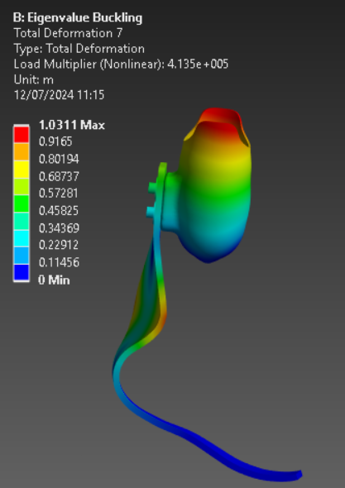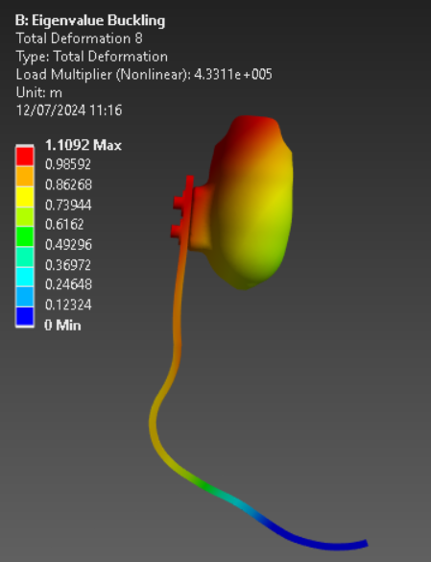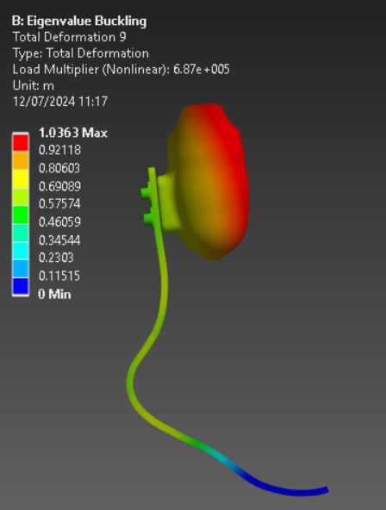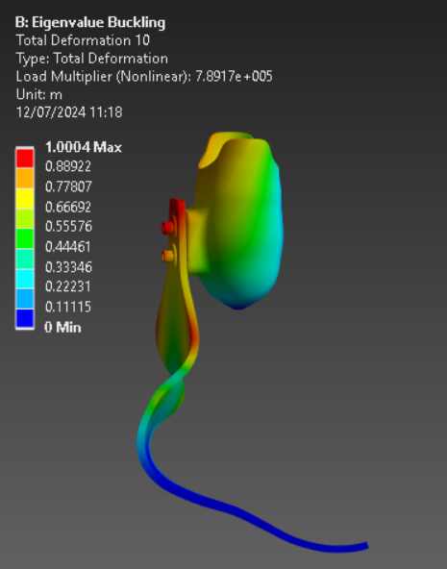
1
2
3
4
5
6
7
8
9
10

Figure 6 - Eigenvalue Buckling Modes – Finer Mesh
It should be noted that the rubber foot was removed from the assembly for the Eigenvalue Buckling study. An initial run was conducted with the foot included, but all buckling modes were related to the rubber foot instead of the carbon fibre components. The foot also had distorted elements in the simulation, indicating errors. Upon suppression of the rubber foot, the simulation focussed on the blade and socket of the prosthetic.

Validation
Before modelling the prosthetic leg was conducted, a simpler geometry was tested in Ansys using the Eigenvalue Buckling module to validate the results. An example of a buckling problem was found [5]. The example problem involved an aluminium column fixed to the ground and under axial compressive loading.
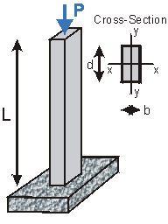
Figure 7 - Buckling example schematic [5]
Where:
L = length = 2.2 m
b = breadth = 210 mm
d = depth = 280 mm
E = Young’s modulus = 70 GPa
P = axial compressive load
The problem asked to find the critical load to buckle the column. This could be determined using the Euler Buckling Formula, given by:
$$P_{cr}=\frac{π^{2}EI}{{L_{e}}^{2}}$$
Where:
L_{e} = effective length of the column. For a single fixed column, the effective length is 2L = 4.4 m
I = moment of inertia. For a rectangle, this is calculated by:
$$I=\frac{{\left(base\right)×\left(height\right)}^{3}}{12}$$
$$I_{x}=\frac{{\left(210\right)×\left(280\right)}^{3}}{12}=3.84×{10}^{8}{mm}^{4}$$
$$I_{y}=\frac{{\left(280\right)×\left(210\right)}^{3}}{12}=2.16×{10}^{8}{mm}^{4}=2.16×{10}^{-4}m^{4}$$
The smaller value is plugged into the Euler Buckling Formula since it results in a smaller buckling load. Therefore:
$$P_{cr}=\frac{π^{2}(70×{10}^{9})(2.16×{10}^{-4})}{{4.4}^{2}}=7.708 MN$$
With the theoretical critical load calculated, the example geometry was recreated in Solidworks (Figure 8) for the Eigenvalue Buckling Analysis to be conducted in Ansys Workbench. Firstly, a simple aluminium material was produced in the engineering data module to assign the Young's modulus of 70 GPa. A Poisson's ratio and compressive strength value were also provided to enable the analyses to run successfully.
A static structural analysis was then conducted. For this, the default mesh was used on the geometry. A load of 1 N in the negative-y direction was defined – the Eigenvalue buckling analysis would increase the load until the critical loading was found, so this initial load value was not critical. The column was then given a fixed support on its bottom face.
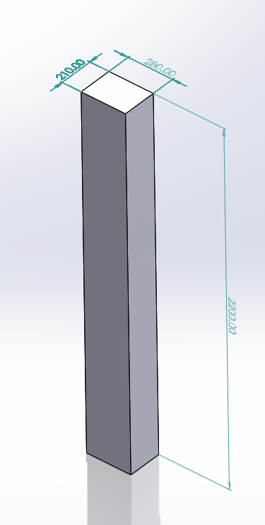
Figure 8 - Euler Buckling example geometry created in Solidworks
With the static structural assessment complete, the Eigenvalue Buckling module was added to the project space in Ansys Workbench. This module utilised the previous results of the static structural analysis as a pre-stress state. In "Analysis Settings", ten maximum buckling modes had been requested from the analysis, which would identify ten ways in which the column could buckle at given loads. The critical loads for the ten buckling modes can be seen in Table 4. The smallest critical load is the required value to cross-check against the theoretical critical load calculated previously. 7.708 MN and 7.739 MN give a 0.4% difference between values, which is very close.
Furthermore, the demonstrated buckling modes in Figure 9 make logical sense: The column fails first along its breadth. This is due to the breadth of the column being thinner than the width. Therefore, it has less strength in that direction. The second smallest buckling mode was failure along the column's width, which is feasible again.
The Eigenvalue Buckling analysis has been validated from the test geometry for use in this study.
Table 4 - Critical load values for the Eigenvalue Buckling test analysis
Mode | Critical Load (N)
1 | 7.7392e+006
2 | 1.37e+007
3 | 6.7683e+007
4 | 1.171e+008
5 | 1.7809e+008
6 | 2.9625e+008
7 | 3.2391e+008
8 | 4.8935e+008
9 | 5.1365e+008
10 | 6.6103+008

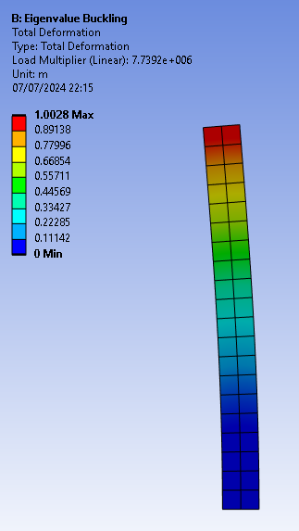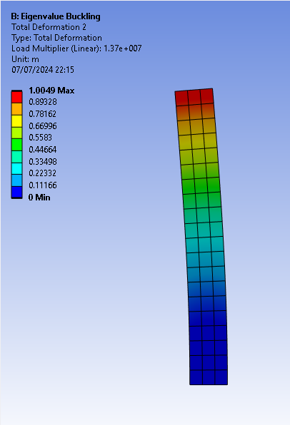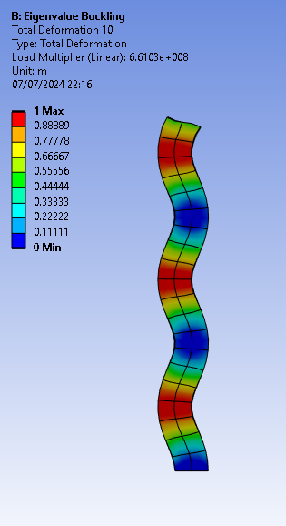
Figure 9 - Eigenvalue Buckling modes 1, 2, and 10 (from left to right, respectively) for the validation test piece
The process can now be applied to the prosthetic leg geometry with the test geometry validated. The area of the fixed support in the simulation determined the base and height values for the moment of inertia calculation. There was no way in Ansys to measure the size of the elements selected, so the scale at the bottom of the model window was used to get a rough value (as per Figure 10).
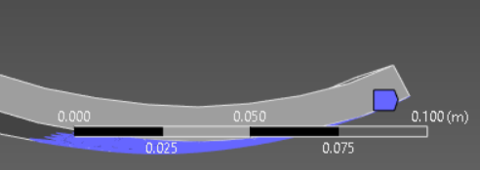
Figure 10 - Gathering height/base values in Ansys for the moment of inertia calculation
From this, the values were estimated to be 100mm by 100mm (the width of the foot was precisely 100mm, as gathered from the CAD model).
$$I_{x}=\frac{100{×100}^{3}}{12}=8.333×{10}^{6} {mm}^{4}=8.333×{10}^{-6} m^{4}$$
I_{y} has the same moment of inertia as I_{x} due to the same base and height values. Therefore:
$$P_{cr}=\frac{π^{2}(129×{10}^{9})(8.333×{10}^{-6})}{{1.447}^{2}}=5.067 MN$$
This value is higher than the smallest critical load values found in the Ansys Eigenvalue buckling simulations (25.178 kN or 14.843 kN, depending on mesh size).
Due to the significant disparity, a secondary face was considered to calculate the moment of inertia to compare results. This time, the end face of the foot was used. The measurements for this face were 10mm and 100mm.
$$I_{x}=\frac{10{×100}^{3}}{12}=833.333×{10}^{3} {mm}^{4}=8.333×{10}^{-7} m^{4}$$
$$I_{x}=\frac{100{×10}^{3}}{12}=8.333×{10}^{3} {mm}^{4}=8.333×{10}^{-9} m^{4}$$
$$P_{cr}=\frac{π^{2}(129×{10}^{9})(8.333×{10}^{-9})}{{1.447}^{2}}=5.067 kN$$
This answer is much closer to the results found from the Eigenvalue buckling analysis than using the area of the fixed support elements.
The Eigenvalue buckling method is a simplified analysis for estimating the critical load for columns. The test block was a simple cuboid column, and the height, width and length were easy to determine. This example is a good fit for the analysis. Conversely, the prosthetic leg that was modelled is a very complex geometry. The area calculated for the moment of inertia was initially determined to be the area of the blade in contact with the ground (the fixed support). Euler’s buckling equation determined a much larger critical load threshold. When using the area of the end face of the blade, a critical load closer to the Ansys study was found. However, there was still a relatively large discrepancy of approximately ten to twenty kilonewtons.

Discussion
This case study validated The Eigenvalue Buckling analysis on a test block using Euler's Buckling Formula. Whilst the validation study returned very accurate results, this was performed against a very simple geometry. A prosthetic leg is a more complex shape than a cuboid block, and whilst it can still be seen as a column, it is a much more difficult geometry to assess. For instance, it was unknown what measurements to use for the "base" and "height" values in the moment of inertia calculation. The height was interpreted to be the blade's cross-sectional area fixed to the ground. Another plausible interpretation could have been the thickness of the blade, giving a smaller cross-sectional area.
Furthermore, the curvature of the blade's profile adds variations to the stress exhibited along its length. As shown in Figure 11, the highest stresses are located at the "ankle" of the blade, whilst the foot's curvature exhibits the lowest stresses. Ansys has seemingly accounted for the curvature of the blade, as the buckling modes exhibited in the Eigenvalue buckling analysis were logical. The problem of complex geometries identifies one of the key limitations of CAE – analysis requires the modeller to understand the problem space to interpret and validate the results that the model outputs correctly. In this instance, the outputs of the analysis could lead to two equally plausible outcomes:
- The prosthetic leg fails before the modelled critical load and potentially breaks during use.
- The prosthetic leg fails after the modelled critical load and is too stiff to be used effectively.
Whilst there is a chance that the prosthetic works correctly, there is little confidence in this outcome.
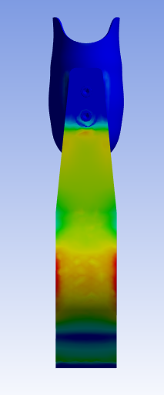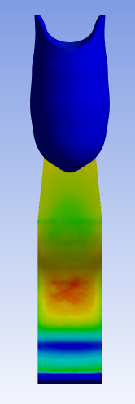
Figure 11 - Stress on the prosthetic blade
The Eigenvalue buckling analysis also highlighted the importance of generating a suitable mesh. The difference in the smallest critical loads between the default and refined mesh was 10.335 kN. In the case of a prosthetic leg, that discrepancy could result in the leg being safe for a runner to use, especially considering that the difference is more significant than what is typically applied as a safety factor for reliable components (Safety factor of 1.5-2.0) [6].
The application of CAE processes to engineering projects, such as the design and analysis of the prosthetic leg in this report, highlights these technologies' impact on product development. By utilising these tools, it has been possible to prototype a product in a virtual environment rapidly. With the geometry created, testing new materials or adjusting the geometry to optimise its design is possible. The efficiency with which a trained user can accomplish these assessments is crucial in most engineering applications due to the time and cost savings that competent use of these tools can yield.
Furthermore, the most compelling advantage of CAE is its ability to simulate real-world physics and perform complex analyses without building physical prototypes. In the context of the prosthesis study within this report, these simulations can predict performance under the most strenuous conditions expected in reality to identify safety factors that are essential to the product’s safe use.
Conversely, despite the ability of CAE software to realistically model physics, the more complex the computational analysis, the more computing power is required to model the vignette. There is a balance to be struck with physics-based modelling: simulating enough geometry to capture the correct loading conditions and simplifying the geometry to save time and not exceed the available computational resources. The balance can often be sought by identifying areas of geometry with the most significant risk regarding failure or performance and focusing the modelling there. This will often require prerequisite studies to know which areas of the product are the most sensitive to changes in geometry.
One difficulty encountered in the case study was that the prosthetic leg required some creative license from the Author. For commercial reasons, engineering drawings and dimension data are challenging to find in open sources. Therefore, the blade's geometry was interpreted from open-source imagery [7], whilst the socket was moulded using images of a genuine amputee patient found online [8]. Therefore, there may be stark differences in the expected safe loads for a real prosthetic leg compared to the one created for this study.
The accuracy of physics-based modelling depends mainly on the quality and accuracy of the data fed into the model. When companies conduct these types of studies, they often perform laboratory tests on the materials to attain accurate, first-hand material property data that can be fed into the simulation. Even when second-hand material property data can be sourced, it is essential to consider that material properties have tolerances and can change for the same material grade.
CAE not only saves money by saving time but also reduces expenditure by derisking the prototyping phase of a project. Product trials can be expensive, so CAE can provide confidence that a product will meet a certain performance threshold before testing.

Conclusion
The exploration of computer-aided engineering in this report, through the case study of a sprinter’s prosthetic leg, underscores the immense potential and critical considerations of utilising CAE tools in modern engineering. By leveraging Ansys for detailed analyses, we have demonstrated how CAE can simulate real-world conditions, offering valuable insights into product performance without the immediate need for physical prototypes. The ability to model and predict the prosthetic leg's stresses, deformations, and buckling modes illustrates CAE’s role in optimising design and ensuring safety and efficiency.
Accurate CAD models and appropriate material selection are foundational to practical CAE analyses. Using Solidworks to create the prosthetic leg’s geometry and Ansys Granta for material properties ensured realistic and reliable simulation outcomes. This meticulous approach to defining the geometry and selecting high-strength materials was essential for capturing the prosthetic leg’s complex interactions and performance under various load conditions.
The meshing process proved critical in determining the accuracy and efficiency of CAE simulations. The study highlighted the importance of mesh quality, density and adaptive meshing techniques in capturing the prosthetic leg's intricate geometry and stress concentrations. Although computationally intensive, a finer mesh provided more accurate results, emphasising the need for careful mesh optimisation. This finding demonstrates that while finer meshes can demand more computational resources, they significantly enhance the reliability of the simulations.
Validating the CAE models against theoretical calculations, as done with the Eigenvalue Buckling analysis, is essential to ensure reliability. While validating a simpler geometry was successful, the complexity of the prosthetic leg posed additional challenges. This indicates that more sophisticated validation methods may be necessary for intricate designs. Ensuring the CAE models accurately reflect real-world conditions remains a critical step in leveraging these tools effectively.
CAE offers significant time and cost savings by enabling virtual prototyping and testing. However, the accuracy of simulations heavily depends on the quality of input data and the computational power available. Simplifying the geometry and focusing on critical areas can balance the need for detail and computational feasibility. This balance is crucial, as it allows for detailed simulations without exceeding computational limitations, ensuring that critical stress points and performance factors are thoroughly analysed.
The prosthetic leg model developed for this study was based on interpreted data due to the lack of available commercial design specifics. Future work should aim to use more precise data and incorporate empirical testing to enhance the fidelity of CAE models. Additionally, ongoing advancements in CAE software and hardware capabilities will further refine the accuracy and applicability of these simulations in diverse engineering fields. Such improvements will continue to push the boundaries of innovation, making CAE an even more indispensable tool in product development.
In conclusion, CAE is a powerful tool in the engineering toolkit, capable of transforming the design and development process. The study of the sprinter’s prosthetic leg demonstrates the strengths and challenges of CAE, highlighting the need for skilled application and continual validation. As CAE technology advances, its integration with empirical testing and iterative design will continue to enhance the development of safer, more efficient, and cost-effective engineering solutions.

References

[1] | Enlyft, “Ansys,” Enlyft, 2024. [Online]. Available: https://enlyft.com/tech/products/ansys. [Accessed 1 July 2024].
[2] | MarathonHandbook, “Running with a prosthetic leg,” [Online]. Available: https://marathonhandbook.com/wp-content/uploads/Running-With-A-Prosthetic-Leg.jpg. [Accessed 30 05 2024].
[3] | Ossur, “Guide to prosthetic legs,” Ossur, 2024. [Online]. Available: https://www.ossur.com/en-gb/prosthetics/information/guide-to-prosthetic-legs. [Accessed 25 June 2024].
[4] | Ansys, “5.9. Static Structural Analysis,” Ansys, 2024. [Online]. Available: https://ansyshelp.ansys.com/public/account/secured?returnurl=%2FViews%2FSecured%2Fcorp%2Fv242%2Fen%2Fwb_sim%2Fds_static_mechanical_analysis_type.html. [Accessed 28 June 2024].
[5] | F. Leckie and D. Dal Bello, “10.1.1. Buckling Examples,” ah-engr, 2006. [Online]. Available: http://ah-engr.com/som/. [Accessed 7 July 2024].
[6] | The Engineering Toolbox, “Factors of Safety,” The Engineering Toolbox, 2010. [Online]. Available: https://www.engineeringtoolbox.com/factors-safety-fos-d_1624.html. [Accessed 16 July 2024].
[7] | J. R. Tacca, O. N. Beck, P. Taboga and A. M. Grabowski, “Running-specific prosthesis model, stiffness and height affect biomechanics and asymmetry of athletes with unilateral leg amputations across speeds,” The Royal Society Open Science, 2022.
[8] | pinimg, “Image of amputee patient,” [Online]. Available: https://i.pinimg.com/736x/2c/63/14/2c6314389de58cc78baf5e159442dffe.jpg. [Accessed 25 April 2024].
[9] | F. P. Beer and E. Russell Johnston, Jr., “6.9. Stresses in thin-walled pressure vessels,” in Mechanics of Materials, McGraw-Hill Book Company, 1981, pp. 325-327.
[10] | pinimg, “Image of leg amputee,” [Online]. Available: https://i.pinimg.com/736x/2c/63/14/2c6314389de58cc78baf5e159442dffe.jpg. [Accessed 24 05 2024].
[11] | O. N. Beck, P. Taboga and A. M. Grabowski, “Prosthetic model, but not stiffness or height, affects the metabolic cost of running for athletes with unilateral transtibial amputations,” Journal of Applied Physiology, Colorado, 2017.

