WJEC
DIPLOMA IN CRIMINOLOGY:
UNIT 3: LO1:
Understand the process of criminal investigations

Topic 1.3 Explain how evidence is processed

NAME:

Criminology
Topic 1.3 Explain how evidence is processed.

Include both physical and testimonial evidence.
Give a clear, detailed explanation of how evidence is processed. Include the collection, transfer, storage and analysis of evidence, and the personnel involved e.g. CSI’s collecting and transferring evidence from crime scenes; forensic scientist analysis. Include examples of physical evidence from the brief and other cases.

Types of evidence
Evidence is central to the process of investigating and prosecuting crime because it is the basis on which a suspect is charged, tried and found either guilty or not guilty. Therefore, the process of collecting and storing evidence must be done with utmost care.
There are many types of evidence, such as material from the crime scene (e.g. fingerprints, blood stains), exhibits such as clothing, CCTV footage, confessions and witness statements. However, we can group evidence into two types:
Physical evidence:

Testimonial evidence:
Physical evidence Physical evidence (also known as ‘real evidence’) is an important part of many criminal investigations and collecting, transferring, storing and analysing it must be done with great care to avoid contamination and to ensure it is admissible in court.
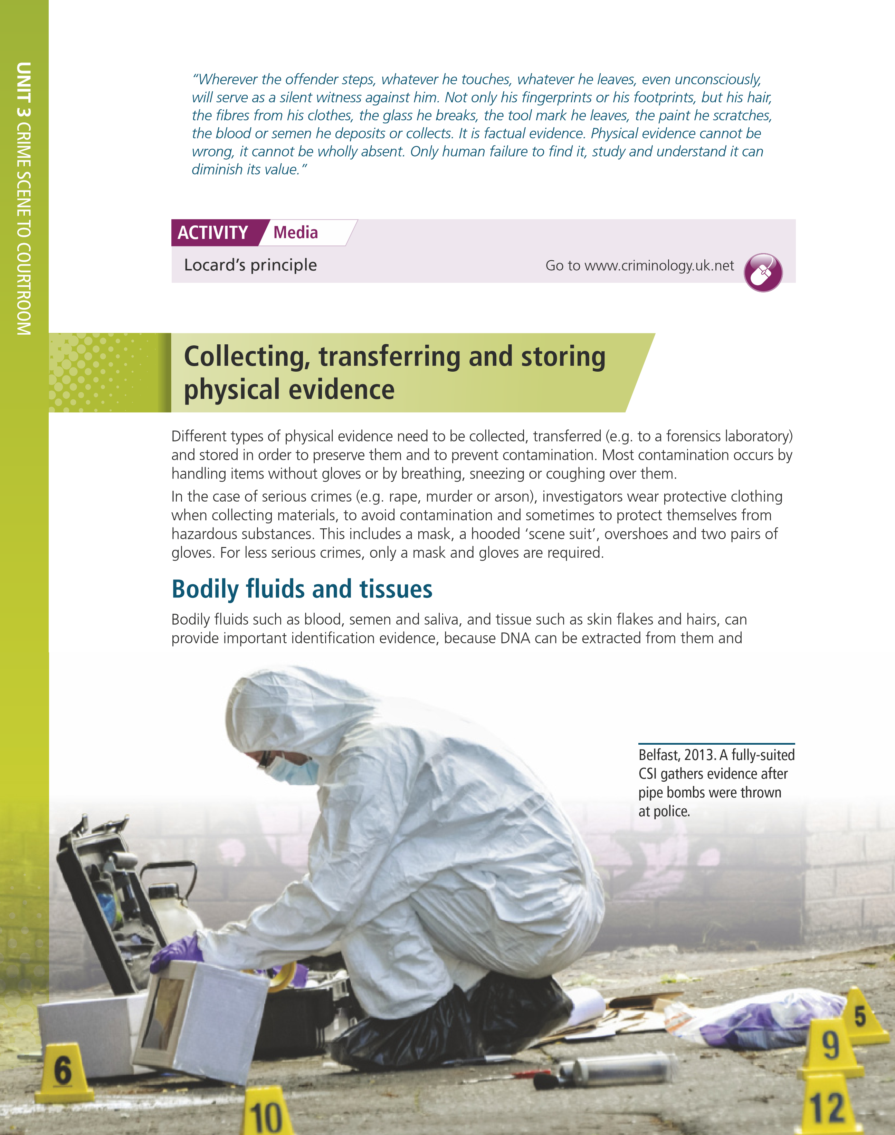
Locard’s exchange principle Edmond Locard (1877-1966) was a pioneer of forensic science and investigators always work on the basis of his exchange principle, which he summed up as ‘every contact leaves a trace’. In other words, material from the crime scene (including from the victim) will be present on the offender – and vice versa. Paul Kirk describes the importance of the exchange principle and physical evidence as follows:

Watch the following video on Locard’s principle and answer the questions below; https://www.youtube.com/watch?v=Mn-a_ImLR40
1. What did Locard establish in 1910?
2. What did Locard find when he examined the body & What did he conclude from his findings?
3. What did Locard find under the suspect’s nails, How was the specimen linked to the victim?
4. What was Locard’s conclusion?
5. How had the suspect staged his alibi
Quick Review
Pick out the following Physical evidence

A woman meets a man on a dating site and goes back to his flat. After having a drink, she decides to leave. The man stops her from leaving and sexuality assaults her. While trying to fight him off, she bites his hand. | Following a burglary, a man tries to sell games consoles and a laptop matching those that were stolen. The burglar cut his hand on broken glass when entering the property. | An armed man enters a busy shop and orders the shopkeeper to hand over cash from the till and cigarettes from behind the counter. When the shopkeeper refuses, the fires his weapon in the air to scare the shopkeeper, who then hands over the money and cigarettes.

Different types of physical evidence need to be collected, transferred (e.g. to a forensics laboratory) and stored in order to preserve them and to prevent contamination.
Most contamination occurs by handling items without gloves or by breathing, sneezing or coughing over them. In the case of serious crimes (e.g. rape, murder or arson), investigators wear protective clothing when collecting materials, to avoid contamination and sometimes to protect themselves from hazardous substances. This includes a mask, a hooded ‘scene suit’, overshoes and two pairs of gloves. For less serious crimes, only a mask and gloves are required.

Contamination
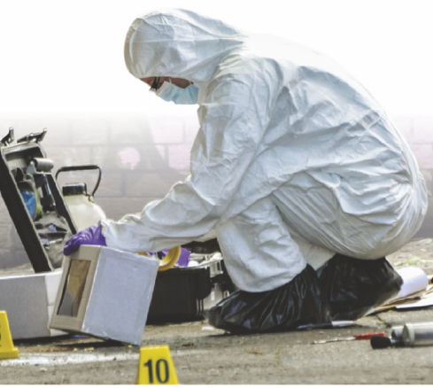
- Contamination is the action or state of making or being made impure by polluting or poisoning.
- An outdoor crime scene is the most vulnerable to loss or contamination of evidence.
- Individuals with access to the scene can potentially alter, destroy or contaminate evidence.
- The risk is greatest when investigators fail to secure the crime scene properly.
- Weather conditions, such as heat, cold, snow and rain can destroy or ruin evidence.

We will now look into the different types of physical evidence;
Bodily fluids and tissues
Bodily fluids such as blood, semen and saliva, and tissue such as skin flakes and hairs, can provide important identification evidence, because DNA can be extracted from them and compared with control samples from suspects to see if there is a match which would put the suspect at the crime scene.
Research the following and for each on say how it is collected, transferred, stored and analysed, and the personnel involved. There are lots of information online and YouTube videos you can watch.

Blood; ________________________________________________________________________________________________________________________________________________________________________________________________________________________________________________________________________________________________________________________________________________________________
Semen; ________________________________________________________________________________________________________________________________________________________________________________________________________________________________________________________________________________________________________________________________________________________________
Saliva; ________________________________________________________________________________________________________________________________________________________________________________________________________________________________________________________________________________________________________________________________________________________________
Skin flakes; ________________________________________________________________________________________________________________________________________________________________________________________________________________________________________________________________________________________________________________________________________________________________
Hairs; ________________________________________________________________________________________________________________________________________________________________________________________________________________________________________________________________________________________________________________________________________________________________
Fingerprints

Fingerprints (and palm, toe and sole prints) are unique to each individual and so they are valuable identification evidence. The ‘prints’ are skin ridges on the fingers and they can leave impressions or marks in or on surfaces. The marks can be from sweat or from contaminants on the skin.
Fingerprints can be of three kinds:
- Latent prints are invisible marks left on a surface that can be made visible by ‘dusting’ with magnesium powder or shining an ultraviolet light on the surface. After photographing them, prints may be lifted using an adhesive strip and placed on an acetate sheet.
- Patent (or positive) prints are visible to the naked eye. They may be left in substances such as blood, ink, oil, powder or dust. They should be photographed for analysis and if possible preserved for use in court.
- Plastic prints are three dimensional shapes made by pressing the fingers into soft material such as wet clay or the putty on a window frame. (‘Plastic’ here means easily shaped or moulded.) They should be photographed and if possible a mould made to capture a copy of the impression.

Once collected from the crime scene, fingerprints can be compared with those stored in the police’s IDENT1 database, which houses prints of all arrested persons, to see if there is a match. Police also have Livescan scanners and Lantern portable units linked to the database that can scan suspects’ prints and obtain a result within minutes.

Using the link below, complete questions that follow;
Fingerprint Analysis: Introduction (forensicsciencesimplified.org)
Why do investigators collect fingerprints?
What are ‘fingerprints’?
Explain the process of collecting Patent prints.
Explain the process of collecting Latent prints.
Who conducts the analysis?
How and where is the analysis performed?

Impression evidence
Impression evidence is created when a suspect ‘presses’ something against a surface. This can be a hand, as in the case of fingerprints, but impressions can be created in other ways too, for example by biting someone, or by leaving a shoeprint or a tyre mark.
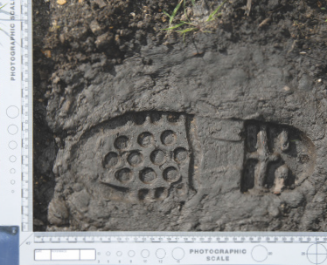

Shoeprint at a crime scene. The photographic scale indicates the size of the print.

Research the following and for each on say how it is collected, transferred, stored and analysed, and the personnel involved. There are lots of information online and YouTube videos you can watch.

Bite marks; ________________________________________________________________________________________________________________________________________________________________________________________________________________________________________________________________________________________________________________________________________________________________________________________________________________________________________________________
Tyre marks; ________________________________________________________________________________________________________________________________________________________________________________________________________________________________________________________________________________________________________________________________________________________________________________________________________________________________________________________
Shoe Prints; ________________________________________________________________________________________________________________________________________________________________________________________________________________________________________________________________________________________________________________________________________________________________________________________________________________________________________________________

Trace evidence
Trace evidence is any material that is transferred from the suspect to the crime scene (including to the victim) or vice versa. It includes things like gunshot residue, glass fragments, paint flakes and fibres, soil and even insects. It also includes toxicology (poisons, drugs and alcohol), for example from roadside breathalyser tests.
- Fibres can be natural or synthetic. They can be transferred from clothing, carpets and seats. They can be collected using gloves and tweezers, wrapped in paper and sealed in a bag, labelled and sent for analysis. Fibres from clothing come in a wide variety of fabric mixes and dyes, often specific to particular manufacturers. This can aid in identifying the garment they came from and this information may be used in compiling a description of the suspect.
- Paint on window frames, doors, cars and other objects comes in many different colours and types (e.g. rustproof, weatherproof, anti-fungal etc.), which can aid identification and allow for matching with flakes found on a suspect’s clothing, tools etc.
- Glass fragments found at a break-in can be compared with those found on a suspect’s clothing. When window glass is smashed, it undergoes ‘backward fragmentation’, throwing out fi ne particles towards the person breaking it. These land on him or her in a particular pattern and can therefore show that they were present when it broke.
- Soils can vary greatly even over short distances and so soil samples found on a suspect’s footwear can help to place him at the crime scene.
- Insects such as blowflies, which lay their eggs in or on dead bodies, can give an indication of the time of death by a forensic entomologist examining how developed their larvae (maggots) are.
Watch the following video and complete questions 1 to 9 that follow. https://www.youtube.com/watch?v=Iy8sm1V0dk0
- What are trace evidence experts trained to do?
2. Briefly describe the picking method.
3. What are high intensity light sources used for?
4. Briefly describe the taping or lifting method.
5. Why is it difficult to avoid leaving trace evidence?
6. List the examples of trace evidence.
7. How does hair look under a microscope?
8. What can be determined by examining hair under a microscope?
9. What is the importance of trace evidence in criminal investigation?

Physical evidence Case Study examples

Read the following case study examples and answer the questions that follow;





Case study Physical evidence

Barry George and the murder of Jill Dando
Jill Dando, the presenter of BBC TV’s Crimewatch, was shot dead outside her home in April 1999. Barry George was arrested and charged with her murder in May 2000 and convicted in July 2001. Part of the case against him was trace evidence in the form of a single microscopic particle of gunshot residue found in his overcoat pocket a year after the murder. The prosecution argued that this had come from a gun ired by George.
In 2006 George appealed on the grounds that two new witnesses said they had seen armed police at the scene when he was arrested – contrary to the police’s claim that no armed oficers had been present.
The defence called forensic experts, including those from the original trial, who told the Court of Appeal that it was no more likely that the residue was from a gun ired by George than from some other source. The defence argued that the armed oficers involved in his arrest could have been the source of the gunshot residue. The court quashed George’s conviction and ordered a re-trial, at which he was acquitted in 2008.

What physical evidence was collected? ________________________________________________________________________________________________________________________________________________________________________________________________________________________________________________________________________

How was the physical evidence collected, stored and analysed?
________________________________________________________________________________________________________________________________________________________________________________________________________________________________________________________________________
What personnel were/ would have been involved? ________________________________________________________________________________________________________________________________________________________________________________________________________________________________________________________________________

What went wrong? ________________________________________________________________________________________________________________________________________________________________________________________________________________________________________________________________________

For more information You can either watch the following documentary https://www.youtube.com/watch?v=erla7Ley4Tw OR you can research the case using the internet or books https://www.bbc.co.uk/news/15036490

What physical evidence was collected? ________________________________________________________________________________________________________________________________________________________________________________________________________________________________________________________________________

How was the physical evidence collected, stored and analysed?
________________________________________________________________________________________________________________________________________________________________________________________________________________________________________________________________________
What personnel were/ would have been involved? ________________________________________________________________________________________________________________________________________________________________________________________________________________________________________________________________________

What went wrong? ________________________________________________________________________________________________________________________________________________________________________________________________________________________________________________________________________

Linking to the brief… what bodily fluids or tissues are there? Where any fingerprints or impressions taken? What about trace evidence? Was it collected, transferred, stored and analysed correctly? What personnel was involved?
Controlled Coursework Practice

The victim was found lying on her back on a brown carpet with visible knife wounds to the neck and the torso. The victim was wearing a black jumper, which had been torn in several places and no trousers. She also had a variety of bite marks on her right arm and on both her legs. The victim was surrounded by blood splatter which also revealed a variety of bloody finger prints. The victim’s underwear had been torn and left at the side of the body. There was also 2 semen stains present at the scene, one on the victims bedding and one on the floor. The bedroom window was smashed from the outside and the ledge had two large boot prints on. Several fingerprints were also present around the window frame along with two long blonde hairs (assumed to be the victims) and four shorter dark brown hairs.

____________________________________________________________________________________________________________________________________________________________________________________________________________________________________________________________________________________________________________________________________________________________________________________________________________________________________________________________________________________________________________________________________________________________________________________________________________________________________________________________________________________________________________________________________________________________________________________________________________________________________________________________________________________________________________________________________________________________________________________________________________________________________________________________________________________________________________________________________________________________________________________________________________________________________________________________________________________________________________________________________________________________________________________________________________________________________________________________________________________________________________________________________________________________________________________________________________________________________________________________________________________________________________________________________________________________________
Testimonial evidence
Testimonial evidence is a written or spoken statement given to the court by a witness. It can be given to support either the prosecution or the defence’s case.
Disclosure Before the case goes to court, prosecution and defence must disclose any written statements that they have taken. Each side must also provide the other side with a list of the witnesses they intend to call to give evidence at the trial. Physical evidence such as CCTV footage must also be disclosed.

Giving evidence
Any evidence that is agreed and accepted as true by both sides can sometimes be read out in court without the witness being present, but normally they must attend in person to testify (give their evidence).
In court, witnesses testify from the witness box. They may then be cross-examined (crossquestioned) by the opposing side to test their evidence. Defendants cannot be forced to testify.
Vulnerable or intimidated witnesses may be allowed to give evidence via a live video link or by a video recording rather than having to attend court in person. If they do have to attend, they may be allowed to give evidence from behind a screen.
Vulnerable witnesses include those under the age of 18, those with a mental health condition or disability, close relatives of someone who died because of a crime, repeat victims (e.g. of stalkers), victims of serious crimes such as sexual offences, and witnesses of gun crime. (See Topic 1.4 for more about vulnerable and intimidated witnesses.)
Eye witness testimony we have previously looked into eyewitness testimony
What was it? ________________________________________________________________________________________________________________________________________________________________________________________________________________________________________________________________________
What personnel takes an eye witness statement?
________________________________________________________________________________________________________________________________________________________________________________________________________________________________________________________________________
Give a case study where it went wrong?
________________________________________________________________________________________________________________________________________________________________________________________________________________________________________________________________________

Why is it not always reliable?
________________________________________________________________________________________________________________________________________________________________________________________________________________________________________________________________________
How should it be collected?
________________________________________________________________________________________________________________________________________________________________________________________________________________________________________________________________________
What is the benefit of EWT?
________________________________________________________________________________________________________________________________________________________________________________________________________________________________________________________________________

Admissibility of testimonial evidence
Rules of evidence lay down what kinds of things can and cannot be given in evidence. Some evidence may not be admissible (allowable) and must not be considered in reaching a verdict. This includes:
- hearsay evidence, for example where a witness is simply repeating a rumour they have heard rather than describing what they themselves saw.
- forced confession, where violence or threats have been used to extract a confession from the defendant
- entrapment, where the police have tried to trick the defendant into committing or confessing to a crime in order to be able to then prosecute them. For example, the ‘honey trap’ set by police for Colin Stagg led to the judge ruling this evidence to be inadmissible.

Testimonial evidence Case Study examples

Read the following case study examples and answer the questions that follow;

Research the case of Colin Stagg; What happened? ________________________________________________________________________________________________________________________________________________________________________________________________________________________________________________________________________

What Testimonial evidence was collected? ________________________________________________________________________________________________________________________________________________________________________________________________________________________________________________________________________

What personnel were/ would have been involved? ________________________________________________________________________________________________________________________________________________________________________________________________________________________________________________________________________

What went wrong? ________________________________________________________________________________________________________________________________________________________________________________________________________________________________________________________________________
summarise (in no more than 150 words) how the case demonstrates issues with testimonial evidence.
________________________________________________________________________________________________________________________________________________________________________________________________________________________________________________________________________________________________________________________________________________________________________________________________________________________________________________________________________________________________________________________________________________________________________________________________________________________________________________________________________________________________________________________________________________________________________________________________________________________________________________________________________________________________________________________________________________________________________________________________________________________________________________________________________________________________
Expert testimony
What is an expert testimony?
__________________________________________________________________________________________________________________________________________
Read through the case study & answer the following questions
What happened in the case of Sally Clarke? ________________________________________________________________________________________________________________________________________________________________________________________________________________________________________________________________________




Case study Testimonial evidence

Expert testimony, disclosure and the cot deaths cases
As we saw in Topic 1.1, Sally Clark was convicted of the murder of her two baby sons in 1999 but acquitted after a second appeal in 2003. Her conviction had been the result of two serious shortcomings by expert witnesses in her original trial.
Firstly, Dr Alan Williams, the Home Offce forensic pathologist who conducted the post mortems on both babies, failed to disclose key evidence to the defence. He withheld laboratory evidence that infection was a possible cause of the second baby’s death, and he changed his original opinion about the frst baby’s death from respiratory infection to death by smothering. Williams was severely criticised by the judges at the second appeal. The court invited him to explain why he had withheld the laboratory results but he declined to do so.
Secondly, the testimony given by the paediatrician Professor Sir Roy Meadow was flawed. He claimed that the chance of two siblings both suffering cot death was 1 in 73 million. The Royal Statistical Society later issued a statement to say there was ‘no statistical basis’ for Meadow’s claim and expressed concern at the misuse of statistics in the courts.
Meadow had also testifed as an expert witness in other cot death cases and had made the same claim. These included the trials of Donna Anthony in 1998 and Angela Cannings in 2002, in both cases for the murder of their two children. Cannings was freed on appeal
in 2003 and Anthony in 2005. Meadow was struck off the medical register for gross professional misconduct in 2005 but was reinstated the following year.

What expert testimony was given & by who? ________________________________________________________________________________________________________________________________________________________________________________________________________________________________________________________________________

Was Sally found guilty? ________________________________________________________________________________________________________________________________________________________________________________________________________________________________________________________________________

What happened at the appeals process? ________________________________________________________________________________________________________________________________________________________________________________________________________________________________________________________________________
Sir Roy Meadows has acted as an expert witness in many cases – therefore these cases have been reviewed as he was so wrong in the Sally Clark case. Angela Cannings is another case that Sir Roy Meadows acted as an expert witness.
Task – Research the case of Angela Cannings
Overview of the case – what happened?
________________________________________________________________________________________________________________________________________________________________________________________________________________________________________________________________________
What evidence did Meadows give?
________________________________________________________________________________________________________________________________________________________________________________________________________________________________________________________________________
Was Angela found guilty?
________________________________________________________________________________________________________________________________________________________________________________________________________________________________________________________________________

What happened at the appeals process?
________________________________________________________________________________________________________________________________________________________________________________________________________________________________________________________________________

Linking to the brief… What testimonial evidence was taken? By who? Was it reliable? Is the person reliable? Was it taken and analysed correctly? What personnel was involved? What could have gone wrong?
AC1.3 Short Mark Questions

- What are the two different types of evidence? (2 marks)

- Name three different types of physical evidence. (3 marks)

- What does the Locard Exchange Principle state? (1 mark)

- What is contamination? (1 mark)

- What three stages need to occur to prevent physical evidence from being contaminated? (3 marks)

- Within how many hours should blood stains be transferred to the laboratory? (1 mark)

- In sexual offences cases where are the two places semen stains are usually found? (2 marks)

- When collecting hair samples where should small fragments of hair be placed? (1 mark)

- Using what two means are fibres and threads picked up with? (2 marks)

- What are the two different types of finger prints? (2 marks)

- What type of powder is used to collect finger prints? (1 mark)

- What type of physical evidence is collected using a tripod and ruler? (1 mark)

- In what type of criminal cases are bite marks common in? (1 mark)

- What case study demonstrates the issues with physical evidence? (1 mark)

- What is testimonial evidence? (1 mark)

- What type of witness may give evidence via a video link? (1 mark)

- What case demonstrates the issues with testimonial evidence? (1 mark)

25

AC1.3 Understand the Process of Criminal Investigations – guide for controlled assessment.

Introduction - 2 types of evidence (Physical & Testimonial)
Definition of physical- Locard’s principle.
Bodily fluids a tissues- write a list of all the different types.
Blood; Collected, stored analysed and by who - Where possible link to brief
One other; Collected, stored analysed and by who - case study? Where possible link to brief
Fingerprints- at least know how 1 type of fingerprint (latent) is collected, stored and analysed - Where possible link to brief.
Impression evidence at least know how 1 type of impression evidence is collected, stored and analysed - Case study? Where possible link to brief.
Trace evidence at least know how 1 type of trace (gunshot or fibres) evidence is collected, stored and analysed - Case study? Where possible link to brief.
Contamination- what it is
any contamination in the brief? what should have never been used.
Conclusion physical - Link physical evidence to brief.
Definition of testimonial- talk about disclosure, giving evidence and vulnerable witnesses.
EWT – what is it? Why is it important? Is it reliable? Case study Ronald cotton? Where possible link to brief. Is the EWT in the brief admissible in court? (Include list of what the rules on admissibility of evidence are).
Expert testimony- what is it? Why is it important? Is it reliable? Case study Sally Clark? Where possible link to brief. Is it reliable?
Conclusion testimonial- Link testimonial evidence to brief. Can it be used? If not, why not?

