Dzhuliano Stefanov 2027630
Software development assessment 1
Lecturer : Renuga Jayakumar

Define list and indicate how different it is from variable
A variable is a symbolic name that points to a python object meant to be store in memory for later retrieval. A list is a python data type that acts as a container that allows you to place multiple items inside it and store them in a single variable. You can then iterate over each item in the list and also perform different operations on both the list and individual items inside it using built in list methods and python flow control statements. The difference between a list and a variable is that a list is a data structure that sores data in a particular way while a variable simply represents data stored in memory with no regard to what form it takes or how it’s stored. Meaning, even a list can be stored in a variable.
A list is initiated using square brackets which may be empty or populated with list items, e.g,
students = ["Will", "Mat", "Nynaeve", "anomander", "Jamie"]

The following are the built in function for lists
- list(tuple) : converts a tuple into a list.
#usage
list((1,2,3,5)) #returns [1,2,3,5]
- cmp(list1,list2) : This function compares two lists. It is a python2 only function so it doesn't work on higher python versions.
#usage
cmp([1,2,3], [5,5,5]) #returns -1
- len(list) : Returns the length of the list. i.e, how many elements it contains.
#usage
len(students) # returns 5
- max(list) : Returns item from the list with greatest value.
#usage
max([1,2,3,4,5,6]) #returns 6
- min(list) : Returns item from the list with least value.
#usage
min([1,2,3,4,5,6]) #Returns 1

Define user-defined function
A function is described as a program within a program. We are provided with built-in function, but you a user can also describe own function, which is the building basis of the built-in function. User-defined functions are blocks of code written by a programmer, meant to execute together as one set of instructions. User-defined functions are important because they help organize code in ways that are meaningful to the programmer as well as making the code reusable which makes writing code for repetitive tasks easy.

#Example of a user defined function
def parrot(text):
"""Prints out and string you pass it. Throws exception if you pass non-string value"""
if type(text) != "str":
raise Exception("parameter 'name' must be a string")
else:
print(text)

Exercise 1
Taking and storing user input via the console for the values of car make, model, and mileage. These values are expected to be strings, since all terminal input is parsed as strings by python, there is no need to validate their types.
The value for “doors” is validated as a number string by convertingit into the ‘int’ python type and raising an error if the value isn’t an integer
Pseudo code
- Take values from the user, one at a time and store them in car_make, car_model, car_mileage and car_doors.
- Validate their types.
- Print them out as a description of the car.
#variables can hold any data type, here are a few expressed as properties of a car
#strings
make = "Toyota"
model = "Land Cruiser"
mileage = "300KM"
doors = 4

#A program that takes car make, model, mileage and door number from user input
# and checks data types
def get_car():
car_make = input("Make \n")
car_model = input("Model \n")
car_mileage = input("mileage \n")
try:
car_doors = int(input("Enter number of car doors \n"))
except ValueError:
raise Exception("door number must be a number")
print(
f"the car make is {car_make} \n" +
f"the car model is {car_model} \n the car mileage is: {car_mileage} \n" +
f"the car has {car_doors} doors \n"
)

if __name__ == "__main__":
get_car()

#TEST1
#get_car()
#inputs:
# Subaru, "Imprezza", "300kM", "three"
#output:
#ValueError: Car door number provided isn't an integer

#TEST2
#get_car()
#inputs:
# Benz, "S class", "100KM", 4
#output:
# the car make is Toyota
# the car model is Supra
# the car mileage is 200M
# the car has 4 doors
Screensots
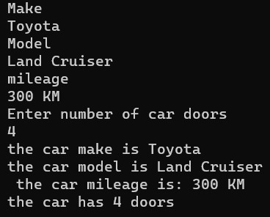
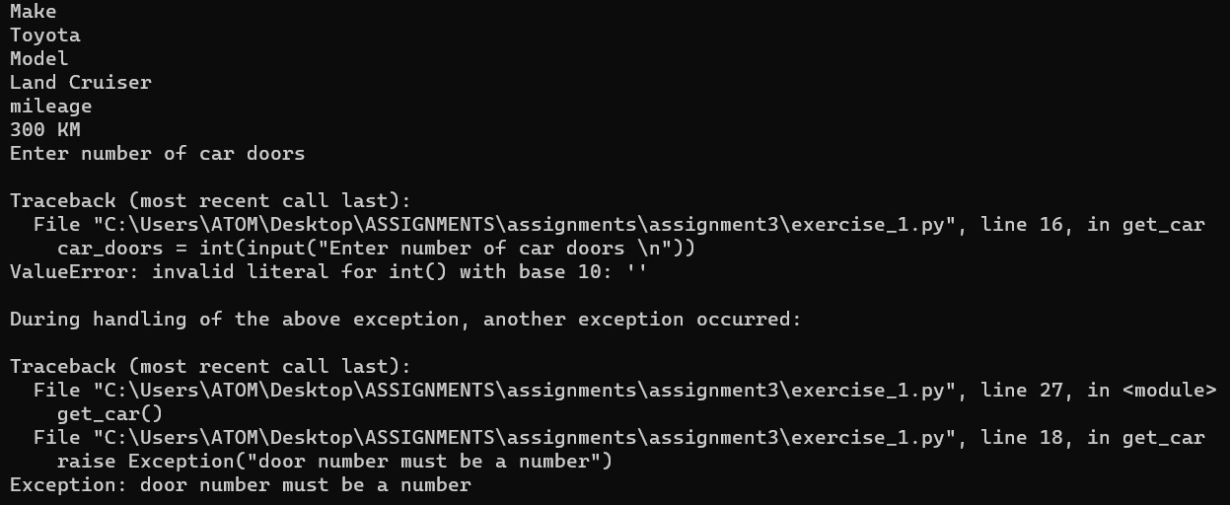
Exercise 2
Pseudo code
- Define a function that calculates area of a circle.
- Define another function to take user input for radius values, compare the values to catch the logical fallacy of inner radius being larger than outer radius and raise an error.
- Calculate the area of shaded parts using function in step 1.
- Print out the values of the areas of shaded parts.
#area of a cirlcle
def area_circle(r):
return 3.1415*float(r)*float(r)

def shaded_area():
r1 = int(input("enter inner radius: \n"))
r2 = int(input("enter middle radius: \n"))
r3 = int(input("enter outer radius: \n"))

#the inner the area the smaller the radius
if r1>r2 or r2>r3:
raise Exception("inner radius can't be bigger than outer radius")
# red area is area with r1
red_area = area_circle(r1)
#black area = middle area - red area
black_area = area_circle(r2) - red_area
# blue area = outer area - middle area
blue_area = area_circle(r3) - (black_area + red_area)
#print results
print(
f"red area: {red_area} sq. units \n black area: {black_area} sq. units \n",
f"blue area: {blue_area} sq. units \n",
)

if __name__ == "__main__":
shaded_area()

Screenshots
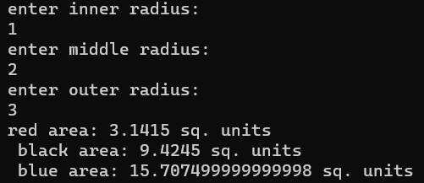
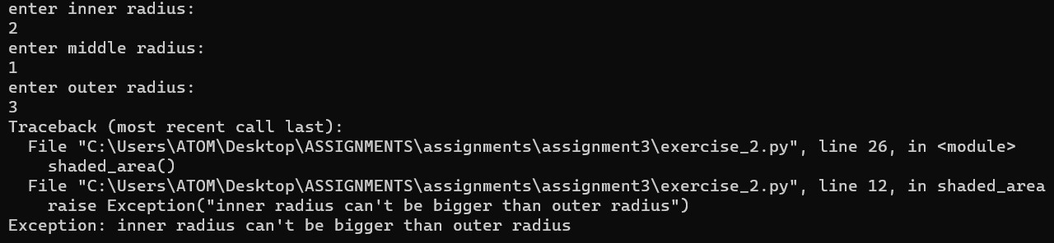
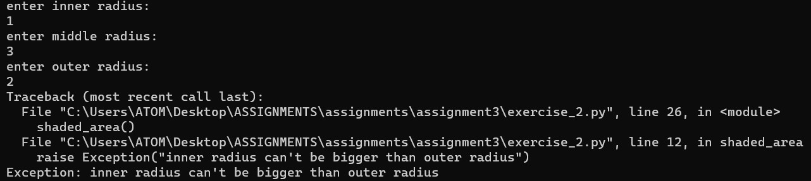
Exercise 3
Pseudo code
- Define a function containing employee property lists as initialized variables.
- Inside the function in step 1, define another function to collect each employee's data.
- Create a loop that takes a new set of employee data until instructed otherwise by user input.
- Print out the employee information in tabular form.
#To run this program just type in "python exercise_3.py"
import csv
import pandas as pd

#initialize arrays
names = []
age = []
gender = []
salary = []

def get_employees():
#Store name
names.append(input("Employee Name?: "))
#store age
try:
age.append(int(input("Employee Age?: ")))
except ValueError:
raise Exception("Age must be a number.")
#store uppercase value for gender initials, make sure it is one of the letters f, F, m or M
sex = input("Employee Gender?: ")
if sex not in "FMfm":
raise Exception(" gender must be M or F")
else:
gender.append(sex.upper())
try:
salary.append(int(input("Employee Salary?: ")))
except ValueError:
raise Exception("Salary must be a number.")

def table_row_headers(path,val):
with open(path, 'w', encoding='UTF8', newline='') as file:
writer = csv.writer(file)
# write the header
writer.writerow(val)

def table_data(path,val):
with open(path, 'a', encoding='UTF8', newline='') as file:
writer = csv.writer(file)
# write the data
writer.writerow(val)

def go():
#collect employee data in a loop (using the 'form' function) until user says no
while True:
get_employees()
again = input("Add employee? (y/n)")
if again=="n" or again=="N":
break
elif again == "y" or again == "Y":
continue
else:
raise Exception("You entered wrong value, y/n was required")

#add table row headers
table_row_headers("employees.csv",['Name', 'Age', 'Gender', 'Salary'])
print("Name Age Gender Salary")
for i in range(len(names)):
table_data("employees.csv",[names[i], age[i], gender[i], salary[i]])
print(f"{names[i]} " ,f" {age[i]} ",f" {gender[i]} ", f" {salary[i]}")
#read the data in csv file
employee_data = pd.read_csv("employees.csv",na_values=["Na"])
#get and print average salaries by gender
avg = employee_data.groupby(["Gender"]).mean()
print(avg)
#plot an age, gender, salary distribution curve
employee_data.set_index('Gender').plot()

if __name__ == "__main__":
go()

Exercise 4
The random package from the python standard library is imported and used for generating random integers. The function “game_engine” handles the game logic, assigning the right points for the right set of random numbers.
The function “game_loop” handles the gameplay, aggregating points as well as watching for the user’s decision to keep playing or stop.
Pseudo code
- Initialize an empty list for storing random numbers.
- Initialize a variable for storing points won(in case of a win)
- Fill the initialized list with random numbers
- Remove non-repeating values from the list
- Count the remaining values and see if they are the special jackpot value "5", then award points accordingly.
import random

#initialize number list
integers = []

def game_engine():
points = 0
#fill integers random integers
for i in range(3):
integers.append(random.randint(0,9))
print(integers[0], integers[1], integers[2])
#create copy of integers, iterate over copy and remove
# corresponding non-repeating values from integers
rands_copy = list(integers)
for i in rands_copy:
if rands_copy.count(i)==1:
integers.remove(i)
#now integers contains either repeating values only or none.
# check length of integers and if it contains number 5.
if len(integers) == 3 and integers[0]==5:
points += 2000
elif len(integers) == 2 and integers[0]==5:
points += 200
elif len(integers) == 3 and integers[0]!=5:
points += 20
elif len(integers) == 2 and integers[0]!=5:
points += 10
integers.clear()
return points

#game loop
def game_loop():
#initialize aggregate points
total_points = 0
while True:
proceed = input("Spin? (y/n)")
if proceed in "Yy":
res = game_engine()
#if spinning wins no point, print a message out
if res == 0:
print(f"You lose, your points are {total_points}")
else:
# if spinning wins points print out the aggregate of all won points
total_points += res
print(f"You won your points are {total_points}")
else:
break

if __name__ == "__main__":
game_loop()
Screenshot
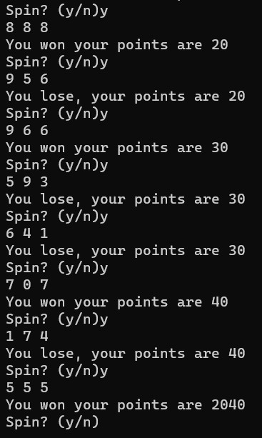

Python Files:

