This survey will refer to the Bowen family graves and mausoleum found at Nevern Church, or St. Brynach’s Church, in the west Wales town of Nevern, in Pembrokeshire.

The church’s history first of all is about Brynach, its namesake; before his sainthood, he was most commonly referred to in conscription as an Irishman who lived in the 6th century, and is believed to have been an active participant of the evangelist-founded Peregrinatio pro Christo, which means ‘Pilgrims for Christ’. Most early and modern conceptions record that he had taken his pilgrimage to Rome, Brittany, and along the coasts of England and Wales to Milford Haven, eventually coming upon Nevern, and founded the church in 540 AD after the area’s Lord Clechre bestowed him the land and retired himself to Cornwall. Specifically, this church in modern-day Nevern is his major shrine and memorial, however, he has many other dedications across Wales and previous Welsh territories to his memory, such as Dinas Cross, Pontfaen, Llanddarog and many more across several counties.

The church’s influence and continual importance to Wales is due to the rise in popularity of pilgrimages to St. David’s Cathedral by “thousands upon thousands of people”, 3 lots of said pilgrimage have been likened to be “equal to one [pilgrimage] to Jerusalem”. ² With this, on the hill next to the church and the ruin of the Norman-built Nevern Castle, is ‘The Pilgrim Cross’, a carving into the rock face of a cross on the path that was likely used by all the pilgrims that passed through Nevern.

The Bowen family, from observation of a plaque referring to their family next to the door on the inside of the church, and their prevalence within the graveyard, clearly has and still holds an extreme amount of significance to the church - the family are mentioned in the church’s website as a part of their history at one point being in the position of vicar, however the wording, “..[David Griffiths was] ordained and married into the Bowen family and became vicar of Nevern in 1782.. for 42 years.” suggests that the Bowen’s already had significance before Griffiths married into the family and only increased that by becoming the vicar.

Not only that, but the family's place within the graveyard and the position they are placed is also highly important - the family are placed behind the church, offering some privacy rather than being placed near the front by the bleeding yews, trees that may have been planted after the Bowens had settled there. They have a small metal and concrete wall surrounding their designated area, and they are all together on top of the small hill rise, with the mausoleum being the main centerpiece after you walk down the path towards the celtic cross, and turn left to follow the church around. The mausoleum grave colours are more of a light blue, and since it is unusual to see brighter colours for graves in cemeteries in most of the country, along with England too, it draws the eye. It is also worth noting that the family's area is actually designated next to the altar of the church, highlighting that the family had strong connections not to just the church, but to Christianity as well.

Supporting their significance, one part of the church is referred to as ‘The Bowen Chapel’;
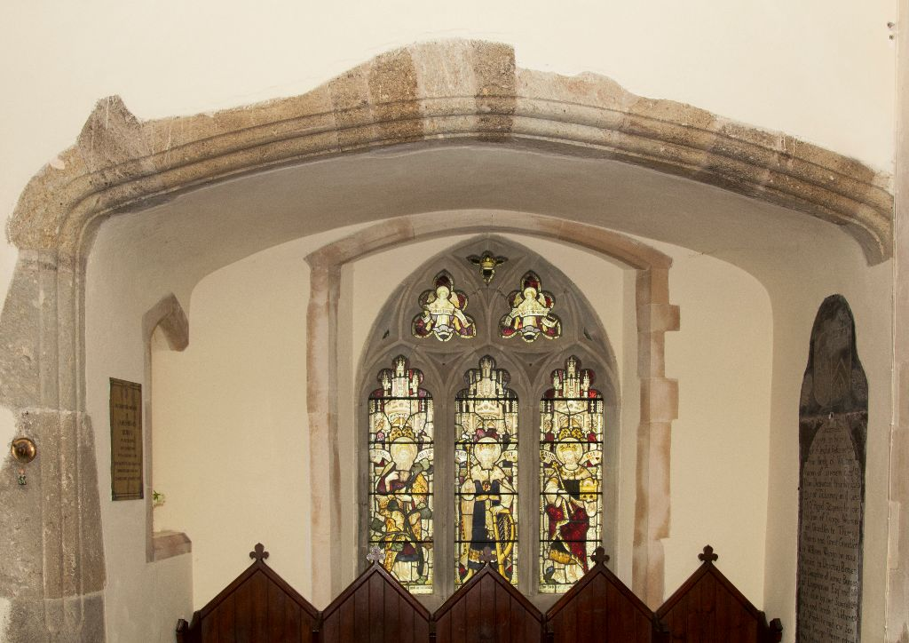

With the thought that the family’s importance in Nevern is significant, the further evidence that the earliest recordings of the Bowen name in Nevern specifically are as early as circa. 1390-1400, with Gwilym Bowen, son of Evan Bowen and Margaret Cubbertson, who was born in 1412 and means that the family’s presence within Nevern has been one constant for around 600 years, and graves of the family survive from at least 300 years ago in the 18th Century. It may have been possible that the Bowens are one of, if not the oldest family potentially still residing in Nevern and the surrounding area, but that they have continuously contributed to both the community and the church through attendance in the church's sermons as both religious residents and as previously confirmed, apart of the managing and care of the church building itself.

Example of Bowen grave below;
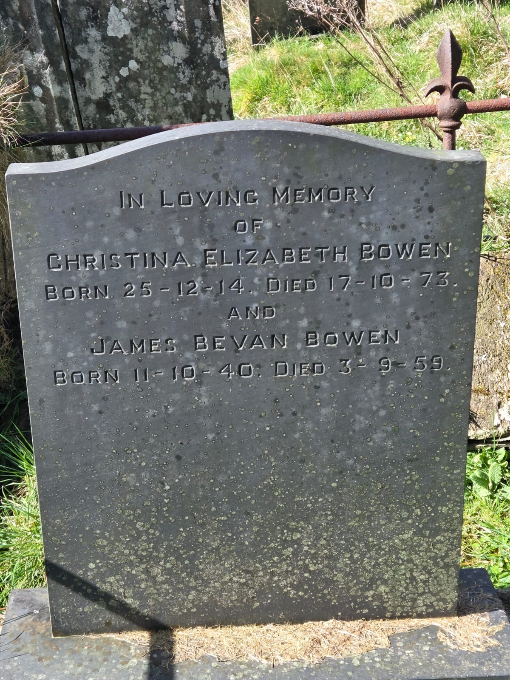
Information given by the church's website infers that the typical language of the town has previously, if not completely, been Welsh, and has only recently (in the last 100 years due to the alienation of the Welsh language) not been the language used for the sermons, hymns and prayer book - due to this and the extensive amount of time that the Bowens have been living in the town and surrounding areas of Nevern and Pembrokeshire, the conclusion that the family are clearly Welsh and have most likely been Welsh-speaking is almost fact. Along with this, the name ‘Bowen’ is actually a mutated derivative of ‘son of Owen/Owain’ in Welsh, which is typically written as ‘ab Owen/Owain’ (interestingly, despite the Welsh spelling of ‘Owen’ being ‘Owain’ and the likelihood of the Bowen family being primarily Welsh, it may be that the name and/or the family was anglicised).

With the origins of the family dating back to at least the end of the 14th Century, it could be possible that they have roots from the Normans, as the church has a surviving Norman tower built on the rear end opposite the altar, along with the fact that the Normans likely ‘hit Nevern in the late 12th Century’. There could be an argument as to whether at that point the Normans still identified as such.

The level of respect that the family have been given by the church in order to have had the opportunity to have this mausoleum and dedication to their family also speaks about their reputation - they have clearly left a significant mark on the town community and the church itself to have their characters reflected and honoured in such the way that they are.

Picture of the Bowen mausoleum below;

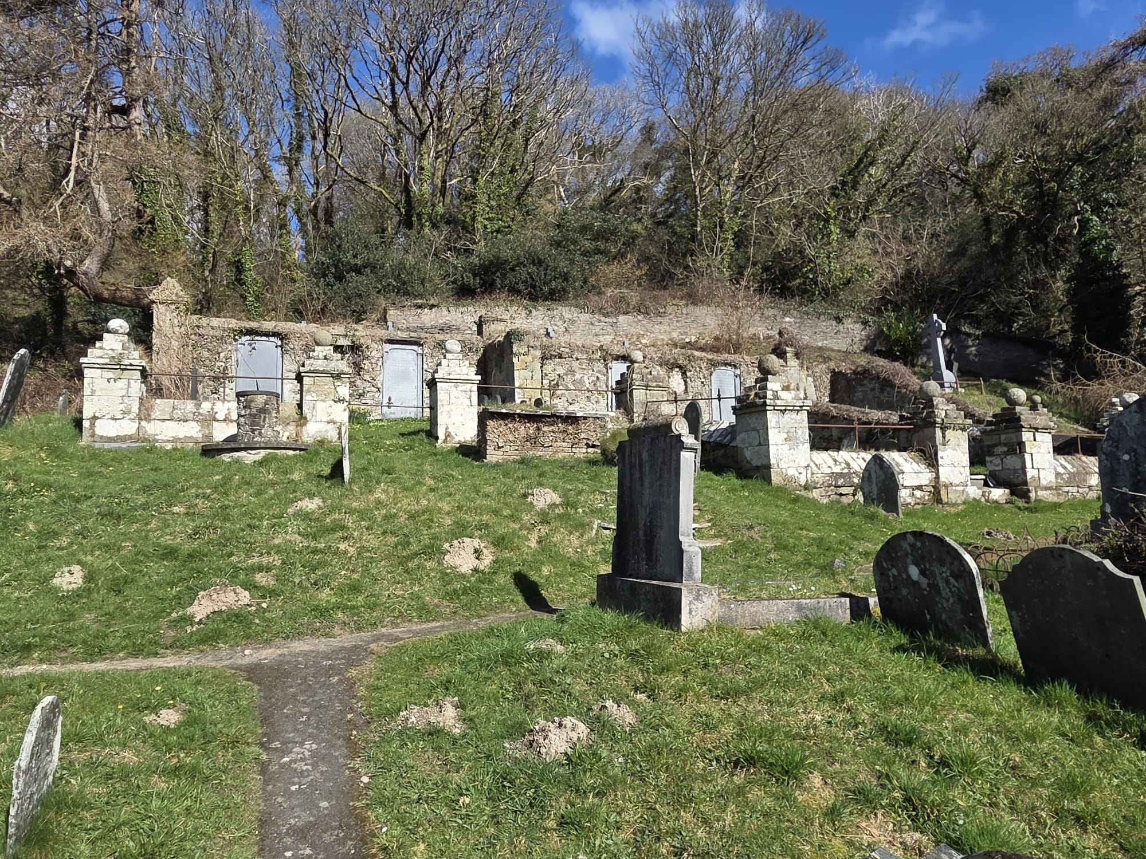

The mausoleum in specific may be evidence of this, as each of the four light-blue graves embedded into the wall of the small rectangular building, they are not dedicated to only one specific individual of the family - in fact, they actually tend to refer more to families of the Bowens in certain generations; so husband, wife, children, their children, and so on. The other graves are in four or more lines facing each other between two of the mausoleum embedded wall graves, and create two paths up to the small building so all are visible and together. This also speaks volumes of how the family through generations perceive each other, even if they may not have met, they are all very close together in death, just like their family has been within the community for over 600 years.

Picture of one of the embedded graves on the mausoleum wall displaying the colour;
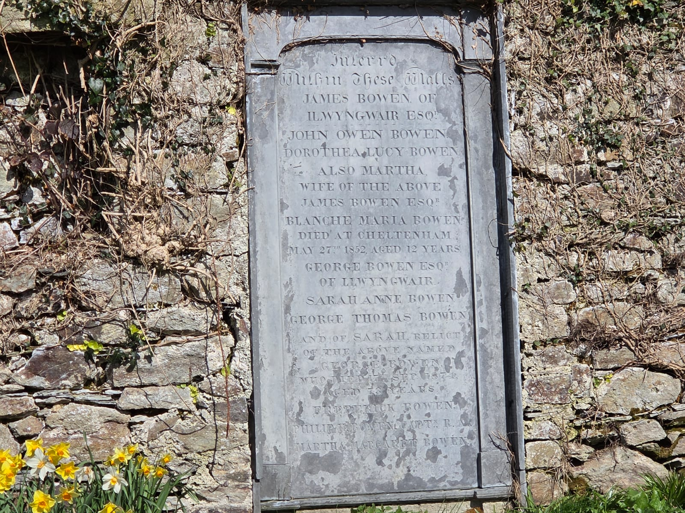

During the visit to Nevern to see the Church with the Archaeology Society, we had an interaction with a tourist whilst observing the mausoleum, whom was a lady visiting whose name was, interestingly enough, Eleri Bowen. When asked of the origin of her family, she was unsure as to whether she was connected to the Nevern Bowens, as she was from Glamorganshire - however, findings of a written family history of the Bowens by what may be another member of the family, it is revealed that some of the previous members over 4-500 years ago did actually move at some point to Glamorganshire - she may in fact be distantly related to the family, and that their reach in communities doesn't just end in Nevern.

The family also likely still has some members living in the surrounding areas, as the latest dates upon the more modern graves refer to the mid 1950s and 1970s, or that the family has generally moved, but for burial returns to the family's site.

celticsaints, “St. Brynach of Carn-Engyle (the Irishman) (Bernach, Bernacus, Brenach, Bryynach)”, celticsaints.org, published 7th April 2017, https://celticsaints.org/2017/0407a.html, access date: 16/03/25
Original Author unknown, edited by A. W. Wade-Evans, “Vita Sancti Bernachius The Life of Saint Brynach”, maryjones.us, publish date circa. 12th Century and revised circa. 1944, https://www.maryjones.us/ctexts/brynach.html, access date: 16/03/25
Steve Watkins and Rhiannon Comeau, “Ancient and Modern”, nevern-church.org.uk, publish date unknown, https://www.nevern-church.org.uk/ancient-modern/, access date: 16/03/25
Photographed by Peter Heard LRPS for nevern-church.org
MerleRomer4, “BOWEN FAMILY HISTORY FOLLOWS:”, familysearch.org, published 18th July 2016, https://www.familysearch.org/en/memories/memory/27552546, access date: 16/03/25
Photographed by Evan T. Davies
Photograph by Evan T. Davies
Photograph by Evan T. Davies

