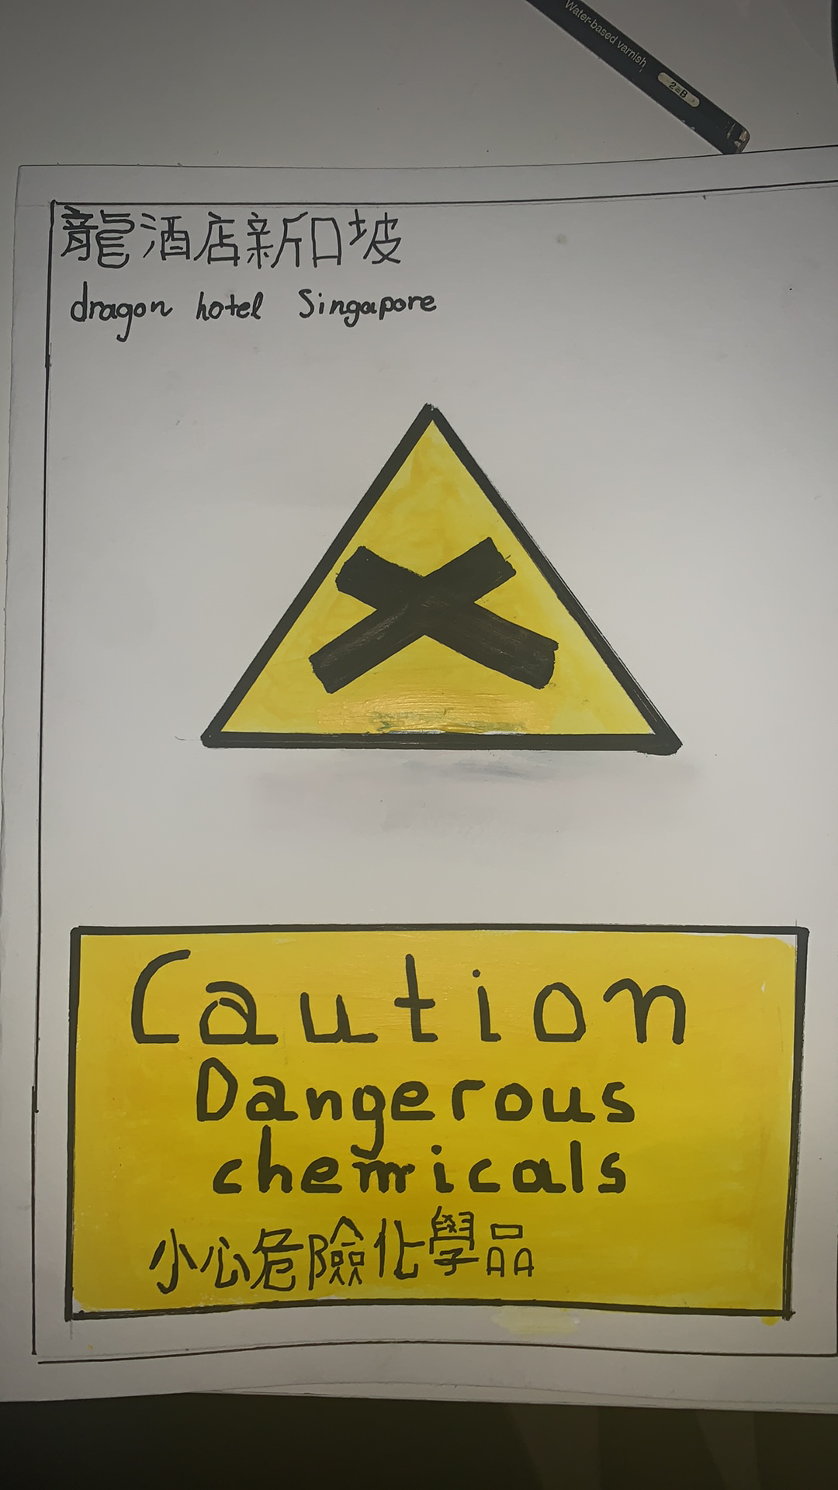
Assignment number 4, Foreign Languages & Cultural Awareness.
Dragon Hotel Singapore, caution sign on a paper.
Student number: 1908247
Name: Konstantinos Soulintzis
Teacher: Jinping Li

