Written Work Based Assignment - 2000 words
Write a report evaluating the effectiveness of the use of modern technologies within own workplace and exploring social media as a tool for marketing, information gathering and communication within the workplace; creating own professional online presence to illustrate and evidence this research.

Digital skills and research methods
BMSK4003
Renuga Jayakumar

Shahnaj Faulkner
1707663

Contents:
Introduction………………………………………………………1
Technology and Employability at workplace……..1
Tablet and Smart phone……………………………………2
Web conference………………………………………………..3
Importance of Social Media………………………………4
Photos………………………………………………………………5-7
Conclusion……………………………………………………….7
Reference………………………………………………………...8

Introduction:
There are revolutionary improvement in the business and workplace due to the improvement of technology, internet and social media. It becomes mandatory for the business owners, employees, customers to rely on the technology. Organisations are employing more qualified people who has a very good knowledge regarding technology and social media. Health industry, tourism industry, education industry where millions of data needs to be protected or uploaded continuously shifted very quickly into the technology market which threaten the traditional methods. However in this competitive market business performances rely on technology by asking people to subscribe on their business (Bitner et al,2000).
According to Kaplan A and Haelein M (2010) seventy five percent internet surfers from all age group use social media such as blogs, Face book, LinkedIn, Twiteer, product feedback which drew companies attention to use these tools for marketing purposes. During 1979 Tom Truscott and Jim Ellis from University of Duke created the Usenet which allowed internet users to post public messages. Twenty years before Bruce and Susan Abelson founded Open diary which was a social networking group for online diary writers. This was established as Blog now. The growing availability of internet access further added to the popularity of the concept of social networking sites such as Facebook in 2004.
I am a self employed health therapist and I have to use technology and social media hugely in my workplace.

Technology and employability at workplace:
Employability is an investment for the human capital which could be a lifelong achievement (McQuaid and Lindsa, 2004 ). Technology improves the employability. People need to learn and adapt different types of technical skills now. Before a doctor could just see a patient and prescribe medicine on the basis of the symptoms. But now doctor need to send the patient for different blood tests or gastrointestinal tests or any other tests for proper diagnosis and check the result online and consult with other health professionals such as cardiovascular team in the hospital or Occupational therapists team to support the patient’s need properly. Medical department completely relies on technology and computer. Education sectors now completely switching over to technology and online. Teachers do not provide hard copies of lectures anymore. All the soft copies are online. These lectures can be accessed into from anywhere at any time if the students have the log in details with them. Submission the assignments also need to be uploaded online. So students can stay at home and submit their work online. People do not have to physically attend any meeting or seminar or workshops anywhere as video conferencing can link people anywhere in the world and has become very popular (Grudin J,1994).

Tablets and Smart phones:
Tablets and smart phones are becoming popular to improve employability at workplace. Professionals and business organisations use these products to maintain their database, calendar, communications, presentations, notes, diary , almost for everything. I also use my tablet and smart phone for my work purpose. I use my smart phone continuously to support my clients. I do Face timing on my Apple phone and it is very easy to use. I use I phone which is a product of Apple brand. I never had any hardware issue with I phone. Previously, I used Samsung galaxy for few months but I did not feel comfortable with it. The internet was very slow and update the phone was not easy all the times and it was time consuming.
My Samsung galaxy was an Android phone and it had some features like Microsoft words but it was slow and took longer time to download something. The reason could be the OS in Samsung phone was not updated on time. Whether I phone IOS keep sending messages to update the IOS regularly. With Apple I Phone the notification of updates pops up and I just run it through. It saves my time.
I find Safari in I phone is as good as Google. Google is as a searching tool which was linked with my Android phone. However I downloaded Google in my smart Apple phone as well. I can use Google and Safari both in my Apple I phone. It gives me choices when I try to search something important.
Apple strictly controls the apps and the internet. Therefore I never had any virus attacked into my phone. But I had to take my Samsung galaxy phone to the service centre due to the virus.
I use my phone as my learning tool and as my business purpose. I do online sessions with my clients. In the face to face treatment I need to play relaxing music or music from different wave length for my clients as a part of the treatment. I can watch any video any time if I need to learn about something which I can use easily with Apple smart phone and I can continue multiple tasks on my I phone such as send the client an email, look for previous email, find the old notes while I am discussing any issue with them. I found my Samsung galaxy phone could not download all the videos on time and could not do multitasks.
A lot of Autistic children are my clients. When they come to me I handover the Apple Tablet to them for keep them focus on it so I can continue the treatment on them. Apple smart phone offers a lot of free learning Apps and lot of free games. It does not cost me any extra money to download those Apps in my tablet. But when I was using Samsung phone I had to buy most of the games. Apple smart device is one of the best friend for special need children.
My Apple I phone is backed up by my Apple Tablet. It helps me so much to find out my current and old clients details rather than looking into my diary and spending hours to find details. Also with Samsung phone I had a bad experience with subscription. One of the special need child click on some of the subscription buttons in you tube and they started to charge me money monthly hundred and fifty pounds. When I called to the mobile network they closed it and mentioned to me how Samsung phone automatically link to the different companies to claim there money from my account. I never had this kind of experience with Apple I phone because Apple I tune always ask for the password and maintain the security
When I used to use my Samsung Galaxy phone there was not any support rather than the network company whether with Apple I phone I can take my phone to an Apple store if any kind issue occurs.
As I run an online business it is very important for my phone and tablet having enough charge when I am receiving a video call from a client. So Battery life of these are very important for my business. My experience with Apple I phone is it has more battery life than Samsung Android phone. I can easily talk to my client for an hour and a half without charging my phone.
Another good feature that Apple I phone have is the camera and ability to take a good photo and also the storage ability of the photo gallery is huge. As a part of the marketing of my business I need to download photos on my website and Social Media quiet often. It is so easy to upload video and photos in social media from Apple products. Also in case I delete any photo it remains in the bin storage for twelve weeks.

Web Conferencing:
Web conferencing and video chatting become popular and it is a very effective tool for communication in order to save money and the time (http://oa.upm.es/11634/1/INVE_MEM_2011_98477.pdf). Most of the companies use Skype as an online communication tool because it is free to use and has easy accessibilities through phones and computers. There are over 600 million users and 30 million simultaneous users online at peak times use Skype for communication. It is good for one to one chat. Skype business is designed for the group conference and it is easy to share the documents, easy to send messages. I used skype as a conferencing tools for one to one in so many occasions. One of the biggest challenge with Skype was call were dropping frequently.
Gradually the business were getting bigger and I had to do web conferences with different clients, agencies, marketing team which I found a bit difficult with Skype. So I started to search for another option. Then I found Zoom. Zoom is fantastic for group conferencing and save the conversation for next time. So if anybody forget anything, they can watch the conference again. Zoom can improve content sharing, scheduling and it is easy to access just by clicking the link on the phone, unifying login, marketing automation. Zoom supports integration One drive.
Zoom is another popular tool for web conference. For business account Zoom charges much higher than Skype. It costs fourteen pounds per month. But Skype business account charges only five pounds a months and it is linked with Microsoft Worldwide. But I still prefer Zoom. The reason is the moment anybody start talking Zoom is able to show that person immediately. When two or three people talk together Zoom is able to show different people constantly prior to the new sounds. It is amazing. I feel like there is a hidden camera man sitting and zooming on the different faces even though every body is hundreds of miles away from each other.
There were another issue I felt with skype is to control the meeting. The organiser do not have the whole power to control the meeting. Zoom allows the meeting organizer in full control of the meeting such as muting all microphones and controlling attendees presentation access. Attendees can virtually raise their hands if they need to contribute anything. (https://help.utk.edu/kb/index2.php?func=show&e=2629 ).
Technology, online information and social media has opened a door to the global marketing. Therefore most of the workplaces are now encouraging their employees to use these tools for business purposes is improving workers employ abilities.

Importance of Social Media:
Facebook, Twitter, Instagram, LinkedIn, are tools for web based social media where people can communicate with each other from anywhere in the world. Social media refers to the information which is linked to articles, video, blogs, documents, photos etc. Social networking is relates to friends, colleagues, anyone from the past where they share likes, comments. Social media gives people a chance to express their views and give feedback which is very popular for business organizations.
Anybody can open a business Facebook page to advertise their business and can invite all the friends in the friend list. Same rules follows for Twitter. Anybody can open a Twiteer page and start tweet people and can get instant feedback. Before people has to spend a lot of money advertisement and had to rely on newspaper, billboard, television or radio. With social media anybody can launch their products for free of cost.
There are LinkedIn which is actually a job website. People create their own profile and update all of the professional skills they have to attract employers attention. There are so many people got jobs through this site. This is saving employers and employees time and money as long they both are using LinkedIn they can find each other.
For my business I pay to an media company who advertise my therapy business to the local community and different social media. I personally upload my work and different offer to my personal face book page. For this assignment I made some of the pages for business purpose and found it easy to create them. I have added myself to different Face book group such as Girls autism group, Chelsea Mum group, Crystal Children, Enlighten to your children and write posts and advantages of the therapy and I get a lot of clients in this way.
I am planning to make some video with my treatment and will download them on Facebook advertisement team. Facebook allows to advertise the products with a very small amount of money for a day or three days or seven days or for a month. If somebody likes that advertise then other friends can see it as well. So far I was using nonverbal videos with clients feedback and was getting a lot of responses. I also allow my clients to access to my personal Facebook page and let them use their feedback.

My business name is Angelic Healing. So I opened a facebook business page by the name of Angelichealing. Here is the link below
https://www.facebook.com/Angelic-Healing-588715841465494/
The name of my Twitter account is Angelic HealingU.
https://twitter.com/angelichealingu

The Linkendon profile is to develop the networking among professionals
https://www.linkedin.com/in/shahnaj-faulkner-4658b311/

Photo: Face book
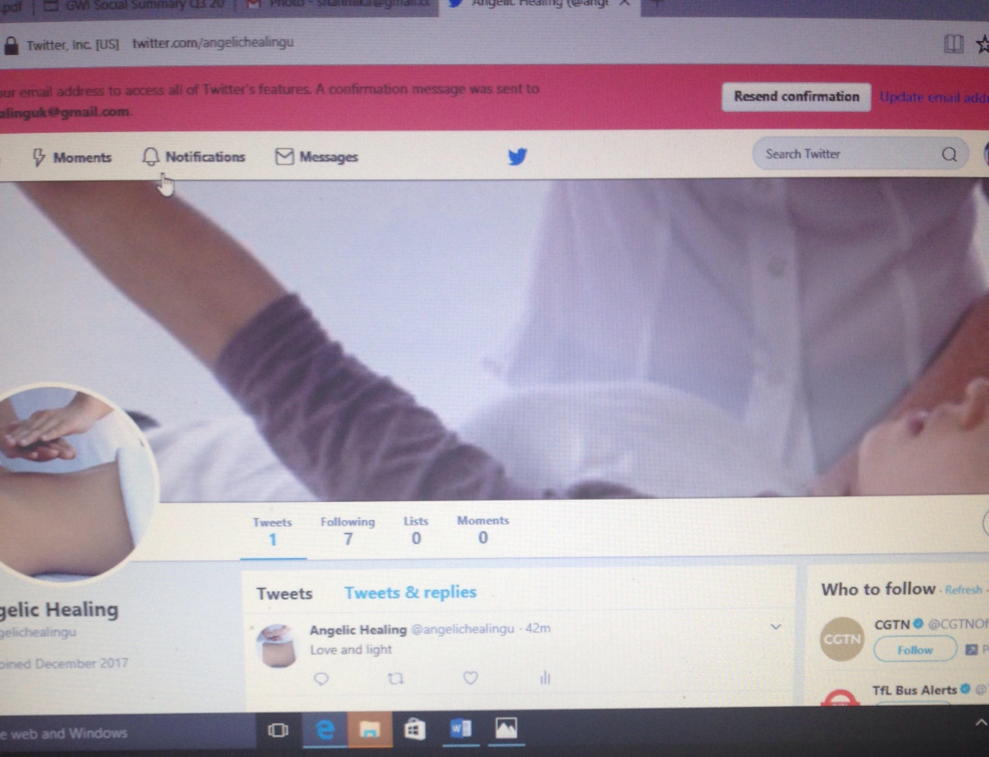

Photo: Twetter

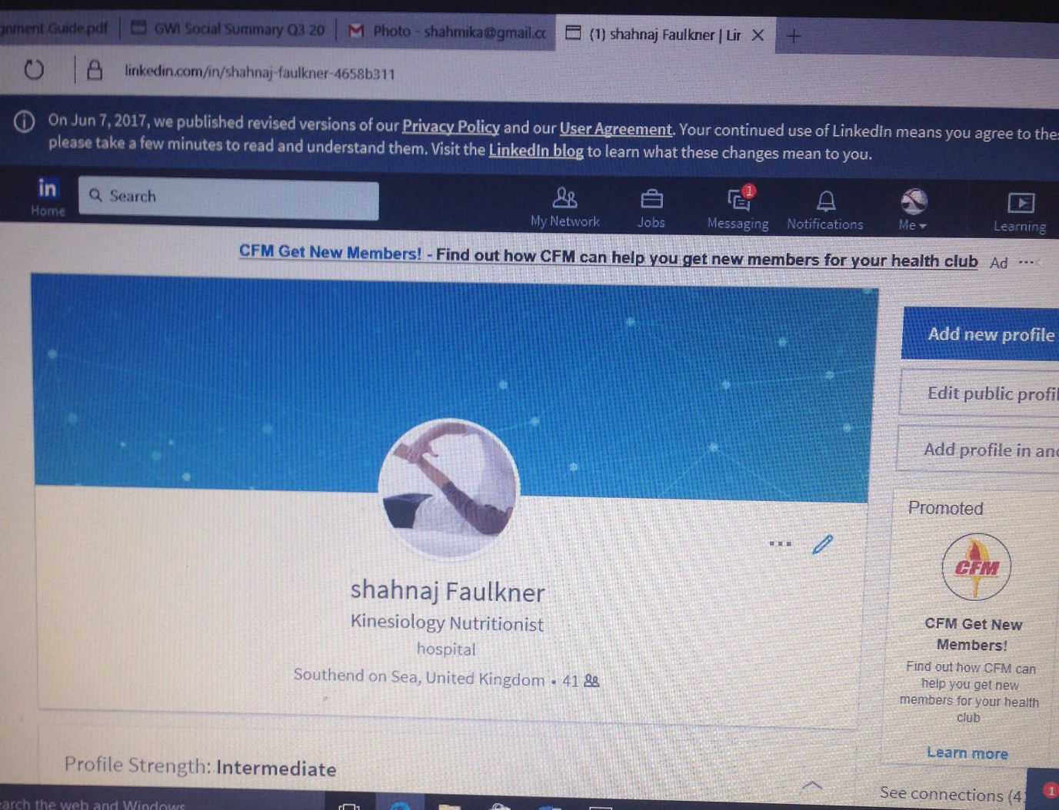
Photo : Linedin

Conclusion: Technology, social media are creating new options for people every day. Life is becoming much more easier. Employers are recruiting social media experts to liaise with people. I personally feel that there is no privacy in the online market. Everybody constantly recording all my data, all my movement. I personally try to avoid technology and social media. However I need to use all of them constantly for my business. Because this is the demand of the mass population for compete the global market.

Reference
Bitner. J.M., Brown. W. Meuter,L,M (2000). ` Technology Infusion in Service Encounters. Journal of the Academy of Marketing Science. 28, No. 1, pp 138-149. Available online
https://s3.amazonaws.com/academia.edu.documents/39294829/00b49537b565de6a5c000000.pdf?AWSAccessKeyId=AKIAIWOWYYGZ2Y53UL3A&Expires=1514729386&Signature=RVnAvz%2BatVwbTEUXAsT0QAOtKbI%3D&response-content-disposition=inline%3B%20filename%3DTechnology_Infusion_in_Service_Encounter.pdf Accessed on (30-12-2017).
Grudin, J,(1994).Computer system development: history, organisation and implementation, Wiley, Chichester.pg19-20. Available online
https://www.microsoft.com/en-us/research/wp-content/uploads/2017/01/IEEEComputer1994.pdf
Accessed on (9-1-18).
Kaplan, M., A, Haenlein M(2010). Users of the world, unite! The challenges and opportunities of Social Media. Business Horizons, 53, pp59—68.Science Direct.com. Available online
http://michaelhaenlein.com/Publications/Kaplan,%20Andreas%20-%20Users%20of%20the%20world,%20unite.pdf Accessed( 30-12-2017).
McQuaid,W.R ., Lindsa. C.(2004). The concept of employability. Urban Studies, Vol. 42, No. 2, 197–219, February 2005.
https://strathprints.strath.ac.uk/40093/1/Concept_of_Employability_FINAL.pdf . Accessed on (30-12-2017).
http://oa.upm.es/11634/1/INVE_MEM_2011_98477.pdf Accessed on (09-01-2018).
https://help.utk.edu/kb/index2.php?func=show&e=2629 Accessed on (09-01-2018).
https://www.lifewire.com/what-is-social-media-explaining-the-big-trend-3486616
Accessed on 07-01-2018

