

REPORT OF MY ACADEMIC AND EMPLOYABILITY SKILLS

Alejandrina Perez Terrero. Student Number: 1818413
Academic and Employability Skills
15th December 2019

Acknowledgements.

I acknowledge to this institution for giving me the opportunity and accepting me here, which has been a very important step for me.
Also to the lecturers for their great dedication and effort such as Tim Hopkins, my supervisor at work for giving me flexibility to study and a special one to my friends for their support and patience with me, which have been very important for this new and exciting period in my life

CONTENTS

- ABSTRACT OR SUMMARY
- INTRODUCTION
- METHODOLOGY
- RESULTS OR FINDINGS
- DISCUSSION
- CONCLUSION
- REFERENCES

- SUMMARY

This report focuses on several key areas and tools that I have developed during my first term, in this case of Academic and Employability Skills, which I will introduce by findings.

- INTRODUCTION
The object of this report is to introduce myself, Alejandrina Perez. The report will also briefly describe some of the topics that I have covered in this term, and then confirm my future employability by using of some of the skills I have learned as well as an improved awareness of my existing skills and potential weaknesses.
I have used some well know and respected tools such as
- SWOT analysis
B) DPD personal development plan
C) SMART goals
D) The Eisenhower method
As well as learning to paraphrase and summarise effectively. Finally the report will discuss 3 articles that are relevant to my chosen future career in Social Work. At the end of the report I will show myself to be improving from a student beginner into an employable person with much to offer in the challenging world of social work. The area of social work I am most interested is children, the elderly and families in crisis.
So, with these tools will significantly help me to focus my attention on overcoming the gaps in my personal

- METHODOLOGY
My methodology section covers the things that I have studied in class and some of the techniques that I learned to make me more aware of my strengths and to work to improve any areas of weakness or any gaps in my knowledge.
In class we looked at the SWOT (Strengths, Weakness, Opportunity and Threats) Analysis, the Eisenhower method to assist us in our time management, and a PDP (Personal Development Plan ) to set out our own personal aims and goals.
I also studied and learned the art of paraphrasing in order to simplify a particular piece of writing whilst not changing its overall message and to always reference our work to avoid the possibility of plagiarism.
Another very useful tool that I have learned was summarising which enables us to communicate the main points of a piece but more briefly and to the point. I have also chosen three relevant articles to discuss in order to show my understanding of these specific subjects and my interest in the social work to which they relate

4. FINDINGS
Now I will develop the elements of my findings in the best possible way so that my knowledge of the subject can be understood.

4.1 SWOT ANALYSIS.

It is a very important characteristic because it allows us to evaluate ourselves to
prepare strategy for a better defence.

STRENGHTS  - Good attitude specially in team working  - Caring person  - Hard worker  - Always eager to learn to improve myself | WEAKNESSES  - Trust people a lot  - Nerves are never my friends  - Very empathic
OPPORTUNITIES  - Easy adaptability  - Open mind for new changes | THREATS  - Don’t have enough time to reach my plan  - Lazy people in my team working

4.2 EISENHOWER METHOD.

Proposed by Dwight Eisenhower, during the period of time 1953 to 1961, it is a brilliant tool based of the strategy plan of the organization which result very helpful in our daily routine, it mean prioritizing the most important things to do and avoiding wasting time to get a effective develop in our daily life

U R G E N T |  | N O T U R G E N T
I  M  P  O  R  T  A  N  T  N  O  T  I  M  P  O  R  T  A  N  T | - Daughter call  - Finish my student report on time  - Buy food  - Job meeting | - Read my book  - Call family  - Paying my bill on time  - Be punctual at work
 | - Call family  - Paying bills on time  - Be punctual at work  - Check my schedule regularly  - Help my parents | - Spending more than 2 hours watching tv  - Wasting money in unnecessary stuff  - Using social media constantly  - Wasting time with negative people

4.3 PARAPHRASING.
This is one of the most used tools based on the transformation of technical words to colloquial words, which helps to make the message of an article easier to understand but without changing the mission or meaning of that content.

EXAMPLE
Article:
If a doctor expects a treatment to be successful, a patient may experience less pain and have better outcomes, according to a new study.
The findings reveal how social interactions between hypothetical healthcare providers and patients have the power to influence how the patients perceive the effectiveness of a treatment even when it is placebo.
Science Daily (OCTOBER 21ST, 2019)

My paraphrasing:
If a Medic is confident that a treatment will work, a patient may feel less pain and have better results,a new study claim,
The study shows that the way in which doctors speak to their patient can affect the outcome of a patients treatment even if the treatment is only imagined.

4.4 SUMMARIZING

It is a useful tool when you need to explain something in a few words. You can summarize in a shorter space a paragraph without losing the purpose in a shorter space of the text in a precise and clear way.

ARTICLE:
If a doctor expects a treatment to be successful, a patient may experience less pain and have better outcomes, according to a new study.
The findings reveal how social interactions between hypothetical healthcare providers and patients have the power to influence how the patients perceive the effectiveness of a treatment even when it is placebo.
Science Daily (OCTOBER 21ST, 2019 )

My summarizing:
Doctor’s attitudes have enormous influences in the result of their patients

4.5 PERSONAL DEVELOPMENT PLAN
It is a useful tool which you can create your project setting your goals, based on your own awareness, personal value and reflection for your personal envelopment within period of time

 | Short-Term Time Frame | Mid-Term Time Frame | Long-Term Time Frame
Section 1 – My Goals | - Finish my assessment successful  - Improving my spelling and grammar | - Get my degree at the University  - Do some practices as beginner social worker | - Get a good job  - Keep improving myself
Section 2 – Skills and Knowledge to be Learned | - Understanding everything in class  - Keep reading books to improve my grammar | - Pass successful my assessments  - Be able to do good research to grow my knowledge | - Try different areas of Social Worker system
Section – 3 Next Step | - Spare enough time to study  - Attending meeting in English to improve my pronunciation | - Develop my knowledge and computer skills  - Proof my understanding in each subject | - Have my own company  - Make my parents feel very proud of me

4.6 ARTICLES

Now I will show my three chosen articles, relating to my field chosen career.

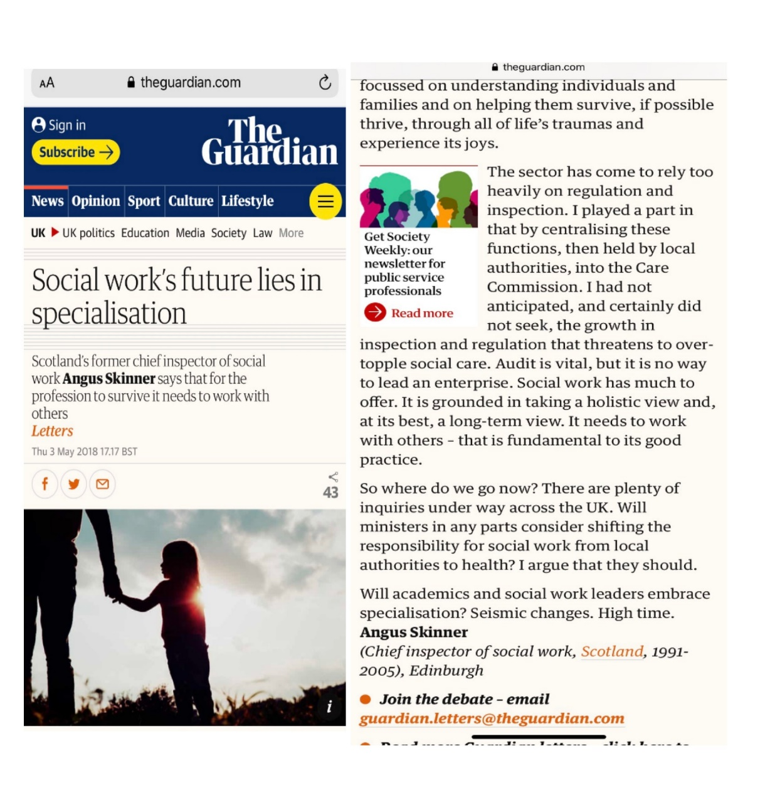
Angus Skinner (2018).
I chose this one because it sounds very interesting to me and it was written by the former chief inspector of social work for Scotland.

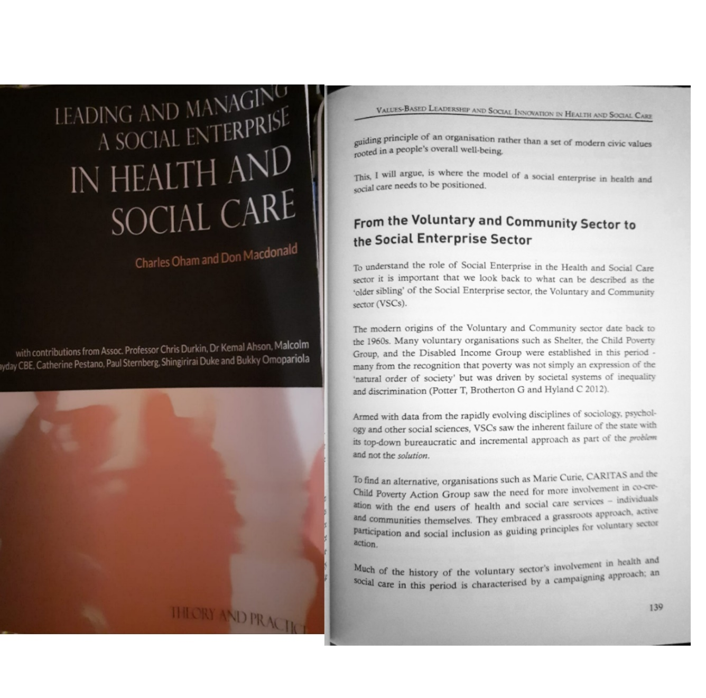
I have selected this article because it shows the development and evolution of voluntary and community sectors into Social enterprise groups as knowledge of social inequality and need has grown.

Charles Oham and Don Macdonald (2016)

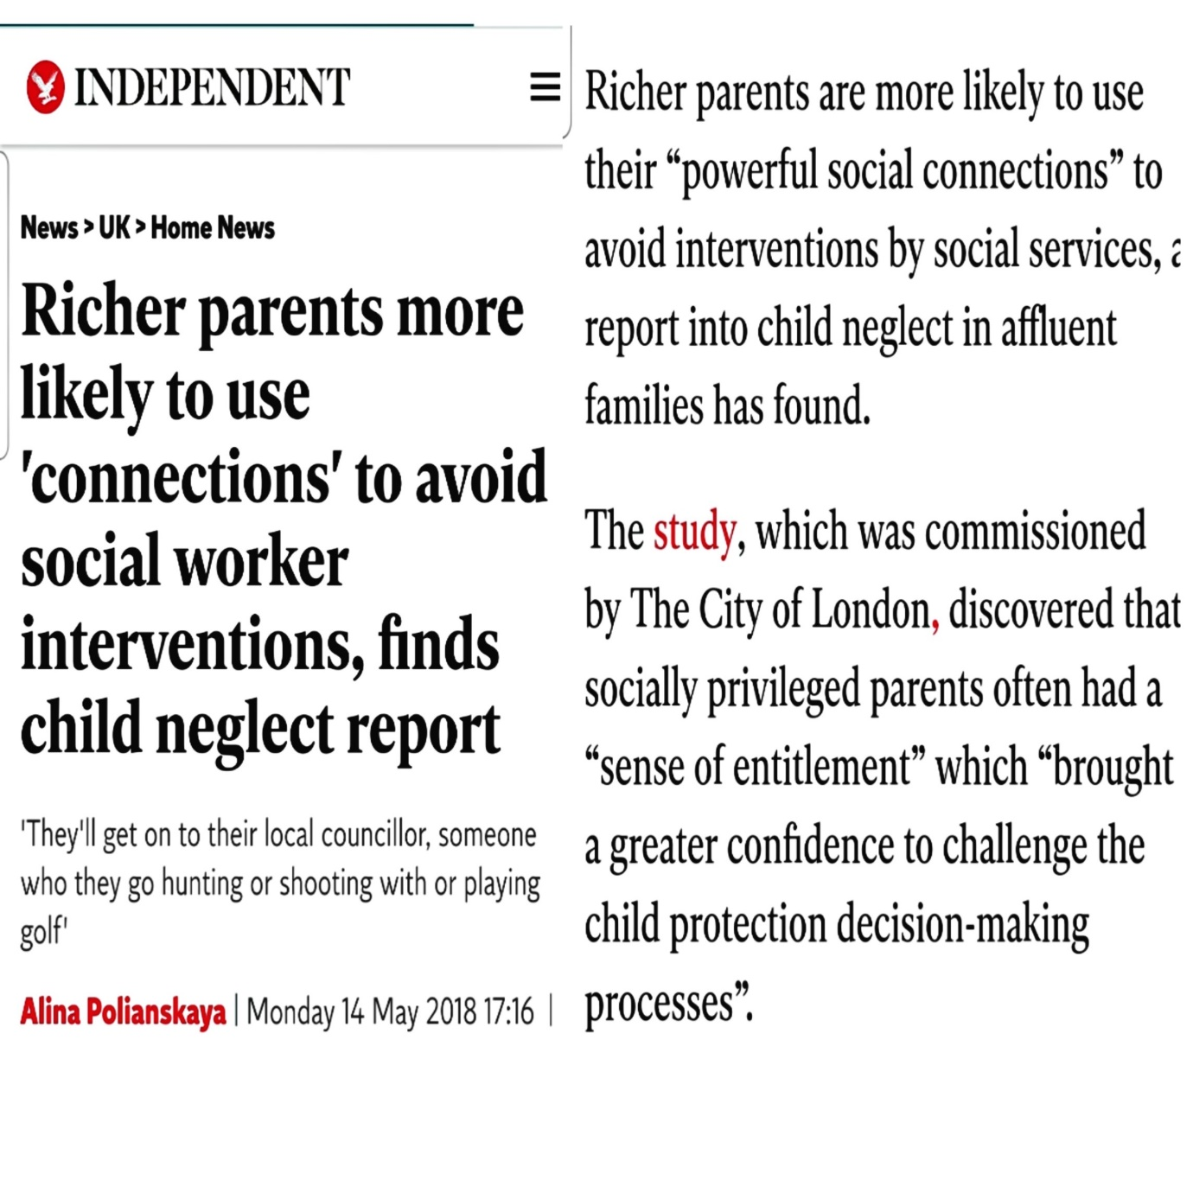
This articles it also interesting because it demonstrates one of the many problems faced by social works.

P. Alina (14-05-2018)

5 DISSCUSSION

The main objective of discussion is to demonstrate the progress that I have made this term.
Firstly, by summarising the tools and techniques that we studied in class throughout the term. This includes tools for my personal development and management of time as well as analysis of my strengths and weaknesses as well as a brief summary of some of the study techniques that I have learned so far.
Secondly, I have selected some articles (3) that are related to the areas of social work that I am interested in and discussed their content and relevance to show my understanding of the subjects. For example, the first article where the author gives a strong argument for specialization in the social work sector and hints at some regrets that he has that he did not give the subject enough attention during his time as chief inspector.
The author claims that social work has become too ‘audit’ based and relies too heavily on inspection and regulation. He says that a more holistic approach to individuals and families would enable them to survive and thrive through life’s trials and tribulations.
Whilst I agree that we should be placing families and individuals’ needs at the centre of our efforts we must accept that in a modern society regulation and testing of systems is unavoidable. I do, however, agree that if we are not careful the needs of our most vulnerable members of society can be lost amongst the endless ‘forms ‘and questionnaires that are required. We must resist the ‘tick-box’ mentality that is creeping into so much of our bureaucratic systems. The needs of people and families are so complicated that they rarely fit into ‘boxes’ with ticks or crosses.
My second article suggests that there is a link between the rapid growth in the study of sociology, psychology and other social needs and the increase in social enterprises such as Marie Curie.
The article criticises our society and states that those in most poverty are victims of inequality and discrimination rather than those created by the ‘natural order of things’.
The formation of social enterprise groups is a by recognition that a more inclusive and ‘hands on’ approach that encourages active participation from at a grass roots level is far more likely to meet the needs of the most vulnerable in our society than the old top-down bureaucratic system.
This is an area of social care that I am passionate about. In my opinion it is far better to involve and equip and empower people to make changes in their lives.

The third article claims that children from wealthier families are more difficult to assess for many reasons. Firstly, their parents tend to be more confident, articulate and much more aware of the various processes in place and in particular the complaints process.
The report states that the neglect of children is much harder to see as the children are often hidden behind a screen of fee-paying schools and paid carers. Social workers often face evasive behaviour as well as obstructive and, in some cases, threatening behaviour.
The threat of complaint or use of ‘influential’ friends in high places was frequently mentioned by interviewees in the report.
As a student, wishing to start a career in Social Work and wanting to specialise in child care myself I think it is vital that the childcare system has robust procedures in place to enable social workers to accurately assess the needs of children irrespective of their social standing, wealth or ‘class’.
The physical needs of more disadvantaged children may appear more obvious or even urgent but the operating systems for social workers must also provide for the emotional and psychological need of ALL children.
Social workers must receive the full support of authorities when investigating less obvious neglect. This will empower Social Workers to be confident and unwavering in their pursuit of the real and full need of every child within their care.
There is certainly an argument for ‘specialist’ social workers with the necessary training to be called in to assist with the assessment of these children.

6. CONCLUSION

I believe that I have successfully shown that I have progressed from student beginner to a student that will have the necessary skills to be employable within the social work industry.
This term has been something new but very exciting for me because I am learning a lot about my ability as a worker as well as my own personal habit. I am learning to use my time more productively and above all to give more priority and focus to what I really want to be and do in my life, for example to graduate and be able to get a better job but above all to be able to lead one day my own company.
I believe that I am well prepared to face the next term with the best of the expected because I really want to continue learning and improving to always give my best.

7. REFERENCES
- Skinner. A, (2018) ‘Social Worker’s future lies in specialisation’. The Guardian, 3rd may.
- Oham, C. and Don Macdonal (2016) LEADING AND MANAGING A SOCIAL ENTERPRISE IN HEALTH AND SOCIAL C
By Community Training Partners,13 Chevening Road, London, NW6 6DB.
- Polianskaya A, (2018) ‘ Richer parents more likely to ‘connections’ to avoid social workers interventions finds child neglect report. INDEPENDIENT.
https://www.independent.co.uk/news/uk/home-news/social-work-report-child-neglect-rich-families-abuse-city-of-london-a8351336.html

