

Student Name :- Vraj A Pandya
Student ID :- 2244599
Programme :- MBA General Management
Module :- Marketing Management
Code :- LCMB7001
Lecturer : Tushara Balendran
Submitted On :- 30 August 2023

MARKETING MANAGEMENT ASESSMENT
Table of Contents
1. Introduction 3
2. Communication 4
2.1 Shannon-Weaver Model 5
3. Integrated Market communication 5
4. New Promotional Strategy of Intel 6
4.1 Online Promotion 7
4.2 Offline Promotion 7
5. Branding and Brand Equity 8
5.1 Branding 8
5.2 Brand Equity 9
6. Keller's Brand Equity Model 10
6.1 Advantages of Keller’s Brand Equity Model 11
6.2 Disadvantages of Keller’s Brand Equity Model 11
7. Customer Journey 13
8. Customer Touch Points 14
8.1 Pre-purchase 14
8.2 Purchases 15
8.3 Post-purchase 15
9. Customer Journey Map 15
9.1 The Persona of an Intel Customer 16
9.2 Critical analysis of Customer Journey map 17
9.3 Strengths 17
9.4 Weakness 18
10. The Total Engagement Mode 18
11. Recommendations 19
12. Conclusion 20
References 21

1. Introduction
Market management involves a set of market activities followed by an organization to perform the sales and marketing practices of a specific product. It helps the organization to achieve its business goals as well as attract customers towards the organization (Deepak, and Jeyakumar, 2019). However, it involves different activities such as buying, storage, distribution, financing, etc. The study demonstrates the overall idea of marketing management of the Intel company by illustrating the communication, promotional strategy, branding, advantages and disadvantages of brand equity, customer journey, customer touchpoints, customer journey map, and total engagement mode. Along with that, the study includes some recommendations to guide the further improvement of the Intel company.

Figure 01: The organization logo
(Source: Intel, 2023)
Intel is the top most popular semiconductor manufacturing company throughout the world. The company came into existence in 1968 holding the hands of Robert Noyce and Gordon Moore. It provides a wide range of computer circuits which made the company famous around the world (Intel, 2023). However, the company achieved great success in the journey of manufacturing microprocessors to semi-computers. The mission of the company is to provide engineered solutions to the customer and the vision is to increase organizational performance by trust building approach.
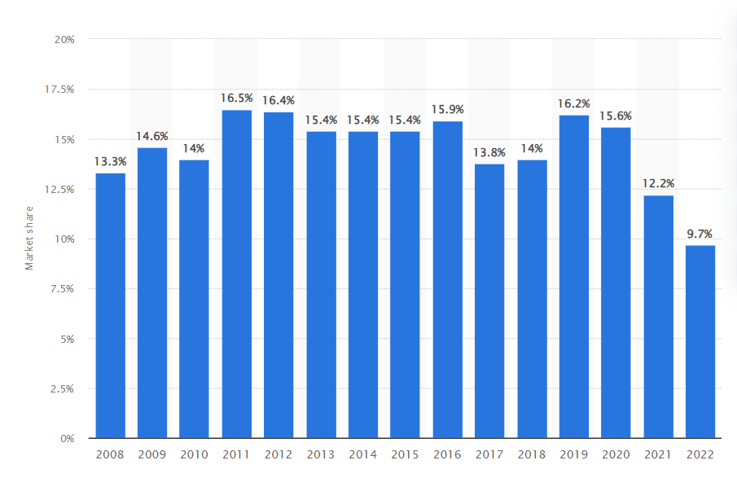
Figure 02: Market share of Intel
(Source: Statista, 2023)
According to the statistical representation, there are significant ups and downs found in the market revenue of Intel. The above figure shows the market share of Intel from the year 2008 to 2022. The market share of the company in 2022 was about 9.7% of the global market revenue which was about 601 billion dollars (Statista, 2023). It implies that Intel has a significant position in the global semiconductor manufacturing industry.

2. Communication
Communication is an essential component of an organization that provides different types of facilities for the organization. The term communication signifies the process of exchanging knowledge and ideas from one person to another person. It helps to provide insights to the Intel company to increase employees' work effectively. Along with that, it is essential to avoid any misunderstanding and dispute among the working individuals of a company. Moreover, an effective communication process encourages the working efficiency of the organization as well as increases the quality of the product. However, there are mainly two types of communication processes available which include verbal and non-verbal communication systems (Febriantini et al. 2021). Language, writing, etc are the components of verbal communication whereas signs, expressions, body language, etc are the components of non-verbal communication systems.

2.1 Shannon-Weaver Model
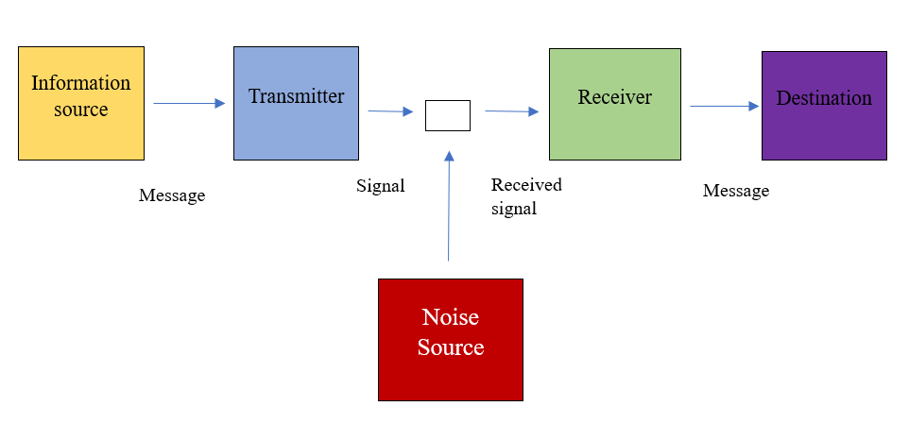
Figure 03: Shannon-Weaver model of communication
(Source: Self-designed)
Shannon and Weaver provided a structural representation of the communication to understand the processing of the communication system from resource to destination. They considered a variety of components in their communication model including information source, transmitter, receiver, destination, and noise source. According to the model, an information source is the person or the resource where the information is generated (Communication Theory, 2020). Next, there is the transmitter which turns the information into a signal and sends it to the receiver. As soon as the signal is received it is again converted to the messages and sent to the final destination. However, the noise source here is the external factor that affects the communication system. This model provides an opportunity for the Intel company to understand the actual information processing system. Along with that, it helps to maintain the communication channel within the organization effectively. On the other hand, understanding the noise source helps the company to assess the possible barriers to communication systems within the workplace.

3. Integrated Market communication
Integrated Market Communication (IMC), also known as relationship marketing, is a strategic process of choosing, developing, evaluating, and coordinating with the stakeholders of the firm. The goal of IMC is to build a strong and healthy relationship between the seller and the customer through an interactive exchange of information (Blakeman, 2023). The tools of integrated marketing communication are regarded as the prime concern currently as they are capable of targeting mass customers, marketing the events of the firm, handling social media sites, and so on.
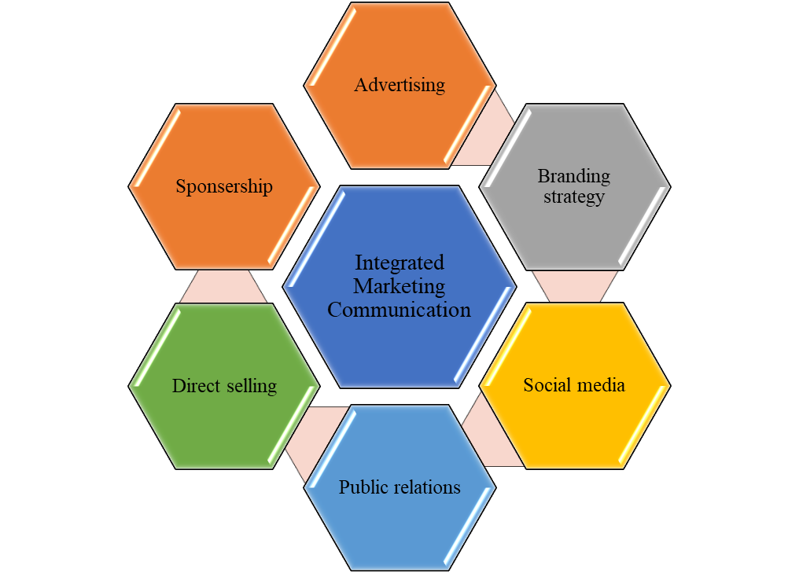
Figure 04: Integrated marketing communication
(Figure: Self-designed)
The tools of IMC are advertising, public relations, sales promotion, and direct marketing (Kushwaha et al., 2020). IMC plays an important role in building long-term and healthy relationships with customers as their messages are specially made for the targeted audience regarding their needs, wants, and lifestyles. This is considered an investment of the company that helps to increase brand equity by gaining customer loyalty (Oliveira and Marques dos Santos, 2022). In recent years, IMC is dominating the communication and market strategies of the companies and succeeding in the companies for their brand performance and brand appeals by reaching individual customers with a specially tailored message as per their demands.

4. New Promotional Strategy of Intel
Promotional strategy refers to the systematic measures taken by an organization to enhance the sales and marketing potential of the organization. However, the promotional strategy should be changed with time to achieve maximum outcomes. The recent promotional strategy of the Itel company can be proved as a great measure for the company to build brand recognition throughout the world. However, two types of promotional strategies can be adopted by the organization including online promotion and offline promotion (Feng et al. 2021).

4.1 Online Promotion
Brand advertisement through different digital platforms can be a great strategy for Intel to promote its brands online. They can advertise their product category, special features, price range, etc on the social media platform (Czinkota et al. 2021). It can attract a large number of audiences to the organization at a certain time.
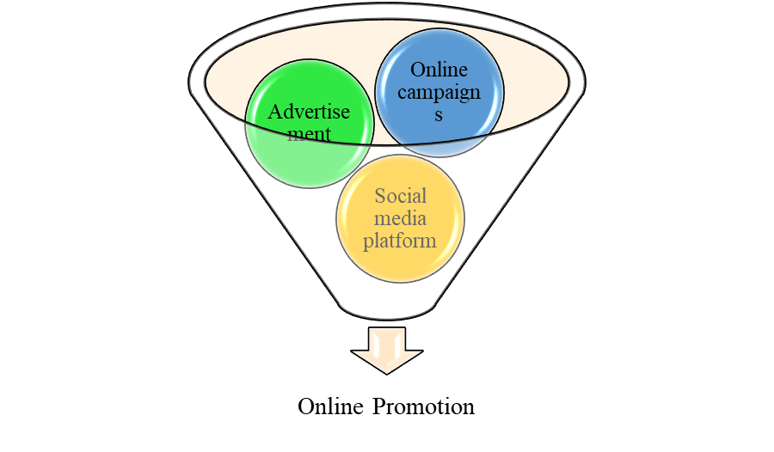
Figure 05: Online promotion of Intel
(Source: Self-designed)
However, Intel has launched the five-note jingle to encourage its promotional process around the globe. It has helped them to spread brand awareness among the people and enhance the marketing potential of the company. Along with that, Intel has organized different promotional campaigns through online platforms which helps them a lot to achieve success.

4.2 Offline Promotion
The measures taken by Intel to encourage offline promotion include direct selling of brands, personal selling, public relations, etc. The company performs a direct marketing system by connecting with wholesalers, retailers, and otter manufacturing companies to sell their products directly to potential buyers as well as encourage the growth of their business.
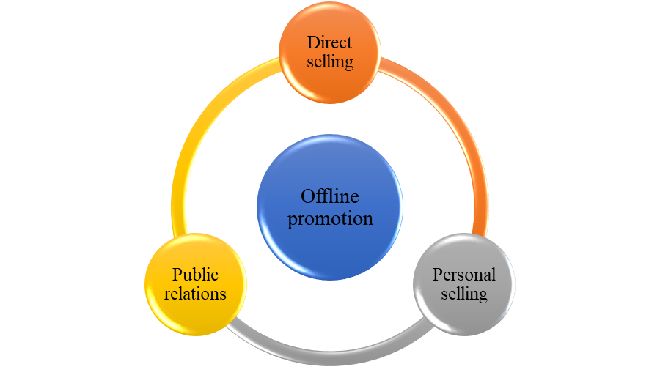
Figure 06: Offline promotion of Intel
(Source: Self-designed)
Along with that, Intel made a strong relationship with the customers as well as the stakeholders to market their brands. However, such offline promotional strategies helped the company in a great way to achieve the business goals of the company as well as get a significant profit (Haeruddin et al. 2023). Along with that this method of promotion helps the organization to build a bonding with the potential customers.

5. Branding and Brand Equity

5.1 Branding
Branding is a process of creating a strong image of the company's products and services in the minds of customers (Dam and Dam, (2021). It combines various elements like the brand design, logo, theme, and mission statement to create a strong impact in the customer's mind. As there are many companies in the market, branding is used as a tool to differentiate an organization from its competitors.
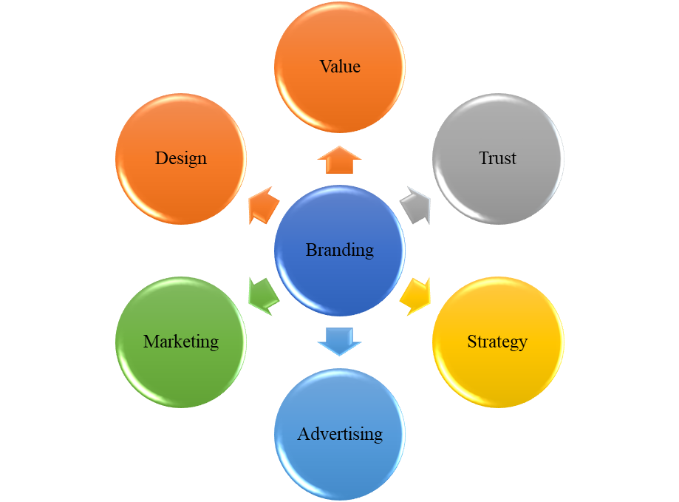
Figure 07: Different aspects of branding
(Source: Self-designed)

Unique and consistent branding can have a huge impact on the business as it gives the business an advantage over the competitors and helps in maintaining loyal customers at a much lower rate, leading to higher profit generation. A strong branding strategy is based on values that are similar to the customers' values or the targeted audience. Intel is one of the leading brands in the technology-based industry. It is dominating the world market with many investors interested in investing in the firm due to the excellent performance of the products developed by the firm.

5.2 Brand Equity
Brand Equity aims to increase the cash flow of the company and competitors from across the globe. Increasing brand equity is the goal of the company to stay strong in the market. Therefore, brand equity is a concept of marketing, branding studies, and management. Intel is a huge corporation that provides excellent services and products to its customers. With great branding and management skills, the firm has managed to stay ahead of its competitors and influence the global market. Good brand equity often has a positive influence on the responses from the stock market, market shares, consumer preferences, brand reputation, and the willingness of the customer to pay for attaining the services of the brand. It has two perspectives, i.e., customer-based and financial-based. The customer-based brand equity refers to the responses of the customers and how they are affected by the goods and services provided by the brand. Whereas, financial-based brand equity focuses on measuring the financial values and data to understand the brand's success (Marques et al.,2020).

6. Keller's Brand Equity Model
The brand is the first and foremost important element of a company which is directly involved with the profit of the company. Therefore, it is essential to develop strong brand equity to get a significant position in the market (Steenkamp et al. 2020). However, Keller has provided a pyramidic model of brand equity to provide knowledge about the level of brand identity and relationships. This model can help Intel to enhance their recognition throughout the world.
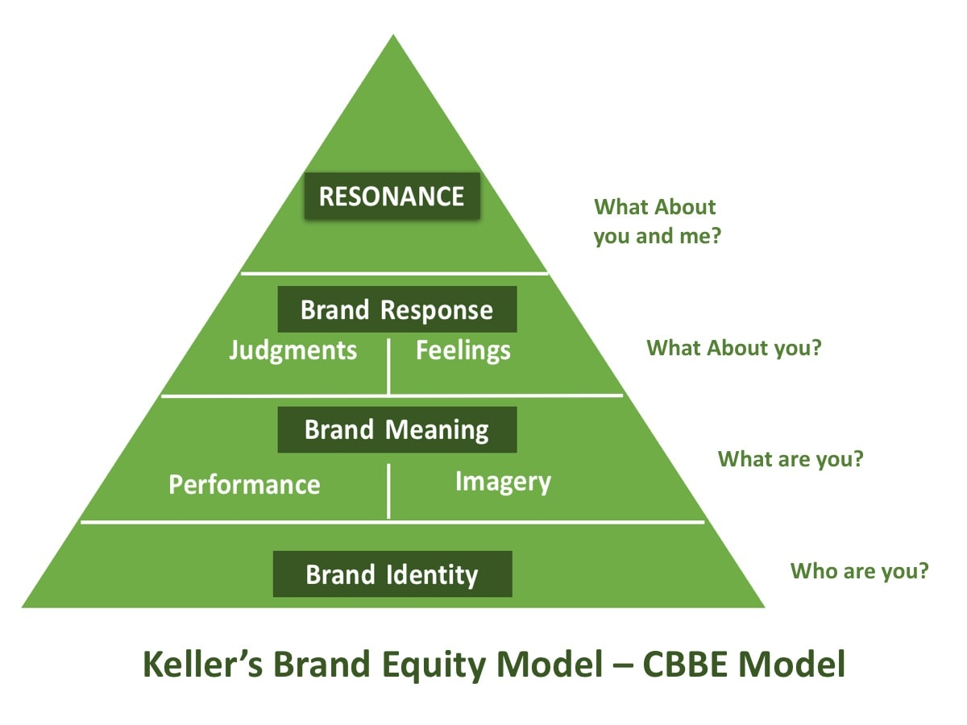
Figure 08: Keller’s Brand Equity Model
(Source: Bhasin, 2023)
According to Keller's model of brand equity, four components are related to the four questions. The first component is the identity which signifies the recognition of the brand. It indicates that Intel should provide all the information about its brand to enhance the reputation of the company. Along with that, they should provide accurate information to the customers. Next, there is the meaning which provides knowledge about the product quality and the pricing system of the product. It provides an opportunity for the customers to buy the right things as per their requirements. The next element is the response which comes from the customer’s end. It affects the reputation of the brands offered by the company (Doddy et al. 2020). The final element is the relationship which signifies the bonding between the company and the customers after purchasing a satisfying product. Intel should assess all these components carefully to increase its brand awareness.

6.1 Advantages of Keller’s Brand Equity Model
Providing strategic framework: Keller's brand equity model provides a strategic framework for Intel to promote its brands in the international market. It also provides a roadmap for the company to enhance business growth
Building brand awareness: Keller's model helps to enhance the awareness of the brand of Intel company which ultimately influences the company to achieve a desirable outcome.
Getting stability in the marketplace: By applying Keller's brand model Intel cab gets a stable position in the market which increases the marketing potentiality of the company.
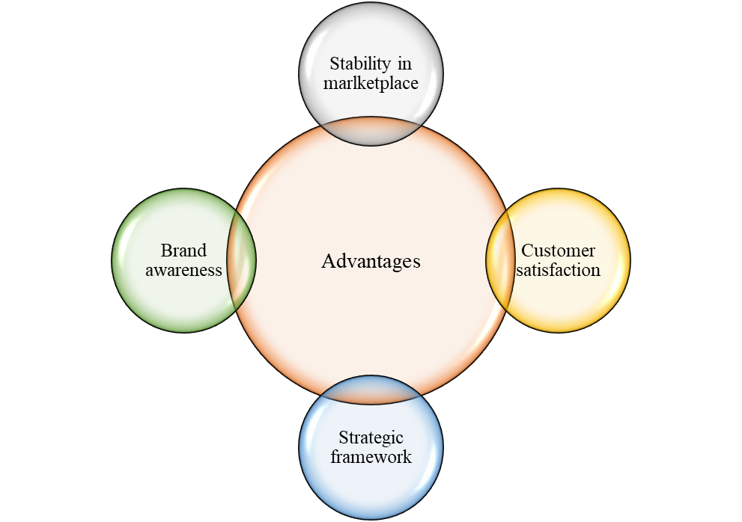
Figure 09: Advantages of Keller’s model
(Source: Self-designed)
Providing customer satisfaction: Customer satisfaction is another important aspect that needs to be considered by the company. However, the above brand model can help to bring loyalty to the brand among the customers.

6.2 Disadvantages of Keller’s Brand Equity Model
Negative impact in the market: Keller's model influences the company to get recognition widely but in that case, a bad product can affect the reputation of the whole brand.
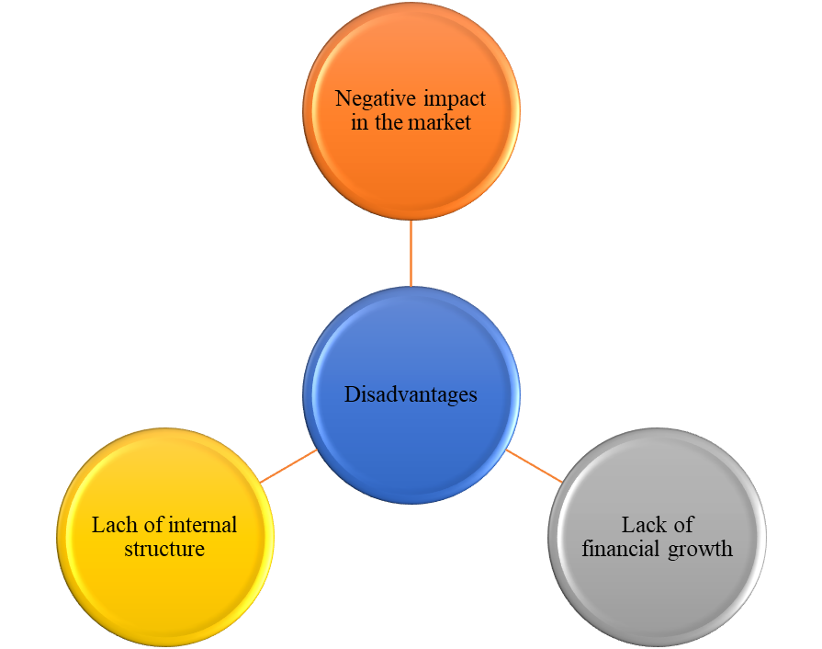
Figure 10: Disadvantages of Keller’s model
(Source: Self-designed)
Lack of improvement in internal structure: Keller's model does not provide much attention to the internal structure of the organization.
Lack of attention to financial growth: Keller's brand equity model also pays less attention to the financial stability of the organization.

7. Customer Journey
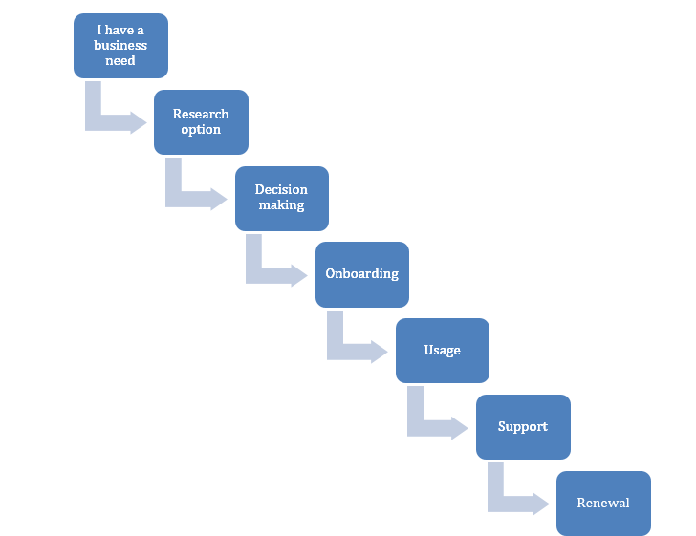
Figure 11: Customer Journey
(Source: Self-designed)
Customer journey is an important concept in understanding the complex behavior of the customers and getting feedback on their experience from the brand. It is a process that a customer goes through to gain access to a company's products and services (Tueanrat et at., 2021).
Four important stages of the customer journey can help Intel company to provide quality services to customers.
Awareness: As the customers need goods and services, they are looking for the best-suited company that offers their desired services and products. They start to become aware of the company and its services. At this stage, the employees of the company can help the customers by talking to them about their requirements and educating them about the business and its offerings. Intel can attract customers by publishing various products offered by them and also advertising their innovations.
Consideration: At this stage, the customer starts to consider one company over the others. The consideration stage of the customer requires more support and communication between the organization and the customers as they need a deeper understanding of the company and its products and services. They expect proof and facts of why the company is better than its rival. Some previous customers' reviews, case studies, or blogs of the company can help the customer to get a better understanding of the company. Intel can talk to their clients about their products and explain all the features of their products and services.
Decision: The decision-making stage occurs when the customer decides to buy products and services from a company. To ensure a smooth and easy way of selling goods and services, the company needs to provide well-established and user-friendly websites or offline stores that offer proper pricing information and multiple payment options to the customers. To get a smooth functioning, Intel might have to set up various branches in all the countries where their customers are based.
Loyalty: Even after a customer buys the products and services from the company, the engagement between the company and the consumer must continue to gain customer loyalty towards the firm. Intel is known to provide good services, but they can strengthen their customer loyalty by providing them with extra benefits to choose their services.

8. Customer Touch Points
Customer touchpoints indicate the interaction between the customers and the company related to the product or services (Larochelle et al. 2019). It helps an organization find opportunities to provide quality services to its customers. Due to the digitization process companies like Intel have advanced their customer touchpoints and enhanced their organizational efficacy. However, there are mainly three types of touchpoints found including pre-purchase, purchase, and post-purchase touchpoints.

8.1 Pre-purchase
Intel website: Intel’s website is a great example of pre-purchase touchpoints for their business. By visiting this website people can check the products as per their requirements.
Advertisement: Intel adopted the advertisement process for increasing brand awareness and attracting a large number of customers to their organization. It helps the company to increase the reputation of the company (Heath and Gaeth, 2019).
Social media platform: Intel uses different types of social media platforms to promote its brands. The popular social media handles of the company include Facebook, Instagram, LinkedIn, Twitter, youtube, etc.
Review: Evaluating customer reviews are also an essential measure for the company to draw the attention of the customers.

8.2 Purchases
Online shop: Intel introduced its online shop to provide purchasing facilities to customers of different countries. However, this approach of the company helped them to get a significant number of customers.
Direct selling: Intel has many stores all over the globe which facilitates the customers to buy products directly from the shop. Customers who want to purchase from a physical store can take this facility of direct selling (Peterson et al. 2020).

8.3 Post-purchase
Customer feedback: Taking customer feedback is an essential step after a successful purchase. Intel takes customer feedback from different digital platforms as well as conducting different surveys (Lucini et al. 2020).
Customer relationship: Intel values its customers to a great extent. They provide significant customer solutions to maintain good relations with them. It helps to influence the company for further development to a great extent.

9. Customer Journey Map
A customer journey map is a description of a customer journey and its stages. It informs the business about customer interaction from the first stage of awareness to the last stage of gaining customer loyalty (Bascur et al. 2019). The firm can detect customers' behavior, gaps, and loopholes, and understand the customers' experience with the help of a customer journey map (Techtarget, 2023).

9.1 The Persona of an Intel Customer
Intel and Lenovo joined hands and came into a multi-year partnership on August 5, 2019 (HT Tech, 2022). Together, they will focus on the creation of High-Performance Computers and AI models.

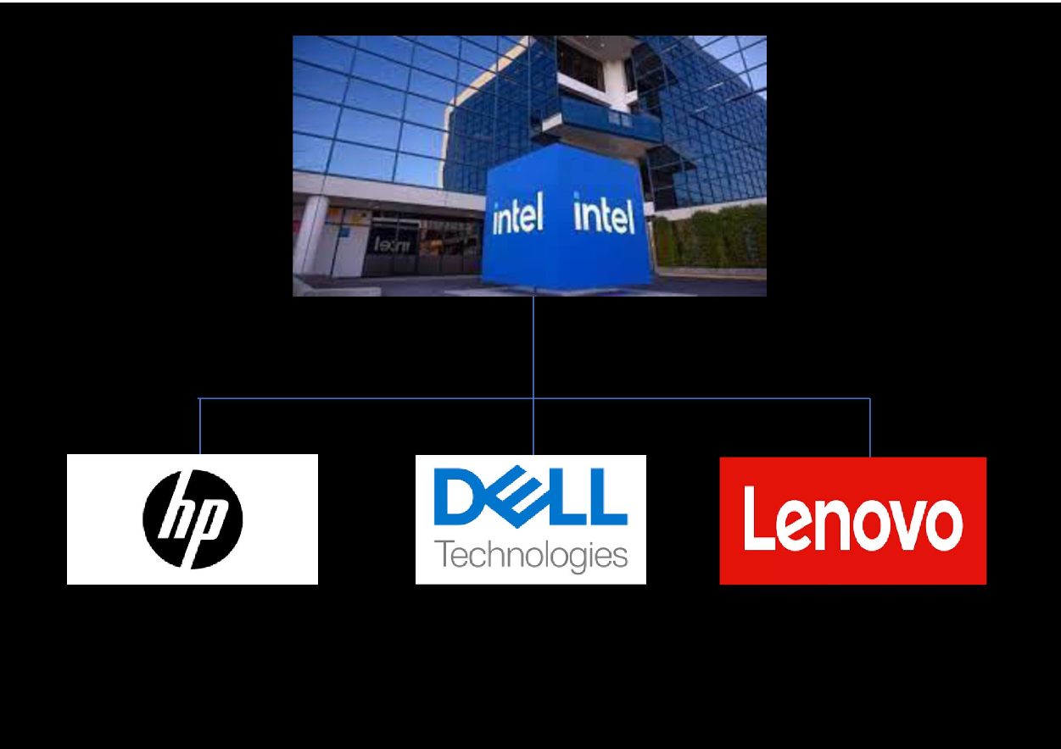
Figure 12: Customers of Intel
(Source: Self-design)
Background: Lenovo is a technology company that produces innovative PCs and mobile phones. Founded in 1984, the worth of Lenovo is US$ 47 billion currently as it has emerged as the world's largest PC vendor company across the globe. Today, the company has expanded to almost all countries and produces all the technological devices including workstations, tablets, servers, smartphones, and many more (Nikkei, 2023). Lenovo products use Intel processors, servers, and AMD-powered appliances.
Demography: Intel has managed to expand worldwide through Lenovo and other customers. The branches of Intel are located in 46 countries and have more than 10 lakh employees working across the globe (Intel, 2023). The company supports diversity in the workplace with 72 percent male employees and 27 percent females. It also gives way to the ethnicity of the company by offering jobs to white people, Asians, Black and African Americans, Latino and Hispanic people (Zippia, 2023).

9.2 Critical analysis of Customer Journey map
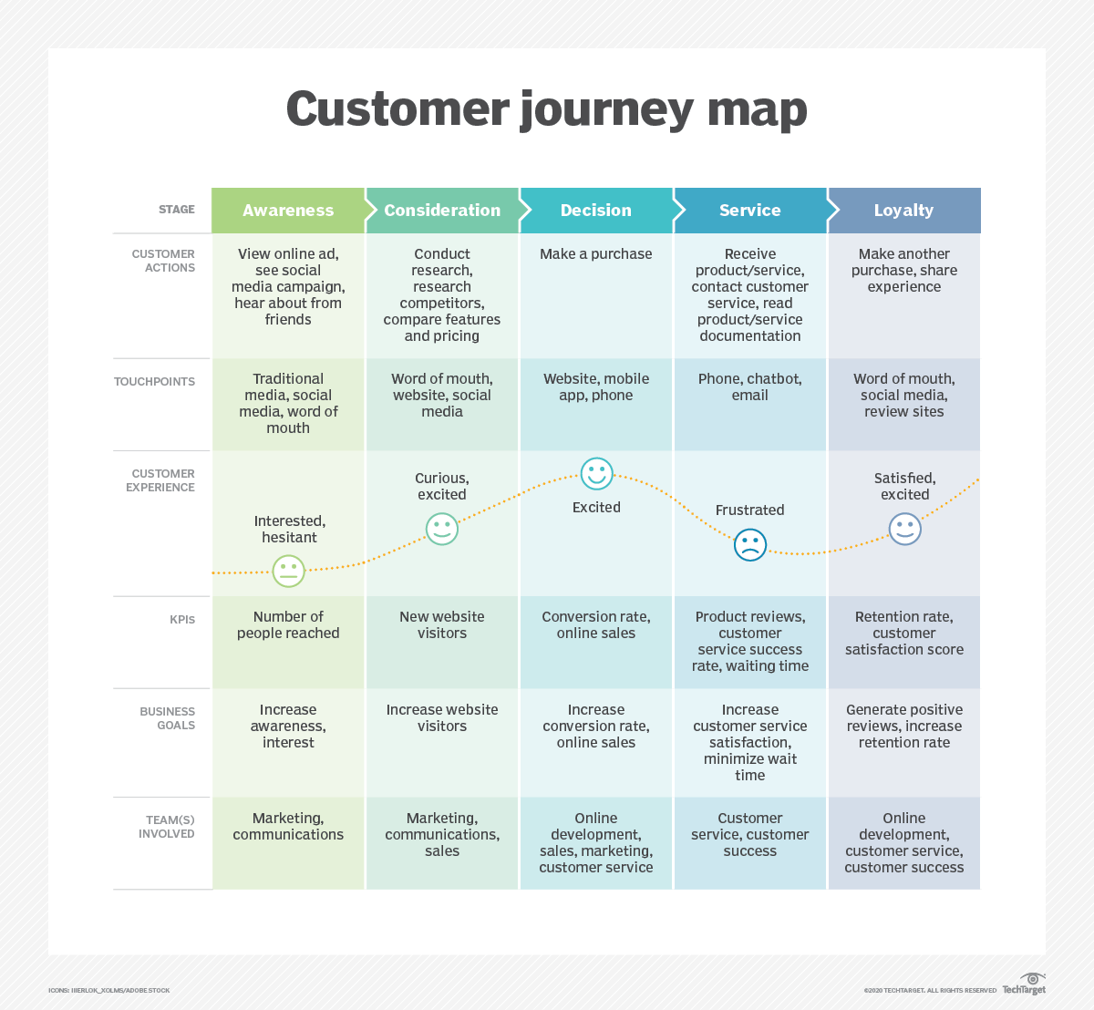
Figure 13: Customer Journey Map
(Source: TechTarget, 2023)
Lenovo joined hands with Intel Corporation on 5th August 2019 and has been in good relations with the firm. Both firms have decided to focus on the development of High-Performance Computers and strengthening the AI models shortly. Intel provides processors and servers to Lenovo for their computers, laptops, and tablets. All Computer Models of Lenovo have adopted Intel processors. With excellent services and quality provided by Intel, Lenovo is indulging more in their partnership.

9.3 Strengths
Intel is one of the leading technology brands. It has several strengths that have led to the success of the company.
Strong brand reputation: Intel is trusted by most customers due to its high performance and high-quality computer products. The processors of Intel are the most trending product.
Innovations and Creativity: Intel has been developing technologies for a long duration and has played a vital role in the evolution of the computer industry. They have been updating their work environment with the global changes and the requirements of the customers.
Strong market position: Intel is the most dominant company in the computer processor market. With many investors, Intel gets the advantage of developing new technologies and products with great investments received.

9.4 Weakness
Being one of the finest companies in processor markets, Intel also has some weaknesses when it comes to customer requirements and experience.
Absence in Mobile Sector: Intel is leading the Computer Industry and now, they are entering the AI sector too with the help of its customers. But still, Intel is missing from the mobile sector. As all people these days have multiple smartphones, Intel doesn't have any plans to enter the Smartphone Industry.
Extra Production: Intel is known to over-produce its products which leads to the reduction of demand in the market. The market gets flooded with its products which have a huge impact on the profits of the firm.
Missing from Developing Countries: Intel has managed to expand in various countries but its branches are still missing from the developing countries of the world. For the production of PCs or tablets in developing countries, Intel has to ship its processors to its customers.

10. The Total Engagement Mode
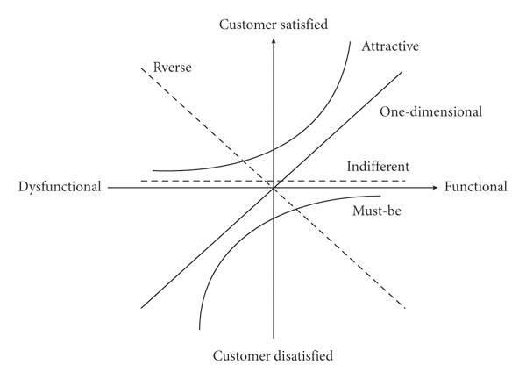
Figure 14: Kano Model of Customer Satisfaction
(Source: Li and Zhang, 2021)
Business companies are increasingly focussing on providing satisfaction to their customers to gain their loyalty. The customer satisfaction models are used to measure the effect of the company's products on the customers and their satisfaction. The Kano Model of Customer Satisfaction is one of the finest models to measure customer satisfaction and improve the problem-solving process of the firm (Li and Zhang, 2021). It tells the organization about product performance and customer satisfaction after using the product. It divides the product attributes into four parts:
Threshold: Threshold attributes are expected by the customers and are a "must" of the products or services provided by the firm.
Performance: If the performance of the services and products provided to the customers is good, the customer will be happy and demand more of it. But if the performance is bad, the satisfaction of the customer will diminish.
Excitement: The excitement attributes are the latent needs of the consumers, i.e., the customer does not expect them but gets highly satisfied if they receive them. It generally comes from the performance of the customer services or extra features and profits in the services and products given to the customer.
Indifferent: These are the attributes that a customer does not expect but have a huge impact on the decision-making of the customer.
Intel can use the Kano Model of Customer Satisfaction to ensure smooth functioning and better quality of the products. They do follow the Threshold and Performance attributes for the clients, but they can apply the other two attributes to make their clients more satisfied. It will also help the company to expand in developing countries as well by attracting other customers that fail to reach the firm.

11. Recommendations
For a company like Intel, finding new investors and clients is an easy task. Though there are some recommendations that the firm can implement to gain better profits and ensure customer satisfaction at all levels:
Expansion to Developing Countries: As Intel is based only in the developed countries of the world, the owners of the company can start to expand in developing countries as well. As developing countries are becoming a hub of innovations and technologies, Intel can find many suitable clients who need guidance and advanced processors to achieve their goals.
Less Production: Most of the processors and servers of Intel flood the market and reduce the demands of the customers. By developing less amount of goods and services, the company can increase the demand for its products in the market. Once the demand is increased, the company can also increase its prices. This will lead to better profits for the company and reduce the wastage of products, efforts, and costs.
Development in Mobile Sector: With many happy and satisfied customers, Intel can expand to the Mobile Industry as well. The company has already managed to create a chain of loyal customers. If the company puts appropriate strategies and methods to set up in the mobile sector, the company may see various profits in the upcoming years.

12. Conclusion
The whole study provides a clear overview of the marketing management theory along with explaining its importance in the most popular semiconductor manufacturing company that is Intel. The study also provides an overview of the company by illustrating the global market share and the revenue of the company. Along with that, the study includes the communication system in the workplace demonstrating Shannon-Weaver's communication model and the integrated communication system. The study also reflects current promotional strategies adopted by Intel including the online and offline marketing strategies. The concept of branding and brand equity is mentioned in the study by explaining Keller's brand equity model. The study also signifies the customer journey and customer touchpoints by critically evaluating the customer journey map.
However, from the above study, it can be concluded that Intel has adopted some marketing management strategies to improve the quality of the business growth of the company. But there is room for improvement for the company to encourage an effective marketing management system as well as achieve the maximum profit per year. The given recommendations can provide insights to the particular organization to inculcate future opportunities to develop its brand throughout the world.

References
Bascur, C., Rusu, C. and Quiñones, D., (2019). User as customer: touchpoints and journey map. In Human Systems Engineering and Design: Proceedings of the 1st International Conference on Human Systems Engineering and Design (IHSED2018): Future Trends and Applications, October 25-27, 2018, CHU-Université de Reims Champagne-Ardenne, France 1 (pp. 117-122). Springer International Publishing. Available at: https://link.springer.com/chapter/10.1007/978-3-030-02053-8_19
Bhasin, H. (2023), Keller’s Brand Equity Model – CBBE model by Keller, Marketing91. Available at: https://www.marketing91.com/kellers-brand-equity-model/ (Accessed: 17 August 2023).
Blakeman, R., (2023). Integrated marketing communication: creative strategy from idea to implementation. Rowman & Littlefield. Available at: https://books.google.com/books?hl=en&lr=&id=tPDIEAAAQBAJ&oi=fnd&pg=PP1&dq=integrated+marketing+communication+for+business&ots=kO2lAKuNuQ&sig=YzWbc9uZeQNMJHbT_kT7vQQwKBk [Accessed 5 August 2023]
Caixin, (2020). Lenovo Wins Bragging Rights With ‘World First’ 5G Laptop. Available at: https://www.google.co.in/url?sa=i&url=https%3A%2F%2Fwww.caixinglobal.com%2F2020-01-08%2Flenovo-wins-bragging-rights-with-world-first-5g-laptop-101502313.html&psig=AOvVaw2QMtllAcyqvBgm07cxaTXy&ust=1691325531547000&source=images&cd=vfe&opi=89978449&ved=0CBEQjRxqFwoTCOjV6OHExYADFQAAAAAdAAAAABAo [Accessed 5 August 2023]
Communication Theory, (2020). Shannon and Weaver Model of Communication. Available at: https://www.communicationtheory.org/shannon-and-weaver-model-of-communication/ [Accessed 5 August 2023]
Czinkota, M.R., Kotabe, M., Vrontis, D., Shams, S.R., Czinkota, M.R., Kotabe, M., Vrontis, D. and Shams, S.R., (2021). Designing effective promotion and advertising strategies. Marketing Management: Past, Present and Future, pp.553-606. Available at: https://www.researchgate.net/profile/Demetris-Vrontis/publication/354106239_Designing_Effective_Promotion_and_Advertising_Strategies/links/6283aa7717ae76609bfd306a/Designing-Effective-Promotion-and-Advertising-Strategies.pdf [Accessed 5 August 2023]
Dam, S.M. and Dam, T.C., (2021). Relationships between service quality, brand image, customer satisfaction, and customer loyalty. The Journal of Asian Finance, Economics, and Business, 8(3), pp.585-593. Available at: https://www.researchgate.net/profile/Dam-Mai/publication/349869313_Relationships_between_Service_Quality_Brand_Image_Customer_Satisfaction_and_Customer_Loyalty/links/60531717458515e83452184e/Relationships-between-Service-Quality-Brand-Image-Customer-Satisfaction-and-Customer-Loyalty.pdf [Accessed 5 August 2023]
Deepak, R.K.A. and Jeyakumar, S., (2019). Marketing management. Educreation Publishing. Available at: https://books.google.com/books?hl=en&lr=&id=_DmvDwAAQBAJ&oi=fnd&pg=PA1&dq=market+management&ots=u49Whggs1e&sig=Vt2JoUHepxeXSg37Wdr-hE9Z2P4 [Accessed 5 August 2023]
Doddy, M., Ali, J., Hindardjo, A. and Ratnasih, C., (2020), December. The Influence of Brand Awareness, Perceived Quality, Brand Association, Brand Loyalty on Brand Equity of Zakat Institutions. In Proceedings of The International Conference on Environmental and Technology of Law, Business and Education on Post Covid 19, ICETLAWBE 2020, 26 September 2020, Bandar Lampung, Indonesia. Available at: https://eudl.eu/pdf/10.4108/eai.26-9-2020.2302683 [Accessed 5 August 2023]
Febriantini, W.A., Fitriati, R. and Oktaviani, L., (2021). An analysis of verbal and non-verbal communication in autistic children. Journal of Research on Language Education, 2(1), pp.53-56. Available at: https://ejurnal.teknokrat.ac.id/index.php/JoRLE/article/download/923/541 [Accessed 5 August 2023]
Feng, N., Chen, J., Feng, H. and Li, M., (2021). Promotional pricing strategies for platform vendors: Competition between first-and third-party products. Decision Support Systems, 151, p.113627. Available at: https://www.sciencedirect.com/science/article/pii/S0167923621001378 [Accessed 5 August 2023]
Haeruddin, M.I.W., Musa, M.I. and Kurniawan, A.W., (2023). Marketing Strategy Analysis in A Global Market. Journal Management & Economics Review (JUMPER), 1(1), pp.17-24. Availabel at: https://malaqbipublisher.com/index.php/JUMPER/article/download/23/29 [Accessed 5 August 2023]
Heath, T.B. and Gaeth, G.J., (2019). Theory and method in the study of ad and brand attitudes: Toward a systemic model. In Attention, attitude, and affect in response to advertising (pp. 125-148). Psychology Press. Available at: https://journals.telkomuniversity.ac.id/ijm/article/download/2234/1078 [Accessed 5 August 2023]
HT Tech, (2022). Available at: https://www.google.co.in/url?sa=t&rct=j&q=&esrc=s&source=web&cd=&ved=2ahUKEwirwNPowsWAAxW-SmwGHTvJBXoQFnoECDAQAQ&url=https%3A%2F%2Ftech.hindustantimes.com%2Ftech%2Fnews%2Flenovo-intel-announce-multi-year-collaboration-on-ai-computing-story-YUqL6QDHYG8KYelwj4hqIL.html&usg=AOvVaw0teRcMB0ySLrL6N9QvDFip&opi=89978449 [Accessed 5 August 2023]
Intel, (2023). Delivering World-Changing Technology. Available at: https://www.intc.com/about-intel [Accessed 5 August 2023]
Intel, (2023). Intel locations. Available at: https://www.google.co.in/url?sa=t&rct=j&q=&esrc=s&source=web&cd=&cad=rja&uact=8&ved=2ahUKEwiV-uaRzcWAAxXRTmwGHVCBA5QQFnoECBEQAQ&url=https%3A%2F%2Fwww.intel.com%2Fcontent%2Fwww%2Fus%2Fen%2Fjobs%2Flocations.html&usg=AOvVaw03pKNq5T2r_1dOXwIH6DGG&opi=89978449 [Accessed 5 August 2023]
Kushwaha, B.P., Singh, R.K., Varghese, N. and Singh, V.N., (2020). Integrating social media and digital media as new elements of integrated marketing communication for creating brand equity. Journal of Content, Community & Communication, 11(6), pp.52-64. Available at: https://www.researchgate.net/profile/Zinggara-Hidayat-2/publication/350639866_Data-Driven_Journalism_Based_on_Big-Data_Analytics_A_Model_Development_from_Indonesia's_Experience/links/6070302692851c8a7bb38cbc/Data-Driven-Journalism-Based-on-Big-Data-Analytics-A-Model-Development-from-Indonesias-Experience.pdf#page=59 [Accessed 5 August 2023]
Larochelle, M.R., Bernstein, R., Bernson, D., Land, T., Stopka, T.J., Rose, A.J., Bharel, M., Liebschutz, J.M. and Walley, A.Y., (2019). Touchpoints–opportunities to predict and prevent opioid overdose: a cohort study. Drug and alcohol dependence, 204, p.107537. Available at: https://www.ncbi.nlm.nih.gov/pmc/articles/PMC7020606/ [Accessed 5 August 2023]
Li, M. and Zhang, J., (2021). Integrating Kano model, AHP, and QFD methods for new product development based on text mining, intuitionistic fuzzy sets, and customer satisfaction. Mathematical Problems in Engineering, 2021, pp.1-17. Available at: https://www.hindawi.com/journals/mpe/2021/2349716/ [Accessed 5 August 2023]
Lucini, F.R., Tonetto, L.M., Fogliatto, F.S. and Anzanello, M.J., (2020). Text mining approach to explore dimensions of airline customer satisfaction using online customer reviews. Journal of Air Transport Management, 83, p.101760. Available at: https://www.sciencedirect.com/science/article/pii/S0969699719302959 [Accessed 5 August 2023]
Marques, C., da Silva, R.V., Davcik, N.S. and Faria, R.T., (2020). The role of brand equity in a new rebranding strategy of a private label brand. Journal of Business Research, 117, pp.497-507. Available at: https://www.sciencedirect.com/science/article/pii/S0148296320303982 [Accessed 5 August 2023]
Nikkei, (2023). Lenovo Group Ltd. Available at: https://www.google.co.in/url?sa=t&rct=j&q=&esrc=s&source=web&cd=&ved=2ahUKEwiluLbXxsWAAxW-bGwGHeIfDm0QFnoECCkQAQ&url=https%3A%2F%2Fasia.nikkei.com%2FCompanies%2FLenovo-Group-Ltd&usg=AOvVaw3qsKGljz_gSlMr0kNRCPdZ&opi=89978449 [Accessed 5 August 2023]
Oliveira, N. and Marques dos Santos, J.P., (2022). Online Brand Community Characterization with Engagement and Social Network Analysis (SNA) for Marketing Communication: The Subreddit r/intel. In Marketing and Smart Technologies: Proceedings of ICMarkTech 2021, Volume 2 (pp. 577-591). Singapore: Springer Singapore. Available at: https://link.springer.com/chapter/10.1007/978-981-16-9272-7_47 [Accessed 5 August 2023]
Peterson, R.A., Albaum, G. and Crittenden, V.L., (2020). Self-efficacy beliefs and direct selling sales performance. International Journal of Applied Decision Sciences, 13(4), pp.448-463. Available at: https://www.inderscienceonline.com/doi/abs/10.1504/IJADS.2020.110618 [Accessed 5 August 2023].
Statista, (2023). Intel semiconductor market revenue share worldwide from 2008 to 2022. Available at: https://www.statista.com/statistics/294804/semiconductor-revenue-of-intel-worldwide-market-share/ [Accessed 5 August 2023]
Steenkamp, P., Jacobus Herbst, F., Christiaan De Villiers, J., Terblanche-Smit, M. and Schmidt, H.J.,(2020). Servbrand framework: A business-to-business services brand equity framework. Journal of Business-to-Business Marketing, 27(1), pp.55-69. Available at: https://www.researchgate.net/profile/Frikkie-Herbst/publication/338740920_Servbrand_Framework_A_Business-To-Business_Services_Brand_Equity_Framework/links/5e2820fda6fdcc70a140edfc/Servbrand-Framework-A-Business-To-Business-Services-Brand-Equity-Framework.pdf [Accessed 5 August 2023]
Techtarget, (2023). customer journey map. Available at: https://www.google.co.in/url?sa=t&rct=j&q=&esrc=s&source=web&cd=&ved=2ahUKEwjM39ehtMWAAxWFSWwGHUZcBaMQFnoECCkQAQ&url=https%3A%2F%2Fwww.techtarget.com%2Fsearchcustomerexperience%2Fdefinition%2Fcustomer-journey-map&usg=AOvVaw0KBArG9zmD6l_kr74gHNsx&opi=89978449 [Accessed 5 August 2023]
Tueanrat, Y., Papagiannidis, S. and Alamanos, E., (2021). Going on a journey: A review of the customer journey literature. Journal of Business Research, 125, pp.336-353. Available at: https://www.sciencedirect.com/science/article/pii/S0148296320308584 [Accessed 5 August 2023]
Zippia, (2023). INTEL DEMOGRAPHICS AND STATISTICS. Available at: https://www.google.co.in/url?sa=t&rct=j&q=&esrc=s&source=web&cd=&cad=rja&uact=8&ved=2ahUKEwiO7Jjry8WAAxUgXGwGHVwqCyYQFnoECBwQAQ&url=https%3A%2F%2Fwww.zippia.com%2Fintel-careers-6055%2Fdemographics%2F&usg=AOvVaw3lYEeE1cQtIA2b9NLgl9ew&opi=89978449 [Accessed 5 August 2023]

