LCBB5004 Managing People
Assessment 2

Name:Daniel Miroslavov Borisov

Student Number: 1907092

Lecturer: Dr. Mushfiqur Rahman

Executive Summary
It can be summarized in the project that due to Covid-19 situation, every industry affected very much. The turnover of the business is also fallen drastically. Thus, the employee engagement rate is also falling due to working from home option. In this project, it is described how a company can make employee engagement in this situation as well. The UK considered one of the developed countries in the whole world; however, the pandemic situation makes their business situation worst as well. The entire task has described the engagement strategies, ideas, engagement measure tools and how to improve the rate of engagement in this situation.

Table of Contents
Executive Summary 2
Introduction 4
The concept and Drivers of employee engagement during the pandemic 4
Theory of employee engagement. 5
Theories of employee motivation 5
The implication of Engagement theory and Motivation Theory 6
Diagnostic tools to measure in the engagement 7
The implication of measuring tool 8
Employee value proportion 9
Strategies to raise the level of engagement. 10
Conclusion 11

Introduction
In this Covid-19 situation, the structure of the business changed enormously. Employees of an organization have started work from home and managing everything online. In this situation, managing people of an organization is not comfortable at all. It takes lots of strategies to regulate the workers rightly. A low level of employee engagement in a company can be a reason for the low turnover of an organization. A low turnover can led a company into poor business experiences. Thus, managing people is a vital factor to make a company successful. In this study, a brief explanation of a UK company is given, and this further includes the concept and drivers of employee engagement during the pandemic and theories of employee engagement and motivation. In the next discussion, it covers some factors like diagnostic tools to measure, employee value proportion, their ideas with analysis and some strategies to raise the level of engagement in a company.

The concept and Drivers of employee engagement during the pandemic
During this Covid-19 situation, a managing business becomes a very tough job for any organization. Whether the workers of the UK or any other country, the post-Covid-19 situation is very difficult for any organization. Nowadays the work depends on online engagement (increased by 66%) more than physical engagement, so managing every employee like always is not possible. The pandemic situation will disappear not any time soon.
Employees can feel isolated and uncertainty in the job while working from home. Though, remuneration hike is an important tool to increase employee engagement; however, in this situation, a hike in remuneration is also quite impossible for any company. So, difficulties in managing the worker become tougher than the previous situation.
According to the research, it has been seen that the UK employee engagement score is 45%. Engagement rate also depends on the feeling of an employee and their involvement in the work. Those employees who are engaged in the work, the company will get the most benefits out of them. Every worker wants to make their contribution significant to the company. So, when employees are working from home, it is somewhat problematic to ensure the contribution of an individual worker.

Theory of employee engagement.
According to De Vito et al. (2018), the father of employee engagement theory is William Kahn. He said in his theories that an organization always needs engaging and motivated employees to span their business widely. A skilled worker always considers useful for the company who thinks beyond the expectation the higher authority of an organization. Automatically, a well-skilled and wide thinker employee gives more turn over to the business than others. Khan’s research on employee engagement includes three psychological engagements.
- Meaningfulness of work is vital to engaging an employee to work. None are interested in working on something which is not important for the company.
- Safety of the employee in the workplace is considered one of the primary factors for engaging an employee into their work.
- Availability of the physical and mental state to tackle that work pressure successfully. The physical and mental environment is needed to be right in the workplace for completing a job successfully.

Theories of employee motivation
According to Rao, Kulshrestha and Ramakrishnan (2019), Maslow's need for the hierarchy is one of the best motivation theories for employee engagement. The main focus of his theory is the needs of hierarchy for an organization. His theory includes five needs for the motivation these are as follows. In the lowest point of motivation, Psychological needs are the primary factor.
- Every person needs safety in the workplace. These refer to the protection from accidents which can occur during working hours, sudden unemployment, physical torture and others.
- Social needs are considered essential points after satisfying an employee's psychological needs and safety needs. This point includes affection, love, association, friendship among the people of the organization.
- In the fourth point, Esteem needs can be included. Every human needs recognition, and with that achievement, a higher evolution of the work.
- Self-actualization needs for improving every day is considered the highest level of motivating an employee. It includes individual desires and development to the maximum level (Joshi and Das, 2017).

The implication of Engagement theory and Motivation Theory
In this situation, everything cannot follow as per the theory; however, engaging employees is important for each business and each time. Here, the explanation of how industry engaging employees has been given.
- During these Covid-19 situations, the people of the UK are facing disturbance in their houses and also in the jobs. The workforce of an organization decreases as the supervision is not possible during work from home. Employee engagement rate can increase by the supervision of higher authority.
- Supportive management who has known the key to managing work from home is suitable for this scenario (Ahmed, 2020). Nowadays, every organization is started working from home option for the safety measure of the employees. So, good management can remote everyone’s work from sitting very far than an employee.
- Working from a new set up is the biggest challenge for any employee when they are starting work from home. Employees have to do work without going to the office and without their colleagues is a discouragement for any worker. Even when they are failing in any work or work more than their capacity, no one can help it out. So accepting the new form of work mode is important.
- Trust among employees and management is one of the key factors in managing people during the pandemic situation. Every employee needs to trust their hierarchy for better productivity of any organization (Risley, 2020). Especially in the time of working home scenarios, it is essential to have faith in the higher authority and management of any organization. Leaders help in the development of employees; thus, individual growth helps in the overall growth of the company.

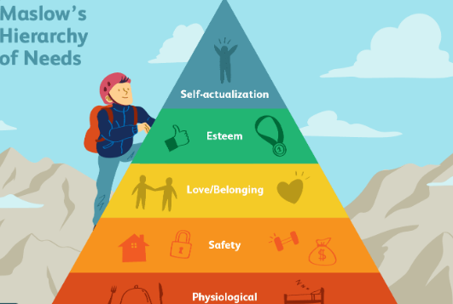
Figure 1: Maslow’s hierarchy theory
(Source: Influenced by Risley, 2020)

Diagnostic tools to measure in the engagement
Measuring employee engagement is an important tool to diagnose the work of individual employees. This management tool helps in motivating the employees and increasing the growth of the company (Jha and Kumar, 2016).
- Focusing on individual opinion is essential in increasing productivity. It is not possible to take the individual point of view in work but listening to the leaders carefully can increase the motivation in employees. So, they become easy going with management. Most importantly, the higher authority should get the most of their ability from every employee.
- Asking one or two questions every day to the employee can uplift the engagement rate in work immediately. The pulse survey has three metrics to increase the engagement rate in the workplace; one is Satisfaction, which describes whether the employee is satisfied with the job. Second is Alignment, which describes the goal of an employee, and the last is future planning and expectation of the employee from the workplace.
- Holding exit interviews can help in improving employee engagement in the organization. Some of the employees give resignation in the job due to personal reasons and some due to the professional environment. Understanding the employee’s requirement is a great way to improve the workforce of the company (Jindal, Shaikh and Shashank, 2017).
- The number of time an employee is getting recognition for their work is another tool to improve the rate of employee engagement in the workplace. The organization can measure the individual employee’s recognition rate to increase the engagement of the employee.
- Measuring the retention rate of an employee is important as it is also a vital tool to improve the engagement rate. This project gives a demonstrate viewpoint about the employees; thus, automatically, it increases the rate of employee engagement. However, with the help of increasing retention, a company can understand the rate of employee engagement.
- There are a lot of diagnostic tools to measure the employment rate; however, metric count considers the best of all (Jha and Kumar 2016). Measuring the productivity of an organization can make the work easier as it helps in measuring a team or an individual employee of the workplace.

The implication of measuring tool
In this pandemic situation, using these tools to measure the engagement rate of the employee is not easy for an organization (Jyoti, 2019).
- In the first point, it has been seen that individual opinion is important, in the working from home situation management can take the feedback of employee is through telephone or online.
- It is also possible to ask various questions about the work and the situations they are facing during this pandemic. An organization should show some concern to the employee’s health and benefit even if they are doing work from home (Allas, Chambers, and Welchman, 2019).
- Though the economic situations of the UK are not stable right now, so most of the people would not think about leaving the job; however, if someone does then the company can discuss the reason behind it.
- Even during this working condition management can recognize the individual work of the employees; thus, it helps to motivate the employees. The monetary increase is the biggest motivation for any employee. In the covid-19 situation where the economic situation is very poor in the UK, hike in the individual remuneration can make an employee immensely motivated.

Employee value proportion
Employee value proportion helps a company to provide the experience to the new employee is an attractive job structure. Ideas that can be followed in the time of making an (Salau, 2018) employee value proportion (EVP) are,
- Employer branding is the greatest idea to attract fresh people who are finding a job. Setting a goal that can help a company to get numerous applicants. It also reduces the time of management. Identifying the persona of the new candidates helps an organization to judge that new candidate. Explaining the EVP of the company to the new candidates can make the situation easier (Salau, 2018).
- The engagement of old employees generates interest among the fresh candidates. In case an old employee gives good feedback about the company to the new lot, it increases the standard of the company. Thus, it also helps in developing the engagement value proportion.
- Human resource department also plays an important part in increasing companies’ engagement value portion. The human resource department can give information to the new candidates. It helps in making a bridge between the company and the employees.
- Brand management of employer increases the value proportion of any organization. People always try to join a reputed company rather than other non-reputed organization (Salau, 2018).
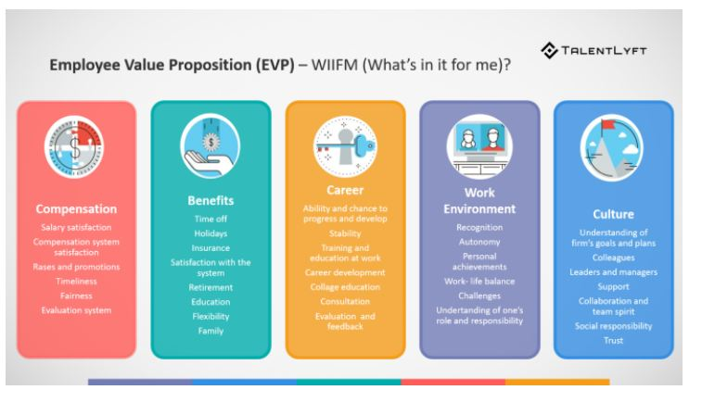
Figure 2: Employee Value Proportion
(Source: Influenced by Salau, 2018)

Strategies to raise the level of engagement
Every organization in the UK needs some strategies to increase the engagement value proportion.
It includes,
- Good communication with the workers of the organization can improve the productivity of the company. Human Resource department should try to communicate deliberately and often with the employees.
- Creating a healthy work environment during Covid-19 situation is quite impossible; however, management should encourage the employee to get a healthy workplace in the home as well (Aithal, and Kumar, 2016).
- Giving feedback through an online portal or telephone is an important strategy to increase the engagement rate. Not only is that but also taking employee’s feedback also an essential tool to measure the engagement rate.
- Defining the purpose of the organization to the people increase the image and brand value of that company. It increases the authenticity and market value of an organization. Moreover, employee engagement is necessary for the reputation of any organization.

\Conclusion
From the above study, it can be concluded that employee engagement rate is seeing a downfall in the pandemic situation of Covid-19. As it is describing the current working situation in the UK; however, the whole world is facing a poor situation in the workplace due to the low rate of employee engagement. Working from home option does not allow the company to make a physical engagement with the employee; thus, it creates a problem in managing the people of any organization. Whether it is the UK or any other country, employee engagement makes a huge impact on the business turn over. The current scenario would go off easily, so the organization should try to manage people according to these situations. Online portals take a huge part nowadays as a medium of communication. For running the business smoothly, an organization should follow some strategies and make the employees connected.

References
Ahmed, T., Shahid Khan, M., Thitivesa, D., Siraphatthada, Y. and Phumdara, T., 2020. Impact of employees engagement and knowledge sharing on organizational performance: Study of HR challenges in COVID-19 pandemic. Human Systems Management, (Preprint), pp.1-15.
Aithal, P.S. and Kumar, P.M., 2016. Organizational behaviour in 21st century–'Theory A'for managing people for performance. IOSR Journal of Business and Management (IOSR-JBM), 18(7), pp.126-134.
Allas, T., Chambers, L. and Welchman, T., 2019. Confronting overconfidence in talent strategy, management, and development. The McKinsey Quarterly.
Jha, B. and Kumar, A., 2016. Employee engagement: A strategic tool to enhance performance. DAWN: Journal for Contemporary Research in Management, 3(2), pp.21-29.
Jindal, P., Shaikh, M. and Shashank, G., 2017. Employee engagement; tool of talent retention: Study of a pharmaceutical company. SDMIMD Journal of Management, 8(2), pp.7-16.
Joshi, L.K. and Das, P.S., 2017. Management of working capital and its impact on the financial performance: An empirical study of some selected steel companies in India (2001-2012) (Doctoral dissertation, Vidyasagar University, Midnapore, West Bengal, India).
Jyoti, K., 2019. Green HRM–People Management Commitment to Environmental Sustainability. In Proceedings of 10th International Conference on Digital Strategies for Organizational Success.
Rao, A.L., Kulshrestha, N. and Ramakrishnan, G., 2019. Adaptability and applicability of need hierarchy theory in assessing employee satisfaction with special reference to EPC company of UAE. International Journal of Business Excellence, 19(1), pp.1-15.
Risley, C., 2020. Maintaining Performance and Employee Engagement During the COVID-19 Pandemic. Journal of Library Administration, 60(6), pp.653-659.
Salau, O., Osibanjo, A., Adeniji, A., Ojebola, O., Oludayo, O., Falola, H. and Atolagbe, T., 2018. datasets on employee value proposition (evp) and performance of selected fast moving consumer goods (FMCGs) firms in Nigeria. Data in brief, 19, pp.1907-1911.

