Marketing Plan for Hilton Hotel

Student name: Alin Axinte
Student Id: 2234129
Module code: BMIH4005
Lecturer: Scott James
Word Count: 1264

Table of Contents
Introduction 3
Situation Analysis 3
Objectives 5
Strategy 6
Tactics 6
Action 7
Gannt Chart: 7
Justification 8
Control 9
Conclusion 9
References 10
Appendix: Presentation 11

Introduction
This marketing plan aims to help Hilton Hotel find a marketing opportunity. A thorough communication strategy will be established according to the plan. This plan was created with hotel management and stakeholders using the SOSTAC, Ansoff matrix, RACE matrix, and 4Ps. Hilton Hotel is one of the prestigious hotel in the UK and around the world. Hilton Hotels & Resorts is the flagship brand of the American multinational hospitality firm Hilton (Hooley et al., 2019). It consists of upscale hotels and resorts all around the world.

Situation Analysis
Company
SWOT analysis helps to identify internal threats, opportunities, strengths, and weaknesses.
Strengths | Weaknesses
The Hilton Hotel possesses two key strengths: an extensive portfolio of hotels and broad recognition (Brassington and Pettitt, 2017). | One of the weaknesses is the potential for service quality variations and intense competition.
Opportunities | Threats
Opportunities lie within emerging markets or within a burgeoning consumer demographic. | Threats may originate from diverse sources, such as fluctuations in consumer preferences and economic recessions.

Customers
Hilton Hotel tailors its offers to certain customer segments using segmentation and targeting. Behavioural, psychological, and demographic data can help define a target audience (Hooley et al., 2019). Main custmer of Hilton hotel are business travellers, familiies and tourists. Preferences, online engagement, and customer behaviour can be discerned through the utilisation of tools such as SimilarWeb (2023).

Competitors
A perceptual positioning map can aid organisations in determining their relative standing in relation to competitors (Jobber and Ellis-Chadwick, 2019). One such organisation is the Hilton Hotel UK. Hilton Hotel can utilise Bowman's strategy clock to gain insights into the strategies of its competitors and devise distinctive approaches. By making use of this analysis, the hotel will be able to set itself apart from its competitors and improve its market positioning.

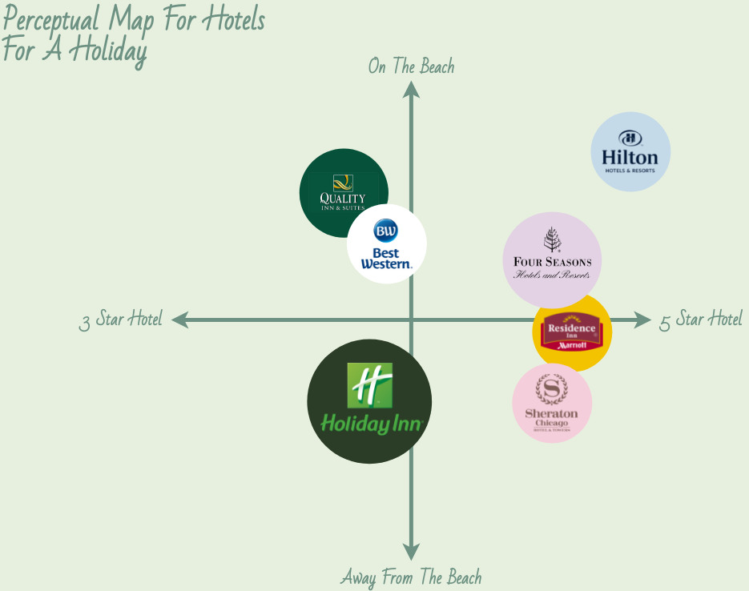
Table 1: Perceptual positioning map
(Jobber and Ellis-Chadwick, 2019)
Collaborators
The Hilton Hotel in the United Kingdom needs to value its business connections. According to Kotler and Keller (2016) Distribution and reach are increased through partnerships with travel agents, event planners, and online travel platforms. Partnerships with local businesses and tourism boards allow for cross-marketing and package deals (McDonald and Wilson, 2016).

Climate
Conducting a PESTLE analysis can help hotels discover potential implications from the macro environment. The following is a PESTLE analysis of the Hilton Hotel:
- Political: Political variables include government regulations and policies that have an impact on the hotel sector.
- Economic: Exchange rates and economic stability are two examples of macroeconomic variables that can have an effect on tourism (West et al., 2015).
- Social: Consumer taste and trends change constantly as a social phenomenon.
- Technological: Technical progress include the evolution of digital distribution and hosting infrastructure (Nozdreva and Churakova, 2021).
- Legal: Particular laws governing a given sector also count as a legal consideration.
- Environmental: Conservation and environmentally sound practises are prioritised in light of environmental concerns.

Marketing Mix
Analysing the hotel's marketing mix can provide opportunities for growth and efficiency (Kotler et al., 2017).
- An integral component of the product review process involves investigating Hilton's selection, service, and facilities (Chang et al., 2019).
- Pricing analysis focuses primarily on strategy, customer value, and market competitiveness.
- Place Analysis takes into account all aspects of a business's distribution strategy, including its online and offline presence.
- Promotion evaluation entails inspecting marketing efforts including communications, ads, and digital campaigns (Mekhruza et al., 2022).

Objectives
The SMART marketing plan objective is to increase online bookings by 20% within the following six months. The number of reservations made via the hotel's website will be tracked as a key performance indicator. Key performance indicators (KPIs) include the percentage of visitors who book, the average booking value, and online booking revenue. To increase revenue, the hotel will improve its online presence and customer engagement.

Strategy
Hilton Hotel plans to boost its value proposition by focusing on providing customised experiences for its customers. Market development, which focuses on acquiring new customer segments through differentiated offerings and focused marketing was selected as the optimal strategy from Ansoff's matrix. The new value proposition will focus on the company's commitment to excellent service and creating a positive customer experience (Armstrong and Kotler, 2017). Hilton's mission is to regain its clients' confidence by catering to their individual preferences and demands, making it the hotel of choice for affluent travellers.
The marketing mix will require several adjustments (Kotler et al., 2017). Hilton may introduce new amenities as part of its ongoing plan to enhance the stay of its hotel guests. As a means of improving perceived value, the strategy may involve lowering prices. Using tools like social media, online reviews, and testimonials, we will highlight positive experiences for our target audience.

Tactics
The RACE framework will be incorporated into Hilton Hotel's communications mix so that the new value proposition and identified concerns can be successfully communicated and dealt with.
- Reach: Hilton wants to expand its customer base by enhancing its social media profiles, concentrating on search engine marketing (SEM), and making its website search engine friendly (Fill and Hughes, 2016).
- Act: Hilton will entice clients to act by offering them interesting reading material and visually appealing videos that emphasise the hotel's features, in addition to exclusive offers, discounts, and loyalty programmes.
- Convert: A smooth booking process, well-placed calls to action, and a great user experience can boost lead conversion.
- Engage: Hilton will incorporate user-generated content, engage customers through customised email marketing, and actively monitor and respond to customer reviews and feedback.
There are a number of ways in which Hilton's current communications could be improved, such as through increased use of social media, a more rapid response rate, and more individualised email marketing. Improve things by using user-generated material, social media, and visually appealing content.

Action

Gannt Chart:
Channel | Metrics | Month
Channel | Metrics | Jan | Feb | March | Apr | May | June | July | Aug | Sep | Oct | Nov | Dec
Ads on Social Media | There has been a surge in website traffic.
Email Advertising | The conversion rate and click-through rate.
The utilisation of influencer marketing | Brand mentions and Engage Rate.
Ad Printing | Brand recognition and influence.
Internet-based marketing | Cost per visit and rate of conversion.
Content Promotion | Traffic generated organically, page dwell time.
Social Media Initiative | Growth in followers and engagement.
Outdoor Advertising | The effects of impressions and brand recall.
Sponsorships and Events | Conversions and income.
Affiliate Marketing | Engagement of attendees and generation of leads.
Mailing Direct Campaign | Customer acquisition and response rate.

Justification
In its marketing strategy, the Hilton Hotel employs both online and traditional channels. By employing these strategies, hotels may ensure that they are communicating effectively with their target demographic (Baines et al., 2019). With consideration for the hotel's target audience, communication objectives, key performance indicators, and seasonal considerations, a marketing channel calendar has been developed to maximise the hotel's marketing effectiveness throughout the year. In this approach, the message reaches its intended audience through the most effective channels, increasing the likelihood of a favourable response.

Control
We will use metrics and key performance indicators (KPIs) to monitor our marketing initiatives for the Hilton Hotel. We will be concentrating on expanding our client base, strengthening existing customer loyalty, and boosting our profits.
For research purposes, we will monitor such customer acquisition indicators as website visits, booking inquiries, and confirmed reservations. These figures demonstrate the marketing channels' ability to bring in new customers and keep them as clients.
We will track indicators of positive business sentiment such as customer feedback, social media sentiment analyses, and brand mentions. Improvements to the guest experience can be measured with these indicators. To maximise profits, we will analyse parameters like revenue per available room and occupancy rate.

Conclusion
In order to increase positioning, customer engagement, and revenue, Hilton Hotel's marketing plan overcame challenges and capitalised on opportunities. The plan enumerates market aspects, competitors, collaborators, strengths, vulnerabilities, customer segments, and rivals, as determined by an analysis of the current situation. The objective of the RACE framework is a 15% increase in online reservations. The marketing channel plan is supported by metrics and critical performance indicators. Increasing revenue, consumers, and the company's reputation constitute success. Personalising email and social media campaigns and enhancing channels in response to customer feedback are among the suggestions. The Hilton Hotel is committed to expanding its market share and service offerings.

References
Armstrong, G., and Kotler, P. (2017). Marketing: An introduction (13th ed.). Pearson.
Baines, P., Fill, C., and Page, K. (2019). Essentials of marketing (4th ed.). Oxford University Press.
Brassington, F., and Pettitt, S. (2017). Essentials of marketing (4th ed.). Pearson.
Brassington, F., and Pettitt, S. (2017). Principles of marketing (8th ed.). Pearson.
Chang, Y. C., Ku, C. H., and Chen, C. H. (2019). Social media analytics: Extracting and visualizing Hilton hotel ratings and reviews from TripAdvisor. International Journal of Information Management, 48, 263-279.
Fill, C., and Hughes, G. (2016). Marketing communications: Engagements, strategies, and practice. Pearson.
Hooley, G., Piercy, N. F., and Nicoulaud, B. (2017). Marketing strategy and competitive positioning (6th ed.). Pearson.
Jobber, D., and Ellis-Chadwick, F. (2019). Principles and practice of marketing (8th ed.). McGraw-Hill Education.
Kotler, P., and Keller, K. L. (2016). Marketing management (15th ed.). Pearson.
Kotler, P., Keller, K. L., Brady, M., Goodman, M., and Hansen, T. (2017). Marketing Management (2nd European ed.). Pearson.
McDonald, M., and Wilson, H. (2016). Marketing plans: How to prepare them, how to use them (8th ed.). Wiley.
Mekhruza, V., Malokhat, S., Rustam, T., and Bakhora, R. (2022). PERFORMANCE OF HILTON: HOW HILTON TACKLES THE EPIDEMIC COVID-19 DISEASE. Thematics Journal of Business Management, 5(2).
Nozdreva, R., and Churakova, A. (2021). Digital tools in empirical marketing strategies of global hotel companies. Digital strategies in a global market: Navigating the Fourth Industrial Revolution, 213-227.
SimilarWeb. (2023). SimilarWeb website. Retrieved from https://www.similarweb.com/
West, D., Ford, J., and Ibrahim, E. (2015). Strategic marketing: Creating competitive advantage. Oxford University Press.

Appendix: Presentation


