Commodity Trade

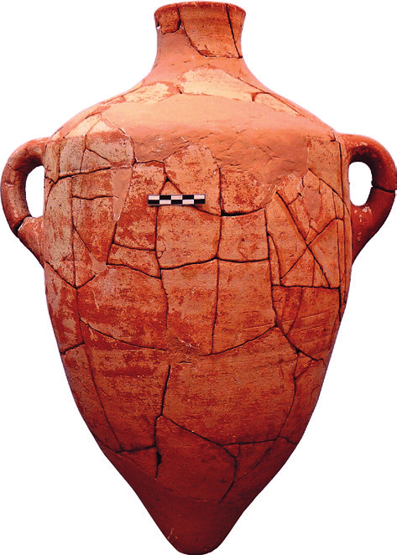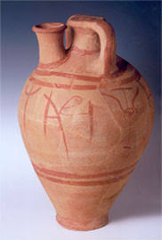
1. Canaanite jar (Ht. c. 60cm) 2. Stirrup jar, Thebes (Boeotia) (Ht: 45cm)
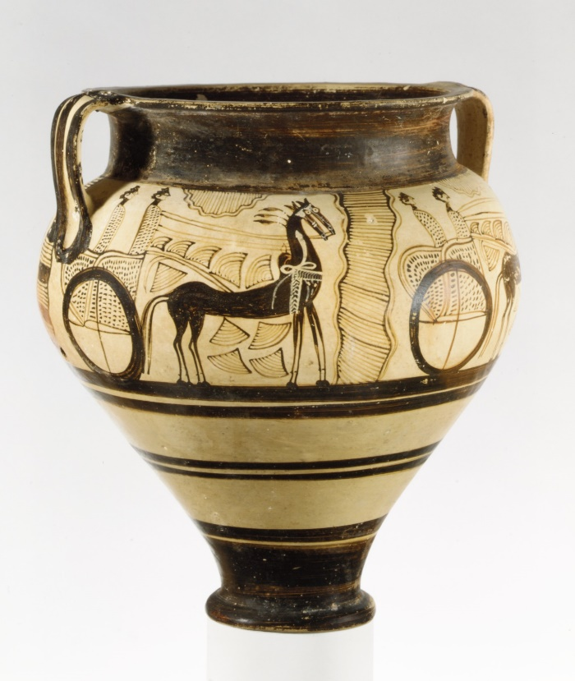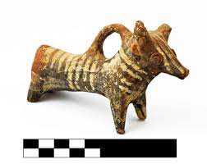
3. Mycenaean krater, Cyprus (Ht: 37cm) 4. Base Ring bull, Jordan
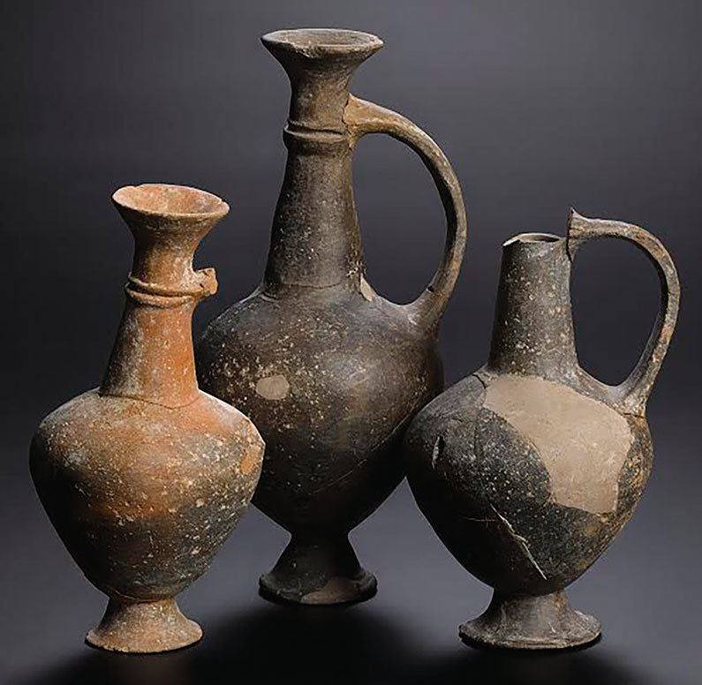
5. Base Ring juglets, Beth Shemesh (palace)
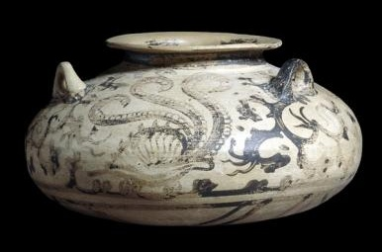
6. Mycenaean alabastron, Armant (Egypt). (Ht. 11.5 cm, Diam. 20cm_
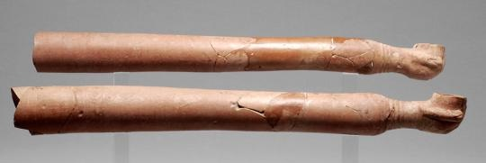
7. Red Lustrous arm-shaped vessels

