3 Key Words
I will be using three key words to describe how games and movies use certain elements to provoke fear from their audiences and how Interactive games are becoming. I will be using several references which include, games, movies and books, and touching upon different takes on horror as a genre, after researching these key words I will find a question for my dissertation.
Psychological horror
Psychological horror is a sub-genre of horror and fixates on mental, emotional and psychological states to instil fear upon the audience. “author Jonas Danielsson (2006, 64) explains that our bodies produce endorphins resembling morphine when we survive a frightening experience. These neurotransmitters provoke a feeling of euphoria, which is an intense feeling of well-being and happiness.” (Lewitzki,2017) this explains why the horror genre as whole is so popular and why people are almost addicted to the horror genre. Psychological horror often overlaps with the psychological thriller genre, the most popular way psychological horror is used, is through disturbing, unstable and distressing themes to enhance the plot of the story, which leave the audience feeling unsettled and unpleasant. The main gaol of a psychological horror is to exploit the audience’s fears to reveal the darker side of humanity that people may feel is unbelievable.
Pyscho (1960) is an excellent example of a psychological horror, due to the main villain being induced with psychological trauma “in which Norman Bates struggles with his horror of the feminine by alternately performing it and destroying it. At the end of the film, a psychiatrist hastens to assure everyone that Norman is not a transvestite, the Norman thinks he is his mother.” (Phillips,1994) this causes Norman to lash out a any female figure he encounters due to his sickness because the voice of his mother tells him to, this leads Norman to question his own insanity and his understanding of his own perception of reality.
In games horror is a huge genre that people flock too such as Outlast, this is arguably one of the most successful horror games to ever be released, this is due to its Psychological horror. Outlast uses sound and visuals to place the player on the edge of their seat, the player must enter rooms that are engulfed in complete darkness it is only when the player looks through the night vision camera that runs out of batteries far too often, the player can see what lies in the dark, a lot times the player doesn’t want to know where the muttering and whispering is coming from within the Mount Massive Asylum. Outlast strips the player of all weapons and does not allow the player lenience when it comes to protecting themselves “You're ostensibly powerless in Outlast, meaning that your main tools for survival are running and hiding. Barrelling down a hallway with a beast right on your heels, bursting through a series of doors when you have no idea what's on the other side, and eventually finding a closet to hide in and evade your pursuer provides a fantastic and terrifying thrill” (Marty Sliva,2013) the dynamic lighting within this game sets the mood for the overall game, providing flickering revealing a body hanging from the ceiling and with the next flicker it disappearing, making the player second guess themselves by making them wonder if they did actually see that body. Footsteps of blood scattered around the Asylum, give the player some idea as to where some enemy’s however these are not always accurate due to the game tricking the player into thinking they have the upper hand; however the game always has control of the player, this is almost psychological torture whilst playing the game as every peak around the corner means life or death for the player. There is one section within outlast and arguably the most terrifying apart of the whole game is where you are captured by a patient who believes he is a doctor and escorts the player around the asylum in a wheel chair, he then proceeds to cut off the players fingers, however this is not the part where it tests your insanity, the player then escapes and has to hide under operating tables where the doctors previous “patients” had died and not knowing where the doctor is, and only hearing him speak to himself, pacing around the surgery is traumatic almost as the exit is in sight.
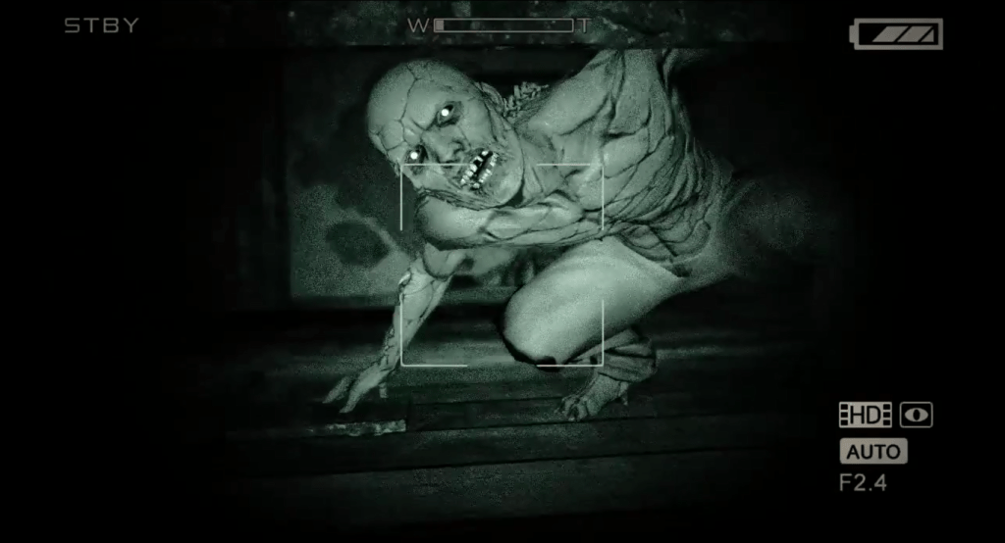
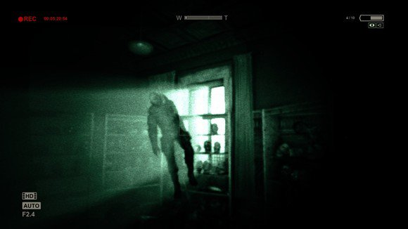
(Outlast, 2013)

Interactivity
In first person games the player is looking through the characters eyes in a sense and experiencing everything that he/she is experiencing this is what makes the game so engaging these games are often social games “This study showed clearly that online FPSG are not played in isolation” (Dr. Jeroen Jansz Martin Tanis 2007) VR (virtual reality) is an excellent example of an interactive experience, the player has all the control of what the character does such as something as simple like throwing a book across a room or being able to open doors with your own hand controlling the handles placement, Players thrive off being able to do whatever they like within games “In virtual environments the computer makes use of the natural way we interact with he physical world. Intuitive movements and actions become computer commands. All kinds of conscious and unconscious bodily movement or changes of state, such as heartbeat or diastolic blood pressure, are potential computer input” (Frank Biocca,1995) when a horror game is made for VR it is usually a success due to players comparing the game so closely to reality due to the player being able to interact with everything and being able to see everything in the game at their height and not looking at a flat screen. The player also has ear phones on compared to when the player plays on a TV for example where the sound would be coming out of speakers, with the sound coming from the players headphones they can here noises individually coming from each ear, such as whispering from behind them that might travel on the left side of them and then to reveal someone coming in front of the player from their left side.
With the player being able to control the character just by moving their neck, this causes a realistic experience for the player regardless of what they are playing. This allows players who are bed ridden to be able to visit the a place that they cannot access such as a beach or a forest “A variety of health care practitioners are using virtual reality technology to enhance patient treatments as well as provide multiple innovative interventions requiring attention and active patient participation” (Abel Angel Rendon, Everett B. Lohman, Donna Thorpe, Eric G. Johnson, Ernie Medina, Bruce Bradley, 2012) this can also increase the movements of patients that are in bed by encouraging them to move their arms and torso to gain as much exercise as possible. With technology accelerating at such a fast pace, interactivity has become increasingly more important to gamers and if a player does not engage and loose themselves within the game, it automatically receives a negative review, this leads me on to my next point, with games becoming more interactive, so has the need for social interaction with players being able to communicate with anyone, through the use of their microphone whilst playing the same game as the other person “students who have personal computers to show significantly higher levels of Internet and computer-game addiction than students who don't have personal computers.” (Sacip Toker,2015)

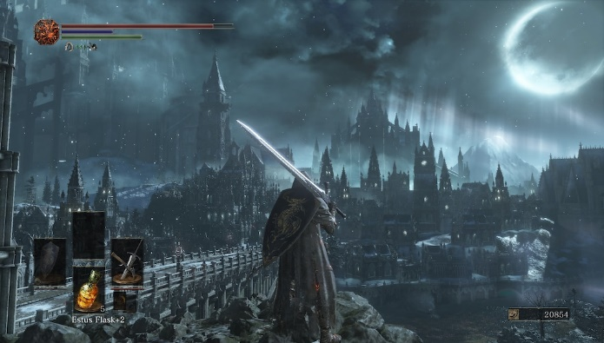
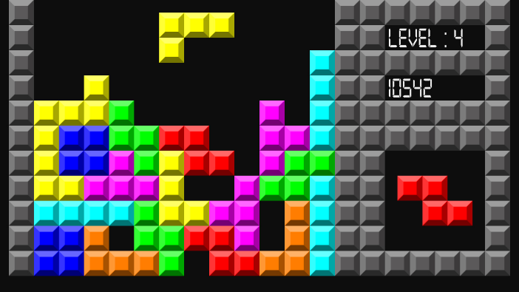
Interactivity is also measured with how engaging the game is to play, this is measured by a range of different factors which include story, music, graphics, etc. “Interactivity has, however, developed significantly since Atari 2600’s line-up of games. Most successful and influential titles are now expected to have well developed environments, industry standard music (if not better), and character models which are imaginative, but identifiable. Interactivity also determines which game mechanics are standardized based on game genres.” (Matt Sautman, Sean Gadus, Luke Martin, 2017) this a key aspect when designing a game, because if the game is not visually stimulating the player will not invest their time into playing it, however you can argue that certain games such as Tetris, which is game that revolves around placing blocks in certain positions in order to not let them reach the top of the screen, is not visually stimulating, however it is still fun and engaging because the gameplay outweighs the need for beautiful sceneries and insane graphics because it would take away from the overall game instead of improving it and would in the long term be a distraction to the player.

(Tetris, 1984) (Dark Souls 3, 2016)

Suspense
Suspense is a crucial theme to have in a game whether it is the suspense of where the story leads or if it’s the suspense of peaking around a corner in a or being chased in a horror game or film, sound has a lot to do with building suspense within horror games. To build suspense using sound, the music will usually start off being quite slow with a bang or a screech of a violin to keep the audience on edge, the speed of the music will then increase until a major thing has happened such as the reveal of a major event or the player just getting away from the thing that’s chasing them, the reason horror movies and games use suspense is because it engages with he audience. Lighting can also be used to build suspense whether it is a flickering light that reveals a major enemy coming towards the player and then vanishes when the light flickers off, this makes the player wonder where the enemy has gone and making them on edge creating a suspenseful and scary atmosphere.
Another way to create suspense is by promising the audience that something will happen, this may be the villain about to attack earth and the hero then has to prepare to stop the villain in a certain amount of time before he arrives, this gives the audience a story to follow where they know a inevitable ending is going to happen they just don’t know how “Suspense happens in the stillness of your story, in the gaps between the action sequences, in the moments between the promise of something dreadful and its arrival.” (Steven James, May 14, 2013) he also states “the problem of readers being bored isn’t solved by adding action but instead by adding apprehension. Suspense is anticipation; action is payoff. You don’t increase suspense by “making things happen,” but by promising that they will. Instead of asking, “What needs to happen?” ask, “What can I promise will go wrong?” (Steven James, May 14, 2013) this shows that in order to create a scene full of suspense the character needs to have a point in the story where they are faced with a dilemma. Where the hero is faced with a problem, explains the problem to the audience and then takes action in order to fulfil this task, this creates anticipation for what will come and as Steven James states the action of the film should serve as almost a reward to the audience because they’ve travelled with the character on their journey.
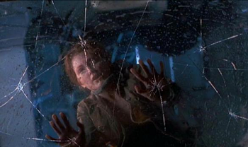
Foreshadowing is another great way to build tension within a game or a movie, this leaves clues and hints for the viewer/audience as to what may happen at throughout or at the end of the game/film. This acts as almost like a puzzle for the viewer to work out whilst watching a film or playing a game, this then leads to the viewer having a “I knew it!” moment which allows them to feel more involved with in the experience, the suspense fits in to the moments between when the audience is working out the ‘puzzle’ up until the moment where the twist in the story is revealed “In the best stories, you can look back and see clues to the outcome of the dramatic question all through the story, so that everything leads up to that final climax where the dramatic question is answered.” (Joe Bunting, 2015) a example of suspense in a movie would be in The Lost world: Jurassic Park where one of the main characters are crawling on a window of a caravan that has been pushed of the side of a cliff, the glass is slowly cracking beneath her and creates tension for the viewer, before the glass breaks with a falling phone from the top of the caravan that smashes the glass. The music and the sound of this scene is the crucial key to what makes it so suspenseful.
(The Lost world: Jurassic Park, 1997)

Conclusion
In conclusion I have looked at how sound and lighting can have a impact on the atmosphere of a scene in a film or a game, creating scary or suspenseful scenes that would be fairly boring without these elements added, I have also talked about how technology is advancing so interactivity between people is becoming easier for people who can not necessarily interact as well as most people. Moreover I have discussed how individuals are entertained in the simplest ways in virtual reality by completing pointless actions that are not seen as entertaining in reality, however entertain the vast majority of players for hours such as throwing a ball and catching it or wrecking a room within virtual reality and knowing you don’t have to clean up the mess afterwards. The question that I have chosen to write about for my dissertation is “how lighting and sound can affect the atmosphere within films and games” I have chosen this question because throughout talking about these key words I found my self talking about how sound and lighting can have such a huge impact on scenes, and can change the way the audience perceive the genre they are watch for example a lot of bright lights in a suspense horror film can easily allow the audience to judge the scene as a action film, due to for example the killer chasing down the victim, however if the scene was darker with dramatic lighting it would give off a completely different atmosphere. Lighting is used in film to create a certain mood, or an atmosphere. “You may not expect it, but even lighting can add to and create meaning in a film. Horror movies, for instance, are known to frequently use lighting to set the tone and mood. The use of shadows is especially important in horror as it adds to the atmosphere and all-round feel of the film.” (Manon de Reeper, February 26, 2014) this quote further ensures my interest in looking deeper into films and games and how underappreciated and important certain aspects are.

Citation

Author: | Stephen Prince
Year published: | 2004
Book title: | The horror film

Author: Alexander Lewitzki
Year published: 2017
Book title: Taking Control of the Horror: Working with Visuals
in the Psychological Horror Game Genre
Author: Kendall R. Phillips
Year published: 1998
Book title: Unmasking buffalo bill: Interpretive controversy and
the silence of the lambs

Author: De Pelsmacker, Patrick, Nathalie Dens, and Shana Verberckmoes
Year published: 2019
Book title: HOW CONGRUITY AND INTERACTIVITY AFFECT FANTASY GAME
PLAYERS' ATTITUDE TOWARD IN-GAME ADVERTISING
Writer: J.T. Petty
Year published: 2014
Game title: Outlast
Publisher: Red Barrels
Author: Marty Sliva
Year published: 4 September 2013
Game Review: Outlast
URL: https://uk.ign.com/articles/2013/09/04/outlast-review
Company: IGN

Author: Dr. Jeroen Jansz Martin Tanis
Year published: 17 February 2007

Book title: Appeal of Playing Online First-Person Shooter Games

Author: Frank Biocca
Year published: 1995

Book title: Communication in the Age of Virtual Reality

Author: Abel Angel Rendon, Everett B. Lohman, Donna Thorpe,
Eric G. Johnson, Ernie Medina, Bruce Bradley
Year published: July 2012
Book title: The effect of virtual reality gaming on dynamic balance
in older adults, Age and Ageing, Volume 41, Issue 4

Author: Han, Lyoo, and Renshaw
Year published: 2012
Book title: Differential Regional Gray Matter Volumes in Patients
with On-line Game Addiction and Professional
Gamers." Journal of Psychiatric Research

Author: Sacip Toker
Year published: 2015
Book title: Antecedents and consequences of game addiction

Author: Matt Sautman, Sean Gadus, Luke Martin
Year published: 2017
Article title: Storytelling and interactivity in video games
URL: https://the-artifice.com/video-gaming-story-telling-interactivity/
Writer: Steven James
Year published: May 14, 2013
Article title: 6 secrets to creating and sustaining suspense
Website: Writers Digest
Writer: Joe Bunting
Year published: 2015
Article title: 7 steps to creating suspense
Website: https://thewritepractice.com/7-steps-to-creating-suspense/
Director: Steven Spielberg
Year Released: 18 July 1997
Movie title: The Lost world: Jurassic Park

Writer: Alexey pajitnov
Year published: 1984
Game title: Tetris
Publisher: Various
Writer: Hidetaka Miyazaki
Year published: 2016
Game title: Dark Souls 3
Publisher: Bandai Namco
Writer: Manon de Reeper
Year published: February 26, 2014
Article title: How to Analyse Movies #5: lighting, sound & Score
Website: https://www.filminquiry.com/analyse-movies-lighting/

