Dissertation – Proposal
LCBB6000
BA (Hons) Business Management
University of Wales Trinity Saint David (London Campus)
Nikola Bachvarov
Student Number- 1914252
Proposed research title: Impact of social media (Facebook) on consumer behaviour: A case study on Zara UK

Contents
Abstract 4
Chapter 1: Introduction 5
1.1 Introduction 5
1.2 Background of the study 5
1.3 Problem statement 5
1.4 Aims, objectives and research questions 6
1.5 Rationale of the study 6
1.6 Methodology 7
1.7 Scope of the study 7
1.8 Structure of dissertation\ 7
1.9 Summary of introduction 7
Chapter 2: Literature Review 8
2.1 Introduction 8
2.2 Background aspects 8
2.3 Theoretical frameworks 9
2.4 Previous studies and lessons 11
2.5 Research gap identified 12
2.6 Summary 12
Chapter 03: Methodology 13
Chapter 04: Data analysis and discussion 15
Chapter 05: Conclusion 26
References 28
Appendix: Survey Questionnaire 30

Abstract
Facebook is one of the most widely used social media platforms that businesses use to interact with their customers, and social media has fundamentally changed how consumers interact with brands. With a focus on Zara UK in particular, this study intends to look into how Facebook has affected consumer behaviour in the fashion sector.
Data was gathered using a survey methodology by conducting survey with 50 consumers of Zara UK. The study used a thematic analysis method to examine the information.
According to the majority of participants, Facebook influences their purchase decisions, which supports the conclusion that Facebook has a considerable impact on consumer behaviour. The analysis also discovered that Facebook postings promoting new collections, sales, and client testimonials were the most significant elements. The survey also discovered that Facebook gives users a chance to communicate with the brand and other users, which has a beneficial impact on their decision-making.
Moreover, the study found some detrimental effects of Facebook on consumer behaviour, including the perceived need to fit in with society and the desire to overspend brought on by continual exposure to new goods. Yet, Facebook was determined to have a beneficial overall impact on customer behaviour.
This study advances our knowledge of how social media affects consumer behaviour in the fashion sector and offers marketers useful takeaways for enhancing their social media strategies. In order to positively affect consumer behaviour, businesses should concentrate on developing interesting material that showcases new collections, discounts, and user reviews.

Chapter 1: Introduction

1.1 Introduction
The consumer behaviour has been changing over the time due to many reasons. The emergence of social media in 2000s has drastically changed the daily activities, consumer decision making, and purchase behaviour of the consumers around the world. The businesses need to understand the customer use of the social media while purchasing, to design effective marketing and campaign to reach to the consumers effectively. This research project focuses on the impact of Facebook, the most popular social media in terms of numbers of hours spent on it, on the consumer behaviour of the fashion brand Zara in the UK.

1.2 Background of the study
The rise of social media in the last two decades has changed the demographics of the advertising, marketing, and approaches of the business organisations in pursuing the customer acquisition. The most effect has been on the fashion and cosmetic industry. According to the Statista (2020), Facebook currently has a 2.96 billion users base which makes the social media platform the largest in the world (Statista, 2022). On the other hand, Zara, one of the most popular fast fashion brands in the UK, has operations in nearly 26 countries around the world with more than 2,000 stores. According to another statistics, around 24% of the retailer’s shops in the UK is fond of Zara products (Zara, 2022). The purchase behaviour of the consumers needs to be assessed to find out the influence of social media on the fast fashion products purchase of Zara consumers in the UK.

1.3 Problem statement
Zara is the modern fast paced fashion company that focuses on the digital marketing on internet and social media platforms rather than on the TV, poster, and print medias. According to its reports, it spends only 0.3% of the annuals sales on promotion, mostly on the digital platforms. Zara focuses on digital and effective marketing to attract the right set of consumers, rather than running heavy campaigns on traditional platforms (Zara, 2022). Hence, Zara needs to find out the specific, research-based information regarding how much and how Facebook influences the Zara customers for product purchase decisions to effectively use its financial resources to pursue the digital marketing for the company.

1.4 Aims, objectives and research questions
Aim
The purpose of this study is to close the knowledge gap by examining Facebook's influence on consumer purchase decisions from Zara's point of view. As a result, the firm (Zara) and platform (Facebook) unique nature of this research goal.
Research Objectives
- To find out the impact of Facebook in information-gathering process of the Zara consumer before the purchase.
- To find out the influence of Facebook in the decision-making process of the Zara consumer.
- To compare the effectiveness of Facebook marketing with that of the traditional marketing process in Zara.
Research questions
- How Facebook impact the information gathering process of Zara customers?
- What are the influences of Facebook in decision-making process of the Zara consumers?
- What are the differences of Facebook marketing with the traditional marketing process of Zara?

1.5 Rationale of the study
There are several aspects and reasons that rationalise the importance and purposes of this particular research study on the influence and impact of social media platform (Facebook) on the product choice and purchase decisions of the consumers of Zara in the UK. First, considering the number of active users, and spread of Facebook around the world, it has immense potential of driving the consumers towards a brand like Zara. Second, the traditional fashion purchase decisions have revolutionised due to the influence of social media platforms, like Facebook groups, stories, reactions in the forms of like, comments, and shares. Third, brand loyalty, engagement, and other purchase decisions of the Zara consumers can further be studied and found out.

1.6 Methodology
The research is a company and platform specific research project which requires primary data collection. Hence, a sample of 50 has been selected from the consumers of Zara to conduct the survey questionnaire. The primary data will be analysed using the charts, graphs, and other representations.

1.7 Scope of the study
The scope of the research is limited to a specific company Zara in the UK boundary. However, the findings also broaden to the other 26 countries where Zara operates in. Hence, it can be inferred that the scope of the study is wide.

1.8 Structure of dissertation\
This research project is divided into five core chapters. They are introduction, literature review, research methodologies, data analysis and discussions, and conclusions. The conclusion chapter will also contain the suggestions and recommendations.

1.9 Summary of introduction
The introduction chapters reflect the overall structure, contents, and intention of the researcher for the whole research. The structure of the research project is based on the primary research, and the rationale and objectives of the research project provide strong motivation of conducting this research project.

Chapter 2: Literature Review

2.1 Introduction
With over 2.9 billion active members globally as of 2021, Facebook is one of the most prominent social media platforms. Social media has permeated every aspect of our life (Statista, 2021). Facebook has grown in popularity and is now a crucial tool for businesses to engage with their clients and advertise their goods and services.
For many studies in recent years, the influence of social media, notably Facebook, on consumer behaviour has been of interest. Some of the ways Facebook affects consumer behaviour include through the accessibility of information, the option to connect with friends and family, and the chance to interact with businesses.
The effect of Facebook on customer behaviour has been the subject of numerous researches. For instance, a 2009 study by Mangold and Faulds discovered that social media significantly influenced consumers' shopping decisions. According to the study, Facebook in particular had a big impact on customers' perceptions of a company, their propensity to buy, and their actual buying behaviour. In a similar vein, a study by Ali and Ahmad (2020) discovered that Facebook marketing and other social media marketing strategies had a favourable effect on customers' brand knowledge, brand loyalty, and purchase intent.
Examining Facebook's effects on consumer behaviour, particularly in terms of brand knowledge, brand loyalty, and purchase intention, is the aim of this study. Businesses may create efficient social media marketing strategies to communicate with their customers and boost sales by comprehending how Facebook affects consumer behaviour.

2.2 Background aspects
The relationship between social media and consumer behaviour may not be as clear-cut as some studies have claimed. Some research has concluded that social media, particularly Facebook, has a major impact on consumer behaviour.
For instance, a study conducted in 2012 by Kim and Ko discovered that while social media may have an impact on consumers' sentiments about a business, it may not always have an immediate effect on how they choose to spend their money. According to the study, rather than promoting sales, social media may be more useful for increasing brand awareness and engagement. Similar findings were made by Kabadayi and Price (2014), who showed that the sort of product or service being marketed can affect how social media affects consumer behaviour. According to the study, social media may be more successful at advertising hedonistic goods like clothing or entertainment than practical goods like furniture or equipment.
Other research has emphasized the possible negative effects of social media on consumer behaviour. For instance, a study conducted in 2011 by Wang, Chen, and Liang discovered that social media may cause information overload and choice fatigue, which may possibly have a detrimental effect on consumers' purchasing behaviour. A study by Smith, Fischer, and Yongjian (2012) also discovered that social media may enhance social comparison and envy, which may have a detrimental effect on customers' well-being and general happiness with their purchase selections.
While some research has identified a large effect of Facebook on customer behaviour, other studies raise the possibility that the relationship may be more complex and subtler, and that the influence may change based on the setting and the kind of product or service being pushed.

2.3 Theoretical frameworks
Some of the theories and models have explained the impact of social media on the consumer behaviours, especially in the fast fashion decision-making. The Technology Acceptance Model (TAM), Social Exchange Theory, Consumer Decision-making Model, Brand Equity Model.
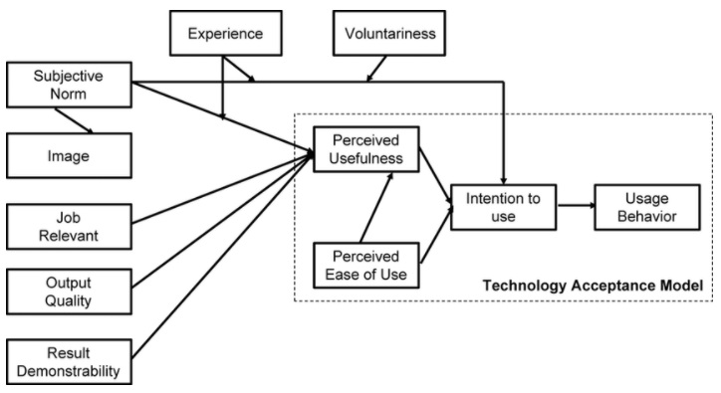
Figure: Technology Acceptance Model (TAM) (Venkatesh & Bala, 2008)
The TAM suggests that perceived utility and perceived ease of use are the two main determinants of users' acceptance of a technology. Perceived utility in the context of Facebook relates to the extent to which users think the website may offer advantages including social connection, entertainment, and information. The degree to which users perceive the platform to be simple to use and comprehend is referred to as perceived ease of use. By including social influence as a crucial variable that can affect users' acceptance of technology, Venkatesh and Bala (2008) expanded the TAM. The term "social influence" describes how much a user's social network affects their choice to adopt a technology. This aspect is especially important when discussing Facebook, a social networking site that lets users interact with their friends and family.
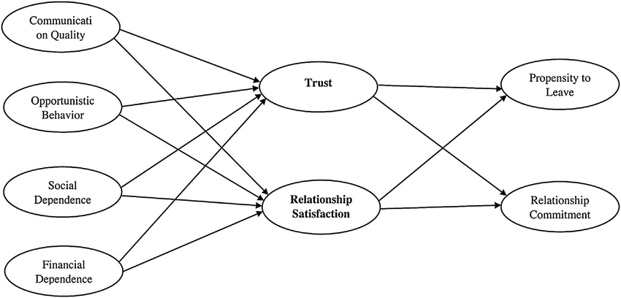
Figure: Social Exchange Theory (Toffel and Gao, 2014)
According to the social exchange hypothesis, social interactions are built on the exchange of resources and advantages. Businesses can use social interactions to market their goods or services on Facebook by providing incentives, rewards, or other perks in return for users' involvement and loyalty. Social exchange theory was utilized by Toffel and Gao (2014) to describe how customer interaction with a brand's social media channels can result in reciprocal behaviour, which can boost brand loyalty and boost purchase intent. According to this notion, building trusting relationships with customers on social networking sites like Facebook is crucial.
According to the brand equity model, brand loyalty, perceived quality, brand awareness, and brand image are the main factors that contribute to brand equity, which in turn can affect how customers behave toward a brand. Businesses can utilize social media marketing techniques to strengthen their brand equity in the Facebook environment by raising brand awareness, enhancing brand image, and boosting brand loyalty.
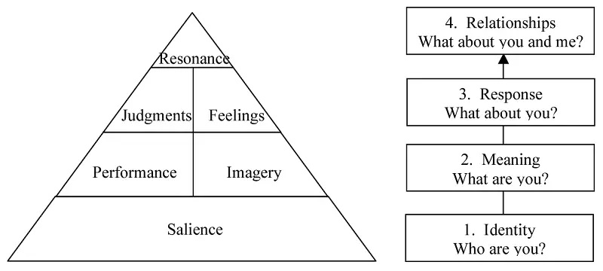
Figure: Brand Equity Model (Esmaeilpour et al., 2019)
The brand equity model was utilized by Esmaeilpour, Bakhshizadeh, and Azar (2019) to demonstrate how social media marketing may improve brand awareness, brand loyalty, and brand reputation, all of which have a beneficial effect on customers' purchase intentions and behaviour. This concept emphasizes how crucial it is to build a strong brand presence on social media sites like Facebook in order to successfully sway consumer behaviour.

2.4 Previous studies and lessons
Past research has looked into how social media, like Facebook, affects customer behaviour. An important takeaway from this study is that customers' purchasing decisions can be influenced by social media since it gives them access to knowledge, social evidence, and social relationships. For instance, a 2011 study by Lin and Lu discovered that social media can boost consumers' perceptions of the usefulness and simplicity of using e-commerce platforms, which can in turn have a favourable impact on their buy intention.
Previous research has also shown that social media can increase brand knowledge and loyalty by giving them interesting and tailored content. According to a study by Kim and Ko (2012), social media marketing can boost customers' brand loyalty by giving them access to interesting and relevant material as well as chances to engage with the business and other customers.
Yet, earlier research has also emphasized the potential dangers of social media, such as the dissemination of false information and unfavourable brand connotations. According to a study by Chen and Xie (2014), even comments that have nothing to do with the brand itself can have a big impact on how consumers feel about a product or service.
Businesses must comprehend the intricate connections between social media use, consumer behaviour, and brand impression in order to use social media for marketing effectively. Future studies should continue to look into these connections and pinpoint the best ways for companies to use Facebook and other social media platforms to influence consumer behaviour and build brand equity.

2.5 Research gap identified
The previous studies, findings of the research projects and others have drawn conclusion regarding the impact of the social media platform, especially Facebook on the consumer purchase decision-making of products and services in general. The specific research on the retail industry and the impact on the fast fashion consumers is the unique value proposition of this research project. This research project also finds company-specific research project on Zara.

2.6 Summary
Although the research project is on the long-known aspect of the impact of the social media platforms on the consumer behaviour. However, this research project also sheds light on the unique value propositions such as the company specific research outcomes on Zara. And the research outcomes also find out the impact of Facebook on consumer behaviour of fast fashion brand of UK.

Chapter 03: Methodology
This chapter of the research project illustrates the methods and methodological choices of the research project (Daniel & Sam, 2011). The research methodologies have been selected based on the research aims, objectives, and purposes following the structure of the Saunders’ Research Onion. The details methodology has been illustrated below:
Research philosophy: There are four philosophies that are mostly applied in conducting research. Those are pragmatism, realism, interpretivism, and positivism. This research project has followed the interpretivism research philosophy which gathered the primary data for the research that can be interpreted and interpreted them accordingly to find out the research outcomes (Sahay, 2016).
Interpretivism is more suitable compared to other philosophies. Because, the this is a causal research project which finds out the impact of Facebook on consumer behaviour of Zara. Hence, interpretivism can better explain the primary data regarding different aspects of consumer behaviour, Facebook, and its impact on the Zara (Sahay, 2016).
Research approach: There are two research approaches widely used. Those are deductive approach which does not produce any new knowledge rather testing the existing notions, models, and theories of the existing researches with the collected data for the research. On the other hand, inductive research approach crates new knowledge, theory, and model with the collected data for the research.
Deductive research approach has been chosen for this research approach to test the overall approach of the research project. The primary data collected from the Zara will be tested against the existing literature of how social media or Facebook impact the consumer behaviour of Zara.
Research strategies: The research project’s overall direction is illustrated in the research strategy section. This research project has used and applied survey method to collect the required primary data for the research project (Orth & Maçada, 2021). The collected primary data afterwards have been proceeded for further analysis and investigation of the research project.
Survey questionnaire is better suited for this research project because the primary data is more suitable for the research project. The primary data can be better collected from the survey questionnaire rather than other methods of data collection such as archival research, case study, experiment, ethnography, grounded research, and action plan which are better suited for other research studies.
Research choices: Mono method of research methodology has been chosen and applied for this research project where only one method of data collection (survey) has been applied to collect the necessary research data and analyse them to find out the research outcomes (Oswald & Plonsky, 2011).
Multi method and mixed method of research approach are not appropriate for this research project since this is not a mixed aimed research project. As a result, the mono method of research approach fulfils the research objectives, aims and better fulfil the overall goals of the research project.
Time horizon: Since the research project collects the primary data from only one source in a single time period, the research methodology is following a single time horizon where the data are of the same time period.
Data collection: This research is primary data based. The primary data are of quantitative and qualitative nature. The age, years of services at Zara, and amount to be received as sales are the quantitative data for the research (Pringle et al., 2011). On the other hand, the reasons for consumers choosing a particular time to shop, the scope of development for Zara to utilise Facebook to attract more consumers are the qualitative data that are required for the research project.
- Sampling method and sample size: The sample size for this research project is 50 employees of Zara from the nearest Zara shops in London, UK. The research project chose simple random sampling method which provides an equal chance for the employees to be included in the survey method.
Data analysis tools: The collected primary data have been organised in response tables. And using MS Excel and other primary tools, the responses have been turned into graphs, charts, and diagrams to interpret the responses of the Zara employees for the research article.
Ethical considerations: Being a primary research, this research project is potentially exposed to ethical issues such as confidentiality, informed consent, privacy, physical harm etc. Hence, the following ethical considerations are taken to totally eliminate any risks arising from the research project.
- Informed consent: The aim, nature, and potential advantages and disadvantages of the research should all be adequately disclosed to the participants. Students should be made aware that participation is entirely voluntary and that withdrawal is always an option. Participants' permission is required before any research may begin (Baltar & Brunet, 2012).
- Confidentiality: Information about participants should be kept private. Without the subjects' permission, researchers should not disclose any identifiable information about them. Data on participants should be protected and kept out of the hands of unauthorised personnel.
- Privacy: Participants' privacy should be respected by researchers. They shouldn't enquire about any personal matters that are unrelated to the study. Without the approval of the participants, they shouldn't record any observations or talks (Baltar & Brunet, 2012).
- Minimisation of harm: Researchers should take steps to protect volunteers from any potential risk. There shouldn't be any threats to the participants' health or mental wellbeing. Participants should not be under any duress to participate, according to researchers.
- Data accuracy: Researchers should make sure that the information gathered is accurate and unaltered. Before the data is evaluated, it should be checked for any errors or omissions. Participants should have the chance to check and confirm their data.
- Debriefing: Participants should receive a debriefing regarding the research findings after the study is over. People should be given the chance to enquire about the study and get answers. Researchers should specify the intended use of the data.
The above-mentioned ethical considerations shield the research project of any ethical issues related to the research, data collection process, and data analysis.
Summary of methodology: The research methodology comprises of primary data, simple random sampling which comprises of 50 employees of customers of Zara. The methodology has been designed according to the purposes of the research project which makes the methodology more suited for the research project.

Chapter 04: Data analysis and discussion
This chapter presents the analysed data and information collected for the research project. The analysis presents the data and interpret them to find out their outcome. Whereas, the discussion of the research describes how the analysis of the research achieves the research goals and complied with the literature review stated above in chapter 2.
1. Gender orientation?
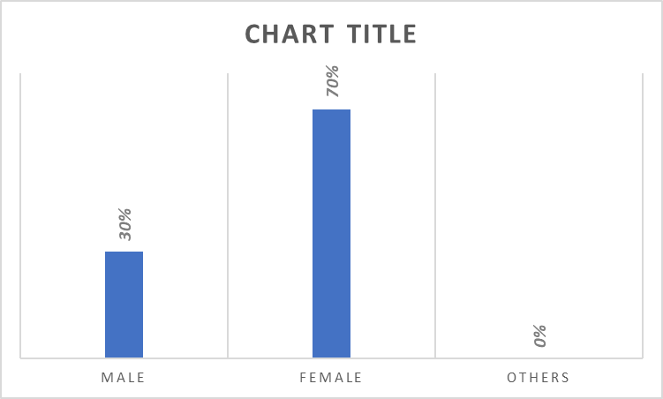
It can be seen that the survey respondents are female majority with 70% representation in the survey participation. This fast fashion brand is more popular among the female gender. On the other hand, no representation from other gender has been found. Whereas, the male employees and consumer were 30%.
2. Age demographic?
On the other hand, from age demographic perspective, the younger consumers ranging from 18 to 25 are the dominant in the survey with 40% representation. Whereas, 26 to 35, 36 to 45 represent 30% and 20% of the total survey respondents respectively. Whereas, older consumers aging more than 45 years were only 10% in the survey participation.
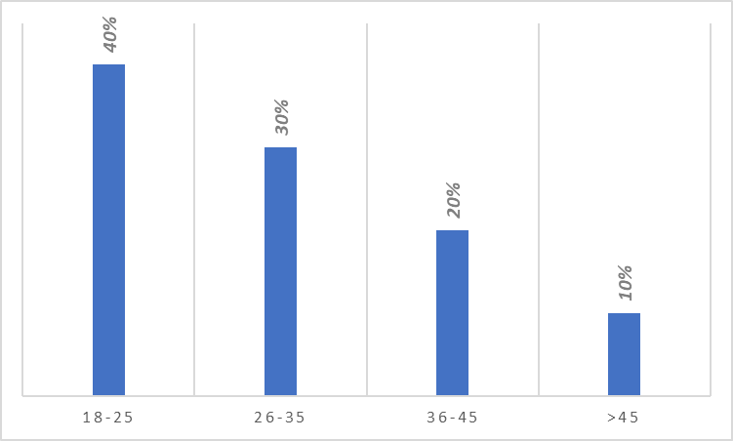
Theme 01: Information gathering process
3. Do you use Facebook to gather information about Zara products before making a purchase?
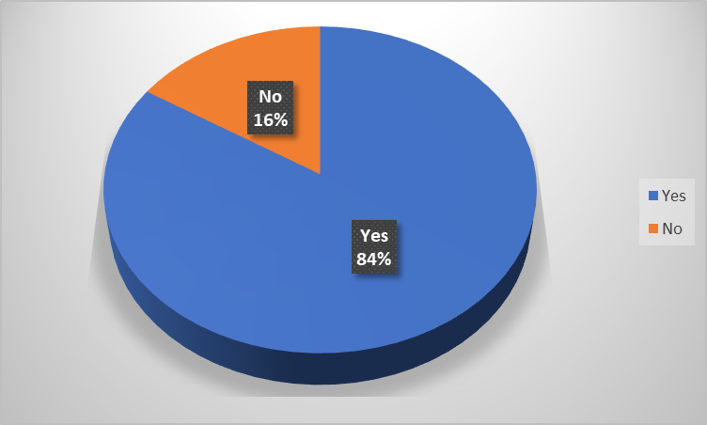
In response to the information gathering process, the consumers responded that the majority of them (84%) use Facebook as information gathering process before making any purchase decisions about Zara products. Whereas only 16% of them do not look upto the Facebook for any purchase decision making. The findings conform with the findings of Wang et al., (2011) who stated that social media platform influences the consumer decision making process of fast fashion products.
4. How often do you visit Zara's Facebook page to learn about their products and promotions?
Learning about the colour, fabric, prices is an important step of making consumer purchase decision. In response to the query of Zara’s Facebook page visit, the consumers responded that majority (40%) of the consumers visit the Zara’s Facebook page once a month before feeling the need of purchase any product. On the other hand, the 10% and 30% of the consumers visit the Facebook page on a daily and weekly basis respectively to look up to the updates, trends, and fashion changes in the Zara collection. However, 14% and 6% of the consumers visit the Facebook rarely and never respectively.
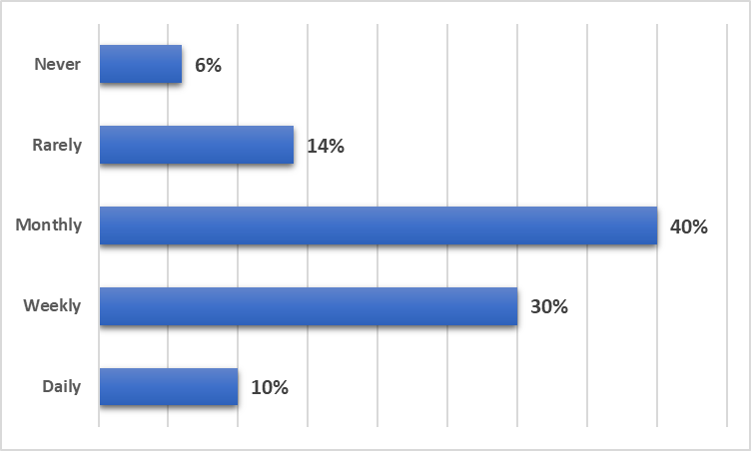
5. How likely are you to purchase a product from Zara after seeing it on their Facebook page?
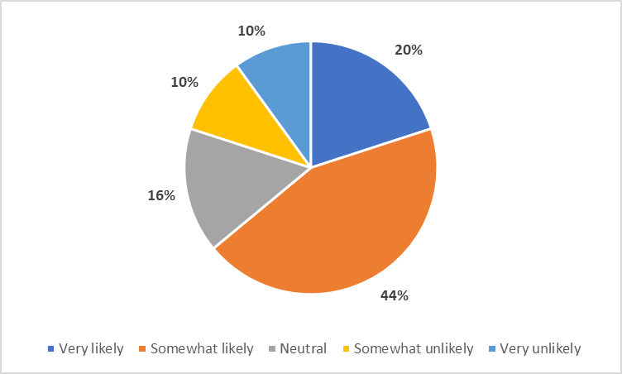
44% of the consumers are “somewhat likely” to purchase a product from Zara after seeing them on their Facebook page. 20% of them are “very likely” to make the purchase decision. Thus, the majority are influenced by the Facebook updates of Zara which also conforms the literature of Chen & Xie (2014), who stated that the social media influence the purchase decisions of consumers. However, 16% of them are neutral. And 10% each are “somewhat unlikely” and “very unlikely” in making a purchase decision after seeing the product on Zara’s Facebook page.
6. Have you ever made a purchase from Zara after seeing an ad on Facebook?
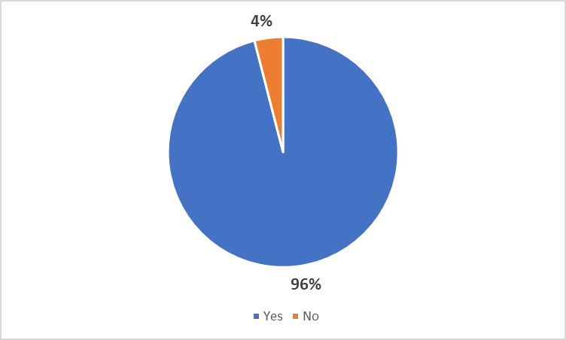
96% of the consumers have made a purchase from Zara even once after seeing the ad online. This shows the power of Facebook marketing over traditional marketing about a fast fashion brand like Zara. Whereas, only 4% of them never purchased seeing an ad on Facebook. This resonates with the findings of Esmaeilpour et al., (2019) who stated that the social media platform influences purchase decision.
7. How often do you make purchases from Zara after seeing an ad on Facebook?
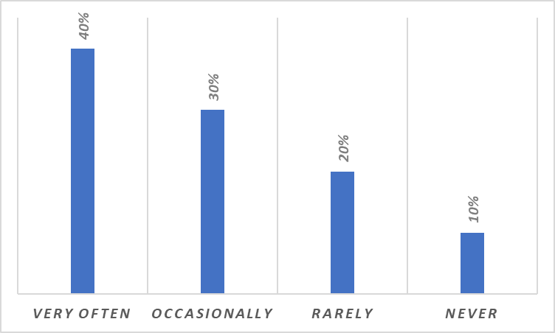
To reinforce the previous question, this outcome shows that the 40% of the consumers purchase very often after seeing ad on Facebook. Whereas, 30% of them make the purchase decisions occasionally. 20% and 10% of the consumers do the rarely and never.
Theme 02: Influences of Facebook
8. Do you feel that Facebook influences your decision-making process when considering Zara products?
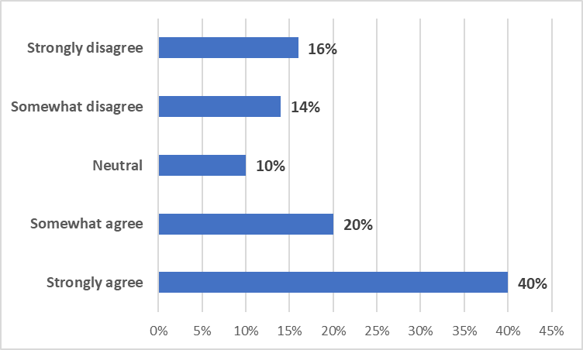
40% of the consumers believe that they are strongly influenced by the Facebook in their decision-making process when it comes to Zara. This can be attributed to the findings of Ali & Ahmad (2020) who stated that the decision-making process of employees are influenced by social media platform, even more in terms of fast fashion products.
9. How much do you trust the information provided by Zara on their Facebook page?
Trust is important in influencing the purchase decisions of the employees. According to the responses, 30% each of the consumers have somewhat distrust and neutrality in terms of Facebook page posts of Zara. Thus, it can be seen that majority of the consumers do not have full trust on the Facebook updates. This is an area; fast fashion brand should work upon to engage more with the consumers on Facebook (Zara, 2022).
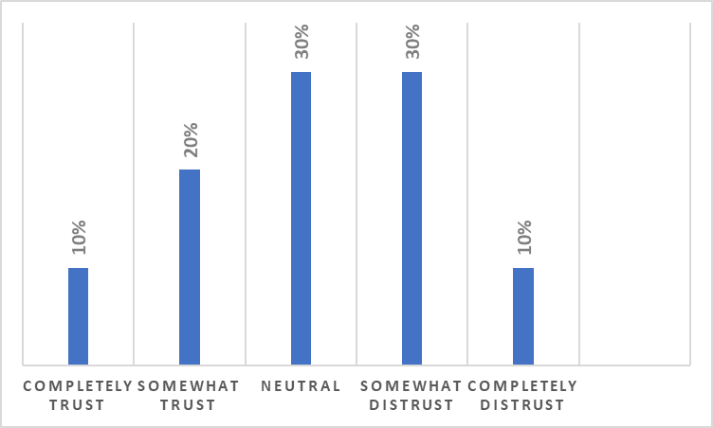
10. Have you ever made a purchase from Zara as a result of a recommendation from a Facebook friend or influencer?
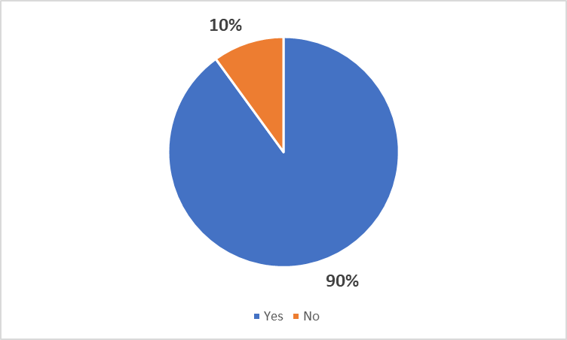
The responses of the employees show that 90% of the employees have more trust on their Facebook friends and influences to make purchase decisions as they listen to their recommendations. It is evident that the consumers are believing the influencers more compared to the direct updates of the companies. The findings conform with the prediction of Kabadayi & Price (2014) who told that influencers influence the consumers more compared to the companies themselves because of filtering in message.
11. How effective do you find Zara's Facebook marketing compared to their traditional marketing efforts?
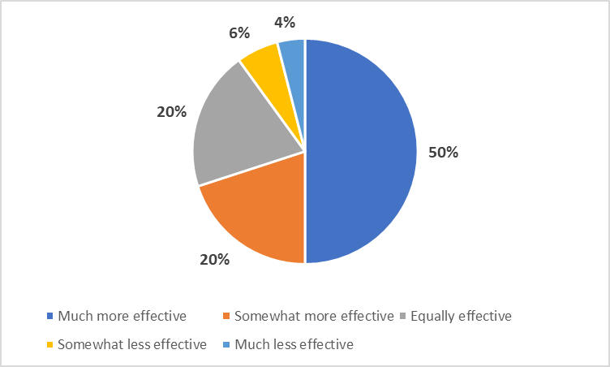
In terms of judging the effectiveness of Facebook marketing with that of the traditional marketing, 50% of the consumers believe that they Facebook marketing is more effective than the traditional marketing on TV, newspaper, radio, and other platforms. The findings also conform with the findings of 2012 by Kim & Ko who enforced that the social media marketing is much more effective compared to the other platforms in the coming decades.
12. What factors do you consider when deciding whether to make a purchase from Zara?
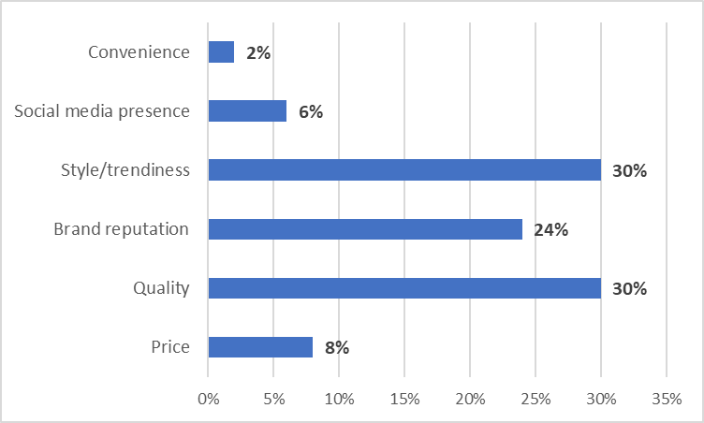
30% each of the consumers prefer style/trendiness and quality while making a purchase decision from Zara. Whereas, price little affect the purchase decision. Brand reputation also causes 24% of the consumers to make their purchase decision from the brand. The social media presence, and convenience influence only 6% and 2% of the consumers of Zara. This aligns with the findings of Venkatesh and Bala (2008), consumers care more about the brand, and trend while purchasing fast fashion products like Zara rather than price, convenience or other factors.
Theme 03: Facebook marketing vs traditional marketing by Zara
13. Which form of advertisements you prefer from Zara?
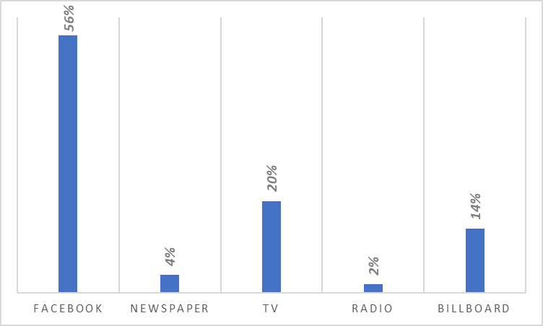
Majority of the consumers are more convenient and comfortable with the Facebook marketing compared to newspaper, TV, Radio, and Billboard. Because, Facebook uses different types of algorithm and systems to customise the ad and deliver to the consumers exactly what they need. The rise of Facebook marketing is undeniable which can also be confirmed from the responses of the consumes in this survey.
14. How Facebook marketing is better than traditional marketing?
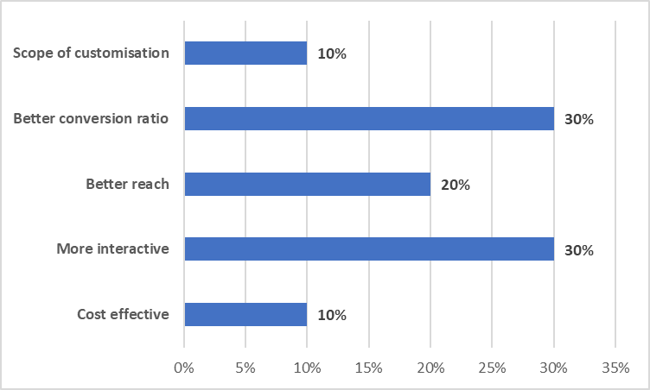
The better conversation ratio, and more interactions with the consumers influence total of 60% consumers to the Zara products online. On the other hand, better reach, and cost effectiveness of the Facebook ad are also important to the decision-making process of the businesses as well as the consumers. The rest 10% prefer Facebook due to its scope of customisation. The findings of Toffel and Gao (2014) also aligns with the findings of this research which show that Facebook marketing is better compared to traditional marketing.
15. Which platforms Zara should more focus in future?
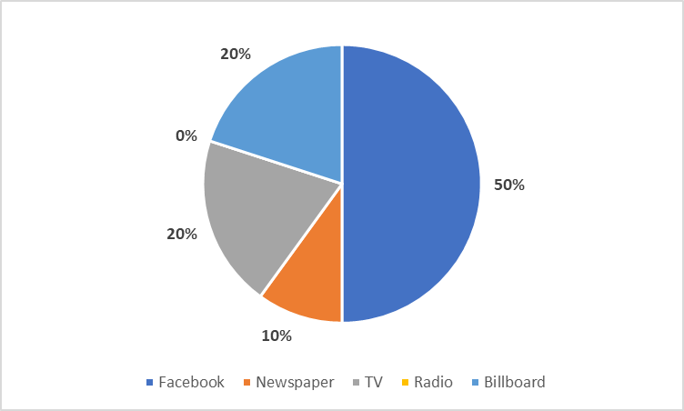
In an enquiry to find out which platform should fast fashion brand like Zara focus on. It has been found that 50% of the consumers believe that the Facebook is more appropriate form of advertising for them hence, it should be reinforced. On the other hand, 20% each prefer TV and Billboard. And radio and newspaper are the least preferred form of advertising for the consumers since ads are hard to find out on those platforms.

Chapter 05: Conclusion
This section summarises the findings and overall work of the research project. This also put together the essence of objectives, and aims of the research project.
To conclude the research project, it is evident that the younger and female are more inclined to fast fashion products like Zara. The outcomes of the research survey questionnaire find that a large number of the Zara consumers use Facebook in their information gathering process before making any purchase decision of Zara products. The consumers visit the Facebook page of Zara to collect basic information like colour, price, and other information. However, thus the Facebook impact the information gathering process of the consumers to a great extent. 70% of the consumers visit Zara’s Facebook page once in a monthly and weekly basis (Lin & Lu, 2011). Whereas, around 44% of the consumers purchase the Zara products after gathering information from the Facebook page and other sources of the brand. Thus, significant impact of Facebook on the consumer decision making process of Zara is evident from the study.
In terms of finding out the influence of Facebook in making the consumers purchase Zara products, the survey research finds that around 40% of the consumers believe that they are influenced by the Facebook platforms of Zara in terms of choosing the products, and even making the final purchase decision on their own. Whereas, 44% of the consumers are “somewhat likely” to make a purchase of Zara products after they get any recommendation from their friends or influencers on the platforms. However, a major issue still persists when 44% of the consumers still mistrusts the information found on the Facebook pages. As a result, they check out the products and short list them using Facebook and physically go to the stores to make the purchase. This lowers the online sales of the company and lead to customer loss due to time and costs required to reach the Zara stores (Chen & Xie, 2014).
The last research objective was about the effectiveness of Facebook marketing compared to that of the traditional marketing on TV, radio, newspaper, Billboard, and other platforms. The survey research also finds that the Facebook marketing is more effective to them compared to any other marketing platforms chosen by the consumers (Esmaeilpour et al., 2019). 50% of the consumers believe that Facebook can reach them well and customise their needs of marketing through rich analysis and algorithm. On the other hand, Facebook has been chosen as the future of marketing compared to other platforms by the consumers. And the majority consumers also believe that Zara should focus more on the Facebook marketing compared to traditional forms of marketing on TV, radio, electronic and print media, and billboard. Rather the company should focus on affiliated marketing, Facebook optimised, digital marketing, and influencer marketing on social media platforms.
To summarise the research findings, Facebook has a significant on consumer behaviour of Zara customers in their information gathering process, influencing their purchase decision, and working as a marketing media to reach a large number of consumers at a time on a single platform. The survey research has found out the answers to the research questions well. Thus, the findings of the research contribute to the academic study, marketing and consumer behaviour field where the research outcome can further improve the overall knowledge level of the enthusiasts, practitioners, and professionals.
Limited number of sample size is the first limitation of the research. The locational limitation is also present. The limitation of time, financial, and non-financial resources of the study. The limitations of the study have somewhat undermined the quality of the research. However, the prudent research has bettered the overall acceptability, reliability, and sustainability of the research project.
The recommendations are that the research can be broadened in terms of number of sample size, location, and areas of social media covered. More social media platforms, and more companies from a diverse background of companies can be taken into further studies to find out more comprehensive research outcomes.
The conclusion and recommendation section of this research project summarised the overall understanding, findings, limitations, and recommendations of the research project. According to the research findings Facebook is a successful marketing for Zara compared to traditional marketing and it has also been able to influence the information gathering and purchase decision making of the consumers in London, UK.

References
- Ali, M., & Ahmad, M. (2020). Impact of social media marketing on brand loyalty and purchase intention: A study of Pakistani consumers. Journal of Islamic Marketing, 11(4), 1014-1030.
- Baltar, F. and Brunet, I., 2012. Social research 2.0: virtual snowball sampling method using Facebook. Internet research, 22(1), pp.57-74.
- Chen, Y., & Xie, J. (2014). Online consumer review: Word-of-mouth as a new element of marketing communication mix. Management Science, 60(3), 545-558.
- Daniel, P.S. and Sam, A.G., 2011. Research methodology. Gyan Publishing House.
- Esmaeilpour, M., Bakhshizadeh, M., & Azar, A. (2019). Social media marketing, brand equity, and purchase intention: An empirical study of Iranian consumers. Journal of Islamic Marketing, 10(2), 336-348.
- Kabadayi, S., & Price, K. H. (2014). Consumer choice behavior in online and traditional supermarkets: The effects of brand name, price, and other search attributes. International Journal of Research in Marketing, 31(2), 167-180.
- Kim, A. J., & Ko, E. (2012). Do social media marketing activities enhance customer equity? An empirical study of luxury fashion brand. Journal of Business Research, 65(10), 1480-1486.
- Lin, J. S., & Lu, Y. C. (2011). The role of website quality in forming customers’ online purchase intentions. African Journal of Business Management, 5(23), 9448-9458.
- Mangold, W. G., & Faulds, D. J. (2009). Social media: The new hybrid element of the promotion mix. Business Horizons, 52(4), 357-365.
- Orth, C.D.O. and Maçada, A.C.G., 2021. Corporate fraud and relationships: a systematic literature review in the light of research onion. Journal of Financial Crime, 28(3), pp.741-764.
- Oswald, F.L. and Plonsky, L., 2010. Meta-analysis in second language research: Choices and challenges. Annual Review of Applied Linguistics, 30, pp.85-110.
- Pringle, J., Hendry, C. and McLafferty, E., 2011. Phenomenological approaches: Challenges and choices. Nurse researcher, 18(2).
- Sahay, A., 2016. Peeling Saunder's research onion. Research Gate, Art, pp.1-5.
- Smith, H. J., Fischer, E., & Yongjian, C. (2012). How does brand-related user-generated content differ across YouTube, Facebook, and Twitter? Journal of Interactive Marketing, 26(2), 102-113.
- Statista (2022). Statista - The Statistics Portal for Market Data, Market Research and Market Studies. [online] Statista.com. Available at: https://www.statista.com/.
- Toffel, M. W., & Gao, D. (2014). Reputational consequences of environmental violations: Evidence from the global hotel industry. Management Science, 60(3), 632-647.
- Wang, Y., Chen, K., & Liang, Y. (2011). The effects of information overload on consumers' subjective state towards buying decision in the internet shopping. International Journal of Information Management, 31(2), 107-115.
- Yan, Y., & Chen, X. (2018). The impact of social media marketing on consumer buying behavior. World Journal of Social Sciences, 8(1), 15-24.
- Zara (2022). ZARA United Kingdom | New Collection Online. [online] Zara.com. Available at: https://www.zara.com/uk/.

Appendix: Survey Questionnaire
Greetings dear respondents, this survey is on the research topic “Impact of social media (Facebook) on consumer behaviour: A case study on Zara UK”. This will take no longer than 5 minutes of your attention. Rest assured the responses will not be used other than the academic purpose. Thank you!

1. Gender orientation?
Male | 15
Female | 35
Others | 0
2. Age demographic?
18-25 | 20
26-35 | 15
36-45 | 10
>45 | 5
Theme 01: Information gathering process
3. Do you use Facebook to gather information about Zara products before making a purchase?
Yes | 42
No | 8

4. How often do you visit Zara's Facebook page to learn about their products and promotions?
Daily | 5
Weekly | 15
Monthly | 20
Rarely | 7
Never | 3

5. How likely are you to purchase a product from Zara after seeing it on their Facebook page?
Very likely | 10
Somewhat likely | 22
Neutral | 8
Somewhat unlikely | 5
Very unlikely | 5

6. Have you ever made a purchase from Zara after seeing an ad on Facebook?
Yes | 48
No | 2

7. How often do you make purchases from Zara after seeing an ad on Facebook?
Very often | 20
Occasionally | 15
Rarely | 10
Never | 5
Theme 02: Influences of Facebook
8. Do you feel that Facebook influences your decision-making process when considering Zara products?
Strongly agree | 20
Somewhat agree | 10
Neutral | 5
Somewhat disagree | 7
Strongly disagree | 8

9. How much do you trust the information provided by Zara on their Facebook page?
Completely trust | 5
Somewhat trust | 10
Neutral | 15
Somewhat distrust | 15
Completely distrust | 5

10. Have you ever made a purchase from Zara as a result of a recommendation from a Facebook friend or influencer?
Yes | 45
No | 5

11. How effective do you find Zara's Facebook marketing compared to their traditional marketing efforts?
Much more effective | 25
Somewhat more effective | 10
Equally effective | 10
Somewhat less effective | 3
Much less effective | 2

12. What factors do you consider when deciding whether to make a purchase from Zara?
Price | 4
Quality | 15
Brand reputation | 12
Style/trendiness | 15
Social media presence | 3
Convenience | 1
Theme 03: Facebook marketing vs traditional marketing by Zara
13. Which form of advertisements you prefer from Zara?
Facebook | 28
Newspaper | 2
TV | 12
Radio | 1
Billboard | 7
14. How Facebook marketing is better than traditional marketing?
Cost effective | 5
More interactive | 15
Better reach | 10
Better conversion ratio | 15
Scope of customisation | 5
15. Which platforms Zara should more focus in future?
Facebook | 25
Newspaper | 5
TV | 10
Radio | 0
Billboard | 10

Thanks for your time!!

Appendix:

