

Programme: Master of Business Administration
Module: Marketing Management
Module code: LCMB7024
Title: Assessment Component 2 – Individual Report
Word count: 2500
Lecturer: Dian Mayasari
Student Name: Krinal Bhikhubhai Gandhi
Student ID: 2504763
Submission Date- 19th November 2025

Table of Contents
Introduction 3
1: STDP Analysis 4
1.1 Segmentation 4
1.2 Targeting 6
1.3 Differentiation 7
1.4 Positioning 8
2: Marketing Mix (4Ps) 9
2.1 Product 10
2.2 Price 11
2.3 Place 12
2.4 Promotion 13
3: Poster of Costa Fresh (Marketing Strategy Pitch) 15
4: Reflection 16
References 18

Introduction
Costa Coffee, founded in 1971 in London, has developed into one of the UK's most recognizable coffeehouse chains, known for its premium coffee and friendly store environments (Costa Coffee, 2024). Over the years, the company expanded globally and was well-known for quality, consistency, and community-based coffee experiences.
With increasing awareness about health, sustainability, and convenience, consumer preference is definitely changing. Most of them now seek an option where taste is combined with wellness. To respond to such an emerging trend, a new sub-brand, Costa Fresh, is proposed under the umbrella of Costa Coffee. The Costa Fresh sub-brand will position itself along lines of healthy snacking, freshly prepared meals, and nutritionally balanced beverages, including smoothies, salads, protein wraps, and sugar-free coffee options.
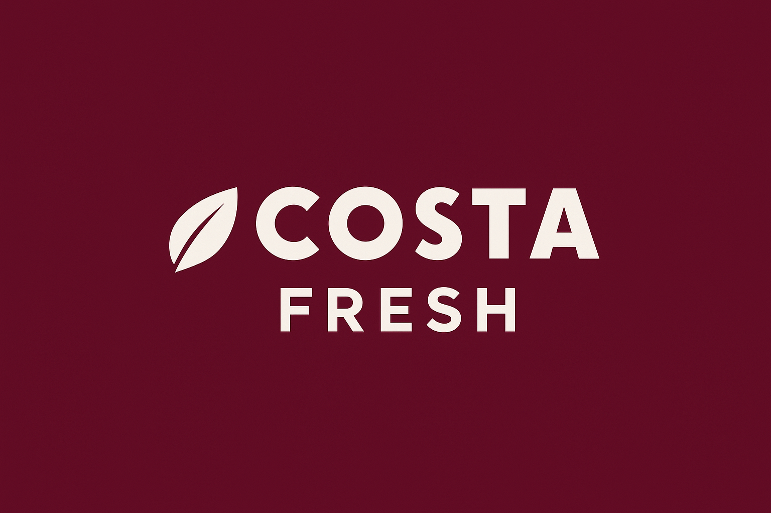
The purpose of this proposal is to develop an overall brand development and marketing strategy for the launch of Costa Fresh. This report will explain exactly how Costa Coffee can effectively extend their brand to meet the changing customer demands of today, yet still retain its reputation for quality and trust. It focuses on how Costa Fresh will appeal to a modern audience of health-conscious individuals and strengthen Costa's competitive position in the UK food and beverage market.
Costa Fresh represents a healthful and sustainable product line for Costa Coffee. The sub-brand will give consumers a refreshing drink that perfectly balances flavour with nutrition. Its menu will feature freshly made wraps, salads, smoothie bowls, and protein-based beverages-perfect for active lifestyle people who still want quick, high-quality meals. The design of Costa Fresh will reflect a modern, eco-friendly image through the use of natural colours, recyclable packaging, and a minimalist brand that accentuates freshness and well-being.
The following proposal is structured into three main elements:
1 - STDP Analysis: This section covers Segmentation, Targeting, Differentiation, and Positioning, which explain how Costa Fresh will identify and attract its ideal customer segments while establishing a unique market position.
2 - Marketing Mix (4Ps): This segment delineates the product, price, place, and promotion strategies to be utilized for the support of the launch and to ensure brand alignment.
3 - Marketing Strategy Pitch: Summarize the key strategic element of the new brand. It should include the specific problem your new brand wants to solve and depict how it creates value for customers.
4 - Reflection: This final section contains a reflective account of the learning experience gained through the development of the Costa Fresh brand, which identifies key skills, insights, and areas for improvement in future projects.

1: STDP Analysis

1.1 Segmentation
Market segmentation involves division of a broad market into small, manageable groups including consumers with similar needs or characteristics. According to Kotler et al. (2022), by segmenting the marketplace into smaller groups, Costa Fresh can easily identify prospective buyers who will most likely be responsive to the firm's healthy and fresh product offerings.
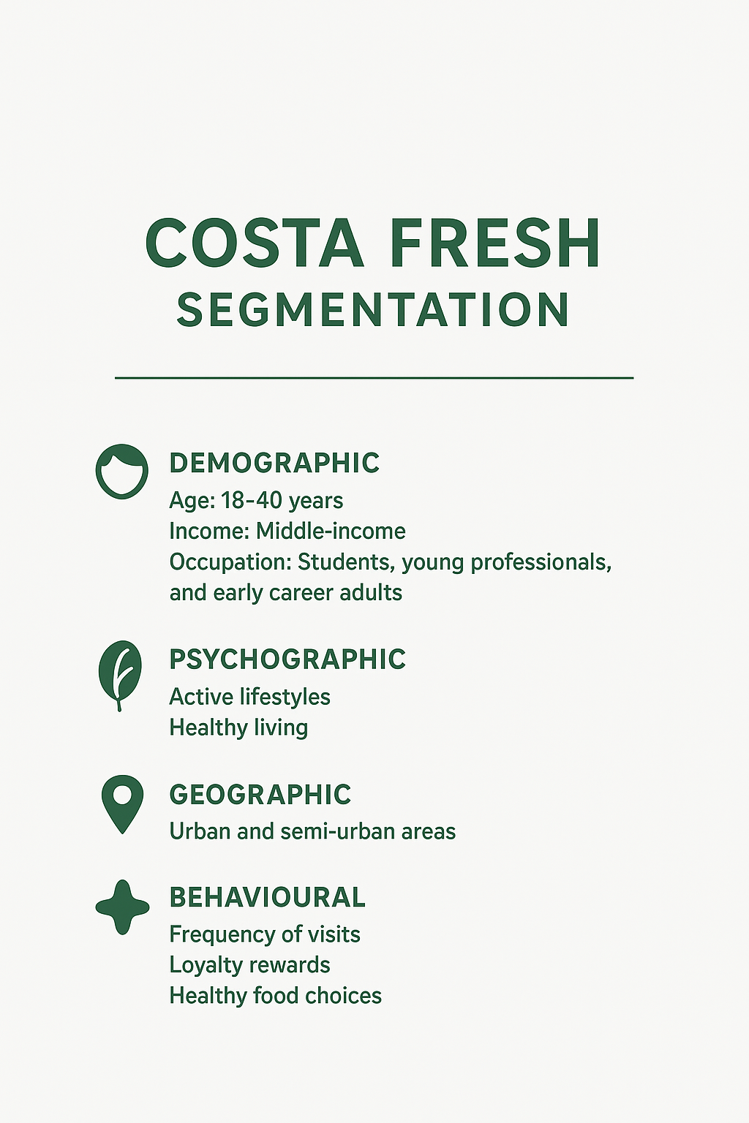
Costa Fresh uses a multi-dimensional segmentation strategy that combines demographic, psychographic, geographic, and behavioural segmentation methods:
- Demographic Segmentation
Age: Ranges from 18 to 40 years, targeting all students, young professionals, and early career adults.
Income: Middle-income consumers willing to pay a small premium for healthier, higher-quality food.
Occupation: Employees working indoors, students, and people who regularly go to the gym and eat out during work/study breaks.
- Psychographic Segmentation
It concentrates on the customers' lifestyle, attitude, and values. Costa Fresh targets people that undertake very active and wellness-oriented lifestyles and prefer food that complements healthy living. These consumers are motivated by sustainability, self-care, and convenience.
- Geographic Segmentation
Costa Fresh will first focus on urban and semi-urban areas with high footfall such as city centres, universities, and business districts. This ensures access to customers who frequently visit cafés or require on-the-go meals. Behavioural Segmentation: In respect of consumption habits, Costa Fresh determines its target customer as one who seeks freshness, good taste, and quality in their daily nutrition. They are frequent café visitors, appreciating healthy alternatives and responding well to loyalty rewards or personalized offers. By combining such segmentation variables, Costa Fresh will be able to develop detailed customer profiles which will guide marketing communications and product development.

1.2 Targeting
Targeting is the selection of specific segments to focus a brand's marketing activity (Baines et al., 2021) Based on analysing market potential and competition, Costa Fresh will target the following primary and secondary market segment:
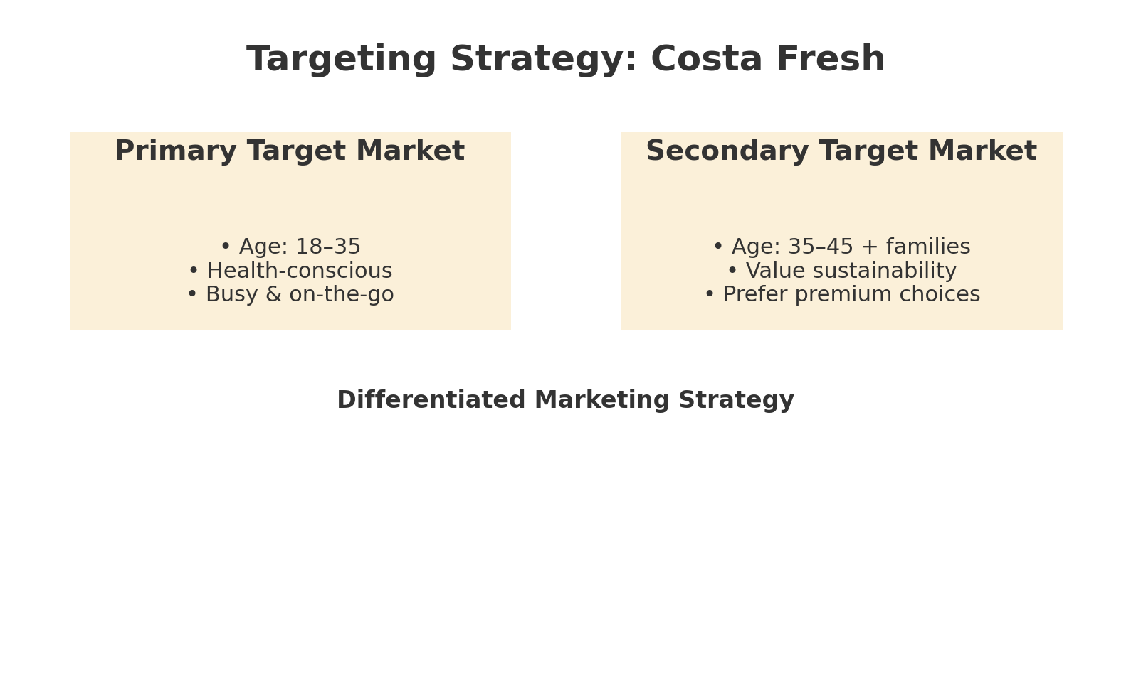
- Primary Target Market
Health-conscious young professionals and students, aged between 18-35 years, living busy lifestyles and seeking quick, nutritious food and beverage options. They are digitally savvy and often active on social media, thus appreciating convenience combined with quality.
- Secondary Target Market
Older professionals 35–45 years; families who are increasingly conscious of diet and well-being. Value sustainability, will pay more for brands that show environmental concern. The targeting strategy will then be one of differentiated marketing, where there will be some variations in product offering for each segment. An example could be meal deals and smoothies for students, while premium salads or organic beverages may be offered to professionals. This allows Costa Fresh to maximize reach without diluting its health-oriented brand image. This choice of target market is supported by current trends showing the growth of demand for healthier fast-food alternatives and on-the-go nutrition in younger age groups. By focusing on this segment, Costa Fresh can position itself as relevant and desirable within a competitive market.

1.3 Differentiation
Differentiation is the means by which a brand creates unique value that sets it apart from competitors. According to Keller (2020), the differentiation for Costa Fresh will be upon four major pillars:
- Health and Freshness
Costa Fresh will put the maximum emphasis on healthy and fresh ingredients in all items. Compared to traditional chains that sell sweet bakery products, fresh salads, smoothies, and snacks prepared from the local ingredient will be featured at Costa Fresh.
- Sustainability
It intends to incorporate eco-friendly practices into its brands through biodegradable packaging, reduction of waste, and sourcing from sustainable suppliers. This is in tandem with increased environmental awareness among consumers (Peattie and Crane, 2023).

- Brand Experience
Interiors in the stores will be designed with natural colours, greenery, and minimalistic design for freshness and calmness. The environment shall be designed to evoke a positive emotional connection, thereby making Costa Fresh a preferred spot for relaxation and productivity.
- Digital Innovation
A dedicated mobile application from Costa Fresh will provide personalized recommendations, pre-ordering, and nutrition tracking. These digital interventions will enhance convenience while also cultivating customer loyalty.
Combined, these features make Costa Fresh something more than a cafe; it's a lifestyle brand cantered on health, community, and sustainability.

1.4 Positioning
Positioning according to Kotler et al. (2022) refers to how customers perceive the brand in relation to competitors. Costa Fresh will position itself as “the go-to destination for fresh, healthy, and sustainable food and beverages, served with Costa’s trusted quality and comfort.”
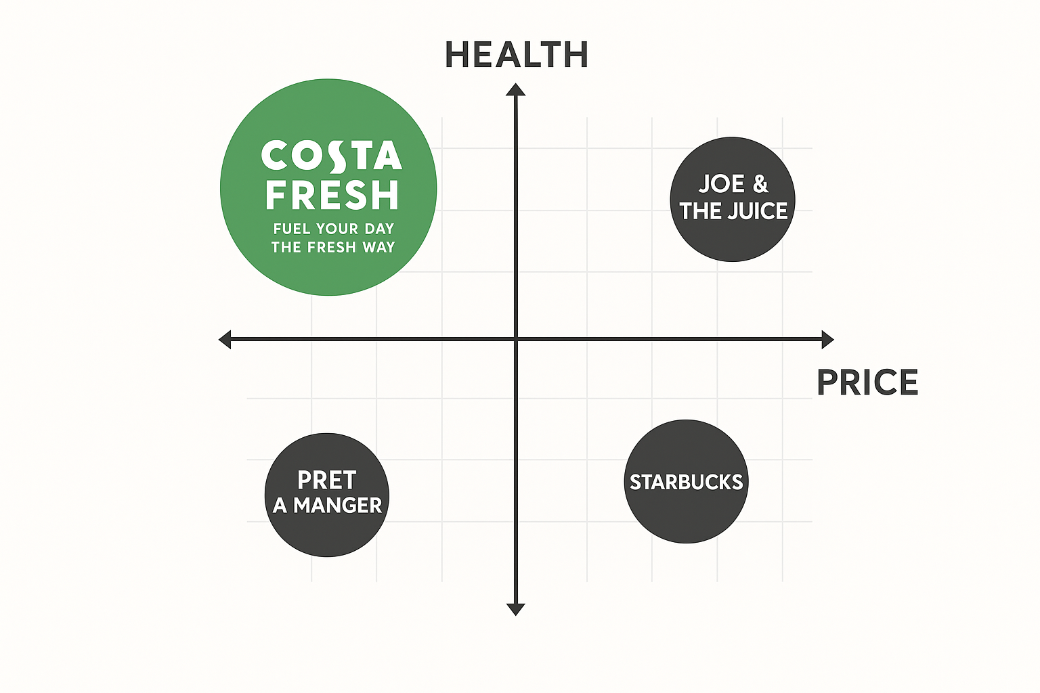
The positioning strategy is going to be directed by the following principles:
- Value Proposition
"Fuel your day the fresh way." Costa Fresh delivers a vibrant range of healthy smoothies, fresh juices and snacks made from 100% natural and locally sourced ingredients.
- Points of Difference
Focus on healthy, fresh, and customizable menu options.
- Points of Parity
Costa Fresh will retain familiarity with the main features of Costa Coffee: warm hospitality, quality beverages, and comfortable seating. In the marketplace, Costa Fresh will take a hybrid positioning between premium health brands such as Pret a Manger and Joe & The Juice, and mainstream coffee chains like Starbucks. In this way, the company is said to be on course to achieve a balanced offering of accessible wellness: guilt-free indulgence, affordable, and convenient.
The positioning map of the brand would place Costa Fresh high on health and freshness dimensions while keeping it moderately priced in comparison with premium competitors. This will ensure broad appeal without losing the premium touch associated with Costa.

2: Marketing Mix (4Ps)
The marketing mix is a strategic means to align product offerings and marketing activities in respect of brand objectives and clearly targeted audiences. At the core of contemporary marketing is the 4Ps model, comprising Product, Price, Place, and Promotion, as previously developed by McCarthy (1960). According to Kotler et al. (2022), each element of the mix must smoothly support another in Favor of the positioning of the brand and the value proposition it promises or offers.
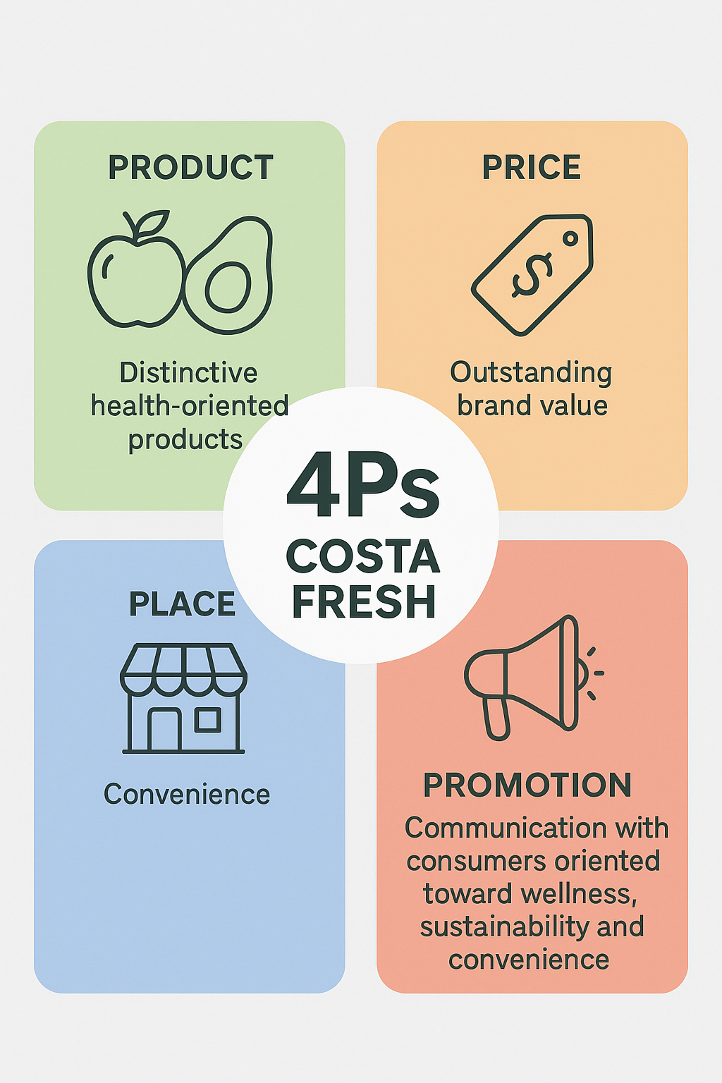
The 4Ps strategy for Costa Fresh is about creating distinctive health-oriented products, offering outstanding brand value, communicating well with consumers oriented toward wellness, sustainability, and convenience.

2.1 Product
In the context of Kotler et al. (2022), the core of the marketing mix includes the product, which is representative of the value satisfying customer needs and wants. The product strategy of Costa Fresh will target freshness, health, and sustainability because there are increasing demands for nutritious and ethically produced food.
1. Product Concept and Range
- Healthy Beverages: Cold-pressed juices, smoothies, protein shakes, and low-sugar iced coffee.
- Food Products: Fresh salads, wraps, fruit bowls, granola pots, and vegan snack boxes.
This coincides with the concept of product differentiation, wherein Costa Fresh wants to give customers an experience that no other direct competitors, such as Starbucks or Pret A Manger, have yet to fully achieve within the healthy quick-service space (Keller, 2020).
2. Product Quality and Design
The brand will focus on premium quality by using locally sourced and organic ingredients where possible. The preparation process will focus on maintaining nutritional value while delivering great taste. According to the Total Product Concept (TPC) model (Levitt, 1980), products have three layers:
- Core product: Healthy, convenient meals.
- Actual product: Costa Fresh’s name, packaging, and appearance
- Augmented Product: Loyalty programme, digital ordering, after-sales experience.
The packaging will be in an eco-friendly and biodegradable material to reinforce the environmental responsibility of Costa Fresh. The design will include light colours-green, white, and beige-and minimalist branding to convey freshness and wellness.
3. Branding and Product Strategy
The brand identity of Costa Fresh will remain closely aligned with the Costa Coffee parent company for brand trust and recognition. It will adopt a modern and youthful image through a new logo and tagline:
"Fuel your day the Fresh Way."
This branding conveys positivity, health, and energy. Product innovation will be ongoing, with seasonal menu updates and limited-edition items that keep the offering dynamic and relevant to current health trends.

2.2 Price
Pricing is related to customer perception and brand positioning. It directly influences the assessment of value by customers in relation to the quality of a product. In this regard, Costa Fresh will embrace value-based pricing, where prices will represent perceived values related to freshness, health benefits, and ethical sourcing.
- Pricing Strategy
The pricing strategy for Costa Fresh will balance value-based pricing and competitive pricing. Prices will be a little higher than Costa Coffee's traditional menu but lower than premium health-focused brands like Leon or Joe & The Juice.
Smoothies: £4.50–£5.50
Wraps or salads from £5.00–£6.00
Smoothie and snack combo deals from £7.00-£8.00
This moves the strategy for Costa Fresh: "affordable wellness," or premium enough to feel special, yet still affordable for students and professionals.
- Psychological Pricing and Bundling
Costa Fresh will also employ psychological pricing, such as £4.99 instead of £5.00, to enhance perceived value. Bundle pricing will offer meal combinations at discounted rates to encourage higher purchase frequency.
The brand will also be using price differentiation across channels-a little lower prices for in-app pre-orders or subscription plans. This, apart from increasing the engagement of the app, helps build customer loyalty through digital convenience.
- Pricing and Perceived Value
According to the theory of perceived value by Zeithaml (1988), customers perceive value through a comparison between benefits and costs. Costa Fresh can command slightly premium prices by highlighting the health, freshness, and sustainability benefits of their products. Furthermore, loyalty rewards through the Costa app will reinforce long-term value and repeat purchases.

2.3 Place
The place aspect of the marketing mix outlines how goods are distributed and made available to the customer. It is extremely important since proper distribution guarantees that products are available at the right place, time, and quantity. Costa Fresh will offer an omnichannel distribution by incorporating every physical and digital touchpoint to maximize customer convenience.
- Physical Outlets
Products of Costa Fresh will be available in:
Dedicated Costa Fresh stores in high-traffic urban areas, universities, and business districts.
Develop Costa Fresh corners within existing Costa Coffee outlets to reduce investment and utilize the existing infrastructure.
These outlets will boast open displays, chillers, and grab-and-go sections to facilitate quick service. In-store designs will include natural lighting and greenery for a refreshing experience.
- Online and Mobile Channels
Digital convenience is at the forefront of Costa Fresh. A dedicated Costa app will enable customers to:
Pre-order food and beverages.
Customize their meals, track nutritional information, and gather loyalty points.
Further reach will be achieved through partnerships with delivery platforms like Deliveroo, Just Eat, and Uber Eats. This is also in line with the concept of place utility, ensuring that consumers can access Costa Fresh wherever and whenever they may choose.
- Supply Chain and Sustainability
Therefore, Costa Fresh is going to implement a green chain supply model and source ingredients from local suppliers to reduce carbon footprint and maintain product freshness. The GSCM theory states that sustainable operations can affect consumers' brand image and trust (Sarkis, 2021).
By keeping the supply chains short and investing in efficient logistics, the outlet will ensure product freshness and quality consistency across all outlets.

2.4 Promotion
According to Keller, promotion builds brand awareness, drives demand, and changes attitudes. Costa Fresh's promotional strategy will be underpinned by a mix of digital marketing activity, experiential campaigns, and collaborations to communicate a singular brand message.
- Promotion Objectives
Improve awareness of Costa Fresh among existing customers of Costa Coffee.
Attract new health-conscious consumers in the 18–35 age bracket.
Build brand loyalty by creating engaging and value-driven campaigns.
- Promotional Tools and Strategies
1. Digital Marketing: Social media campaigns on Instagram, TikTok, and YouTube will feature fresh products and healthy lifestyle content. Collaborations with fitness influencers and nutritionists, who can promote Costa Fresh as part of a balanced lifestyle. Using user-generated content in order to build authenticity and community engagement.
2. Advertisement: Launch of digital adverts with the tagline “Fuel your day the Fresh way.” In-store posters and outdoor billboards with striking visuals and sustainability messages.
3. Sales Promotion: Loyalty rewards via the Costa app, such as every 6th smoothie free. Introductory discounts and combo offer during the launch phase. Free tasting sessions in high-footfall stores to create product trial.
4. Public Relations: Partner with health and wellness events, universities, and eco-campaigns. Press releases on Costa Fresh's sustainable sourcing and packaging initiatives.
5. Integrated Marketing Communications: The promotion mix will be designed based on the IMC model to maintain congruity across all touchpoints. Each campaign should reinforce the positioning of the brand as fresh, healthy, and sustainable (Kotler et al., 2022).
In short, the marketing mix for Costa Fresh has been aligned to assure each element, including product, price, place, and promotion, matches the positioning of its brand as a fresh, healthy, and sustainable café concept.

3: Poster of Costa Fresh (Marketing Strategy Pitch)
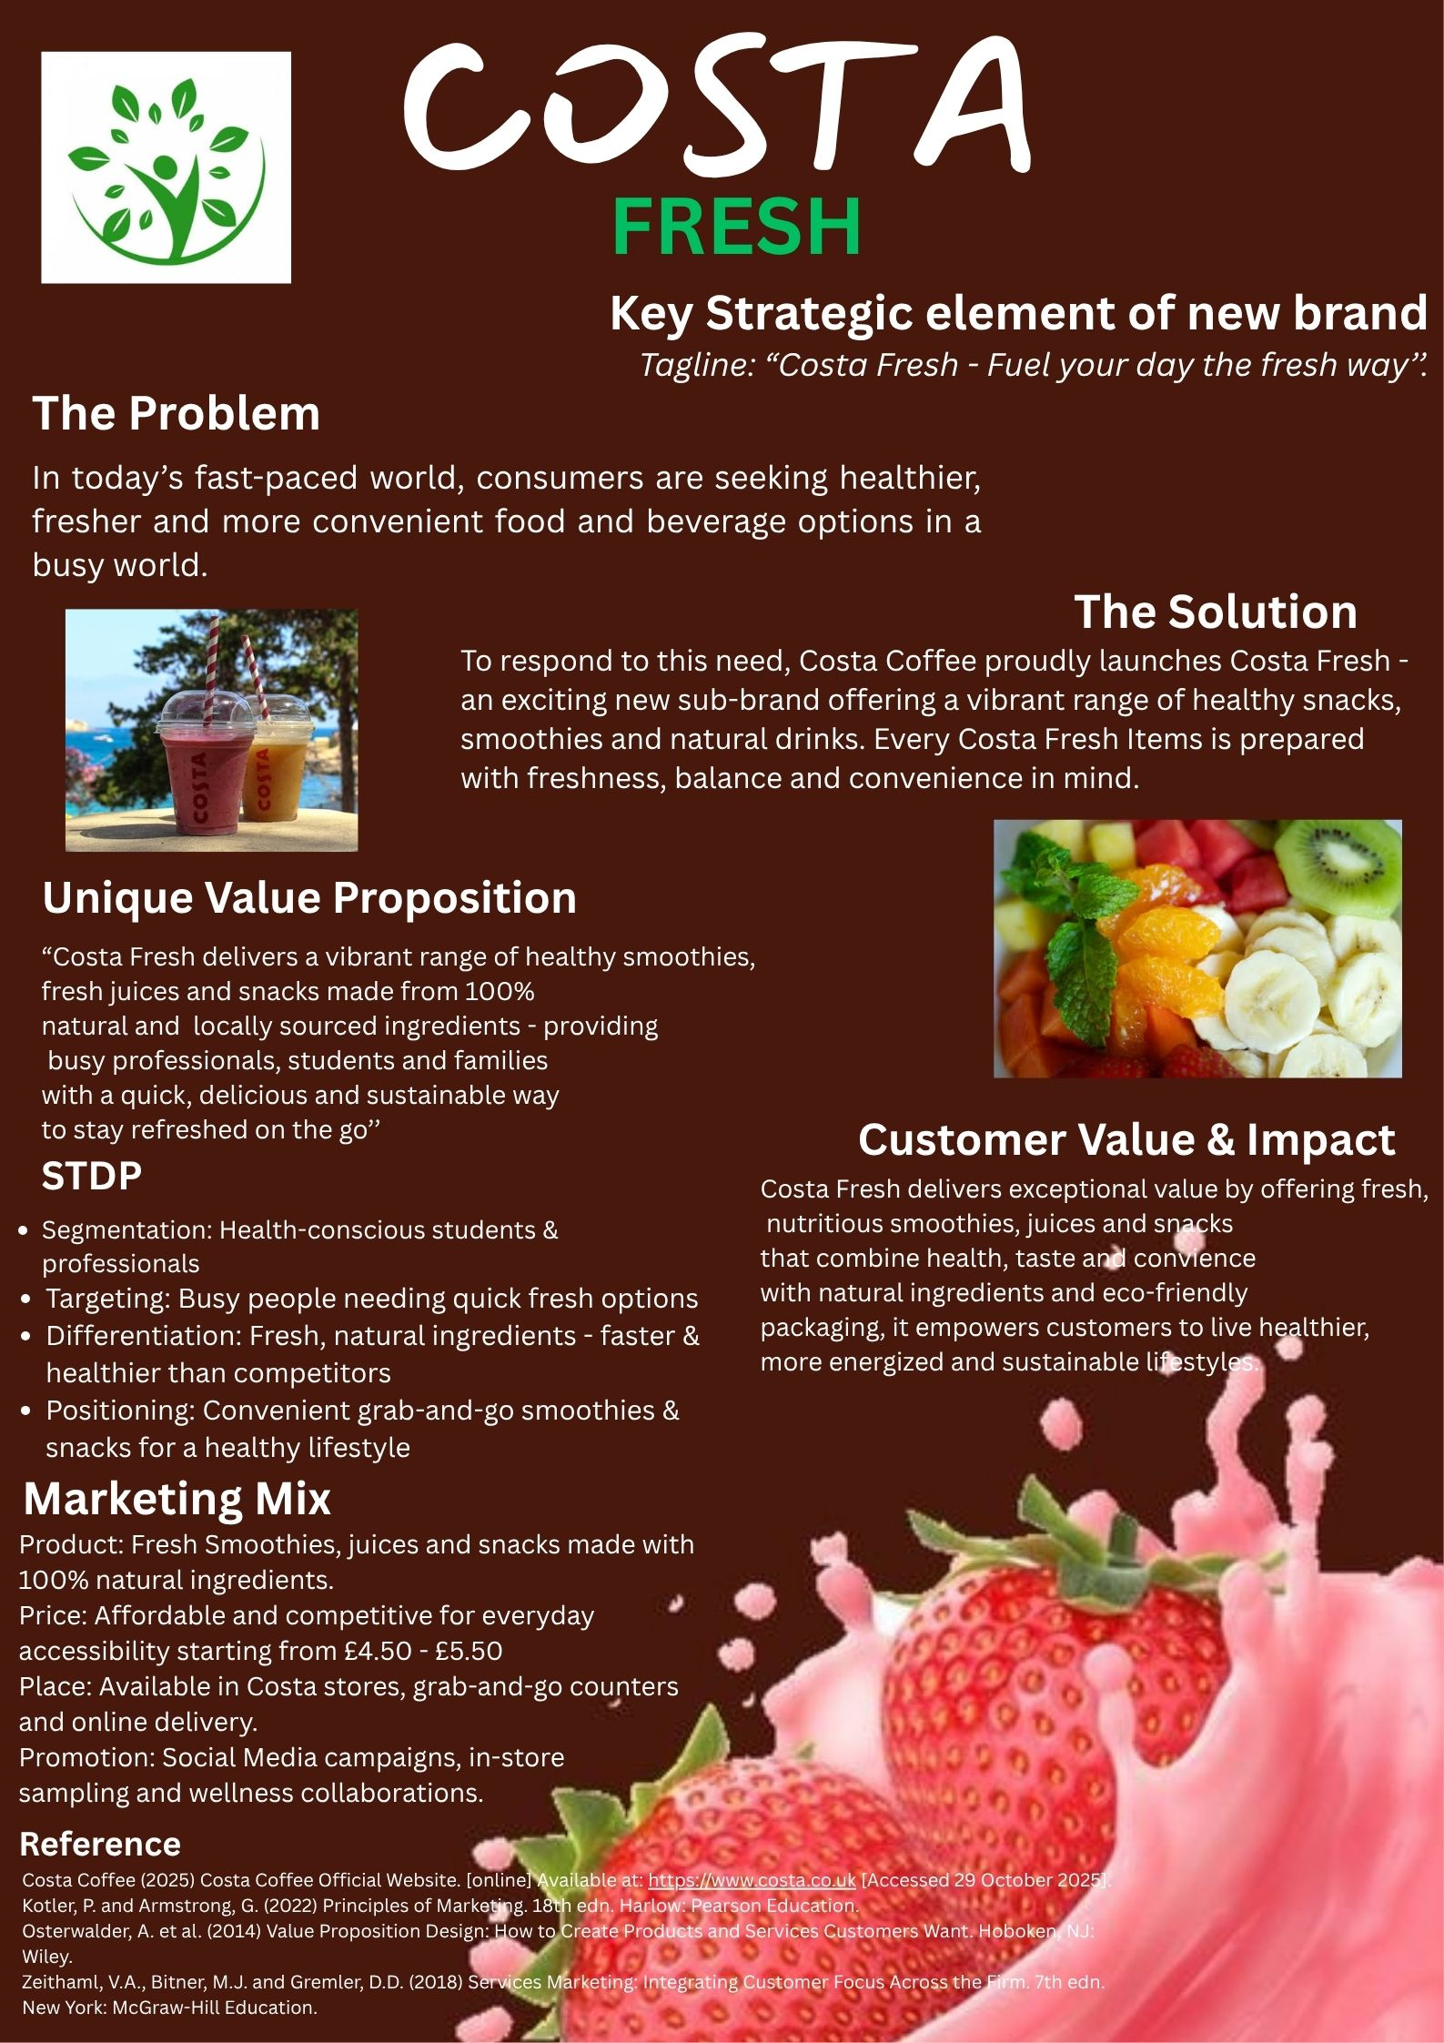
This poster introduces the new health-focused sub-brand, Costa Fresh, developed under Costa Coffee to meet the changing consumer preferences. The faster the pace of life, the more customers want healthier, fresher, and more convenient food and beverages. According to Mintel, this trend is to continue well into 2024. The poster sums up the core strategic focus behind Costa Fresh, highlighting its interest in nutritious smoothies, freshly squeezed juices, and wholesome snacks made from 100% natural ingredients. The key value proposition revolves around offering busy professionals, students, and families a quick yet healthy option on-the-go.
The STDP framework summarized in the poster can be used to explain that the brand targets health-conscious consumers whose purchase behaviours revolve around their wellness and convenience. Differentiation is achieved through the use of natural ingredients, eco-friendly packaging, and quick service compared to other traditional food outlets. According to Kotler et al. (2022), Costa Fresh is targeting to position itself as the preferred destination for healthy grab-and-go items within the coffee shop environment.
It also describes, very briefly, the marketing mix: affordable pricing, widespread availability in the Costa stores, and integrated promotional activities involving social media marketing and wellness collaborations. Overall, the positioning of Costa Fresh serves to deliver value for healthier lifestyles, while strengthening Costa Coffee's brand relevance in the competitive market.

4: Reflection
The development of the brand concept and marketing strategy for Costa Fresh was a perfect opportunity to put into practice various theories and frameworks related to marketing in a realistic business context. Throughout this project, I gained an appreciation for the fact that innovation at the brand has to accommodate changes around consumer trends in consumption. Because consumers increasingly expect food and beverage businesses to support healthier and more sustainable choices, I realized that brands such as Costa Coffee would need to offer products that align with such lifestyle choices if they were interested in staying competitive and relevant.
Of all the important skills I developed during this process, I would single out market analysis and customer segmentation. STDP enabled me to very clearly identify who this brand should target and why they would be interested in Costa Fresh. I learned that the art of segmentation is not just about choosing groups of people but rather about understanding what motivates them, what kind of challenges they face, and how a certain product can enhance their daily routines. This helped me in creating a more focused brand strategy and sharpening my strategic thinking.
The work on the marketing mix also enhanced my creative and decision-making skills. While developing the new product line, I had to think about how each single product feature should be of value to the target market. I realized how closely pricing, promotion, and distribution are related to molding the overall brand experience. Being able to apply theory, such as the Total Product Concept, was a great opportunity to go deeper into ways by which Costa Fresh can differentiate its offering. I also developed a better understanding of integrated marketing communications and made sure that all promotional messages were consistent with brand identity and positioning.
The preparation of the pitch presentation developed my confidence in clearly and persuasively communicating marketing ideas. Storytelling was an approach considered important in presenting a brand to an audience. It was not enough to describe theories but rather how Costa Fresh would connect emotionally with customers and solve a real need. Delivering the pitch developed my presentation, teamwork, and time management skills, which will be useful for future business projects.
There were also challenges in this task, one of which was to make sure that decisions made upon marketing would be supported with credible evidence and comply with the existing Costa Coffee brand values. This required critical thinking as a way of filtering out ideas that are exciting yet not practical. Another challenge was balancing theory with realism, pushing me to apply academic models more effectively rather than describing them generally.
If I have to conduct a similar project in the future, I will try to include more primary research, like customer surveys or interviews that provide much deeper insights into consumer preferences. I would also like to enhance my financial analytical capabilities regarding the forecast of the potential revenue and costs of the new brand. This will enhance the commercial validity of the marketing plan. Most importantly, this project strengthened my academic knowledge and practical marketing capabilities. It taught me how to create customer value, how to position a brand effectively, and how to pitch professional marketing ideas confidently. I believe that the skills gained in the process will support my future career in marketing and help me to become more strategic and innovative in future projects.

References
Aaker, D.A. (2014) Aaker on Branding: 20 Principles That Drive Success. New York: Morgan James Publishing.
Armstrong, G. et al. (2020) Marketing: An Introduction. 14th edn. Harlow: Pearson.
Baines, P., Fill, C. and Rosengren, S. (2017) Marketing. 5th edn. Oxford: Oxford University Press.
Blythe, J. (2018) Consumer Behaviour. 4th edn. London: Cengage Learning.
British Coffee Association (2023) UK Coffee Consumption Report. London: BCA. Available at: https://britishcoffeeassociation.org (Accessed: 8 November 2025).
Costa Coffee (2024) Official Website. Available at: https://www.costa.co.uk (Accessed: 8 November 2025).
Euromonitor (2024) UK Coffee Shop Market Trends. London: Euromonitor International. Available at: https://www.euromonitor.com (Accessed: 8 November 2025).
Grant, R. (2019) Contemporary Strategy Analysis. 10th edn. Chichester: Wiley.
Jobber, D. and Ellis-Chadwick, F. (2020) Principles and Practice of Marketing. 9th edn. London: McGraw-Hill.
Kotler, P. and Armstrong, G. (2022) Principles of Marketing. 18th edn. Harlow: Pearson.
Kotler, P. and Keller, K.L. (2016) Marketing Management. 15th edn. Harlow: Pearson.
Lantos, G.P. (2015) Consumer Behaviour in Action. London: Routledge.
Mintel (2024) Healthy Eating and Drink Trends in the UK. London: Mintel Group Ltd. Available at: https://www.mintel.com (Accessed: 8 November 2025).
Oliver, R.L. (2015) Satisfaction: A Behavioural Perspective on the Consumer. 2nd edn. New York: Routledge.
Osterwalder, A. et al. (2014) Value Proposition Design: How to Create Products and Services Customers Want. Hoboken, NJ: Wiley.
Payne, A. and Frow, P. (2017) Strategic Customer Management: Integrating Relationship Marketing and CRM. 2nd edn. Cambridge: Cambridge University Press.
Porter, M.E. (2008) ‘The Five Competitive Forces That Shape Strategy’, Harvard Business Review, 86(1), pp. 78–93.
Solomon, M.R. (2020) Consumer Behaviour: Buying, Having, and Being. 13th edn. Harlow: Pearson.
Statista (2024) UK Coffee Shop Industry Revenue. Available at: https://www.statista.com (Accessed: 8 November 2025).
Zeithaml, V.A., Bitner, M.J. and Gremler, D.D. (2018) Services Marketing: Integrating Customer Focus Across the Firm. 7th edn. New York: McGraw-Hill Education.

