Global Business Environment
Written by Maria Doogaru
Student number 1816233
For Prof. Kenny Tang
6 January 2020

Contents
Introduction 3
Part 1 4
A. 4
B. 6
C. 8
Conclusion for Part 1 9
Part 2 10
A. 10
B. 11
C. 12
Conclusion of Part 2 13
Conclusion 14
References 15

Figure 1: PESTEL 4
Figure 2: Analysis of porter's five forces 6
Figure 3: Analysis of porter’s value chain 10

Introduction

The assessment comprises of the two parts relating to the automotive sector, which further includes the two parts describing various points relating to the electric vehicle industries. The assessment is about the electrical vehicle business environment that is global. The part one includes the porter’s five force model which is to be explained, the PESTEL analysis and the organizational behaviour. The second part also contains further three sections defining the preferred definitions. The second part includes the Porters value chain model analysis, the new opportunities for the new comers or the new buyers. Also includes the challenges faced by the organization and also the situations is to be described for the discontinued operations of the business.

Part 1

A.
PESTEL Analysis
According to (Reinhardt, et al, 2017), the automotive sector appears to be as the revolution tip towards the mobility of electric vehicle which uses renewable energy batteries containing chemical energy. PESTEL analysis is the tool or the framework utilized by the marketers of the electric vehicle company to monitor and analyse macro environment or the external environment of marketing. The company monitors the factors that create an impact on the organization, which results in the identification of the threats and the weakness or the reductions used in SWOT analysis. The word PESTEL refers to (Kauerhof, 2017)
P: Political
E: Economic
S: Social
T: Technological
E: Environmental
L: Legal

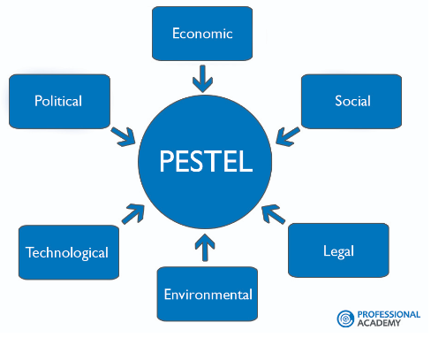
Figure 1: PESTEL
Political Factors: The factors are about the procedure and the degree of intervention of the government in economy. It includes political stability, policies of the government, the instability in the markets overseas, environmental law, foreign policy trade, labour law, tax policy, restrictions of the trade and many more. From the list given, it is understandable that the political factors have an impact on the institutions and their procedure towards the electric vehicle business (Hutchinson, et al, 2018).
Economic Factors: The significant or the important factors of the economic factors of the procedure that how is the business done by the electric vehicle organization and also how they are profitable through the vehicle marketing. These includes the factors that are mentioned below
- Interest rates of the vehicle
- Economic growth of the vehicle company
- Exchange growth of vehicles
- Consumer’s disposal income
The above factors are further more categorized into the factors named as micro-economic and macro-economic factors of the electric vehicle organization. Macro factors include the dealing of the factors which involves the demand’s management of an electric vehicle company’s economy. The main mechanism of its utilization are taxation policy, governmental schemes, interest controls rates (Karmaker, 2019).
Social Factors: These socio-cultural factors involve the standard beliefs of the individuals in the organization.
Environmental Factors: These are necessary because of the raw material (that is the components used in the vehicles manufacturing) scarcity increasing in the market, pollution targets of the vehicle, carbon foot printing.
Legal Factors: This includes the opportunities that are safe, equal and are healthy for an organization. If the industry trades globally this becomes an important point, that each has its own regulations and rules (Pan, Chen and Zhan, 2018).

B.
Analysis of the Porter’s 5 forces
According to (Eskandari, et al, 2015), this is the framework used for the analysis of the competition level within the organization and also analyse the strategy for the automotive sectors developments. The five forces of Porter’s are mentioned as below (Mathooko and Ogutu, 2015)
- Threats to the substitute services and the products
- Bargaining strength of the suppliers
- Threats of the new members
- Bargaining strengths of the buyers
- Intensity of the ruthless completion
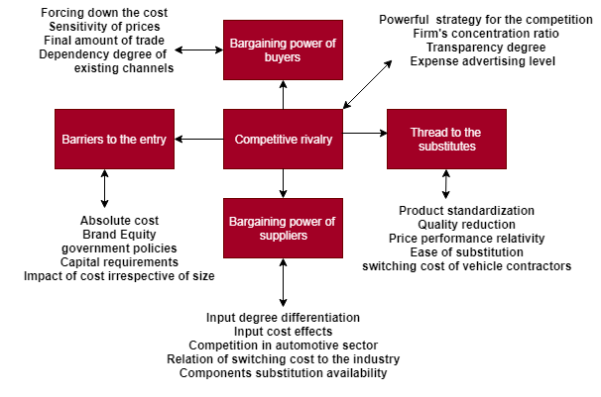
Figure 2: Analysis of porter's five forces

According to (Adhaditya and Sutanto, 2016)
Threats to the substitute: The existing products of the automotive domain of the buyer’s boundaries of the products are responsible for the increment of the possibilities of the buyers to switch over other sectors available except the automotive. The potential factors of the automotive sector business includes
- Product standardization
- Relativity of the price performance
- Depreciation of the quality
- Ease in substitution
- Switching cost of the vehicle contractors’
Bargaining strength of the automotive suppliers: The input of the automotive market depends on the suppliers bargaining strengths. The suppliers of the various things to the industry can be the power source over it. The potential factors involves the following
- Differentiation degree of the inputs
- Switching cost of the supplier relates to the industry
- Availability of the components substitution
- Effects of the inputs cost
- Competition in automotive sectors

Threats of the new entry: The profiting markets resulting in the high yielding returns always attracts the automotive industry. This results in the arrival of the new members resulting in the reduction of profitability. The factors involves
- Absolute cost
- Policies of the government
- Disadvantage of the cost irrespective to the size
- Requirements of the capitals
- Equity of the brands

Bargaining strengths of the buyers: The output of the markets depends on the bargaining strengths of the buyers. The potential factors include the following
- Dependency degree on the existing distribution channels
- Concentration of the buyers to the ratio of the concentration to the firms
- Forcing down the prices
- Final amount of the trading
- Sensitivity of the consumer’s price
Competitive Rivalry: It is the major points of the competition of the automotive market. The following point includes the potential factors of the ruthless competition
- Powerful strategy of the competition
- Transparency degree
- Concentration ratio of the firm
- Advertising level of the expense

C.
Organizational Behaviour
The definition of the organizational behaviour is provided by different authors in accordance to the understanding. According to Davis and Newstrom, the organizational behaviour is the application and the study of the knowledge about the behaviour of the individual in an organization. This is the tool for the human benefits. It involves all kinds of the organisation. According to Raman.J.Aldag, this is the social science branch that builds theories that can be made applicable. This is the management activity consider the understanding, influencing and the prediction about the behaviour of an individual. The theory of the behaviour mainly depends on the following two important factors (Kaplan, et al, 2016)
- Nature of an individual
- Organization’s nature
The organizational behaviour is a bit similar to the theories of the organization, management of human resources and the psychology. Psychology of the organization limits to the psychological factors and the behaviour of the institution includes everything that is study of every branch of the science. The management of human resource and the development are based on the organizational behaviour. The characteristics of the behaviour of the organization are as mentioned below (Buchanan and Huczynski, 2019)
- Management of the behavioural approach
- As the branch of the social science
- Art as well as science
- Effect and cause of the relationship
- Three level of analysis
- Benefits of individual and the organization
- Theory, research and development
The organizational behaviour’s nature is to observe and study the behaviour of an individual within an organization. At the time of joining of an individual in an organization, he comes with a set of unique experience and characteristics from the previous institution. The organizational behaviour depends on the two stages. The first stage comprises of unique perspective looks that every individual has. Second stage of the institutional behaviour is the observation of a how a new individual interact within the organization. They contact the pre-existing individuals in different ways (Wellin, 2016).

Conclusion for Part 1

The part one considered various external forces of the automotive sector. The part comprises of the analysis of the porter’s five forces. All the five forces are properly explained with by providing the particular and accurate definitions for each force. The next section of the part includes the PESTEL analysis. The analysis was properly defined with justified definitions. The last section includes the note on organizational behaviour of an individual within the institution.

Part 2

A.
Porter’s value chain
According to (Vardar, 2018)
The analysis of the porter’s value chain is a management concept of the business that explains that it is the collection or the combination of activities that are performed for the customer to create value by the organization. The creation of the value added leads to the advantage of the competition. It also generates high profit in an organization. The approach of the value chain is its strength. The analysis of the value chain mainly focuses on the activities and the system with the customers considered as the principle of centre as compared to the department of the expense of accounting category. This connects the activity and the system to one another and has no effect on the profit and the cost. The value chain of porter’s including variety of activities categorized as the support activities and the primary activities. The primary activities consist of immediate impact on the production, sales, maintenance and support to the services or the products to be supplied. These activities consist of the elements as mentioned below (Koc and Bozdag, 2017)

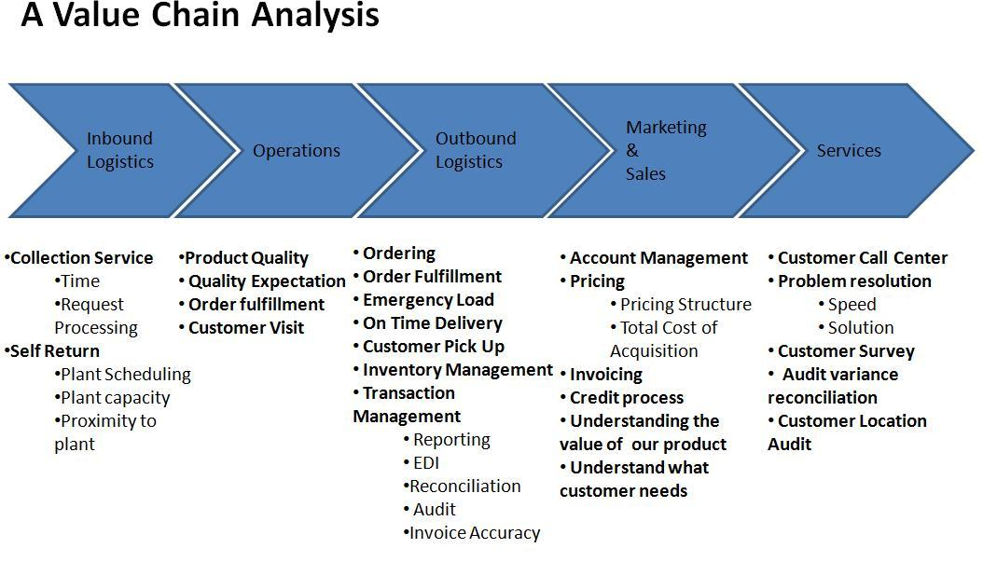
Figure 3: Analysis of porter’s value chain

- Inbound logistics
- Outbound logistics
- Services
- Sales and marketing
- Operations
Support activities within the value chain analysis aids the primary activities and form the basis of an organization. The management of human resource is the support activity and is of the importance in the primary activity but also supports the other activities too. The following mentioned points are the analysis of the support activity of the value chain
- Management of human resources
- Infrastructure of the organization
- Development of the technology
- Acquisition
There are basic four steps that is to be followed when u want to use the value chain model. With the use of the following steps the analysis of the organization can be done using the porter’s chain model
- Identifying the activities for every primary activities
- Indirect activities
- Direct activities
- Assurance of the quality
- Identifying the activities for every support activities
- Link identification
- Solution optimization

B.
New opportunities
The analysis of porter’s five forces and value chain provides several opportunities to the automotive company. The threats provide a chance to improve the failures within the time and create opportunity. According to (Nilsson and Nykvist, 2016), the opportunities and the challenges that arise in the automotive sector business environment are mentioned globally. As the economic landscapes are accelerating the shifts globally, the automotive sector finds the new operating vehicle marketing environment. These dynamics creates a new opportunity, risks, challenges and threats in the electric vehicle industry which is needed to be understood, if the success of the business is desired. The new opportunities for the business environment globally include the following points (Gibson, Rosen and Stucker, 2015)
- Accessibility to new buyers from the new country
- Accessibility to the cheap and new resources of finance
- Learning about the new buyers present in the market
- Accessibility of new resources like natural resources, skilled labour
- Accessibility to the trade agreements regionally
- Avoiding the trading barriers
The challenges faced by the organization in creating the new opportunities are as mentioned (Taniguchi, Thompson and Yamada, 2016)
- Fluctuations in the exchange rates
- Global contagion of finance
- Increased competition for the existing buyers in the market
- Large supply chain management
- Capital for the multitude of local regulations and national laws
- Social corporate responsibility issues
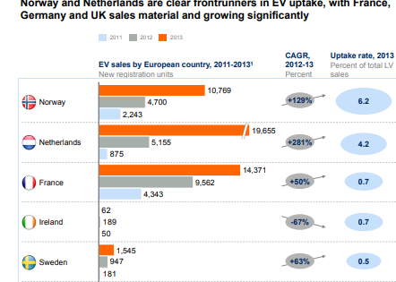
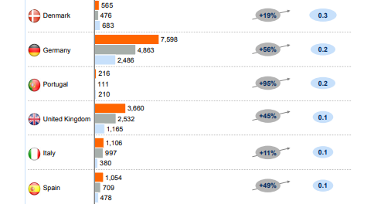
The above diagram shows the ranking of growth of electrical vehicle in different European countries considering three different years. The ranking according to the sale in European countries in 2013 are
- Netherlands
- France
- Norway
- Germany
- UK
- Others…

C.
Dis-Continued Business
In the finance accounting, the discontinued business refers to the part of the core of the company, product or the business. They are separately reported from the operations continuing in the statement of income. They are listed separately as it is necessary for the investors to differentiate between the cash flow and the profits. The distinction is used especially when the merger of the company occur (Tardi, 2019).
When the operations are to be discontinued, then the organization includes the reports of several line items on the statement of finance. Though the component of the business is closed or shut off, still it produces a loss or a profit in the accounting current period. The total loss or the profit from the discontinued business is reported, following the suitable or the relevant taxes. The considered tax is always the tax benefiting the future because the discontinued business incurred the loss. To determine or the calculation of the net income of the company, the loss or the gain from the discontinued operations is calculated from the operation counting.
In order not to get confused by the adjustment to the statement of finance which relates to the previous reports of the discontinued operations, an organization can categorize the adjustments in a separate manner for the discontinued operations. Due to the obligations in plan benefits, contract terms, liabilities that are contingent adjustments might occur. If the consumer of the business which is discontinued, considers the associated debt of the business operations then the allocated sales of the operations is to be discontinued. The accounting principle accepted generally that is GAAP that does not allow the general corporate to the discontinued operation allocation. Some takeaway points are mentioned as below (Kapustin and Grushevenko, 2019)
- The discontinued business is the term of an accounting which refers to the core part of the company and the product lines are shut off.
- On the statement of the income the discontinued business are reported separately the operations counting.
- When the merger of the company occurs, an understanding of the assets is divested and provides a clear picture of the future procedure towards the work of the company.
An organization might report the discontinued business, operations under the GAAP meets the two conditions. Firstly, the shutdown of the transaction divested the business results by eliminating the cash flows and the operations. Secondly, once the operations or the business is been discontinued, the business then has no significant in progress involvement with the operations. If the given two conditions are met, then the business might report the operations to be discontinued on their statement of finance (Nykvist, Sprei and Nilsson, 2019).

Conclusion of Part 2

The part two considers the new opportunities for the automotive business environment globally. This includes the value chain model of porter, which includes management concepts of the business. The section also involves the activities in the model considered. Further the part discuss about the challenges faced by the organization in making it global and making the environment of the business preferable. The section further discuss about the discontinued operations in the business or the business that is discontinued.

Conclusion

The competition in the automotive sector is gradually increasing. The above assessment talks about different points considering the electrical vehicle companies. The assessment successfully describes both the parts including the external forces and the new opportunity in the automotive sector. The parts further contained the sections including topics like discontinued business, new opportunities, challenges faced by the organizations, the organizational behaviour and the two porter’s theory which was properly defined and explained.

References

Mathooko, F.M. and Ogutu, M., 2015. Porter’s five competitive forces framework and other factors that influence the choice of response strategies adopted by public universities in Kenya. International Journal of Educational Management, 29(3), pp.334-354.

Pan, W., Chen, L. and Zhan, W., 2018. PESTEL analysis of construction productivity enhancement strategies: A case study of three economies. Journal of Management in Engineering, 35(1), p.05018013.

Song, J., Sun, Y. and Jin, L., 2017. PESTEL analysis of the development of the waste-to-energy incineration industry in China. Renewable and Sustainable Energy Reviews, 80, pp.276-289.

Koc, T. and Bozdag, E., 2017. Measuring the degree of novelty of innovation based on Porter's value chain approach. European Journal of Operational Research, 257(2), pp.559-567.

Tardi, C., 2019. Discontinued Operations. [Online] Investopedia. Available at: https://www.investopedia.com/terms/d/discontinued-operations.asp [Accessed at: 24 December 2019]
Gibson, I., Rosen, D. and Stucker, B., 2015. Business Opportunities and Future Directions. In Additive Manufacturing Technologies (pp. 475-486). Springer, New York, NY.
Reinhardt, R., Domingo, S.G., García, B.A. and Christodoulou, I., 2017, June. Macro environmental analysis of the electric vehicle battery second use market. In 2017 14th International Conference on the European Energy Market (EEM) (pp. 1-6). IEEE.
Karmaker, A.K., 2019. OPTIMIZATION OF HYBRID RENEWABLE ENERGY BASED ELECTRIC VEHICLE CHARGING STATION (Doctoral dissertation, DHAKA UNIVERSITY OF ENGINEERING & TECHNOLOGY).
Kauerhof, A., 2017. Strategies for Autonomous, Connected and Smart Mobility in the Automotive Industry. A Comparative Analysis of BMW Group and Tesla Motors Inc. GRIN Publishing.

Hutchinson, L., Waterson, B., Anvari, B. and Naberezhnykh, D., 2018. Potential of wireless power transfer for dynamic charging of electric vehicles. IET Intelligent Transport Systems, 13(1), pp.3-12.

Eskandari, M.J., Miri, M., Gholami, S. and Nia, H.R.S., 2015. Factors Affecting The Competitiveness of The Food Industry by Using Porter's Five Forces Model Case Study in Hamadan Province, Iran. Journal of Asian Scientific Research, 5(4), pp.185-197.

Adhaditya, C. and Sutanto, J.E., 2016. Strategy Analysis Using the Five Forces and SWOT Methods Towards Handmade Products of CAD.

Kaplan, S., Gruber, J., Reinthaler, M. and Klauenberg, J., 2016. Intentions to introduce electric vehicles in the commercial sector: A model based on the theory of planned behaviour. Research in Transportation Economics, 55, pp.12-19.
Buchanan, D.A. and Huczynski, A., 2019. Organizational behaviour. Pearson UK.
Wellin, M., 2016. Managing the psychological contract: Using the personal deal to increase business performance. Routledge.
Vardar, N., 2018. “The Faster Fish Beats the Larger Fish:” Applying Porter’s Value Chain. SAGE Publications: SAGE Business Cases Originals.
Nilsson, M. and Nykvist, B., 2016. Governing the electric vehicle transition–Near term interventions to support a green energy economy. Applied Energy, 179, pp.1360-1371.
Taniguchi, E., Thompson, R.G. and Yamada, T., 2016. New opportunities and challenges for city logistics. Transportation research procedia, 12, pp.5-13.

Kapustin, N.O. and Grushevenko, D.A., 2019. Long-term electric vehicles outlook and their potential impact on electric grid. Energy Policy, p.111103.
Nykvist, B., Sprei, F. and Nilsson, M., 2019. Assessing the progress toward lower priced long range battery electric vehicles. Energy policy, 124, pp.144-155.

