

University of Wales Trinity Saint David
School of Engineering
Evaluating the Effectiveness of Chosen Maintenance Strategies for Dedicated Equipment
Faith Over
1904483
03/04/2023
ACMA 6007 – Plant and Asset Engineering

Contents Page

Contents
Contents Page ii
1.0 List of Illustrations / Tables 3
2.0 Introduction 3
3.0 Critical Review of Current Maintenance Practices 3
3.1 SMT Line Functions and processes 3
3.1 An Outline of the Current Maintenance Strategy 5
3.1.1 Maintenance sign off sheet 5
3.1.2 140 hour SMT Maintenance Documentation 5
3.1.3 Daily Cleaning and Visual Inspection Sheets 8
3.1.4 System Integrator Engineer Maintenance Visits 8
4.0 Improvement Opportunities 9
5.0 Costs and Resources Required to Implement Improvements 12
6.0 Conclusion & Recommendations 13
7.0 References 14
References 14
8.0 Appendix 15

List of Illustrations / Tables
Figure 1: Fully Integrated SMT Line 4
Figure 2: A completed PCBA assembly after the SMT line 4
Figure 3: SMT Maintenance standard work 5
Figure 4: 140 hour SMT Maintenance Documentation 7
Figure 5: 24 hour Daily Cleaning & Check Reference sheet 8
Figure 6: Panasonic placement machine quarterly external maintenance activities 9
Figure 7: Eight Steps of RCM 10

2.0 Introduction
This report will critically review the effectiveness of the maintenance strategy deployed at Eaton Electrical Products for their Surface Mount Technology (SMT) line. The aim of this report is to analyse the effectiveness of the current maintenance strategy, propose improvements and conduct a cost benefit analysis of these improvement suggestions to assess the applicability of these suggestions.

3.0 Critical Review of Current Maintenance Practices
The rising pressure from competition for manufacturing sites to reach world class performance (Miyake & Enkawa, 1999) has led to a rise in companies examining their maintenance strategies in order to improve productivity and cost position (Modgil & Sharma, 2016).
The role of maintenance is to extend equipment lifetime, increase mean time to failure (Endrenyi, et al., 2001) and to increase the machines availability for production for reliable and repeatable manufacturing process results (Swanson, 2001).
When implemented correctly, maintenance can improve system reliability and reduce to frequency of service interruptions, however the expenditure of these systems must be considered to find a balanced cost-effective maintenance solution (Endrenyi, et al., 2001)

3.1 SMT Line Functions and processes
This report will assess the effectiveness of the maintenance strategy deployed to the three core machines of Surface Mount Technology (SMT) line at the company. This is as all machines in the line are integrated and maintained as one system. The SMT line consists of the following machines:
- Desen DSP-1008 Printer
  - Solder paste printer and stencil washer. This machine consists of two print heads and an automatic stencil cleaning system (Advanced Manufacturing Services (AMS) Ltd, 2023).
- Panasonic NPM-W
  - Component placement mounting machine with a 16-nozzle head (Panasonic, 2015)
- HTS-0601
  - Lead free reflow oven using hot air and nitrogen to create 12 heated zones (6 top and 6 bottom) (Advanced Manufacturing Services (AMS) Ltd, 2023)
Below is a diagram of how these units are aligned and work together. The three machines are linked with a conveyor system. Blank printed circuit boards are fed into the machine, the solder paste printer uses a stencil to deposit solder paste into the correct locations on the board. The boards are then fed into the component placement machine which uses XYZ coordinates form Gerber files to place appropriate components to the right locations. This is then fed into the reflow oven which melts the solder paste, soldering the components from here an automated optical inspection (AOI) unit conducts quality checks onto the boards before offloading the printed circuit board assemblies.

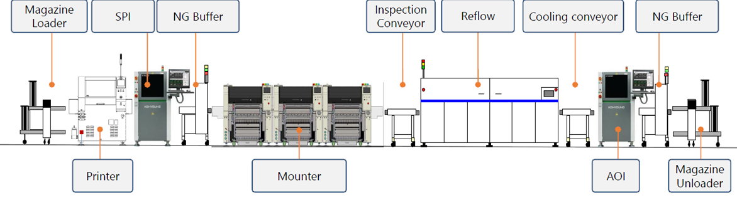
Figure 1: Fully Integrated SMT Line
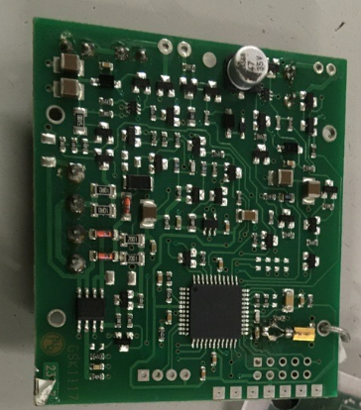
Figure 2: A completed PCBA assembly after the SMT line
The SMT line currently runs for an average of 400 hours per calendar month with a monthly average overall equipment effectiveness (OEE) of 68%. OEE is calculated at availability x performance x quality.
The factory makes fire devices, which compose of electronic assemblies housed in plastic assemblies. Therefore, the SMT line is integral to the overall factory’s value stream, as it is the first step in the value stream, it feeds the rest of the factory. Due to the integrity of this line and the number of processes it feeds afterwards, the SMT line has the most comprehensive maintenance schedule out of all machines in the factory.

3.1 An Outline of the Current Maintenance Strategy
The current maintenance strategy followed by the company is a preventative scheduled maintenance approach. These activities are conducted both internally and externally and are all decentralised maintenance approaches – the internal or external engineer goes to the line to service it.

3.1.1 Maintenance sign off sheet
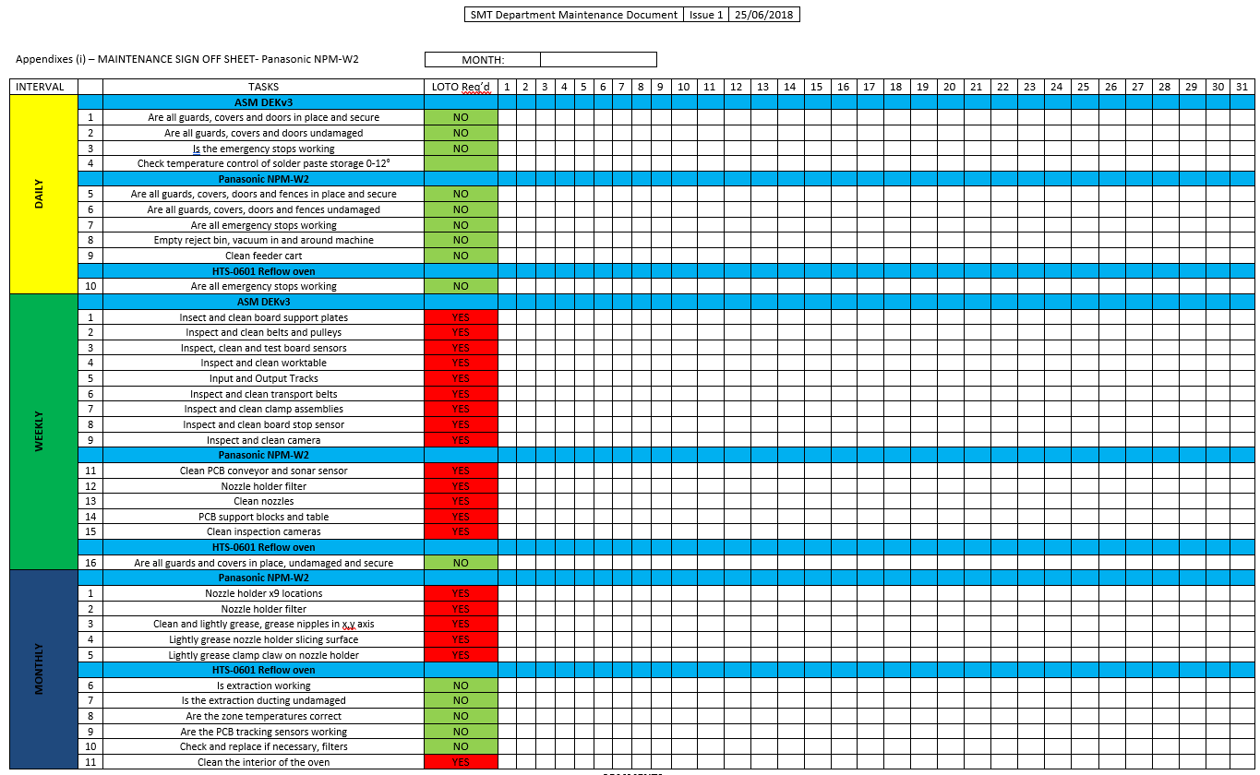
The company has a daily weekly and monthly list of activities which are listed in the maintenance standard of work, linked in the appendix. Machine operators follow this standard and complete the scheduled tasks listed and sign off once completed.
Figure 3: SMT Maintenance standard work

3.1.2 140 hour SMT Maintenance Documentation
This document lists tasks in a similar fashion to the standard work, however the schedule of tasks to be completed are based on 140 hours of operating machine time. This means all tasks are completed every 140 hours, regardless of the day/ week/ month. Considering the current run time of the machine, this averages out at about twice per month.
These tasks are separated by each machine in the line, again it is the role of the machine operator to conduct these cleans and visual inspections. The operator signs off that they completed a task and makes note if a spare part was consumed so that more spares can be ordered to replenish the Kanban system in place.
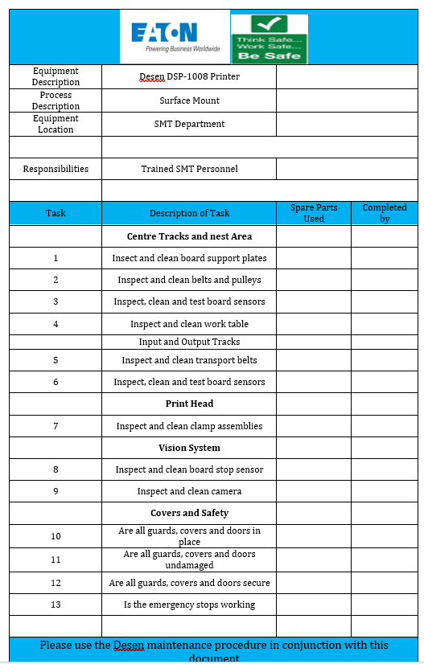

.
Figure 4: 140 hour SMT Maintenance Documentation

3.1.3 Daily Cleaning and Visual Inspection Sheets
In addition to these check systems, the operators also have a daily inspection sheet, detailing check points and when to check them (such as before or after operation). These sheets contain visual diagrams to assist the operator in fully understanding what and where they are inspecting.
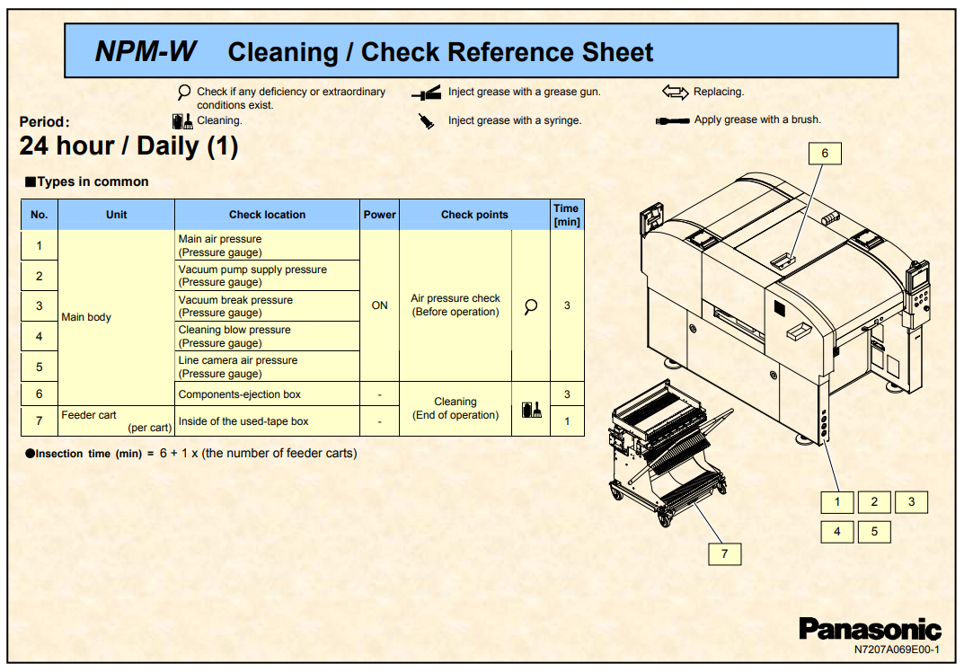
Figure 5: 24 hour Daily Cleaning & Check Reference sheet

3.1.4 System Integrator Engineer Maintenance Visits
In addition to these internal maintenance practices, the company also has an external maintenance strategy. This is again scheduled preventative maintenance whereby a thorough visual inspection is conducted of the internal components followed by component replacement based on either failing visual inspection or predefined time intervals, which are dictated by the equipment manufacturer:
- Desen DSP-1008 Printer – every 3 months
- Panasonic NPM-W Placement machine– every 3 months
- HTS-0601 Reflow Oven – every year
An example of the externally completed check sheets is shown below:
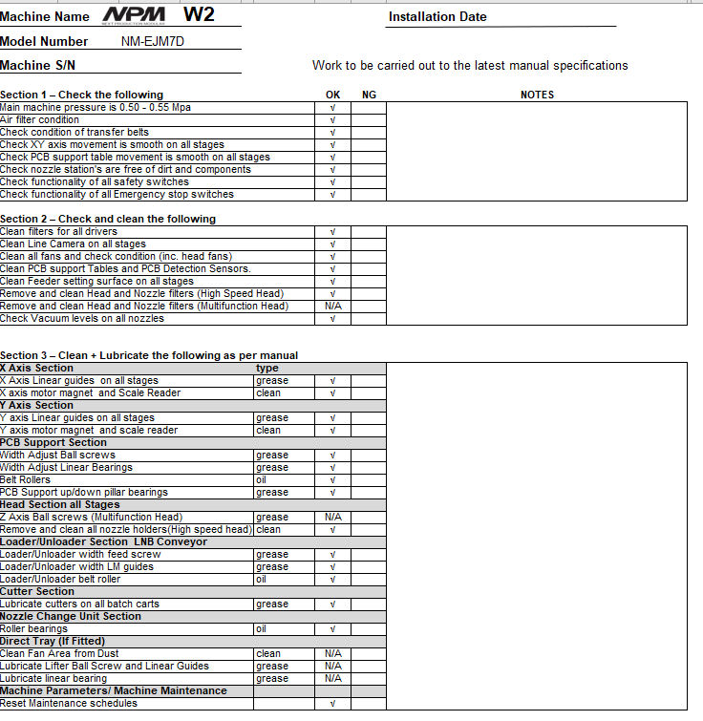
Figure 6: Panasonic placement machine quarterly external maintenance activities

4.0 Improvement Opportunities
As discussed, the company currently conducts scheduled preventative maintenance to the machines in their SMT line, with daily/ weekly/ monthly/ quarterly / annual tasks and tasks completed after a set number of run time hours (140). These tasks are completed both inhouse and outsourced to the original equipment manufacturers. The frequency of which these tasks are completed are based on manufacturers’ recommendations. It is recommended the company further progresses this approach by integrating a reliability centred maintenance (RCM) approach. The basis of RCM is that reliability is a design characteristic that can be preserved during operational life in a cost-effective way by using decision logic (Brauer, 1987).
RCM entails condition-based monitoring for effective preventative maintenance schedules and an analysis on components lifespan, calculating mean time to failure which links the component deterioration process to the maintenance strategy deployed and thus enabling predictions for the effectiveness of the current maintenance strategies deployed (Endrenyi, et al., 2001). RCM also includes leveraging potential failure modes and effects analysis (PFMEAs) and investigations of operating needs and priorities and an analysis of component failure history to understand which are key critical components to the machine (Jardine & Tsang, 2005).
RCM consists of eight basic steps as outlined by Brauer et al. (1985) below:
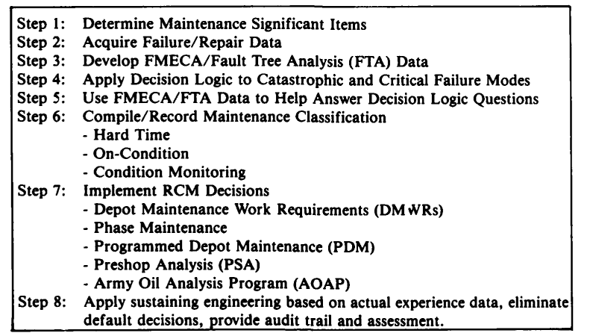
Figure 7: Eight Steps of RCM
(Brauer, et al., 1985)
For determining maintenance significant items, it is recommended to leverage tools such as potential failure modes and effects analysis (PFMEAs). This has already been completed for the site. An extract is shown below of the SMT part of a product line’s PFMEA. The PFMEA looks at each step of the process, theorises what could go wrong at each step, the outcome and severity of said potential issue and reviews current prevention and detection processes in place to safeguard against these issues from either happening or escaping into the next step of the process. Potential failure modes with no detection or prevention processes in place need action. Examples below outline potential quality risks at each step, but safety risks are missing.
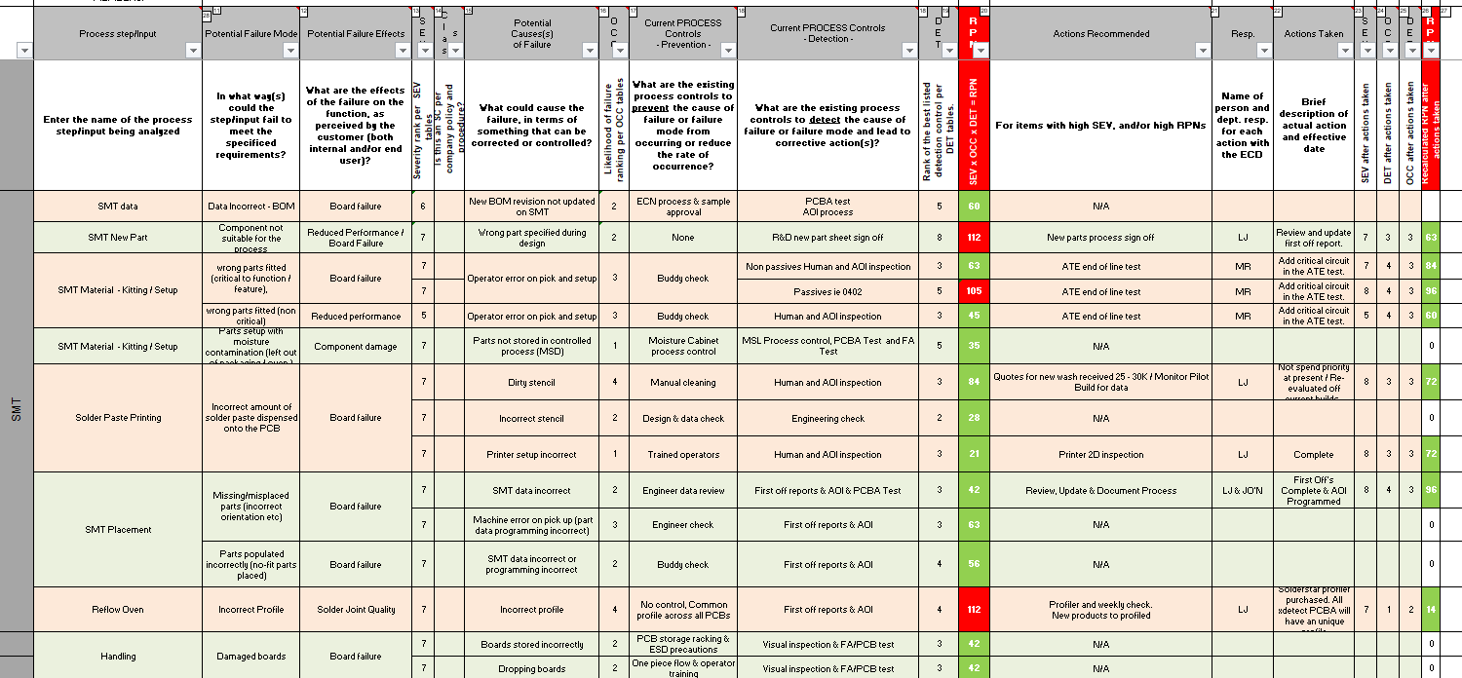
Due to the nature of the company’s value steam listed above, SMT line has already been identified as a key component as it feeds the rest of the process steps. However, this identification step is the only RCM step the company follows.
Acquiring failure and repair data at the company is within its infancy. Quality fails from the SMT line are collected via the end of line automated optical inspection machine at the end of the line and immediately flagged for stop the line & rework processes. This data however is not leveraged or correlated from different set ups.
The company also does not currently conduct fault tree analysis as suggested in step 3 to identify critical components and quantify failure mode data. This is crucial for step 4- establishing accurate relationships between fault types in components of the system as root causes of failures and the resulting quality and safety consequences. This data enables a mathematical model to be developed to quantify the impact of intervention and control procedures and evaluate proposed changes both before and after implementation (Brauer, 1987). This is called a probabilistic model, which works by mapping the consequences of deterioration of a component over time through a sequence of stages of increasing wear until failure. The company currently implements maintenance scheduled on predefined time intervals based on the equipment manufacturers recommendation to prevent component deterioration until failure, however it would be more accurate to differentiate between deterioration stages by visual inspection of physical signs such as wear and corrosion (Endrenyi, et al., 2001).
Step 6 of the RCM process is to segregate the formulated maintenance requirements into three categories; on-condition maintenance (scheduled tests and inspections followed by corrective actions), hardtime maintenance requirements(scheduled component replacement at predetermined fixed intervals) and condition monitoring maintenance requirements (unscheduled component inspection/ testing enabling impending failure to be detected through routine, monitoring during normal operations) (Brauer, 1987). In Section 3.1 An Outline of the Current Maintenance Strategy, it is evident that the company already conducts on-condition and hardtime maintenance. What is not evident is condition-based monitoring, without which risks overspend on unnecessary maintenance tasks or component replacements and blind spots to necessary but unscheduled items.
When implementing RCM decisions, the objective is the elimination of excessive maintenance costs, reducing cost and time burdens from scheduled maintenance whilst maintaining the necessary readiness and reliability states. Each data collection point should lead towards a higher degree of certainty of the predicted future state whilst previous steps help analyse key critical components and failure severity thus enabling reliability vs risk decision making (Endrenyi, et al., 2001).
The aforementioned steps lead towards enabling step 8, which is the recommendation for the company; applying sustainable engineering based on actual data and experience. Though the critical equipment (SMT line) has been correctly identified, the company could take this one step further by identifying critical components in the machines of this line, deepening the potential failure modes effects analysis by completing a more in depth analysis on every process within the SMT line and within the machines, understanding the lifespan and deterioration of these key components and the consequences of their deterioration and ultimately eliminating portions of the scheduled maintenance activities and replacing them with visual inspection and condition based monitoring. It is important to note a large percentage of the daily weekly and monthly scheduled maintenance tasks for machine operators outlined are cleaning activities, which are crucial for prevention of corrosion and increasing longevity of each component’s lifecycle. It is not recommended to reduce cleaning activities of the machine, nor the visual inspection or realignment and calibration checks which are required for reliable and good quality outputs. However, there is opportunity to reduce the costly third party scheduled maintenance and replacement of components.

5.0 Costs and Resources Required to Implement Improvements
The major setback of the proposed recommendations is the requirement for a growth in the current maintenance engineering team. This not only has cost implications, but due to the company’s geographical position there are currently significant recruitment difficulties in finding candidates with the right technical competence to manage these activities.
Furthermore, the current strategy can be viewed or interpreted as a “safe” strategy, and the company has benefited from this. It has not experienced a single break down since the SMT line was installed 7 years ago. However, this comes at the cost of possibly unnecessary expenses. The recommended strategy needs to be implemented correctly as any possible cost saving which may be achieved by reducing these routine activities has the potential to be wiped out by any on cost from unplanned downtime and machine break down if critical components are not correctly identified or monitored.
Therefore, the recommended solution has the risk of increasing cost and risk if not implemented correctly, therefore it is imperative to have the correct resources and level of skills and knowledge applied when creating this RCM strategy.
These changes may also be met with pushback as the current system is perceived to work very well, with the “if it’s not broke, don’t fix it” mentality commonly seen across the company. This would require support and backing form higher management and change instigators to support the change process and consistent involvement of the parties against the change would be needed, to provide them with assurance that their concerns are adequately considered with sufficient countermeasures put into place.

6.0 Conclusion & Recommendations
As mentioned in 4.0 Improvement Opportunities, it is recommended a full RCM approach is taken, with condition-based monitoring identified as the key missing step. This would require more detailed PFMEA analysis of the specific line processes and a fault tree analysis of the consequences of component deterioration. This would enable the formulation of a comprehensive probabilistic model which would predict component failure over time and replace critical components based on condition. This however requires significant upfront cost as the time required to collect, review, and interpret this data will be great considering the company’s current lack of data collection. Furthermore, both training and visual standards will be required to train engineers on acceptance levels of component deterioration, and the categorisation into different deterioration stages can be subjective and thus results may vary from engineer to engineer. Training and ensuring all maintenance engineers have alignment on acceptance levels for a variety of wear and deterioration signs for a variety of different components on the SMT line will be a nearly impossible feat, especially considering the small size and access difficulty of many critical components within these machines. This method is also at risk to human error, an incorrectly review of corrosion by an engineer could still risk to machine failure and unplanned downtime. It is recommended to therefore incentivise machine operators with a reward system if they spot issues missed by maintenance engineers in their cleaning routines. This would ensure a layered audit system to reduce the risk of escapes.
This recommendation is a long-term solution and require substantial investment in more maintenance engineers to collect the data, trend the data and conduct the condition-based monitoring and maintenance systems. A key contributing factor to the company’s reliance on third party scheduled maintenance systems is due to the lack of hiring ability for the right skill set within the local area. At the time of writing this report, there has been a job opening for a maintenance technician for 14 months which the company is struggling to backfill both internally and externally. Therefore, the following short term immediate actions are recommended:
Leverage the quality engineers and manufacturing engineers to create an SMT line specific PFMEA and fault tree analysis with the EHS manage. This would enable the team to identify keep components for the machine and process and would assist in refining down the data collection process to a manageable activity without the requirement for extra resources. The purchase and integration of sensors to assist in this is recommended where possible, for example the reflow oven already continuously monitors the temperature stability in all 12 heated zones. Once the data is collected for at least 6 months it is recommended to analyse these for trends and review this initially against only the tasks completed by thirds parties to review where tasks can be reduced / cut or changed for a most cost-effective third-party solution.
Once the third-party activities are refined down and if the company can hire more maintenance engineers it is recommended that as a medium-term plan, a greater focus is paid on these top highlighted critical components in house. The addition of visual inspection by maintenance engineers to categorise where a component lies on the deterioration process of all top high-risk components is strongly recommended. It is also recommended that the company uses this data to analyse the effectiveness of this condition-based monitoring approach and understand whether the components initially identified in the PFMEA and the fault tree analysis are the correct components to focus on.
The recommended long-term approach is to spend more time on data analysis than on routine checks. There is a significant amount of resource currently deployed to check and review and replace different components ad different cadences. Once the data collection and condition monitoring has been in place for over 12 months the company would be in a good position to review which of these tasks can be cut back, and which cadences can be reduced or completely removed or replaced by condition-based monitoring instead. This method would ensure a more effective utilisation of the human workforce for analytics and decisions rather than repetitive set routine tasks.

7.0 References

References
Advanced Manufacturing Services (AMS) Ltd, 2023. Desen DSP 1068 Automatic Solder Paste Printe. [Online]
Available at: https://www.ams-electronics.co.uk/shop/capital-equipment/screen-printers/inline/desen-dsp-1068-automatic-solder-paste-printer/
[Accessed 27 March 2023].
Advanced Manufacturing Services (AMS) Ltd, 2023. HTS0601 6 Zone Lead Free Reflow Oven. [Online]
Available at: https://www.ams-electronics.co.uk/shop/capital-equipment/soldering/reflow-soldering/hts0601-6-zone-lead-free-reflow-oven/
[Accessed 27 March 2023].
Brauer, D., Anderson, R., Law, H. & Matzkanin, G., 1985. Depot Maintenance Handbook. 1 ed. San Antonio: US Army Aviation Systems Command.
Brauer, D. B. G., 1987. eliability-Centered Maintenance. IEEE TRANSACTIONS ON RELIABILITY,, R-36(1), pp. 17-23.
Endrenyi, J. et al., 2001. The present status of maintenance strategies and the impact of maintenance on reliability. IEEE Transactions on Power Systems , 16(4), pp. 638-646.
essemtec, 2023. SMART AND HIGHLY FLEXIBLE SMT SOLUTIONS. [Online]
Available at: https://essemtec.com/en/products/
[Accessed 27 March 2023].
Jardine, A. & Tsang, A., 2005. Maintenance, Replacement and Reliability - Theory and Applications. 1 ed. Boca Raton: CRC Press.
Miyake, D. & Enkawa, T., 1999. Matching the promotion of total quality control and total productive maintenance: an emerging pattern for nurturing of well-balanced manufactures. Total Quality Management & Business Excellence, 10(2), pp. 243-269.
Modgil, S. & Sharma, S., 2016. Total productive maintenance, total quality management and operational performance. Journal of Quality in Maintenance Engineering, 22(4), pp. 353-377.
Panasonic, 2015. NPM-W2 Electronics Assembly System. [Online]
Available at: https://eu.industrial.panasonic.com/sites/default/pidseu/files/npmw2_en_15_0101.pdf
[Accessed 27 Mar 2023].
Swanson, L., 2001. Linking maintenance strategies to performance. International Journal of, 70(3), pp. 237-244.

8.0 Appendix

