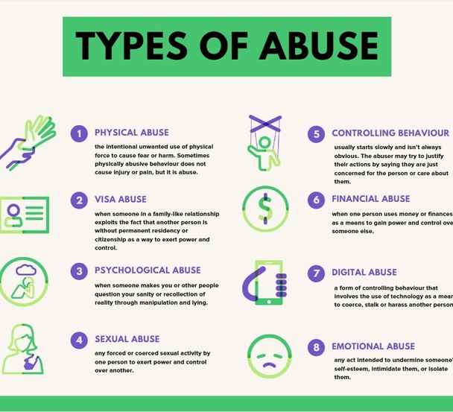
SOCIAL AND EMOTIONAL DEVELOPMENT

What is Abuse?
There are many forms of abuse. The four main types of abuse are physical abuse, emotional abuse, sexual abuse and neglect.
Child abuse relates to whenever anyone under the age of 18 is being harmed or not properly looked after. Abuse, however can happen to people of all ages. ( Metropolitan Police )

(Daily infographic, 2020)

KEY THEORIES

Bruner: Bruner’s theory of scaffolding is that humans learn better when provided the support to lean a new concept or skill and then they are better able to use that knowledge independently. ( Reed, 2006 )

Bandura’s social learning theory (1977) : Bandura’s theory highlights the importance of a child modelling, watching and imitating the behaviours, emotional responses and attitudes of others. Bandura believed that behaviours are learnt from the environment through observational learning. Bandura believed that this observation, imitation and modelling allowed children to learn to self regulate their emotions. (McLeod, 2016)
Skinner’s Operant Conditioning ( 1969 ) : In skinners theory it looks at the experiences of a child through operants ( responses) and the operants will influence the future actions of the child. Encouragement reinforces behaviour and a negative response will reduce the likeliness that the child will do that behaviour again. Skinner believed the way a child behaved was due to positive and negative - reinforcement. ( Murray, 2000 )

All the theorists above agree that in a child’s development they are susceptible to their environment and their development is influenced by these external factors. Bruner, Bandura and Skinner all agree that behaviours are closely observed by children and mimicked and this is how they learn new skills concepts and be

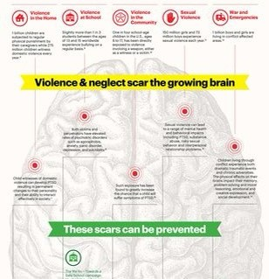
WHAT POLICIES / LEGISLATION ARE IN PLACE?

The Children Act 1989: This act provides the legislative framework for child protection. It highlights the legal importance of the child’s welfare as well as the duty of care. ( The Childrens Act, 1989 )

The Social Services and Wellbeing Act 2014: This act is responsible and provides the legal framework for child protection in Wales. ( The social Services and Wellbeing Act, 2014 )

The Education Act 2002: This act places a duty on all educational settings to ensure that the safeguarding and welfare of children is paramount to the way in which their setting functions. ( The Education act, 2002 )

(without violence, 2017)

SOCIAL AND EMOTIONAL DEVELOPMENT

WHAT POLICIES / LEGISLATION ARE IN PLACE?

Keeping Children Safe in Education 2019: This document contains safeguarding information for staff, the management of safeguarding, safer recruitment, allegations of abuse against teachers and other staff as well as child on child sexual violence and sexual harassment. ( Keeping Children Safe in Education, 2019 )

The Equality Act 2010: This act protects the following characteristics: Age, disability, sexual orientation, sex, gender reassignment, marriage and civil partnerships, pregnancy and maternity, race, religion and belief. This is in order to prevent discrimination against those characteristics and to entitle everyone to fair treatment. ( Equality Act, 2010 )
Children and Families Act 2014: The aim of this act is to ensure greater protections to vulnerable children. This act also ensures an Education, Health and Care Plan is produced for any child who has been identified as having additional needs. ( Children and Families Act, 2014 )

The Human Rights Act 1998: This act protects everyone’s human rights. The right that is protected in this case is
“ The right to freedom from torture and inhumane or degrading treatment or punishment “ ( The Human Rights Act, 2014 )

How Can Abuse Affect Development?

ACCORDING TO BRUNER’S THEORY, A CHILD WHO IS BEING ABUSED AT HOME WILL DEVELOP SLOWER THAN THEIR PEERS IN A NON ABUSIVE HOME AS THEY DO NOT HAVE THE POSITIVE INFLUENCE TO SCAFFOLD FROM. IN AN ABUSIVE HOME IT IS UNLIKELY THE CAREGIVER IS SUPPORTING THE LEARNING OF NEW SKILLS AND CONCEPTS WHILST ALLOWING THE CHILD TO DEVELOP THAT KNOWLEDGE INDEPENDENTLY. THIS CAN CAUSE DEVELOPMENTAL DELAYS. (MCLEOD, 2016)
ABUSE CAN ALSO AFFECT SOCIAL AND EMOTIONAL DEVELOPMENT IN LINE WITH BANDURA’S THEORY. ACCORDING TO BANDURA CHILDREN LEARN THROUGH OBSERVING. THEREFORE, IN AN ABUSIVE HOME THE CHILD DOES NOT HAVE A POSITIVE ROLE MODEL, THEY WILL BE PICKING UP ON NEGATIVE BEHAVIOURS, ATTITUDES AND COPING MECHANISMS WHICH WOULD STUNT THE EMOTIONAL AND SOCIAL DEVELOPMENT OF THE CHILD. IN A HOME WHERE THE BEHAVIOURS ARE ABUSIVE, THAT IS ALL THE CHILD WILL KNOW TO MODEL AND IMITATE. ABUSED CHILDREN STRUGGLE MORE WITH EMOTIONAL SELF REGULATION ( RUMJUAN AND NAROD, 2020 )

WITH SKINNER’S THEORY, A CHILD IN AN ABUSIVE HOME MIGHT BE RECEIVING WHAT THEY PERCEIVE TO BE AS NEGATIVE REINFORCEMENT CONSTANTLY. IN SKINNER’S THEORY PUNISHERS ARE THE RESPONSES FROM THE ENVIRONMENT THAT DECREASE THE LIKELIHOOD OF A BEHAVIOUR BEING REPEATED, PUNISHMENT WEAKENS THE BEHAVIOUR. THEREFORE IF A CHILD IS BEING ABUSED THEY MAY VIEW THIS ABUSE AS PUNISHMENTS WHICH CAN CAUSE THE CHILD TO BECOME WITHDRAWN. (MCLEOD, 2018)

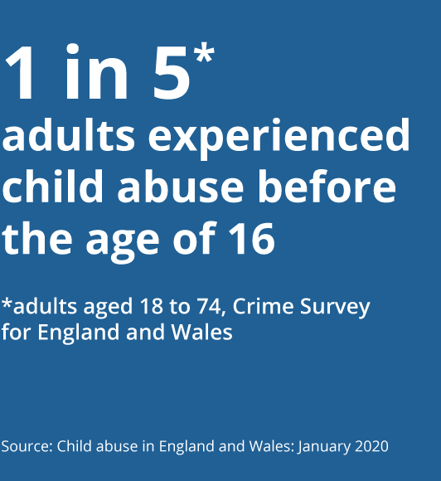
( ONS,2020 )

SOCIAL AND EMOTIONAL DEVELOPMENT

What do I do if one of my students discloses they
are being abused?
In these cases it is important to refer and report. NOT INVESTIGATE OR PASS JUDGEMENT

Each school or institution will have their own policy for safeguarding and it is important to follow these procedures. I an emergency where a child is in imminent danger call 999. The National Society for the Prevention of Cruelty to Children has a dedicated helpline for educators, for advice and support and they can be reached on 0800 136 663.

Report to your safeguarding lead as soon as possible.

Add a little The following steps can be followed to help support the child alongside following your policies:

- Listen carefully but try not to express your own feelings
- Reassure them they did the right thing by disclosing the abuse
- Remind the student it is not their fault. Abuse is NEVER the victim’s fault
- Don’t confront the alleged abuser
- Explain your next steps – being left in the dark while in a vulnerable state can be anxiety provoking.

Remember, it can be an incredibly hard thing for a student to open up about what has happened to them. ( NSPCC ) of body text

HOW DO I SUPPORT MY STUDENTS DEVELOPMENT?

In line with Bruner’s theory of scaffolding, IN LINE WITH BANDURA’S THEORY,

teachers can provide active support in order
PRACTITIONERS CAN BE A POSITIVE RO

to allow the student to learn a new skill or
MODEL AND THE CHILD CAN OBSERV

concept. Providing the resources and
knowledge to allow the child to learn a new concept semi – independently. (Chaudhary and Pillai, 2019)
THEIR BEHAVIOURS, RESPONSES AN ATTITUDES TO EXTERNAL STIMULI AN PICK UP HEALTHIER RESPONSES.
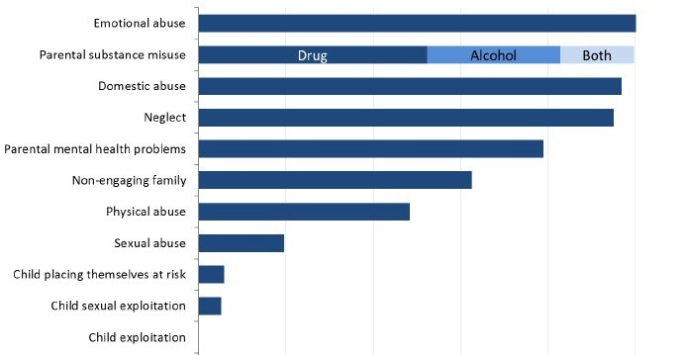
( ANDERSON AND KRAS, 2008 )

(GOVUK, 2017)

