
BA (Hons) Leadership and Management Skills for the Workplace

Module: Design Thinking and Innovation
Module Code: LCLM 6002
Innovation & Customer Journey
“Strategic Evolution in UK Retail: An Analysis of Innovation Ambition and Customer Journey Optimization at Tesco PLC”

Lecturer’s Name: Dr Seyed Navid Nasirpourosgoei
Student Name: JUNIOR NGIMBI
Student ID: 2314796

Table of Contents
1. Introduction and Background of the Chosen Company 3
2. Part One 4
3. Part Two 10
4. Conclusion 15
5. References 16

1. Introduction and Background of the Chosen Company
Tesco PLC is the biggest grocery store in United Kingdom as it commands about 27.7 percent of the grocery market share in 2025. The company also has a comprehensive chain of brick-and-mortar supermarkets and convenience stores, and a highly structured online shopping hub that caters to millions of clients on a weekly basis. The efficiency in operations, supply chain streamlining and data-based customer loyalty programs like the Clubcard programme have largely contributed to Tesco strong competitive position (Tesco Plc, 2025).
Nevertheless, the modern retailing world is getting more invigorating and dynamic. The fast pace of digitalisation, economic instability and changing consumer demands is redefining the competitive and innovative approaches of retailers. The customers are also demanding more convenient retail experiences in both brick-and-mortar stores and online shops, and at the same time, the retailers are required to be price competitive and efficient in their operations (Mason and Jarvis, 2023).
The present report is a critical analysis of the Tesco innovation strategy and customer engagement strategy through two analytical frameworks: the Innovation Ambition Matrix and Customer Journey Mapping. The Innovation Ambition Matrix assists in analysing the way Tesco can focus its innovation activities on core, adjacent, and transformational projects, whereas Customer Journey Mapping can be used to trace the main touchpoints and possible areas of friction in the omnichannel shopping process in the company (Khimesara, 2024).
There are also several trends in the industry that also affect the strategy of Tesco. Omnichannel retailing needs high level of integration of physical shops with digital platforms and stores are becoming fulfilment and service centres. Simultaneously, new technologies like artificial intelligence, predictive analytics, and the Internet of Things are facilitating hyper-personalised shopping experiences and also developing an issue of data governance and privacy (Hossain et al., 2021). Digitally empowered and customer-focused innovation has at that consequently become central to the future competitiveness of Tesco.

2. Part One
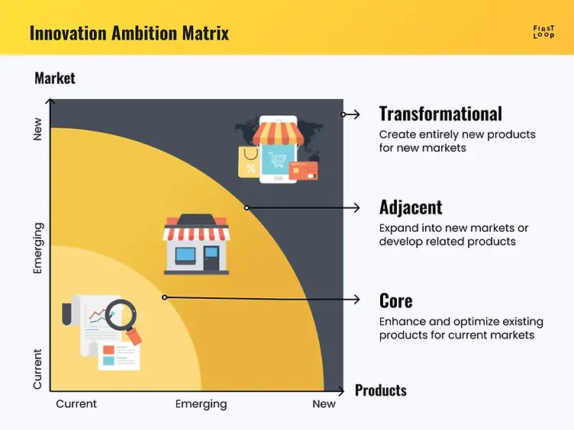
Figure 2: Innovation Ambition Matrix (Khimesara, 2024)
In order to comprehend the strategic path of Tesco, its recent action might be analysed in the frames of the Innovation Ambition Matrix, which defines innovation in terms of the distance between it and current markets as well as current capabilities into those related to core, adjacent, and transformational (Khimesara, 2024; Pichler, 2025). A combination of these categories in an equal measure is broadly believed to be required to maintain competitiveness and deal with uncertainty (Bumann & Peter, 2019). Organisations which specialise in core innovation run the risk of stagnating through incrementalism, whilst those that over-invest in the transformational initiatives would run the risk of falling into operational and financial dishonesty (Pinto et al., 2017). The profile of Tesco innovation indicates activity in all of the three areas, but on the whole, based on the profile, Tesco is highly geared towards efficiency, cost management, and value protection which is indicative of the challenges of the modern UK grocery market (Tesco Plc, 2025).
The Tesco strategy is based on core innovation, which is the enhancement of the existing products to current customers (Wolniak, Stecuła & Aydın, 2024). Such actions enhance the competitiveness but do not radically transform the model. One notable instance is the Clubcard Prices programme that changed the reward scheme of loyal customers getting loyalty rewards by redemption of points in delayed form to getting discounted prices on the checkout counter (Singh & Kakkar, 2025). This change albeit simple in terms of structure, drastically transformed the perception of value to customers by making savings visible and real and affirming the positioning of Tesco in a price-sensitive market. Instead of launching a new service, Tesco made use of the existing infrastructure and used it to generate patterns of basket frequency and behavioural loyalty (Moorman & Lemon, 2020). On the same note, the adoption of artificial intelligence in pricing is a process innovation. Machine learning systems cause the prices to be adjusted to competitor information, demand trends, and stock quantities, allowing Tesco to maintain the margins without losing price competitiveness (Hossain et al., 2021). These advancements are integrated into the existing retail models and this shows how digital tools are being applied to perfect operational performance as opposed to revolutionising the retail model. Incremental upgrades to Scan as You Shop devices, digital shelf-edge labels and inventory management systems are other examples of upgrading to minimise friction, minimise error and maximise efficiency (Wolniak, Stecuła & Aydın, 2024). Taken as a whole, these illustrations point to a high degree of operational excellence, but also give an impression that Tesco innovation culture is too much geared towards optimisation as opposed to radical reimagination (Mason & Jarvis, 2023).
Adjacent innovation, where the current capabilities are adapted to new markets or formats, shows that Tesco is engaged in the process of adapting to changing consumer demands (Bumann & Peter, 2019). This is the case of Tesco Whoosh, its fast grocery delivery service. To enter the quick-commerce market with relatively minimal commitment of assets, Tesco used the stores it already had as micro-fulfilment centres rather than building special fulfilment infrastructure (Hanus, 2016). This project builds on recent supply chains, store networks, and brand trust demonstrating the way Tesco reconfigures existing resources to respond to new demand of immediacy and convenience. The Tesco Media and Insight Platform is another neighbouring step, changing the in-house data analytics functions into a supplier-to-supplier business service. Monetising Customer Data Tesco can access additional revenue streams by hardening customer data via targeted advertising and insight services, and positioning data as a strategic asset, as opposed to an operational tool (Moorman & Lemon, 2020; Singh & Kakkar, 2025). The sustainability initiatives, like the implementation of electric delivery fleet and in-store recycling spots, are no exception and belong to this category as well (Pinto et al., 2017). Such projects are a reaction to regulatory and social demands but also expand the value proposition of Tesco to an area of environmental responsibility, but without radically changing the essence of the supermarket format. Associated innovations are thus strategic adaptability but still found within the current retail ecosystem (Mason & Jarvis, 2023).
Transformational innovation is the development of new models or markets on a fundamentally new basis and has greater risk and reward that may be in the long term (Pichler, 2025). Tesco GetGo stores, which have checkout-free stores, are the most obvious experimental transformation that Tesco has undertaken (Wolniak, Stecuła & Aydın, 2024). This format re-establishes the store experience as being based on frictionless access instead of a transactional exchange with the use of computer vision and sensor technologies to remove the traditional checkout processes (Hossain et al., 2021). It disrupts the old retail patterns and is an indication of interaction with independent retail patterns. Vertical farming partnership explorations also suggest the interest in redesigning the grocery supply chain, to reduce the environmental impact and ensure the food security to a long-term perspective (Pinto et al., 2017). The experiments with autonomous delivery technologies also imply a desire to redefine last-mile logistics with the help of automation (Wolniak, Stecuła & Aydın, 2024). Nevertheless, these efforts notwithstanding, transformational projects are still small-scale and mostly experimental. This is an organisational prudence: Tesco is aware of the new disruptive directions but still focuses on safeguarding current sources of revenue rather than aggressive expansion of radical innovation (Bumann & Peter, 2019). The balance of the portfolio is therefore more inclined towards stability and transformational work is done on the periphery and not on the centre of strategy (Khimesara, 2024).
This approach to analysing innovation as the customer journey will demonstrate how these strategic decisions are applied to the experience of life (Rosenbaum, Otalora & Ramírez, 2017). Customer Journey Mapping emphasises that competitive advantage is starting to rely more and more on operational efficiency as well as on emotional and cognitive aspects of service encounters (Moorman & Lemon, 2020). The image of an active professional parent represents a premium segment, which is time-starved and has expectations based on convenience, reliability, and transparency. During the awareness and planning stage, digital applications like Tesco app offer personalised offers and list management, although it is rather complex to navigate and stock information available online and offline store is not consistent which leads to uncertainty (Hanus, 2016; Wolniak, Stecuła & Aydın, 2024). The lack of real-time synchronisation compromises trust and adds to the mental workload, which implies digital integration is highly technical and poorly experience (Mason & Jarvis, 2023).
Technologies like Scan as You Shop are also used during in-store discovery to help with monitoring of the budget, however, when it comes to customers wanting to find dietary or health-specific items, it is still necessary to use the manual reading of the labels (Wolniak, Stecuła & Aydın, 2024). This reveals a disconnect between data capability and physical experience: Tesco has much information on the preferences of customers, but the intelligence does not fully imply shelf-level guidance (Moorman & Lemon, 2020). The buying phase also demonstrates that there were clashes between customer perception and operational protection. Unpredictable security inspections are linked to self-scanning mechanisms, which creates emotional tension, which does not go in line with the intended convenience of online shopping (Hanus, 2016). Another problem that is a pain point is online fulfilment. The replacement mechanisms usually focus more on the picker efficiency rather than on the individual dietary or brand preferences resulting in dissatisfaction when the replacements may not be as expected (Wolniak, Stecuła & Aydın, 2024). There is also minimal post-purchase engagement and the feedback systems are seen to be time consuming (Rosenbaum, Otalora & Ramírez, 2017). These concerns show that although Tesco innovations enhance efficiency, they do not always touch on the experience continuity on the touchpoints (Mason & Jarvis, 2023).
Using the design thinking approach, Tesco is partially mature (Panwar & Khan, 2021). The company exhibits good analytical insights of customer behaviour using loyalty data, and emotional empathy does not seem to be integrated in decision-making. The definition of the problems is often based on cost, speed, and risk reduction instead of the lived experience. Digital tools are produced by ideation, though a number of them are incremental. Prototyping is done via pilots like GetGo but these are not integrative of the larger ecosystem (Pichler, 2025). Testing is more dependent on quantitative measures and very little has been shown in terms of systematic feedback loops to cater to emotional outputs. This implies that Tesco innovation practices are not complete technological practices but technologically advanced (Bumann & Peter, 2019).

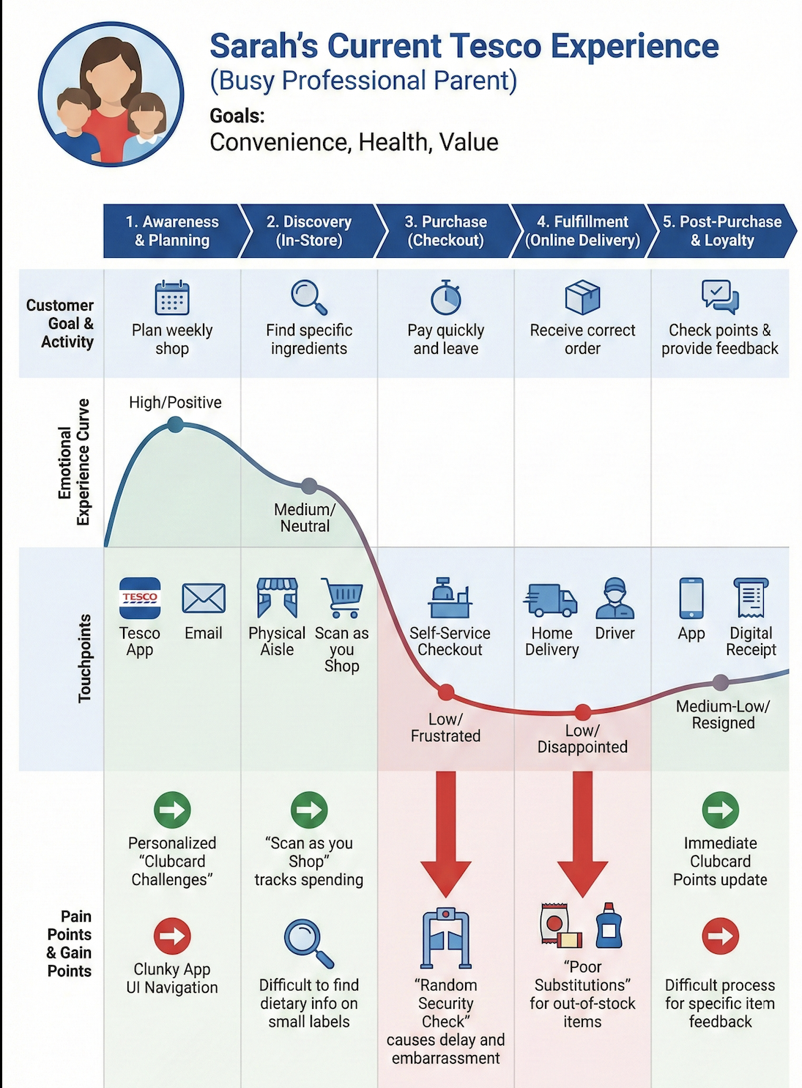
Figure 3: Customer Journey Map (Author)
The first stage, that Sarah goes through is the awareness and planning stage, which is mostly facilitated by the Tesco App. Though she feels that the personalised "Clubcard Challenges" make her feel special, the app has a large pain point in its sometimes-unwieldy navigation of the shopping lists and the offers. She frequently notices that the products she has put in her favourites list, are unavailable whenever she gets to the physical store, and this shows that there is no synchronisation of inventory in real-time. Going to discover the product stage in-store, she uses the option of scan as you shop to monitor her budget. Nevertheless, one of the greatest sore points is when she must provide her children with certain dietary information. Gluten-free or low-sugar products can be found only physically in the shelf, which is time-consuming and involves hand sorting of all the labels. This presents a severe disparity in real-time online support in the physical world.
Her buying phase is a rather controversial one. Although the time taken by the Scan as you Shop is a gain, random security check is a big friction factor. In the case of Sarah, such an intervention is intrusive, and it increases minutes to a fast journey she had planned. It sets a psychological obstacle to the apparent convenience and may hypothecate lack of truth. The main source of dissatisfaction in online orders fulfilment stage is the issue of substitution. In cases of out of stock, Sarah is usually given an alternative that cannot satisfy her demand (e.g. a different brand with a lot of sugar). This is one of the main reasons of online grocery abandonment, which is caused by this substitution gap. Lastly, during the post purchase phase, although her loyalty points are automatically updated, feedback on certain products or alternatives is a time-consuming task and once would have to work through several customer service menus to get the desired response, which does not contribute to active participation.
The current method of design thinking used in Tesco is largely oriented towards operational efficiency but sometimes fails to help them with the emotional and cognitive process of the customer. The random security check e.g. is such a solution that is aimed at securing the business against shrinkage, yet it does not consider the fact that the customer feels under scrutiny. It is a customer-centric solution, and not business-centric.
Likewise, replacing the picker is optimised on the speed of the picker, as opposed to the dietary or brand preferences of the particular customer. Digital innovation has a definite chance of transitioning away reactive problem-solving, in which the customer is informed about what they will receive, to active experience design, in which the customer is empowered to make decisions. Bridging the information gap between the physical shelf and the digital app needs to be done through the use of technology in creating a single experience that values the time and intellect of the customer.

3. Part Two
To address the obstacles that were explored in Part 1, I will recommend the introduction of the Tesco Vision-Link which is a comprehensive digital change initiative that will incorporate the Augmented Reality (AR) and the Agentic Artificial Intelligence (AAI) into the current Tesco ecosystem. Vision-Link will mitigate the most critical pain points identified, namely the inaccessibility of physical shelves, the inability to manage online substitutes properly, and the inconvenience of the random check by the in-store security. Through the use of innovative digital solutions, Vision-Link will design a smooth, customised, and interactive shopping experience to advance customer satisfaction, interaction, and loyalty as well as operational effectiveness (Wolniak, Stecula and Aydin, 2024; Mason and Jarvis, 2023). This project coincides with the trend of digital transformation in the field of retail where retailers progressively use AR, AI, and Internet of Things (IoT) technologies to bridge the physical and digital shopping experiences to provide their customers with more convenience, relevant information, and control over their shopping experience (Hossain et al., 2021; Bumann and Peter, 2019).
The AR component is the first feature of Vision-Link that is integrated into the Tesco App. When customers are inside the store, they can use the app on their smartphones and scan a shelf to obtain a digital layer of information that is specific to their Customer Profile. It is a layer that contains the items which fit the dietary preferences or restrictions of the customer with visual cues, i. e., colour coding of the items- e.g. green category could be the low sodium items, blue category could be the gluten free items etc. grey one may be the items that do not fit the requirements. Moreover, individual Clubcard rates are highlighted in gold where customers can determine the discounts and offers without the need to browse through miniature printed labelling. The interactive digital overlay is a direct solution to the issue of information overload and inefficient product discovery in that the physical aisle is transformed into a personalised, digitalised experience, making the experience of convenience and allows making decisions faster and more informed (Moorman and Lemon, 2020; Wolniak, Stecula and Aydin, 2024). Studies have found that AR in the retail setting enhances consumer interest, lessens mental load, and influences consumers to make more confident buying choices, especially when paired with personalised online material (Panwar and Khan, 2021; Singh and Kakkar, 2025).

Vision-Link also enhances online shopping experience with Virtual Substitution Room in addition to in-store benefits. In the event that an item cannot be picked, the system will take high-resolution images of the three best replacements, depending on the purchase history and preferences of the customer. Through push notification, the customers are informed and may access the Virtual Substitution Room in the app and view and choose options with just a single tap. In case the customer fails to respond within a designated time, the AI system automatically picks the most appropriate one based on the customer profile on diets. This capability serves as a solution to the common disappointments that can be linked to the inability to obtain the right or desired replacements in internet shopping of groceries where the customer lacks control over the situation and instead the substitution is depending on the preferences of the customer. The research in the areas of hyper-personalisation and analytics-driven retail emphasises that allowing customers to exercise agency in the selection process leads to a high level of satisfaction and trust and a decline in abandonment or negative expectations of online fulfilment (Hanus, 2016; Singh and Kakkar, 2025). Vision-Link empowers the consumers to engage in the process of substitution and thus builds loyalty and improves the overall online experience.
Another inconvenience that is being solved through Vision-Link is the inconvenience of the physical stores having random security checks. Although such checks are needed to prevent the loss, they can be annoying to the shopping experience especially to the long-term consumers who are well used to the Tesco Scan as You Shop services that scan the items. Vision-Link uses computer vision and sensor technologies to provide an individual customer with a Predictive Trust Score. Overhead cameras also track the items in bags and ensure that all the products are scanned properly. Shoppers who have a high trust rating are cleared without the random inspection of their baggage and are given a message of Clearance Granted as they head to the door. This system will turn one of the most frequently used sources of friction in the physical retail into an efficient flow of events, which will reward compliant behaviour and enhance customer satisfaction. In the studies of smart retail and digital transformation, predictive trust systems have been found to increase the convenience, efficiency of the operations, and customer loyalty by minimising unnecessary disruptions in the shopping process (Hossain et al., 2021; Wolniak, Stecula and Aydin, 2024; Mason and Jarvis, 2023).
The introduction of Vision-Link is suggested as the implementation in phases to control technical risk and guarantee a customer uptake. The pilot phase will be the implementation of the AR overlay in the Innovation Hub stores in areas with heavy flow and high technology like London and Manchester. In this phase, the system will be demonstrated using a small number of dietary filters to confirm the correctness of computer vision recognition in different light and shelf scenarios. The members of staff will be trained to assist customers with the AR feature without sacrificing the human component and offer assistance to customers who will not be as familiar with digital tools. The second phase consists of the introduction of the Virtual Substitution Room to the online customers nationwide, providing pickers with high-resolution cameras in their handheld devices, and adding live chat and approval functions to the customer-facing application. This will make online fulfilment procedures responsive, personalised, and complete. The last phase is putting the AI-based Predictive Security Clearance system in place in the physical stores, which requires the installation of sensor arrays and overhead cameras, preferably when a physical store is being refurbished to avoid causing as much disruption as possible. One will use a detailed change management programme to facilitate every step such as personnel training, customer orientation, and feedback to maintain the system through an iterative process. The studies of digital transformation maturity models underline that challenging and gradual implementation and involvement of employees is the key to the successful introduction of innovative technologies (Bumann and Peter, 2019; Mahboub et al., 2023; Khimesara, 2024).
In addition to meeting the pain points that have been mentioned above, Vision-Link has other strategic advantages. In-store engagement is enhanced by the AR overlay which offers an active, personalised shopping experience allowing customers to explore the products with efficiency and persuading them of returning to the store again. The focus on individualised Clubcard offers enhances the engagement in the loyalty programme, and the Virtual Substitution Room decreases customer dissatisfaction with online fulfilment, which leads to customer loyalty and retention. The Predictive Security Clearance will increase the efficiency of the operations, reduce queued at the exits, and has a tangible payoff to compliant behaviour, solidifying the positive impression of Tesco among the customers. Together, the characteristics assist in Tesco in achieving an omni-channel strategy, which bridges the digital and physical shopping experience, creates a consistent, personalised and efficient customer experience (Mason and Jarvis, 2023; Moorman and Lemon, 2020; Pinto et al., 2017).

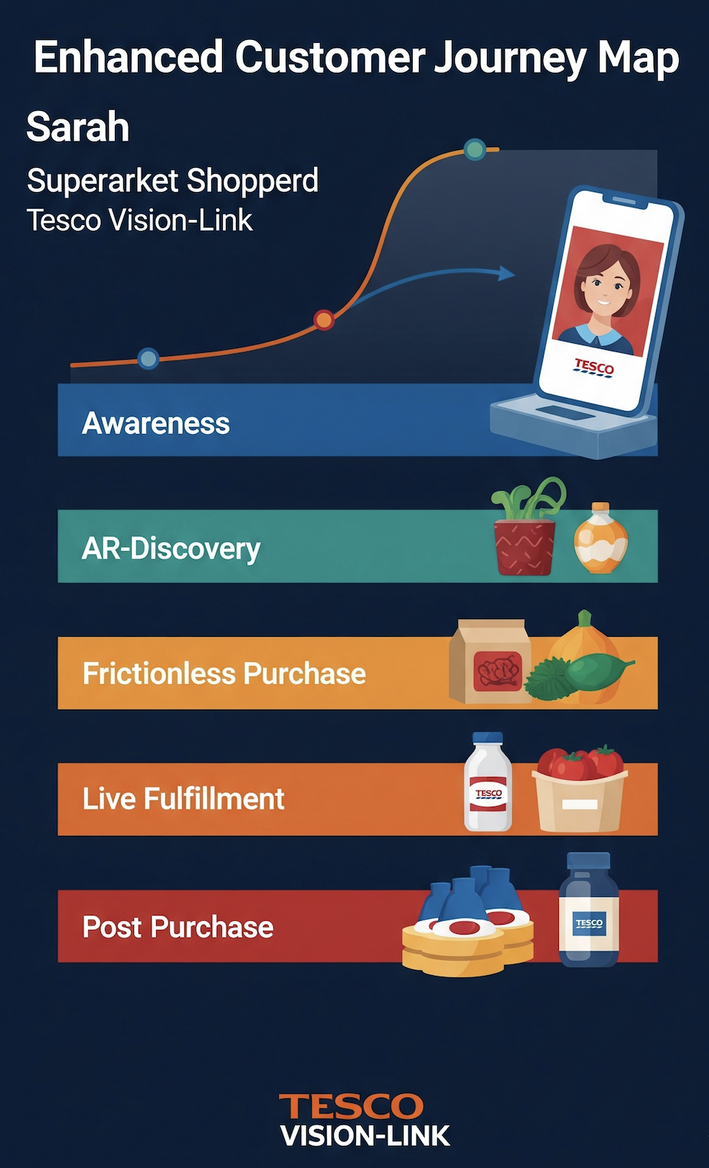
Figure 4: Enhanced Customer Journey Map (Author)
Introduction of Vision-Link essentially transforms the situation of Sarah at all touchpoints. During the planning stage, now she establishes her dietary filters and substitution preferences in one instance in her profile. As she enters the store, the discovery stage is changed; her phone is used as a digital guide, pointing her out to the best items to purchase in her family immediately and saves her fifteen minutes every time she goes to the store.
The buying stage is no longer accompanied with anxiety of being inspected, since the Vision-Link sensors have already proven her basket to be invisible. During the fulfilment stage, she is no longer being substituted, but rather, she is an active participant and signs her alternative milk via a push notification during a meeting. Emotional condition during the whole journey is changed to a state of empowered/delighted instead of the previous neutral/frustrated state. The online technologies are at last keeping up with her life.
The Vision-Link initiative will be a value addition to Tesco since it will enhance the "Basket Size" due to improved discovery and also reduce the "Cost of Returns" of rejected substitutions. It also enhances efficiency in operations by saving time that is used by staff to carry out manual security checks as well as the time used to handle substitution complaints.
To quantify success, Tesco will monitor a set of KPIs which are digital first:
CX RX (Customer Experience Return on investment): This will be following the gain in lifetime value of the customers who will frequently utilise the Vision-Link features.
Conversion Rate of AR-Viewed Items: this measures the number of items that are highlighted by the AR overlay to make a purchase relative to the number of items highlighted by the standard shelf-viewed items.
Substitution Rejection Rate: The target decrease of thirty percent in the initial year of the roll out of the Virtual Room is thirty percent.
Frictionless Score: This is a new value that is calculated by the average length of stay at the exit relative to the usual checkout procedures.
The long-term success will be measured on the basis of the "Digital Maturity Score" of this organisation which will determine the quality of adoption and integration of these new tools in the everyday shopping activity of the core customer base.
Vision-Link is subject to inherent risks, as any massive digital transformation. It would be very frustrating to customers in case of technical failure (e.g. app crashes or sensor glitches). To reduce this, Tesco should invest in high quality edge-computing infrastructure so that the AR overlays and AI verification continue even in the case the external internet connection of the store is disconnecting. Another risk of significant concern is data privacy. Overhead sensors and computer vision may be viewed as an intrusion in tracking items. Tesco should be open with its data usage, where the computer vision recognises items and not people and that anonymisation and encryption of all the data is performed. Lastly is the threat of customer digital exclusion where the customers have no access to smartphones. To overcome this, Tesco will also maintain the use of traditional service methods alongside provision of In-Store Tablet which can be mounted on the trolleys to serve those customers who would like to exploit the Vision-Link features without carrying their own tablets.

4. Conclusion
The Tesco PLC management of the UK grocery market is maintained by an advanced combination of both the fundamental pricing protection and transformational exploration of technology. Nevertheless, as has been shown in this analysis, there are still major areas of friction in the omnichannel journey, especially the transparency of information, control of fulfilment, and the human-technology interface during the checkout. The use of the Innovation Ambition Matrix indicates that although Tesco possesses a healthy portfolio, its transformational initiative such as GetGo should be incorporated in the core of the customer experience to deliver universal value beyond a limited number of niche locations. The Tesco Vision-Link initiative proposed will be a strategic program towards hyper-personalisation and the concept of a retail that has gone frictionless. Digital maturity is a lifelong learning and adaptation journey as opposed to a destination. Through the adoption of the design thinking principles and the investment in predictive and agentic technologies, Tesco is poised to be the leader in digital age of grocery retail, transforming each of the pain points into the competitive edge.

5. References
Bumann, J., & Peter, M. (2019). Action fields of digital transformation–a review and comparative analysis of digital transformation maturity models and frameworks. Digitalisierung und andere Innovationsformen im Management, 2(November), 13-40.
Hanus, G. (2016). Consumer behaviour during online grocery shopping. In CBU International Conference Proceedings (Vol. 4, pp. 010-013).
Hossain, M. S., Chisty, N. M. A., Hargrove, D. L., & Amin, R. (2021). Role of Internet of Things (IoT) in retail business and enabling smart retailing experiences. Asian Business Review, 11(2), 75-80.
Khimesara, M. (2024). Innovation Tools and Methods - The Innovation Ambition Matrix. [online] First Loop. Available at: https://www.firstloop.se/post/innovation-tools-and-methods-innovation-ambition-matrix [Accessed 5 Feb. 2026].
Mahboub, H., Sadok, H., Chehri, A., & Saadane, R. (2023). Measuring the digital transformation: a key performance indicators literature review. Procedia Computer Science, 225, 4570-4579.
Mason, T., & Jarvis, S. (2023). Omnichannel retail: How to build winning stores in a digital world. Kogan Page Publishers.
Moorman, C., & Lemon, K. (2020). CX RX: Innovating and competing on customer experience. Marketing News, 54(2), 48-53.
Panwar, T., & Khan, K. (2021). Integrating design thinking in service design process: A conceptual review. Journal of Design Thinking, 2(1), 23-36.
Pichler, R. (2025). The Innovation Ambition Matrix. [online] Roman Pichler. Available at: https://www.romanpichler.com/blog/innovation-ambition-matrix/ [Accessed 5 Feb. 2026].
Pinto, G. L., Dell’Era, C., Verganti, R., & Bellini, E. (2017). Innovation strategies in retail services: solutions, experiences and meanings. European Journal of Innovation Management, 20(2), 190-209.
Rosenbaum, M. S., Otalora, M. L., & Ramírez, G. C. (2017). How to create a realistic customer journey map. Business horizons, 60(1), 143-150.
Singh, A., & Kakkar, A. (2025). Marketing in the age of hyper-personalisation: Lessons from analytics-driven brand success. Applied Marketing Analytics, 11(1), 72-86.
Tesco Plc (2025). Tesco PLC Annual Report and Financial Statements. [online] Available at: https://www.tescoplc.com/media/ky0bfwpo/tesco_ar25_interactive.pdf.
Wolniak, R., Stecuła, K., & Aydın, B. (2024). Digital transformation of grocery in-store shopping-scanners, artificial intelligence, augmented reality and beyond: A review. Foods, 13(18), 2948.
‌

‌

‌

