

Post Graduate Certificate in Teaching For Higher Education

  - Teaching Portfolio
  - (Year 1)

David Anthony Williams BSc(hons). MSc.
David.Williams2@UWTSD.ac.uk

Declaration
I declare that the content of this document along with the accompanying programmed facets are all my own work. Where ever work of a different author(s) has been researched or discussed it has been properly referenced using the numeric referencing in accordance with the standards laid down by the University of Wales Trinity Saint David. At any point where the opinion of a third-party has been queried through-out the content, this too has been documented.


David Anthony Williams BSc(hons). MSc.

Acknowledgements & Permission to Print
I would like to acknowledge the works of the authors referenced through-out the project whose works have formed the cornerstone of the investigative portion of this project. Finally, I acknowledge the staff of the University of Wales Trinity Saint David for the mentorship and guidance given through-out my course of study.
I grant full permission to redistribute, alter or print this work or any portion thereof to the University of Wales Trinity Saint David.
David Anthony Williams BSc(hons). MSc.

Dedications

“Dedicated with love
To all those I lost this year whatever the reasons may be
And with loving gratitude to all my friends and family
For their patience helping me in finding my way through the pain
---------------------------------------------------------
With Special Thanks to
All the Staff at University of Wales Trinity Saint David and Swansea Metropolitan University
for all they have taught me through the years.”

David Anthony Williams BSc(hons). MSc.
30 April 2018

Table of Contents
Higher educational analysis from a learner’s point of view 5
1.1. Introduction 5
1.2. Description 6
1.3. Feelings 7
1.4. Evaluation 8
1.5. Analysis 8
1.6. Conclusion 9
1.7. Action plan 9
Micro-teach 10
2.1. Introduction 10
1.8. Consideration on content and reflection on delivery and feedback 11
CPD engaged with 13
3.1. National Autistic Society (five Modules) 13
3.1.1. Understanding autism 16
3.1.2. Autism and communication 17
3.1.3 Autism and sensory experience 18
4. Observations 19
4.1. Over-view 19
4.2. Observation one: author observation of colleague 20
4.2.1. Introduction 20
4.2.2. Content 20
4.2.3. Analysis and Reflection 21
4.3. Observation two: author being observed by colleague. 22
4.3.1. Introduction 22
4.3.2. Content 22
4.3.3. Analysis and Reflection 23
4.4. Observation three: author being observed by colleague 24
4.4.1. Introduction 24
4.4.2. Content 24
4.4.3. Analysis and Reflection 25
Intervention one 26
4.5. Introduction 26
4.6. Main body 27
4.6.1. Note taking 28
4.6.2. Study assistance 29
4.6.3. Specialist mentor 30
4.6.4. Assistive technology tutor 32
4.6.5. Specialist 1 to 1 study skills support 33
4.7. Analysis and Reflection 35
Reflection on the First Year of the Course 36
6.1. Swansea ITeC 37
1.2. University of Wales Trinity Saint David 38
4.7.1. Lecturing at SABNE 38
4.7.2. Teaching in Learning Support 38
6.3. Ongoing Action Points 39
Bibliography 40
Appendices 44
Appendix A: Microteach Materials 44
Appendix B: CPD Evidence 48
NAS: Understanding Autism 48
NAS: Autism and Communication 49
NAS: Autism and Sensory Experience 50
NAS: Autism, Stress and Anxiety 51
NAS: Autism, Supporting Families 52
Note-taking for Disabled Students Certificate 53
Assistive Technology Certificate 54
PREVENT Training for Practitioners Certificate 55
Appendix C: Observation Forms 56
Appendix D: Student Services Paperwork 62
Appendix E: Evidence of Teaching Hours 67
Appendix F: Examples of Lesson Plans 76
ITeC Apprenticeship Lesson plan C# 76
Built Environment lesson plan (observation 2) 79
Built Environment lesson plan (observation 3) 81
Assistive Technologies Sonnocent 83
Lesson Plan Key 84

Higher educational analysis from a learner’s point of view

Introduction
The purpose of this paper is to describe the author’s experience of higher education as a learner. The author has since concluding their studies worked in several teaching posts both within the university and teaching apprenticeships at various levels between two and four within a separate organisation, in addition to working for the university in student service posts (mainly study assistant and note taker). The Author will use an adaption of Gibbs reflective cycle within this element of the portfolio [1].
This paper will focus on the years between 2005 and 2013 where the author attended, in the following order, Swansea institute of higher education (SIHE), Swansea Metropolitan University (SMU), and finally University of Wales Trinity Saint David’s (UWTSD). It is therefore a possibility that this paper may provide a somewhat unique overview of how the organisation has changed and the impact that this has had on the learners who are studying within it (A5, K1, K3, K6, V2, V4 [2]).
During the course of constructing this document, the author has consulted with a colleague who has mentioned some factors about their educational experience that is at variance to the material presented here (K3, V1, V2 [2]). While this is not addressed within the main body of this report (as they did not impact the author’s experience), it is the author’s deepest desire that some of these issues discussed not to be a problem within any class that the author was delivering [3] [4] (A1, A2, A4, K3, V4 [2]). Resultantly, there are some elements included in the action plan that go beyond the elements mentioned in the main body of the report.

Description
The author of this report is David Anthony Williams. Academic background is as follows-
- Primary school
  - Pontardulias primary school (see below)
  - Home schooling for 6-month interludes while visiting father working in Saudi Arabia
  - Tairgwaith Primary School
- Secondary school
  - Cwmtawe Comprehensive school
- College
  - Coleg Cwmtawe
  - Neath College
Brief overview of pre-university education – plenty of potential but could do better (this is repeated time and again on school reports which the author is reviewing at the time of writing). This is a common story that is often told by learners who go one to flourish in specific fields ti it often the case that at secondary school will find some elements of the curriculum engaging and others not leading to a general apathy with academic life, this could have an impact on how a learner will perceive the concept of continuing studies at higher levels. [5] [6](K3, K4, V1, V2 [2])
However, family life led to the decision that the best course of action was to actually fulfil one’s potential and finish one’s education. Having always had an interest and somewhat of a flare in computing, arrangements were made to meet up and discuss options with Bob Grove and Karen Jones at Swansea Institute of higher education to enrol on a course (computing and information systems) in the School of Applied Computing.
This was to be done on a part time basis as it was considered that the family could not bear the brunt of the costs of full time education (the institute at the time used to wave fees for low income individuals (V2 [2])). These studies were delayed for a year owing to a duodenal ulcer.
Upon resuming studies, the following institutions were attended (these were in fact a single organisation being shunted through restructuration and mergers)
- Swansea Institute of Higher Education
- Swansea Metropolitan University
- University of Wales Trinity Saint David
As previously mentioned, the under-graduate degree path followed was computing and information systems and having succeeded this with a strong first (K1 [2]) it was suggested that studies continue with a fully funded master’s degree in Applied Computing which was carried out with Access to master’s Funding. This elevated the level of activity from part-time to full-time and involved a work-placement element as a proviso of the funding. The author completed this course of study achieving the grade of merit (K1 [2]).

Feelings
The Author often felt as a part-time student that the author existed as an entity apart from the rest of his cohort. This was largely due to the fact that a part time ‘year’ takes two academic years to complete so the full-time cohorts seemed to be a group of people that simple came and went, never to be seen again. This used to prove particularly challenging wherever group work was involved (there was a distinct move towards integrating more group working within the school of computing after the organisation elevated from being Swansea institute to SMU), it is much easier to produce a high quality of work within an established team or at least where the team members are aware of each other’s strengths and weaknesses (K1, K3, V1, V2 [2]). This changed to a degree when an individual of approximately the same level of ability joined the cohort also on a part-time basis. The author feels that we both benefited in being in the same situation and often an element of friendly rivalry led to us both producing some ‘top-drawer’ work (K1, K3, V1, V2 [2]).
The merger (when SMU became UWTSD) brought fourth its own difficulties, not least the in procedures that are still in place today for extenuating circumstances. The author had an issue during his study of the MSc, his grandfather (who, if truth be told, was more like a farther to me than the genuine article) passed away and the author was naturally finding the workload somewhat too much to take. the author applied for extenuating circumstances and even presented a death certificate only to be told that his case would be put before a board (no definite yes or no). With this uncertainty the author completed the work on schedule and submitted as normal. The author was informed after the submission date that his application for extenuating circumstances had been approved. To this day the author does not believe that anything that the author submitted in this time was his best work. Under SMU the author could have just discussed his situation with Steve Hole (head of school) or Beverly Holland (course director) whereby the author would have received a simple yes or no answer [7]. the author believe that this kind of blatant bureaucracy is highly inhibitive for the student population – especially where a document like a death certificate is presented and the student may not be in the right mind-frame to conduct this kind of communication or be ‘put on hold’ until the university makes a decision.
In spite of any negativity, an important side-note to remember is that when the author had nothing, Swansea Met gave me everything- the author carry this thought in his mind every day and have never shirked from any task when called upon (particularly from those individuals within the organisation who the author feel were instrumental in his academic success).

Evaluation
The author of this report does indeed have a somewhat singular view-point of the organisation. This is largely due to the long time-frames involved in part-time study and the many institutional changes that have occurred during this time.
Some of the current policies in place are not fit for purpose. Should a student have certain problems and sufficient supporting evidence the head of school or course director should have carte-blanche to resolve the situation within reasonable constraints. This is also true from a staff point of view in terms of the seeming lack of job security that exists within the organisation. It could be argued that this does not affect the learner but it the staff are not happy then this has a natural ‘trickle down affect’ and media comments about redundancies within the organisation are certainly not going to help this situation [8] (V4 [2]).

Analysis
In general, it is the finding of this paper that the university offered the best service that it could for a student in the author’s situation. Furthermore, the author was incredibly fortunate to be in education at a time where funding opportunities were available that, sadly, simply do not exist today (V4 [2]).
Recent developments within the school of computing could have mitigated this with entry to the applied computing BSC\MComp whereby there is a more ‘pick-and-mix’ approach to modules and the possibility of twenty credits being written off against a documentation of the work done on a placement or relevant job (K1, V1, V4 [2]).
It is an important factor for consideration that any individual employed as a note taker is still in a classroom environment albeit as a professional and not as a learner and as such it is safe to say that they still have an ongoing experience of the classroom from the ‘student side of the desk’ [9]. Wherever this is coupled with teaching position (however meagre they may be), it makes for possibly the truest and fairest overview of the educational landform that can possibly be ascertained [4](A2, K1, K3, V1, V4 [2]).

Conclusion
The Key elements that the research behind this paper have illustrated are-
- Not all learners are the same (in terms of requirements), more flexibility should be provided within the framework on a student by student basis (not a ‘one size fits all’ mechanism like UWTSD currently have in place) (A1, K3, V1, V2 [2]).
- Not all modes of study are the same, and a teacher should be aware of each student’s external commitments and how this impacts on their studies (this generally relates only to students who are studying as a part of their job NOT students who are over playing the ‘work-life balance card’) (A1, K3, V1,V2 [2]).
- The experience gained during academic study can have profound implications on a student’s future motivation towards ongoing or re-entry to education (K3, V1, V4 [2]).

Action plan
- To continue his role within the organisation and help the student population to fulfil their potential (both in terms of learning support and lecturing) (A1, A2, K3, K4, V1, V2 [2]).
- To obtain a recognised teaching qualification (A5, K2, K3, K5, K6, V3, V4 [2])
- To continue the best practices that have been observed in the past (and continue to be seen while in the classroom as a note taker (see intervention one)) as a part of developing his own teaching materials and delivering them in an appropriate environment utilising a range of tools, techniques and technologies (A1, A2, A4, A5, K2, K4, K5, K6, V2 [2]).
- To support his colleagues wherever the author can (A2 [2]).
- To ensure that no member of his class ever feels alienated or too uncomfortable to ask for help through thorough support and helpful feedback (A2, A3, K3, K4, K5, V1 [2]).
- To continue learning in order to always keep his knowledge and skills up to date in an ever-changing sphere of study (A5, K1, K6, V3 [2])
- To continue to support, teach and assess learners in a university and work-based context both with UWTSD and Swansea ITeC (A1, A2, A3, K2, K5, V1, V2, V4 [2])

Micro-teach

2.1. Introduction
The topic of choice for the micro teach session, was entitled ‘An introduction to Geographic Information Systems’. Fundamentally speaking, Geographic information systems are systems that combine database technologies and datasets (e.g. census data [10]) with locational information to deliver geo-visualised outputs which can be combined with mapping resources such as the ordinance survey or UK borders libraries [11] to allow a different view of the data for demonstrative and analytical purposes [12] [13] [14] [15](K1 [2]).
This was topic was chosen for four key reasons –
- Having formed an integral area of research for both the author’s bachelor’s and master’s degrees, there was a ‘level of comfort’ with the underlying subject matter [16] [17] [18] [19] [20](K1, A5 [2]).

- Having both delivered and assessed this topic as a formal module there was a feeling of confidence that any fielded questions could be both anticipated and adequately addressed [21] [22](K1, K2, A1, A2 [2]). This particular topic has been a source of ongoing development throughout the author’s academic career (A5 [2])

- Having delivered the topic across schools within UWTSD (both for the school of computing and for the school of the built environment) [21] [22], the author was mindful of the need to adapt the tone, style and technical content for learners of a non-computing background (K1, K2, K3, A1, A2, V1 [2]). This point was particularly important in the case of the micro teach session as it was known that the cohort would be formed from individuals of many background disciplines (although, what these disciplines would be remained unknown until the day of delivery). This factor made lesson planning (K1, K2, K3, A1, A2, V1, V3 [2]).

- This topic was delivered as a taster-session to some trainee learners at Swansea ITeC on 05/01/2018 with a view to sparking interest and boosting engagement with continued education (V2 [2]).

Consideration on content and reflection on delivery and feedback
When considering the content of the presentation the author opted to discuss the concepts in a business orientated context; this decision was reached to mitigate the fact that the cohort members disciplinary backgrounds were largely unknown and the business and socio-demographic elements would be more relatable to a wider group of learners than those normally taught through the schools of computing and built environment [23] (K3 [2]). The scope of the deliverable was to broadly introduce the topic to the cohort by giving information on the following key points (K1 [2]). The reader is advised to refer to the slides included in the appendices.
- A general breakdown of how the course would normally run complete with learning outcomes (both theoretical and practically based) and assessment methods (A3 [2]). This was included to provide the cohort with a flavour of how the full module would run.

- Historical uses and the Evolution of GIS from pre-computing examples through to modern systems. In a longer session this would include use of video content derived from a number of sources (K1 [2]), however, time constraints on the micro-teach session meant that images and text would have to suffice. Is was unfortunate as it has been observed from previous deliveries of this topic that use of video content engages the learner to a higher degree than presentation alone, the same can be said for the practical elements that generally would be incorporated into this topic [24] (V3 [2])

- Underlying technologies and how they would be used and how this would shape the teaching environment and delivery style in a full-length module. This topic would normally require a portion of time set in a computer lab with access to specific hardware and software (A4, K1, K2 [2]). Some of the main features of the software and its architecture, what it can achieve and how were covered in the micro-teach session [25] [26] [27].

- Types of mapping resource and practical applications of layers. This section was a largely graphical section of the session that included examples of using the technology to display the data on a range of resources.

- Questions and answers. This section was included in an effort to allow an opportunity to demonstrate knowledge in an unrehearsed basis and to gauge the effectiveness of the delivery on the cohort (K1, K5 [2]).

The session was fairly well received; however, the author deems that the questions and answers section caused the delivery to overrun slightly. While this was unfortunate it was an excellent vehicle by which to gauge the audience interest and understanding (A3, K2, K5 [2]).
The most critical feedback that was received by peers was that the beginning of the presentations was somewhat lacking in graphics (this ran the risk of losing engagement with learners from certain disciplinary backgrounds, particularly those who are more amenable through learning through visual resources [24] (K3 [2])), however, this comment was followed up with a further observation that this changed after the initial introduction and course breakdown.
The author observes that their delivery was aided through the enhanced technical understanding provided to the cohort through the previous micro-teach presentation which was focused on database fundamentals [28]. Since this is a related field there was more underlying knowledge provided to the cohort than the author initially expected (K1 [2]).

CPD engaged with

3.1. National Autistic Society (five Modules)
The National Autistic Society (NAS) provides five core units each of which is an accredited Continuing Professional Development (CPD) module [29]. The purpose behind CPD accreditation is to ensure that practical or academic skills are kept up-to-date while providing recognised and independent benchmarks are met by the delivered training [30] (A5, K6, V3 [2]).
The five modules covered were [30] -
- Understanding autism
- Autism and communication
- Autism and sensory experience
- Autism, stress and anxiety
- Autism: supporting families
The author had the opportunity to engage with this training under staff development as a member of staff for learning support (University of Wales Trinity Saint David (UWTSD)) (A2, A5, K6, V3 [1]). This development opportunity was offered with a view of allowing the author’s career progression to encompass the grade four teaching position of specialist mentor for autistic students (the reader is advised to refer to teaching intervention one) (A2, A5, K6, V3 [2]).. The necessity for this particular training being the requirements laid-down by the Disabled Students Allowances Quality Assurance Guidelines and framework (DSA-QAG [31] and DSA QAF [9]); the guide lines state that in order for a non-medical helper (NMH) to be able to provide the role of support mentor for autistic students they must hold the following qualifications (A1, A5, K6, V3, V4 [2])-
“Holds a degree
AND
Comprehensive training in adult autism which must include: -
All 5 NAS core autism online training modules (Understanding Autism; Autism and Communication; Autism and Sensory Experience; Autism, Stress and Anxiety; Autism: Supporting families)
Or
NAS tutor-led course ‘Understanding Autism’
Or
‘Introduction to autism and the SPELL framework’
Or
Other training, including at a HE institution, delivered by an appropriately qualified trainer (a qualified trainer from a recognised organisation/charity, or a trainer who can demonstrate a relevant qualification in autism)
Or
Holds a PG Certificate in Autism / PG Certificate in Asperger’s” [31]

While, as seen above, there is a range of feasible learning routes to achieve this role, learning support for the Faculty of Architecture, Computing and Engineering (FACE) at UWTSD favour the NAS route (A1, A2, A5, K6, V1, V3 [2]).
The purpose of this training, in brief, is to equate the learner with the differences in mind-sets that can occur with students who have been diagnosed or may be on the autistic spectrum and how this may impact on how that individual may perceive both the world around them and more specifically how the teacher may adapt their approach to ensure appropriate delivery methods to find the most effective way of conducting a session (A1, A2, A5, K6, V1, V3 [2]). It should be stated at an early stage that being a spectrum disorder, no two autistic students requirements will be the same (the same can be said for any two students [24], but this issue can be amplified for students ‘on the spectrum’ [29]), educators have a duty to mitigate these barriers to the best of their ability (more on this later) [32](A1, A2, A5, K6, V1, V3 [2]).
It is the view of the author that this training possibly does not go far enough for individuals who specialise in mentoring autistic students due to the obvious limitations associated with e-learning materials and assessment [33]. However, the author takes the view that all teaching staff should receive this (or similar) training in the knowledge that there is a high level of probability that in the large cohorts we see as a matter of course these days there will be a proportion of individuals who are on the autistic spectrum (A1, A2, A5, K3, K6, V1, V3 [2]). Student services for the Faculty of Architecture, Computing and Engineering have observed growth within student intake of individuals who have been diagnosed as being somewhere on the autistic spectrum; particularly within the School of Applied Computing where this author is largely based (A1, A2, A5, K6, V1, V2, V3, V4 [2]).
The author will now reflect on each of these five modules in detail (the project brief calls for a reflection of individual events, but owing to the area of overlap, the author deemed it expeditious to include the above piece of narrative which relates to all five courses) (A5, K6, V1, V3 [2]).
The website claims that the module should take forty to ninety minutes for completion. It was the finding of the author that some of the resources were hugely interesting and contained a fair amount of key information and requires a second viewing. The training has a range of interactive features, including [30] (A5, K6, V1, V3 [2]):
- A pre-assessment to give the learner a summary of how well they knew the topic prior to proceeding.
- short film clips
- exercises and scenario-based learning
- reflective activities
- printable information sheets
- top tips to take away
- Further links and references.
- A final multiple-choice test to ensure the appropriate knowledge had been gained during the module.

As been previously mentioned (and as stated by Arkorful [33]); there can be some limitations to these kind of module provisions in terms of a ‘disconnect’ between the learner and the organisation delivering the course and no true way of gauging success of the course itself (other than the final assessment) (A2, A5, K6, V3 [2]).
The final assessment could also be said to be somewhat flawed, owing largely to the fact that that the ability to continuously retry the test until the answers are correct without penalisation, also, this kind of assessment has been described as (A2, A5, K5, K6, V3, V4 [2])–
“Incapable of truly measuring understanding, and while performance on such exams can be noticeably improved simply by learning a few tricks” [34]
This being said, the author found these resources to be both informative and insightful and believes that providing that the recipient does not just adopt a ‘click-through’ approach, which is always a risk with this kind of resource [33] (although it should be considered that the £140 price tag for this training [35] should ensure that the learner would want to get the best of the resources), that any potential learner should be able to get a great deal of knowledge and understanding from this set of modules in various areas that can impact on the educational experience of an autistic student and how to mitigate this in their teaching approaches [35](A4, K2, K3, V1, V2 [2]).
There is a great deal of research available from a number of sources that support the need for this kind of understanding and adaption for teachers providing educational sessions and teaching environments to ensure that their students are given a ‘level-playing field’ [36] [37] as is both morally and ethically correct and is legally required under the United Kingdom’s Equality Act 2010 [32](A4, K2, K3, V1, V2 [2]). With a view to this a number of techniques are currently emerging in how to best mitigate these learning barriers, this being an ongoing and evolving sphere of research and experimentation [38] (A4, K2, K3, V1, V2, V4 [2]).
“where a provision, criterion or practice of A’s puts a disabled person at a substantial disadvantage in relation to a relevant matter in comparison with persons who are not disabled, to take such steps as it is reasonable to have to take to avoid the disadvantage.”
Equality Act 2010 section 20 sub-section 3 [32]

3.1.1. Understanding autism
This module was designed as the overall introduction to the on-coming modules. During this module, the learner is provided with a general overview with key concepts associated with Autism to give a better understanding of the specific needs of autistic individuals to form the basis by which of the following modules can build upon [29] (A2, A5, K6, V3 [2]).
It should be stressed that this point that the content contained within the national autistic society is resources’ can be adapted to any number of job roles. However, as previously mentioned the job role of specialist mentor for autistic students lists this set of qualifications as mandatorily for job role as laid-down by the quality assurance guidelines of student finance England [9](A2, A5, K6, V3, V4 [2]). As discussed in the previous section, however, that it is the belief of the author that this training would be beneficial for wide range of individuals working within the educational sphere [24] [38] (A2, A5, K3, K6, V2, V3, V4 [2]).
As with all the sources on the national autistic society’s web page on-line learning, the resources include a combination of plain text and multimedia facets inclusive of interviews with professionals and autistic individuals [39]. The author believes this provided a good balance of point of views which were carried on through each of the following modules. Some of the interviews involve detailed explanations by autistic individuals regarding their personal perceptions of various situations and environments (A5, K1, K3, K6, V1, V2, V3, V4 [2]). .
This module provides [39]:
- Defining and diagnosing autism and how this has changed over time
- Discussion on the difficulties that people with autism may face along with the strengths and unique attributes of people with autism
- challenge common stereotypes about people on the autism spectrum
- Identification on the requirements to make environments more enabling for people on the autism spectrum.
Reflectively speaking, the author found these materials to be of a high standard; the video content and provided texts were highly informative and gave several specific viewpoints that allowed the learner to truly empathise with the interviewees, which could be invaluable when planning a lesson or support session with a student who has been identified as being on the Autistic spectrum [37] [36]. But as with all the assessments related to this suite of training is a little unconvinced of the effectiveness of the on-line method of gauging the assimilation of the provided knowledge [33]. The learner is presented with a final multiple-choice test that can be sat repeatedly until success is attained [34]. The provision of a multiple choice set of answers as an assessment medium is already a matter of some debate owing to the role that probability can play in the overall score when some answers are simply guessed [34] [33] (A5, K5, K6, V3, V4 [2]). .
Suggestions of improving this could include –
- a larger bank of questions
- a set of questions that should include a more qualitative response
- limiting the numbers of resits or imposing a time limit before a resit could be taken

3.1.2. Autism and communication
This material was formulated so that the learner would recognise communication differences for autistic people and the impacting elements which can impede successful communication. The aim being to facilitate the learner’s ability to respond to differences in communication and to subsequently be able to support people on the autism spectrum in an effective manner [40](A2, A5, K6, V3 [2]).
Naturally, reduction of communication barriers is a key element to successfully teaching a cohort should be a foremost consideration to any teacher when formulating both the deliverable materials and when planning the desired delivery of material to their students [24](A1, A2 [2]). When it comes to designing materials for deployment with students on a One-to-One basis however, the teacher has the opportunity to more specifically tailor the learning material to the needs of each individual student [31](A1, A2, K1, K2, K3, V1, V2 [2]). This is an area that will be further discussed within teaching interception number one where the author will examine the various teaching grade roles that he has conducted in the past academic year (A1, A2 [2]). This particular area of development plays a particularly important role in how to ensure alacrity when conveying information to students from the autistic spectrum [37] [40] (A1, A2, K1, K2, K3, V1, V2 [2]).
The key areas that within this module include the following points [40]-
- The description of how language and communication can be perceived differently by autistic students and how you should reflect on your own style of communication when dealing with these individuals
- How to modify language in order to optimise communication with autistic students
- Understanding both positive and negative elements that can either adversely affect successful communication for be of benefit to said communications
- Being able to identify and recognise the natural preference is for individuals on the autistic spectrum and learning how to best work with the learner is to ensure the successful working relationship and clear communications.
It was found by the author that this was among the more informative modules of overall training suite as it provided a valuable insight into many possible areas where learning barriers may exist with certain individuals at the author had not previously considered. Furthermore, with the author being due to uptake the new post as a specialist mentor for students with autism [9], this module gave a great insight into what to expect possible barriers to communication and how best to mitigate them [40] (A1, A2, K1, K2, K3, V1, V2 [2]).
As previously mentioned (and as will be an ongoing theme with most of these web-based learning modules), the author does question the effectiveness of the final assessment method (please refer to module one to avoid repetition) [33] [34]. As previously mentioned the author found the materials provided for the learning element to be have an extremely high standard and of great relevance.

3.1.3 Autism and sensory experience
In a nutshell, this module is how different environments can affect learning and communication with autistic students. As with all learning on this programme it must be observed that when dealing with autistic students there are no hard and fast rules that applied across the board. Some students may react well to some stimuli while others may find the same stimuli inhibitive to their engagement, understanding and eventual learning of the materials being delivered [41] (A2, A5, K6, V3 [2])..
The particularly interesting elements of this module was the various interview films in which autistic individuals stated the effect that elements such as bright lights, loud sounds or even strong smells have on their ability to interact with their surrounding environment [41]. From a teaching point of view the knowledge gained from this module allows the lecturer to somewhat to mitigate these elements should the needs of an individual student be made clear to them [37](A1, A2, A4, K1, K2, K3, V1, V2 [2]). This may be difficult particularly in large classes where you have many students with many specific needs [38], however, him more intimate teaching scenarios such as those seen within the student services or learning support roles (please refer to teaching intervention one) [31], this kind of information can be invaluable to anyone formulating both the lesson plan and the learning space [38] [41](A1, A2, A4, K1, K2, K3, V1, V2 [2]).
Key elements to be discussed in this module included [41]-
- Reflecting on your own processes and preferences on how an individual best process information for example what kind of learner is a given individual in terms of the better absorb visual or oral means of delivery. Also, identifying the personal preferences of the learner as far as the space used or material delivery.
- Understanding the differences that can be experienced by individuals on the autistic spectrum in relation to the above point, with a view to establishing ways of adapting delivery and learning spaces for these individuals.
- Looking beyond the teaching environment this module also gives the learner the opportunity to find out about every day environmental issues that can impact on an autistic individual.
- The ultimate aim being the ability to both recognise and respond to the specific sensory needs of autistic individuals.
This module raised some important questions in the mind of the author when considering learning spaces available to learning support for students are allocated under the role of specialist mentor for autism. Some of the teaching rooms available to student services may be considered as unfit for purpose for certain students [37] [36]. There are a range of considerations that should be taken into account including elements such as external noise that could cause destruction, lighting and even room temperature [41]; the latter of which the biggest problem with some of the teaching spaces available to learning support (A1, A2, K1, K2, K3, V1, V2 [2]).
As previously mentioned, the author finds that the method of final assessment is open to several underlying problems [33] [34]. However, the actual underlying resources provided by the national autistic society as part of this eLearning resource for have a very high quality which are both insightful and informative [41] (A5, K6, V3, V4).

Observations

4.1. Over-view
This section covers the observation element of the course, during the first element of the course it is was a requirement that the author observed a colleague delivering course material once and that a colleague observed the author in the classroom twice (A2 [2]). The second instalment of the course sees the author being observed teaching by a colleague on three occasions. These elements are presented in this portfolio and should be appropriately cross mapped to the HEA professional standards framework [2]; the observed sessions are as follows-
- Observation one: author observation of colleague – James Williams teaching the module ‘managing people and change.
- Observation two: author being observed by colleague – Valerie Harding observes data analysis with Excel for students of a non-computing background
- Observation three: author being observed by colleague – Valerie Harding observes data analysis and Geographic Information Systems
- Observation four: author being observed by colleague – TBA (second module)
- Observation five: author being observed by colleague – TBA (second module)
- Observation six: author being observed by colleague – TBA (second module)

Observation one: author observation of colleague

Introduction
During this session, the author observed James Williams delivering a session for a level six cohort comprised of mixed streams (studying Business Information Technology and Applied Computing) in the School of applied computing (UWTSD) (K1, V1 [2]). The session’s indicative content was focused on teaching the module managing people and change and dealt largely with the definitions and foundations of change management [42]

Content
Everything changes. This is particularly true for the realm of technologies; organisation need to adapt to accommodate this change in order to remain competitive and thus stay in business. Change is important in society, business and technology [23]. This innovation can be seen when using the Google example, before Google there were many different search engines, they achieved this through the simplification of the search engine. Google have also been innovative in terms of web-based applications such as Google drive Gmail etc. All organisations are going through change constantly [20] [23] [42] (K1 [2]).
The games industry has really pushed the computing field as they have such a need for better graphics and speed. But how do you manage this change when new products supplant old ones? There is often resistance to this change. Managing this is what this module is all about (this change is not only limited to computing). James ran a couple of videos for the class - the links for these are on Moodle and provide a clear overview of change management [42](K1, A4, K4 [2]).
Next James set the class the task of finding two definitions of change management. This ties into task one of the assignment so telling the cohort that will want to save the URL and will want to find two or three supporting sources (K1 [2]).
The last thing that James set the class to look at was Kondratieff wave theory [42]. These show economic periods showing a new innovative idea. Society is currently in the sixth wave which is the overlap between IT and psycho-science [42](K1 [2]).

Analysis and Reflection
This topic is a somewhat more business-orientated topic that the author often experiences within the school of computing, as such on the surface this could have been perceived from students of various streams as a dry subject; particularly where students are accustomed to modules which have an even-to-heavy balance of practical elements (e.g. databases, spreadsheets, coding or web development). However, James’ teaching style makes these sessions truly enjoyable and informative. It is the view of the author that James has achieved this largely due to the following points (A2, A3, K1, K2, K3, K4, K5, V1, V2 [2]) –
- First and foremostly, James demonstrates a deep, far reaching knowledge of his subject; which is the obvious foundation on which any should build their material and delivery.
- James has a naturally relatable attitude along with enthusiasm passion for his subject matter. Throughout his sessions these elements of his teaching style visibly enthuse the learners and facilitate engagement and involvement where ever tasks are set.
- The subject matter is split into manageable chunks with time being allocated for individual research and subsequent discussion. In doing this the group are given the opportunity to both demonstrate autonomy and cooperation in successive bouts, while preventing an overload of lecturer-delivered theory.
- The associated material takes a variety of forms including traditional slides, video, audio and oral forms; little or no use of whiteboard (which is in line with emerging and innovative techniques and learning spaces).
- Direct questioning in a gentle and encouraging manner to individual members of the cohort to ascertain knowledge accrued ensures synthesis of the subject matter.
It is very difficult for the author to find any possible flaws in the observed session but from an academic point of view the following points could be of interest(A1, A2, A3, A4, K1, K2, K3, K4, K5, V1, V2 [2]) –
- The level of autonomy in the research sections could facilitate disengaged students not to do the task at hand. However, James mitigates this extremely well by getting each student to relay their findings to the group after a set amount of time.
- Some learners of a more traditional vent may be unaccustomed to some of the more innovative approaches and learning environment style that James promotes. But again, this is mitigated well through provision of all materials via Moodle and through the approachable, helpful and relatable ethos that James promotes.
The author has found James’ session highly informative and enjoyable and has found his teaching style to be one that is highly effective to the synthesis of knowledge to the student body. While the author would describe their own use of media, materials and resources as a more traditional nature; James’ relatability to the cohort, his enthusiasm for subject matter and methods of ensuring engagement are all elements that the author would like to eventually learn be able to emulate or incorporate in their own teaching style (A1, A2, A4, k1, K2, K3, K4, V1 [2]).

Observation two: author being observed by colleague.

Introduction
During this session, Valerie Harding (Learning Support Coordinator for the Faculty of Architecture, Computing and Engineering, UWTSD) observed the author delivering a session for a level six cohort studying environmental conservation in the School of architecture and the built environment. The session’s indicative content was focused on data analysis with Excel for students of a non-computing background [43]. (A2, K4 [2])

Content
The content of this module relates to achieving the objectives laid down by the assignment brief, what the cohort was required to do was to acquire census data sets from Casweb and infuse [10] and conduct some statistical operations on it to create a Townsend index (this is a measure of depredation for a given area) [16](A1, A2, K1,K2,K3, K4, K5 [2]).
The secondary objective being that the students create several visualisations of the data (e.g. graphs and charts) using the inbuilt operations within excel [43] (A1, A2. K1, K2, K3, K4 [2]).
In order to achieve this, it is a required that the learner be made aware of how to conduct formulas and functions within excel [43]. This presents challenges in so much as the teacher is aware that in the case of conducting this kind of training for a student-body from a non-computing background there is a high probability that the cohort will contain individuals of mixed computing ability which may mean that the lecturer will have to begin at first principles while still keeping individuals of higher ability engaged [44] [6]. The lecturer made use of the following teaching approaches to facilitate learners understanding and synthesis of knowledge [44](A1, A2, A3, A4, K1, K2, K3, K4, K5, V1 [2]) -
- Pre-created slides portraying theory and techniques (A1, A2, K1, K2, K3 [2])
- Practical demonstration of data acquisition from census sources [10](A2, K1, K3, K4 [2])
- Time allowed for the students to replicate the process for their required data for their chosen region. During this time the lecturer toured the class observing student participation offering help as necessary to ensure learner understanding [4] (A2, A3, K1, K2, K5, V1 [2]).
- Practical demonstration of data manipulation using formulae and functions in excel [43] to create a Townsend index [16](A2, K1, K2, K3, K4 [2]).
- Time allowed for the students to replicate the process for their required data for their chosen region. During this time the lecturer toured the class observing student participation offering help as necessary to ensure learner understanding [4]. (A2, A3, K1, K2, K5, V1 [2]).
- Practical demonstration of data visualisation using excel operations [43] to create a graphs and charts, the lecturer also used the white board to demonstrate how visualised data is more human compatible to plain numbers and strings. (A2, K1, K2, K3, K4 [2]).
- Time allowed for the students to replicate the process for their required data for their chosen region. During this time the lecturer toured the class observing student participation offering help as necessary to ensure learner understanding [4]. (A2, A3, K1, K2, K5, V1 [2]).
- By the end of the lecture the cohort had a functional data set for one area at one level of granularity, for homework the cohort was instructed to obtain additional datasets at different levels and repeat the process. This was done in order to ascertain the cohort had retained the information [44]. (A1, A2, K1, K2, K3, K4, K5 [2])

Analysis and Reflection
The full Observation form for this session can be seen in the appendices, however, the author shall analyse and reflect on the key points here.
The author is very pleased with the feedback Valerie identified the following key factors (A1, A2, A3, A4, K1, K2, K3, K4, K5, V1 [2]) -
- The lesson was well planned with a balance amount of theory and practical elements
- The lesson built upon prior lessons to ensure continuity within the course
- The author demonstrated their knowledge of the subject matter well
- The session was well paced
- The observer found the delivery to be professional, challenging and engaging
- Atmosphere and environment conducive to learning through a positive atmosphere
Examples of good practice (A2, A3, A4, K1, K2, K3 [2]):
- Observer commented on an excellent learner-teacher relationship
- The observer seemed impressed with the level of knowledge displayed and that means of extending this was identified
Suggestions for continued development included incorporation of multisensory aides, ensuring that quieter learners are engaged in the discussion and to maintain the demonstrated standard. (A1, A2, A4, K1, K2, K3, V1 [2])
The author was satisfied both with the response from the learners and the observer. The author will certainly take on-board the feedback in particular the statement regarding the engagement of quieter learners and the suggestion of incorporating multi-sensory material as it is an important point that the author has raised throughout this report that every effort should be made by the teacher to engage each individual of the cohort to the best of their ability. (A1, A2, A3, A4, K1, K2, K3, K4, K5, V1 [2])

Observation three: author being observed by colleague

Introduction
During this session, Valerie Harding (Learning Support Coordinator for the Faculty of Architecture, Computing and Engineering, UWTSD) observed the author delivering a session for a level six cohort studying environmental conservation in the School of architecture and the built environment (UWTSD). The session’s indicative content was focused on data analysis and Geographic Information Systems [15]. (A2, K4 [2])

Content
The content of this module relates to achieving the objectives laid down by the assignment brief, what the cohort was required to do was to continue working with the acquired data from Casweb and infuse [10] from the previous session in order to present the data in a geo-visualised form using MapInfo [16] [26] (A1, A2, K1, K2, K3, K4, K5, V1 [2]).
In order to achieve this, it is a required that the learner be taught how to interoperate with data between excel and Pitney-Bowes MapInfo [26] [43] (A1, A2, K1, K2, K3 [2]). As previously mentioned this can present problems when dealing with learners from a non-computing background whom may require varying levels of assistance throughout the cohort [44] [6](A1, A2, K1, K2, K3, K4, K5, V1 [2]).
The lecturer made use of the following teaching approaches to facilitate learners understanding and synthesis of knowledge [44]-
- Recap of previous session (A1 [2])
- Observation of the work completed by the students to ensure that the cohort were at a suitable point in the activity to be able to proceed.
- Pre-created slides portraying theory and techniques associated with thematic mapping in MapInfo [16] [26](A2, A3, K1, K2, K4, K5, V1 [2]).
- Practical demonstration of creating thematic maps from a pre-prepared dataset in MapInfo on the projector [26](A2, A3, K1, K2, K4, K5, V1 [2]).
- Time allowed for the students to replicate the process for their required data for their chosen region. During this time the lecturer toured the class observing student participation offering help as necessary to ensure learner understanding [4] (A2, A3, K1, K2, K4, K5, V1 [2]).
- Practical demonstration of data manipulation using formulae and functions in excel [43] to create a Townsend index [16]. (A2, A3, K1, K2, K4, K5, V1 [2]).
- Time allowed for the students to replicate the process for their required data for their chosen region. During this time the lecturer toured the class observing student participation offering help as necessary to ensure learner understanding [4]. (A2, A3, K1, K2, K4, K5, V1 [2]).
- The students were now required to repeat this process for each of the datasets and levels of granularity that they have created. (A2, A3, K1, K2, K4, K5, V1 [2]).

Analysis and Reflection
The full Observation form for this session can be seen in the appendices, however, the author shall analyse and reflect on the key points here.
The author is very pleased with the feedback Valerie identified the following key factors (A1, A2, A3, A4, K1, K2, K3, K4, K5, V1 [2])-
- Excellent preparation of resources
- Professional style of delivery
- Excellent grasp of subject matter
- Positive reinforcement, relaxed attitude and excellent attitude demonstrated
- The session was well paced and catered to the learner’s needs
- Participation encouraged and welcomed
- Understanding was gaged through questions and answers
- Appropriate teaching aides deployed
- Observer commented on an excellent teacher-learner rapport
- The observer commented on the fact that the learning methods were appropriate
Examples of good practice:
- Autonomous learning promoted through giving thinking time
- Positive language used
Suggestions for continued development included maintaining the high demonstrated standard and to more clearly states the aims of the session to that students can relate the tasks to the objectives.
The author was incredibly pleased that this second observation also yielded such a positive feedback, knowledge that the lessons are considered as well planned and accessible boosts confidence in the author’s abilities. The author is always open to feedback whether of a complementary or critical nature as it is the author’s belief that the only way the teacher can ever grow in the role is by taking on-board the views of others and incorporating suggestions that are presented. The author will certainly make every effort to be clearer with aims and objectives and relate these back to the various tasks and delivery elements throughout the session in the future. (A1, A2, A3, A4, K1, K2, K3, K4, K5, V1 [2])

Intervention one

Introduction
The purpose of this section is to demonstrate teaching interventions. A teaching intervention can be described as a single instance of where the teacher has to adapt their teaching style for a specific cohort, individual or environment. As a part of the postgraduate certificate for teaching in higher education the author is required to conduct three teaching interventions; two in the form of written narrative and one in the form of a poster.
During the past academic year, the author has conducted several roles for the University of Wales Trinity saint David’s within the department of student services working from an early for learning support dealing with students for the faculty of computing, architecture and engineering. Owing to the nature and structure of roles within Learning Support, some can be considered as teaching roles while others are not [9]. However, all roles will be discussed within this intervention to give the reader and overview of the differences between providing support and to providing lectures in roles within the faculty (during the last year the author has also provided lecturing for the school of the built environment within the same faculty on a part-time basis, see appendices).
Support roles provided by the University of Wales Trinity saint David’s are defined by the disabled students allowance quality assurance framework and guidelines [9] [31].
The grade seven teaching roles that the author has performed over the last academic year include the following posts-
- Specialist mentor for students with autism
- Assistive technology trainer
- Specialist 1 to 1 study skills support lecturer
The auxiliary roles the author has performed include-
- Note taker
- Study assistant

Main body
As mentioned in the introductory passage the author has conducted numerous roles within learning support of the last academic year. Those roles which are considered as teaching roles differ sizably to the standardised lecturing role that the author also fills. This will be discussed at length in a reflective element of this section. However, the reader should also be aware of the other roles that the author conducts within learning support on the insight and knowledge that they provide to the genuine teaching roles that the author fills.
Owing to the fact that several roles will be discussed in this section, the reflective element will deal with isolating the differences from formal lectures that are true for each of the given roles. This should fulfil the requirements laid down by the project brief to demonstrate changes that the author has implemented to their teaching during the course to enhance their teaching requirements. It should be noted that this intervention deals with a number of subtle and ongoing changes to the way that the author conducts teaching within the learning support roles.
It is not uncommon for any of the teaching-grade support roles to be provided to students who are also in receipt of support in other roles [9]. In cases where these other roles are fulfilled by other support workers, it is of paramount importance that all involved staff members make every attempt to regularly meet to discuss the current strategies they are employing, and any areas of concern or successful techniques employed in order to facilitate the adaption of teaching on an ongoing basis to best suit the needs of the student [45] [36] [38], this can be reinforced through use of the standardised work plans which are produced on a lesson-by-lesson basis (however, since these documents only need to be produced by teaching level ). In some cases, a single member of support staff may support a learner under a number of different roles the implications of this being –
- From a consistency point of view, this is positive as the teacher has builds a greater rapport with the student and in so doing is better equipped to create specifically tailored content on an ongoing basis [39].
- Counter wise, the negative impact could be that the learner becomes over reliant on the support worker over time which can be a barrier to the autonomy that the roles are geared towards achieving [9]. Also, a blurring of lines between the roles can become a factor when multiple roles are fulfilled by a single support teacher which can make formalising any role-specific lesson planning difficult [44].
For reasons of alacrity the author shall first deal with the non-teaching roles in order to demonstrate their relevance to the teaching roles.

Note taking
While this is not a teaching role, this is all the same worthy of mention within this intervention in brief form. As the role title suggests this support role is provided for students who require notes to be taken during sessions on their behalf owing to any of a range of disabilities to ensure a ‘level playing-field’ as required by the equality act [9] [32]. A range of different session types can require note taking including (non-exhaustively); seminars, field trips, lectures and tutorials (A2, K1, K3, V1 [2])
The relevance of this role to the development of the authors teaching development is two-fold-
Firstly, there is a high requirement for disability awareness by the note-taker as the notes produced must be in an appropriate form that must be negotiated with the student [9] [46], as previously discussed in the report, the support must be tailored on an individual basis and should never be generically decided based on the nature of an individual’s disability alone as the needs of a student are person-specific and as such are not necessarily one-to-one transferrable [5] [47]. (A2, K1, K3, V1 [2]). This awareness is promoted throughout the through the mandatory training which was provided by the OCN’s training (note taking for Disabled Students in Higher Education level two – see appendices) [46] [31] (A5, V3 [2]). This foundation becomes enhanced with experience within the job role [44] and forms a solid basis on which to draw when engaging with learning support students for any of the higher-grade roles [9]. (A2, K1, K3, V1 [2])

The second element relevance is the fact that under the role of note taker the author attends sessions of various types (see above). As a part of this report, the author had to reflect on a single peer observation that he conducted, however, as a note taker the author has attended a plethora of taught sessions delivered by many peers in a number of learning spaces based on varying subject matter. This has given the opportunity to enhance their own outlook on teaching by both exposing them to different ways of delivering material [48] [49] while expanding and renewing the knowledge of subject specific material relevant to their own area of specialty [49] [50]. (A2, A5, K1, K3, V1, V3 [2])

Study assistance
Again, not a true teaching role [9], however, this role does have a bearing on how the author has gained many insights into how to provide teaching support at the higher-grade roles (and as such a brief overview has been included here). (A2, K1, K3, V1 [2])
Primarily, this role is conducted in a one-to-one basis and is aimed at if students who are encountering certain learning barriers or a complex set of circumstances [36]. Alternatively called a study buddy, the study assistant can help the student in a number of ways during the sessions. This can include elements such as the provision of help in the following areas (non-exhaustively) [9] (K1, K3, V1 [2])-
- Providing information on the higher education environment as a whole e.g. signposting.
- Helping the student with affective timekeeping strategies and ensuring that they are keeping on track with assignment and revision workloads.
- Helping with organisational skills.
- Ensuring that the student has someone relatable even speak to regarding any worries or concerns they are currently experiencing in relation to their chosen course.
The reason that the author has chosen to include this job role within this section of the report is fundamentally because this is the vehicle that led to further roles within learning support. Steady assistants are often (though not always) deployed as auxiliary support alongside the higher-grade learning support provisions and has such experience in this role gives the staff member both a sound working relationship with other staff members in other roles and a solid foundation and understanding as to what other roles entail [49](A2, K1, K3, V1 [2]). For the author found this invaluable when been elevated teaching roles within learning support particularly the roles of specialist 1 to 1 study skills support and specialist mentor for autistic students [9](K1, K3, V1 [2].
Owing to the fact that typically students will be awarded more hours with a study assistant then they will wither more specialised roles, this role gives the opportunity for the support worker truly get to know their student any specific problems they are having and in a wider train of scope be able to identify commonly recurring issues that students can face [9]. This kind of gained knowledge can be invaluable to a teacher as he can play a part in avoidance and mitigation of known issues that can affect the student-body as a whole [6] [5]. (A2, A5, K1, K3, V1, V3 [2]).

Specialist mentor
This was the first teaching role that the author was elevated to in learning support this year. Specialist Mentorship at UWTSD is provided in two main areas
- Specialist Mentor for Autism
- Specialist Mentor for Mental Health
This report will only concern itself with the role of specialist mentor for Autistic students owing to the fact that this is the only one of the two roles that the author currently holds. In order to be considered for this position the author was required to complete the national autistic society’s online training in 5 modules [29] (please refer to CPD section and Appendices) in order to achieve compliance with the DSA quality framework [31]. The Author believes that the training (both the NAS modules and the second module of the OCN training) [46] [29] and available literature [36] [38] [5] gave a strong foundation on what would be required to best achieve this role (more on this reflective element of intervention) (A2, A5, K2, K3, K6, V1, V3 [2]).
The DSA Quality Assurance Guidelines state that -
“Specialist mentors provide highly specialist, specifically tailored, one to one support which helps students address the barriers to learning created by a particular impairment.” [9]
This kind of support teaching differs vastly from a formalised lecture or tutorial- based teaching session, this is largely due to the demands of the role itself. Some areas can be taught in a formal manner with will allow for the creation of formalised lesson plans and delivery materials, however, owing to the nature of this support the teacher must be dynamic and approach any given session in a fluid manner in order to accommodate the needs of the learner and to reinforce their understanding (this becomes easier as the relationship with the learner progresses as the teacher will become more aware of their natural attributes) [51] [38] [36] [29](A1, K2, K3, V1 [2]).
It is not uncommon for a student to attend a session with the need to work on an unplanned activity and the specialist mentor must be dynamic enough to assist in this [9]. It is there for learning support practice to utilise on-going work plans that detail the work that was intended to be covered, the work that was actually covered and what the student needs to work on before the next session (see appendices) (A1, K2, K3, V1 [2]).
Support sessions could be aimed at elements (this list is a non-exhaustive sample of potential topics) [9] (A1, A2, K2, K3, V1 [2]).-
- Anxiety and stress coping strategies
- Overcoming concentration difficulties
- Time management techniques
- Workload prioritisation
- Creating and sustaining an acceptable work-life balance

As can be seen by the list above, this role could be said to sit somewhere between the non-teaching role of study assistant and the teaching role of Specialist one-to-one support and as such it is not uncommon for any student who has a specialist mentor to also be receiving support in either or both of these areas [9](A2, K2, V1 [2]).
As previously mentioned, with any student clear direction should be established between the support staff in these circumstances but this can be particularly important when serving a student who is on the Autistic spectrum where communication issues could already be a potential barrier (contradictory strategies employed by support could be detrimental to the student’s well-being and ability to learn and produce work of the required standard) [5] [36] [38] [29](A1, A2, A3, K2, K3, V1 [2]).
As with all support roles, the ultimate aim of the teacher must be the facilitation of autonomy in the student [9]; this will not always be one hundred percent possible dependant on the level of the specific needs of the learner, but the goal should always be to make the student more capable of completing tasks on their own [38] [36]. In many cases, success in teaching can be gaged not only through increased academic success but also though the learners reducing reliance on support [9](A1, A2, A3, K2, K3, K5, V1 [2]).

Assistive technology tutor
Further to receiving assistive technology training (see appendices), the author was elevated to the support role of assistive technology tutor. As a part of their needs assessment, disabled students are often awarded various elements of technologies that can be utilised in an attempt to provide the student with a ‘level playing-field’ with their peers as required by the equality act [9] [32]. This award can include various hardware and software exponents [9] (A1, A2, K2, K3, K4, V1 [2]).
Hardware can include –
- OSx Mac computer – the apple-based system which will run the various software.
- Windows-based PC – the Microsoft-based system which will run the various software.
- Digital Recorders – such as a standard Dictaphone
- Smart Pens – a hybrid solution to notetaking and audio recording [52]
Software can include –
- Office 365 – the common medium for completing course related content, this suite of applications includes (amongst others) [43]-
  - Microsoft Word. Word Processing Software.
  - Microsoft PowerPoint. Software for building and viewing presentations.
  - Microsoft Excel. Spreadsheet software.
- Sonnocent Audio Note-Taker. A piece of software to organise audio notes with other resources [53].
- Nuance Dragon Dictate. Software that translates audio to text allowing the user to dictate to the computer [54].
- Claro. Software for relaying printed text to audio [55].
- Grammarly. Software to check spelling and grammar in text documents and web pages [56].
- Mindview. Software to create mind maps and Gantt charts which can be interchanged with various applications [57].
This role is possibly the most compatible with traditional planning and delivery of the three learning support roles that the author currently fulfils. This is largely due to the fact that the packages, despite being awarded in different combinations to students, are standardised [9](A1, A2, K3, V1 [2]). This being said, the content and timeframes that the teacher must incorporate into their delivery must be adapted to the needs of the student; this can be relative to (–
- The learner’s natural learning preferences
- The level of IT literacy that the learner possesses
- The number of technologies that must be covered during the sessions
Generally, students are awarded a comparatively low number of taught hours for this provision of support and they are intended to be delivered at the earliest time in the course. It is unfortunate that this often leads to a waiting list for the provision of assistive technology training (A1, A2, K2, K3, K4, V1 [2]).

Specialist 1 to 1 study skills support
This is the most recent role that the author has attained during their employment within learning support at UWTSD. The role itself is similar to that described under the support mentor section and indeed it is fair to say that the following roles not only often are used in conjunction with each other, but also can involve a certain level of over-lap [9]–
- Study Assistant
- Specialist mentor
- Specialist one-to-one study skills support
This role has been awarded under the proviso of the author completing the post graduate certificate in higher education along with the already completed core National Autistic Association modules in accordance with the guidelines laid down by the Disabled Students Association’s quality assurance guidelines [31].
This role is primarily geared towards learners with a Specific Learning Difficulty or an Autistic Spectrum Disorder [9] [37] (A1, A2, V1, V2 [2]).
The aim of this support is to aid in the development of the student skills in the hope of helping them to become incrementally independent learners [9] [44] [50]. As with all support roles the underlying goal is always that of facilitating either total or at least improved autonomy of the learner to prepare them for life beyond the academic environment [6] [5]. As previously mentioned, a gage of the success of teaching for learning support roles there are three factors (A2, A3, K2, K3, V1 [2])–
- Measuring the improvement (or lack thereof) of engagement with the lectures and support sessions [4].
- Measuring the improvement (or lack thereof) of grades achieved [4].
- Promotion of autonomy; do the improvements stated above continue as the quantity of support reduces [9] [58]
As with the Specialist Mentor role, formal lesson planning is possible where dealing with some of the general subject matter relating to the core elements associated with the support role such as [9](A1, A2, K3, V1 [2])–
- Addressing barriers which learners can exhibit in acquiring, retaining and utilising information when provided in either written or spoken form.
- Addressing difficulties in numeracy and other basic skills
- Techniques for enhancing the range of memory.
- Attention enhancing strategies.
- Introducing strategies to enhance organisational skills.

However, formal lesson planning is not always the most appropriate method of addressing all students who are receiving this kind of support [38] [36] [9]. Often the teacher will have to employ a wide-reaching ethos of flexibility and fluidity to tailor the material to the individual needs of the learner, as mentioned under the specialist mentor role it is not unusual for the student to arrive at a session with a different requirement to the one that the teacher has planned; in these cases, it is imperative that the teacher be dynamic enough to change topic on the spur of the moment (A1, A2, A4, K2, K3, V1 [2]).
As with all teaching roles learning support roles lessons are generally documented using an initial individual learning contract and each successive session will include completion of a work plan (see appendices) which provides information on [9] (A1, A2, A4, K2, K3, V1 [2])–
- What is planned for the session
- What was covered in the session
- What needs to be done before and to be covered in next session
These work plans are devised to mitigate the flexibility that the role entails while still providing a tailored structure and action points that both the teacher and the student can follow on a session-by-session basis [38] (A1, A2, A4, K2, K3, V1 [2]).
Another facet that the DSA documentation [9] indicates towards when discussing this particular job role is that the teacher is to identify the strengths which students who are either diagnosed as having a specific learning difficulty or as being on the Autistic spectrum and aiding the learner to utilise these strengths when addressing the barriers that they are encountering in their learning in the higher educational environment(A1, K3, V4 [2]). Obviously, this cannot be done on a generic basis as all students on the Autistic spectrum or with specific learning difficulties will have individual characteristics and differing strengths and unique barriers [36] [38] [29] (A1, A2, A4, K2, K3, V1 [2]). Therefore, building a rapport with the student and incrementally planning the sessions is of paramount importance (A1, A2, K2, V1 [2]).

Analysis and Reflection
The main changes exposed during this intervention as discussed during the main body of the section are –
Working on a one-to-one basis. Prior to working within learning support the teacher has always had to design and deliver material towards a cohort rather a single individual (A1, A2, K3, V1 [2]). One-to-one teaching is generally considered as inefficient inn the wider scope of education [49], but in the roles of learning support it is a requirement [9] (A1, A2, K3, V1 [2]). Advantages of one-to-one tuition include –
- Full attention of the teacher to the student. This means that the content, pace and delivery can be individually tailored to the learner [9] [3] (A2, K3, V1 [2])
- Nervous students may be more likely to ask questions than they would within a classroom environment [6] (A4, K3, K4, V1 [2])
- The learning space can be chosen and adapted to cater for specific needs [41] (A4, K3, K4 V1 [2])
Disadvantages can include –
- The student may become reliant on this kind of teaching environment [36] (A2, K2, V1 [2])
- The sessions do not benefit from the range of views that a full cohort can contribute [49] (K2, V1 [2])
Another key difference between Support teaching and formal lecturing is the goal of achieving autonomy. In the formal classroom the lecturer knows that they have to deliver a given amount of content in a given amount of time [4] [44]; this differs from the support roles whereby the ultimate aim is to deliver flexible content with a view to reducing support as the learner becomes less reliant on support [9] [29] (A4, K3, V1 [2]).
It is the view of the author that this is a sphere of teaching that is invaluable to incorporating students with disabilities into the student population by providing a ‘level playing-field’ through on-going support [9] [32](A4, K3, V1 [2]).
Working forward the author would like to further investigate and integrate multi-sensory learning materials into their teaching to further engage with students to whom this kind of teaching is deemed to be of benefit [5] [37] [38] [29](A1, A4, K2, K3, V1 [2]).

Reflection on the First Year of the Course
This section is involved with reflecting over the last year and considering facets learnt while on the course and during the teaching sessions that the author has been involved with during the accompanying period.
This has not been an easy year for the author due to a series of bereavements and the breakdown of their relationship of twelve years. It is the consideration of the author that his work life has largely unaffected by these factors owing to the fact that this has become an area of focus and distraction from external issues. However, the same cannot be said for the accompanying academic work, which the author believes while of an acceptable standard is not truly representative of the quality of work produced for previous academic submissions such as those produced during their bachelor’s and master’s degrees (K1 [2]).
It was the authors initial goal to submit both modules by the April 2018 deadline having completed all associated activities relating to the course some time ago (CPD and teaching hours), all that is remaining is to document this and receive further observations (which have been organised). The author has completed more than the required six CPD activities (A5, V3 [2]) and has logged teaching hours amassing to 338 hours in the last year which breaks down to (A3 [2])–
- 243 hours teaching at Swansea ITeC
- 26 hours teaching for the school of the built environment UWTSD
- 69 hours teaching in support roles for Learning support in UWTSD
Working forward it is the author’s objective to complete the second module by the September 2018. From the teaching view point the author believes that they have had a very productive year which has seen some positive developments in each of the areas referred to when discussing teaching hours (A5, V3 [2]).
Peer observations and the micro-teach sessions went incredibly well and provided some extremely positive feedback (as discussed in previous sections). The author is grateful to all those involved in conducting these observations and the feedback they provided.

6.1. Swansea ITeC
Swansea ITeC is a small to medium sized enterprise that is a part of the Skills academy Wales consortium which provides IT training to Traineeships, Apprentices and Commercial clients (A1, A2, K1, K2, V1, V4 [2]). Here the author has had great success in the following areas-
- The author’s work-based and learners most of whom have been passing their modules on the software development modules with grades of distinction (A1, A2, A3, K2, K5 [2]).
- This year has seen the author gain extra responsibilities including the development of centre desired assignments for the level four apprenticeship which have been accepted by city and guilds without complaint (A1, A3, A4, K2, K6 [2]).
- This year has seen the author gain extra responsibilities including the work place assessing of learners in addition to the original classroom only role that was expected of him (A1, A3, A4, K2, K6 [2]).
- The author has run a number of specialty commercial courses devised for specific requirements of third party organisations including the NHS and Power and Water (A1, A2, A4, K1, K2, K3, K6, V1, V4 [2].
- Experienced teaching younger learners during ITeC’s summer school, this scheme was set up to ensure that young learners remain engaged with education during the lengthy summer break. (A1, A2, K1, K2, V4 [2])
As part of the employment with Swansea ITeC, the author has also engaged in the following training and membership opportunities-
- The author was required to conduct online training provided by home office requirements into the governments PREVENT strategy to make learners aware of elements such as radicalisation (see appendices). (A5, K6, V3, V4 [2])
- The author underwent an online information security course in line with Swansea ITeC’s information security policy. (A5, K6, V3, V4 [2])
- The author is currently awaiting confirmation of his registration with the Education Workforce Council as a recognised teacher for work-based learning (A5, K6, V3, V4 [2])
Working with Swansea ITeC as a freelance tutor\assessor has taught the author a lot about educating learners beyond the scope of studying university degrees and about the importance of tailoring the learning materials to cater for the skills that employers want [23] [50] [59](A1, A2, A4, K1, K2, K3, K6, V1, V4 [2]). The author is greatly impressed with the concept of apprentices and is considering an in-depth discussion on the differences between educating these learners in intervention two.

University of Wales Trinity Saint David

Lecturing at SABNE
UWTSD School of built environment, the author’s relationship with this school is largely centred around lecturing computing-based content to students on the environmental conservation stream. This always produces a unique set of challenges as some of the content required has been adapted from material the author has previously designed and developed for the school of computing, as such some of the required concepts will need a deeper explanation and more demonstration to facilitate its accessibility to students from a non-computing background [44] [49](A1, A2, K2 K3, K4, V1 [2]). Counter-wise, challenges can be presented to the teacher as the data that needs interpreting can be speciality-specific which means extending research into the given field [20] [23](A5, K1, V1, V3 [2]).
The author feels that they have learned a lot from teaching in this school on the many occasion that they have done so (both within the scope of this course and proceeding it), as it has given the author the opportunity to teach outside of their comfort zone in terms of catering to students from outside their own specialty area of computing [60] [51](A1, A2, K2 K3, V1 [2]) (prior to taking up posts within learning support all UWTSD and ITeC modules that the author taught were specifically geared towards computing students).

Teaching in Learning Support
Learning support has already been covered in some length during the intervention section of this report and as such will only be discussed in brief here. The author performs a number of roles within learning support, some of which are considered as teaching positions others which are not [9]. However, all roles have, and continue to, have a profound effect on how the author perceives the role of teaching and adapts their style of delivery (A1, A2, V1 [2]).
The grade seven teaching roles that the author has performed over the last academic year include the following posts (in order of attainment)-
- Specialist mentor for students with autism
- Assistive technology trainer
- Specialist 1 to 1 study skills support lecturer
The auxiliary roles the author has performed include-
- Note taker
- Study assistant
The added responsibility that the additional roles and the training undertake to attain them has given the author new insights into teaching and the psychology thereof [5](A1, A2, A3, K3V1, V3, V4 [2]). Each role has its importance and when combined properly can have far reaching affects to the success of the student [9] [5](K3, V1, V3, V4 [2]). It is the consideration of the author that many academic staff seem unaware of the roles, responsibilities and importance of the support that learning support offers to students which can sometimes lead to the department being somewhat under-valued by some teachers [38] [29](K3, V1, V3, V4 [2]). The experience gained while working within these roles means that wherever the author’s career path in teaching may lead the value of learning support will never be over-looked. (V1, V3, V4 [2])

6.3. Ongoing Action Points
- Complete written element of course by September (A5, K1, V3 [2])
- Continue working with work-based learners at Swansea ITeC in both teaching and assessing capacities (A1, A2, A3, K2, K5 [2])
- Hopefully organise teaching hours with School of Architecture, Built and the Natural Environment for next academic year at UWTSD (A1, A2 [2])
- Hopefully organise teaching hours with School of Applied Computing for next academic year at UWTSD. (A1, A2 [2])
- Continue to support UWTSD students in the Faculty of Architecture Computing and Engineering (FACE) in all attained Learning Support roles. (A1, A2 [2])
- Continue to engage in both mandatory CPD training and any training relevant to continued evolution as a teacher (A5, K1, V3 [2])
- Continue to engage in on-going research into all facets relevant to both roles and specialised subject area to ensure skills and best practice are kept up to date. (A5, K1, V3 [2])
- Expand my practice to embrace new technologies and the new learning spaces that will be available after FACE relocate to SA1 (A4, K4 [2])

Bibliography

[1] | Academic services and Retention team, Gibbs' reflective cycle, University of Cumbria, 2016.
[2] | The UK Professional Standards Framework, “The UK Professional Standards Framework teaching and supporting learning in higher education,” UKPSF, 2011.
[3] | H. H. Gibbs, 53 Interesting things to do in your lectures, Bristol: TES Ltd, 1992.
[4] | B. Cox, Practical Pointers for University Teachers, London: Kogan Page Ltd., 1994.
[5] | D. Child, Psychology and the teacher, London: Cassell Education, 1997.
[6] | D. Lawrence, Enhancing Self-esteem in the classrom, London: Paul Chapman Publishing, 1996.
[7] | Swansea Metroplitan University, student hand book, 2006.
[8] | BBC, “University of Wales Trinity Saint David to cut jobs,” BBC, 31 03 2017. [Online]. Available: http://www.bbc.co.uk/news/uk-wales-south-west-wales-39460205. [Accessed 09 04 2017].
[9] | Disabled Students Allowences, “Non-medical Helper Providers:Quality Assurence Framework,” DSA, 2017.
[10] | “CasWeb Census Home page,” Manchester university, [Online]. Available: http://casweb1.ds.man.ac.uk/. [Accessed 20 12 2010].
[11] | “UKborders home,” [Online]. Available: http://borders.edina.ac.uk/html/. [Accessed 19 12 2010].
[12] | H. R, Information driven business, wiley, 2010.
[13] | D. Lush, “Fundamentals of GIS: Emphasizing GIS use for natural resource Management,” Dept. of geography; Michigan State University, 1999.
[14] | D. S. Sutton, “A Gentle Introduction to GIS,” Department of Land Affairs, Office of the premier, Province of Eastern Cape South Africa, 2009.
[15] | S. Xiong, Encyclopedia of GIS, New York: SpringerScience+Buisiness Media, LLC., 2008.
[16] | B. Holland, GIS Course Notes, Swansea metropolitan university, 2011.
[17] | D. Williams, “BSc Project - Critical Appraisal of Survey Collection and output of a related solution incorporating Geov-visualisation Techniques: Tracing development from initialisation to deployment,” Swansea Metropolitan University, Swansea, 2012.
[18] | D. Williams, “MSc Project - Experimentation into the utilisation of open data : A view to enriching existing datastores for the purpose of expanding visual, functional and analytical boundaries,” Swansea Metropolitan University, Swansea, 2013.
[19] | B. Kaplin, Information Systems Research: Relevant Theory and Informed Practice, Boston MA: Kluwer Academic Publishers, 2004.
[20] | E. M. Trauth, Handbook of Critical Information Systems Research Theory and Application, Massachusetts 01060: Edward Elgar Publishing, Inc., 2005.
[21] | D. Williams, Geographic Information Systems Lecture notes (school of applied computing), Swansea: University of Wales Trinity Saint David, 2013.
[22] | D. Williams, Geographic Information Systems Lecture notes (school of the built environment), Swansea: University of Wales Trinity Saint David, 2016.
[23] | T. White, What Business really want from IT: a collaborative guide for business directors and CEOs, Burlington MA: Elsevier Butterworth-Heinwmenn, 2004.
[24] | Swansea metropolitan university, Final school experience hand book, Swansea: Swansea metropolitan university, 2010.
[25] | Pitney Bowes, Map BASIC reference guide, New York: Pitney Bowes, 2008.
[26] | Pitney Bowes, MapInfo Professional 10.5 User Guide, New York: Pitney Bowes Software Inc., 2010.
[27] | Pitney-Bowes, MapXtreme Developers Guide ver 7.00, Pitney-Bowes Software inc, 2009.
[28] | K. Jenkins, Databases a basic overview - Microteach, Swansea: University of wales Trinity Saint David, 2017.
[29] | The National Autistic Society, “The National Autistic Society | NAS,” 2017. [Online]. Available: http://www.autism.org.uk/professionals/training-consultancy/online.aspx. [Accessed 10 12 2017].
[30] | The CPD Certification service, “The CPD Certification service - Continued Professional Development Accreditation,” Parallax, 2018. [Online]. Available: https://cpduk.co.uk/explained. [Accessed 28 01 2018].
[31] | Disabled Students Allowances Quality Assurance Guidelines, “DSA-NMH Mandatory Qualifications or Professional Body Membership Criteria,” DSA, 2016.
[32] | UK Government, Equality Act, ERII Crown Publications, 2010.
[33] | V. Arkorful, “The role of e-learning, the advantages and disadvantages of its adoption in Higher Education,” vol. 2, no. 12, 2014.
[34] | V. Strauss, The real problem with multiple-choice tests, 2013.
[35] | The National Autistic Society, “on-line training | NAS,” 2017. [Online]. Available: http://www.autism.org.uk/professionals/training-consultancy/online.aspx. [Accessed 10 12 2017].
[36] | M. R. D. S. Q. Owen, “Supporting Students With Autism Spectrum Disorder in Higher Education,” University of Tazmainia, 2015.
[37] | N. &. Shore, “Supporting Students on the Autism Spectrum in Higher Education,” vol. 5, no. 3, 2013.
[38] | Rochester Institute of Technology (USA), “Emerging Practices for Supporting Students on the Autism Spectrum in Higher Education: A Guide For Higher Education Professionals,” RIT, Rochester, 2014.
[39] | The National Autistic Society, “Understanding Autism On-line Training,” 2017. [Online]. Available: http://www.autism.org.uk/professionals/training-consultancy/online/understanding.aspx. [Accessed 10 12 2017].
[40] | The National Autistic Society, “The National Autistic Society,” 2017. [Online]. Available: http://www.autism.org.uk/professionals/training-consultancy/online/communication.aspx. [Accessed 10 12 2017].
[41] | The National Autistic Society, “sensory experience On-line Training | NAS,” 2017. [Online]. Available: http://www.autism.org.uk/professionals/training-consultancy/online/sensory.aspx. [Accessed 10 12 2017].
[42] | J. Williams, Managing People and change lecture, Swansea: UWTSD - SOAC, 2018.
[43] | Microsoft, “What is Office 365?,” Microsoft, 2018. [Online]. Available: https://www.office.com/. [Accessed 23 04 2018].
[44] | R. CAFFARELLA, Planning Programs for Adult Learners: A Practical Guide for Educators, Trainers and Staff Developers, Jossey-Bass, 2001.
[45] | D. Minton, Teaching Sills in further Education, London: Thomas Learning, 2005.
[46] | OCN, “Note Taking for disabled students in higher education,” purpose Media, 2018. [Online]. Available: http://www.learningsupportcentre.com/ocn-london-note-taking-disabled-students-higher-education/. [Accessed 22 04 2018].
[47] | L. Curzon, Teaching in further education: an outline of principles and practice, London: Continuum, 2003.
[48] | P. Ramsden, Learning to teach in higher education, London: Routledge, 1992.
[49] | D. Willetts, A University Education, Oxford: Oxford Universirty Press, 2017.
[50] | P. Jarvis, Adult and Continuing Education Theory and practice, London: Routledge, 1995.
[51] | G. Petty, Teaching Today: a Practical Guide, 2004: Stanley Thomas, Cheltenham.
[52] | LiveScribe, “Echo SmartPen,” LiveScribe, 2017. [Online]. Available: https://www.livescribe.com/en-gb/smartpen/echo/. [Accessed 25 04 2018].
[53] | Sonocent , “Sonocent audio note-taker,” Sonocent , 2018. [Online]. Available: https://www.sonocent.com/en/. [Accessed 22 02 2018].
[54] | Nuance, “Dragon Speech Recognition Software,” Nuance Communications, Inc, 2018. [Online]. Available: https://www.nuance.com/en-gb/dragon.html. [Accessed 01 04 2018].
[55] | Claro, “ClaroRead for PC,” claro Software Ltd, 2015. [Online]. Available: https://www.clarosoftware.com/claroread. [Accessed 15 03 2018].
[56] | Gammerly, “Gammerly,” 2018. [Online]. Available: https://www.grammarly.com/?q=brand&utm_source=google&utm_medium=cpc&utm_campaign=brand_f1&utm_content=76996511046&utm_term=grammarly&matchtype=e&placement=&network=g&gclid=EAIaIQobChMI34319Pbe2gIVS7TtCh1IzQj4EAAYASAAEgJhBPD_BwE. [Accessed 25 01 2018].
[57] | MatchWare, “MatchWare software for Creative Minds,” MatchWare A/S, 2018. [Online]. Available: https://www.matchware.com/mind-mapping-software. [Accessed 22 04 2018].
[58] | H. Bell, Evaluating Assessing for Learning, London: Kogan Page, 1996.
[59] | A. Rogers, Teaching Adults, Glasgow: Bell & Bain Ltd, 2002.
[60] | W. Reece, Teaching, Training and Leaning, Oxford: Business Education Publishers Ltd, 2007.
[61] | The National Autistic Society, “Stress and Anxiety On-line Training,” 2017. [Online]. Available: http://www.autism.org.uk/professionals/training-consultancy/online/stress-anxiety.aspx. [Accessed 10 12 2017].
[62] | The National Autistic Society, “Family Support on-line Training,” 2017. [Online]. Available: http://www.autism.org.uk/professionals/training-consultancy/online/family-support.aspx. [Accessed 10 12 2017].

Appendices

Appendix A: Micro-teach Materials

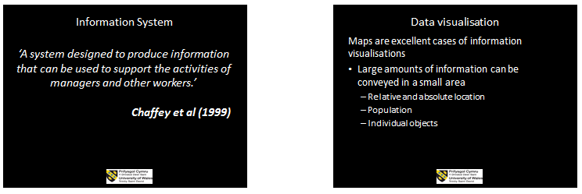


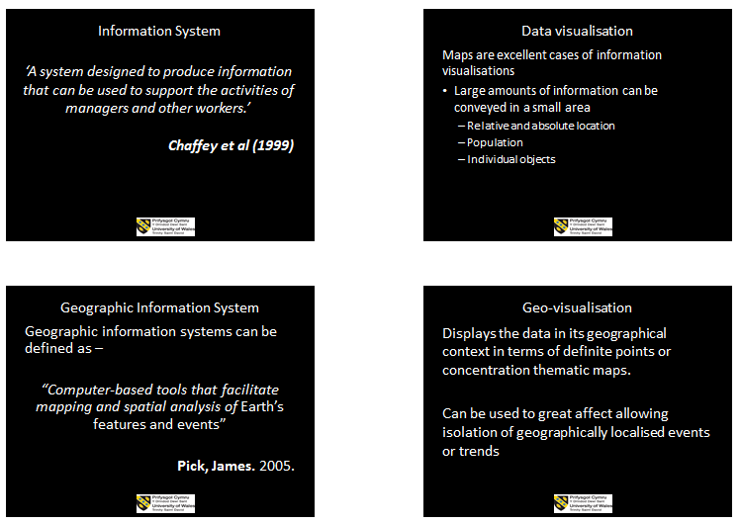

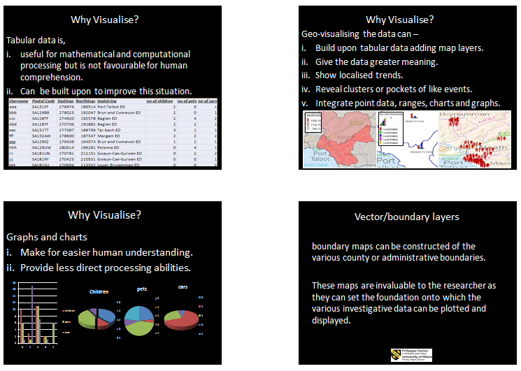
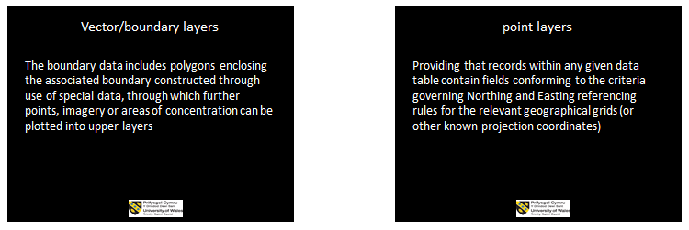

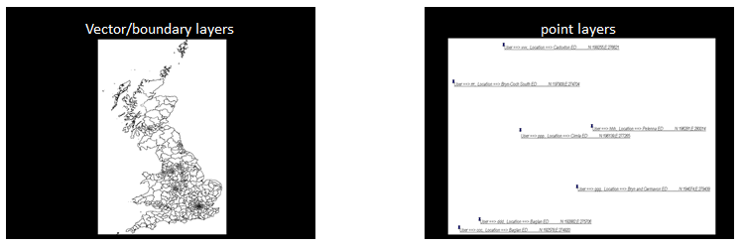
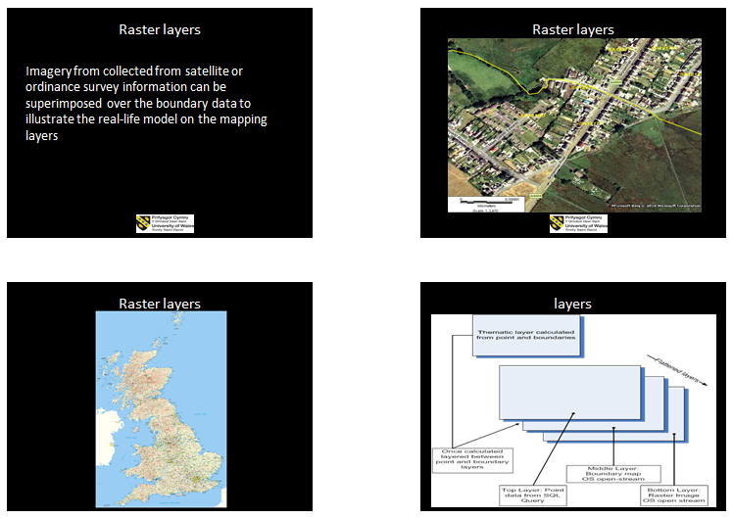

Appendix B: CPD Evidence

NAS: Understanding Autism
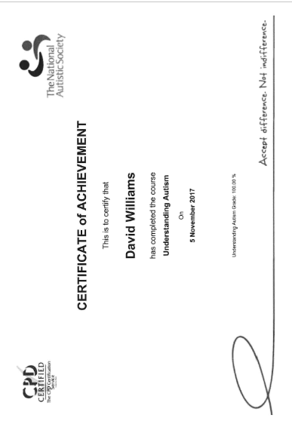

NAS: Autism and Communication
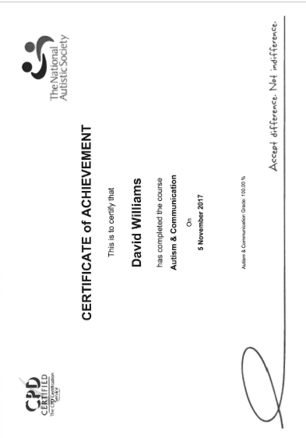

NAS: Autism and Sensory Experience
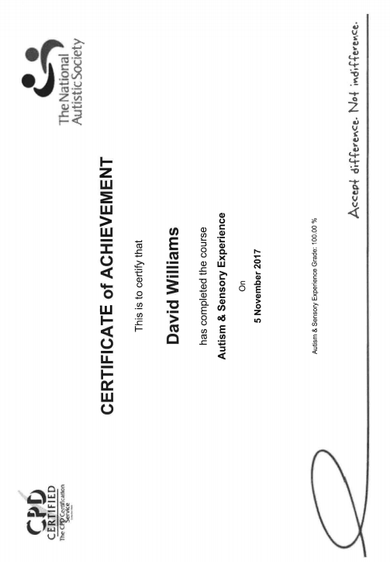

NAS: Autism, Stress and Anxiety
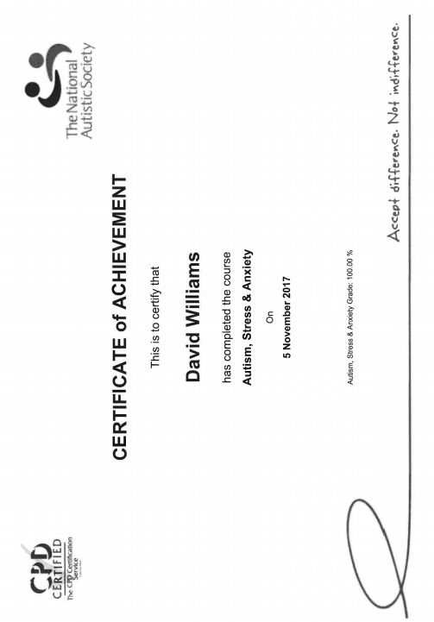

NAS: Autism, Supporting Families
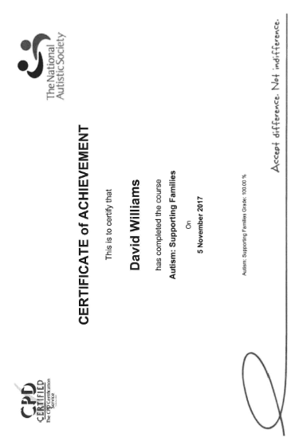

Note-taking for Disabled Students Certificate
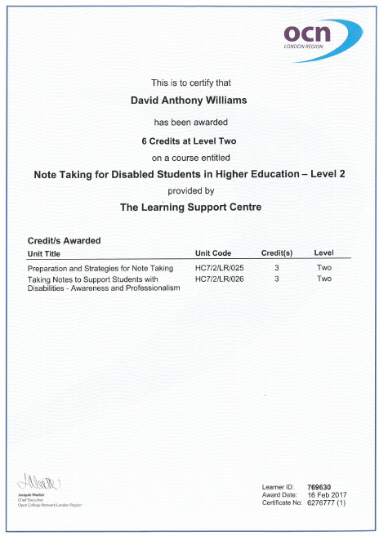

Assistive Technology Certificate
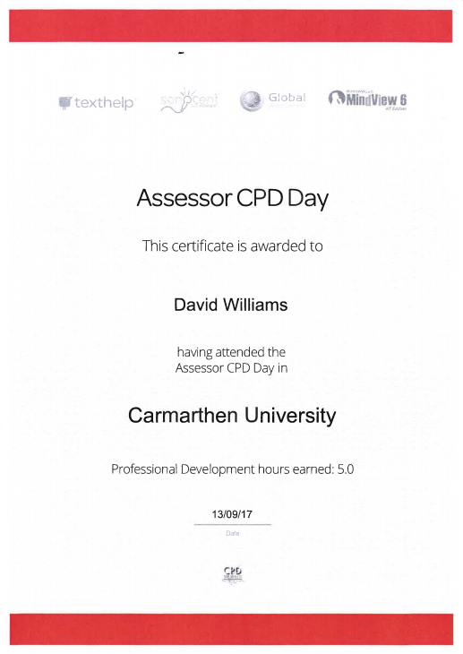

PREVENT Training for Practitioners Certificate


Appendix C: Observation Forms

PGCert tHE STAFF OBSERVATION FORM  Name of Staff member: James Williams | Date: 23/11/2017
Name of Observer: David Williams | Number in class: 5
Student level: 3 | Location: MH306
Topic/s: Managing people and change | Start Time: 15:00  Finish Time: 17:00
Teaching Characteristics: Preparation, selection and organisation of content. Choice of teaching/learning methods.
- James prepared materials and timing indicate a well-planned lesson
- Content organised into manageable chunks with sufficient time for thinking to promote independent learning

Presentation: Beginning class, introduction, continuity with other sessions, students’ prior knowledge. Clarity of presentation. Pace. Attitude to subject matter. Use of appropriate reinforcement. Ending the session – summary, future work etc.
- Well-paced delivery ensuring that all students keep up with the rest of the cohort
- Delivery is given in a clear manner
- Presentation materials of an excellent standard
- James utilises web, video and audio sources and has stated he is looking forward to innovative technologies that he can incorporate into the classroom environment in SA1

Technique and Aids: General apparatus – board, data projector, use of handouts. Question and answer technique. Other evaluation procedures, class management, instructions to students.
- Projector used
- Whiteboard not used
- Questions and answers used frequently in a positive and encouraging manner
Student Responses: General class atmosphere, level of participation, attention and interest. Student attitude and ability to carry out classwork. Where learning problems identified and overcome? Awareness of individual needs. Attitude to students.
- The group seem comfortable putting forward ideas to James
- James emits an encouraging and non-judgmental demeanour at all times
- Students are fully engaged at all times – the fact that this is a theory heavy module and learner participation remains so high is a testimony to James’ ability to create an ethos conducive to learning
General: Was effective communication achieved? Was there good student – teacher rapport? Were the aims/outcomes achieved? Appropriateness of teaching/learning methods
- James has an excellent rapport with the learners
- Q&A utilised to ensure understanding at various points through the lecture
- Open discussion on key theory encouraged in a positive way

Examples of good practice:
- Learner independence promoted via research periods
- Understanding assessed in group discussion
- Materials appropriate and conducive to learner needs
- James creates a relaxed atmosphere while maintaining a professional ethos at all times
Action points:
- Continue to implement the excellent standards
- Consider the needs of students of a more tridiagonal background in the material delivery design

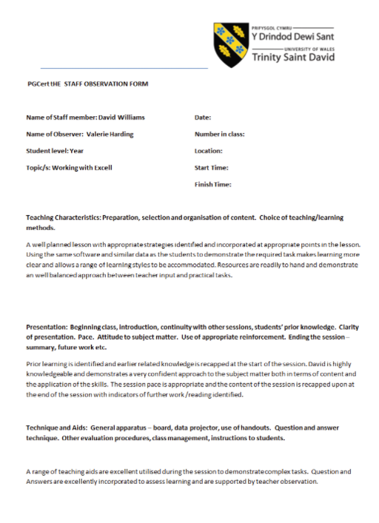

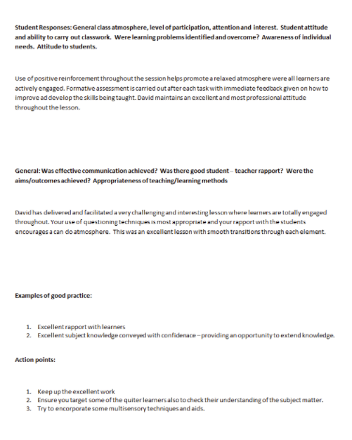
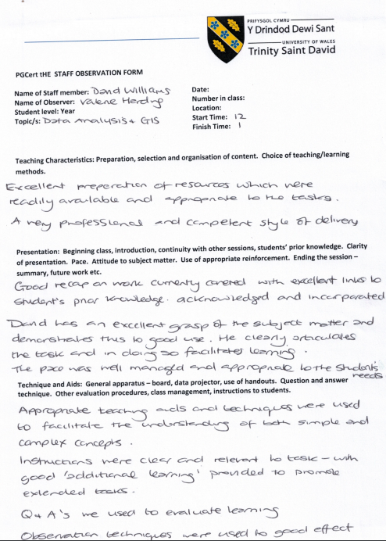
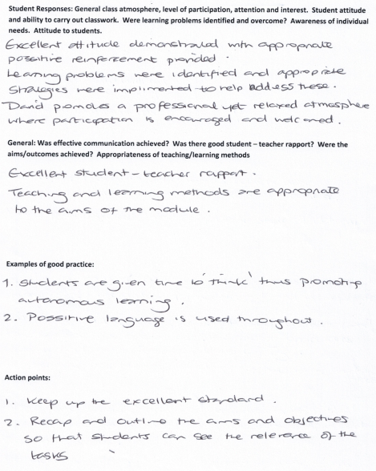

Appendix D: Student Services Paperwork










Appendix E: Evidence of Teaching Hours
Breakdown of Teaching Hours

November 2017
Date | Hours | Signed by
Specialist mentor (Autism) | 11 | Valerie Harding  Learning Support Co-ordinator (FACE - UWTSD)
Assistive Technology Tutor | 0
Specialist 1:1 Study Skills Support | 0
Total | 11

December 2017
Date | Hours | Signed by
Specialist mentor (Autism) | 7 | Valerie Harding  Learning Support Co-ordinator (FACE - UWTSD)
Assistive Technology Tutor | 0
Specialist 1:1 Study Skills Support | 0
Total | 7

January 2018
Date | Hours | Signed by
Specialist mentor (Autism) | 7 | Valerie Harding  Learning Support Co-ordinator (FACE - UWTSD)
Assistive Technology Tutor | 0
Specialist 1:1 Study Skills Support | 0
Total | 7

Breakdown of Teaching Hours
February 2018
Date | Hours | Signed by
Specialist mentor (Autism) | 3 | Valerie Harding  Learning Support Co-ordinator (FACE - UWTSD)
Assistive Technology Tutor | 3
Specialist 1:1 Study Skills Support | 0
Total | 6

March 2018
Date | Hours | Signed by
Specialist mentor (Autism) | 6 | Valerie Harding  Learning Support Co-ordinator (FACE - UWTSD)
Assistive Technology Tutor | 4
Specialist 1:1 Study Skills Support | 7
Total | 17

April 2018
Date | Hours | Signed by
Specialist mentor (Autism) | 14 | Valerie Harding  Learning Support Co-ordinator (FACE - UWTSD)
Assistive Technology Tutor | 1
Specialist 1:1 Study Skills Support | 6
Total | 21

Total hours 01/11/2017 to 30/04/2018 (inclusive)
Total | 69 | Signed by | Signature
Total | 69 | Valerie Harding  Learning Support Co-ordinator (FACE - UWTSD) | 

Breakdown of Teaching Hours 

Object orientated programming in Java Cohort 1
Date | Hours | Signed by
16/11/2016 | 6 | Helen Necrews  Managing Director Swansea ITeC 01792 464561
30/11/2016 | 6 | Helen Necrews  Managing Director Swansea ITeC 01792 464561
14/12/2016 | 6 | Helen Necrews  Managing Director Swansea ITeC 01792 464561
11/01/2017 | 6 | Helen Necrews  Managing Director Swansea ITeC 01792 464561
25/01/2017 | 6 | Helen Necrews  Managing Director Swansea ITeC 01792 464561
08/02/2017 | 6 | Helen Necrews  Managing Director Swansea ITeC 01792 464561
15/02/2017 | 6 | Helen Necrews  Managing Director Swansea ITeC 01792 464561
Total | 42 | Helen Necrews  Managing Director Swansea ITeC 01792 464561

Trainees C#
Date | Hours | Signed by
09/11/2016 | 6 | Helen Necrews  Managing Director Swansea ITeC 01792 464561
23/12/2016 | 6 | Helen Necrews  Managing Director Swansea ITeC 01792 464561
07/12/2016 | 6 | Helen Necrews  Managing Director Swansea ITeC 01792 464561
Total | 18 | Helen Necrews  Managing Director Swansea ITeC 01792 464561

Study skills
Date | Hours | Signed by
09/12/2016 | 6 | Helen Necrews  Managing Director Swansea ITeC 01792 464561
Total | 6 | Helen Necrews  Managing Director Swansea ITeC 01792 464561

REACT training (MS project 2 day event)
Date | Hours | Signed by
18/01/2017 | 6 | Helen Necrews  Managing Director Swansea ITeC 01792 464561
20/01/2017 | 6 | Helen Necrews  Managing Director Swansea ITeC 01792 464561
Total | 12 | Helen Necrews  Managing Director Swansea ITeC 01792 464561

Breakdown of Teaching Hours
Systems Development
Date | Hours | Signed by
17/03/2017 | 6 | Helen Necrews  Managing Director Swansea ITeC 01792 464561
31/03/2017 | 6 | Helen Necrews  Managing Director Swansea ITeC 01792 464561
21/04/2017 | 6 | Helen Necrews  Managing Director Swansea ITeC 01792 464561
28/04/2017 | 6 | Helen Necrews  Managing Director Swansea ITeC 01792 464561
26/05/2017 | 6 | Helen Necrews  Managing Director Swansea ITeC 01792 464561
Total | 30 | Helen Necrews  Managing Director Swansea ITeC 01792 464561

Object orientated programming in Java Cohort 2
Date | Hours | Signed by
15/03/2017 | 6 | Helen Necrews  Managing Director Swansea ITeC 01792 464561)
12/04/2017 | 6 | Helen Necrews  Managing Director Swansea ITeC 01792 464561)
16/04/2017 | 6 | Helen Necrews  Managing Director Swansea ITeC 01792 464561)
03/05/2017 | 6 | Helen Necrews  Managing Director Swansea ITeC 01792 464561)
24/05/2017 | 6 | Helen Necrews  Managing Director Swansea ITeC 01792 464561)
31/05/2017 | 6 | Helen Necrews  Managing Director Swansea ITeC 01792 464561)
07/06/2017 | 6 | Helen Necrews  Managing Director Swansea ITeC 01792 464561)
Total | 42 | Helen Necrews  Managing Director Swansea ITeC 01792 464561)

Summer School (c#)
Date | Hours | Signed by
24/07/2017 | 6 | Helen Necrews  Managing Director Swansea ITeC 01792 464561
07/08/2017 | 3 | Helen Necrews  Managing Director Swansea ITeC 01792 464561
Total | 9 | Helen Necrews  Managing Director Swansea ITeC 01792 464561

Commercial training (MS project 1-day event NHS)
Date | Hours | Signed by
14/07/2017 | 6 | Helen Necrews  Managing Director Swansea ITeC 01792 464561
Total | 6 | Helen Necrews  Managing Director Swansea ITeC 01792 464561

Breakdown of Teaching Hours
Commercial training (MS project 3-day event Power and Water)
Date | Hours | Signed by
18/07/2017 | 6 | Helen Necrews  Managing Director Swansea ITeC 01792 464561
25/07/2017 | 6 | Helen Necrews  Managing Director Swansea ITeC 01792 464561
01/08/2017 | 6 | Helen Necrews  Managing Director Swansea ITeC 01792 464561
Total | 18 | Helen Necrews  Managing Director Swansea ITeC 01792 464561

Creating software with SQL (structured querying language)
Date | Hours | Signed by
19/07/2017 | 6 | Helen Necrews  Managing Director Swansea ITeC 01792 464561
02/08/2017 | 6 | Helen Necrews  Managing Director Swansea ITeC 01792 464561
16/08/2017 | 6 | Helen Necrews  Managing Director Swansea ITeC 01792 464561
30/08/2017 | 6 | Helen Necrews  Managing Director Swansea ITeC 01792 464561
13/09/2017 | 6 | Helen Necrews  Managing Director Swansea ITeC 01792 464561
20/09/2017 | 6 | Helen Necrews  Managing Director Swansea ITeC 01792 464561
Total | 36 | Helen Necrews  Managing Director Swansea ITeC 01792 464561

React training Object orientated programming in Java
Date | Hours | Signed by
31/08/2017 | 6 | Helen Necrews  Managing Director Swansea ITeC 01792 464561
04/09/2017 | 6 | Helen Necrews  Managing Director Swansea ITeC 01792 464561
Total | 12 | Helen Necrews  Managing Director Swansea ITeC 01792 464561

React Training using SQL (structured querying language)
Date | Hours | Signed by
05/09/2017 | 6 | Helen Necrews  Managing Director Swansea ITeC 01792 464561
07/09/2017 | 6 | Helen Necrews  Managing Director Swansea ITeC 01792 464561
Total | 12 | Helen Necrews  Managing Director Swansea ITeC 01792 464561

Total hours 16/11/2016 to 20/09/2017 (inclusive)
Total | 243 | Signed by | Signature
Total | 243 | Helen Necrews  Managing Director Swansea ITeC 01792 464561 | 



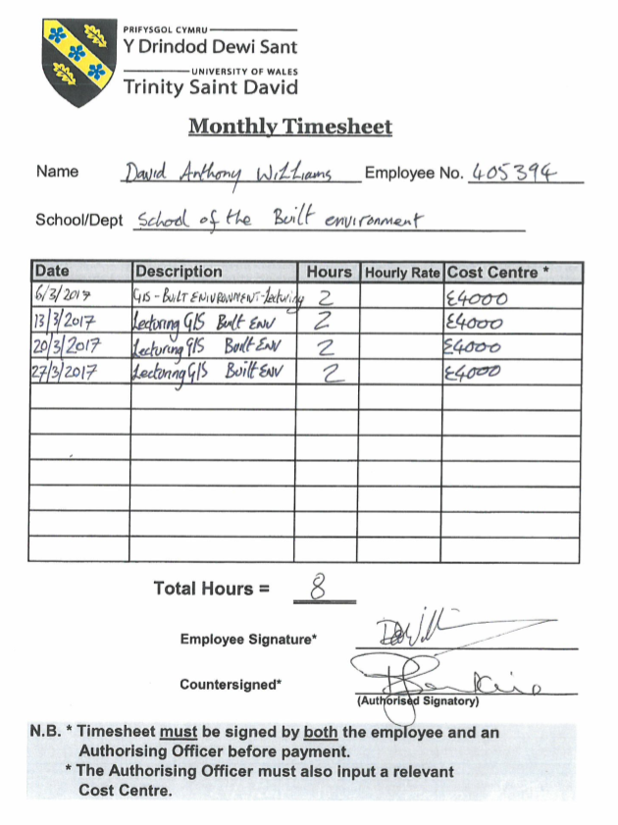





Appendix F: Examples of Lesson Plans

ITeC Apprenticeship Lesson plan C#

Topic: | 325 Creating an Object orientated program in c#
Learning Activity Reference: | Apprentices
Basic Skills Reference | 325 Creating an Object orientated program in c#
Links to cross cutting themes:  - ESDGC Links  - The Welsh Dimension  (Including key vocab from e.g. http://termau.org) | ● Choices and decisions.  ● Critical thinking  ● Belief that people can make a difference
Length: | 09:30-10:45 1:15 mins  10:45-11:00 15 min break  11:00-12:30 1:30 mins  12:30-13:15 Lunch  13:15-14:30 1:15 mins  14:30-14:45 15 min break  14:45-16:00 1:15 mins
Objectives: | Day 1 of C# taught element – by the end of the day the learners should be capable of understanding the following  - Software development concepts within a team  - The visual studio Integrated Development Environment  - Basic design using pen and paper and software alternatives   - Basic programming concepts  - Creating basic computer programs using Variables, operators and decisions

Time  Mins | Tutor Activity | Learner Activity | Extension activity | Resources
1:15  09:30-10:45 | Presentation and discussion relating to stages of software development and best practices (development models, consistent styles anming conventions and comments in code ). | Listen and interact | Team working, respecting the ideas of others  | Slides, Discussion, Q&A
15  10:45-11:00 | Break | Break | Break | Break
1:30  11:00-12:30 | Introduction to basic Design concepts and software  Introduction to Visual Studio | Listen and interact  Group work activity completing Flowcharts  Explore the Visual studios IDE (while tutor draws attention to the key operations) | Team working, respecting the ideas of others  Discuss the advantages of using software fort design rather than traditional methods in terms of remote collaboration , Flexibility and sustainability | Slides, Discussion, Q&A, Visual Studio 2013(software), Draw.io (software)
45 | 12:30 – 13:15 Lunch | 12:30 – 13:15 Lunch | 12:30 – 13:15 Lunch | 12:30 – 13:15 Lunch

1:15  13:15-14:30 | Introduction to Variables and operators in c# | Listen and interact  Completion of Coding examples and independent tasks | Examples and tasks will relate to various mathematical problems such as creation of programs to calculate areas of shapes | Slides, hand-outs, Discussion, Q&A, Visual Studio 2013(software), Draw.io (software)
15  14:30-14:45 | Break | Break | Break | Break
1:15  14:45-16:00 | Introduction to Decisions and loops in c# | Listen and interact  Completion of Coding examples and independent tasks | Examples and tasks will relate to various mathematical problems such as creation of programs to calculate a user defined number of monetary operations based on user selection | Slides, hand-outs, Discussion, Q&A, Visual Studio 2013(software), Draw.io (software)
By next session | INDEPENDENT ACTIVITY – completion of tasks | Completion of Coding examples and independent tasks | Practice what has been covered today, promoting self-advocacy | Slides, hand-outs, Visual Studio 2013(software), Draw.io (software)

Built Environment lesson plan (observation 2)

Topic: | data analysis with Excel for students of a non-computing background
Links to cross cutting themes:  ESDGC Links  The Welsh Dimension  (Including key vocab from e.g. http://termau.org) | ● Choices and decisions.  ● Critical thinking  - The natural environment
Length: | 12:00-12:15 15 mins  12:15-13:00 45 min  13:00-13:15 15 min  13:15-13:45 30 min  13:45-14:00 15 min
Objectives: | - acquire census data sets from Casweb and infuse [= and conduct some statistical operations on it to create a Townsend index (this is a measure of depredation for a given area)  - The secondary objective being that the students create several visualisations of the data (e.g. graphs and charts) using the inbuilt operations within excel

Time  Mins | Tutor Activity | Learner Activity | Extension activity | Resources
12:00-12:15 15 mins | Presentation and discussion relating to Census Data and acquisition | Listen and interact | - Critical thinking | Slides, Discussion, Q&A
12:15-13:00 45 min | Practical demonstration of data acquisition from census sources | Time allowed for the students to replicate the process for their required data for their chosen region. During this time the lecturer toured the class observing student participation offering help as necessary to ensure learner understanding | - Critical thinking | Internet  Casweb  Infuse  excel
13:00-13:15 15 min | Presentation and discussion relating to Census Data manipulation in excel | Listen and interact | - numeracy | Data sets  Excel
13:15-13:45 30 min | Practical demonstration of data acquisition from census sources | Time allowed for the students to replicate the process for their required data for their chosen region. During this time the lecturer toured the class observing student participation offering help as necessary to ensure learner understanding | - numeracy   | Data sets  excel
13:00-13:15 15 min | Recap on session key point | for homework the cohort was instructed to obtain additional datasets at different levels and repeat the process. | - Critical thinking  - Autonomous learning | Assignment brief

Built Environment lesson plan (observation 3)

Topic: | data analysis with Gis
Links to cross cutting themes:  ESDGC Links  The Welsh Dimension  (Including key vocab from e.g. http://termau.org) | ● Choices and decisions.  ● Critical thinking  - The natural environment  - Wealth and poverty
Length: | 12:00-12:15 15 mins  12:15-13:00 45 min  13:00-13:15 15 min  13:15-13:45 30 min  13:45-14:00 15 min
Objectives: | - continue working with the acquired data from Casweb and infuse [10] from the previous session in order to present the data in a geo-visualised form using MapInfo

Time  Mins | Tutor Activity | Learner Activity | Extension activity | Resources
12:00-12:15 15 mins | Recap on last week’s session | Demonstration of the datasets collected and manipulated by the students since last weeks session | - Critical thinking | observation Discussion, Q&A  Datasets
12:15-13:00 45 min | Presentation on MapInfo basics including types of map and layered mapping  Practical demonstration of importing data into mapInfo | Time allowed for the students to replicate the process for their required data for their chosen level of granularity.  During this time the lecturer toured the class observing student participation offering help as necessary to ensure learner understanding | - Critical thinking | Internet  excel  MapInfo  Access to UK Borders  Mapping resources  Data Sets
13:00-13:15 15 min | Presentation and discussion relating to Thematic Mappin in MapInfo | Listen and interact | Critical Thinking | Slides  Q&A
13:15-13:45 30 min | Practical demonstration of Creation of differing types of thematic maps included ranges, graded and graphs\charts | Time allowed for the students to replicate the process for their required data for their chosen region level of granularity.  During this time the lecturer toured the class observing student participation offering help as necessary to ensure learner understanding | - numeracy | Data sets  Excel  MapInfo  Access to UK Borders  Mapping resources  Data Sets
13:00-13:15 15 min | Recap on session key point | for homework the cohort was instructed to repeat the techniques used today to create various types of thematic maps for various elements of each of the datasets collected as homework last week | - Critical thinking  - Autonomous learning | Assignment brief  MapInfo  Access to UK Borders  Mapping resources  Data Sets

Assistive Technologies Sonnocent
Topic: |  | Introduction to Sonnocent
Links to cross cutting themes:  ESDGC Links  The Welsh Dimension  (Including key vocab from e.g. http://termau.org) |  | ● Choices and decisions.  ● Critical thinking
Length: |  | 09:00-09:15 15 mins  09:15-09:45 30 min  09:45-10:00 15 min
Objectives: |  | - Assistive technology session introducing sonnocent audio note take to the student, by the end of this session the student should have a working knowledge of the sonnocent software and be in a possition to experiment with deployment and usage that best fits their needs
Time  Mins | Tutor Activity | Learner Activity | Extension activity | Resources
09:00-09:15 15 mins | Present a general overview of the interface and abilities of Sonnocent audio note taker to the student | Listen and interact | - Critical thinking   | Slides  Sonnocent
09:15-09:45 30 min | Demonstrate –  Recording,  Importing/export  Playback  Taking notes  Sowing sections  Showing importance | Teacher will demonstrate the features of sonnocent with some pre made materials for importing and manipulation, during this time the student is encouraged to try the techniques for themselves | - Critical thinking | sonnocent  Sample presentation  Sample sound file  Sample images
09:45-10:00 15 min | Give overview and demonstrate how to use the mobile application and how this can interact with the desktop version | Listen and interact | - numeracy | Sonnocent Mobile App  Sonnocent PC App
Extended task | Autonomous activity | Practise with using the various usages of sonnocent on forthcoming lessons to find the best use for the individual ready for discussion next session | - critical thinking | Learner must have –  Own computer with sonnocent installed and activated  Optional-  Mobile device with sonnocent app  Sound recording device

Lesson Plan Key
ESDG links from the following should identified wherever possible.
7 Key Themes  - Identity and culture  - The natural environment  - Wealth and poverty  - Health  - Climate change  - Consumption and waste  - Choices and decisions. | Skills  - Critical thinking  - Ability to argue effectively  - Ability to challenge injustice and inequalities  - Respect for people and things  - Co-operation and conflict  - Resolution | Values and attitudes  - Sense of identity and self esteem  - Empathy  - Commitment to social justice and equity  - Value and respect for diversity  - Concern for the environment and commitment to sustainable development  - Belief that people can make a difference
The following logos should be used to identify cross cutting themes
 | Global citizenship
 | Health and Well being
 | Numeracy
 | Literacy
 | Sustainability
 | Welsh
 | Equality & Diversity

Concepts
- Interdependence
understanding how people, the environment and the economy are inextricably linked at all levels from local to global
- Citizenship and stewardship
recognising the importance of taking individual responsibility and action to make the world a better place
- Needs and rights
understanding our own basic needs and about human rights and the implications for the needs of future generations of actions taken today
- Diversity
understanding, respecting and valuing both human diversity – cultural, social and economic – and biodiversity
- Sustainable change
understanding that resources are finite and that this has implications for people’s lifestyles and for commerce and industry
- Quality of life
acknowledging that global equity and justice are essential elements of sustainability and that basic needs must be met universally
- Uncertainty and precaution
acknowledging that there are a range of possible approaches to sustainability and global citizenship and that situations are constantly changing, indicating a need for flexibility and lifelong learning
- Values and perceptions
developing a critical evaluation of images of and information about the less and more economically developed parts of the world and an appreciation of the effect these have on people’s attitudes and values
- Conflict resolution
understanding how conflicts are a barrier to development and a risk to us all and why there is a need for their resolution and the promotion of harmony.

Promoting Welsh Culture Bilingualism links from the following should identified wherever possible
- Encouraging the use of Welsh language
- Promoting opportunities to acquire and develop Welsh language skills
- Contributing to the learners’ knowledge and understanding of the cultural, economic, environmental, historical and linguistic characteristics of Wales

