Name: Hussain Ahmed
Student ID: 1815238
Module: Professional Career Development
Module Code: BMSW 4005
Lecturer’s Name: Janet Green
Assignment Title: Reflective Portfolio

Executive Summery
This assignment relates to “Professional Career Development”, which demonstrates the knowledge and capabilities I would have as a potential employee. The reflective report will be divided into three sections, in the first part it will be explained how the self-awareness tool is used and its importance to my future employment. The second part is based on the “Mock Interview” experience and feedback received and the third part will consist of a “Career Development Plan” with SMART objectives, strategies, and detailed actions with explanation.

Table of Content

Introductions……………………………………………………………………………………page 3
Self-Awareness………………………………………………………………………………page 4-6
Mock Interview…………………………………………………………………….…………page 7-8
Career Development………………………………………………………….…………..page 8 -11
Conclusions…………………………………………………………….…………….……….page 12
References……………………………………………………….……………………………page 13

Introduction
I am a student at University of Wales Trinity Saint David, currently studying the “Certificate in Higher Education Skills for the Workplace (level 4)” qualification. I am also in full-time employment or self-employed as a “Private Hire Driver”, which I have been since 2010 after leaving the catering industry, where most of my experience treasures. At a very young age I started working part-time, a week-end job as a pot washer in the kitchen, at this restaurant and worked my way up to be my own “Boss” of a small Indian Take Away business in a few years. Since then I owned and managed another Indian Take Away business and finally a 106 seater “Fully Licenced Indian Restaurant”. After being in the trade for nearly sixteen years, in 2010 I decided to do something different as a profession. Nevertheless, I was missing out on the family time together, where our children were growing far too quick and not having any time for socialising too.

Self-Awareness
I have always been aware of my abilities as I know what I am capable of doing and what I am not capable of doing, while I am in a work environment or in my personal life. However, I have used the Johari window tool so it can help me discover a little bit more about myself and my personality from my peers which I may not be aware of “It can show me whether I need more training or experience. It can reveal what skills I have that makes me a strong candidate for a specific job” (Alison Doyle, 2020). This tool has given me more understanding on my strengths, weaknesses, values and interests all this can reveal what skills I have to make me a strong candidate for my job.

The Johari Window
The Johari Window tool (Figure 1) is a technique which was created by the psychologist Joseph Luft (1916-2014) and by using this tool it has helped me to understand myself better as a person from that I had a broader field of my personality (Health, 2020). After putting this personal information together, I have analysed and realised with all my abilities and previous experiences as an individual, that I can go further as my options are wide open.
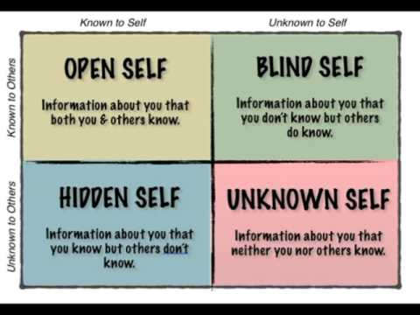
Figure 1 - Johari's Window

(2020)

In the table below I have completed the Johari’s Window grid and found out the different aspects about myself. These are split into 4 categories, Arena, Blindspot, Façade and Unknown
 | Known to self | Unknown to self
Known to others | Arena  I am a very hard working and helpful person.  Very easy to communicate with without any I barrier.  I feel confident when having a conversation. | Blindspot  I am a very good team worker.  I have excellent communication skills.  Respective manors.  Sometime I can be over confident.
Unknown to others | Façade  I am very trustworthy.  I can be in a mood for a little while if things aren’t going to my plan, but that don’t affect any performance of my work.  I like challenges but don’t show others. | Unknown  The hidden talents I may treasure and what I may be capable of doing.

Kolb’s Experiential Learning Theory
Kolb’s theory of learning basically says that learning comes from experience. This makes sense as we are taught to walk, to write and ride a bike only by practicing. Therefore, it makes perfect sense that all learning is through experience so knowledge is made by evolving through each of the experiences we go through, but this only results by understanding the meaning of he experiences and how to transform these experiences into other forms (SimplyPsychology, 2020).
In reference to Figure 2, the cycle begins by having the first experience i.e. taking an exam which is then sent to be marked. The second stage of this cycle is the reflection on how well I have done in that exam, perhaps by discussing with other individual students, looking back at my revision/class notes and contrasting these with what I had written in the exam. I would be evaluating on how well I had done. Once the marks for the exam are released, I continue to reflect and think on how I could improve the next time I experience the event i.e. the exam. However, in order to improve on this examination skill, I must continue to reflect by understanding where I went wrong and how to improve this. Perhaps by asking my assessor for written feedback so I can learn from my mistakes. I would then enter the third stage of Theorising. This is an analytical step which considers why the failure happened and what can be done to better it. The final stage is to plan what I would be doing differently the next time until I sit another exam and experience this again. The cycle repeats in a series, practicing occurs and with time and effort in understanding each previous experience, I would perform better in the upcoming exams.
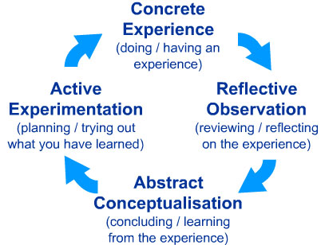

Figure 2 - Kolb's Experiential Learning Theory

Mock Interview
It was 20th February 2020 and I was required to find a job advertised and apply for this position by attending a “Mock Interview”. Here, I have decided to apply for an “Assistant Managers’ post at the “Ego Restaurant”. This Mediterranean Pub and Restaurant is located in Cannock which is about 25 miles from my residence.
At the interview I thought I was dressed quite smart as I’ve applied for a Managerial position. The first impression, I always thought makes a massive judgement on the characteristics of a person, hence I was punctual, greeted the interviewers quite well and spoke very clearly. The interviewers asked me several different questions and one of the questions was “Why did you choose to apply for this particular job?” My answer was “I always had a passion for food and most of my working life was in the food or catering industry where I have owned and managed different takeaway businesses and restaurants. Therefore, I think I will be the right candidate to fill in this position”. The next question was to “How can you convince us or offer the company anything out of the ordinary, so we can employ you?” This one was quite a nice question which I was happy to answer, because I do have a lot to offer, firstly many years of experience in catering trade, where I am multi-talented, as well as a manager I am also a Chef which means if you were to introduce me to a selected range of Indian Signature dishes in your menu that may attract more clients to come in and experience the fusion style of cooking under one roof.
As I was told if I wanted to ask any further questions towards the end of the interview, that’s when I found out that there were no staff accommodation facility available, which means I will need to be commuting at all time and this will need to be considered as there will be an extra fuel expense. There will be opportunities to progress perhaps to become a General Manager in future. Also, I’ve realised it could be another fantastic opportunity for me take on this job and learn different types of cuisine of food, which was my dream to open up a fusion restaurant. However, at least for now I can manage one and maybe later think of opening one with my own brand (What to Expect During a Job Interview, 2020).
After the interview the feedback I received were pretty positive, that I was well dressed as I greeted all panel members. I had a good and confident approach to the interview and had provided related and relevant examples to topics which cropped up during the conversations. I had maintained good eye contact with the interviewers and also presented my background information in a professional manner. During the interview I had a conversation about going back into the food and catering trade in the near future, to which I will need to find a suitable location and the right kind of staffs who would be trustworthy and will motivate together to make the business work, and here I managed to turn this challenging situation in to my advantage.

Career Development
SMART
Specific: I will be focusing on completing my education in the ‘Leaderships and Management’ Level 5 & 6 course in order to complete my degree. Measurable: As I will be attending the University for my further study. I believe I will be assessed every so often by the moderator where I will be able to find out roughly how well I am progressing or if I need to improve in any areas. Achievable: It is always wise to have a goal in life, without it or a target where you want to be or what you want to do in order to achieve realistic goal. To achieve this degree, it is achievable as I will be completing all my assessments to the best I can. (Here Are Some Business Goals That Follow the SMART Criteria, 2020). Realistic: Relates to measuring a target goal which can be achieved at a certain time scale. For example - my further study will take another two years to complete and from the third year I can plan a relating career profession if I wish. Time-Based: It can be set to a time band as and when my degree will be completed, also any future plans can be specified with time scale (The Business Student’s Guide to Study and Employability | Online Resources, 2020).
My future objectives will be to complete my education to a degree level in the ‘Managerial and Leadership’ field. By studying further, it will be a great opportunity for me to explore the up to date trends and the needs in the existing and upcoming market.
The different types of skills including Presentation skills, Communication skills, Socialising skills, Leadership skills, Management skills, Analytical skills, Time Management skills, Digital skills and Career Developing skills, that we have learnt which we can adapt and use in the work environment as well as during our everyday life and this can be very essential. The Analytical skills was one of the skills I thought could be a very important tool in decision making as there are many different analytical tools like the CDP and SWOT.
When dealing with a competitive environment any kind of drawback that delays from executing orders or carrying on toward its mission (Kinichi & Williams,2009 p.180). This also applies when dealing with individuals if something or someone gets held back from being competitive with others can be a weakness (Personal SWOT Analysis – Oneself / Myself, 2020).

Career Development Process (CDP)
The rationale behind following this Career Development Process (CDP) is to demonstrate the readiness to forward my career change or advance my career. This process was done to find out what I am capable of? as for studying will it be future job related? Have I got my options open? When will I be ready to take action? These are some of the things needs to be taken in consideration when planning ahead.
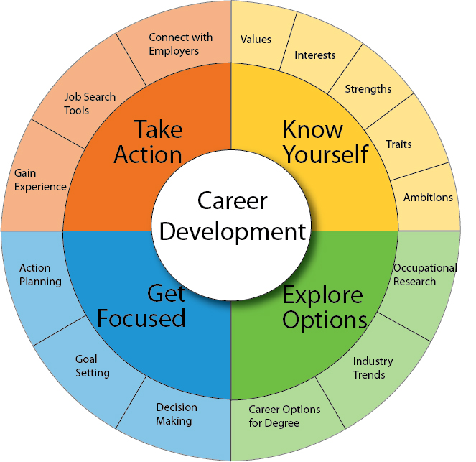
(Career Development Process | Career Center | USC, 2020)
CAREER DEVELOPMENT PROCESS (CDP)
Discover Yourself >>> See what I am capable of
Explore Options >>> Have more than one option
Make Choices >>> Prioritise my options 1,2,3 & set goals
Take Action >>> Try options starting from 1

SWOT ANALYSIS
Strengths
My strengths as an individual are that I have excellent communication skills dealing with people and serving customers at a workplace, which is very enjoyable. I hold a personal Liqueur Licence which allows me to supervise or sell alcohol as long as this occurs in my presence. I hold a full UK Driving Licence with no convictions or points and this Licence allows me to drive many other vehicles like the “Luton Van or a Mini-Bus (12-seater)”. Whereas, the recently passed drivers are not permitted to drive these vehicles in the first two years of passing their driving test, under the new Highway Law. I have been holding a “Private Hire Licence or a Badge” and currently working in this sector. As I was running my own Indian Take Away businesses and a Licenced Indian Restaurant over sixteen years where I gained Managerial and Leadership experiences. I have worked as a shop front manager. Also, I am a very creative Indian Chef so have knowledge to train others. One of the other strengths is that I am bilingual which is always something quite useful with employees and customer coming over from abroad, I am able to converse with them and ensure excellent customer service is provided.
Weaknesses
One of the weaknesses which I now experience is managing time. This is because I am working full time and attending university two days a week with a lot of work to do at home. Researching the unknown is often a difficult process so takes me a lot longer to read through and decide which information is appropriate and needed. Moreover, I need to practice to plan ahead if I was to do something or go anywhere. This will mean that I am keeping up to date with competitors and prioritising the most important tasks.
Opportunities
With my Managerial and Leadership skills I can advance my experience and gain an academic qualification, where I can learn or explore the use of the “Digital skills” to keep up with the trends. Another opportunity is to get to use social media more for communicating and advertising much more often which can be a boost to my business and this will also enhance future job prospectives by getting my name and company out there in the wider public.
Threats
As I have a passion for “Food” I like creating my own recipes and try different dishes. There is always a lot of competition in the market, therefore by just assuming the best and being the best could be a threat. Hence why there must be a continuous evolving environment within the company. Moreover, keeping up with trends, especially with the Digital Technology can be a threat as it can be very difficult to stay on top of as it is changing rapidly in the moving world.
Another threat is that the merging of my social life and business affairs can create issues therefore it is best to keep both personal and business separate to prevent any hassle or problems from occurring.

Conclusions
In conclusion, studying this course further to complete Leadership and Management level 5 and 6 to achieve this degree will be another key achievement to put together with many years of my previous Managerial experience.
An advantage is that I have surely learnt one thing by attending the Mock interview was to only ask or talk about things which are more relevant. For example, when I mentioned I will be looking forward to join their company for employment; at the same time, I was discussing how I am planning to go back into the Catering Trade in the near future. This had contradicted as they were expecting to employ a long-term manager. However, I did make them think that I will not be there for long term, as I was asking when or if there were any opportunities there for me to progress further and develop my role within the company.

References
Careers.usc.edu. 2020. Career Development Process | Career Center | USC. [online] Available at: https://careers.usc.edu/family/career-development-process/ [Accessed 27 March 2020].
Health, M., 2020. The Johari Window: A Communication Tool To Improve Relationships. [online] YouMeMindBody. Available at: https://youmemindbody.com/mental-health/Johari-Window [Accessed 27 March 2020].
I.ytimg.com. 2020. [online] Available at: https://i.ytimg.com/vi/MJiw6HMKIwg/0.jpg [Accessed 27 March 2020].
Simplypsychology.org. 2020. [online] Available at: https://www.simplypsychology.org/learning-kolb.jpg [Accessed 26 March 2020].
Study.sagepub.com. 2020. The Business Student’S Guide To Study And Employability | Online Resources. [online] Available at: https://study.sagepub.com/morgan [Accessed 27 March 2020].
The Balance Careers. 2020. What To Expect During A Job Interview. [online] Available at: https://www.thebalancecareers.com/what-to-expect-during-a-job-interview-2063897 [Accessed 27 March 2020].
The Balance Careers. 2020. Alison Doyle. [online] Available at: https://www.thebalancecareers.com/alison-doyle-2058389 [Accessed 27 March 2020].
The Balance Small Business. 2020. Here Are Some Business Goals That Follow The SMART Criteria. [online] Available at: https://www.thebalancesmb.com/smart-goal-examples-2951827 [Accessed 27 March 2020].
UKEssays.com. 2020. Personal SWOT Analysis – Oneself / Myself. [online] Available at: https://www.ukessays.com/essays/business-strategy/personal-swot-analysis.php [Accessed 26 March 2020].

