Digital Skills for Personal Development and Business Growth (BMSW4008_CARD)

UWTSD
Jaroslav Demeter (2240603)
2024

Contents
Introduction 2
About Me 3
Storytelling 4
Questionnaire Analysis 6
Website & Marketing Materials 9
Website 11
11
12
12
Logo 14
Business Card 14
Flyer 15
References 16

Introduction

This academic e-portfolio is a comprehensive report that covers various aspects of business marketing. It starts with my LinkedIn "About Me" section, highlighting my professional expertise, insights, and accomplishments as a seasoned Cleaning Supervisor at Mitie Cleaning, where I have dedicated over a decade of service. This portfolio is a testament to my steadfast commitment to excellence, continuous learning, and passion for personal and professional growth.
Through a thorough exploration of the power of storytelling, data analysis, and brand development, this portfolio provides valuable insights drawn from practical examples, theoretical frameworks, and empirical data. It highlights the transformative impact of effective storytelling and data-driven decision-making, which can elevate brand identity, enhance customer loyalty, and improve marketing materials.
The portfolio includes a questionnaire analysis section that reflects the insights provided by this marketing tool and its applications in providing directions to our business.
Finally, it concludes with the design of a website and marketing material based on the responses to our business research questionnaire.

About Me

My name is Jaroslav Demeter and I have been serving as a Cleaning Supervisor at Mitie Cleaning for over ten years. I take immense pride in my work and am deeply committed to personal and professional growth. Over the years, I have established a reputation for reliability, leadership, and an unwavering pursuit of excellence. Originally from Slovakia, I am now proud to call Bristol my home and have always embraced the diversity of cultures and perspectives. My transition to the United Kingdom has not only broadened my horizons but also instilled in me a profound appreciation for the rich tapestry of human experiences.
Driven by an insatiable thirst for knowledge and growth, I am currently enrolled in a Level 4 course on Employability Skills at University Trinity St. Davies. I passionately believe that staying up to date with industry trends and best practices is essential to providing the highest quality service as a Cleaning Supervisor. As a Cleaning Supervisor, I understand that effective time management is the cornerstone of success. I have developed a meticulous and efficient approach to my work, ensuring that every task is completed with precision and within the designated time. I am responsible for coordinating cleaning schedules and overseeing inventory management, ensuring that operations run seamlessly day in and day out.
It is often said that mindfulness is the hallmark of excellence, and this is particularly true in the realm of professional cleaning. With an unwavering focus on precision, I leave no stone unturned in my pursuit of perfection. Whether conducting inspections to ensure that workspaces meet cleanliness standards or identifying opportunities for improvement, I always aim to deliver nothing short of excellence.
As a supervisor, my responsibilities go beyond mere oversight. I am committed to inspiring and empowering my team members to achieve their full potential. I believe in leading by example and fostering a culture of collaboration, and mutual respect within my team. Whether it is conducting interviews to select new talent, covering managerial duties in my manager's absence, or providing mentorship and guidance to my colleagues, I approach each interaction with empathy, integrity, and a genuine desire to support the success of all team members.
In addition to my work, I am deeply enthusiastic about personal development and holistic well-being. My pursuits include exploring the transformative power of meditation and delving into the realms of psychology and self-discovery. My drive for growth and self-improvement is insatiable, as I am constantly seeking new avenues to unlock my potential. To recharge and rejuvenate both my mind and soul, I find solace in music and travel.
I am enthusiastic about connecting with other professionals who share my ardour for excellence, personal growth, and making a positive impact in the world. Whether you are searching for a seasoned supervisor to elevate your team or simply looking to exchange insights and experiences, I am eager to engage in meaningful conversations and explore opportunities for collaboration and constructive collaboration.

Storytelling

According to the Oxford College of Marketing (2023), Brand storytelling is a highly effective strategy that can help businesses increase their audience by creating an emotional connection with them. It involves telling the story of the brand, encompassing its values, mission, and purpose, and how it serves the customers. By doing so, businesses can capture the attention of their target audience and strengthen their connection with them, while promoting greater engagement with the brand.
Brand storytelling can be conducted through various digital mediums, including social media posts, images, and videos. When executed successfully, it can establish a better relationship between the business and its audience, as the audience learns more about the brand.
Therefore, businesses need to develop a successful brand storytelling strategy to establish a better relationship with their audience, increase brand awareness, and promote engagement with the brand (Oxford College of Marketing, 2023).

To devise a captivating brand story, several key components must be considered to ensure that it is compelling, memorable, and impactful. The fundamental characteristics that should be pursued are authenticity, emotional resonance, relatability, consistency, and the inclusion of compelling characters. It is imperative to comprehend that the narrative associated with your brand is not an isolated domain restricted solely to the authority of the marketing team. The art of brand storytelling exerts a substantial impact on all facets of your business, functioning as a foundational element that undergirds the perception of your company, the way customers interact with your entity, and the operational dynamics of your enterprise (Play Play, 2023).

The importance of a brand story cannot be overstated in terms of connecting with customers. Customer care is more than just providing support and answering questions; it involves building an emotional connection with customers and fostering loyalty. Through brand storytelling, businesses can highlight these empathetic customer touchpoints and promote their brand values. Storytelling is a fundamental component of social media marketing and a crucial aspect of any social media strategy. Every post on platforms such as Instagram, TikTok, or YouTube Shorts contributes to the overall brand narrative. For instance, a behind-the-scenes look at how a brand sources its material on social media becomes part of the brand story (Sprout Social, 2024).

Brand storytelling is about creating engaging narratives that connect with an audience's values. Warby Parker is an excellent example of this, having revolutionized the eyeglass industry with affordable, sustainable, and convenient eyewear. By crafting a brand story around the founder's personal experience and implementing a 'Buy a Pair, Give a Pair' program, Warby Parker established its brand identity on a meaningful foundation. The company also uses social media platforms like Instagram and YouTube to stay connected with customers and keep up with pop culture trends (Acquia, 2024)
Storytelling marketing is a method of communication that utilizes a narrative to convey a message, and it can be effective for businesses of all sizes. Its primary purpose is to elicit an emotional response from the viewer, which in turn motivates them to act and increases their loyalty to the brand. The use of storytelling in marketing can help consumers understand the relevance of a product or message and can also serve to humanise a brand (Attest, 2021)

Jerome Bruner, a psychologist, discovered that people remember details better when stories convey messages rather than just facts and numbers. Brand loyalty is more likely to come from customers who share your values, as emotional connections are significant drivers of brand loyalty and are the best indicators of future customer value, according to a study in the Harvard Business Review. Furthermore, brand storytelling can enhance your SEO strategies by making it easier for your content to be noticed and ranked well by search engines (Semrush Blog, 2023)

Storytelling is a powerful tool that can help individuals express their life journey, experiences, challenges, and aspirations. A one-hour recording of someone's life can provide valuable insights into their personality, background, and aspirations, and help professionals understand who the people they support are, who they were, and who they want to be. Therefore, the use of storytelling in care planning and delivery should receive more attention from researchers, practitioners, and policymakers (Mencap, 2023)

’’ Good stories surprise us. They make us think and feel. They stick in our minds and help us remember ideas and concepts in a way that a PowerPoint crammed with bar graphs never can’’.
(Shane Snow, 2018)

Questionnaire Analysis

Cint (2022) defines a questionnaire as a type of research tool that involves presenting a set of questions to individuals to gather valuable information. The respondents are asked to provide their answers to the questions posed in the survey.
According to Williams (2024) a questionnaire that is considered good should be free from bias, concise and easy to comprehend. The crucial factor that determines the effectiveness of a questionnaire is the clarity of the questions.
Questionnaires usually consist of open-ended questions, closed-ended questions, or a blend of both. This approach enables researchers to obtain both qualitative and quantitative data based on their requirements (Cleave, 2023).
Questionnaires used in surveys have the potential to offer dependable, precise, and significant first-party information that is customized to your business's specific goals. This data can be utilized to identify the requirements and inclinations of customers, assess marketing initiatives, keep track of industry trends, and experiment with new products and services, (Chan, 2023).
Indeed (2023) believes that engaging in market research is an effective method to enhance customer satisfaction and promote business growth. The use of market research queries can assist in comprehending the requirements of a business's clients and provide essential knowledge to direct a marketing plan.
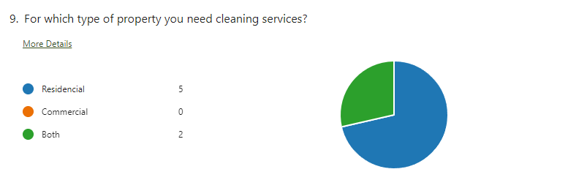

The purpose of this question was to determine the type of property for which cleaning services are needed. The responses indicate that there is a strong preference for residential properties, with five out of seven respondents (71.4%) selecting this option. No respondents expressed a need for cleaning services exclusively for commercial properties, which suggests that there is a lack of demand in this sector among the participants. Two respondents (28.6%) require cleaning services for both residential and commercial properties, which could imply a niche market or a potential area for growth if the trend is observed in a larger sample size. Overall, the data points towards a cleaning service market focused on residential properties within this group.

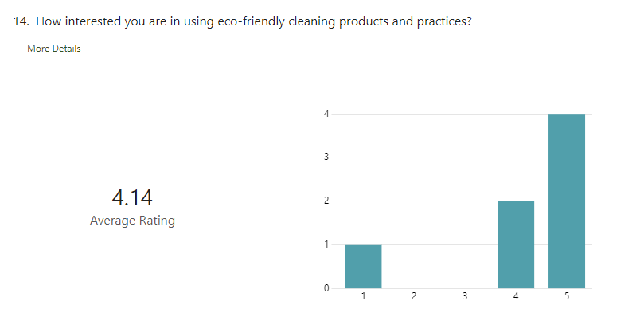

Based on the data gathered, the participants have a positive attitude towards eco-friendly cleaning products and practices. A total of four respondents (57.1%) gave the highest rating of five on a scale of 1 to 5, indicating a strong interest in environmentally conscious options. The second-highest score of 4 was chosen by two respondents (28.6%), which further supports the trend of eco-friendliness. Notably, the mid-range option of three received no votes, indicating that participants tend to have a more definite opinion rather than being neutral on the matter. Only one respondent (14.3%) selected the lowest interest level of one, suggesting minimal resistance to the concept. Overall, these results suggest that the market is open to eco-friendly cleaning solutions, with a majority expressing a high level of interest.

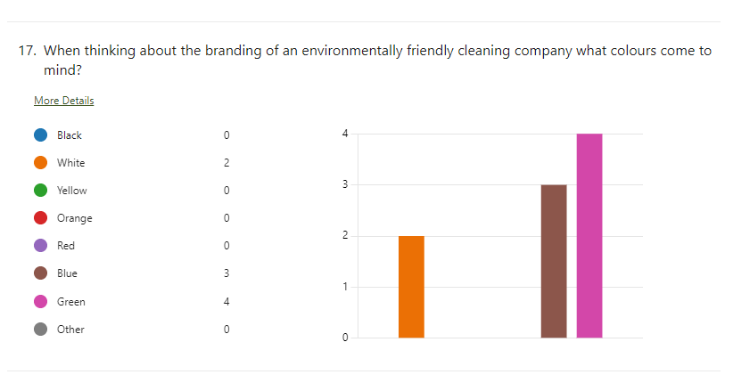

According to the survey results, people prefer colours that are associated with nature and cleanliness. The colour green was the most popular choice with four votes (57.1%). This is because green is often associated with eco-friendliness and sustainability. Blue came in second with three votes (42.9%), due to its connection with purity and water which are essential elements in cleaning. The colour white received two votes (28.6%), possibly because it symbolizes simplicity and hygiene. None of the other colours, such as black, yellow, orange, or red, received any votes, indicating that they are not top-of-mind for consumers when thinking about eco-friendly cleaning brands. This data could help the company create a brand image that aligns with environmental values.

Website & Marketing Materials

According to Forbes, a business's online presence is crucial to its success, regardless of the industry. In today's digital age, customers often visit a business's website before making a purchase. A visually appealing website that provides high-quality information is an opportunity for businesses to enhance their credibility, differentiate themselves from competitors, and instil confidence in potential customers. The absence of a website may raise doubts about a business's legitimacy, leading potential customers to be sceptical (Forbes, 2020).

The concept of the Zero Moment of Truth (ZMOT) introduced by Google in 2011 underscores the importance of a website as a crucial tool for businesses to interact with consumers and establish their brand's credibility. According to this concept, a website can help businesses not only generate revenue but also announce new product or service launches, host sales, share relevant content, and address customer queries. By utilizing feedback and contact forms, businesses can manage leads, and inquiries, and generate sales (Seattle New Media, 2023).

Creating marketing materials such as promotional videos and having an SSL-encrypted website, custom email addresses, secure payment methods, and privacy rules are crucial for enhancing your online presence and ensuring the safety of your client's information. Transparency is key to building trust with potential customers by being open about your business processes, ( Dorik, 2023).

Effective marketing material is crucial for business success. Consistent branding creates a lasting impression. Use business cards and branded folders for P2P marketing. Prioritizing design increases chances of achieving marketing goals, (TLC, 2024).

Marketing materials serve as a platform to highlight your brand's unique identity and colour scheme, aiming for instant recognition among customers. Consistency in brand voice is crucial across all materials. Combining informative text with visuals enhances message effectiveness. Seamless navigation to product pages increases sales, facilitated by well-designed websites and printed materials with clear contact information (Noun Project, 2024)

Market research is essential for businesses to understand customers and shape effective marketing strategies, (Cint, 2022).

Market research is crucial for businesses to make informed decisions about sales and profitability, and to stay competitive. It should be a key part of any business growth strategy, (Webflow, 2024).

In the creation of a brand identity for Green Cleaning Solutions, the design decisions are deeply rooted in the preferences and values of our target audience. The insights gathered from our questionnaire have been instrumental in shaping a visual language that not only resonates with our customers but also embodies the ethos of our brand.
Our audience has expressed a clear preference for eco-friendly products and practices, with a strong inclination towards the colours green and blue, which are synonymous with nature and cleanliness. These colours are not just aesthetically pleasing but also carry a message of commitment to environmental sustainability, which is at the core of Green Cleaning Solutions.
The design choices for our logo, website, and marketing materials reflect these insights. They are not arbitrary but are instead a strategic alignment with the conscious and environmentally aware mindset of our clientele. By embracing these preferences, we ensure that our brand stands out as a beacon of sustainability and responsibility in the cleaning industry.

- Logo Design:
It has been decided to use green and blue as the central theme of the logo, based on the preference for these colours in the questionnaire. Green represents eco-friendliness and sustainability, while blue symbolizes purity and water. To convey simplicity and hygiene, white can be used as an accent colour. We have incorporated an image of a mop into the logo to emphasize the company's commitment to eco-friendly cleaning practices. The mop has been designed using the same colour scheme as the rest of the logo.

- Website Design:
To ensure consistency with our brand, we have utilized a colour palette based on our logo. The website should prominently highlight green and blue colours to emphasize our company's commitment to the environment. We will be highlighting our customer's preference for eco-friendly products and practices by featuring testimonials and case studies from satisfied customers who prioritize sustainability.

- Marketing Material:
To promote Green Cleaning Solutions, we have created a business card, brochures, flyers, and digital ads that incorporate the company's logo colour scheme and imagery. As the preferred property type for cleaning services is residential, the use of images of clean homes aligns with this preference. The questionnaire results revealed a high interest in eco-friendly cleaning products and practices, so it is important to emphasize this aspect in the marketing materials. To effectively resonate with the target audience's environmental consciousness, persuasive language should be used.

Website
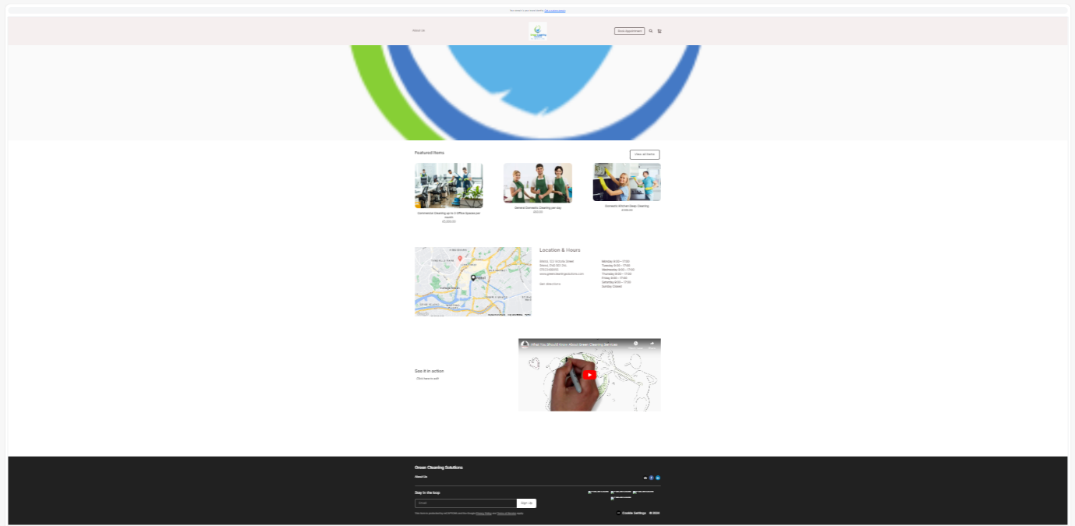

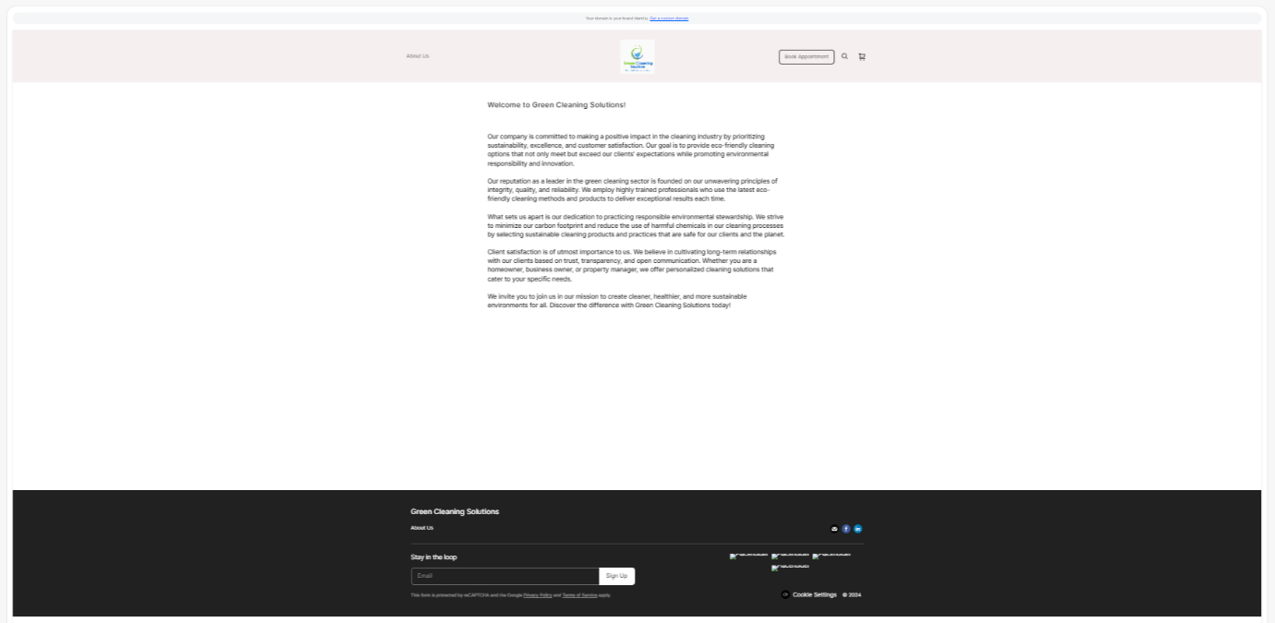
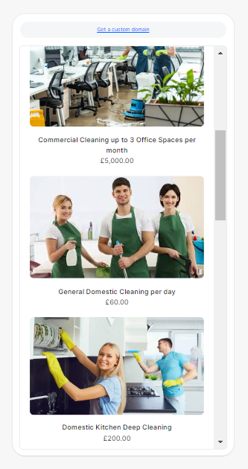
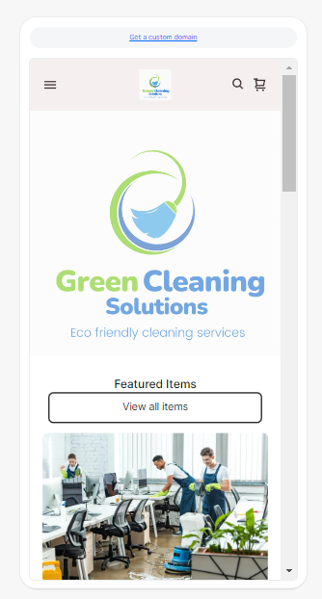
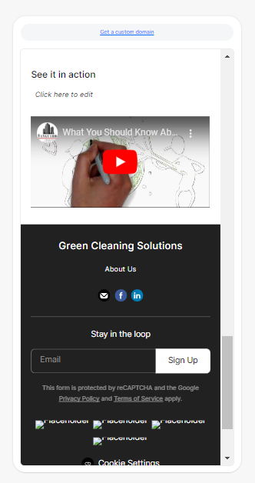
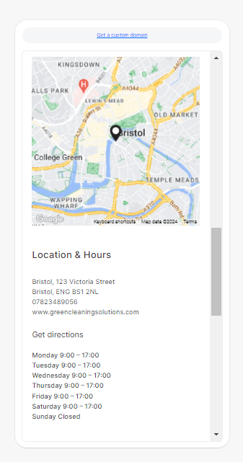
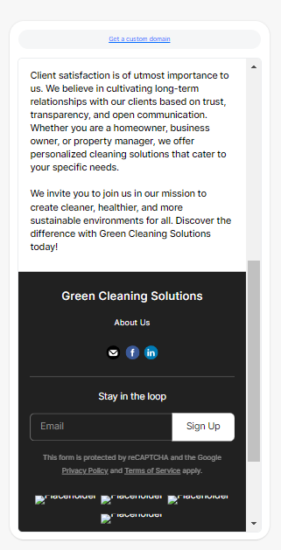
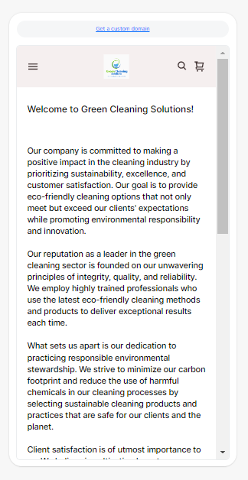



Logo

Business Card
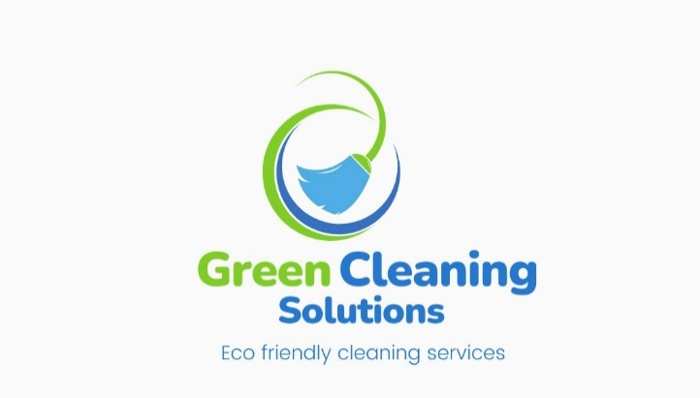
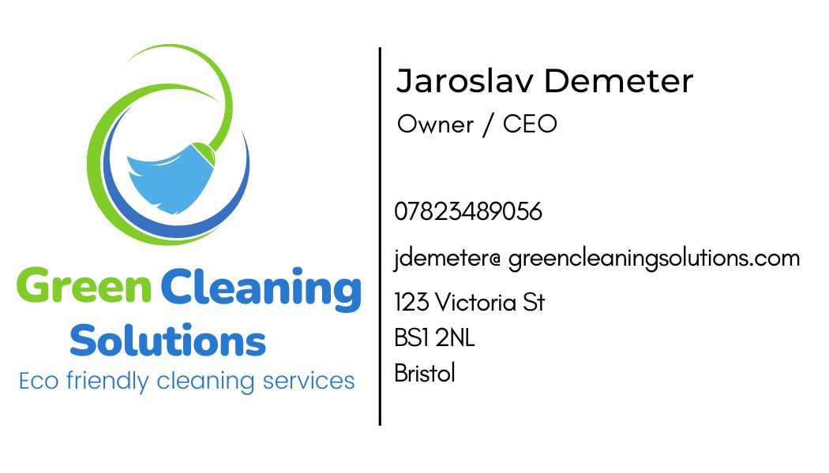

Flyer


References

Acquia. (2024). Brand Storytelling: What It Is and Why It Matters. [Online]. acquia.com. Last Updated: 19 March 2024. Available at: https://www.acquia.com/blog/brand-storytelling [Accessed 20 March 2024].

Attest. (2021). 12 Top storytelling marketing examples: how brands tell stories. [Online]. www.askattest.com. Last Updated: 19 September 2021. Available at: https://www.askattest.com/blog/articles/12-top-storytelling-marketing-examples [Accessed 2 March 2024].

Cint. (2022). What Is a Questionnaire and How Is It Used in Research? [Online]. cint.com. Last Updated: 29th June 2022. Available at: https://www.cint.com/blog/what-is-a-questionnaire-and-how-is-it-used-in-research [Accessed 20 March 2024].

Cleave, P. (2023). Advantages Of Questionnaires in Online Research. [Online]. smartsurvey.co.uk. Last Updated: 26th January 2023. Available at: https://www.smartsurvey.co.uk/blog/advantages-of-questionnaires-in-online-research [Accessed 21 March 2024].

Chan, D. (2023). How survey questionnaires can boost your brand. [Online]. kantar.com. Last Updated: 28th June 2023. Available at: https://www.kantar.com/inspiration/research-services/how-survey-questionnaires-can-boost-your-brand- [Accessed 18 March 2024].

Dorik. (2023). 15 Ways Your Business Can Benefit from Having a Website. [Online]. dorik.com. Last Updated: 30 October 2023. Available at: https://dorik.com/blog/benefits-of-having-a-website [Accessed 20 March 2024].

Forbes. (2020). Why Every Business Needs a Website. [Online]. forbes.com. Last Updated: 3 February 2020. Available at: https://www.forbes.com/sites/theyec/2020/02/03/why-every-business-needs-a-website/ [Accessed 20 March 2024].

Indeed. (2023). The importance of market research questions (Plus tips). [Online]. uk.indeed.com. Last Updated: 20th June 2023. Available at: https://uk.indeed.com/career-advice/career-development/market-research-questions [Accessed 25 March 2024].

Mencap. (2023). The importance of storytelling. [Online]. mencap.org. Last Updated: 26 July, 2023. Available at: https://www.mencap.org.uk/resource/importance-storytelling#:~:text=Storytelling%20helps%20build%20em [Accessed 20 March 2024].

Noun Project. (2024). What are Marketing Materials? + 15 Effective Examples. [Online]. thenounproject.com. Last Updated: 31 May 2024. Available at: https://blog.thenounproject.com/what-are-marketing-materials/#:~:text=Marketing%20materials%20are%20 [Accessed 20 March 2024].

Oxford College of Marketing. (17 June, 2022). What Is Brand Storytelling And Why Is So Important. [Online]. blog.oxfordcollegeofmarketing.com. Last Updated: 23 November 2023. Available at: https://blog.oxfordcollegeofmarketing.com/2022/06/17/what-brand-storytelling-is-and-why-it-is-so-imp [Accessed 26 March 2024].

Play Play. (14 August 2023). What is brand storytelling? [Online]. playplay.com. Last Updated: 19 March 2024. Available at: https://playplay.com/blog/brand-storytelling/ [Accessed 20 March 2024].

Seattle New Media. (2023). Importance of Website: Why Website is Important for a Business. [Online]. seattlenewmedia .com. Last Updated: 3 May 2023. Available at: https://www.seattlenewmedia.com/blog/importance-of-website-for-business [Accessed 20 March 2024].

Semrush Blog. (2023). Brand Storytelling: The Definitive 2024 Guide (with Examples). [Online]. semrush.blog. Last Updated: 26 January, 2023. Available at: https://www.semrush.com/blog/definitive-guide-to-brand-storytelling/ [Accessed 20 March 2024].

Shane Snow. (2018). The Storytelling Edge: How to Transform Your Business, Stop Screaming into the Void, and Make People Love You .: Wiley.

Sprout Social. (2024). Brand storytelling: Creating a story that resonates. [Online]. Sproutsocial.com. Last Updated: 27 February, 2024. Available at: https://sproutsocial.com/insights/brand-storytelling/ [Accessed 20 March 2024].

The Logo Company. (.). Importance Of Great Marketing Material Design. [Online]. thelogocompany.net. Last Updated: .. Available at: https://thelogocompany.net/importance-of-great-marketing-material-design/ [Accessed 20 March 2024].

Webflow. (2024). Importance of a website: 10 reasons why it matters. [Online]. webflow.com. Last Updated: 2024. Available at: https://webflow.com/blog/importance-of-website [Accessed 20 March 2024].

