
Task 1: Business plan, and Reflection

Managing Enterprise (BMSW4011)

Student Name: Andrei Silviu Popina

Student number: 2332738

Lecturer Name: Mel Squire

Submission Deadline: 21.03.2025

Word Count: 1566

Table of Contents

MATART BUSINESS PLAN…………………………………………………………….3
1.0 Business Description and Origin Story……………………………………………3
1.1 Business Structure……………………………………………………………….….3
2.0 Mission, Aims and USP……………………………………………………………..4
2.1 Physical Location…………………………………………………………………....4
2.2 Human Resources…………………………………………….………………….....5
3.0 Marketing Activities………………………………………………………………….5
3.1 Digital Marketing………………………………………………………………….....5
3.2 Physical Marketing…………………………………………………………………..6
3.3 Market Research…………………………………………………………………….6
4.0 Financial Resources…………………………………………………………………7
4.1 Cash Flow Projection…………………………………………………….….………7
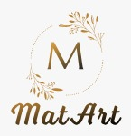
4.2 Cash Flow FORECAST MatArt…………………………………………….………7
5.0 The 7 P’s of Marketing for MatArt………………………………………………….8
6.0 SWOT Analysis………………………………………………………………………9
7.0 Conclusion…………………………………………………………………………..10
8.0 Individual Reflection………………………………………………………………..11
9.0 References………………………………………………………………………….13

MatArt BUSINESS PLAN
1.0 Business Description and Origin Story
Custom photo engravings can be made to a wooden gift, home decoration or anything else with the laser precision technology of MatArt. McKinsey & Company (2023) quoted that, the business turns the normal wooden materials into extraordinary art pieces in an eco-friendly way that matches the current environmentally aware consumers. I have always been a fan of warmth and permanence of the wooden engraved gift, so I started to study the techniques and market opportunities. This gave birth to the initial idea. After responding well, the hobby of making gifts for friends and family became a vision for a sustainable wooden art business.
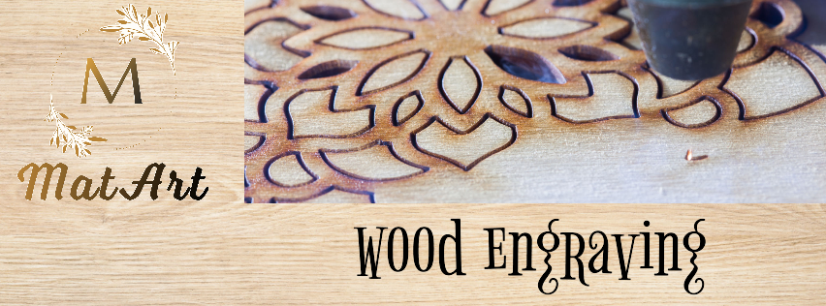
1.1 Business Structure
Initially MatArt will run as a Sole Trader, which will be simple, with complete control and little legal requirements (Federation of Small Businesses, 2023). The direct profit with no corporate taxation and simple account processing process is supported with the structure. The uncapped personal liability and limited access to capital disadvantages point of this approach are nonetheless assuaged by the ability to evolve the business model as the market participates in response. After period of time, in year 3, there will be a transition to a Limited Company structure when the business will reach to a certain level of market presence.

2.0 Mission, Aims and USP
Turning precious memories into everlasting wooden keepsakes that convey sentimentality and individuality to events and keep homes warm.
Mission Statement: To build MatArt as London’s leading wooden engraved product customized company.
The business differentiates itself through a signature combination of craftsmanship and technology. The pieces are custom artistic enhanced, perfected using proprietary finishing process, made from ethically sourced material, and they come with augmented reality preview technology. In competitive markets with increasing value for uniqueness and sustainability, such differentiation is essential, as Kotler and Armstrong (2023) state.
2.1 Physical Location
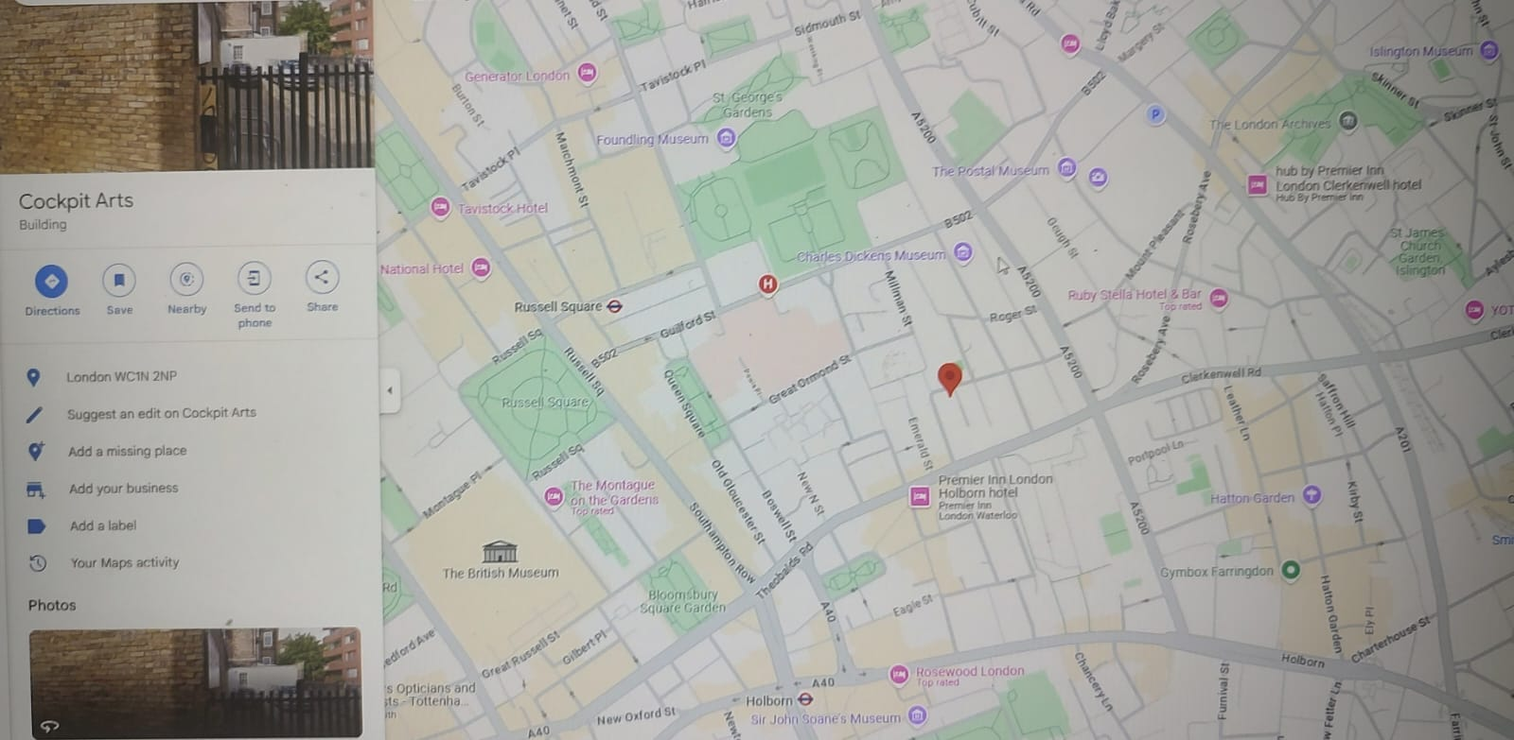
The operations will be in a 400 square foot workshop at, Southeast London. With over 165 independent businesses hosted by this creative incubator, connections can be made, and business can be grown (Cockpit Arts, 2023). Below market rent is offered through a subsidized program, business development services, decent access to transport links, and evidence Deptford’s emergence as a hub for artisans’ business that will attract target demographics.

2.2 Human Resources
A small and lean team structure will be suitable for the business.
For our owner/head artisan is responsible for the design, production, business development and customer service.
Sorts, prepares and finishes packaging and prepares, records, and closes paperwork for each sale, creating a clean bill of lading and provides production records.
Freelance Graphic Designer: Complex design customization
Online inquires, order processing, social media.
This structure mirrors the increasing craft sector tendency to use casualised staffing patterns to manage costs throughout the initial growth phase (i.e. no full–time roles) (Craft Council, 2023).
3.0 Marketing Activities
Therefore, MatArt’s marketing strategy consists of the effective combination of digital presence and physical marketing actions, respecting the principles of integrated marketing communication (Baines et al., 2022).
3.1 Digital Marketing
Social media presence across Instagram, Pinterest, Facebook, and TikTok
Content marketing through blog features and email newsletters
E-commerce optimization with SEO-optimized listings
3.2 Physical Marketing
Regular stalls at the top London craft markets
Monthly workshops teaching basic wood engraving techniques will be held.
Select gift shops and boutiques have wholesale partnerships
Metal engraved business cards are among premium branded materials.
Statista (2023) states that companies with the ability to merge online and offline marketing channels retain their clients 37% more often than those that are limited to one channel.
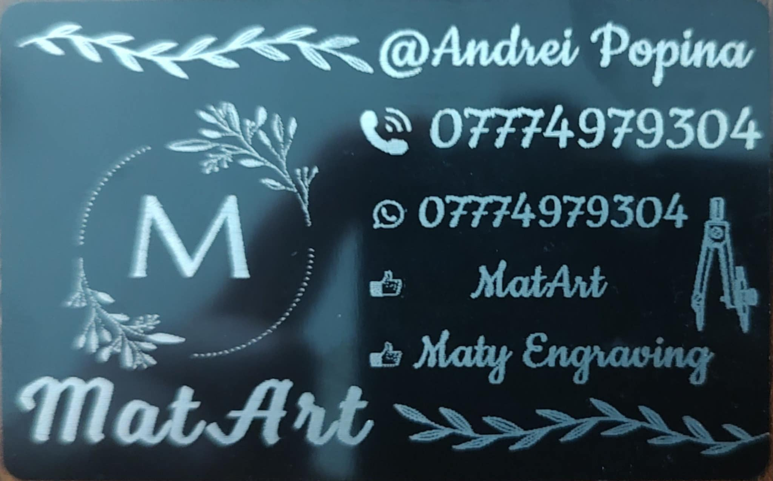

3.3 Market Research
The business concept was comprehensively researched in the market to validate it.
According to Technavio, the personalized gift market is expected to record a market growth of just over 8.1% CAGR from 2020–2026
The main UK wooden homeware market is growing at 9.7% annually (Mintel, 2023).
Eco friendly consumers who have a willingness to pay 25% premium for eco-friendly products (McKinsey & Company, 2023)
These findings directly led the product development, pricing strategy, marketing emphasis, and technology implementation decisions.
4.0 Financial Resources
Previous business experience strengthens the Start Up Loan application, and this wide covering business plan (British Business Bank, 2023). The Cockpit Arts grant was given because it reflects a focus on sustainability and growth potential.
4.1 Cash Flow Projection
In 12 months, total income of 48,910 £ versus expenses of 35,633 £, the business has a closing balance of 13,277£ in the first year. The financial structure of this is the same as previous craft startups that reach sustainability within 12-18 months (Federation of Small Businesses, 2023).
4.2 Cash Flow FORECAST MatArt
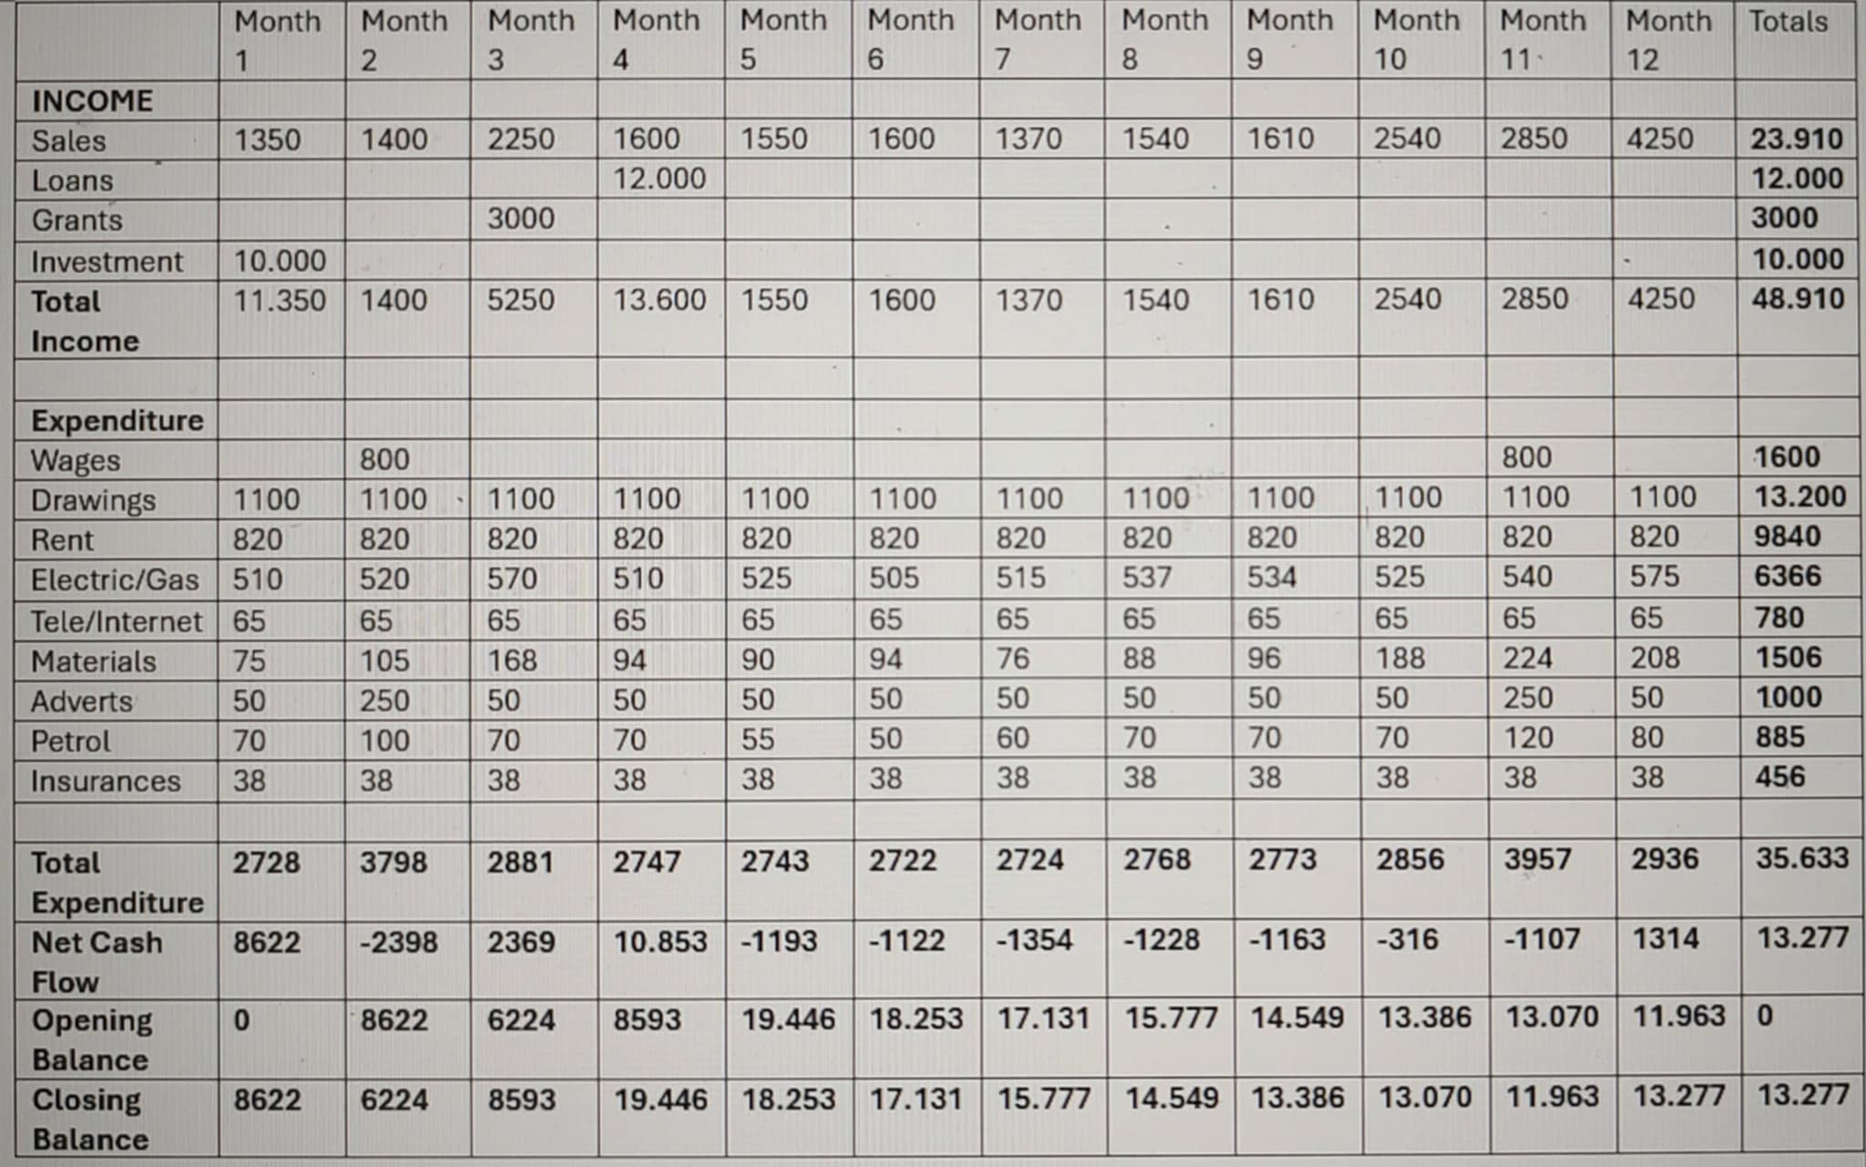

5.0 The 7 P’s of Marketing for MatArt
1. Product
- High-quality, custom wood engravings such as A4 wooden frame pictures, signs, gifts, and personalized décor.
- Offering unique finishes, intricate detailing, and custom designs.
- Additional services like bulk orders for businesses for example metal business cards or personalized engraving for events.
2. Price
- Competitive pricing based on material costs, engraving complexity, and customization level.
- Bundled discounts for bulk orders or recurring customers.
- Premium pricing for high-end custom pieces.
3. Place
- Selling through an e-commerce website, Etsy, or Amazon Handmade, Ebay.
- Having a physical store or workshop where customers can see product samples.
- Attending craft fairs, trade shows, and local markets.
4. Promotion
- Social Media Marketing – Showcasing work on Instagram, Pinterest, and Facebook.
- Influencer Collaborations – Partnering with home décor or DIY influencers.
- SEO & Online Ads – Optimizing a website for local searches and running targeted ads.
- Referral Program – Offering discounts to customers who bring new business.

5. People.
- Customer service that provides fast responses and order updates.
- Partnering with local artists or designers for unique collaborations.
6. Process
- Easy online ordering and customization through a website.
- Clear proofing and approval process for personalized designs.
- Fast turnaround times with reliable delivery and packaging.
7. Physical Evidence
- High-quality product images and customer reviews as proof of craftsmanship.
- Branded packaging to create a memorable unboxing experience.
- Showroom or workshop showcasing different engraving options.

6.0 SWOT Analysis
Strengths:
Uniquely different artistic enhancement process as compared to competitive brands.
Catering to the need for sustainable material sourcing and promoting premium positioning
A way to reduce purchase hesitation through innovative AR preview technology.
Versatile product range serving multiple market segments
Weaknesses:
Limited production capacity in early stages
Reliance on single production equipment
Higher price point than mass-market alternatives

Opportunities:
An increasing trend of sustainable, personalized gifts by consumers.
Increasing markets of wedding and corporate gifts
E-commerce growth allowing nationwide scaling
Threats:
Economic uncertainty impacting discretionary spending
Potential equipment failure disrupting production
New market entrants with similar positioning
The emergence of a growth and changing sharing economy and sustainability has given craft businesses both opportunity and challenge (Frenken and Schor, 2023). The most critical threat to avoid – equipment failure – will be addressed by using a multi layered approach which includes preventative maintenance, service contracts, contingency partnerships and equipment insurance.

7.0 Conclusion
There is a growing need for a personalized sustainable wooden product, which MatArt is meeting. With a strong identity and certain strategic positioning, coupled with well-planned differentiated offerings, the business has the potential to carve a niche for itself in the London craft market . Drawing on McDonnell (2023), material culture is increasingly valuing the idea of authenticity and sustainability which positions the type of craft business such as MatArt is a perfect brand to be successful in a market that is seeking meaning beyond mass production. Inspired by the Etsy (2022) success model, which is focused on selling unique, handcrafted products, MatArt desires to draw a customer base of its own by offer its products with quality, sustainability and personalization.

8.0 Individual Reflection
Developing the MatArt business plan has been a process that has enriched my professional development. Before such a gigantic thing like this, I so much had an idealistic view of how business operates but practically bringing this creative idea while learning has endowed me with skills that are not only applicable in only one sphere or area.
Financial planning and forecasting is the most significant skill that I have gained. I had to research real prices for equipment, materials and workshop space to make a comprehensive cash flow projection. I found the right way to balance optimism with pragmatism, to project ahead revenue grow with seasonal fluctuations, but also allowing for unwanted budgetary surprises. This exercise gave numbers tangible for planning the business.
Another area that has grown valuably has been article methodology of market research. I faced the challenge of no idea where to start working on the concept, and when you don't know how you validate business assumptions, the first point from which to start is almost nothing, except with trying to find a way to get people talking about it at least.
For me, creative problem solving is my strongest entrepreneurial attribute. In market differentiation challenge of MatArt, I created the proprietary finishing process and AR preview tool that were innovations that fill in the gaps of customer pain points and create a competitive advantage.
This journey has proven to be resilient and adaptive core strength. After following initial research about price sensitivity, I did not give up the idea but steer it to develop a tiered product strategy that keeps the quality, while it also offers entry level products.
The third strength that I have is relationship building. I gained valuable connections through the process of researching supplier partnerships, exploring Cockpit Arts community opportunities and developing the wholesale strategy mostly by using the natural interpersonal skill. To develop the collaborative partnerships that will help push MatArt to a higher elevation organization, the ability to build these authentic relationships with a stakeholder however will be of utmost importance.
Although this is not without the strengths identified, the business planning process has identified delegate and building a team as my most area of development for the entrepreneurship. My habit was revealed of centralising control on the organisational structure and the financial planning, which with it could create a bottleneck limiting business growth.
I am a perfectionist by nature and tend to personally deal with all operational and customer related matters, which leaves me no time for anything else. However, with this it ensures quality control, but the business model is vulnerable and scalable. This weakness is understood by the current plan, as part time staff are included but I continue to have apprehensions with delegation as evidenced by the narrow scope of their responsibilities.
I will first enrol in the Cockpit Arts leadership development program which focusses on and addresses the challenges that creative entrepreneur face in delegation. The framework will provide an effective structure to task assignment and team empowerment.
Second, I will use a phased delegation procedure where I will start with the standard production jobs, which are accompanied with extensive process documentation and built quality control checks. This will be done gradually, in such a way that I build my comfort with delegation, while at the same time keeping up quality standards.

9.0 References
- Baines, P., Fill, C. and Rosengren, S. (2022) Marketing. 6th edn. Oxford: Oxford University Press.
- British Business Bank (2023) Start Up Loan Scheme: Terms and Conditions. London: British Business Bank. https://www.british-business-bank.co.uk/business-guidance/guidance-articles/finance/start-up-loan
- Cockpit Arts (2023) Seedbed Fund Application Guidelines. London: Cockpit Arts. https://cockpitstudios.org/apply/awards-and-bursaries/
- Craft Council (2023) Market for craft. [online] Available at: https://www.craftscouncil.org.uk/insight-and-advocacy/research-library/market-for-craft. Deloitte (2023) Global Powers of Luxury Goods. London: Deloitte. https://www.deloitte.com/global/en/Industries/consumer/analysis/gx-cb-global-powers-of-luxury-goods.html
- Etsy, Inc. (2022) Annual Report 2022. Brooklyn: Etsy. https://investors.etsy.com/financials/annual-reports-and-proxy/default.aspx
- Federation of Small Businesses (2023) Small Business Index, Quarter 2, 2023. [online] www.fsb.org.uk. Available at: https://www.fsb.org.uk/resource-report/small-business-index-quarter-2-2023.html.
- Frenken, K. and Schor, J. (2023) 'Putting the sharing economy into perspective', Environmental Innovation and Societal Transitions, 23, pp. 3-10. https://ideas.repec.org/h/elg/eechap/18253_8.html
- Kotler, P. and Armstrong, G. (2023) Principles of Marketing. 19th edn. London: Pearson.
- McDonnell, T.E. (2023). Cultural Objects, Material Culture, and Materiality. Annual Review of Sociology, 49(1). https://doi.org/10.1146/annurev-soc-031021-041439.
- McKinsey & Company (2023) The State of Fashion 2023: Sustainability First. New York: McKinsey & Company. https://www.mckinsey.com/~/media/mckinsey/industries/retail/our%20insights/state%20of%20fashion/2023/the-state-of-fashion-2023-holding-onto-growth-as-global-clouds-gathers-vf.pdf
- Mintel (2023) UK Home Accessories Market Report. London: Mintel Group Ltd. https://store.mintel.com/report/uk-homewares-retailing-market-report
- Statista (2023) Craft and Handicraft Market in the United Kingdom. London: Statista Research Department. https://www.statista.com/statistics/284985/crafts-industry-gross-value-added-gva-in-the-united-kingdom-uk/
- Technavio (2022) Global Personalized Gifts Market 2022-2026. London: Technavio. https://www.technavio.com/report/personalized-gifts-market-size-industry-analysis

