Elena Degl’Innocenti

Student Number: 2332534

Word count: 6559

Title: Effects of a Mindfulness-Based Body Scan Meditation in Online Voice Lessons: a Mixed Methods Study.

TABLE OF CONTENTS:

Proposal………………………………………………………………………….. 4

Introduction………………………………………………………………………. 6
Can Mindfulness For Singers Release Body Tension, Enhance Body
Awareness, and Increase Singing Ease?.........……………………………….7
Methodology: Philosophical Underpinnings and Mixed Methods………...…9
Methodology: Research Design, Participants and Methods……………......10
Quantitative Findings……………………..…………….…………………….....14
Qualitative Findings……………………………………………………………...17

Discussion: Effects on Body Tension……………….………………………….19

Discussion: Effects on Body Awareness……………….………………….…..21

Discussion: Effects on Singing Ease……………….……………………….....23

Conclusion………………………………………………………………………..25

References…………………………………………………………………….….27

Appendix 1: Glossary of Terms…………………………………………………34

Appendix 2: GANTT Chart………………………………………………………36

Appendix 3: Body Scan Meditation Script……………………………………..38

Appendix 4: Post-Home Practice Average Scores on Body Tension……..39

Appendix 5 Post-Home Practice Average Scores on Mental Distraction…39

Appendix 6: Post-Home Practice Average Scores on Body Awareness….40

Appendix 7 Pre-Intervention EASE Questionnaire Answers……………….41

Appendix 8: Post-Intervention EASE Questionnaire Answers …………….51

Appendix 9: Post-Home Practice Questionnaire Answers with Scores…..60

Appendix 10: Interview Questions…………………………………………….64

Appendix 11: Interviews Transcripts………………………………………..…65

Appendix 12: Coding Process in Taguette Software……………………….158

Appendix 13: Example of Handwritten IPA Thematic Analysis……………160

Appendix 14: Example of Handwritten Field Note………….………………163

Appendix 15: Signed Ethics Form ……….…………………………………..164

Appendix 16: Participants’ Info Sheet …………………..……………………181

Appendix 17: Redacted Participants’ Consent Forms………………………184

APPENDIX 18: Body Scan Meditation Track Link…………………..………196

PROPOSAL
Title: Effects of a Mindfulness-Based Body Scan Meditation in Online Voice Lessons: a Mixed Methods Study.
Studies in clinical fields have explored mindfulness-based practices in recent years, noting significant improvements in health and cognitive functions for patients with symptoms of anxiety and depression (Eberth and Sedlmeier, 2012; Blyskal, 2022). However, limited literature currently addresses their application specifically to singing, with only three studies reporting some benefits: improved body awareness, pitch accuracy, and reduction of body tension when mindfulness is practiced before singing (Czajkowski and Greasley, 2015; Czajkowski, Greasley & Allis, 2021; Ornoy and Cohen, 2022).
As a voice teacher trained in mindfulness techniques, I am interested in exploring if body scan meditations, a practice in which the focus of attention is gradually shifted throughout the entire body (De Bruin, 2021), can increase a sense of singing ease, enhance body awareness and reduce muscular tension. Differently than previous studies, the body scan meditation in this study will include a singing practice during online lessons. Teaching online may pose challenges such as lack of student contact and sound quality issues but offers a trusting environment for practice in private spaces (Hrabluk, 2023). The aims of this study are to further explore body scans, hopefully providing my teaching practice and voice educators with methods to integrate mindfulness into vocal training.
This project will have a total of five adult participants who are my current voice students. I will be using a qualitative-first mixed methods approach, and I intend to follow a case study research design, suitable for developing a complex understanding of each participant’s experience (Hancock, Algozzine and Lim, 2021). The study will be conducted over four online voice lessons, where each participant will be guided through a body scan meditation and will be asked to practice the same at home with an audio recording. Quantitatively, an EASE questionnaire method (Evaluation of the Ability to Sing Easily) will be used once before the beginning and once at end of this study, along with a short questionnaire that participants will complete at the end of each home practice. Qualitatively, I will conduct semi-structured interviews at the end of the study and collect field notes based on my observations of the participants throughout the study. An in-depth literature review on mindfulness applied to singing will provide context and ground the research in current literature. I will use descriptive statistics to analyze my quantitative data and interpretative phenomenological analysis (IPA) for my qualitative data–an inductive process greatly focused on the participants’ unique prospectives (Smith, 2004).

Ethical approval was granted by the UWTSD ethics committee, and I will ensure respect for the participants, their confidentiality and anonymity, data protection, informed consent and right to withdraw from the investigation (Mamondo, 2018; Bos, 2020). As a practitioner-researcher I will have to consider the issues of insider research, where the researcher is positioned within what they seek to study (Bulk and Collins, 2024). Practically, I will keep a reflexive journal to identify any arising biases due to my mindfulness practice history and familiarity with the participants.

The project timeline is presented in a GANTT chart (see Appendix 2).

Personal Learning Outcomes
- Learning how to conduct a mixed methods research study using interpretative phenomenological analysis and descriptive statistics.
- Deepening my understanding of mindfulness in singing.
- Assessing whether and how this research can inform my module six assignment.

INTRODUCTION
Mindfulness has been described as a way to pay attention to the experience of the present moment without judgment or attachment (Elliott, 2010; Eberth and Sedlmeier, 2012; Verhaeghen, 2017; Blyskal, 2022), and its applications have been the subject of much interest among researchers in clinical and scientific fields over the last forty years (Kozasa et al., 2012; Fox et al., 2014; Czajkowski, Greasley and Allis, 2021; Anurag et al., 2023). Three peer-reviewed studies have explored mindfulness for singers, reporting enhanced body awareness, improved pitch accuracy, and reduced body tension when mindfulness is practiced prior to singing (Czajkowski and Greasley, 2015; Czajkowski, Greasley and Allis, 2021; Ornoy and Cohen, 2022). As an online voice teacher, I sought to explore whether practicing a mindfulness-based body scan meditation in online voice lessons could release excessive muscular body tension, enhance body awareness and increase singing ease. This mixed methods research investigated the effects of a body scan meditation combined with a singing practice. Previous studies have investigated mindfulness practices, including body scans, but separately from singing (Czajkowski and Greasley, 2021). The rationale behind integrating body scan with singing was to allow the participants to sing while fully immersed in the meditation. The intended impact of this study was to support amateur singers feel more relaxed, more aware of their bodies and more at ease while singing. My learning outcomes were:
- Learning how to conduct a mixed methods research study using interpretative phenomenological analysis and descriptive statistics.
- Deepening my understanding of mindfulness in singing.
- Assessing whether and how this research can inform my module six assignment.

CAN MINDFULNESS FOR SINGERS RELEASE BODY TENSION, ENHANCE BODY AWARENESS, AND INCREASE SINGING EASE?
The term mindfulness, translated as insight or clear seeing, can be traced back to ancient Buddhist traditions and it refers to a style of meditation called Vipassana (Elliott, 2010; Czajkowski, Greasley and Allis, 2021). Mindfulness meditation has been defined as paying attention to one’s experience in the present moment without judgment or attachment, and entails a voluntary focusing on one object, such as the experience of breathing or a repetitive mantra (Elliott, 2010; Kozasa et al., 2012). Even though it has been practiced for centuries, its secular practice has been researched only in recent decades in clinical fields, psychology, psychiatry, medicine and neurosciences (Eberth and Sedlmeier, 2012; Van Dam et al., 2018; Czajkowski, Greasley and Allis, 2021). One large contribution to research has been the creation of the Mindfulness-Based Stress Reduction Clinic at the University of Massachusetts by scientist Jon Kabat-Zinn in 1979, which has been successful in helping patients presenting symptoms of anxiety, panic disorder, depression, and low self-esteem (Eberth and Sedlmeier, 2012; Blyskal, 2022).
Proprioception (the physiological and psychological perception of body movement and position) has been thoroughly investigated as one of the primary facets of conscious body experience (Paparo, 2022; Pérez-Peña et al., 2022). This study aimed to determine whether mindfulness practices enhance body awareness. Two studies on proprioception and mindfulness found that mindfulness-based interventions were possibly improving body awareness (Pérez-Peña et al., 2022), and that there was a detectable link between mindfulness and accuracy of body awareness (Treves et al., 2019). However, literature on mindfulness for singers has largely been theoretical and non-empirical (Czajkowski, Greasley, & Allis, 2021). Elliott (2010) for instance, provided theoretical support showing that mindfulness can enhance singers’ breath awareness, potentially improving technique and performance.
Czajkowski and Greasley (2015) conducted what is known to be the first study on the effects of mindfulness on singers, and it consisted of an 8-week course of group classes and a retreat day. It involved breathing meditation, gentle yoga movements, mindful body scanning–systematically shifting one’s attention throughout the body, head to toe–walking and eating meditation, and daily practices at home. The results indicated that practicing mindfulness exercises before singing had a series of positive effects: improved awareness of body perceptions, musculature control, pitch accuracy, reduction of shoulders and neck’s tension, and improved breath control. However, this study was limited by a small sample size and the absence of a control group. Czajkowski, Greasley, and Allis (2021) conducted a larger mixed methods study on mindfulness for singers, concluding that mindfulness training had positive holistic effects on students, suggesting its strong potential for integration into conservatory and studio teaching. These findings seemed relevant to this study’s research questions, potentially helping to provide methods to successfully integrate mindfulness into vocal training. However, I was specifically interested in discovering the potential benefits of body scan meditations. In popular culture, body scan meditations have been linked to improved awareness of body perception, musculature relaxation, stress reduction, emotional regulation and alleviation of symptoms of pain, anxiety, and depression (Michigan State University, 2024). Blyskal (2022) found that incorporating mindfulness practices like body scans into collegiate voice lessons increased students’ body awareness, vocal ease, and reduced their singing anxiety. Only one short-term online intervention study has considered the effects of mindfulness meditation on vocal proficiency, reporting tendencies for vocal improvements (Ornoy and Cohen, 2022). More generally, online mindfulness programs have demonstrated the effectiveness of body scans in reducing stress and enhancing self-awareness within clinical workplace settings (Mohammed et al., 2018; Begin et al., 2022).

There have been contrasting views on the importance of the teacher’s role in facilitating mindfulness interventions. Hoch (2020) discouraged teachers with little meditation experience to simply try what they know on students but instead lean on pre-existing resources in written texts and recordings that could be used as scripts. Varner (2022) instead emphasized that teachers did not need to be experts and should consider a series of simple mindful approaches. The level of depth and complexity of mindfulness interventions may be the cause of such different opinions, and they remain opinions as there is little empirical evidence and no peer-reviewed studies to back up these theories (Czajkowski, Greasley and Allis, 2021). Based on my experience, preparatory training seemed necessary as both researchers and educators should be equipped to handle a wide range of situations involving individuals who may respond differently to these practices. For instance, Wästlund, Salvesen and Stige (2024) studied mindfulness and compassion interventions in the treatment of trauma and noted that mindfulness required hard work for the participants of their study, often activating grief in the process. Finally, body scan meditations and mindfulness practices have grown in popularity with online apps like Headspace and Calm (Begin et al., 2022), but, to my knowledge, they have rarely been applied to singing.
METHODOLOGY
Philosophical Underpinnings and Mixed Methods
As a first-time practitioner researcher, I had to consider that assumptions and beliefs about the development of knowledge and nature of reality can appear at any stage of research (Saunders, Lewis and Thornhill, 2016). Ontologically I aligned with a relativist stance, where multiple conceptions of realities can exist and are influenced by experiences and interpersonal relationships (Saunders, Lewis and Thornhill, 2016; Pessu, 2019). Epistemologically I aligned with a constructionist stance, where meaning cannot exist without a mind (Al-Ababneh, 2020). I adopted a qualitative-first mixed methods approach, combining both qualitative and quantitative data collection and analysis, as existing research on the topic highlighted the benefits of mixed methods to develop robust and multifaceted findings (Czajkowski and Greasley, 2015). Some researchers have questioned if this approach could be viable due to the complexity of merging philosophical stances–paradigms such as post-positivism, constructivism and pragmatism (Bradt, Burns and Creswell, 2013; Heeks, Wall and Graham, 2024). To address those limitations, I integrated both data sets in my analysis, using the small portion of quantitative data as supplementary data to gain a deeper understanding of the participants’ experiences. In fact, the union and cross-examination of both data sets was suggested to provide deeper insights to the research than from the two separate sets alone (Creswell and Creswell, 2018).
Research Design, Participants and Methods
I followed a case study design aimed at developing a complex, multi-layered understanding of each participant’s experience and appropriate for a small sample size (Hancock, Algozzine and Lim, 2021). The five participants, all amateur singers and my students for at least one year, included three men and two women aged 28 to 72. No prior mindfulness meditation was required and three of the five participants had previous experience, which may have positively impacted their decision to join this study. Table 1 illustrates every stage of this study.
Table 1 Study’s Stages.
To evaluate the participants' perceptions of their singing voice status, an EASE questionnaire (Evaluation of the Ability to Sing Easily) was administered at both the beginning and end of the study. EASE questionnaires, which use a simple language that does not assume vocal issues, have been successfully employed to assess perceptions of current singing voice status in both healthy singers and those at risk for voice disorders (Phyland et al., 2013; Marchand, Kavaliunas & Cassol, 2019). This study used EASE questionnaires to assess participants' initial singing ease and determine if changes occurred at the end of the intervention.
Each participant was guided through a twelve-minute body scan meditation at the beginning of four online singing lessons, once every week for four weeks. The body scan practice included four sections as shown in table 2.
Table 2 Body scan meditation practice.
The first part consisted of a body scan based on Jon Kabat-Zinn’ body scan, which he developed in the late 1970s as part of his MBSR program (Mindfulness-Based Stress Reduction) helping patients with chronic pain, depression and anxiety (Czajkowski and Greasley, 2015; de Bruin, 2021). I chose this form of body scan because of its proven benefits in MBSR studies and its instructional clarity in shifting the focus of attention through different body parts (de Bruin, 2021).
In the second part of the meditation, I guided the participants to feel their whole bodies and the space surrounding their whole bodies as outlined in the body scan script (see Appendix 3). I included these instructions to help participants maintain a greater degree of body awareness. Transcendental meditation and, in more recent years, secular practices like quantum healing meditation have investigated the concept of a body scan connected to the perception of the space surrounding one’s body, which might facilitate a heightened state of awareness (Domash,1975; Dispenza, 2012).
The third part of the meditation was a brief singing practice (see Appendix 3). To my knowledge, merging singing practice and meditation practice can be considered a novel practice and no literature is currently available. However, singing as a form of meditation can be traced back to ancient forms of yogic meditation in which the focus of attention was directed to the sound that is repeated when chanting (Deshmukh, 2020; Perry, Polito and Thompson, 2024). Bringing awareness to the singing voice, as the participants were guided to do in this study, might be beneficial to lower mind wandering and stress as it was reported in studies on the effects of chanting (Perry et al., 2022; Chokkan et al., 2024).
To encourage consistent practice, homework was assigned: participants were given two recordings of the same meditation used during the live session, one with background music and one without (see Appendix 18). An eleven-question google form questionnaire was given to the participants to be completed after every home practice and rated on a 5-point Likert scale ranging from ‘strongly disagree’ to ‘strongly agree’. The advantages of employing a Likert scale included its simplicity and reliable estimates of a person’s abilities; nevertheless, there may be limitations if not utilized with other data collection methods (Nemoto and Beglar, 2013). I created this questionnaire based on my research questions in a way that might show discrepancies between positive and negative body perceptions. For example, reverse coding–asking opposite sets of questions such as ‘my body is more relaxed now than before the meditation’ followed by ‘I feel more tension now than before the meditation’. At the end of the intervention, I conducted one semi-structured interview with each participant, which appeared to be the most suitable approach for encouraging them to reflect on and articulate their lived experiences in a focused manner, using both open and closed questions (Creswell and Creswell, 2018; Mamondo, 2021). A focus group might have been also a useful method, but it could have jeopardized the authenticity of the participant's experience in comparison to other participants.
Quantitative data collected from questionnaires were analyzed separately using descriptive statistics. Qualitative information collected from the interviews was analyzed using interpretative phenomenological analysis (IPA), a highly inductive process ideal for detailed, nuanced analysis of single cases (Smith, 2004). I utilized Taguette software for coding the interview transcripts and used handwritten notes for thematic analysis (Appendix 12 and 13). Field notes of my observations of the participants were collected throughout the study (Appendix 14). Observations are not frequently utilized as a primary data collection strategy in IPA, because information would not come directly from the participant (Smith, 2004; Fletcher, Davidson and Krause, 2024). In fact, I gathered a small amount of field notes, limiting the observations to allow each participant to feel comfortable during the meditation.
This project was approved by the UWTSD ethics committee and ensured respect for the participants, their confidentiality, anonymity, and data protection. Since mindfulness practices may elicit emotional responses and negative thoughts due to different body perceptions and sensitivities, the participants were informed about it and their right to withdraw from the investigation at any time (Hoch, 2020; van den Engh, 2024; Wästlund, Salvesen and Stige, 2024). Given that this study involved mindfulness practices in singing lessons, which is outside of the boundaries of its original environment, I spent the three months leading up to the project practicing different forms of body scans. In fact, Hoch (2020) has recommended mindfulness training prior to teaching or conducting research. I draw on two decades of meditation experience, including retreats and studies in Tibetan Buddhism, Zen, Vipassana, and Taoist traditions.
As a meditation practitioner, my beliefs and experiences are positively biased towards the benefits of mindfulness. But as an insider researcher, I had to approach each session and interview with what has been described as ‘beginner’s mind’–a present, open and curious mind–practicing the same body scan alongside the participants to mitigate possible biases (Moniz et al., 2016). I kept a learning journal, which is a tool to nurture self-awareness and transparency throughout a study and monitor arising biases (Holmes, 2020). To prevent participant bias, which can occur when a participant's response is influenced by the researcher's presence or their perception of what the researcher expects (Lynn Institute, 2023), I ensured their confidentiality and gave each a pseudonym. To mitigate possible bias towards meditation practices, I informed the participants that the study’s aim was to understand their genuine, lived experience.
QUANTITATIVE FINDINGS
The participants (N=5) completed an EASE questionnaire at the beginning and end of this investigation to highlight general trends of singing ease pre- and post-intervention (Marchand, Kavaliunas and Cassol, 2019).
Table 3 shows the pre- and post-intervention EASE mean and median scores. All participants’ scores post-intervention decreased, which meant a general increased level of singing ease.
Table 3 Pre- and post-intervention EASE mean and median scores.
A normality test (Shapiro-Wilk) was conducted to determine if the samples were normally distributed W=0.975, p=0.906. Therefore, there was no violation of any assumption of normality. Considering these findings, the parametric paired samples t-test was appropriate. The paired samples t-test demonstrated that there was a significant difference between pre- and post-intervention mean scores, t(4)=4.3, p=0.013, Cohen’s d=1.92. The mean difference between pre- and post-intervention was 14 (pre intervention scores were higher). The effect size (Cohen’s d) was very large, which meant that the intervention had a very large effect (Cohen, 1988).
However, given that the sample size was small, I felt that it might be appropriate to run the non-parametric equivalent of the paired sample t-test, Wilcoxon signed-rank test. This test suggested that there was no significant difference between pre- and post-intervention median scores, W=15, p=0.063, Rank biserial correlation=1. Even though the test did not reveal a significant difference pre- and post-intervention, given that the effect size was large, I am still interpreting it as there was a significant intervention effect. Table 4 shows a box plot of all participants pre- and post-intervention’s EASE scores, visually showing the decreased scores post-intervention.

Table 4 Box plot of all participants pre- and post-intervention’s EASE scores.

Table 5 EASE questionnaire individual participant’s scores.
Table 5 shows that Mel, Jenni and Mark saw the biggest difference pre- and post-intervention. Interestingly they were also the three participants already familiar with mindfulness techniques. EASE scores post-intervention decreased by one point for all participants for most of the questionnaire’s answers. Notably, scores for the answer to ‘I am having difficulty sustaining long notes’, decreased by two points for Mel, Jenni and Frank. It is possible that this was due to a lower level of body tension post-body scan (which also emerged through the home questionnaire) and their continuing singing training. However, these measurements could not be generalized due to the inconsistent amount of home practices.
Table 6 shows the home questionnaire’s average scores for answer ‘I felt relaxed in my body while singing’ and its opposite ‘I felt tension in my body while singing’ (reverse coding). The left axis represents their scores, and the lower axis the number of practices for each participant. All reported steady high scores, which meant a low level of perceived body tension while singing, with Frank being the most inconsistent but still ending with an increased score after three practices.
Table 6 Post-home practice average scores between ‘I felt relaxed in my body while singing’ and ‘I felt tension in my body while singing’.
Appendices 4, 5 and 6 show more average scores related to body tension, mental distraction and body awareness, which appeared to indicate that each participant followed a distinct path, with a tendency toward a higher level of body awareness and a lower level of muscular body tension with increased practice.
QUALITATIVE FINDINGS
Following an Interpretative Phenomenological Analysis I immersed myself into the five interview transcripts and my own field notes. What initially emerged was how unique each participant’s experience had been and how each developed an imaginative journey to navigate their physical perceptions. All participants communicated that the practice allowed them to feel more relaxed and improved the quality of their singing. They all reported a heightened level of body awareness compared to before the intervention, especially after being guided to move their attention from single parts of the body to the sensation of their whole body. After a process of coding in which many relevant snippets of conversation were highlighted, the following themes emerged: relaxation, repetition, whole-body, body tension habits, imagery creation, mental activity, voice availability, improved vocal tone and transitioning from meditation to singing. I consolidated the themes to three broader themes to help answer my research questions:
- Effects on body tension
- Effects on body awareness
- Effects on singing ease
Based on my field notes, four participants experienced some restlessness, particularly in the first week, and one participant had instead the tendency to fall asleep. There was a slight difference in instructional pace between the live meditation (slower) and the hope practice track (faster), possibly due to my live interaction with them and my reaction to their restlessness. However, this did not seem to affect the participants negatively. In fact, spending more time with each instruction allowed them to improve the quality of their experience over time. Based on my interaction with them right after the meditation they all appeared calmer in the way they spoke and in their facial expressions, which aligned with what they reported in their interviews. Knowing them as my voice students, I noticed the quality of their singing in the last part of the meditation, especially how long and how easily they were able to sustain notes without being forceful.
Two participants experienced some distraction online as they were unable to avoid the presence of family members during the live meditation. They did not, however, mention that as a problem in their interviews, so I am interpreting it as minor distraction that was resolved. Finally, three participants found the home practice meditation track without music to be less distracting, while two chose to use the track with music. This choice seemed to be due to personal preference and may have been influenced by familiarity with meditation as well as individual differences in learning and concentration styles. Considering this study’s small sample size, I could not generalize this finding.

DISCUSSION
Effects on Body Tension
This study aimed to determine whether and how a body scan meditation might reduce muscular body tension, as studies have reported in singers and musicians (Varner, 2022; Brown et al., 2023). All five participants reported greater body relaxation in their interviews. For example, Jenni felt ‘Very relaxed’. Mark said: ‘I think, overall, a cumulative relaxation effect.’
Frank answered: ‘I was more relaxed. I was more… I think I'd learned how to, you know, at a moment's notice, relax.’ Frank described himself as a ‘high-key person’ who has difficulty relaxing, ‘it's hard for me to sit still’. In fact, using mindfulness techniques has been successfully linked to stress reduction and the release of tension in singers (Blyskal, 2022). Furthermore, mindfulness meditation training for people affected with ADHD, subjects who struggle to relax, has been the subject of research, reporting improved attention and emotional regulation (Zylowska et al., 2008; Mitchell et al., 2017). Frank was also the participant who had trouble staying awake during meditation, experiencing a dream-like state. Based on what I have learned about him I could infer that the combination of his high-key personality and his older age may indicate that his body needed to rest, taking advantage of any chance to do so. His home questionnaire scores related to body tension were not steady, highlighting discontinuity throughout the four-week intervention. However, he stated that he felt more relaxed after the intervention, which suggested that his path to relax was not as easy and linear as the other participants’.
The positive reports from the participants’ interviews aligned with the high scores from the first answer to the home questionnaire ‘my body is more relaxed now than before the meditation’ (Appendix 4). Mel, for example, noticed tension in her sitting posture when she first started paying attention to different body parts: ‘I did notice things that I felt were inhibiting me, and when I made those adjustments, I felt a lot more openness in my body.’ She first noticed tension in the way she was sitting, and repeating the practice helped her make some adjustments: ‘Being in regular practice of meditation has made it easier to get to a state where I'm sitting with the relaxation.’ She practiced at home only two times, but together with the four live sessions, she initiated a process of familiarization and eventually relaxation. Similarly, Mark said: ‘So the more I did it, the more I was able to focus on the body and get into it.’ And Pete: ‘I was more familiar with what I was doing in all the areas of my body that I was trying to get in touch with.’
Even though only three participants had previously experienced body scan meditations, repetition appeared to be necessary for all participants to achieve more relaxation. Blyskal (2022) found that when using mindfulness techniques on singers, relaxation is often an immediate response, but it takes time and repetition for long-term mental and physical changes to occur. In cognitive research Kats, Ando and Wiseheart (2021) studied how repetition of song cues could help optimal memory retention, especially if spaced out through several sessions.
Relaxation appeared also in the transition between body scan and singing, in which they brought awareness to their whole body. Jenny for example said that ‘It was very enlightening and empowering’, helping her relax every part of her body.
Also, Mel: ‘when we got to the part of like, you know, the awareness of your whole body that I really felt like a more cohesive sense of relaxation throughout.’ My field notes showed that all the participants looked physically still and calmer during this transition as if connecting to the perception of their whole body could help them deepen into the meditation.
Lowered tension was also reported during the singing part of the meditation. Pete said: ‘I think I have become more comfortable. Like not having to tense up or try so hard, and especially with breathing and support.’
I noticed through the transcripts that the word ‘tension’ was used only twice in all five interviews, whereas the word ‘relaxed’ was used thirty-four times. This study was certainly geared towards relaxation because these techniques are inherently built for finding peace and calm (Penman and Willams, 2011). Given the recent surge in mindfulness’s popularity as a tool for relaxation (Van Dam et al., 2018; Blyskal, 2022), responses may have been influenced by participant bias—participants focusing on positive experiences to align with what they believed the researcher expected.
There were no reported issues with the study's online format. Some studies on stress reduction utilizing online mindfulness training methods, primarily for health professionals, have demonstrated the effectiveness of online settings (Gupta, Kemper and Lynn, 2018; Beshai et al., 2020). Practically, it seemed that this online body scan meditation had a significant effect on lowering the participants’ body tension, where repetition helped familiarization, ultimately enhancing body relaxation.
Effects on Body Awareness
The five participants reported that their level of body awareness grew over four weeks. Quantitative data from home questionnaires showed a steady high level of body awareness for four participants, with only Frank showing a decreased level over the course of three home practices (see Appendix 6), again, possibly due to his difficulty staying awake.
Each participant followed a distinctive mental and perceptual process. For example, Pete said: ‘I'm not always aware’. His body awareness increased by visualizing single body parts through internal sensations because they were adjacent to each other. In fact, experiences of body connectedness and visualizations emerged in the second part of the meditation in which the participants moved their awareness to their whole body, as opposed to awareness of individual parts. Connecting to a whole-body perception helped increase body awareness. Mark said that he felt ‘whole, that sense of at peace, whole and relaxed… I feel a presence of my entire body connected’. Mel said: ‘I felt very physically comfortable, very connected like that. That was kind of the best part for me, putting the whole thing together’.
Czajkowski and Greasley (2015) reported improved body awareness in their mindfulness study on singers even though the specific link between whole-body perception and increased body awareness has not been explored in literature. However, there are methods such as the Alexander Technique, the Feldenkrais method and Body Mapping that have enhanced a kinesthetic experience of singing, where the whole body becomes the vocal instrument (Hoch, 2020; Phelan, 2021; Stapleton, 2024).
Pete mentioned: ‘Like be one whole… like there's a big pipe going down through the whole body. That feeling particularly, I felt like it stuck pretty hard after meditation.’ For both Mel and Pete, being aware of each body part was not immediate, but connecting to a whole-body sensation built a new habit they could use after the meditation. Their initial difficulty was possibly due to mental distraction and physical tension. In fact, they were the only two participants with higher scores to the question ‘my mind was busy thinking during meditation’, which decreased with the passing weeks. Shamini et al. (2007) found that students who practiced mindfulness reported a considerable reduction of distracting thoughts.
Each participant found imaginative ways to sustain a whole-body sensation. As Pete concisely said, ‘It was a journey each time’. The creation of visualizations and imagery seemed to get reinforced each time they practiced and by the end of the intervention they would actively use their imageries to reconnect to a whole-body sensation. In fact, voice teachers can help connect mind and body to develop vocal expression using tools such as mental imagery and visualizations (Fields and Maxfield, 2019).
Additionally, I instructed them to ‘feel the space surrounding their body’ and to ‘take space’ (see Appendix 3). This instruction was inspired by quantum meditation practices which have explored using proprioception and applying it to quantum physics principles to balance body awareness and consciousness (Dispenza, 2012; Liou et al., 2016). Practically quantum meditation utilizes mental visualizations, and its main benefits include achieving a heightened state of awareness and inner peace, suggesting that consciousness can influence reality (Shonin and Gordon, 2014; Dubois and Miquel, 2015).
Mel said ‘I have this little like mental image that I developed… a big, you know, like a big soap bubble around like the whole area that I'm sitting in.’ She continued saying that the moment I instructed her to ‘take space’ she imagined a white fog filling up that bubble, ‘so, I'm sort of like in a cloud inside this bubble.’ Frank mentioned something similar: ‘It was like, I was in a big bubble of saran wrap, you know, the big bubble all around me.’ Jenni said ‘it's almost like I pictured a triangle, and so the base of the triangle got wider’ adding that she became aware of the space immediately outside her body as an extension of herself.
Participants were asked to choose a place in their imagination to be in right at the beginning of the meditation. This prompt did not seem to be an easy task for Mel and Pete, but it may have stimulated their imagination, which showed later in their interviews. Brown (2025) theorized the integration of personalized imagery (created by the students) into singing practices to improve vocal learning through greater autonomy and self-awareness. Enhancing body awareness was one of the main aims of this study and interestingly imageries were a tool created by the participants to sustain body awareness.
Quantitatively, unsteady scores emerged to the question regarding mental distraction (see Appendix 5). However, it was not clear if the unsteadiness meant negative distraction or more mental activity, perhaps the creation of imagery. I could conclude that mental activity was, in fact, a positive component based on both sets of data, particularly in light of the benefits associated with imagery creation.
Effects on Singing Ease
Tillotson Bauer (2016) explained that when the whole body functions as the vocal instrument, maintaining a relaxed body could lead to a relaxed throat, larynx, articulation and help the voice open to free resonance and accurate registration. Experiencing a whole-body connection and including the space around the body seemed to have an effect on the participants’ singing quality. Quantitative data from EASE questionnaires showed a significant increase of singing ease from pre- to post-intervention. All participants experienced the singing practice differently, but all discovered something new about their singing. Jenni for example said, ‘I could almost visualize like the peaceful sound, you know, and I was a little surprised that it was full and rich, and much easier than I had originally thought it was going to be.’ She moved past her apprehension and found a rich sound, which aligned with the results from her EASE questionnaires, which saw the most significant change among the participants, from 66 to 43, which meant overall increased singing ease.

Mel discovered she was in a good physical position to produce a good sound and mentioned ‘it didn't sound like someone who hadn't warmed up’. Pete instead said that he found a way of singing ‘without necessarily having to just explode out in one go. I guess that more consistent release of sound.’ Singing from a place of relaxation created the opportunity to approach singing differently for Pete. This concept has been explored by Czajkowski and Greasley (2015) where singers learning mindfulness techniques progressively became aware of unnecessary vocal or physical tension, improving vocal tone and the onset of sound.
Transitioning between body scan meditation and singing seemed initially an impediment to singing easily as they all felt, in different ways, that they were not ready to sing yet. Frank said: ‘I was not connected at all to my body parts, and then slowly, everything, you know, started connecting.’ He felt like he had undergone anesthesia as he fell into a dream-like state and his body needed to wake up before singing. By the end of the intervention, he was able to find a stronger voice: ‘I'd say it's less raspy. It's… it's… There's more… It's stronger.’ It is possible that after his body was able to rest during the meditation, some muscle tension was released, and he was able to find a stronger voice tone. In fact, literature has linked singing with relaxation: producing a rich vocal tone requires the release of habitual muscle tension (Broadbeck, 2000; DeGroot, 2008; Titze, 2019). This seemed to connect to his EASE scores which decreased less significantly, possibly suggesting more difficulties easing into the singing practice.
Mel felt that parts of her body were not ready to sing yet, and Pete reported his voice felt weak during the first week. Mark said that he had to awake from a very relaxed state. Singing required muscular activity and moving from a very relaxed to a more active state was perhaps a novel experience for all the participants. My field notes revealed that they all initially seemed to tense their bodies just before singing, learning to maintain relaxation while singing with the passing weeks. EASE scores seemed to corroborate my observations, as general singing ease increased. Singing online in the privacy of their own home space perhaps helped accessing a deeper level of relaxation as literature has suggested (Hrabluk, 2023).
The research question—whether mindfulness practices for singers can increase singing ease—appeared to be positively answered. Furthermore, reflecting on these positive results–relaxation, increased body awareness and singing ease–I understood that they were intrinsically connected, reinforcing each other throughout the intervention. A deeper relaxation informed and enhanced body awareness, which increased singing ease.

CONCLUSION
This qualitative-first mixed methods study explored whether a mindfulness-based body scan meditation, integrated with singing practice, could reduce muscular tension and enhance body awareness and singing ease. Pre- and post-intervention quantitative data from two EASE questionnaires revealed a significant decrease in scores, indicating greater singing ease. Although post-home practice questionnaires were used inconsistently over the course of the four-week intervention, they demonstrated improvements in singing ease, body awareness, and relaxation. Qualitative data from interviews revealed that each participant followed their unique journey and all reported lowered body tension and increased body awareness. Particularly, the body scan instruction to connect to a whole-body perception helped deepen into the meditation and sustain body relaxation. The imageries that participants developed during meditation also appeared to support body awareness and singing ease. These positive results–relaxation, increased body awareness and singing ease–seemed inextricably connected, one didn’t happen without the other, reinforcing each other throughout the intervention. The study achieved its aims, but a larger sample size with control group would be recommended for future studies. The participants experienced challenges transitioning from body scan to active singing. Although integrating body scan meditation, whole-body awareness, and singing appeared promising, future research could focus on improving this transition. Including a twelve-minute meditation practice in weekly voice lessons can be challenging. However, given the reported benefits from this and previous studies (Czajkowski, Greasley and Allis, 2021; Blyskal, 2022), effectively incorporating body scans into voice lessons could be a valuable area for further exploration. Participants experienced only minor distractions at home during the online sessions, and overall increased relaxation may in fact have been supported by being in their familiar environment (Hrabluk, 2023). Future research could compare online and in-person interventions to better assess the benefits and limitations of online mindfulness for singers. Anecdotally, my current voice students, who participated in this study, returned to lessons with improved body awareness, showing greater relaxation and increased confidence in their vocal abilities and expression. In conclusion, I achieved my learning outcomes by conducting a mixed methods study using IPA and descriptive statistics. The four-week intervention revealed areas to refine the body scan meditation, and the positive results may encourage further mindfulness research for my module 6 assignment.

REFERENCES
Al-Ababneh M. (2020) ‘Linking Ontology, Epistemology and Research Methodology’, Science & Philosophy, 8 (1), pp 75-91.
Anurag, S., Singh, B., Krishna, D., Prasanna, K., Deepeshwar, S. (2023) ‘Heart–Brain Rhythmic Synchronization During Meditation: A Nonlinear Signal Analysis’, International Journal of Yoga, 16 (2), pp 132-139.

Bégin, C., Berthod, J., Martinez, L., Truchon, M. (2022) ‘Use of Mobile Apps and Online Programs of Mindfulness and Self-Compassion Training in Workers: A Scoping Review’, Journal of Technology in Behavioral Science, 7 (4), pp 477-515.

Beshai, S., Bueno, C., Yu, M., Feeney, J., Pitariu, A. (2020) ‘Examining the Effectiveness of an Online Program to Cultivate Mindfulness and Self-Compassion Skills (Mind-OP): Randomized Controlled Trial on Amazon's Mechanical Turk’, Behaviour Research and Therapy, 134, pp 1-12.
Blyskal, E. (2022) ‘A Case for Mindfulness Practice in the Collegiate Voice Studio, Part 1’, Journal of Singing, 79 (1), pp 79-86.
Bos J. (2020) ‘Research Ethics for Students in the Social Sciences’. Switzerland: Springer International Publishing.
Bradt J., Burns D., Creswell J. (2013) ‘Mixed Methods Research in Music Therapy Research’, Journal of Music Therapy, 50 (2), pp 123-148.
Broadbeck C. (2000) ‘Singing and relaxation [Vocal technique]’, Canadian Musician, 22 (3), pp 31. Available at: https://www.proquest.com/docview/216492519?accountid=130472&parentSessionId=U%2Ft61N0mob01meE5tFLQmqlwuLejkQdAQOV963INGmA%3D&pq-origsite=primo&searchKeywords=singing%20with%20relaxation&sourcetype=Magazines
Brown C., Vazquez J., Metz S., McCown D. (2023) ‘Effects of an 8-Week Mindfulness Course in People With Voice Disorders’, Journal of Voice. Available at: https://www.sciencedirect.com/science/article/abs/pii/S0892199723003533
Brown J. (2025) ‘Keep it Clean! A New Approach to Imagery in Singing Pedagogy’, Voice and Speech Review, 19 (1), pp 17-29.
Bulk L., Collins B. (2024) ‘Blurry Lines: Reflections on “Insider” Research’, Qualitative Inquiry, 30 (7), pp 568-576.
Chokkan D., Bhel A., Kalyani T., Ramesh P. (2024) ‘Effectiveness of Om Chanting on Perceived Stress, Negative Affectivity, and Social Inhibition in Individuals with Pre-Hypertension’, Asian Journal of Medical Sciences, 15 (3), pp 221-224.
Cohen J. (1988) ‘Statistical Power Analysis for the Behavioral Sciences’. New Jersey: L. Erlbaum Associates.
Cresswell J., and Cresswell D. (2018) ‘Research Design: Qualitative, Quantitative, and Mixed Methods Approaches’. Thousand Oaks, CA: Sage.
Czajkowski, A., Greasley, A., Allis, M. (2021) ‘Mindfulness for Singers: A Mixed Methods Replication Study’, Music and Science, 4, pp 1-16.
Czajkowski, A., Greasley, A. (2015) ‘Mindfulness for Singers: The effects of a Targeted Mindfulness Course on Learning Vocal Technique’, British Journal of Music Education, 32 (2), pp 211-233.
De Bruin A. (2021) ‘Mindfulness and Meditation at University: 10 Years of the Munich Model’. Bielefeld: transcript Verlag.

DeGroot J. (2008) ‘CHORUS AND VOCAL: Techniques for Muscle Relaxation’, Teaching Music, 16 (1), pp 70-71.

Deshmukh V. (2020) ‘Jala-Bhramari, OM chanting, and Kaivalya: A Neuroscience Perspective’, Yoga Mimamsa, 52, pp 38-44.
Dispenza, J. (2012) ‘Breaking the Habit of Being Yourself’. London: Hay House UK Ltd.
Dubois F., Miquel C. (2015) ‘Towards a Quantum Model for Meditation’, Advances in Systems Science and Application, 15 (2), pp 99-118.
Eberth, J., Sedlmeier, P. (2012) ‘The Effects of Mindfulness Meditation: A Meta-Analysis’, Mindfulness, 3 (3), pp 174-189.
Elliott, M. (2010) ‘Singing and Mindfulness’, Journal of Singing, 67 (1), pp 35-40.
Fields V., Maxfield L. (2019) ‘How Mind Governs Voice. Part 2: A Basic Approach in the Teaching of Singing’, Journal of Singing, 76 (1), pp 65-72.
Fletcher, H., Krause, A., Davidson, J. (2024) ‘Examining the empathic voice teacher’, Research Studies in Music Education, 46 (2), pp 337-352.
Fox, K., Nijeboer, S., Dixon, M., Floman, J., Ellamil, M., Rumak, S., Sedlmeier, P., Christoff, K. (2014) ‘Is Meditation Associated with Altered Brain Structure? A Systematic Review and Meta-Analysis of Morphometric imaging in Meditation Practitioners’, Neuroscience and Biobehavioral Reviews, 43, pp 48-73.
Gupta, S., Kemper, K., Lynn, J. (2018) ‘Interest in Online Interprofessional Elective Mind-Body Skills (MBS) Training’, Complementary Therapies in Medicine, 36, pp 137-141.
Hancock D., Algozzine B., Lim J. (2021) ‘Doing Case Study Research: A Practical Guide for Beginning Researchers’. New York: Teachers College Press.
Heeks R., Wall P., Graham M. (2024) ‘Pragmatist-Critical Realism as a Development Studies Research Paradigm’, Development Studies Research, 12 (1), pp 1-15.
Hoch, M. (2020) ‘So You Want to Sing with Awareness’. London: Rowman & Littlefield.
Holmes A. (2020) ‘Researcher Positionality - A Consideration of Its Influence and Place in Qualitative Research - A New Researcher Guide’, Shanlax International Journal of Education, 8 (4), pp 1-10.
Hrabluk, R. (2023) ‘Teaching Presence in Private Online Music Lessons’, Canadian Music Educator, 64 (4), pp 19-28.
Katz J., Ando M., Wiseheart M. (2021) ‘Optimizing Song Retention Through the Spacing Effect’, Cognitive Research: Principles and Implications, 6 (1), pp 1-17.
Kozasa, E., Sato, J., Lacerda, S., Barreiros, M., Radvany, J., Russell, T., Sanches, L., Mello, L., Amaro, E. (2012) ‘Meditation Training Increases Brain Efficiency in an Attention Task’, Neuroimage, 59 (1), pp 745-749.
Liou C., Hsieh C., Wang C., Chen J., Lee S. (2016) ‘A Multidimensional Quantum Model of Brain Activity: The Exploration of Increased Neural Energy States in Daoist Meditation’, NeuroQuantology, 14 (3), pp 524-534.
Lynn Institute (2023) Dealing with Research Participant Bias in Clinical Studies: The Practical Approach. Available at: https://lhsi.net/research-participant-bias-in-clinical-studies/ (Accessed: 5 July 2025).
Mamondo S. (2021) ‘Data Analysis and Methods of Qualitative Research: Emerging Research and Opportunities’. Hershey, PA: IGI Global.
Marchand D., Kavaliunas F., Cassol M. (2019) ‘The Effectiveness of the EASE Scale in the Development of a Vocal Warm-up Program for an Amateur Choir’, Journal of Voice, 33 (3), pp 310-316.

Mitchell J., McIntyre E., English J., Dennis M., Beckham J., Kollins S. (2017) ‘A Pilot Trial of Mindfulness Meditation Training for ADHD in Adulthood: Impact on Core Symptoms, Executive Functioning, and Emotion Dysregulation’, Journal of Attention Disorders, 21 (13), pp 1105-1120.

Michigan State University (2024) The Many Benefits of Mindful Body Scan Meditations.

Available at: https://www.canr.msu.edu/news/the-many-benefits-of-mindful-body-scan-meditations (Accessed: 3 July 2025)
Mohammed W., Pappous A., Muthumayandi K., Sharma D. (2018) ‘The Effect of Mindfulness meditation on Therapists’ Body-Awareness and Burnout in Different Forms of Practice’, European Journal of Physiotherapy, 20 (4), pp 213-224.
Moniz R., Eshleman J., Henry J., Slutzky H., Moniz L. (2016) ‘The Mindful Librarian’. Kidlington, UK: Chandos Publishing.
Nemoto T., Beglar D. (2014) ‘Developing Likert-Scale Questionnaires Campus Reference Data’, JALT2013 Conference Proceedings, Tokyo 2013, pp 1-8. Available at: https://jalt-publications.org/proceedings/articles/3972-selected-paper-developing-likert-scale-questionnaires
Ornoy, E., Cohen, S. (2022) ‘The Effect of Mindfulness Meditation on the Vocal Proficiencies of Music Education Students’, Psychology of Music, 50 (5), pp 1676-1695.
Penman, D., Williams M. (2011) ‘Mindfulness: A Practical Guide to Finding Peace in a Frantic World. London: Piatkus.
Pérez-Peña, M., Notermans, J., Desmedt, O., Van der Gucht, K., Philiippot, P. (2022) ‘Mindfulness-Based Interventions and Body Awareness’, Brain Sciences, 285 (12), pp 1-27.
Perry G., Polito V., Thompson W. (2024) ‘Exploring the Physiological and Psychological Effects of Group Chanting in Australia: Reduced Stress, Cortisol and Enhanced Social Connection’, Journal of Religion and Health, 63, pp 4793-4815.
Perry G., Poilto V., Sankaran N., Thompson W. (2022) ‘How Chanting Relates to Cognitive Function, Altered States and Quality of Life’, Brain Science, 12, pp 1-22.
Pessu R., Author C., (2019) ‘Understanding Research Paradigms: An Ontological Perspective to Business Research’, Journal of Research & Method in Education, 9 (4), pp 38-40.
Phelan, L. (2021) ‘Vocal Pedagogy and the Alexander Technique: A Reflection’, Revista de Investigacion e Innovacion en Ciencias de la Salud, 3 (2), pp 128-135.
Phyland D., Pallant J., Thibeault S., Benninger M., Vallance N., Smith J. (2014) ‘Measuring Vocal Function in Professional Music Theater Singers: Construct Validation of the Evaluation of the Ability to Sing Easily (EASE)’, Folia Phoniatrica et Logopaedica, 66, pp 100-108.
Saunders M., Lewis P., Thornhill A. (2016) ‘Research Methods for Business Students’. Edinburgh: Pearson Education.
Shamini J., Shapiro S., Swanick S., Roesch S., Mills P., Bell I., Schwartz G. (2007) ‘A Randomized Controlled Trial of Mindfulness Meditation Versus Relaxation Training’, Annals of Behavioral Medicine, 33 (1), pp 11-21.
Shonin E., Van Gordon W. (2014) ‘Searching for the Present Moment’, Mindfulness, 5 (1), pp 105-107.
Smith J. (2004) ‘Reflecting on the Development of Interpretative Phenomenological Analysis and its Contribution to Qualitative Research in Psychology’, Qualitative Research In Psychology, 1 (1), pp 39-54.
Stapleton, S. (2024) ‘Healthy Singing Practices: An Analysis of Body Mapping Education on Undergraduate Vocalists’, Journal of Singing, 80 (4), pp 387-395.
Tillotson Bauer, K. (2016) ‘The Role of Kinesthesia in a Pedagogy for Singing’, Journal of Singing, 73 (2), pp 129-136.
Titze I. (2019) ‘Training the Vocal Instrument’, Journal of Singing, 76 (1), pp 43-45.
Treves, I., Tello, L., Davidson, R., Goldberg, S. (2019) ‘The Relationship Between Mindfulness and Objective Measures of Body Awareness: A Meta-Analysis’, Scientific Reports, 9 (1), pp 1-12.
Van Dam N., van Vugt M., Vago D., Schmalzl L., Olendzki A., Meissner T., Lazar S., Kerr C., Gorchov J., Fox K., Field B., Britton W., Brefczynski-Lewis J., Meyer D. (2018) ‘Mind the Hype: A Critical Evaluation and Prescriptive Agenda for Research on Mindfulness and Meditation’, Perspectives on Psychological Science, 13 (1), pp 36-61.
van den Engh, M. (2024) ‘“I’m a fish!” Deepening Receptivity to Neurodiversity: a Neuroscientifically Informed Integration of Psychoanalytic Psychotherapy, Reciprocal Prediction, and Mindfulness’, Neuropsychoanalysis, 26 (1), pp 57-71.
Varner E. (2022) ‘Mindfulness Access Points in General Music: Singing, Breathing, and Self-Awareness’, Journal of General Music Education, 35 (2), pp 43-46.
Wästlund M., Salvesen K., Stige S. (2024) ‘Clients’ Experiences with a Trauma-Sensitive Mindfulness and Compassion Group Intervention: a First-Person Perspective on Change and Change Mechanisms’, Psychotherapy Research, 34 (1), pp 81-95.
Zylowska L., Ackerman D., Yang M., Futrell J., Horton N., Hale T., Pataki C., Smalley S. (2008) ‘Mindfulness Meditation Training in Adults and Adolescents With ADHD’, Journal of Attention Disorders, 11 (6), pp 737-746.

APPENDIX 1
GLOSSARY OF TERMS:
Body Awareness | The capacity to perceive internal body sensations, including body’s position, movements and the relationship with the surrounding physical environment.
Body Scan Meditation | A practice in which the focus of attention is gradually shifted throughout the entire body.
Cohen’s d | A standardized measure used to indicate the size of the difference between two group means
Descriptive Statistics | Methods used to summarize and describe the main features of a dataset, including measures of central tendency (like mean, median, and mode) and measures of variability (like range and standard deviation).
EASE Questionnaire | Evaluation of the Ability to Sing Easily Questionnaire.
Epistemology | The branch of philosophy that examines the nature of knowledge
Focus Group | A Group interview involving a small number of demographically predefined participants
IPA | Interpretative Phenomenological Analysis
Kinesthesia | The sense that detects bodily position, weight, or movement of the muscles, tendons, and joints
Likert Scale | A psychometric scale widely used approach to scaling responses in survey research.
Mean | A measure of central tendency that represents the average of a set of numbers.
Median | The middle value of a dataset when the numbers are arranged in order from smallest to largest.
Mindfulness | From old style of Buddhist meditation called Vipassana. Defined as paying attention to one’s experience in the present moment without judgment or attachment and entails a voluntary focusing on one object.
Mixed Methods | Mixed methods research combines both quantitative and qualitative research approaches.
Ontology | The philosophical study of being and existence.
Paired sample t-Test | A statistical method used to compare the means of two related groups to determine if there is a significant difference between them.
Proprioception | The ability to sense position and movements in space
Qualitative Data | Descriptive information that captures qualities and characteristics not represented by numbers, often gathered from interviews, observations, and open-ended survey responses.
Quantitative Data | Information that can be expressed in numerical form, allowing for measurement and statistical analysis.
Shapiro-Wilk Normality Test | A statistical test used to determine if a sample comes from a normally distributed population. It tests the null hypothesis that the data is normally distributed, with a low p-value indicating that the data is not normally distributed.
Wilcoxon signed-rank test | A non-parametric rank test for statistical hypothesis testing used either to test the location of a population based on a sample of data, or to compare the locations of two populations using two matched samples.

APPENDIX 2 GANTT Chart – Module 3 Project Timeline.

APPENDIX 3
Body scan meditation script.

APPENDIX 4
Post-Home Practice average scores between ‘My body is more relaxed now than before meditation’ and ‘I feel more tension in my body now than before meditation’.
APPENDIX 5 Post-Home Practice average scores between ‘My mind was free of thoughts during meditation’ and ‘My mind was busy thinking during the meditation’.
APPENDIX 6 Post-Home Practice average scores between ‘I was aware of my whole body while I was singing’ and ‘I was not aware of my whole body while I was singing’.

APPENDIX 7 Pre-Intervention EASE Questionnaires Answers.

Participant 1, Mel:

Participant 2, Pete:

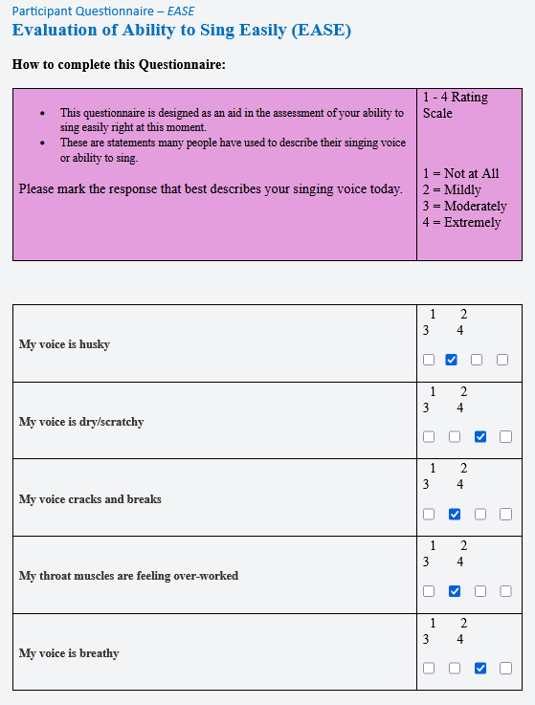

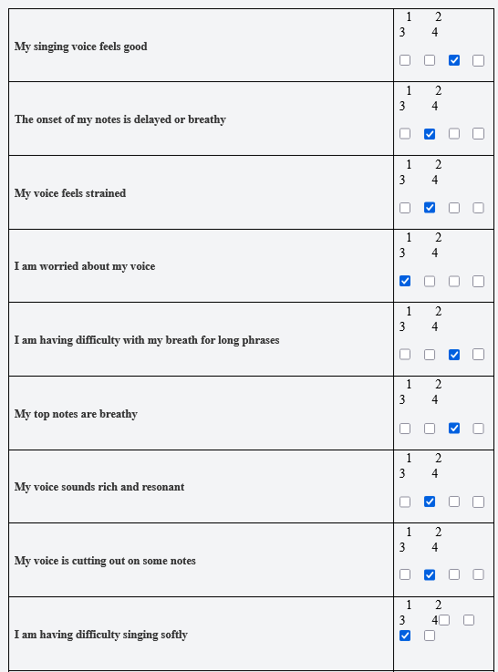

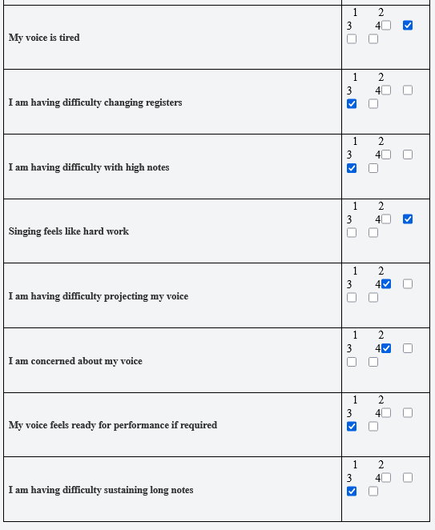

Participant 3, Jenni:

Participant 4, Mark:

Participant 5, Frank:
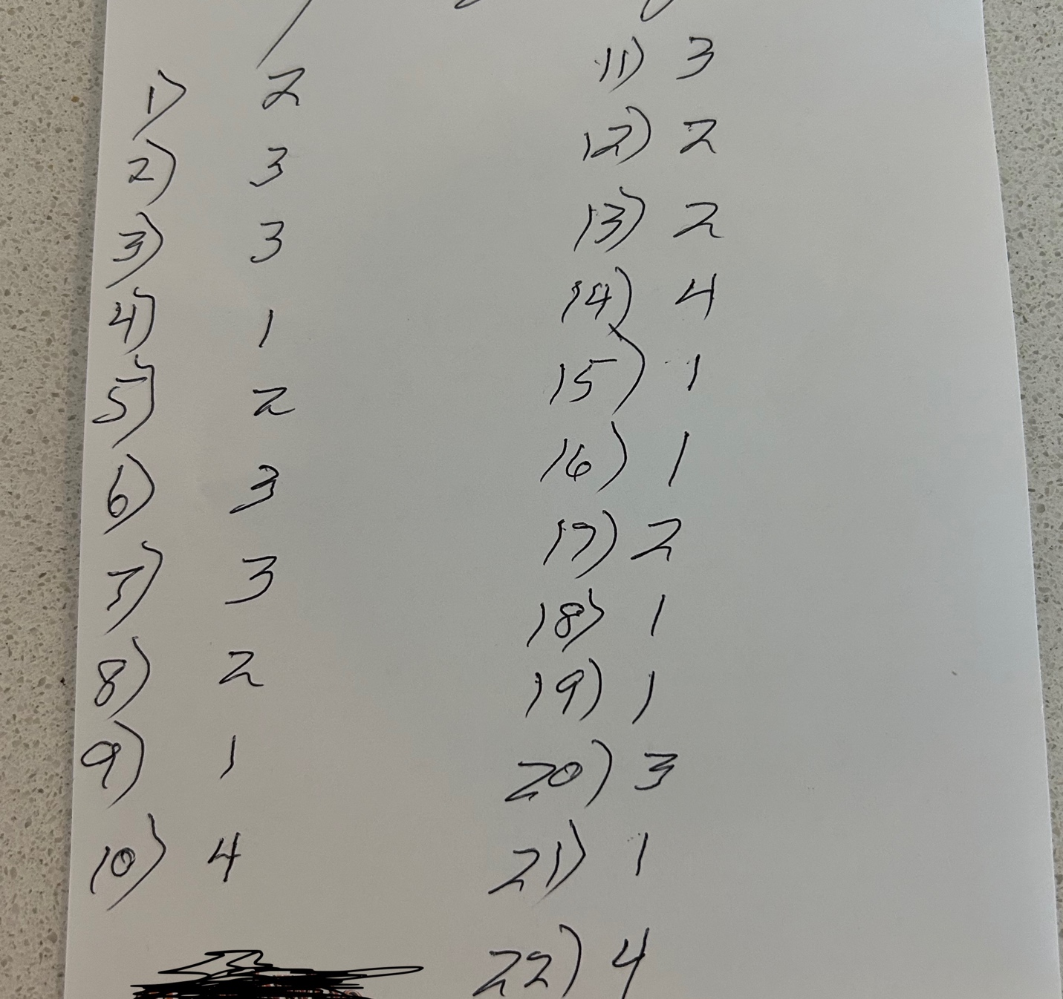

APPENDIX 8 Post-Intervention EASE Questionnaires Answers.

Participant 1, Mel:

Participant 2, Pete:
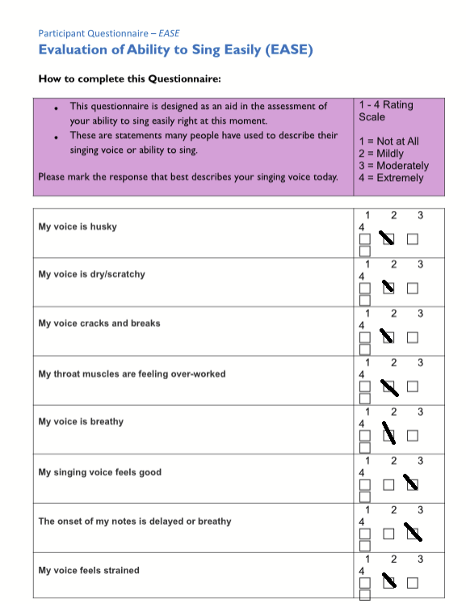
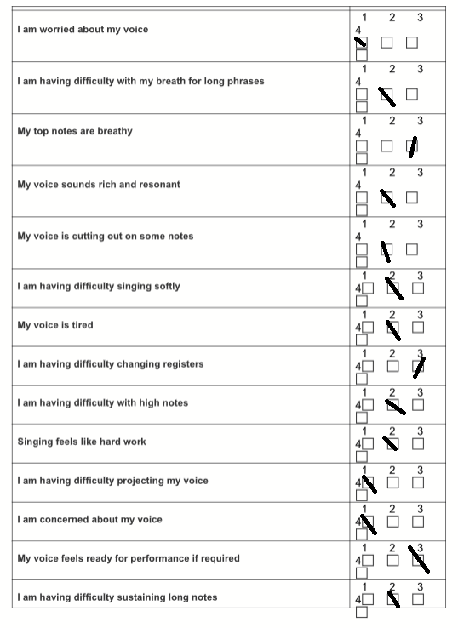
Participant 3, Jenni:
Participant 4, Mark:

Participant 5, Frank:
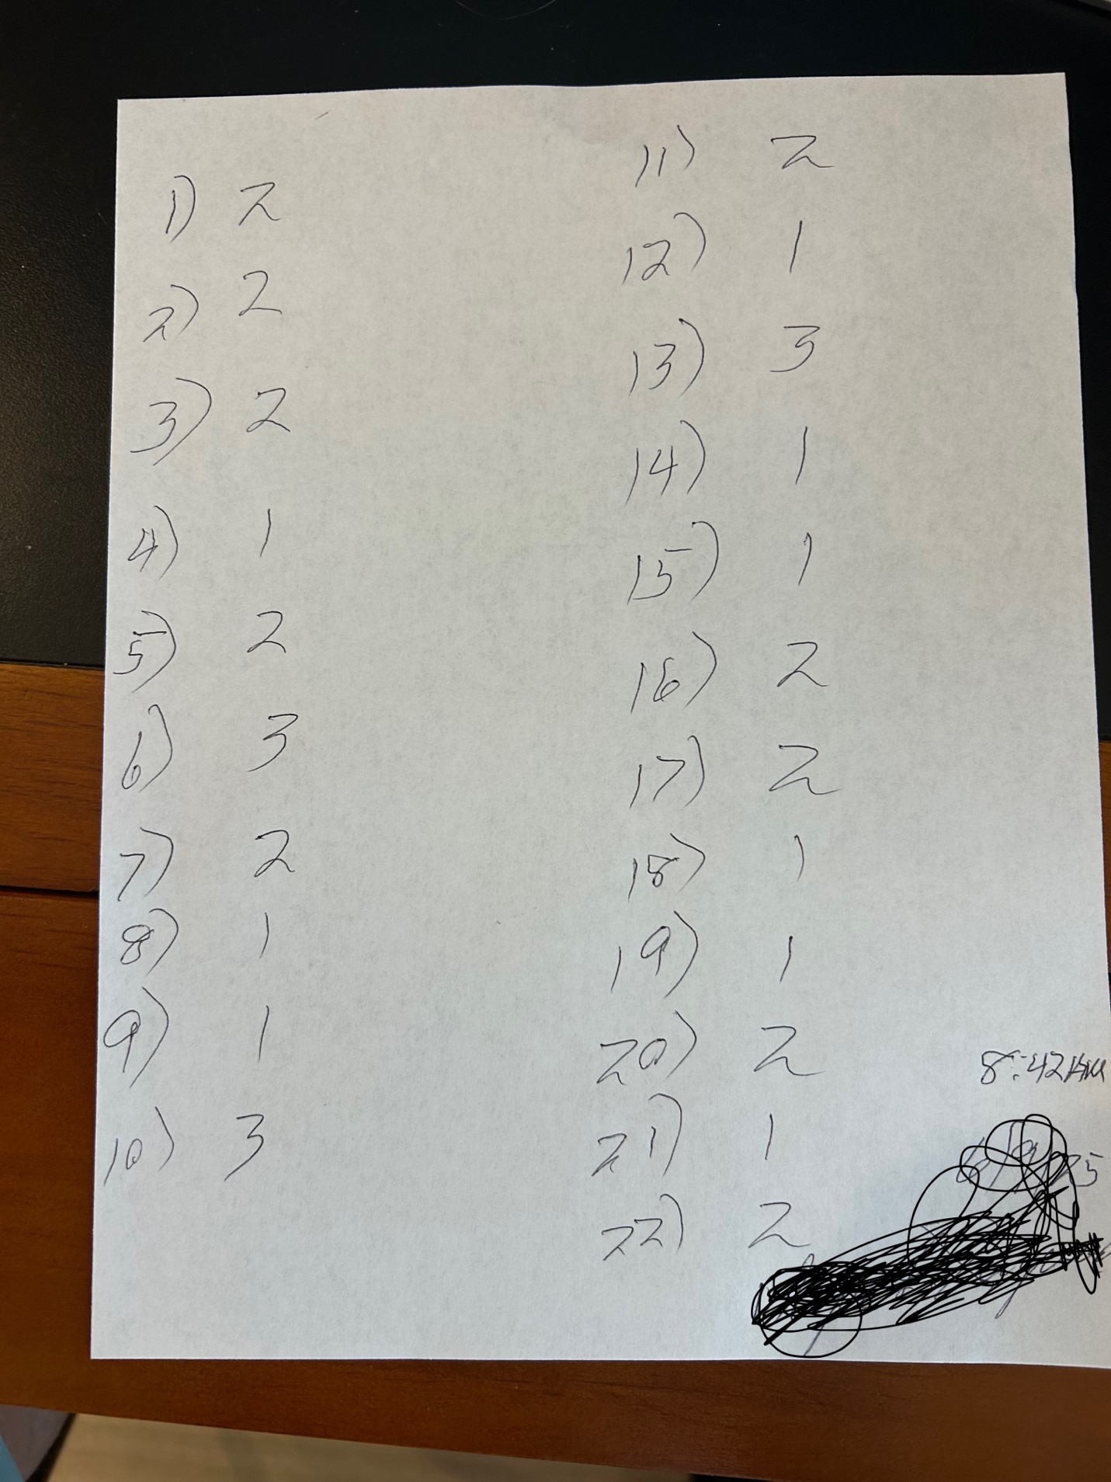
APPENDIX 9 Post-Home Practice Questionnaire Answers with Scores.

APPENDIX 10 Interview Questions

APPENDIX 11 Interviews Transcripts

Participant 1: Mel
1
00:00:00.000 --> 00:00:00.820 Elena Degl’Innocenti: M.
2
00:00:02.470 --> 00:00:03.590 Participant 1: Recording.
3
00:00:04.520 --> 00:00:13.960 Elena Degl’Innocenti: So just a couple of general questions before. One is just if you have ever had any previous experiences with body scan meditations.
4
00:00:13.960 --> 00:00:24.700
Participant 1: I have. Yeah, I've done some usually like sleep meditations that are pre-recorded body scan meditations that I listen to on Youtube when I'm having trouble settling down at night.
5
00:00:24.940 --> 00:00:31.610
Elena Degl’Innocenti: Okay. And how was the experience of taking your attention through different parts of your body?
6
00:00:32.650 --> 00:00:58.850
Participant 1: It was really interesting. I know the point was not necessarily to make adjustments, but just to notice what your body was doing, but I did notice things that I felt were inhibiting me, and when I made those adjustments I felt a lot more openness in my body. Do you want me to go into a little bit of detail about that, or yeah.
7
00:00:58.850 --> 00:00:59.930 Elena Degl’Innocenti: To go. Yeah.
8
00:00:59.930 --> 00:01:00.540 Participant 1: Right.
9
00:01:00.640 --> 00:01:07.765
Participant 1: So I think sort of the the main 2 things is, I've been working on my posture lately.
10
00:01:08.460 --> 00:01:35.189
Participant 1: So realizing, you know that I thought I was sitting up straight, but then I actually wasn't. And then, once I, you know, took took a moment to notice that I found a lot more room to expand. But then I also noticed that the way I was sitting, that my hips rocked forward a little bit that was constricting
11
00:01:35.470 --> 00:01:45.320
Participant 1: the ability of my diaphragm to expand down because it was sort of blocking off the top of my pelvis, and if I sort of
12
00:01:45.320 --> 00:02:11.200
Participant 1: sat more back on my hip bones. Then I had a much more open flow through of the breath in my body, which is really helpful, because one of my interests in singing particularly is musical theater where you're not because of, you know acting or what's going on in the scene, you're not always able to stand in an optimal position, you know, if you're doing, you know, concert music or something like that.
13
00:02:11.780 --> 00:02:22.709
Participant 1: So it's really helpful to be able to notice little adjustments that I can make that can improve my singing when I'm not able to like, you know.
14
00:02:23.110 --> 00:02:26.040 Participant 1: you know, be be in the most optimal physical position.
15
00:02:26.260 --> 00:02:35.799
Elena Degl’Innocenti: Yeah, yeah, absolutely. And can you recall any body areas that felt new to you?
16
00:02:42.510 --> 00:03:01.750
Participant 1: I liked the note that you gave about relaxing the back of your eyeballs. That was not really a part of my body that I had really thought about. But when you said to do that, I realized like, Oh, I know exactly what she means. I had just never thought about it in that way.
17
00:03:07.512 --> 00:03:13.668
Participant 1: I think that's the only area of my body that I was like. Oh, I've I've really never
18
00:03:14.630 --> 00:03:17.999
Participant 1: sort of engaged with this in a meditation practice.
19
00:03:18.440 --> 00:03:30.109
Participant 1: but other times that I do. The body scans. You know
I've usually done them for sleep, so I'll be lying down this one I was usually doing sitting you know, before our lesson I'm usually at my piano.
20
00:03:30.772 --> 00:03:37.340 Participant 1: So doing it sitting. I was a little bit more aware of. You know the way my diaphragm and my pelvis.
21
00:03:37.685 --> 00:03:38.030 Elena Degl’Innocenti: Hmm.
22
00:03:38.030 --> 00:03:50.430
Participant 1: Interact with each other. So while it wasn't new sort of thinking about the way those parts of my body are affecting each other was. Something was a new way of thinking about it.
23
00:03:50.430 --> 00:03:51.740 Elena Degl’Innocenti: Yeah. Yeah.
24
00:03:52.580 --> 00:03:59.580
Elena Degl’Innocenti: And did you have any difficulty being aware of any part of the any body part.
25
00:04:00.410 --> 00:04:03.770
Participant 1: In terms of it being the body part, or my awareness like.
26
00:04:03.770 --> 00:04:09.150
Elena Degl’Innocenti: Your awareness, like staying with that body, part with awareness.
27
00:04:09.150 --> 00:04:36.550
Participant 1: Oh, yeah, yeah, that's something that I have struggled with in meditation in general. And I feel like when I'm meditating. I have a hard time staying with my body, and I would mentally sort of feel tempted to jump ahead to the next section, so that that was a challenge for me. It was something I really needed to work on, and just depending on what was going on with me. Some days went better than others.
28
00:04:36.900 --> 00:04:46.660
Elena Degl’Innocenti: Well, actually, this leads me very quickly to very, very well, actually, to the next question, which is like, How was your mind? Because that's connected to how the mind was. Yeah.
29
00:04:46.850 --> 00:04:49.970
Elena Degl’Innocenti: So how was your mind during the body? Scan meditation?
30
00:04:50.140 --> 00:05:04.740
Participant 1: Yeah, yeah, some some days, you know, I'm someone who struggles with shutting my brain off. And I mean, I know that's not entirely the point of meditation. But I that's something that I struggle with about it.
31
00:05:04.740 --> 00:05:05.140 Elena Degl’Innocenti: In general.
32
00:05:05.140 --> 00:05:35.060
Participant 1: And then, you know, some days were worse than others, but I remember telling you at one time that we did it together, that while I felt like I was really struggling during it, that by the time we got to the end, in the sort of you know, being aware of your whole body. Once we sort of put the whole thing together. I felt very sort of deep into the meditation, and so it took me a while, but I kind of got there in the end.
33
00:05:35.800 --> 00:05:39.470 Elena Degl’Innocenti: Got it, which is, you know, actually.
34
00:05:40.250 --> 00:05:42.150 Participant 1: Another question would be like.
35
00:05:42.540 --> 00:05:58.999
Elena Degl’Innocenti: If there's any difference between the live track. Sorry the live track, the track, and the live version of this. If you find, if you found any difference, you know, between the 2 when it comes to, you know to your mind and.
36
00:06:05.270 --> 00:06:12.400
Participant 1: I think that sort of the difference, for my mind was just like the awareness of
37
00:06:14.450 --> 00:06:19.112 Participant 1: a a being perceived while I was doing it
38
00:06:19.930 --> 00:06:26.080
Participant 1: And then also just sort of like the difference in anticipation
39
00:06:26.210 --> 00:06:39.910
Participant 1: that I had a pretty good idea of when the track was going to move on to the next thing, whereas doing it in real time with you, I, you know, could never be quite sure when when your voice was going to come back.
40
00:06:40.230 --> 00:06:48.669
Elena Degl’Innocenti: Yes, yes, I understand. And if you look back at the beginning of this practice, you know a few weeks ago.
41
00:06:49.470 --> 00:06:57.150
Elena Degl’Innocenti: how did you feel, then, at the beginning, if you can recall it about the level of your attention
42
00:06:57.710 --> 00:06:59.150 Elena Degl’Innocenti: during the body, scan.
43
00:07:03.700 --> 00:07:05.732 Participant 1: I think that
44
00:07:06.810 --> 00:07:13.900
Participant 1: the 1st couple of times we did it. I I wouldn't necessarily remember what the next
45
00:07:14.130 --> 00:07:26.200
Participant 1: step was going to be so I might be like a little bit more focused on that, because I didn't necessarily know exactly where we're going next, whereas by the time I was used to it. I think it was a little easier to anticipate.
46
00:07:27.225 --> 00:07:30.200 Participant 1: Where where we were going. After that.
47
00:07:30.200 --> 00:07:30.660 Elena Degl’Innocenti: Got it.
48
00:07:30.660 --> 00:07:34.868
Participant 1: Gonna be like, oh, okay, we did the arms, and then we're gonna go back to the chest after.
49
00:07:35.360 --> 00:07:44.220
Elena Degl’Innocenti: So how would how? How do you feel now? Like, you know? Sort of at the at the end of the of this meditation.
50
00:07:44.220 --> 00:07:44.740 Participant 1: Yeah. So
51
00:07:45.250 --> 00:08:04.649
Participant 1: sort of in that regard. It fed a little bit into my temptation to just like mentally move on to the next step, but also I feel like being in regular practice of meditation has made it easier to get to the.
52
00:08:05.520 --> 00:08:11.350
Participant 1: to a state where I'm I'm sitting with the relaxation, and the body part a little bit more so.
53
00:08:11.945 --> 00:08:12.540 Elena Degl’Innocenti: Yeah.
54
00:08:13.180 --> 00:08:14.589 Participant 1: Little bit of the other.
55
00:08:14.590 --> 00:08:25.159
Elena Degl’Innocenti: Yeah. Yeah. And then, when I asked you to pay attention to your whole body, I know you have already mentioned this. But just how was that experience in your own words?
56
00:08:26.022 --> 00:08:37.299
Participant 1: That I I the part of it that I really love is not just like being aware of your whole body. But like there's the moment where you say, like to take space.
57
00:08:37.545 --> 00:08:39.669 Elena Degl’Innocenti: That was my next question. So there you go!
58
00:08:39.669 --> 00:08:40.219 Participant 1: I'm jumping.
59
00:08:40.220 --> 00:08:42.260 Elena Degl’Innocenti: No, no, no, that's perfect.
60
00:08:42.640 --> 00:08:43.179 Elena Degl’Innocenti: Okay.
61
00:08:43.837 --> 00:08:59.082
Participant 1: Yeah, I have this little like mental image that I developed that when you're aware of your whole body that I imagine like a big, you know, like a big soap bubble around like the whole area that I'm sitting in. And then, when you said to take space, I
imagine, like
62
00:08:59.499 --> 00:09:08.157
Participant 1: like a white fog, like filling up that bubble. So I'm sort of like in a cloud in inside this bubble.
63
00:09:08.889 --> 00:09:14.804
Participant 1: And that was a mental image that worked well for me, that
64
00:09:15.789 --> 00:09:21.917
Participant 1: that that. Yeah, that's sort of like putting putting the whole thing together. The awareness of your whole body.
65
00:09:23.329 --> 00:09:26.492 Participant 1: I felt very like physically comfortable.
66
00:09:27.329 --> 00:09:35.489
Participant 1: very connected like that. That was kind of the best part for me was putting the whole thing together at the end.
67
00:09:36.069 --> 00:09:42.237
Participant 1: Yeah. And and that sort of visual metaphor of like taking space and filling up this bubble.
68
00:09:43.629 --> 00:10:07.889
Participant 1: was something that. Yeah, I felt that I could sort of like fulfill that metaphor and like. And then, after we would sing a note, you'd say like, Come back, you know, like, you know, go back to like being aware of your whole body, and then I would like step back into, like, you know, revisualize myself in the bubble, and it was a very comfortable thing to come back to.
69
00:10:08.660 --> 00:10:13.279 Elena Degl’Innocenti: Okay? And let's see how
70
00:10:15.200 --> 00:10:28.289
Elena Degl’Innocenti: this is just more specific to the body sensations, how did your body or body parts feel when you 1st placed your attention there, you know, like that moment.
71
00:10:36.000 --> 00:10:52.739
Participant 1: I mean, yeah, I mostly I would notice if I was like hold holding myself too much. So I I you know, or then like, if I moved on to something else, I would might be like, Oh, I'm overcompensating with this other body part. Yeah.
72
00:10:53.060 --> 00:10:55.152 Elena Degl’Innocenti: Yeah, yeah, yeah, I understand.
73
00:10:56.240 --> 00:11:05.459
Elena Degl’Innocenti: And and after meditation, how did your body feel after meditation?
74
00:11:05.460 --> 00:11:18.269
Participant 1: Yeah, definitely like by the end. And when we got to the part of like, you know, the awareness of your whole body that I really felt like a more cohesive sense of relaxation throughout.
75
00:11:18.270 --> 00:11:20.819 Elena Degl’Innocenti: Good morning. Okay, great. Yes.
76
00:11:21.120 --> 00:11:33.569
Elena Degl’Innocenti: So from the beginning of these few weeks until now, basically, did anything change in your body after meditation, like kind of to see the arch of.
77
00:11:34.320 --> 00:11:34.810 Elena Degl’Innocenti: If you had.
78
00:11:35.077 --> 00:11:41.240
Participant 1: Mentioned this a little bit before that sort of being aware of the way that I was holding my body where I was.
79
00:11:41.240 --> 00:11:41.750 Elena Degl’Innocenti: That's right.
80
00:11:43.280 --> 00:11:54.520
Participant 1: like, yeah, a little bit like the tension. But I think mostly the way that, like, you know, my my posture was slumped, or my or I was leaning a little bit too much forward, and it was sort of cutting off
81
00:11:54.780 --> 00:12:03.379
Participant 1: my my expansion. So and that's that's an awareness that
I have now that even when I just like
82
00:12:03.540 --> 00:12:11.530
Participant 1: just to sit down at the piano, or when I sing my daughter a lullaby at night. And I'm like curled up on the floor next to her bed.
83
00:12:13.350 --> 00:12:17.459
Participant 1: That I can be aware of
84
00:12:17.950 --> 00:12:27.259
Participant 1: how those areas of my body interact and how I can find that expansion to have sort of a more optimal flow.
85
00:12:28.190 --> 00:12:28.760 Elena Degl’Innocenti: Yeah.
86
00:12:28.760 --> 00:12:30.359 Participant 1: One single.
87
00:12:30.360 --> 00:12:33.310 Elena Degl’Innocenti: Yeah, that's cool.
88
00:12:34.750 --> 00:12:48.279
Elena Degl’Innocenti: And since you're already starting to think about singing, that was actually my next question. You're reading my head. No, it's okay, how did your body feel when you were vocalizing that part of the meditation.
89
00:12:49.310 --> 00:12:52.999
Elena Degl’Innocenti: How did your body feel while you were vocalizing.
90
00:12:53.000 --> 00:13:10.029
Participant 1: It's only because, you know, we we had gone through the whole body like top to bottom. And then by the time I was like, Okay, we're gonna sing. I was like, I haven't thought about what my mouth and throat and face are doing. In several minutes, like we were, we were at my toes. That was a long way away.
91
00:13:11.375 --> 00:13:11.970 Participant 1: Yes.
92
00:13:12.440 --> 00:13:23.960
Participant 1: so I would always be a little worried that, like, you know, like, Oh, God! My mouth is dry like my mouth is glued shut. I'm gonna open my mouth and like nothing's gonna come out. But it always did.
93
00:13:24.000 --> 00:13:45.399
Participant 1: and it always like maybe I could have used like a little to like clear my throat, but like it wouldn't just like croak out, it would be like, Oh, that's actually a nice resident sound. So even though, yeah, I would be a little worried. I'm like, Oh, is this is, am I actually going to be able to produce a sound. It was always like it was always there for me. By the time I got.
94
00:13:45.400 --> 00:14:03.059
Elena Degl’Innocenti: Yeah. Yeah. My next action actually was kind of almost like, like, how did you did your voice feel when you 1st opened your mouth to vocalize you like that 1st one. You basically already said it. But it's you know.
95
00:14:03.580 --> 00:14:10.169
Elena Degl’Innocenti: But it, you know it sounds like it. It. Tell me if I'm actually you know what? No, no, if you
96
00:14:10.330 --> 00:14:16.740
Elena Degl’Innocenti: you already said that if you want to add anything to it, it's fine, or if you don't want to add anything to it. It's also fine.
97
00:14:17.430 --> 00:14:35.782
Participant 1: Yeah, like, sometimes, you know, I had last been thinking about my toes. So maybe you know some some bad habits like, you know, I had my tongue relaxed in my mouth, but now I've stuck it back to the roof of my mouth, or like Oh, my! My neck has sort of like, you know.
98
00:14:36.370 --> 00:14:39.129 Participant 1: bowed forward. And now I'm not flowing, and I'm late
99
00:14:40.320 --> 00:14:49.184
Participant 1: re readjust, because some of those bad habits back there have crept back in by the time I'm like, Oh, I'm finally thinking about like that part of my head again.
100
00:14:50.900 --> 00:14:55.431
Participant 1: So there was like, Oh, Sing, I wasn't like, yeah, I'm ready. But
101
00:14:55.910 --> 00:15:06.689
Participant 1: but yeah, anytime I sang. It was never like, Oh, no, there was always like a sound that was available to come out that.
102
00:15:06.690 --> 00:15:07.530 Elena Degl’Innocenti: Yeah, yeah, yeah. 103
00:15:07.530 --> 00:15:12.849 Participant 1a: Didn't sound like someone who had hadn't warmed up.
104
00:15:14.370 --> 00:15:40.130
Elena Degl’Innocenti: Yeah, well, that no. I mean, you basically told me everything. My next question would have been like, How did your voice feel during this vocalization. So you know, I asked you about the beginning of the vocalization. But then they continued, right, I mean you did it, you know, a few times, and you even sang a long note, and and then a longer phrase. So you know, this was a pretty long type of sound held out right?
105
00:15:40.590 --> 00:15:45.209
Elena Degl’Innocenti: So it's more about like how you felt during during.
106
00:15:45.330 --> 00:15:46.490 Participant 1: Which is.
107
00:15:47.050 --> 00:15:49.160 Elena Degl’Innocenti: If you noticed anything really.
108
00:15:54.500 --> 00:16:01.019
Participant 1: yeah, I always felt like I was in a good physical position to produce a good sound
109
00:16:01.848 --> 00:16:07.951
Participant 1: you know, there are times I'm like, I wish I had a sip of water right now.
110
00:16:08.430 --> 00:16:14.480 Participant 1: But yeah, I didn't feel like tight or locked up.
111
00:16:14.700 --> 00:16:15.390 Elena Degl’Innocenti: Okay.
112
00:16:15.390 --> 00:16:16.244 Participant 1: Like that. Yeah. 113
00:16:16.530 --> 00:16:17.070 Elena Degl’Innocenti: Yeah.
114
00:16:18.050 --> 00:16:28.080
Elena Degl’Innocenti: And since the beginning of this practice, have you? I mean, have you noticed any changes in your singing? This is just general question about singing.
115
00:16:28.440 --> 00:16:30.648 Participant 1: Yeah, I I think so.
116
00:16:32.900 --> 00:16:52.839
Participant 1: yeah, you know, sort of the things that I mentioned before about being more aware of what body positions allow for really maximum expansion of my lungs and my diaphragm, my neck, so that I'm not sort of like kind of like turtlenecking forward and closing off that space.
117
00:16:54.950 --> 00:17:07.720 Participant 1: yeah. And sort of like, aware of of the the openness. Then I'm able to more quickly achieve that, because I've I've gotten so familiar with what that feels like.
118
00:17:08.270 --> 00:17:20.149
Elena Degl’Innocenti: Yeah, yeah, and just a few more questions. It is just a feedback. Well, for me, actually, and for the track, you know, for making tracks like that. How did you feel about the background? Music.
119
00:17:20.430 --> 00:17:29.889
Participant 1: I was fine with it. I know you said a few other people found it distracting, but it's similar to other music that I have listened to for other meditations so.
120
00:17:29.890 --> 00:17:30.380 Elena Degl’Innocenti: Yes.
121
00:17:30.635 --> 00:17:36.500
Participant 1: So May. Maybe it was just because I it. It did not feel unusual to me that I did not find it distracting.
122
00:17:36.500 --> 00:17:41.658 Elena Degl’Innocenti: Yes, what are you doing, my! My cat? Just
123
00:17:42.630 --> 00:17:46.650 Elena Degl’Innocenti: She just like planted her paws in me.
124
00:17:47.094 --> 00:17:47.359 Participant 1: Okay.
125
00:17:48.280 --> 00:17:49.380 Elena Degl’Innocenti: She's I don't know.
126
00:17:49.380 --> 00:17:50.760 Participant 1: See you back there.
127
00:17:51.300 --> 00:17:54.340
Elena Degl’Innocenti: She's like she's taking most of the the chair, anyway.
128
00:17:54.580 --> 00:17:56.990 Participant 1: Mine's on the top of the chair back there now.
129
00:17:56.990 --> 00:17:57.610 Elena Degl’Innocenti: I see, I see.
130
00:17:57.610 --> 00:17:58.479 Participant 1: What else he has here.
131
00:17:58.480 --> 00:18:04.436
Elena Degl’Innocenti: I see it. There's a big halo, but I can see the cat. Yeah, I can see it now
132
00:18:04.980 --> 00:18:14.679
Elena Degl’Innocenti: and now, and was the where the instructions? In the meditation track clear to you, generally speaking. Yes, okay.
133
00:18:15.192 --> 00:18:20.479
Elena Degl’Innocenti: And and how did you feel about choosing a place to be in your imagination?
134
00:18:23.370 --> 00:18:28.163
Participant 1: I I would a little bit like overthink it. I'd be like no, that one's not good enough.
135
00:18:29.637 --> 00:18:33.260 Elena Degl’Innocenti: Like, yeah.
136
00:18:34.530 --> 00:18:39.290
Participant 1: so I and and it. It wasn't an image that I would really feel like I held on to.
137
00:18:39.520 --> 00:18:40.050 Elena Degl’Innocenti: One of the.
138
00:18:40.050 --> 00:18:41.180 Participant 1: Duration of it.
139
00:18:43.060 --> 00:18:45.310
Participant 1: So I don't know. I'm
140
00:18:45.600 --> 00:19:00.249
Participant 1: I'm not sure that I would get a different result if we skipped that part, and I thought that I would, and I personally felt like I would a little bit like critique. My my choice of relaxing.
141
00:19:00.250 --> 00:19:01.329 Elena Degl’Innocenti: I understand it.
142
00:19:01.330 --> 00:19:04.228 Participant 1: That might. That might just be a me thing.
143
00:19:04.550 --> 00:19:20.860
Elena Degl’Innocenti: No, I mean, this is this is all. Yeah. I mean, it's it's your interview. So I definitely want to know what your experience was. So that's good, and any feedback at all about the track. Anything that you would want to hear different, anything, anything.
144
00:19:22.671 --> 00:19:24.728 Participant 1: Nothing's really jumping to mind.
145
00:19:25.410 --> 00:19:26.160 Elena Degl’Innocenti: Okay
146
00:19:27.170 --> 00:19:38.789
Elena Degl’Innocenti: and just final final question. This is just about a general level of awareness of your body now, compared to before. Like I know you already.
147
00:19:39.080 --> 00:19:47.939
Elena Degl’Innocenti: You already said a lot about this, but this is sort of like to close it off to kind of like dig even deeper into it like you know about? How do you feel about.
148
00:19:47.940 --> 00:19:53.412 Participant 1: That I mentioned that. I've I've been aware of
149
00:19:55.010 --> 00:20:15.830
Participant 1: that I have terrible posture, and it was something I was already trying to correct. But I think, having a practice like this, that it's not just like, hey, are you sitting up straight? No, you're not sit up straight, but really knowing what it feels like when your body is
150
00:20:16.730 --> 00:20:23.745
Participant 1: experiencing the a more like optimized like flow and sense of connection.
151
00:20:24.500 --> 00:20:28.340 Participant 1: makes it easier to find that place again.
152
00:20:28.810 --> 00:20:30.929 Elena Degl’Innocenti: Yes, yes, I understand.
153
00:20:31.710 --> 00:20:34.609 Elena Degl’Innocenti: Awesome. Thank you so much.
154
00:20:34.610 --> 00:20:35.380 Participant 1: You're welcome.

Participant 2: Pete
1
00:00:03.240 --> 00:00:09.110
Elena Degl’Innocenti: Okay, so general question about this body. Scan meditation.
2
00:00:09.830 --> 00:00:14.920
Elena Degl’Innocenti: Have you had any previous experiences of body scan mutations.
3
00:00:16.980 --> 00:00:18.469 Participant 2: No, no, I haven't.
4
00:00:20.530 --> 00:00:23.050 Elena Degl’Innocenti: The cat is no.
5
00:00:23.530 --> 00:00:24.430 Elena Degl’Innocenti: Okay.
6
00:00:25.670 --> 00:00:31.710
Elena Degl’Innocenti: How was the experience of taking your attention through different areas of your body?
7
00:00:35.324 --> 00:00:42.190 Participant 2: I thought it was pretty interesting, and especially
8
00:00:42.460 --> 00:00:49.459
Participant 2: I think I'm someone who doesn't really fixate too strongly on my body
9
00:00:49.590 --> 00:00:59.300
Participant 2: like I'll notice that I have like a like a scab, and I don't even remember cutting my leg, you know, stuff like that, and so
10
00:00:59.500 --> 00:01:04.769 Participant 2: taking the time to be connected with everything did
11
00:01:05.670 --> 00:01:09.570 Participant 2: really make it feel more like like one whole unit. 12
00:01:11.660 --> 00:01:14.270 Elena Degl’Innocenti: Yeah, that's awesome.
13
00:01:14.730 --> 00:01:19.269
Elena Degl’Innocenti: And can you recall any body areas that felt new to you?
14
00:01:24.820 --> 00:01:29.479 Participant 2: I think I guess.
15
00:01:31.780 --> 00:01:50.190
Participant 2: thinking about it. A lot of them felt new in general, because I was thinking of them in more in context, especially like like the from the top of the head to the to the forehead and temples. This becoming like
16
00:01:50.700 --> 00:01:53.310 Participant 2: the the sort of the model of the head.
17
00:01:54.625 --> 00:02:02.020 Participant 2: And also, like the I guess, like connecting to the
18
00:02:02.370 --> 00:02:05.979 Participant 2: like hip area into like the thigh.
19
00:02:06.892 --> 00:02:14.949
Participant 2: Felt like and the plant, and getting that all into the plant of the feet at the end.
20
00:02:15.960 --> 00:02:17.130 Elena Degl’Innocenti: Yeah. Yeah.
21
00:02:17.590 --> 00:02:27.369
Elena Degl’Innocenti: But did you have any difficulty being aware of any of those parts or any of the parts of your body?
22
00:02:29.725 --> 00:02:36.240
Participant 2: I think the ones that I found the hardest to like connect with were
23
00:02:37.193 --> 00:02:39.010 Participant 2: especially the ones that don't
24
00:02:39.470 --> 00:02:48.296
Participant 2: move quite as actively so like the the lower back. The temples,
25
00:02:49.820 --> 00:02:58.229
Participant 2: and you know, trying to feel like some of the like the toes and fingers where it's like, if you're not moving it, it's like
26
00:02:58.520 --> 00:03:02.810 Participant 2: not as aware of it as like an individual thing.
27
00:03:04.170 --> 00:03:05.630 Elena Degl’Innocenti: Yeah, I understand.
28
00:03:06.975 --> 00:03:11.680 Elena Degl’Innocenti: And let's see.
29
00:03:11.980 --> 00:03:16.250
Elena Degl’Innocenti: And how was your mind during the Bodhiskan meditation?
30
00:03:17.796 --> 00:03:38.489
Participant 2: I mean, I think at the beginning, especially when I was doing it with the music. I really couldn't focus. My mind was constantly wondering, and I kept having to like pull it back, which I find I just find it very easy for my mind to wander in general, if I'm in any situation
31
00:03:38.630 --> 00:03:49.390
Participant 2: where it's not being stimulated. And but like once I did it more without the music. And then, progressively.
32
00:03:49.520 --> 00:04:05.850
Participant 2: as I was more familiar with what I was doing in all the areas of my body that I was trying to get in touch with. It felt more like a game because I knew what the goal was, and so it was easier to stay focused on it.
33
00:04:07.240 --> 00:04:10.254 Elena Degl’Innocenti: Yeah, yeah, yeah, that's cool.
34
00:04:11.590 --> 00:04:15.821 Elena Degl’Innocenti: is, was it? Was it any difference?
35
00:04:17.279 --> 00:04:28.230
Elena Degl’Innocenti: different between the the live body scan edition with me and the recording. You know what I mean, like, as far as your mind.
36
00:04:33.610 --> 00:04:38.960 Participant 2: You know I don't feel like I
37
00:04:39.120 --> 00:04:45.029
Participant 2: felt a huge difference between doing it in person and and listening to it.
38
00:04:45.200 --> 00:04:48.660 Participant 2: I think it felt felt pretty similar to me.
39
00:04:48.660 --> 00:04:50.430 Elena Degl’Innocenti: Okay, yeah.
40
00:04:51.590 --> 00:04:59.279
Elena Degl’Innocenti: And I mean, you partially already answered this question actually like, if you look back at the beginning of this practice a few weeks ago.
41
00:05:01.250 --> 00:05:07.159
Elena Degl’Innocenti: How how did you feel then? You know about the level of your attention during the body scan.
42
00:05:08.963 --> 00:05:11.496
Participant 2: It's pretty pretty low
43
00:05:13.160 --> 00:05:13.840 Elena Degl’Innocenti: Okay.
44
00:05:13.840 --> 00:05:22.599
Participant 2: I definitely wasn't it especially beginning to more visualize what was happening? And
45
00:05:23.210 --> 00:05:42.529
Participant 2: because I find at least like when I'm in a situation like that. Then, if I'm not paying attention, it's just like random images of different things. I start coming to mind but slowly, being able to visualize. You know your body through the sensation of it.
46
00:05:43.150 --> 00:05:44.750 Elena Degl’Innocenti: Yeah, yeah, yeah.
47
00:05:45.590 --> 00:05:48.479 Elena Degl’Innocenti: And how do you feel now? After a few weeks.
48
00:05:50.020 --> 00:05:59.159
Participant 2: I mean, I feel pretty good about it. It definitely could still stand to be more connected. And I think it's something that
49
00:05:59.655 --> 00:06:04.349
Participant 2: is the kind of thing that you need to do regularly for it to
50
00:06:04.690 --> 00:06:11.859
Participant 2: work, because the your awareness will fade if you're not checking in continually.
51
00:06:13.660 --> 00:06:17.773
Elena Degl’Innocenti: Yeah, yeah, well, we can definitely talk more about this later.
52
00:06:19.050 --> 00:06:22.908 Elena Degl’Innocenti: I have some thoughts about that. But
53
00:06:25.020 --> 00:06:33.750
Elena Degl’Innocenti: oh, yeah. When I asked you to pay attention to your whole body at the end. How was the experience in your words? Your own words.
54
00:06:38.830 --> 00:06:41.940 Participant 2: in a way almost a little overwhelming.
55
00:06:42.400 --> 00:06:43.520 Elena Degl’Innocenti: Okay.
56
00:06:45.250 --> 00:06:51.420
Participant 2: Because it's like so many different things, and you can sort of like
57
00:06:52.030 --> 00:07:01.059
Participant 2: feel the sense of them when you fixate on each part and doing that across the whole body.
58
00:07:02.880 --> 00:07:07.650
Participant 2: Feels like, you're kind of like juggling your your awareness.
59
00:07:07.910 --> 00:07:13.810
Participant 2: Yeah, where you can have the balance. But you have to really like, find the moment to
60
00:07:14.980 --> 00:07:17.349 Participant 2: encapsulate it all at once.
61
00:07:18.660 --> 00:07:24.730
Elena Degl’Innocenti: Yeah, that's interesting. I mean, it's interesting. What you're saying. Actually, it's an interesting yeah.
62
00:07:24.940 --> 00:07:38.899
Elena Degl’Innocenti: anyway, it's interesting. And and and you know, after after that part, I say, in the you know, live or in the recording, I said, take space. How was that experience
63
00:07:39.480 --> 00:07:40.970 Elena Degl’Innocenti: in your own words? 64
00:07:42.286 --> 00:07:49.060
Participant 2: That I think, is really it? Actually, it made me think of I hadn't ever.
65
00:07:49.400 --> 00:07:56.019
Participant 2: I feel like seeing this in a way that I had thought about it, but like like when you see someone use Chi
66
00:07:56.140 --> 00:07:57.310 Participant 2: where.
67
00:07:57.310 --> 00:07:57.690 Elena Degl’Innocenti: Yes.
68
00:07:57.690 --> 00:08:15.519
Participant 2: Have, like their spirit energy that surrounds them, and they are able to manipulate that as an extension of their own energy. And it was that kind of sensation where it feels almost like you have a field around you that's like the extension of of yourself.
69
00:08:15.710 --> 00:08:16.610 Elena Degl’Innocenti: Awesome.
70
00:08:18.530 --> 00:08:24.515 Elena Degl’Innocenti: That's very cool. I like that and
71
00:08:26.490 --> 00:08:34.370
Elena Degl’Innocenti: and more in the specific of of sensations of body sensations.
72
00:08:34.620 --> 00:08:45.920
Elena Degl’Innocenti: How did your body or body parts, you know either the whole body or body parts feel. When you 1st placed attention your attention there, like
73
00:08:46.250 --> 00:08:51.979
Elena Degl’Innocenti: the 1st moment, you know, like when you move from one to the next, like how that 1st moment.
74
00:08:56.330 --> 00:09:02.930
Participant 2: I think in the 1st moment it's almost like a little bit of discomfort, because it's like the feeling of
75
00:09:03.090 --> 00:09:06.540 Participant 2: like your nerd, I guess, like your
76
00:09:07.170 --> 00:09:12.890
Participant 2: muscle, like your motor nerves being ready to activate but not activating.
77
00:09:12.960 --> 00:09:19.490 Elena Degl’Innocenti: Huh? Yeah, yeah, very interesting.
78
00:09:20.640 --> 00:09:23.400
Elena Degl’Innocenti: I don't know. And
79
00:09:25.290 --> 00:09:32.130
Elena Degl’Innocenti: And after meditation after the meditation, so that was the 1st moment right? But after.
80
00:09:35.130 --> 00:09:38.359 Elena Degl’Innocenti: You left with in your body, you know.
81
00:09:38.630 --> 00:09:40.120 Participant 2: In terms of like sensation.
82
00:09:40.120 --> 00:09:41.909 Elena Degl’Innocenti: Yeah, in terms of cessation. Yeah.
83
00:09:45.700 --> 00:09:48.580 Participant 2: I mean I feel like it. It makes
84
00:09:50.220 --> 00:09:54.409 Participant 2: like it made me feel more rooted
85
00:09:56.640 --> 00:10:00.299 Participant 2: when like, whenever it was after it. 86
00:10:00.430 --> 00:10:03.350 Participant 2: and I did feel more like I could
87
00:10:03.580 --> 00:10:09.360 Participant 2: like be one whole, especially like the feeling of
88
00:10:09.470 --> 00:10:21.300
Participant 2: like breath, like like there's a like a big pipe going craw down through the whole body. That feeling particularly, I felt like stuck
89
00:10:21.610 --> 00:10:24.470 Participant 2: pretty pretty hard after meditation.
90
00:10:27.300 --> 00:10:32.490
Elena Degl’Innocenti: You felt stuck. Sorry. Can you can you explain that a little more.
91
00:10:32.790 --> 00:10:38.489 Participant 2: Sorry like. Just the the air coming through
92
00:10:38.780 --> 00:10:46.370 Participant 2: lungs, diaphragm exhalation out as one long motion
93
00:10:46.780 --> 00:10:50.639
Participant 2: rather than each thinking specifically about like the lungs.
94
00:10:50.640 --> 00:10:51.160 Elena Degl’Innocenti: I see.
95
00:10:51.160 --> 00:10:55.900 Participant 2: Or you know you're the middle of the body, etc.
96
00:10:56.090 --> 00:10:58.710 Elena Degl’Innocenti: I understand now. Okay, thank you.
97
00:10:58.890 --> 00:11:05.840
Elena Degl’Innocenti: And from the beginning of these Bothiskana meditation till now.
98
00:11:06.180 --> 00:11:12.829
Elena Degl’Innocenti: did anything change in your body after meditation? So I guess you already. You basically have already told me. But
99
00:11:15.000 --> 00:11:21.090
Elena Degl’Innocenti: if you see any differences, basically from the beginning to later, you know to now, really.
100
00:11:26.220 --> 00:11:30.590 Participant 2: Hmm! Can't think of anything outside of
101
00:11:30.720 --> 00:11:32.690 Participant 2: what I've what I've already said.
102
00:11:33.360 --> 00:11:38.360 Participant 2: Because it feels more like it's just like a a
103
00:11:38.590 --> 00:11:41.930 Participant 2: feeling that's the same, but gets stronger.
104
00:11:42.964 --> 00:11:43.770 Elena Degl’Innocenti: Yeah.
105
00:11:43.990 --> 00:11:44.680 Elena Degl’Innocenti: Yeah.
106
00:11:45.370 --> 00:11:53.429
Elena Degl’Innocenti: And how did your body feel when you were vocalizing that part of the meditation.
107
00:11:58.420 --> 00:12:02.489 Participant 2: At the beginning it was hard to stay relaxed.
108
00:12:02.650 --> 00:12:12.150
Participant 2: because I wanted to go just immediately back into all my previously learned habits.
109
00:12:12.620 --> 00:12:19.269
Participant 2: but towards the and I think that's the one that took the longest to feel more comfortable with.
110
00:12:19.780 --> 00:12:24.680
Participant 2: But towards the end I did have a feeling where it was like
111
00:12:25.380 --> 00:12:31.889
Participant 2: able to just like settle into a sense of, I guess, like release rather than
112
00:12:32.882 --> 00:12:36.610 Participant 2: so much trying to really activate something.
113
00:12:38.250 --> 00:12:39.780 Elena Degl’Innocenti: Yeah. Yeah.
114
00:12:41.230 --> 00:12:47.950 Elena Degl’Innocenti: And another question about localizing.
115
00:12:48.940 --> 00:12:54.119
Elena Degl’Innocenti: How did your voice feel when you 1st opened your mouth to book lice.
116
00:12:57.370 --> 00:12:58.940 Participant 2: Pretty weak!
117
00:12:59.950 --> 00:13:00.740 Participant 2: The.
118
00:13:01.090 --> 00:13:02.040 Elena Degl’Innocenti: Okay.
119
00:13:06.900 --> 00:13:07.760 Participant 2: Yeah, I mean it. 120
00:13:08.110 --> 00:13:09.309 Participant 2: Oh, go ahead. Sorry.
121
00:13:09.310 --> 00:13:11.149 Elena Degl’Innocenti: No no no keep going, keep going.
122
00:13:11.150 --> 00:13:20.359
Participant 2: Oh, I mean, it's just especially at the beginning, because it's fully relaxed and like the larynx is
123
00:13:20.930 --> 00:13:23.239 Participant 2: lower. It's just like
124
00:13:24.010 --> 00:13:31.169
Participant 2: this big release of of breath and air, and so it doesn't have much, much behind it.
125
00:13:31.170 --> 00:13:31.660 Elena Degl’Innocenti: Damn!
126
00:13:31.660 --> 00:13:42.420
Participant 2: But I felt like I was able to find, like more of a pillow point, like somewhere where it can rest without necessarily having to just
127
00:13:43.330 --> 00:13:50.129
Participant 2: explode out in one go. I guess that more consistent release of of sound.
128
00:13:50.820 --> 00:13:52.940 Elena Degl’Innocenti: Yeah, I understand.
129
00:13:55.410 --> 00:14:11.289
Elena Degl’Innocenti: and I guess you partially have said that already. But like, because that's just the 1st moment you opened your mouth. But then you kept singing right? I mean, you kept, you know you sent some long notes. So during, you know, during the long notes.
130
00:14:14.500 --> 00:14:15.850 Elena Degl’Innocenti: How was that?
131
00:14:21.800 --> 00:14:25.750
Participant 2: I mean, I felt like the
132
00:14:26.170 --> 00:14:35.850
Participant 2: a lot a lot of the notes it was like from the beginning, kind of did define the quality of it overall. So if I.
133
00:14:35.850 --> 00:14:36.280 Elena Degl’Innocenti: Yes.
134
00:14:36.280 --> 00:14:37.380 Participant 2: Very
135
00:14:37.860 --> 00:14:51.090
Participant 2: set in place when I started. Then it would it would tended to stick I guess at the beginning that was more way wishy-washy in terms of even if I had a stronger start.
136
00:14:51.200 --> 00:14:56.820 Participant 2: If I if it didn't sort of waver out towards the end
137
00:14:58.120 --> 00:15:00.964 Participant 2: like being able to hold on to that
138
00:15:01.640 --> 00:15:07.629
Participant 2: feeling of strong vibration, kind of like the the resonance from when you're
139
00:15:07.760 --> 00:15:11.400 Participant 2: like when you're really in tune, that you can hear.
140
00:15:11.400 --> 00:15:18.210 Elena Degl’Innocenti: Yeah, yeah, and and just in general, like.
141
00:15:18.490 --> 00:15:21.050
Elena Degl’Innocenti: since the beginning of this practice, have you noticed.
142
00:15:21.170 --> 00:15:27.869
Elena Degl’Innocenti: or or have you noticed any changes in your singing, or can you say something about your singing? You know, after this.
143
00:15:30.548 --> 00:15:38.070 Participant 2: I mean, I think I think I have become more comfortable.
144
00:15:38.290 --> 00:15:39.410 Elena Degl’Innocenti: And.
145
00:15:40.150 --> 00:15:46.609
Participant 2: Like not having to tense up or try so hard, and especially
146
00:15:47.090 --> 00:16:00.370
Participant 2: with like breathing and support. I think it's useful, just because I can think of things that will like center me or reset my position like
147
00:16:00.540 --> 00:16:04.260 Participant 2: building back up from having a good
148
00:16:04.370 --> 00:16:10.429
Participant 2: centering on the ground. Or, yeah, thinking about like the
149
00:16:10.990 --> 00:16:14.349 Participant 2: the expansion of the breath, and like how like the back
150
00:16:14.710 --> 00:16:22.380
Participant 2: opens up when your when your breath is coming in things like that that help reduce.
151
00:16:22.910 --> 00:16:23.590 Elena Degl’Innocenti: Yeah.
152
00:16:23.590 --> 00:16:24.460 Participant 2: Tension.
153
00:16:28.070 --> 00:16:35.389
Elena Degl’Innocenti: Very interesting and well, you already told me how you felt about the background music. So I'm not going to ask you that question again.
154
00:16:35.700 --> 00:16:48.830 Elena Degl’Innocenti: but was the instruction. This is just for me.
This is a little feedback. Just a few more questions about, you know, just stuff that I could improve. You know the instruction of the meditation track were clear to you
155
00:16:49.010 --> 00:16:55.960
Elena Degl’Innocenti: or not, or there's any really any feedback that you you may want to give me
156
00:16:56.550 --> 00:17:01.619
Elena Degl’Innocenti: about any of you know about that beside the music? Obviously, that already you've already told me.
157
00:17:06.410 --> 00:17:09.940 Participant 2: I feel like I thought it. It was pretty clear.
158
00:17:11.770 --> 00:17:13.920 Participant 2: Trying to think if there was anything.
159
00:17:15.060 --> 00:17:17.969 Participant 2: But nothing's coming to the top of my mind.
160
00:17:17.970 --> 00:17:25.029 Elena Degl’Innocenti: You can always tell me later as something extra. No, no, for this study, anyway.
161
00:17:25.319 --> 00:17:30.969
Elena Degl’Innocenti: Oh, yeah. How did you feel about choosing a place in your imagination? Is it something that
162
00:17:31.410 --> 00:17:33.780
Elena Degl’Innocenti: you know? How? How did you feel about that?
163
00:17:36.526 --> 00:17:37.560 Participant 2: It was.
164
00:17:37.800 --> 00:17:47.449
Participant 2: I guess I don't. It made me think that I don't visualize myself in spaces, I mean, I imagine things often, but I don't visualize myself in a place very often.
165
00:17:47.570 --> 00:17:49.530 Participant 2: so it was
166
00:17:49.770 --> 00:17:55.589
Participant 2: a little hard at first, st like the location changed a couple times because I couldn't. I didn't know
167
00:17:55.750 --> 00:17:59.280
Participant 2: what. I didn't know. What a place I find relaxing was, I guess.
168
00:17:59.890 --> 00:18:11.979
Participant 2: at a desk with a pen and paper I ended up picturing a park I was in in. I went to in Japan. That was full of crows that became my place.
169
00:18:12.850 --> 00:18:15.210 Participant 2: So it was a.
170
00:18:17.310 --> 00:18:21.630 Participant 2: It was interesting, like trying to find find that.
171
00:18:22.300 --> 00:18:23.000 Elena Degl’Innocenti: Yeah.
172
00:18:23.600 --> 00:18:44.159
Elena Degl’Innocenti: yeah, that's I find it to be a very interesting thing, because everyone is very different about this. And some people are more visual than others, and internally, visually, you know. Not just visual in general. I'm sure you're visual, but you know, it's like it's a different type of it's an imaginative kind of process, and
173
00:18:44.440 --> 00:19:00.640
Elena Degl’Innocenti: it may take some time. And anyway, I find it really interesting to see how people react to that. And finally, just generally about the level of your awareness in your body now, compared to before, like, and again it could be.
174
00:19:02.280 --> 00:19:04.360 Elena Degl’Innocenti: But how do you feel about that?
175
00:19:06.581 --> 00:19:14.460
Participant 2: I think that it is a good bit higher in in the sense that
176
00:19:15.340 --> 00:19:25.689
Participant 2: I'm not always aware. But it's a lot easier to be aware, like I know what it feels like to be aware, and if I'm in a moment where
177
00:19:26.050 --> 00:19:30.520 Participant 2: I want to become more conscious of it.
178
00:19:30.640 --> 00:19:35.110
Participant 2: it, like all I have to do is mentally think for a
second, and then I
179
00:19:35.320 --> 00:19:38.909 Participant 2: like, can feel that whole unit, or even like I
180
00:19:39.500 --> 00:19:48.770
Participant 2: felt this doing some like auditions and stuff. We're just like taking a moment to like feel my space
181
00:19:49.320 --> 00:19:52.069 Participant 2: and feeling like that. That helped.
182
00:19:56.080 --> 00:19:58.019 Elena Degl’Innocenti: Awesome. Thank you so much. 183
00:19:58.400 --> 00:20:03.229
Elena Degl’Innocenti: Thank you so much for answering. I will stop the recording now.

Participant 3: Jenni
WEBVTT
1
00:00:06.900 --> 00:00:18.060
Elena Degl’Innocenti: So 1st of all, thank you so much for participating and doing the homework and doing. You know your your part at home. Thank you so much
2
00:00:18.260 --> 00:00:32.290
Elena Degl’Innocenti: so I'll just ask you a few questions. Some are going to be pretty general and some very specific. For example, the very 1st one is very specific, which is, have you had any previous experiences with body scan meditations?
3
00:00:33.320 --> 00:00:34.409 Participant 3: Yes, I have.
4
00:00:35.060 --> 00:00:38.460
Elena Degl’Innocenti: Okay, and
5
00:00:38.940 --> 00:00:47.339
Elena Degl’Innocenti: very general question, how was the experience of taking your attention through different parts of the body?
6
00:00:49.260 --> 00:00:53.029 Participant 3: It was very interesting and eye-opening.
7
00:00:53.880 --> 00:00:55.060
Elena Degl’Innocenti: Okay,
8
00:00:57.560 --> 00:01:04.430
Elena Degl’Innocenti: And can you recall any body areas that felt new to you?
9
00:01:06.620 --> 00:01:09.079 Participant 3: Yes, on your scan.
10
00:01:09.865 --> 00:01:14.919 Participant 3: The separation in between, like my torso that was new.
11
00:01:15.468 --> 00:01:22.210
Participant 3: Your body scan went into more detail than the previous body scans that I've done, and
12
00:01:22.420 --> 00:01:24.820 Participant 3: the space outside of our bodies.
13
00:01:26.179 --> 00:01:33.689
Elena Degl’Innocenti: That's cool! And did you have any difficulty being aware of any part of your body?
14
00:01:34.570 --> 00:01:35.380 Participant 3: No.
15
00:01:35.960 --> 00:01:41.899 Elena Degl’Innocenti: Okay, and how was your mind?
16
00:01:42.470 --> 00:01:44.859 Elena Degl’Innocenti: During the the meditation.
17
00:01:45.770 --> 00:01:57.609
Participant 3: Most times prepared to do the body scan just maybe 2 or
3 times. The chatter was a little louder, but that quieted down as I went into it.
18
00:01:58.040 --> 00:02:12.400
Elena Degl’Innocenti: Okay, okay, did you notice like differences between the live body scan meditation and the one that was recorded in terms of how your mind was.
19
00:02:15.570 --> 00:02:17.519 Participant 3: No, I was present in both.
20
00:02:18.440 --> 00:02:25.279
Elena Degl’Innocenti: Okay. And now, if you look back at the beginning of this practice 4 weeks ago, I guess.
21
00:02:26.230 --> 00:02:34.049
Elena Degl’Innocenti: how do you feel? How did you feel actually about the level of your attention during the body scan.
22
00:02:35.140 --> 00:02:36.409 Elena Degl’Innocenti: So at the beginning.
23
00:02:36.410 --> 00:02:36.780 Participant 3: Real.
24
00:02:36.780 --> 00:02:37.620 Elena Degl’Innocenti: Please, practice.
25
00:02:37.620 --> 00:02:39.420 Participant 3: Yeah, it, definitely.
26
00:02:39.420 --> 00:02:43.920
Elena Degl’Innocenti: So. How was it at the beginning? If you could describe it?
27
00:02:44.470 --> 00:03:00.399
Participant 3: I think the very 1st time I was probably curious, so I was following along with almost curious kind of what next? That kind of a thing, but with practice. And that's what I did. It was much easier because you already knew what was coming.
28
00:03:00.540 --> 00:03:02.030
Participant 3: so it was easier to just
29
00:03:02.450 --> 00:03:07.539
Participant 3: it, or I also noticed that if, like on the days that my mind was full of chatter.
30
00:03:08.638 --> 00:03:12.709 Participant 3: having your perfectly paced and timed
31
00:03:12.910 --> 00:03:17.240
Participant 3: instructions helped to mitigate that it was very helpful.
32
00:03:17.690 --> 00:03:30.099
Elena Degl’Innocenti: Oh, great how and how do you feel now about that like after? You know you already said that? It's it's greater now, but like how do you feel now?
33
00:03:30.980 --> 00:03:31.600 Participant 3: Yeah.
34
00:03:31.820 --> 00:03:36.989
Elena Degl’Innocenti: About your attention about the level of your level of attention.
35
00:03:38.000 --> 00:03:51.739
Participant 3: Much more attention and an easier time keeping my attention with your body scan. Last Sunday I do these Sunday Sanghas, these meditation Sanghas and a woman did a body scan.
36
00:03:51.950 --> 00:04:01.979
Participant 3: and it was difficult for me, because her timing was off. She wasn't going into detail. I mean, I was so used to what you did that hers felt
37
00:04:02.720 --> 00:04:03.720 Participant 3: awkward.
38
00:04:04.330 --> 00:04:05.360 Elena Degl’Innocenti: Okay.
39
00:04:05.856 --> 00:04:06.850 Participant 3: Oh, good!
40
00:04:07.180 --> 00:04:15.949
Elena Degl’Innocenti: I get it. Then, when I asked you to pay attention to your whole body towards the end.
41
00:04:16.230 --> 00:04:19.750 Elena Degl’Innocenti: how was that experience in your own words?
42
00:04:21.529 --> 00:04:25.269 Participant 3: That was the the newer kind of sensation.
43
00:04:26.369 --> 00:04:27.399 Elena Degl’Innocenti: So.
44
00:04:28.229 --> 00:04:30.609 Participant 3: It made me focus definitely.
45
00:04:31.430 --> 00:04:39.930
Elena Degl’Innocenti: To the whole body like it, made to the whole body. It made you focus in what sense it made you focus more or or like. What do you mean by that.
46
00:04:40.480 --> 00:04:49.380
Participant 3: It made me focus more. It made me more aware of the whole body and not just parts, and then that space beyond so.
47
00:04:49.380 --> 00:04:50.549 Elena Degl’Innocenti: Okay, so that that's my.
48
00:04:50.550 --> 00:04:52.559 Participant 3: Carried that pot. Yeah, I
49
00:04:53.140 --> 00:05:04.059
Participant 3: part over into daily life like I would be out in a store, and I would say, like, Mind your posture and take up space, and, like, be aware of my whole body.
50
00:05:04.520 --> 00:05:05.230 Elena Degl’Innocenti: Interesting.
51
00:05:05.980 --> 00:05:20.629
Elena Degl’Innocenti: Yeah, that was my next question about the the take. When I say, take space. If that, how was that experience? Since it's you know I do understand that it's not common in a body scan. This is something that I added to it.
52
00:05:20.800 --> 00:05:33.989
Elena Degl’Innocenti: taken from various things that I've learned along along the way. So how was that? I mean, you practically already said it. But just in a few more words like about the taking space.
53
00:05:34.850 --> 00:05:46.810
Participant 3: It was very enlightening and empowering. So I use that part of the scan which I think when I focus on that, it helps to relax all the other parts and kind of
54
00:05:47.380 --> 00:05:54.450
Participant 3: everything. But yeah, I think the taking space part was the most eye-opening.
55
00:05:55.190 --> 00:06:00.569 Elena Degl’Innocenti: Interesting. And how did your body
56
00:06:00.710 --> 00:06:19.000
Elena Degl’Innocenti: either the whole body or parts of the body? It's up to you to decide which parts or you can talk about both. So how did they feel, or parts of the body feel when you 1st placed your attention there like that moment.
57
00:06:22.310 --> 00:06:24.370 Participant 3: Not terrible.
58
00:06:24.960 --> 00:06:25.430 Elena Degl’Innocenti: Okay.
59
00:06:25.600 --> 00:06:26.730 Participant 3: Some.
60
00:06:26.850 --> 00:06:39.469
Participant 3: I know. I noticed that if I was focused on one my throat especially was saying like, Hurry up! Hurry up! Get to me, you know, like they were almost calling out like, It's my turn, my turn to relax.
61
00:06:39.470 --> 00:06:40.660 Elena Degl’Innocenti: I see.
62
00:06:41.670 --> 00:06:46.380
Participant 3: Which I thought was kind of silly, but you know it's just like calm down. Relax. We'll get there.
63
00:06:47.375 --> 00:06:47.980 Elena Degl’Innocenti: That's.
64
00:06:47.980 --> 00:06:55.560
Participant 3: But I didn't feel any kind of specific more sensation like there wasn't more tension.
65
00:06:55.560 --> 00:06:56.030 Elena Degl’Innocenti: Or P.
66
00:06:56.030 --> 00:07:05.679
Participant 3: Pain or discomfort anywhere. Some parts I could get in touch with better like the back of my eyes and my hips.
67
00:07:05.850 --> 00:07:10.489
Participant 3: I couldn't really fully connect with as much as other parts of my body.
68
00:07:10.670 --> 00:07:21.979
Elena Degl’Innocenti: Yeah, that's yeah. That's an interesting thing to me to to hear. Yeah, it's part of, like, you know, sort of like, yeah, new new areas or parts that
69
00:07:22.420 --> 00:07:32.140
Elena Degl’Innocenti: maybe feel a little bit more difficult to connect. Yeah, and how did your body feel after meditation?
70
00:07:33.010 --> 00:07:34.539 Participant 3: Very relaxed.
71
00:07:36.230 --> 00:07:37.470 Participant 3: Just like.
72
00:07:38.070 --> 00:07:52.779
Participant 3: Sometimes we go on autopilot, and we just do so. I was for the rest of the day. I was more in touch with my body, you know, and that's what I said. I would bring that take space. So if I was out at a crowded place, too, and I just felt like
73
00:07:53.020 --> 00:07:54.440
Participant 3: too many people close to me.
74
00:07:55.060 --> 00:08:02.879
Participant 3: Kind of stand taller, and I'm a rather short person. So it was just nice to feel bigger and kind of take up space.
75
00:08:03.270 --> 00:08:10.550
Elena Degl’Innocenti: Awesome. And now, from the beginning of these few weeks which you've been doing this.
76
00:08:10.950 --> 00:08:15.000
Elena Degl’Innocenti: did anything change in your body after meditation?
77
00:08:15.360 --> 00:08:20.079
Elena Degl’Innocenti: If you understand the question, but like basically from the beginning until now.
78
00:08:21.030 --> 00:08:27.090 Elena Degl’Innocenti: So there has been some time in between. Right? Did anything change in your body after meditation?
79
00:08:28.560 --> 00:08:29.390 Participant 3: Hmm!
80
00:08:30.580 --> 00:08:37.159 Participant 3: I think maybe my voice I'm more aware of of
81
00:08:37.980 --> 00:08:40.900 Participant 3: like a richness or a fuller.
82
00:08:41.559 --> 00:08:43.219 Participant 3: I have more to pull from.
83
00:08:43.460 --> 00:08:47.083 Participant 3: Oh, doesn't feel as closed off, you know.
84
00:08:48.540 --> 00:08:51.680 Participant 3: And then overall, I would think just columnar. 85
00:08:52.600 --> 00:08:53.390 Elena Degl’Innocenti: Because.
86
00:08:53.390 --> 00:08:55.930 Participant 3: The scan got easier to do as I.
87
00:08:55.930 --> 00:09:13.169
Elena Degl’Innocenti: Yeah, yeah. Actually, you practically get got into the next question. You're reading my mind right now, which was like, How did your body feel when you were vocalizing when you were singing in the meditation? How did your body feel
88
00:09:13.570 --> 00:09:14.300 Elena Degl’Innocenti: when.
89
00:09:14.300 --> 00:09:14.640 Participant 3: One.
90
00:09:14.640 --> 00:09:15.920 Elena Degl’Innocenti: Vocalizing.
91
00:09:16.590 --> 00:09:37.869
Participant 3: Because of the meditation I feel. And I do this now, too. If I notice that I'm tight. My breathing capacity, you know I feel like I have more space to breathe which supports the breath. So it's especially at night. I'll do this when I'm getting ready for sleep, when all those thoughts come in, you know, and I stop. And I say.
92
00:09:38.050 --> 00:09:49.020
Participant 3: I mean, we're always telling ourselves. Breathe right, just breathe. But the body scan helped me to go deeper, and it's almost like I pictured a triangle. And so the base of the triangle got wider
93
00:09:49.020 --> 00:09:54.174
Participant 3: sweet like. Relax those lower parts that we're kind of offline.
94
00:09:54.660 --> 00:09:59.120
Elena Degl’Innocenti: Oh, that I like that that visual. I like that visual. Yeah.
95
00:10:00.134 --> 00:10:10.939
Elena Degl’Innocenti: And let's see. How did your voice feel when you 1st opened your mouth to vocalize like that 1st note.
96
00:10:14.110 --> 00:10:17.960 Participant 3: Rich, comfortable.
97
00:10:20.420 --> 00:10:28.340 Elena Degl’Innocenti: Okay, and what is that question? Sorry.
98
00:10:32.210 --> 00:10:47.210
Elena Degl’Innocenti: So that was amazing. The question was about the moment that you open your mouth. But how did you feel during? Because, you know, like, when you were holding the notes while you were doing? Because you basically do it, you know a few times right.
99
00:10:47.330 --> 00:10:58.169
Elena Degl’Innocenti: and, as you know, you know, on your own. I don't know if you sang the note that I was singing, or if you tried something different. I don't know. But that's not the point. The point is that
100
00:10:58.660 --> 00:11:05.180
Elena Degl’Innocenti: when you kept going, basically, how how did you feel during.
101
00:11:06.751 --> 00:11:11.810 Participant 3: So when I 1st started, I think the very 1st time I
102
00:11:12.540 --> 00:11:21.249
Participant 3: was like apprehensive, like a second of apprehension, just because it was new, but then, when I did it, I could almost visualize.
103
00:11:21.250 --> 00:11:21.860 Elena Degl’Innocenti: Hmm.
104
00:11:21.860 --> 00:11:22.540
Participant 3: The
105
00:11:23.680 --> 00:11:34.230
Participant 3: like the peaceful sound, you know, and I was a little surprised that it was full and rich, and much easier than I had originally thought it was going to be.
106
00:11:34.750 --> 00:11:35.100 Elena Degl’Innocenti: Okay.
107
00:11:35.260 --> 00:11:38.529 Participant 3: So it was really just that 1st time. That was the.
108
00:11:38.830 --> 00:11:42.579
Participant 3: It was a shocker cause. Then I knew what it was, you know, and.
109
00:11:42.580 --> 00:11:43.930 Elena Degl’Innocenti: Like a little surprise.
110
00:11:43.930 --> 00:11:45.790 Participant 3: Power. Yeah.
111
00:11:45.790 --> 00:11:47.280 Elena Degl’Innocenti: Yeah, yeah, yeah, that's true.
112
00:11:47.560 --> 00:11:55.700
Elena Degl’Innocenti: And since the beginning of this practice, a few weeks ago, until now, have you noticed any changes in your singing?
113
00:11:57.150 --> 00:12:04.229
Participant 3: Yes, I am much less apprehensive, especially getting that 1st note out, because I can picture.
114
00:12:04.450 --> 00:12:07.149 Participant 3: you know, the breath taking up space and
115
00:12:07.430 --> 00:12:10.509 Participant 3: having more trust in my voice.
116
00:12:11.610 --> 00:12:15.940
Elena Degl’Innocenti: Alright and just a few more questions, and this is just more like a feedback
117
00:12:16.050 --> 00:12:21.750
Elena Degl’Innocenti: for me. Well, I mean, everything is a feedback from you, but specifically about the track.
118
00:12:22.305 --> 00:12:25.500 Elena Degl’Innocenti: So how did you feel about the background? Music.
119
00:12:26.420 --> 00:12:34.009
Participant 3: So I liked the background music. I didn't think it was bad. There was just one period. I had a migraine for one of the.
120
00:12:34.010 --> 00:12:34.550 Elena Degl’Innocenti: Weeks.
121
00:12:34.550 --> 00:12:45.940
Participant 3: And so the music was a little loud for that part, but I didn't think it was distracting. If it was turned down a little bit. I think it would have been perfect.
122
00:12:46.090 --> 00:12:55.619 Elena Degl’Innocenti: I understand? Yeah, yeah, thank you for that. And what was the instruction? Or were the instructions in the track clear? Enough.
123
00:12:56.320 --> 00:12:57.380 Participant 3: Oh, very.
124
00:12:57.620 --> 00:12:58.080 Elena Degl’Innocenti: Okay, good.
125
00:12:59.070 --> 00:13:03.909
Elena Degl’Innocenti: And how did you feel about choosing a place in your imagination?
126
00:13:05.491 --> 00:13:13.078
Elena Degl’Innocenti: The 1st time, I mean, because I've done meditations like that guided meditations where they take us to a place, and
127
00:13:13.680 --> 00:13:18.849
Participant 3: Sometimes I wouldn't have to go anywhere. I mean, I usually go to a beach.
128
00:13:18.970 --> 00:13:22.019 Participant 3: I was raised on a you know, a beach area, and.
129
00:13:22.020 --> 00:13:22.510 Elena Degl’Innocenti: No, no.
130
00:13:22.510 --> 00:13:33.030
Participant 3: That's where I normally go to the ocean. But there were at least 4 times that I did the meditation, and I didn't go anywhere. It was like I created a bubble of.
131
00:13:33.030 --> 00:13:33.680 Elena Degl’Innocenti: Yeah.
132
00:13:33.680 --> 00:13:40.469
Participant 3: Peace right there, because I knew it was like my body knew what was coming, and I was like, yes, you're going to be able to relax and sink in.
133
00:13:40.470 --> 00:13:41.467 Elena Degl’Innocenti: Yeah, yeah. Yeah.
134
00:13:42.010 --> 00:13:45.934 Elena Degl’Innocenti: When when you use that
135
00:13:46.940 --> 00:13:53.960
Elena Degl’Innocenti: the place, you know in your imagination. So when you actually went somewhere, did that help or not.
136
00:13:54.350 --> 00:13:55.400 Elena Degl’Innocenti: or it did.
137
00:13:55.400 --> 00:14:03.700
Participant 3: Because it kind of gave me permission to turn the world off to just focus on. Yeah, yeah, especially if, like, I said, if I created
138
00:14:03.910 --> 00:14:07.030 Participant 3: that space being the Meditation.
139
00:14:07.030 --> 00:14:28.909
Elena Degl’Innocenti: Yeah, yeah, I mean, I think the idea of creating a place is like it could be anything. It could be like a blank space. Literally it could be anything. As long as it's peaceful to you. It doesn't have to be like a physical place, right? So I'm just curious to know where where it took you right.
140
00:14:29.100 --> 00:14:37.599
Elena Degl’Innocenti: Is there any feedback that you'd like to give about the meditation track? I mean anything that that could be improved, or
141
00:14:37.710 --> 00:14:46.939
Elena Degl’Innocenti: anything that you thought. Oh, yeah, maybe this one I don't know, you know. Sometimes you listen to something, and something pops up and and you're thinking about it for a split second.
142
00:14:48.000 --> 00:14:54.530
Participant 3: Like, I said I thought it was really well done. I like the pacing, the tempo. I liked the
143
00:14:54.820 --> 00:14:58.380 Participant 3: you know how you described everything where we went.
144
00:14:59.450 --> 00:15:06.319
Participant 3: I didn't think there was any delays. I had the other woman do her body scan, and it was clunky
145
00:15:06.510 --> 00:15:09.139 Participant 3: and not timed right, and it was. 146
00:15:10.430 --> 00:15:13.460
Participant 3: I don't know the way she kind of introduced everything it was like.
147
00:15:13.670 --> 00:15:18.770
Participant 3: Get it done where yours was an invitation to bring awareness to it, you know.
148
00:15:18.770 --> 00:15:22.669 Elena Degl’Innocenti: Oh, I see, I see. Oh, good, good and
149
00:15:25.290 --> 00:15:29.679
Elena Degl’Innocenti: how? How do you feel about the level of awareness
150
00:15:30.380 --> 00:15:33.980 Elena Degl’Innocenti: of your body now, compared to
151
00:15:34.900 --> 00:15:41.910
Elena Degl’Innocenti: basically, you know, like throughout this time, right? How? What's the level of your general awareness of your body? Now.
152
00:15:42.220 --> 00:15:43.169 Elena Degl’Innocenti: how do you feel about that?
153
00:15:43.170 --> 00:16:03.840
Participant 3: I thought that I was a very aware person, but this actually helped me to increase areas like I said, the back of my eyes, my hips, that triangular space of breath, and definitely, the space outside of my body, which I mean is still my space. Right? So yeah.
154
00:16:04.470 --> 00:16:05.480 Elena Degl’Innocenti: Awesome.
155
00:16:05.860 --> 00:16:07.300 Elena Degl’Innocenti: Thank you so much.
156
00:16:07.830 --> 00:16:08.920 Elena Degl’Innocenti: That's awesome.
157
00:16:09.070 --> 00:16:11.549 Elena Degl’Innocenti: I will stop the recording now.

Participant 4: Mark

1
00:00:04.449 --> 00:00:11.789 Elena Degl’Innocenti: So let's start with a very general question.
Have you had any previous experiences of body scan meditations.
2
00:00:13.230 --> 00:00:14.999 Participant 4: A few times. Yes.
3
00:00:17.420 --> 00:00:22.119
Elena Degl’Innocenti: And how was the experience of taking your attention through different areas of your body?
4
00:00:22.500 --> 00:00:23.380 Elena Degl’Innocenti: General.
5
00:00:25.540 --> 00:00:29.450 Participant 4: It was relaxing. Focused.
6
00:00:30.050 --> 00:00:36.308 Participant 4: And yeah, that's the main thing
7
00:00:36.740 --> 00:00:43.280
Elena Degl’Innocenti: Okay, can you recall any body areas that felt new to you?
8
00:00:45.460 --> 00:00:51.800
Participant 4: I've had less. I've only done this a few times. But I don't remember focusing as much
9
00:00:52.620 --> 00:01:01.649
Participant 4: on my throat like neck jaw muscles, maybe. But yeah, it was
10
00:01:01.770 --> 00:01:07.920
Participant 4: when I was doing it. I was thinking as much about like the lungs and singing and goat on.
11
00:01:08.140 --> 00:01:11.829
Participant 4: So that was that was new. Yeah. The focus was new.
12
00:01:12.010 --> 00:01:20.359
Elena Degl’Innocenti: Interesting. And did you have any difficulty like being aware of any part of the body.
13
00:01:23.460 --> 00:01:25.060 Participant 4: No, I don't think so.
14
00:01:25.060 --> 00:01:25.430 Elena Degl’Innocenti: In the city.
15
00:01:25.430 --> 00:01:25.840 Participant 4: Nice.
16
00:01:25.840 --> 00:01:27.960 Elena Degl’Innocenti: Connecting to that part.
17
00:01:28.461 --> 00:01:30.469 Participant 4: Not that I noticed.
18
00:01:31.820 --> 00:01:39.640
Elena Degl’Innocenti: Okay, and how was your mind? During these meditations?
19
00:01:39.970 --> 00:01:48.740
Participant 4: It's good mostly relaxed but also focused like I said, kind of
20
00:01:49.240 --> 00:01:53.080 Participant 4: it allowed me to to to really be in the body
21
00:01:53.830 --> 00:01:57.430 Participant 4: and notice the the things going on around me
22
00:01:57.970 --> 00:02:00.361 Participant 4: like the trees blowing as they are now.
23
00:02:00.830 --> 00:02:05.730
Participant 4: so I could. It's like I could be outside my body and inside
24
00:02:05.920 --> 00:02:08.990 Participant 4: in a congruent way, which I think
25
00:02:09.590 --> 00:02:14.919
Participant 4: in a in a performance aspect it could be beneficial with
26
00:02:15.150 --> 00:02:21.290
Participant 4: being able to connect with audience or any movement out there, things going on while also being
27
00:02:21.700 --> 00:02:25.729 Participant 4: relaxed in my body over time with practice, you know.
28
00:02:27.630 --> 00:02:28.370 Elena Degl’Innocenti: Very cool.
29
00:02:33.700 --> 00:02:40.989
Elena Degl’Innocenti: yeah, I guess there was an extra question that I didn't add here. But I want to. I asked the other 2 people before you.
30
00:02:42.020 --> 00:02:52.340
Elena Degl’Innocenti: If there was any difference in in how your your mind was between like the body scan that you did on your own and the body, scan that you did with me. Live.
31
00:03:03.890 --> 00:03:09.629 Participant 4: There was some differences. So I did that once.
32
00:03:13.570 --> 00:03:16.719 Participant 4: So I felt more. It was internal
33
00:03:17.030 --> 00:03:21.980
Participant 4: because I was listening to the voice, but it was you were not in front of me. So that was.
34
00:03:22.280 --> 00:03:24.970 Participant 4: it was a different experience because of that. Like the
35
00:03:27.900 --> 00:03:30.829 Participant 4: I'm not sure how to describe it, but more in.
36
00:03:30.830 --> 00:03:31.490 Elena Degl’Innocenti: You see more.
37
00:03:31.490 --> 00:03:31.890 Participant 4: Bear with me.
38
00:03:31.890 --> 00:03:34.690 Elena Degl’Innocenti: You use the word internal right.
39
00:03:34.690 --> 00:03:36.039 Participant 4: Is that sorry?
40
00:03:36.040 --> 00:03:37.210 Elena Degl’Innocenti: You were breaking up a little bit.
41
00:03:37.210 --> 00:03:38.690 Participant 4: Oh, internal, yes.
42
00:03:38.690 --> 00:03:47.539
Elena Degl’Innocenti: Internal. Yeah. So it was a little more internal because you didn't have me in front of you. Basically. So there wasn't a presence right. Is that what you're saying.
43
00:03:47.540 --> 00:03:48.920 Participant 4: Presence. Exactly. Yes.
44
00:03:48.920 --> 00:03:53.569
Elena Degl’Innocenti: Okay. No, I don't want to put words in your mouth, but I'm I'm just trying to kind of understand.
45
00:03:53.570 --> 00:03:54.530 Participant 4: That's what I mean. 46
00:03:55.110 --> 00:03:55.710 Elena Degl’Innocenti: Okay. Okay.
47
00:03:55.710 --> 00:03:56.300 Participant 4: Kiosk.
48
00:03:56.300 --> 00:03:57.130 Elena Degl’Innocenti: Okay.
49
00:03:57.720 --> 00:03:58.210 Elena Degl’Innocenti: Okay.
50
00:03:58.210 --> 00:04:00.530 Participant 4: With the awareness of the presence there.
51
00:04:00.530 --> 00:04:00.829
Elena Degl’Innocenti: And
52
00:04:01.130 --> 00:04:08.409
Participant 4: There's the observer presence that that changes the feeling of it.
53
00:04:08.860 --> 00:04:10.300 Participant 4: It's not bad or good.
54
00:04:10.300 --> 00:04:10.729 Elena Degl’Innocenti: I see.
55
00:04:10.730 --> 00:04:12.419 Participant 4: It's just what it is.
56
00:04:15.060 --> 00:04:18.160 Elena Degl’Innocenti: I see. Yeah, yeah, absolutely.
57
00:04:19.050 --> 00:04:22.016 Elena Degl’Innocenti: There's I have a cat situation here. 58
00:04:22.630 --> 00:04:26.570
Elena Degl’Innocenti: So if you look back at the beginning of this practice a few weeks ago.
59
00:04:28.640 --> 00:04:36.630
Elena Degl’Innocenti: How did you feel then about the level of attention during the body scan.
60
00:04:41.037 --> 00:04:43.419 Participant 4: Let's repeat that one more time.
61
00:04:43.740 --> 00:04:47.960
Elena Degl’Innocenti: So if you look back at the beginning of this practice, so basically, the the you know, the first.st
62
00:04:47.960 --> 00:04:48.739
Participant 4: The very first.st
63
00:04:48.740 --> 00:04:52.108 Elena Degl’Innocenti: Yeah, right? Right at the beginning.
64
00:04:52.960 --> 00:04:59.869
Elena Degl’Innocenti: how did you feel about the level of your attention during the meditation.
65
00:05:03.280 --> 00:05:09.509
Participant 4: Less practiced. So the more I did it, the more I was able to
66
00:05:09.900 --> 00:05:14.150 Participant 4: focus on the body and and get into it. Really.
67
00:05:14.150 --> 00:05:15.109 Elena Degl’Innocenti: I see? Yeah.
68
00:05:15.110 --> 00:05:16.209 Participant 4: Think it is a.
69
00:05:16.420 --> 00:05:18.249 Participant 4: It is a practice. Yeah.
70
00:05:19.350 --> 00:05:19.780 Elena Degl’Innocenti: Okay.
71
00:05:20.410 --> 00:05:22.190 Elena Degl’Innocenti: And how do you feel now?
72
00:05:22.340 --> 00:05:23.899 Elena Degl’Innocenti: After a few weeks.
73
00:05:24.880 --> 00:05:28.711 Participant 4: Yeah, so it's easier to step into it.
74
00:05:29.510 --> 00:05:31.849 Participant 4: and then you start the meditation.
75
00:05:32.520 --> 00:05:40.770
Participant 4: And it's a journey each time. So I've even found, like the.
76
00:05:42.120 --> 00:05:43.570 Elena Degl’Innocenti: The space.
77
00:05:44.080 --> 00:05:51.900
Participant 4: That I like to be in, though that could change. But it's like an old oak tree with like the ocean.
78
00:05:52.692 --> 00:05:58.553
Participant 4: Sitting under this, and so I've gone back to that, you know, several times now.
79
00:05:59.070 --> 00:06:00.360 Elena Degl’Innocenti: That's cool.
80
00:06:03.760 --> 00:06:08.990
Elena Degl’Innocenti: Yeah, I'll I'll I'll ask you a little more about
this specific thing later. But for now
81
00:06:11.120 --> 00:06:18.110
Elena Degl’Innocenti: When I ask you to pay attention to your whole body towards the end of the meditation.
82
00:06:18.620 --> 00:06:21.840
Elena Degl’Innocenti: How was that experience in your your, in your own words.
83
00:06:23.970 --> 00:06:25.698 Participant 4: Yeah, so it's interesting.
84
00:06:27.380 --> 00:06:35.190
Participant 4: how do I describe? But without repeating? But it's I have to. It's like, it's like, I feel a presence of my entire body
85
00:06:35.620 --> 00:06:42.399
Participant 4: connected, but as a whole, like you said, without the parts. And I'm able to kind of feel this
86
00:06:43.450 --> 00:06:46.179 Participant 4: really a presence of the body.
87
00:06:46.905 --> 00:06:53.470
Participant 4: And then you say, maybe jumping ahead. But you say, like, you know, connect with the outside, too.
88
00:06:53.880 --> 00:06:59.930
Participant 4: and and I'm able to differentiate the outside from my body, and
89
00:07:00.140 --> 00:07:03.699 Participant 4: but also watch it meld into the environment.
90
00:07:04.150 --> 00:07:08.989 Participant 4: and which helps me feel at peace with the environment. Once again.
91
00:07:09.120 --> 00:07:14.962
Participant 4: That sort of specific benefit. You know.
92
00:07:15.760 --> 00:07:16.170 Elena Degl’Innocenti: Yeah.
93
00:07:16.170 --> 00:07:18.380 Participant 4: Which again could help me connect with.
94
00:07:18.690 --> 00:07:19.050 Elena Degl’Innocenti: Sure.
95
00:07:19.050 --> 00:07:22.860
Participant 4: The audience and reduce my anxiety. I think in the future.
96
00:07:25.020 --> 00:07:31.909
Elena Degl’Innocenti: Well, you you already said the thing about the feeling that on the outside, what about the taking space.
97
00:07:32.980 --> 00:07:33.730 Participant 4: Hmm.
98
00:07:33.730 --> 00:07:37.300 Elena Degl’Innocenti: They say that at some point I say, take space. How was that?
99
00:07:37.300 --> 00:07:38.040 Elena Degl’Innocenti: Yeah.
100
00:07:38.830 --> 00:07:47.369
Participant 4: Maybe that's what I meant when you say like, take space. That's kind of what I do like. I I take the space that I'm in.
101
00:07:47.820 --> 00:07:55.893
Participant 4: And take it in to my body, I guess, so that I meld space with my body. That's that's how I interpret it. Yeah.
102
00:07:56.420 --> 00:08:03.256 Elena Degl’Innocenti: Oh, yeah, it's yeah. That's your absolutely.
It's your interpretation.
103
00:08:03.940 --> 00:08:09.719
Participant 4: I enter into the space. That's what I mean. That's what I understand by for me, taking space. It's like.
104
00:08:09.720 --> 00:08:10.400 Elena Degl’Innocenti: Yeah, yeah.
105
00:08:10.400 --> 00:08:15.580
Participant 4: Opening in the space, taking in the space and becoming, you know.
106
00:08:16.500 --> 00:08:19.420 Participant 4: Yeah, the space oops.
107
00:08:19.940 --> 00:08:21.260 Elena Degl’Innocenti: Absolutely.
108
00:08:21.540 --> 00:08:23.534
Elena Degl’Innocenti: And how about
109
00:08:26.040 --> 00:08:42.559
Elena Degl’Innocenti: How did your body or body parts actually felt when you, when you 1st place attention there like that moment you go from one thing to the next. At that moment you place your attention.
110
00:08:42.710 --> 00:08:47.070 Elena Degl’Innocenti: How how do they feel to you?
111
00:08:48.057 --> 00:08:52.890 Participant 4: Depending on the body part and the day it's.
112
00:08:53.320 --> 00:08:55.959 Participant 4: It's more or less tense. So I just noticed
113
00:08:56.370 --> 00:09:05.860
Participant 4: at 1st I just noticed that place in me, you know, as as
suggested, and and then I noticed
114
00:09:06.290 --> 00:09:10.200 Participant 4: where it's at. As soon as I start relaxing I can.
115
00:09:10.580 --> 00:09:15.510
Participant 4: I can gauge sort of the tension in that space. And then sometimes I'm surprised
116
00:09:15.710 --> 00:09:21.290
Participant 4: that oh, it was tense, because I didn't know that until you know.
117
00:09:22.510 --> 00:09:27.780
Elena Degl’Innocenti: And and after the meditation, how did your body feel.
118
00:09:31.070 --> 00:09:37.770 Participant 4: Again whole, that sense of at peace, whole and relaxed.
119
00:09:38.110 --> 00:09:38.830 Elena Degl’Innocenti: Okay.
120
00:09:39.390 --> 00:09:41.849 Participant 4: Yeah, I I can't think of a time when
121
00:09:41.970 --> 00:09:44.870 Participant 4: there wasn't a benefit to the process.
122
00:09:45.480 --> 00:09:49.640
Participant 4: There may be a time in the future where I'm so stressed that
123
00:09:51.300 --> 00:09:56.512
Participant 4: it it, you know it couldn't help or something, but I haven't seen it yet.
124
00:09:57.060 --> 00:09:57.790 Elena Degl’Innocenti: Alright. 125
00:09:58.762 --> 00:10:06.460
Elena Degl’Innocenti: Because from the beginning of you know from the beginning of these 4 weeks what it is.
126
00:10:08.630 --> 00:10:15.640
Elena Degl’Innocenti: Did anything change in your body after meditation so like. If you look at the the r.
127
00:10:16.530 --> 00:10:17.430 Elena Degl’Innocenti: the arch.
128
00:10:29.100 --> 00:10:33.490 Participant 4: I think, overall accumulative relaxation effect. Yeah.
129
00:10:33.490 --> 00:10:34.070 Elena Degl’Innocenti: Okay.
130
00:10:34.830 --> 00:10:37.520 Participant 4: Across time.
131
00:10:38.020 --> 00:10:38.970 Elena Degl’Innocenti: Yeah, yeah.
132
00:10:39.490 --> 00:10:48.219 Elena Degl’Innocenti: And more specific about the vocalization part. How did your body feel when you were vocalizing.
133
00:10:50.530 --> 00:10:59.409
Participant 4: This, I think, is interesting, because there's a transition between relaxed and and work of voice
134
00:11:01.320 --> 00:11:04.809 Participant 4: so awakening from the relaxed state into
135
00:11:05.120 --> 00:11:08.068 Participant 4: the voice is interesting, that transition
136
00:11:09.860 --> 00:11:13.339
Participant 4: And then, once it starts to to come out.
137
00:11:13.700 --> 00:11:19.790 Participant 4: I I felt a sense of like an ethereal nature. I think
138
00:11:20.470 --> 00:11:33.760
Participant 4: I don't think the sirens have a good connotation, but like if if I were like, you know, on an island, and like the voice was coming out of me into the breeze, you know, and I wasn't having malint intent, you know. Like
139
00:11:33.900 --> 00:11:41.080 Participant 4: as the sirens are, it would be like this, you know. Sort of angelic feeling. Connection. Yeah.
140
00:11:41.080 --> 00:11:49.379
Elena Degl’Innocenti: I just realized what you were saying about the sirens, because I am such a voice teacher, that when you say sirens, I immediately.
141
00:11:49.380 --> 00:11:49.929 Participant 4: In the news.
142
00:11:49.930 --> 00:11:50.310 Elena Degl’Innocenti: 2.
143
00:11:51.120 --> 00:11:56.360
Elena Degl’Innocenti: Yeah, but you're talking about the actual Cyrus, like the look of the creature.
144
00:11:57.190 --> 00:11:59.549 Elena Degl’Innocenti: I see, I see, I see that's cool.
145
00:11:59.550 --> 00:12:05.510
Participant 4: This place of yeah. It's like a a finite end of the infinite, you know, but that that
146
00:12:05.910 --> 00:12:10.840
Participant 4: sort of the beginning of voice from silence is interesting.
147
00:12:11.660 --> 00:12:16.270
Participant 4: and then it becomes, you know, it's like creation. It's I'm going deep. But.
148
00:12:16.600 --> 00:12:17.653 Elena Degl’Innocenti: Yeah. Great.
149
00:12:18.540 --> 00:12:18.900 Participant 4: Yeah.
150
00:12:19.855 --> 00:12:37.709
Elena Degl’Innocenti: Make it calm, you know. Keep it coming. That's great. A little more. Actually, I'd like to ask you a few more questions about like how did your voice feel the moment you opened your mouth to vocalize that moment.
151
00:12:37.710 --> 00:12:38.120 Participant 4: Yeah.
152
00:12:38.120 --> 00:12:39.930 Elena Degl’Innocenti: On set right.
153
00:12:40.460 --> 00:12:42.188 Participant 4: So in the beginning.
154
00:12:43.550 --> 00:12:44.839 Participant 4: It was.
155
00:12:46.440 --> 00:12:50.907
Participant 4: It was like waking up from sleep. That sort of cracky crackliness
156
00:12:51.280 --> 00:12:51.770 Elena Degl’Innocenti: Yes.
157
00:12:51.770 --> 00:12:53.116 Participant 4: Not smooth.
158
00:12:53.790 --> 00:12:54.600 Elena Degl’Innocenti: Yes.
159
00:12:54.600 --> 00:12:57.000 Participant 4: It's it's awakening. Yeah, so
160
00:12:57.572 --> 00:13:08.569
Participant 4: but I noticed with time towards the end I was able to bring vocal because the focus is on vocalizing after silence. It's like I was able to
161
00:13:08.980 --> 00:13:14.630
Participant 4: focus more on that beginning of vote, voice and kind of nail it more like, Okay, here's
162
00:13:15.190 --> 00:13:20.050 Participant 4: here's where I want to begin rather than frackliness. Kind of in the smoothness.
163
00:13:20.050 --> 00:13:21.430 Elena Degl’Innocenti: Yeah, yeah, absolutely.
164
00:13:21.430 --> 00:13:22.200 Participant 4: Yeah.
165
00:13:22.970 --> 00:13:33.670
Elena Degl’Innocenti: And and since the beginning of this practice until now, have you noticed any difference in your singing or any changes? Really not differences, any changes really.
166
00:13:34.410 --> 00:13:45.240
Participant 4: I did notice and in beginning to sing I started with a more relaxed state when I was
167
00:13:45.350 --> 00:13:48.332 Participant 4: recording into the digital audio workstation.
168
00:13:49.970 --> 00:13:51.820 Participant 4: like a week or 2 ago. 169
00:13:52.640 --> 00:13:59.740
Participant 4: I just had these ideas in my head of what I wanted to lay down on the track with an instrument, and I use my voice, and
170
00:14:00.120 --> 00:14:02.770 Participant 4: and I noticed I felt more relaxed in the
171
00:14:03.220 --> 00:14:05.609 Participant 4: in the beginning and in the
172
00:14:07.070 --> 00:14:13.680
Participant 4: in the vocalizing. So it's it's starting to cut, you know, kind of be ingrained in my head.
173
00:14:13.950 --> 00:14:15.410 Participant 4: This practice.
174
00:14:15.840 --> 00:14:16.350 Elena Degl’Innocenti: Cool.
175
00:14:16.350 --> 00:14:16.960 Participant 4: Okay.
176
00:14:16.960 --> 00:14:25.313
Elena Degl’Innocenti: Cool and forgetting if I wanted to ask anything else.
177
00:14:27.600 --> 00:14:34.360
Elena Degl’Innocenti: yeah, if you, how did you feel during these vocalizations? I asked you about the beginning.
178
00:14:34.810 --> 00:14:42.020
Elena Degl’Innocenti: and I ask you if you, if you notice some changes over time, but like during the vocalizations like.
179
00:14:42.790 --> 00:14:44.650 Elena Degl’Innocenti: How how was that. 180
00:14:44.760 --> 00:14:49.309
Participant 4: And for anytime not beginning or end, but just in general.
181
00:14:49.310 --> 00:14:52.589
Elena Degl’Innocenti: In between. Yeah, in between. While you were singing these notes.
182
00:14:53.400 --> 00:14:55.640 Participant 4: And that's when I'm doing the meditation.
183
00:14:57.200 --> 00:14:58.939 Elena Degl’Innocenti: During, yeah, during the meditation. Yeah.
184
00:14:59.460 --> 00:15:03.210
Participant 4: Yeah, that's that goes back to that sort of ethereal nature. So.
185
00:15:03.210 --> 00:15:03.600 Elena Degl’Innocenti: Okay.
186
00:15:03.600 --> 00:15:07.670
Participant 4: Voice occurs like I'm floating like on a breeze with vo voice.
187
00:15:08.010 --> 00:15:08.789 Elena Degl’Innocenti: Okay, I got you.
188
00:15:08.790 --> 00:15:13.500 Participant 4: And it's I don't know. It's more
189
00:15:14.160 --> 00:15:25.523
Participant 4: that whole idea of taking in space, you know, and also giving into the space. It feels like the voices I I visualize more visual. There's a visualizing of this
190
00:15:26.220 --> 00:15:30.120
Participant 4: that comes from being in that meditative state. It's I can.
191
00:15:30.340 --> 00:15:43.899
Participant 4: I can visualize the vocal, and it's going out into space, and like I almost like waves on a waveform meter, you know, or in a daw, you know, it's like there it is, floating into the space.
192
00:15:43.900 --> 00:15:45.144 Elena Degl’Innocenti: That's super interesting.
193
00:15:45.560 --> 00:15:52.840
Participant 4: If that helps. Yeah, I think somebody told me I'm a visual person. So maybe that helps me visualize to the voice
194
00:15:53.700 --> 00:15:57.549 Participant 4: almost like incense smoke which is happening over here.
195
00:15:58.140 --> 00:16:01.619 Elena Degl’Innocenti: As it flows kind of into the air. That's it.
196
00:16:01.810 --> 00:16:06.420
Elena Degl’Innocenti: Yeah, I mean, this is your totally your unique experience about this. So I'm I'm interested.
197
00:16:06.860 --> 00:16:17.549
Elena Degl’Innocenti: any any of it. It's very interesting. Just a few more questions about like just the feedback about the track. This is just for me, just in order to see.
198
00:16:17.810 --> 00:16:23.740
Elena Degl’Innocenti: I don't know if I if I can improve something about it. So how did you feel about the background? Music.
199
00:16:24.170 --> 00:16:25.050 Participant 4: Okay,
200
00:16:29.130 --> 00:16:32.850 Participant 4: let's see, I'm recalling. That's it.
201
00:16:33.660 --> 00:16:44.290
Participant 4: So you had mentioned. So there was a bit of bias because you had mentioned that someone had thought it was distracting. So when I started listening to it, the 1st thing I thought was, Is this distracting.
202
00:16:44.690 --> 00:16:49.870
Elena Degl’Innocenti: I know that wasn't very good on my part. I should have just sent both versions
203
00:16:50.010 --> 00:16:54.470
Elena Degl’Innocenti: without saying anything. But that's actually very.
204
00:16:54.470 --> 00:16:56.449 Participant 4: Good feedback. No, that's it.
205
00:16:56.450 --> 00:17:00.340
Elena Degl’Innocenti: Very good feedback, because it's true. That was bias right there.
206
00:17:00.900 --> 00:17:12.449
Participant 4: And so I hadn't had a chance to listen yet before you mentioned this, and then corrected or or changed, not corrected. But I. So I looked for what could be distracting and and
207
00:17:13.280 --> 00:17:14.439 Participant 4: and then
208
00:17:15.400 --> 00:17:20.590
Participant 4: critique, yeah, so I'm like, well, let me see what could be this. So I think the the
209
00:17:20.700 --> 00:17:21.899 Participant 4: like this.
210
00:17:22.500 --> 00:17:22.989 Elena Degl’Innocenti: The, the.
211
00:17:22.990 --> 00:17:23.800 Participant 4: Rise of the. 212
00:17:23.800 --> 00:17:24.670 Elena Degl’Innocenti: Yes. Yeah.
213
00:17:25.180 --> 00:17:26.610 Participant 4: Caught my attention.
214
00:17:26.730 --> 00:17:27.290 Participant 4: National.
215
00:17:27.290 --> 00:17:27.640 Elena Degl’Innocenti: Yeah.
216
00:17:27.640 --> 00:17:28.290 Participant 4: I think.
217
00:17:28.290 --> 00:17:28.810 Elena Degl’Innocenti: Yeah, yeah.
218
00:17:28.810 --> 00:17:31.349 Participant 4: That sort of siren effect. The other kind of siren.
219
00:17:31.350 --> 00:17:32.100 Elena Degl’Innocenti: Yeah, yeah.
220
00:17:32.100 --> 00:17:34.890 Participant 4: And and
221
00:17:35.150 --> 00:17:47.854
Participant 4: and then it would come at different times, you know, and maybe had a cadence. But it was. If there was anything that was distracting. It was just the rising of it which made me focus on the rise. So if yeah,
222
00:17:48.150 --> 00:17:49.830 Elena Degl’Innocenti: Yeah, thank you. No, that's.
223
00:17:49.830 --> 00:17:55.939
Participant 4: As I let go of it was also like a practice. So that let go of
224
00:17:56.260 --> 00:18:02.289
Participant 4: this, quote distraction or focus on that, I was able to come back around.
225
00:18:02.720 --> 00:18:03.370 Elena Degl’Innocenti: Level.
226
00:18:03.370 --> 00:18:07.439 Participant 4: The meditation. So it became part of the practice.
227
00:18:07.680 --> 00:18:16.349
Elena Degl’Innocenti: That's great. But, anyway, that's that's very useful to me to know. And were the instructions clear to you.
228
00:18:16.350 --> 00:18:19.139 Participant 4: Oh, yeah, all fine.
229
00:18:19.420 --> 00:18:34.559
Elena Degl’Innocenti: Okay, and oh, you already mentioned that? You know. How did you feel about choosing a place in your imagination? You already said that. But if you want to say anything else, so how do you feel about choosing a place in your imagination? It was something that
230
00:18:34.900 --> 00:18:36.009 Elena Degl’Innocenti: are we not.
231
00:18:36.410 --> 00:18:37.356 Participant 4: It did.
232
00:18:38.230 --> 00:18:45.470
Participant 4: And I remember going to these places when I've done creative visualization meditations like or or what guided meditations.
233
00:18:45.470 --> 00:18:45.850 Elena Degl’Innocenti: Yes.
234
00:18:45.850 --> 00:18:47.960 Participant 4: I've kind of been to that place before.
235
00:18:49.260 --> 00:18:51.559
Participant 4: And so at 1st it was
236
00:18:52.610 --> 00:19:02.540
Participant 4: me working on making a decision of where I want to be, which which can be distracting, because, like. I have trouble with that sometimes. I don't want to miss out on that space, so I'll be in the space, you know.
237
00:19:03.710 --> 00:19:08.160
Participant 4: But then, once I settled in. It was like, Okay, I'm okay with this space. And
238
00:19:08.300 --> 00:19:11.590 Participant 4: and then it became like neat. How
239
00:19:12.220 --> 00:19:15.289 Participant 4: it evolved from 1st the just the tree.
240
00:19:15.909 --> 00:19:23.150
Participant 4: A special tree that I've it's also a real tree that I've I've known in the past. And and then the how the ocean came
241
00:19:23.350 --> 00:19:27.550
Participant 4: around it. I'm like, Oh, yeah, I like this cause I'm listening to traffic going by.
242
00:19:27.710 --> 00:19:33.770
Participant 4: and it sounds a bit like an ocean out there. And so I I incorporated that into the visual.
243
00:19:34.370 --> 00:19:36.640 Participant 4 Yeah, alright.
244
00:19:36.640 --> 00:19:37.120 Elena Degl’Innocenti: Cool. 245
00:19:37.120 --> 00:19:41.950 Participant 4: Like the the being being there is nice.
246
00:19:43.170 --> 00:19:49.300
Participant 4: and the voice would flow out from the tree, like, you know, over sort of the land where the ocean was
247
00:19:49.550 --> 00:19:54.270
Participant 4: from there. So that that helped. I liked the visualization part. Yeah.
248
00:19:54.270 --> 00:19:55.090 Elena Degl’Innocenti: Yeah, cool.
249
00:19:56.055 --> 00:20:02.880
Elena Degl’Innocenti: And I guess you know, if you have any feedback about the meditation track, I don't know if you have anything
250
00:20:03.940 --> 00:20:10.319
Elena Degl’Innocenti: anything that popped up in your head. Besides, you know the music you already told me, but if there was anything that
251
00:20:10.710 --> 00:20:13.799 Elena Degl’Innocenti: can be improved, or any kind of feedback really.
252
00:20:16.360 --> 00:20:20.059
Participant 4: I don't have any other thoughts of improvement. Yeah, just
253
00:20:21.910 --> 00:20:27.276
Elena Degl’Innocenti: You know, if I want to go into my like mixing, mastering production brain.
254
00:20:27.660 --> 00:20:29.150 Elena Degl’Innocenti: they need. They need it somehow.
255
00:20:29.150 --> 00:20:30.900 Participant 4: Case so I can. 256
00:20:31.150 --> 00:20:33.590 Participant 4: You know I would play with it, and
257
00:20:34.450 --> 00:20:39.370
Participant 4: maybe add a little more reverb, or something, you know, like in.
258
00:20:39.520 --> 00:20:45.879
Participant 4: and then tone down the notes a little bit versus a a little less on the harsh or the the rise like.
259
00:20:45.880 --> 00:20:46.210 Elena Degl’Innocenti: Yeah.
260
00:20:46.210 --> 00:20:49.179 Participant 4: Kind of make it more sort of
261
00:20:50.450 --> 00:20:53.430 Participant 4: so a compressor on it, maybe a little more saturated.
262
00:20:53.430 --> 00:20:54.260 Elena Degl’Innocenti: Feedback from me.
263
00:20:54.760 --> 00:20:56.379 Elena Degl’Innocenti: No, that's all great feedback for me.
264
00:20:56.380 --> 00:20:56.860 Participant 4: But.
265
00:20:56.860 --> 00:20:57.939 Elena Degl’Innocenti: It is, it is.
266
00:20:57.940 --> 00:20:59.070 Participant 4: Doing that, you know.
267
00:20:59.070 --> 00:20:59.490 Elena Degl’Innocenti: Yeah. 268
00:21:00.505 --> 00:21:01.180 Participant 4: Yeah.
269
00:21:01.180 --> 00:21:02.980 Elena Degl’Innocenti: Okay, and.
270
00:21:02.980 --> 00:21:06.449 Participant 4: The contents. Okay, yeah. The the guide, the.
271
00:21:06.800 --> 00:21:07.150 Elena Degl’Innocenti: Yes.
272
00:21:07.150 --> 00:21:08.040 Participant 4: Everything's fine.
273
00:21:08.040 --> 00:21:08.375 Elena Degl’Innocenti: Okay.
274
00:21:09.150 --> 00:21:10.869 Participant 4: I'm a sense nerd. So of course I'm listening.
275
00:21:11.420 --> 00:21:15.660
Participant 4: too. I'm like I could add, like a wave table like a a pad.
276
00:21:15.660 --> 00:21:16.110 Elena Degl’Innocenti: Of it.
277
00:21:16.730 --> 00:21:20.870
Elena Degl’Innocenti: It is part of it, because I mean you were influenced by what you hear. So it's.
278
00:21:20.870 --> 00:21:21.199 Participant 4: I see.
279
00:21:21.200 --> 00:21:27.380
Elena Degl’Innocenti: I want to know what it does to people, and
finally, like
280
00:21:28.566 --> 00:21:32.219 Elena Degl’Innocenti: how do you feel about your level of awareness
281
00:21:32.590 --> 00:21:36.890
Elena Degl’Innocenti: of your body now compared to before? This is the final question.
282
00:21:40.440 --> 00:21:41.240 Participant 4: Wow.
283
00:21:41.900 --> 00:21:43.900 Participant 4: So I have more awareness.
284
00:21:45.940 --> 00:21:49.269 Participant 4: In that I I can step into that space.
285
00:21:49.530 --> 00:21:54.459 Participant 4: I have to think about stepping into the space, because
286
00:21:54.740 --> 00:21:57.939 Participant 4: it's part of mindfulness. If if I'm not thinking about
287
00:21:58.250 --> 00:22:07.690
Participant 4: mindfulness, I am not as mindful. So I that makes sense. It's it's something I can tap into. That's a better way of saying it.
288
00:22:07.810 --> 00:22:11.859 Participant 4: and it's easier to tap into it the more I've practiced.
289
00:22:12.390 --> 00:22:18.339
Participant 4: and I haven't been able to perform yet. Had the chance to perform yet with this.
290
00:22:18.790 --> 00:22:23.339
Participant 4: you know, in in front of, like an audience. But I'm I'm looking forward to incorporating this.
291
00:22:24.250 --> 00:22:27.510 Participant 4: helping me in the in that space with audience.
292
00:22:28.490 --> 00:22:35.399
Participant 4: Oh, yeah, I mean, even now, just thinking about it, I can go deeper into connecting with others like
293
00:22:35.720 --> 00:22:40.010 Participant 4: taking on space, you know, taking on this audience the
294
00:22:40.250 --> 00:22:45.780
Participant 4: the world around me as I sing and vocalize into it. So yeah, that's all I got.
295
00:22:45.780 --> 00:22:47.033 Elena Degl’Innocenti: That's awesome.
296
00:22:47.660 --> 00:22:48.070 Participant 4: Thank you.
297
00:22:48.070 --> 00:22:54.102
Elena Degl’Innocenti: So much for all of this feedback. Thank you so much. I will stop the recording.

Participant 5: Frank

WEBVTT
00:00:00.000 --> 00:00:00.000
Yeah, sure, no problem. Okay. Okay?

ELENA: 00:00:00.000 --> 00:00:03.000
I'm gonna start recording again.

00:00:03.000 --> 00:00:05.000
Okay, alright. Okay?

ELENA: 00:00:05.000 --> 00:00:10.000
Perfect. Okay, so... First question! Have you ha- have you had any
previous experiences of body scans, meditations?

00:00:10.000 --> 00:00:16.000
Yeah.

00:00:16.000 --> 00:00:19.000
Nope, not at all.

ELENA: 00:00:19.000 --> 00:00:27.000
And how was the experience of taking your attention through different
areas of the body?

00:00:27.000 --> 00:00:36.000
Yeah, it was really great. It was... very relaxing to all parts of my
body. I'm a real high-key person.

00:00:36.000 --> 00:00:42.000
Um, usually I have a lot of energy, and uh, boy, it just takes me down
to the basement.

00:00:42.000 --> 00:00:47.000
As far as being just low level.

ELENA: 00:00:47.000 --> 00:00:54.000
Nice. And can you recall any body areas that felt new to you?

00:00:54.000 --> 00:00:59.000
Um... Noob.

00:00:59.000 --> 00:01:00.000
Mm-hmm.

00:01:00.000 --> 00:01:07.000
I think that more... up in my head?

00:01:07.000 --> 00:01:17.000
It felt... new. I mean, it was like... My head was somewhere else.

ELENA: 00:01:17.000 --> 00:01:18.000
Your physical head.

00:01:18.000 --> 00:01:25.000
I mean, it was in a good way, you know. Right, but my head felt... This
is gonna sound really weird.

00:01:25.000 --> 00:01:33.000
But my... so yeah, I had my head. And then there was this... basically,
like, I was an astronaut.

00:01:33.000 --> 00:01:40.000
With a big... helmet on. And that, yeah, and that's how I felt.

00:01:40.000 --> 00:01:50.000
Yeah, that... and it was, uh... but it... It moved, and it was like... Yeah,
again, it was very relaxing. Mm-hmm.

ELENA: 00:01:50.000 --> 00:01:58.000
And did you have any difficulty being aware of any part of the body.

00:01:58.000 --> 00:02:07.000
Um... I don't know, not that.

00:02:07.000 --> 00:02:13.000
No, no, no. Uh, not really, no? Nuh-uh. Everything was... I was aware
of. Yep, mm-hmm.

ELENA: 00:02:13.000 --> 00:02:16.000
All right, yeah. Great, great.

00:02:16.000 --> 00:02:18.000
Yep.

ELENA: 00:02:18.000 --> 00:02:25.000
And how was your mind? During the body scan meditation.

00:02:25.000 --> 00:02:31.000
Well, um... Today's... scan, um... I was one that said I was doing some sleeping.

00:02:31.000 --> 00:02:37.000
Yes.

00:02:37.000 --> 00:02:52.000
Two, I'm so relaxed. Two is that, um, sometimes I was thinking about
other things, um, and so... But, um... Not as much. I did a body scan this morning.

00:02:52.000 --> 00:02:57.000
Oh my gosh, I was thinking about this and that and this and that, but
this one that we did.

00:02:57.000 --> 00:03:03.000
It was pretty minimal, but there were... There's a couple things I was
thinking about.

ELENA: 00:03:03.000 --> 00:03:09.000
So there was, um Just a second, I forgot to... Recorded here, too.

00:03:09.000 --> 00:03:12.000
Mm-hmm. Okay.

ELENA: 00:03:12.000 --> 00:03:23.000
So there was a... do you think that there was a difference between... the...the meditations that you were doing by yourself and with me, or it just depended on the day?

00:03:23.000 --> 00:03:26.000
I think they're more dependent on the day. Yeah, and So, that... mhm.

ELENA: 00:03:26.000 --> 00:03:33.000
Yeah. Yeah. Okay. I understand. Yeah, yeah, absolutely.

ELENA: 00:03:33.000 --> 00:03:41.000
And, um... If you look back at the beginning of this practice, the first week.

00:03:41.000 --> 00:03:42.000
Okay. Hmm? Sure. Right.

ELENA: 00:03:42.000 --> 00:03:52.000
You know, a few weeks ago. How... How... How did you feel about the level
of your attention during the body scan?

00:03:52.000 --> 00:03:56.000
Well, it became greater. The more I did it. The more that, um... it was impactful.

00:03:56.000 --> 00:04:01.000
Okay.

00:04:01.000 --> 00:04:02.000
Um... Oh, pretty relaxed.

ELENA: 00:04:02.000 --> 00:04:06.000
So how do you feel now? Okay, no, I mean, how do you feel now about
the level of your attention? That's what I mean.
00:04:06.000 --> 00:04:10.000
Yeah.

00:04:10.000 --> 00:04:18.000
Um... I'd say the level of attention has increased.

ELENA: 00:04:18.000 --> 00:04:19.000
Okay, got it. And when I ask you to pay attention to your whole body.

00:04:19.000 --> 00:04:25.000
Mm-hmm. Mm-hmm.

00:04:25.000 --> 00:04:26.000
Yeah. Mm-hmm.

ELENA: 00:04:26.000 --> 00:04:36.000
Towards the end of the meditation. Um, how was that experience in your
own words?

00:04:36.000 --> 00:05:03.000
I was... I was levitating a little bit. Um, I was... Uh, again, I had that astronaut helmet with... like... like... There was my body, and then there was this... space in between my body and the... In the, uh... let's call it the Astronaut or spaceman suit.

00:05:03.000 --> 00:05:10.000
But it... but it didn't have any... It was like I was in a big bubble of saran wrap.

00:05:10.000 --> 00:05:16.000
But... I haven't... that's, I don't know, cellophane, saran wrap. But that was... that was kind of how I felt, yeah.

00:05:16.000 --> 00:05:19.000
Yeah. Okay, okay.

00:05:19.000 --> 00:05:21.000
Yeah. Oh, yeah, yeah, yeah.

ELENA: 00:05:21.000 --> 00:05:26.000
And when I ask you to take space. Because I asked you right after
that, right? And how was that experience?

00:05:26.000 --> 00:05:32.000
Yeah, right.

00:05:32.000 --> 00:05:37.000
Oh, well, it was... it was, like, I was in another place.

00:05:37.000 --> 00:05:38.000
Um, yeah, I... Another place. In other words.

ELENA:00:05:38.000 --> 00:05:42.000
You were where? In another place. Okay, okay, gotcha.

00:05:42.000 --> 00:05:44.000
Yeah, so in other words, I... I was... you know, I might have been
physically here.

00:05:44.000 --> 00:05:50.000
Yeah.

00:05:50.000 --> 00:05:58.000
But I may have, um, stepped over 6 feet away. Yeah. Yeah, yeah.

00:05:58.000 --> 00:05:59.000
Yeah.

ELENA:00:05:59.000 --> 00:06:15.000
Huh. Very interesting. Um, and... How... How did your body, or... single parts of your body felt when you first placed your attention there.

00:06:15.000 --> 00:06:16.000
Um... like... like, I got all done, yeah. When I got all done.

00:06:16.000 --> 00:06:22.000
Like, the first moment.

00:06:22.000 --> 00:06:46.000
Um, I was, uh... There was a little time that I... was reconnecting, so I was, um... I wasn't connected. Let me put it to the odd way. Initially, when I came out of that, I was not connected at all to my body parts, and then slowly, everything

00:06:46.000 --> 00:06:56.000
You know, started connecting.

00:06:56.000 --> 00:06:57.000
After.

ELENA:00:06:57.000 --> 00:07:08.000
Can you... can you re-describe this for a second? Are you saying after
the meditation, or before? That's... So after the meditation, it felt
disconnected, and then... it started in how long? Like, after.

00:07:08.000 --> 00:07:22.000
Oh, it probably... Yeah, it was probably, like, a minute you know, I
was... I kind of like... got reconnected. It's sort of like when you
undergo anesthesia.

00:07:22.000 --> 00:07:27.000
And, you know, they do the procedure on you, and all of a sudden.

00:07:27.000 --> 00:07:35.000
Boom, you wake up, and you're, like, looking around. And then it's
like, oh, then you're with it.

00:07:35.000 --> 00:07:39.000
And so, I don't know. That's the way I would describe it.

ELENA:00:07:39.000 --> 00:07:45.000
I see, I see. So it's going back to the... to the astronaut kind of
feeling.

00:07:45.000 --> 00:07:51.000
Oh, yeah, yeah, yeah, mm. And, you know, the big bubble all around me.

00:07:51.000 --> 00:07:57.000
And that...

00:07:57.000 --> 00:07:58.000
Right. Yeah.

ELENA:00:07:58.000 --> 00:08:06.000
Yeah, yeah. Yeah, well, this was actually my next question. How did
you feel after the meditation? But you already told me, so I don't
have to ask you that question. Um, yeah But from the beginning of
these few weeks.

00:08:06.000 --> 00:08:07.000
Yeah, sure. Uh-huh.

ELENA:00:08:07.000 --> 00:08:15.000
Okay. Until now. Did anything change in your body after the
meditation?

00:08:15.000 --> 00:08:17.000
On a continual basis.

ELENA:00:08:17.000 --> 00:08:34.000
Just compared from the beginning of these meditations until now, did
you feel that anything changed In your body, and how you experience
your body after the meditation.

00:08:34.000 --> 00:08:51.000
I... I was more relaxed. I was more... I think I'd learned how to... you know, at a moment's notice, relax.

00:08:51.000 --> 00:08:52.000
Uh, if that makes any sense. Yeah...

ELENA:00:08:52.000 --> 00:09:05.000
Mm-hmm. Yeah, absolutely, it does, yeah. And how did your body feel
when you're vocalizing?

00:09:05.000 --> 00:09:10.000
Oh, wow. Oh, when we did the notes.

00:09:10.000 --> 00:09:17.000
Um... That was, like, that part... I was connected.

00:09:17.000 --> 00:09:23.000
And, uh, because I had to be. So, uh, but... but it was... this is gonna sound really weird.

00:09:23.000 --> 00:09:29.000
But it was, like, there was my throat, there was my tongue, my teeth.

00:09:29.000 --> 00:09:37.000
Maybe a little bit of my head. And, um... a little bit of breathing.

00:09:37.000 --> 00:09:49.000
So, but the rest of my body was still in the astronaut seat.

ELENA:00:09:49.000 --> 00:09:56.000
Sorry, Wayne, I lost you. I think I... I don't know why, but it doesn't seem that we have a great connection right now. I don't know if there's... Is there any way that you can maybe move to a place that is maybe closer to your modem?

00:09:56.000 --> 00:10:05.000
Oh! The... Let me do...

00:10:05.000 --> 00:10:07.000
Yeah, sure, yeah, no problem, just a minute. And, uh, I can't
guarantee the dog won't... All right, that's fine. And just a second.

ELENA:00:10:07.000 --> 00:10:16.000
Thank you! Because I think I'm losing some words. Thank you.

00:10:16.000 --> 00:10:21.000
Yeah, no problem. Just a minute here.

00:10:21.000 --> 00:10:32.000
Just a minute. I don't want to trip on anything. There we go.

00:10:32.000 --> 00:10:38.000
I'd be nervous. Don't go with an arch.
00:10:38.000 --> 00:10:43.000
No wolfen. Okay? A little woofing. Yeah.

00:10:43.000 --> 00:10:49.000
Ooh, okay. All right, I'm closer to the, uh, to the modem.

00:10:49.000 --> 00:10:50.000
Okay? So... Yeah, no, no, no problem.

ELENA:00:10:50.000 --> 00:10:55.000
Thank you so much. So, I was saying, um, sorry, I'm gonna ask you the
question again, so I know then in the transcription where I'm at.

00:10:55.000 --> 00:10:59.000
Yeah, sure.

ELENA:00:10:59.000 --> 00:11:05.000
How did your body feel when you were vocalizing, when you were singing
the notes?

00:11:05.000 --> 00:11:13.000
Oh, so when I was vocalizing. It was like, you know, my... Throat, my
teeth, my tongue.

00:11:13.000 --> 00:11:18.000
A little bit of my brain... Um, woke up.

00:11:18.000 --> 00:11:23.000
And... then I was connected. And then also a little bit of my breathing.

00:11:23.000 --> 00:11:30.000
But the rest of the body was still, like, in the spaceman suit.

ELENA:00:11:30.000 --> 00:11:32.000
Okay. Yeah, it's still breaking up here. I don't know what's going on
today, but I don't know if it's me or you.

00:11:32.000 --> 00:11:42.000
I'm sorry, yeah, that's... Hey, I'm looking... Is it really? Hmm... Okay.

00:11:42.000 --> 00:11:43.000
Here, let me... let me... let me just set it down.

00:11:43.000 --> 00:11:47.000
I... I don't know. I don't know why, it's so weird. I mean, it's been
fine.

00:11:47.000 --> 00:11:50.000
Yeah. Uh, it's okay. Mhm?

00:11:50.000 --> 00:11:57.000
Okay.

ELENA:00:11:57.000 --> 00:12:04.000
So, can you... sorry, can you... can you say that one more time? Because I really did not get much. Um, you said... that it was weird because it went from what to what?

00:12:04.000 --> 00:12:09.000
Oh, okay, okay.

00:12:09.000 --> 00:12:14.000
So, when I was vocalizing, it was like my throat, my tongue.

00:12:14.000 --> 00:12:19.000
I might take a little bit of my head and my breathing, like, woke up.

00:12:19.000 --> 00:12:29.000
And they were connected. But the rest of my body. Was... in a different place.

ELENA:00:12:29.000 --> 00:12:32.000
Okay, gotcha. Okay. And, um, yeah!

00:12:32.000 --> 00:12:38.000
Alright.

ELENA:00:12:38.000 --> 00:12:43.000
How did your voice feel? When you first open your mouth.

00:12:43.000 --> 00:12:47.000
To sing those notes.

00:12:47.000 --> 00:12:52.000
I'm my... how'd my voice feel? Uh, it was a little raspy.

00:12:52.000 --> 00:12:53.000
Okay. Yeah.

00:12:53.000 --> 00:12:57.000
It felt raspy.

00:12:57.000 --> 00:13:04.000
The whole time, every time after the meditation, or... it changed.

00:13:04.000 --> 00:13:09.000
Uh, the longer I held the note, the less raspy it got.
ELENA:00:13:09.000 --> 00:13:17.000
Yeah. And... Have you... have you noticed any change from the beginning of this practice until now, after a few weeks?

00:13:17.000 --> 00:13:26.000
In your voice, in how you experienced your voice when you started
singing.

00:13:26.000 --> 00:13:27.000
Okay.

00:13:27.000 --> 00:13:33.000
I'd say it's less raspy. It's... it's... There's more... It's stronger,it's, um...

ELENA:00:13:33.000 --> 00:13:36.000
Even during the meditation, I mean. Yeah, okay. Yeah, that's... that was my specific question, yeah, after... yeah.

00:13:36.000 --> 00:13:48.000
Yeah, even after... yeah, absolutely. Okay?

00:13:48.000 --> 00:13:49.000
Mm-hmm.

ELENA:00:13:49.000 --> 00:13:54.000
Okay, cool. Um... Great, um... Let's see... I do have a few extra questions.

00:13:54.000 --> 00:13:56.000
Sure. Mm-hmm.

ELENA:00:13:56.000 --> 00:14:02.000
I don't remember if I asked you this, but how did you feel about the
background music?

00:14:02.000 --> 00:14:03.000
I'm about the what now? Oh, the background music? It was a little
distracting.

ELENA:00:14:03.000 --> 00:14:08.000
The background music in the track. Okay.

00:14:08.000 --> 00:14:24.000
Um, it... I like the music, but it was... Um, it was just a little
distracting. I was like... concentrating more... well, I shouldn't say
more on the music, but it took a little bit away from my...
concentrating, yeah.

ELENA:00:14:24.000 --> 00:14:27.000
Yes, I understand, yeah, yeah, yeah. And where the instructions in the
meditation clear to you?

00:14:27.000 --> 00:14:33.000
Okay.

ELENA:00:14:33.000 --> 00:14:34.000
Or enough to you? Yes, okay, cool.

00:14:34.000 --> 00:14:37.000
Oh, yeah. Yeah, they were fine. Yep.

00:14:37.000 --> 00:14:46.000
They were fine, okay. Um, and how did you feel about choosing a place
to be in your imagination? How was that?

ELENA:00:14:46.000 --> 00:14:47.000
Yeah? Cool.

00:14:47.000 --> 00:15:01.000
Oh, that was easy. Yeah. Yeah, that was easy. That was, like... Um... uh...So, my first wife... Uh, we were in Aspen, Colorado.

00:15:01.000 --> 00:15:02.000
Uh-huh

00:15:02.000 --> 00:15:09.000
And we'd take... we had taken a hike. Um, obviously, up among the trees and the evergreens.

00:15:09.000 --> 00:15:16.000
And there was this one... just an awesome view. And then, I never forgot it.

00:15:16.000 --> 00:15:22.000
And that was... That was almost 50 years ago.

00:15:22.000 --> 00:15:23.000
Hell yeah.

00:15:23.000 --> 00:15:31.000
Uh... Oh, wow. So, do you... Do you think it helped, uh, like, kind of
connecting to what you... to moving your attention, or... or not?

00:15:31.000 --> 00:15:42.000
Oh, yeah! Yeah, yeah, because I immediately... I've gone to that...
sometimes when I had to relax or do something like that, I had to...
that's a place that I always go to.

00:15:42.000 --> 00:15:48.000
And it's always, um... And it's always, uh, it's always there.

00:15:48.000 --> 00:15:55.000
And then... and there's... what's kind of crazy is that, yeah, obviously we were pretty high up.

00:15:55.000 --> 00:16:03.000
Um, but... there's... I remember the trees, I remember the... space, or the valley.

00:16:03.000 --> 00:16:05.000
Um, and then... but that's all that was in there. Mm-hmm. Nope, what?

00:16:05.000 --> 00:16:13.000
Nope.

00:16:13.000 --> 00:16:18.000
Uh-oh. We lost it again? Shazam!

ELENA:00:16:18.000 --> 00:16:22.000
Yeah. Did you... did you look at my face? That was... I was a little lost?

00:16:22.000 --> 00:16:23.000
Yeah. Yes, I know, isn't it? Okay, so...

ELENA:00:16:23.000 --> 00:16:36.000
Yeah, I don't know what is going on today. I don't understand, I've
had a great week of recordings and things, and today is crazy.

00:16:36.000 --> 00:16:37.000
Sure! Right.

ELENA:00:16:37.000 --> 00:16:45.000
I'm sorry, can you, can you say this last concept, you know, about...
the, you know, the place in your imagination, if it helped or not.

00:16:45.000 --> 00:16:49.000
Yes, it did. I mean, it... that's... that's my go-to place.

00:16:49.000 --> 00:16:57.000
Uh, when I need to relax a little bit. And so, as a consequence, that
was easy for me to do.

00:16:57.000 --> 00:17:15.000
To go there, and it's just... It was up in the... up in the mountains in Aspen, and we were on a... We're on a trail, and there were the
evergreens, and... Obviously, there's a very big valley below.

00:17:15.000 --> 00:17:16.000
Yep.

ELENA:00:17:16.000 --> 00:17:27.000
Yeah, that's great. So. Do you have any feedback for me about the
meditation track?

ELENA:00:17:27.000 --> 00:17:28.000
I lost you again.

00:17:28.000 --> 00:17:35.000
Um... Yeah, because it was... it was going ding, ding, ding, ding, ding- doing, ding. Um...

ELENA:00:17:35.000 --> 00:17:41.000
No, no, I mean, just in gen... yeah, beside the music.

00:17:41.000 --> 00:17:56.000
Yeah, as far as... Feedback goes, as far as That was concerns... Not... not really. The only thing I would tell you is that Because it's hard for me to sit still.

00:17:56.000 --> 00:18:01.000
Is that... For me to actually sit down and do it.

00:18:01.000 --> 00:18:02.000
Was difficult. And that... because I... I'm... I move all the time.

ELENA:00:18:02.000 --> 00:18:07.000
Yeah.

00:18:07.000 --> 00:18:12.000
Yeah.

ELENA:00:18:12.000 --> 00:18:13.000
Yeah. No, it's okay, that's... it's good to... it's good to know.

00:18:13.000 --> 00:18:28.000
So, but... but that's just me. Um, and then, so, anyway... Boom. So... Is that... that's so... That's the only... that's the only thing that... that's the only thing that's kind of got... kind of got made. And you know what? I was glad... the other thing I'll tell you is that...

00:18:28.000 --> 00:18:35.000
Once I did it, I was bad I did it. Um, because it... it mellowed me out.

00:18:35.000 --> 00:18:38.000
So it's like, the difficulty is, like, to show up, basically.
ELENA:00:18:38.000 --> 00:18:39.000
Yes, correct. Absolutely. Yeah.

ELENA:00:18:39.000 --> 00:18:52.000
Right, right. I understand. And the... not that I want to put words in
your mouth, but that sounded like what you wanted to say, that it's
like to start, right?

ELENA:00:18:52.000 --> 00:18:53.000
Is that what you want to say? Yeah, to start. Okay, cool.

00:18:53.000 --> 00:18:55.000
Correct. Yep. Yes.

ELENA:00:18:55.000 --> 00:19:01.000
Um, and then final, final question! Like...

ELENA:00:19:01.000 --> 00:19:12.000
I don't know, how do you feel about the level of your awareness of
your body now compared to when we start... when you started doing this?

ELENA:00:19:12.000 --> 00:19:14.000
Is there any difference, or is it... is it the same?

00:19:14.000 --> 00:19:16.000
Oh yeah, it's... you pay more... yes. Yeah, the awareness is greater.

00:19:16.000 --> 00:19:21.000
So the level of awareness of your body.

00:19:21.000 --> 00:19:25.000
And the fact that I pay attention more. And I would tell you, as far
as it gets connected to the singing.

00:19:25.000 --> 00:19:29.000
Is greater.

00:19:29.000 --> 00:19:34.000
Is that it puts me... I can go in and out of it.

00:19:34.000 --> 00:19:47.000
And it puts me in a place that... Uh, if I need to relax on a note or a phrase or something like that, you know, I can go ahead and do it. So,in other words, I can switch... it taught me to switch off and on.

00:19:47.000 --> 00:19:50.000
And that... which, I don't know if that makes any sense.

00:19:50.000 --> 00:19:53.000
Um, and then... You know, I gotta tell... I got... I gotta... I gotta tell you one thing, though.

ELENA:00:19:53.000 --> 00:19:58.000
Yeah, it sounds... yeah, it... Yeah.

00:19:58.000 --> 00:20:00.000
Um, and I... And I... I don't know, this may sound really weird to you.

00:20:00.000 --> 00:20:05.000
Yeah.

00:20:05.000 --> 00:20:11.000
But when I was practicing. And I had to put an animal to sleep.

00:20:11.000 --> 00:20:17.000
Um, I actually... this is... gonna sound really weird.

00:20:17.000 --> 00:20:29.000
My... I physically did it. But my mental part... or my emotional part?

00:20:29.000 --> 00:20:39.000
Hmm... Yeah.

00:20:39.000 --> 00:20:40.000
Yeah.

00:20:40.000 --> 00:20:48.000
Was standing 6 feet away. Because otherwise... Because otherwise, the...the drain on you, the... physical... not the physical impact, but the, um...emotional impact Um... it's like a burnout.

00:20:48.000 --> 00:20:49.000
Yeah.

00:20:49.000 --> 00:21:03.000
And that it'll... it'll... it'll wear you out, and then, so... I... I learned to do some of this Before I ever... started with your, um... study, but I would say now.

ELENA:00:21:03.000 --> 00:21:05.000
Yeah. I understand.

00:21:05.000 --> 00:21:16.000
Um, I'm more relaxed Yeah, mm-hmm.

ELENA:00:21:16.000 --> 00:21:17.000
Okay.
ELENA:00:21:17.000 --> 00:21:22.000
Yeah. Yeah. No, no, I can hear you. I know, it's been a little bit...
we'll see how the transcription will be.

00:21:22.000 --> 00:21:23.000
Okay.

ELENA:00:21:23.000 --> 00:21:38.000
I don't know how it works in terms of what the software does, so we'll
see how it is, but I also have the boarding here, so hopefully...
Between this and that, I have everything that I need, and um... Yeah, I understand. It's, um... well, I'll stop it here.

APPENDIX 12 Coding Process in Software Taguette (codes in left column).

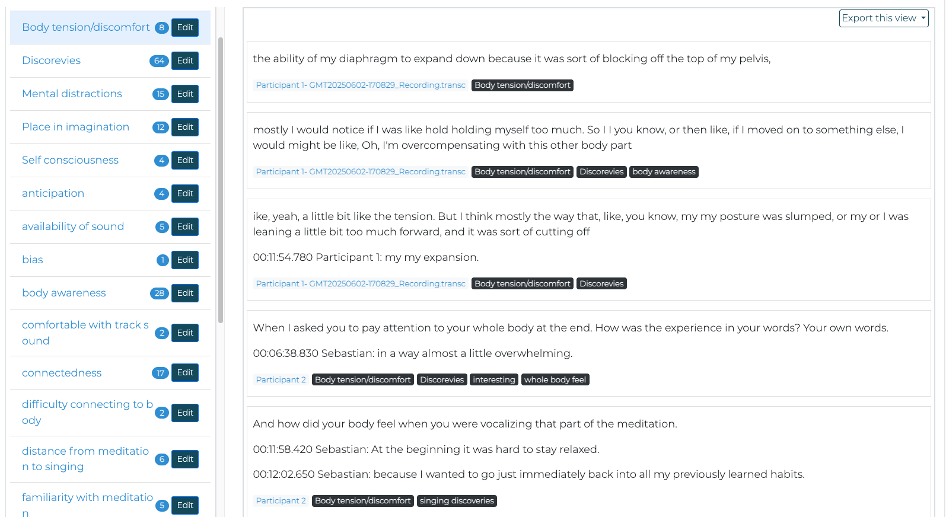
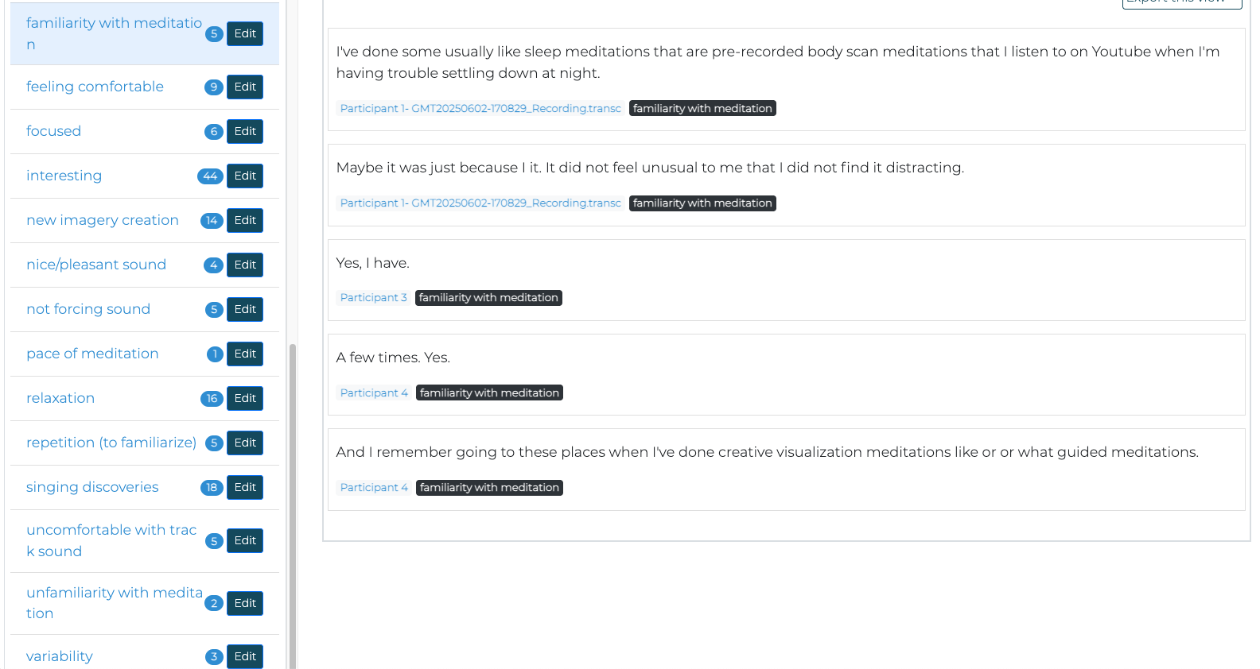

APPENDIX 13 Examples of Initial Phase of Handwritten IPA Thematic Analysis Process.

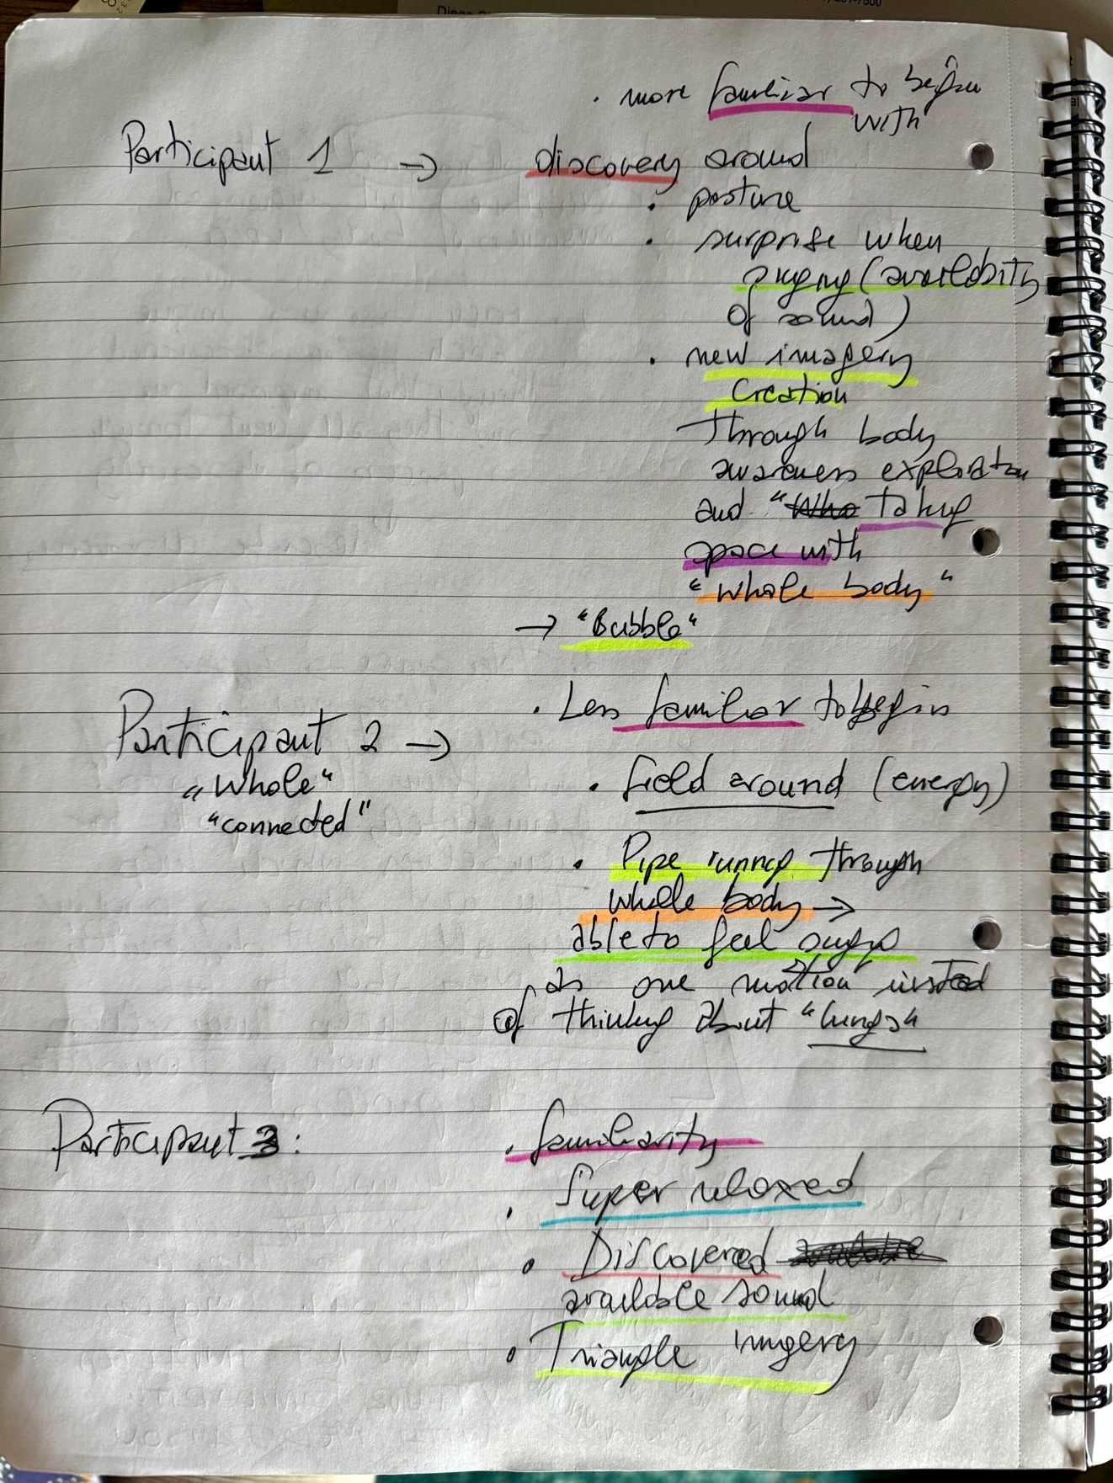

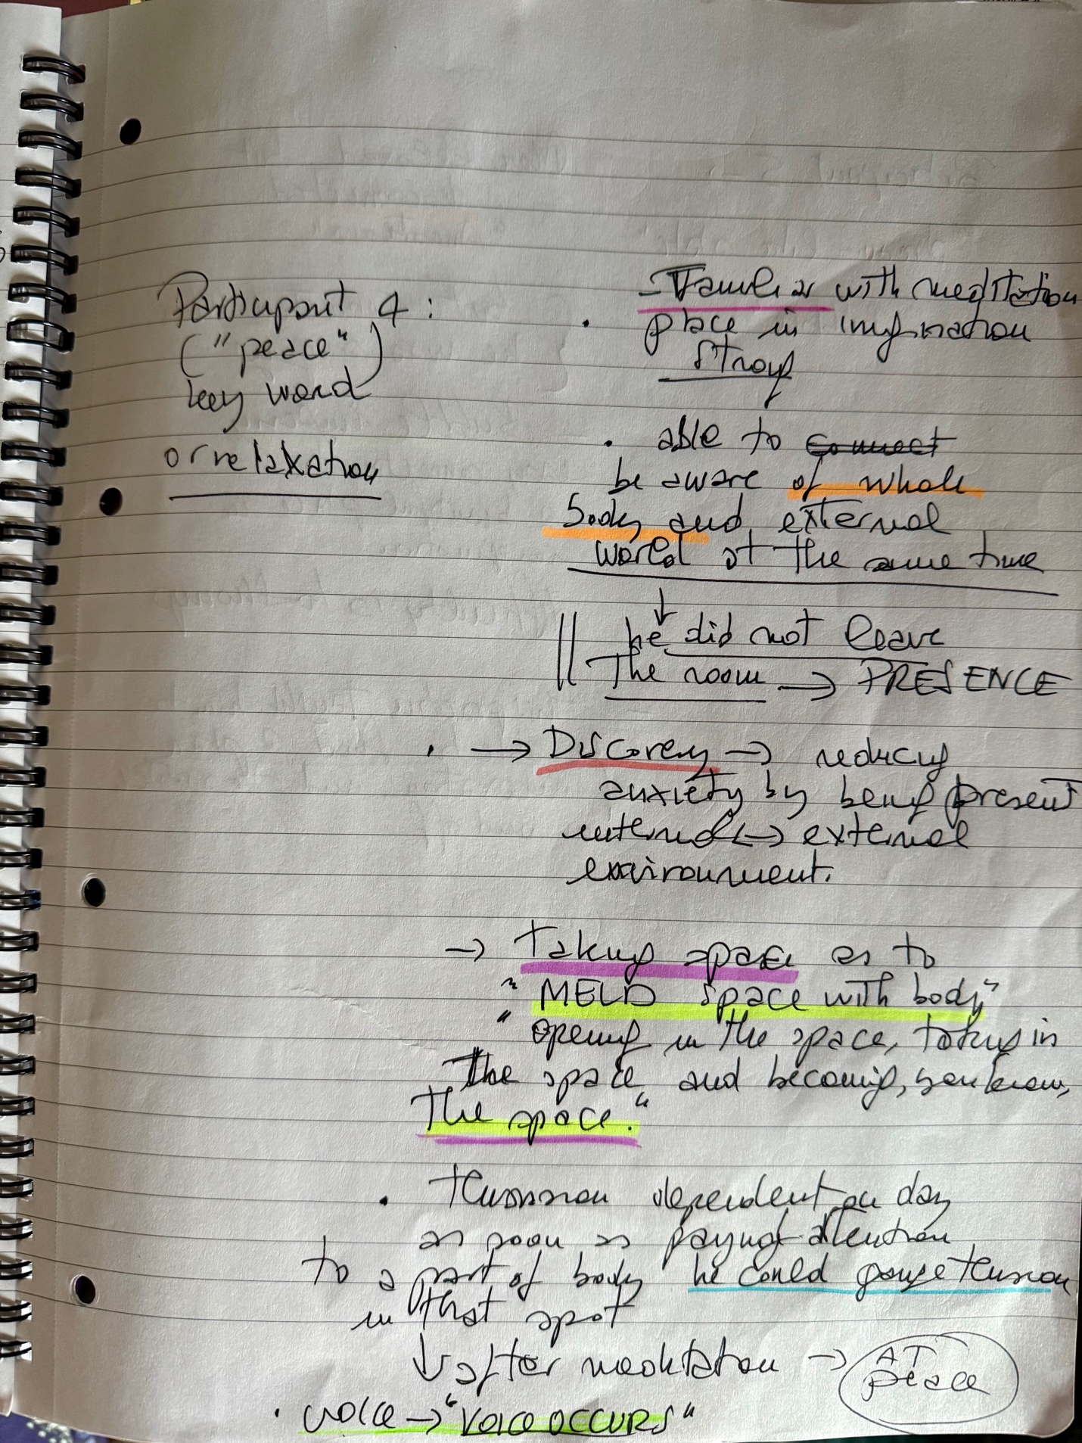

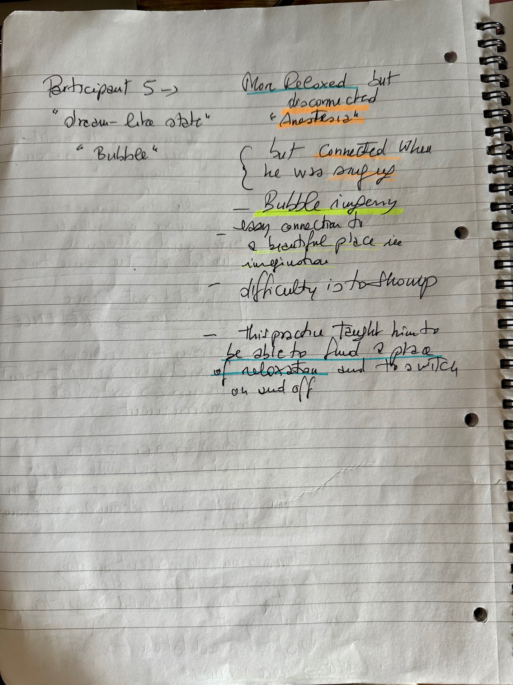

APPENDIX 14 Example of Handwritten Field Note of Participants’ Observations.
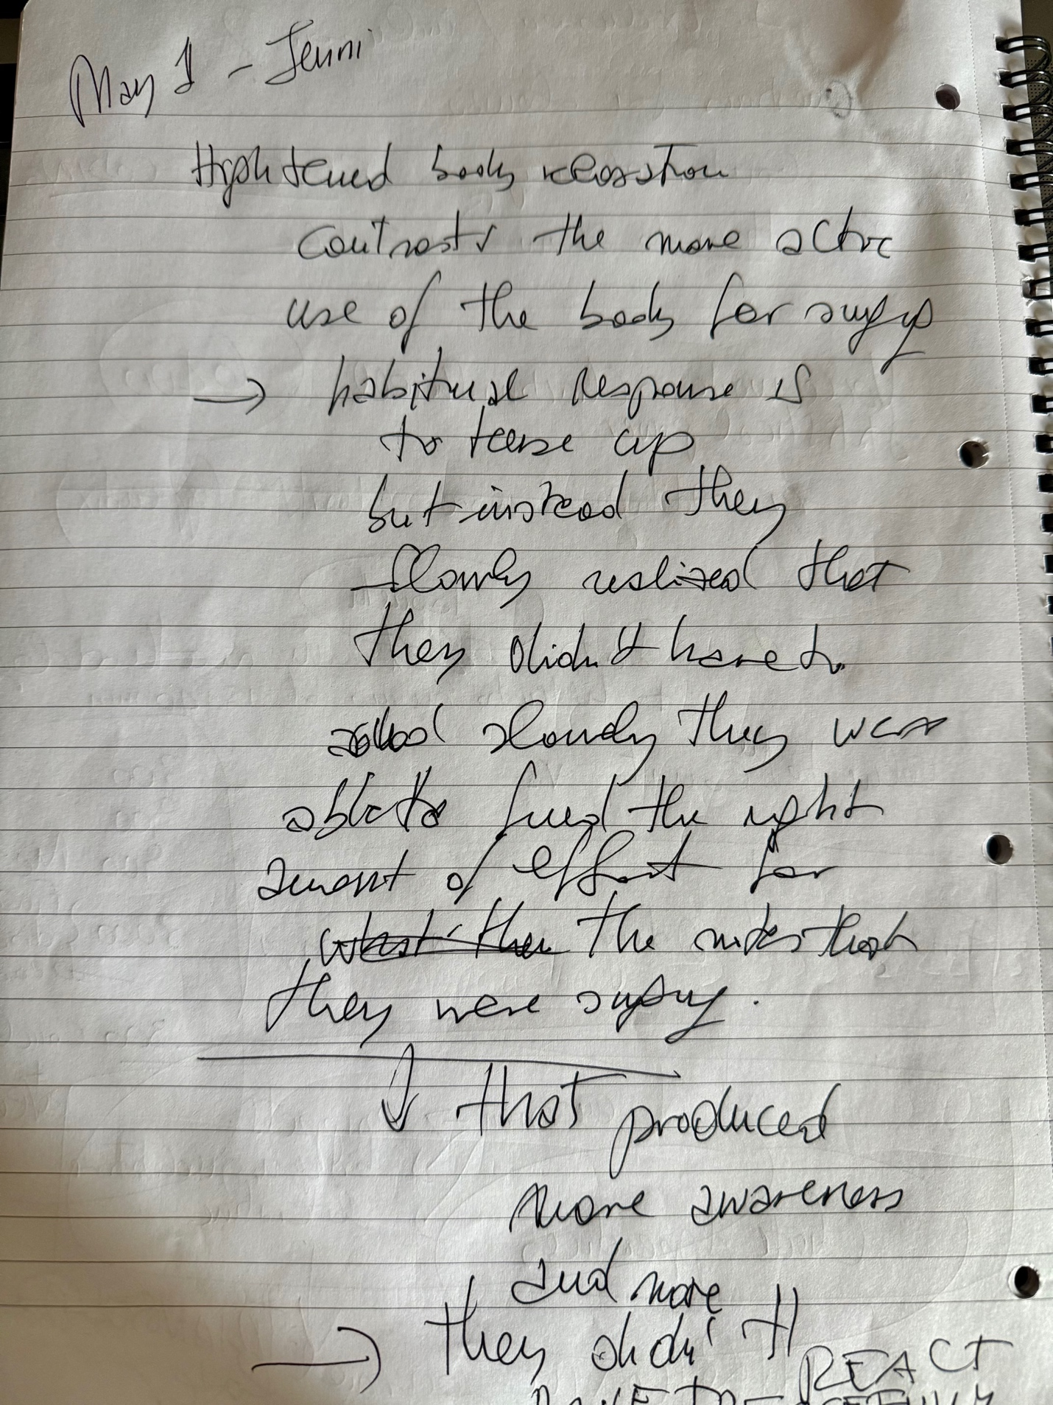
APPENDIX 15 Signed Ethics Form.

APPLICATION FOR ETHICAL APPROVAL

RESEARCH STUDENTS
This form is to be completed by the student within SIX months for full-time students and TWELVE months for part time students, after the commencement of the research degree or following progression to Part Two of your course.

Once complete, submit this form via the MyTSD Doctoral College Portal at (https://mytsd.uwtsd.ac.uk).

This document is also available in Welsh.

RESEARCH STAFF ONLY
All communications relating to this application during its processing must be in writing and emailed to pgresearch@uwtsd.ac.uk , with the title ‘Ethical Approval’ followed by your name.

STUDENTS ON UNDERGRADUATE OR TAUGHT MASTERS PROGRAMMES should submit this form (and receive the outcome) via systems explained to you by the supervisor/module leader.

In order for research to result in benefit and minimise risk of harm, it must be conducted ethically. A researcher may not be covered by the University’s insurance if ethical approval has not been obtained prior to commencement.

The University follows the OECD Frascati manual definition of research activity: “creative work undertaken on a systematic basis in order to increase the stock of knowledge, including knowledge of man, culture and society, and the use of this stock of knowledge to devise new applications”. As such this covers activities undertaken by members of staff, postgraduate research students, and both taught postgraduate and undergraduate students working on dissertations/projects.

The individual undertaking the research activity is known as the “principal researcher”.

Ethical approval is not required for routine audits, performance reviews, quality assurance studies, testing within normal educational requirements, and literary or artistic criticism.

Please read the notes for guidance before completing ALL sections of the form.

This form must be completed and approved prior to undertaking any research activity. Please see Checklist for details of process for different categories of application.

SECTION A: About You (Principal Researcher)
1 | Full Name: |  | Elena Degl’innocenti
2 | Tick all boxes that apply: |  | Member of staff: | ☐ | Honorary research fellow: | ☐
 | Undergraduate Student | ☐ | Taught Postgraduate Student | ☒ | Postgraduate Research Student | ☐

3 | Institute/Academic Discipline/Centre: | WAPPAR
4 | Campus: | Carmarthen
5 | E-mail address: | eledinn@gmail.com
6 | Contact Telephone Number: | +39 375 9131381
 | For students:
7 | Student Number: | 2332534
8 | Programme of Study: | MA Professional Practice (Voice Pedagogy)
9 | Director of Studies/Supervisor: | Louise Emanuel/Julie Crossman/Debbie Winter

SECTION B: Approval for Research Activity
1 | Has the research activity received approval in principle?  (please check the Guidance Notes as to the appropriate approval process for different levels of research by different categories of individual) |  | YES | ☒ | NO | ☐
 |  |  |  |  | Date
2 | If Yes, please indicate source of approval (and date where known): Approval in principle must be obtained from the relevant source prior to seeking ethical approval | Research Degrees Committee |  | ☐
2 |  | Institute Research Committee |  | ☐
2 |  | Other (write in)  WAPPAR Ethics Board Representative |  | ☒ | 01/03/2025

SECTION C: Internal and External Ethical Guidance Materials
 | Please list the core ethical guidance documents that have been referred to during the completion of this form (including any discipline-specific codes of research ethics, location-specific codes of research ethics, and also any specific ethical guidance relating to the proposed methodology). Please tick to confirm that your research proposal adheres to these codes and guidelines. You may add rows to this table if needed.
1 | UWTSD Research Ethics & Integrity Code of Practice | ☒
2 | UWTSD Research Data Management Policy | ☒
3 | https://www.cnr.it/sites/default/files/public/media/doc_istituzionali/linee-guida-integrita-nella-ricerca-cnr-commissione_etica.pdf?v=4 | ☒

SECTION D: External Collaborative Research Activity
If there are external collaborators then you should gain consent from the contact persons to share their personal data with the university. If there are no external collaborators then leave this section blank and continue to section E.
1 | Institution
2 | Contact person name
3 | Contact person e-mail address
4 | Is your research externally funded? |  | YES | ☐ | NO |  | ☐
5 | Are you in receipt of a KESS scholarship? |  | YES | ☐ | NO |  | ☐
6 | Are you specifically employed to undertake this research in either a paid or voluntary capacity? | Voluntary | YES | ☐ | NO | ☐
7 |  | Employed | YES | ☐ | NO | ☐
8 | Is the research being undertaken within an existing UWTSD Athrofa Professional Learning Partnership (APLP)? | If YES then the permission question below does not need to be answered. | YES | ☐ | NO |  | ☐
9 | Has permission to undertake the research has been provided by the partner organisation? | (If YES attach copy)  If NO the application cannot continue | YES | ☐ | NO |  | ☐

Where research activity is carried out in collaboration with an external organisation
10 | Does this organisation have its own ethics approval system? | YES | ☐ | NO | ☐
 | If Yes, please attach a copy of any final approval (or interim approval) from the organisation (this may be a copy of an email if appropriate).

SECTION E: Details of Research Activity
1 | Indicative title: | Effects of Mindfulness practices in online singing lessons.
2 | Proposed start date: | 31/03/2025 | Proposed end date: | 15/09/2025
Introduction to the Research (maximum 300 words per section)
Ensure that you write for a Non-Specialist Audience when outlining your response to the points below:
- Purpose of Research Activity
- Proposed Research Question
- Aims of Research Activity
- Objectives of Research Activity
Demonstrate, briefly, how Existing Research has informed the proposed activity and explain
- What the research activity will add to the body of knowledge
- How it addresses an area of importance.
3 | Purpose of Research Activity  The purpose of this research is to explore the effects of mindfulness practices applied to online singing lessons in order to develop new teaching tools to facilitate a “whole body” experience of singing, the release of excessive muscular body tension, and to enhance body awareness while singing. Having researched mindfulness techniques applied to singing in literature and having practiced mindfulness and body awareness techniques through years of training, I have learned about the importance of releasing muscular tension and paying close attention to one’s body sensations in order to develop a “whole body” experience of singing to enhance singing performance. I have developed a mindfulness practice–a body scan meditation followed by single notes vocalizations–which will be taught to the participants during a series of 5 voice lessons and then practiced weekly at home in their own time.  Before the start of this research an Evaluation of the Ability to Sing Easily (EASE) questionnaire will be given to the participants to evaluate their starting point perceived ease in singing. A semi-structured interview will be conducted at the end of research and the participants will be invited to keep a diary at home to track their sensations after practicing on their own using an audio recording of this practice. Another Evaluation of the Ability to Sing Easily (EASE) questionnaire will be given to the participants at the end of research.  (this box should expand as you type)
4 | Research Question  Can Mindfulness practices applied to singing lessons enhance a “whole body” singing experience, the release of excessive muscular tension and enhance body awareness?  (this box should expand as you type)
5 | Aims of Research Activity  The overall aim of this research is to discover if body scan meditations are useful for an increased sense of ease while singing, body awareness, and general muscular release.  (this box should expand as you type)
6 | Objectives of Research Activity  The objectives are:  - to conduct an in-depth literature review on mindfulness applied to singing, which will provide context and ground the research in current literature.  - to use mixed methods, collecting quantitative data about singing ease first and then qualitative data about the experience of the participants, through their recollections, which will provide an overview of the participants’ perceptions before and after the research.  - to identify potential benefits of mindfulness applied to singing through body scans, which can be used to enhance body awareness.  - to identify the effectiveness of this practice and ways to improve it.  - to find out if participants are motivated by this practice routine and are able to continue on their own.  (this box should expand as you type)
Proposed methods (maximum 600 words)
Provide a brief summary of all the methods that may be used in the research activity, making it clear what specific techniques may be used. If methods other than those listed in this section are deemed appropriate later, additional ethical approval for those methods will be needed. You do not need to justify the methods here, but should instead describe how you intend to collect the data necessary for you to complete your project.
7 | A literature review.  The Evaluation of the Ability to Sing Easily (EASE) questionnaire once the beginning and once at the end of research.  One semi-structured interview with each participant, at the end of the last lesson.  The use of participants’ diaries.  The researcher’s reflective journal throughout the research.  (this box should expand as you type)
Location of research activity
Identify all locations where research activity will take place.
8 | Online lessons using the platform zoom. The participants will be asked to keep their camera on but also advised that they will be free to turn it off at any moment if they feel in any way uncomfortable during the meditation.  (this box should expand as you type)
Research activity outside of the UK
If research activity will take place overseas, you are responsible for ensuring that local ethical considerations are complied with and that the relevant permissions are sought. Specify any local guidelines (e.g. from local professional associations/learned societies/universities) that exist and whether these involve any ethical stipulations beyond those usual in the UK (provide details of any licenses or permissions required). Also specify whether there are any specific ethical issues raised by the local context in which the research activity is taking place, for example, particular cultural and/or legal sensitivities or vulnerabilities of participants. If you live in the country where you will do the research then please state this.
9 | This research will be conducted online from Italy, which is where I reside and work. This research will be conducted in full compliance with the following ethical guidelines provided by the Italian Ethical Committee for Research Integrity: https://www.cnr.it/sites/default/files/public/media/doc_istituzionali/linee-guida-integrita-nella-ricerca-cnr-commissione_etica.pdf?v=4  (this box should expand as you type)

10 | Use of documentation not in the public domain: Are any documents NOT publicly available? | NO | ☒
10 |  | YES | ☐
11 | If Yes, please provide details here of how you will gain access to specific documentation that is not in the public domain and that this is in accordance with the current data protection law of the country in question and that of England and Wales.  (this box should expand as you type)

 | Does your research relate to one or more of the seven aims of the Well-being of Future Generations (Wales) Act 2015? | YES | NO
12 | A prosperous Wales | ☐ | ☒
13 | A resilient Wales | ☐ | ☒
14 | A healthier Wales | ☐ | ☒
15 | A more equal Wales | ☐ | ☒
16 | A Wales of cohesive communities | ☐ | ☒
17 | A Wales of vibrant culture and thriving Welsh language | ☐ | ☒
18 | A globally responsible Wales | ☐ | ☒
19 | If YES to any of the above, please give details:
 | (this box should expand as you type)

SECTION F: Scope of Research Activity
 | Will the research activity include: | YES | NO
1 | Use of a questionnaire or similar research instrument? | ☒ | ☐
2 | Use of interviews? | ☒ | ☐
3 | Use of focus groups? | ☐ | ☒
4 | Use of participant diaries? | ☒ | ☐
5 | Use of video or audio recording? | ☒ | ☐
6 | Use of computer-generated log files? | ☐ | ☒
7 | Participant observation with their knowledge? | ☐ | ☒
8 | Participant observation without their knowledge? | ☐ | ☒
9 | Access to personal or confidential information without the participants’ specific consent? | ☐ | ☒
10 | Administration of any questions, test stimuli, presentation that may be experienced as physically, mentally or emotionally harmful / offensive? | ☐ | ☒
11 | Performance of any acts which may cause embarrassment or affect self-esteem? | ☐ | ☒
12 | Investigation of participants involved in illegal activities? | ☐ | ☒
13 | Use of procedures that involve deception? | ☐ | ☒
14 | Administration of any substance, agent or placebo? | ☐ | ☒
15 | Working with live vertebrate animals? | ☐ | ☒
16 | Procedures that may have a negative impact on the environment? | ☐ | ☒
17 | Other primary data collection methods. Please indicate the type of data collection method(s) below. | ☐ | ☒
 | Details of any other primary data collection method:  (this box should expand as you type) | ☐ | ☒
If NO to every question, then the research activity is (ethically) low risk and may be exempt from some of the following sections (please refer to Guidance Notes).

If YES to any question, then no research activity should be undertaken until full ethical approval has been obtained.

SECTION G: Intended Participants
If there are no participants then do not complete this section, but go directly to section H.

 | Who are the intended participants: | YES | NO
1 | Students or staff at the University? | ☐ | ☒
2 | Adults (over the age of 18 and competent to give consent)? | ☒ | ☐
3 | Vulnerable adults? | ☐ | ☒
4 | Children and Young People under the age of 18? (Consent from Parent, Carer or Guardian will be required) | ☐ | ☒
5 | Prisoners? | ☐ | ☒
6 | Young offenders? | ☐ | ☒
7 | Those who could be considered to have a particularly dependent relationship with the investigator or a gatekeeper? | ☐ | ☒
8 | People engaged in illegal activities? | ☐ | ☒
9 | Others. Please indicate the participants below, and specifically any group who may be unable to give consent. | ☐ | ☒
 | Details of any other participant groups:  (this box should expand as you type) | ☐ | ☒

Participant numbers and source
Provide an estimate of the expected number of participants. How will you identify participants and how will they be recruited?
10 | How many participants are expected? | 6-8 participants.  (this box should expand as you type)
11 | Who will the participants be? | Adults singing students and colleagues (singing teachers) known through my professional network.  (this box should expand as you type)
12 | How will you identify the participants? | Most participants I intend to contact will be my current singing students. I will first informally ask them and explain my research aim and procedures during a voice lesson followed by a consent form sent via email–which I already have access to–if they are interested in participating in this research. If the number of participants/students doesn’t reach the number I intend to reach, I will contact a few colleagues and send a consent form as well via emails I already have access to.  (this box should expand as you type)

 | Information for participants: | YES | NO | N/A
13 | Will you describe the main research procedures to participants in advance, so that they are informed about what to expect? | ☒ | ☐ | ☐
14 | Will you tell participants that their participation is voluntary? | ☒ | ☐ | ☐
15 | Will you obtain written consent for participation? | ☒ | ☐ | ☐
16 | Will you explain to participants that refusal to participate in the research will not affect their treatment or education (if relevant)? | ☒ | ☐ | ☐
17 | If the research is observational, will you ask participants for their consent to being observed? | ☐ | ☐ | ☒
18 | Will you tell participants that they may withdraw from the research at any time and for any reason? | ☒ | ☐ | ☐
19 | With questionnaires, will you give participants the option of omitting questions they do not want to answer? | ☒ | ☐ | ☐
20 | Will you tell participants that their data will be treated with full confidentiality and that, if published, it will not be identifiable as theirs? | ☒ | ☐ | ☐
21 | Will you debrief participants at the end of their participation, in a way appropriate to the type of research undertaken? | ☒ | ☐ | ☐
22 | If NO to any of above questions, please give an explanation
 | (this box should expand as you type)

 | Information for participants: | YES | NO | N/A
24 | Will participants be paid? | ☐ | ☒ | ☐
25 | Is specialist electrical or other equipment to be used with participants? | ☒ | ☐ | ☐
26 | Are there any financial or other interests to the investigator or University arising from this study? | ☐ | ☒ | ☐
27 | Will the research activity involve deliberately misleading participants in any way, or the partial or full concealment of the specific study aims? | ☐ | ☒ | ☐
28 | If YES to any question, please provide full details
I will be conducting lessons and interviews via Zoom on my lap top computer using a USB microphone connected to my laptop. I will also be using a separate audio device (zoom H3-VR) to record the interviews.

(this box should expand as you type)

SECTION H: Anticipated Risks

Outline any anticipated risks that may adversely affect any of the participants, the researchers and/or the University, and the steps that will be taken to address them.

If you have completed a full risk assessment (for example as required by a laboratory, or external research collaborator) you may append that to this form.
1 | Full risk assessment completed and appended? |  | Yes | ☐
1 |  |  | No | ☒
2 | Risks to participants  For example: sector-specific health & safety, emotional distress, financial disclosure, physical harm, transfer of personal data, sensitive organisational information
 | Risk to participants:  - Body scan meditations might elicit uncomfortable or negative emotional, psychological or physical responses, especially if there is any history of trauma.  - Participants might feel uneasy or uncomfortable when talking about their physical sensations during the interview.  - Participants might feel uneasy answering the questions on the EASE questionnaire.  - Participants might feel uncomfortable writing about their experiences in their diaries, knowing that their thoughts will be read by the researcher.  - Recording the interviews (audio only) might put the participants personal data at risk (loss of confidentiality).  (this box should expand as you type) | How you will mitigate the risk to participants:  - To mitigate possible negative responses, the body scan meditation will be carried out in a gentle way, leaving space for the participants to stop at any moment and/or turn off their cameras. Participants will be informed about the possible psychological and emotional risks involved through an informed consent form.  - To minimise potential discomfort, interviews will be carried out in a comfortable, relaxed way and participants can skip any questions they do not want to answer ,or withdraw from it at any point.  - The participants can skip any questions they do not want to answer.  - The participants can decide not to disclose their written notes.  - The interview’s audio recording will be deleted after its transcription and all transcriptions kept in a password-protected folder on the investigator’s lap top and password-protected USB drive only accessible by the investigator.  (this box should expand as you type)
3 | If research activity may include sensitive, embarrassing or upsetting topics (e.g. sexual activity, drug use) or issues likely to disclose information requiring further action (e.g. criminal activity), give details of the procedures to deal with these issues, including any support/advice (e.g. helpline numbers) to be offered to participants. Note that where applicable, consent procedures should make it clear that if something potentially or actually illegal is discovered in the course of a project, it may need to be disclosed to the proper authorities
Not applicable

(this box should expand as you type)
4 | Risks to the investigator  For example: personal health & safety, physical harm, emotional distress, risk of accusation of harm/impropriety, conflict of interest
 | Risk to the investigator:  - The investigator might feel psychological discomfort from exposure to discomfort or trauma of others.  - Suspicion or doubt concerning the investigator’s primary motivation might cause stress to the investigator.  (this box should expand as you type) | How you will mitigate the risk to the investigator:  - To mitigate discomfort there will be clear communication with the participants prior and during research, a plan for exit strategies and establishing support prior to research (experts in mindfulness practices, colleagues who are well versed in mindfulness practices).  - Clear communication about the aims, risks and procedure of this research will be provided to the participants.  (this box should expand as you type)
5 | University/institutional risks  For example: adverse publicity, financial loss, data protection
 | Risk to the University:  - Adverse publicity and reputational damage.  - Data protection breach.  (this box should expand as you type) | How you will mitigate the risk to the University:  - The investigator will share the guiding principles of honesty, openness, and accountability in research, prioritizing informed consent, anonymity and confidentiality.  - To assure data protection, no data will be shared during research with any other institution. Data will be stored only inside the investigator’s password-protected lap top computer and backed up on one password-protected USB drive. All data will be permanently deleted no later than the end of MA Professional Practice (Voice Pedagogy)–April 2027–as it might be used for final dissertation.  (this box should expand as you type)
6 | Environmental risks  For example: accidental spillage of pollutants, damage to local ecosystems
 | Risk to the environment:  - Printing.  - Travel.  (this box should expand as you type) | How you will mitigate the risk to environment:  - Nothing will be printed, everything will be read and stored on a password-protected computer and password-protected USB drive.  - Research will be conducted online.  (this box should expand as you type)

 | Disclosure and Barring Service
 | If the research activity involves children or vulnerable adults, a Disclosure and Barring Service (DBS) certificate must be obtained before any contact with such participants. | YES | NO | N/A
7 | Does your research require you to hold a current DBS Certificate? | ☐ | ☒ | ☐
8 | If YES, please give the certificate number. If the certificate number is not available please write “Pending”; in this case any ethical approval will be subject to providing the appropriate certificate number.

SECTION I: Feedback, Consent and Confidentiality

1 | Feedback  What de-briefing and feedback will be provided to participants, how will this be done and when?
I will be providing my email address that they might contact for further details or results. Member checking–allowing the participants to check the accuracy of reporting–will be used after transcription.

(this box should expand as you type)
2 | Informed consent  Describe the arrangements to inform potential participants, before providing consent, of what is involved in participating. Describe the arrangements for participants to provide full consent before data collection begins. If gaining consent in this way is inappropriate, explain how consent will be obtained and recorded in accordance with prevailing data protection legislation.
Participants will be provided with an information sheet via email (which I already have access to) containing the purpose of the research, what their involvement would entail, risks, and their rights, including the right to withdraw from the research project at any time. Consent in writing (online only) would be obtained before data collection starts. Since I will be using a questionnaire–a pdf file which the participants will be able to write on–the participants will be provided an appropriate consent form prior to filling out the questionnaire.

(this box should expand as you type)
3 | Confidentiality / Anonymity  Set out how anonymity of participants and confidentiality will be ensured in any outputs. If anonymity is not being offered, explain why this is the case.
I will not collect names. All participants will be given a pseudonym/identifier to ensure their identity is not revealed. Data will be stored on a password-protected computer and backed up on a password-protected USB drive, and only the researcher will have access to raw data. Identifying information will be removed from all publications and reports. All audio recordings from interviews will be deleted once transcripts have been made.

(this box should expand as you type)

SECTION J: Data Protection and Storage

 | Does the research activity involve personal data (as defined by the General Data Protection Regulation 2016 “GDPR” and the Data Protection Act 2018 “DPA”)? | YES | NO
1 | “Personal data” means any information relating to an identified or identifiable natural person (‘data subject’). An identifiable natural person is one who can be identified, directly or indirectly, in particular by reference to an identifier such as a name, an identification number, location data, an online identifier or to one or more factors specific to the physical, physiological, genetic, mental, economic, cultural or social identity of that natural person. Any video or audio recordings of participants is considered to be personal data. | ☒ | ☐
 | If YES, provide a description of the data and explain why this data needs to be collected:
2 | I will delete all audio recordings of interviews after transcription. I will anonymise names and no contact details will be available to anyone other than the researcher.  (this box should expand as you type)
 | Does it involve special category data (as defined by the GDPR)? | YES | NO
3 | “Special category data” means sensitive personal data consisting of information as to the data subjects’ –  (a) racial or ethnic origin,  (b) political opinions,  (c ) religious beliefs or other beliefs of a similar nature,  (d) membership of a trade union (within the meaning of the Trade Union and Labour Relations (Consolidation) Act 1992),  (e) physical or mental health or condition,  (f) sexual life,  (g) genetics,  (h) biometric data (as used for ID purposes), | ☒ | ☐
 | If YES, provide a description of the special category data and explain why this data needs to be collected:
4 | e. Physical or mental conditions might be disclosed by the participants on their diary entries as it is one of the qualitative ways in which data will be collected in order to find out the participants’ written point of views of their physical/mental experiences after the mindfulness practice. If participants do choose to disclose physical or mental conditions, I will ensure anonymity and these conditions will only be included in the final report with the permission of the participant, and they will not be identifiable in any way.  (this box should expand as you type)

 | Will data from the research activity (collected data, drafts of the thesis, or materials for publication) be stored in any of the following ways? | YES | NO
5 | Manual files (i.e. in paper form)? | ☐ | ☒
6 | University computers? | ☐ | ☒
7 | Private company computers? | ☐ | ☒
8 | Home or other personal computers? | ☒ | ☐
9 | Laptop computers/ CDs/ Portable disk-drives/ memory sticks? | ☒ | ☐
10 | “Cloud” storage or websites? | ☐ | ☒
11 | Other – specify: | ☐ | ☒
12 | For all stored data, explain the measures in place to ensure the security of the data collected, data confidentiality, including details of backup procedures, password protection, encryption, anonymisation and pseudonymisation:
Data will be stored inside the investigator’s password-protected lap top computer and backed up on one password-protected USB drive that only the investigator will have access to. Audio data will be transcribed and would be shown to participants to check accuracy of reporting before being deleted. All participants will be given a pseudonym/identifier to ensure confidentiality, and this list will be kept securely in the password protected folder.

(this box should expand as you type)

 | Data Protection
 | Will the research activity involve any of the following activities: | YES | NO
13 | Electronic transfer of data in any form? | ☒ | ☐
14 | Sharing of data with others at the University outside of the immediate research team? | ☐ | ☒
15 | Sharing of data with other organisations? | ☐ | ☒
16 | Export of data outside the UK or importing of data from outside the UK? | ☒ | ☐
17 | Use of personal addresses, postcodes, faxes, emails or telephone numbers? | ☒ | ☐
18 | Publication of data that might allow identification of individuals? | ☐ | ☒
19 | Use of data management system? | ☐ | ☒
20 | Data archiving? | ☒ | ☐
21 | If YES to any question, please provide full details, explaining how this will be conducted in accordance with the GDPR and Data Protection Act (2018) (and any international equivalents, where appropriate):
All data will be kept in a password protected folder on the investigator’s lap top computer which will not be shared. A USB drive used to store data will be password protected. All data transfers will be encrypted, and password protected. All data will be collected/imported/transferred on a computer outside of the UK, in Italy, and all data will be protected as described above. All participants will be given a unique identifier to ensure confidentiality and this list will be kept securely in the password protected folder. The data will be stored until the completion of the project and then deleted. In accordance with the DPA2018, participants will have the right to ask to see what data is held relating to them, and this data will be deleted immediately if the participant requests this, in which case the data will not be used in the project. All audio recordings will be deleted once transcripts have been made.

(this box should expand as you type)
22 | List all who will have access to the data generated by the research activity:
The principal researcher and the research supervisor.

(this box should expand as you type)
23 | List who will have control of, and act as custodian(s) for, data generated by the research activity:
The principal researcher only.

(this box should expand as you type)
24 | Give details of data storage arrangements, including security measures in place to protect the data, where data will be stored, how long for, and in what form. Will data be archived – if so how and if not why not.
All data will be encrypted and kept in a password protected folder on the investigator’s lap top computer which will not be shared. The USB drive used to store data will be password protected and will be reformatted at the end of the project in order to destroy the data. The data will be stored until the completion of the project and deleted at the end of MA Professional Practice (Voice Pedagogy)–April 2027– as it might be used for final dissertation. All audio recordings will be deleted once transcripts have been made.

(this box should expand as you type)
25 | Please indicate if your data will be stored in the UWTSD Research Data Repository (see https://researchdata.uwtsd.ac.uk/ ). If so please explain. (Most relevant to academic staff)
Not applicable

(this box should expand as you type)
26 | Confirm that you have read the UWTSD guidance on data management (see https://www.uwtsd.ac.uk/library/research-data-management/) | YES | ☒
27 | Confirm that you are aware that you need to keep all data until after your research has completed or the end of your funding | YES | ☒

SECTION K: Declaration
The information which I have provided is correct and complete to the best of my knowledge. I have attempted to identify any risks and issues related to the research activity and acknowledge my obligations and the rights of the participants.

In submitting this application I hereby confirm that I undertake to ensure that the above named research activity will meet the University’s Research Ethics and Integrity Code of Practice which is published on the website: https://www.uwtsd.ac.uk/research/research-ethics/
1 | Signature of applicant: | 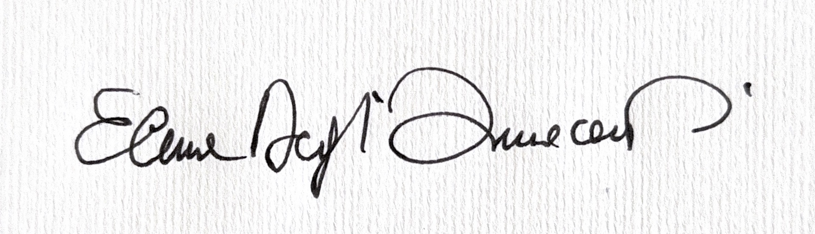 | Date: 01/03/2025

For STUDENT Submissions:
2 | Director of Studies/Supervisor: | Laura James | Date:  9.4.25
3 | Signature: | Laura James | Date:  9.4.25

For STAFF Submissions:
4 | Academic Director/ Assistant Dean: |  | Date:
5 | Signature: |  | Date:

Checklist: Please complete the checklist below to ensure that you have completed the form according to the guidelines and attached any required documentation:
☒ | I have read the guidance notes supplied before completing the form.
☒ | I have completed ALL RELEVANT sections of the form in full.
☒ | I confirm that the research activity has received approval in principle
☐ | I have attached a copy of final/interim approval from external organisation (where appropriate)
☐ | I have attached a full risk assessment (where appropriate) ONLY TICK IF YOU HAVE ATTACHED A FULL RISK ASSESSMENT
☒ | I understand that it is my responsibility to ensure that the above named research activity will meet the University’s Research Ethics and Integrity Code of Practice.
☒ | I understand that before commencing data collection all documents aimed at respondents (including information sheets, consent forms, questionnaires, interview schedules etc.) must be confirmed by the DoS/Supervisor, module tutor or Academic Director.

RESEARCH STUDENTS ONLY
Once complete, submit this form via the MyTSD Doctoral College Portal at (https://mytsd.uwtsd.ac.uk).

RESEARCH STAFF ONLY
All communications relating to this application during its processing must be in writing and emailed to pgresearch@uwtsd.ac.uk , with the title ‘Ethical Approval’ followed by your name.

STUDENTS ON UNDERGRADUATE OR TAUGHT MASTERS PROGRAMMES should submit this form (and receive the outcome) via systems explained to you by the supervisor/module leader.

APPENDIX 16 Participants’ Information Sheet.

APPENDIX 17 Redacted Participants’ Consent Forms.

Participant 1: Mel

Participant 2: Pete

Participant 3: Jenni

Participant 4: Mark

Participant 5: Frank
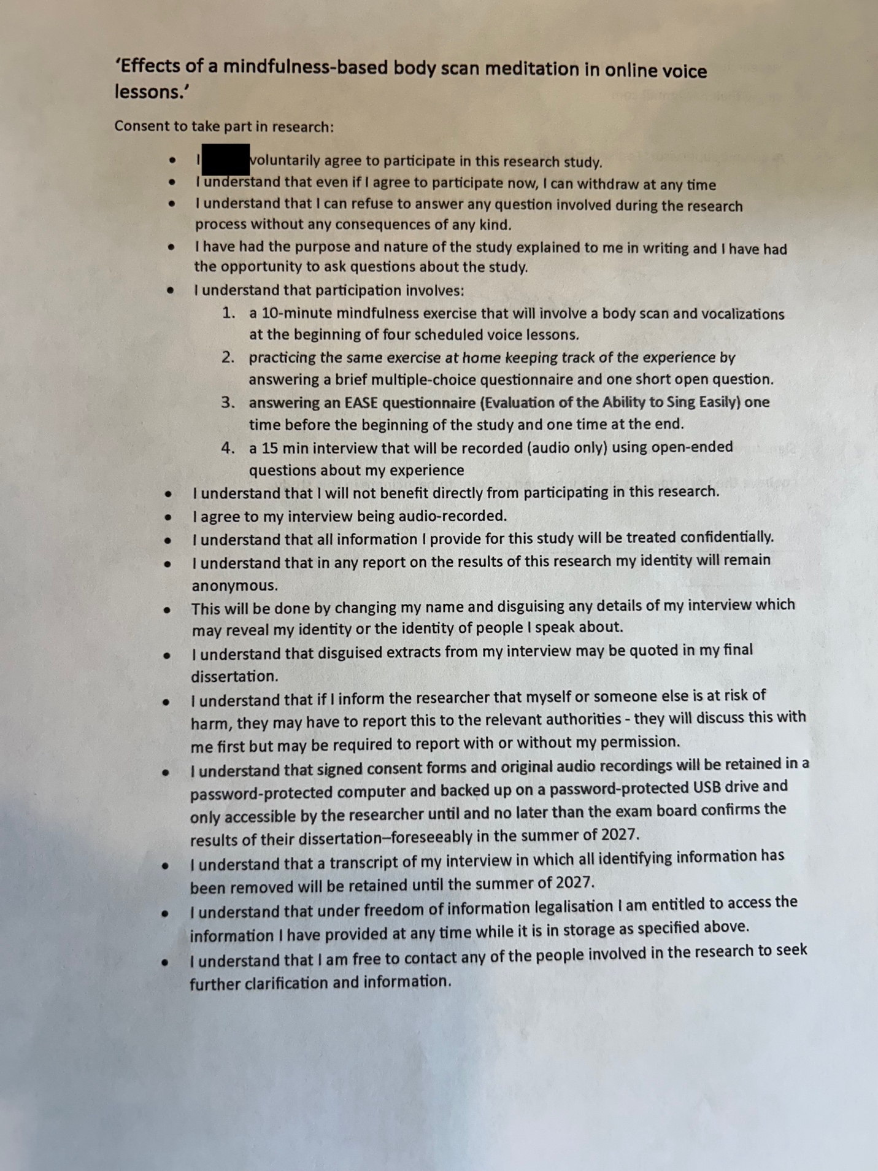
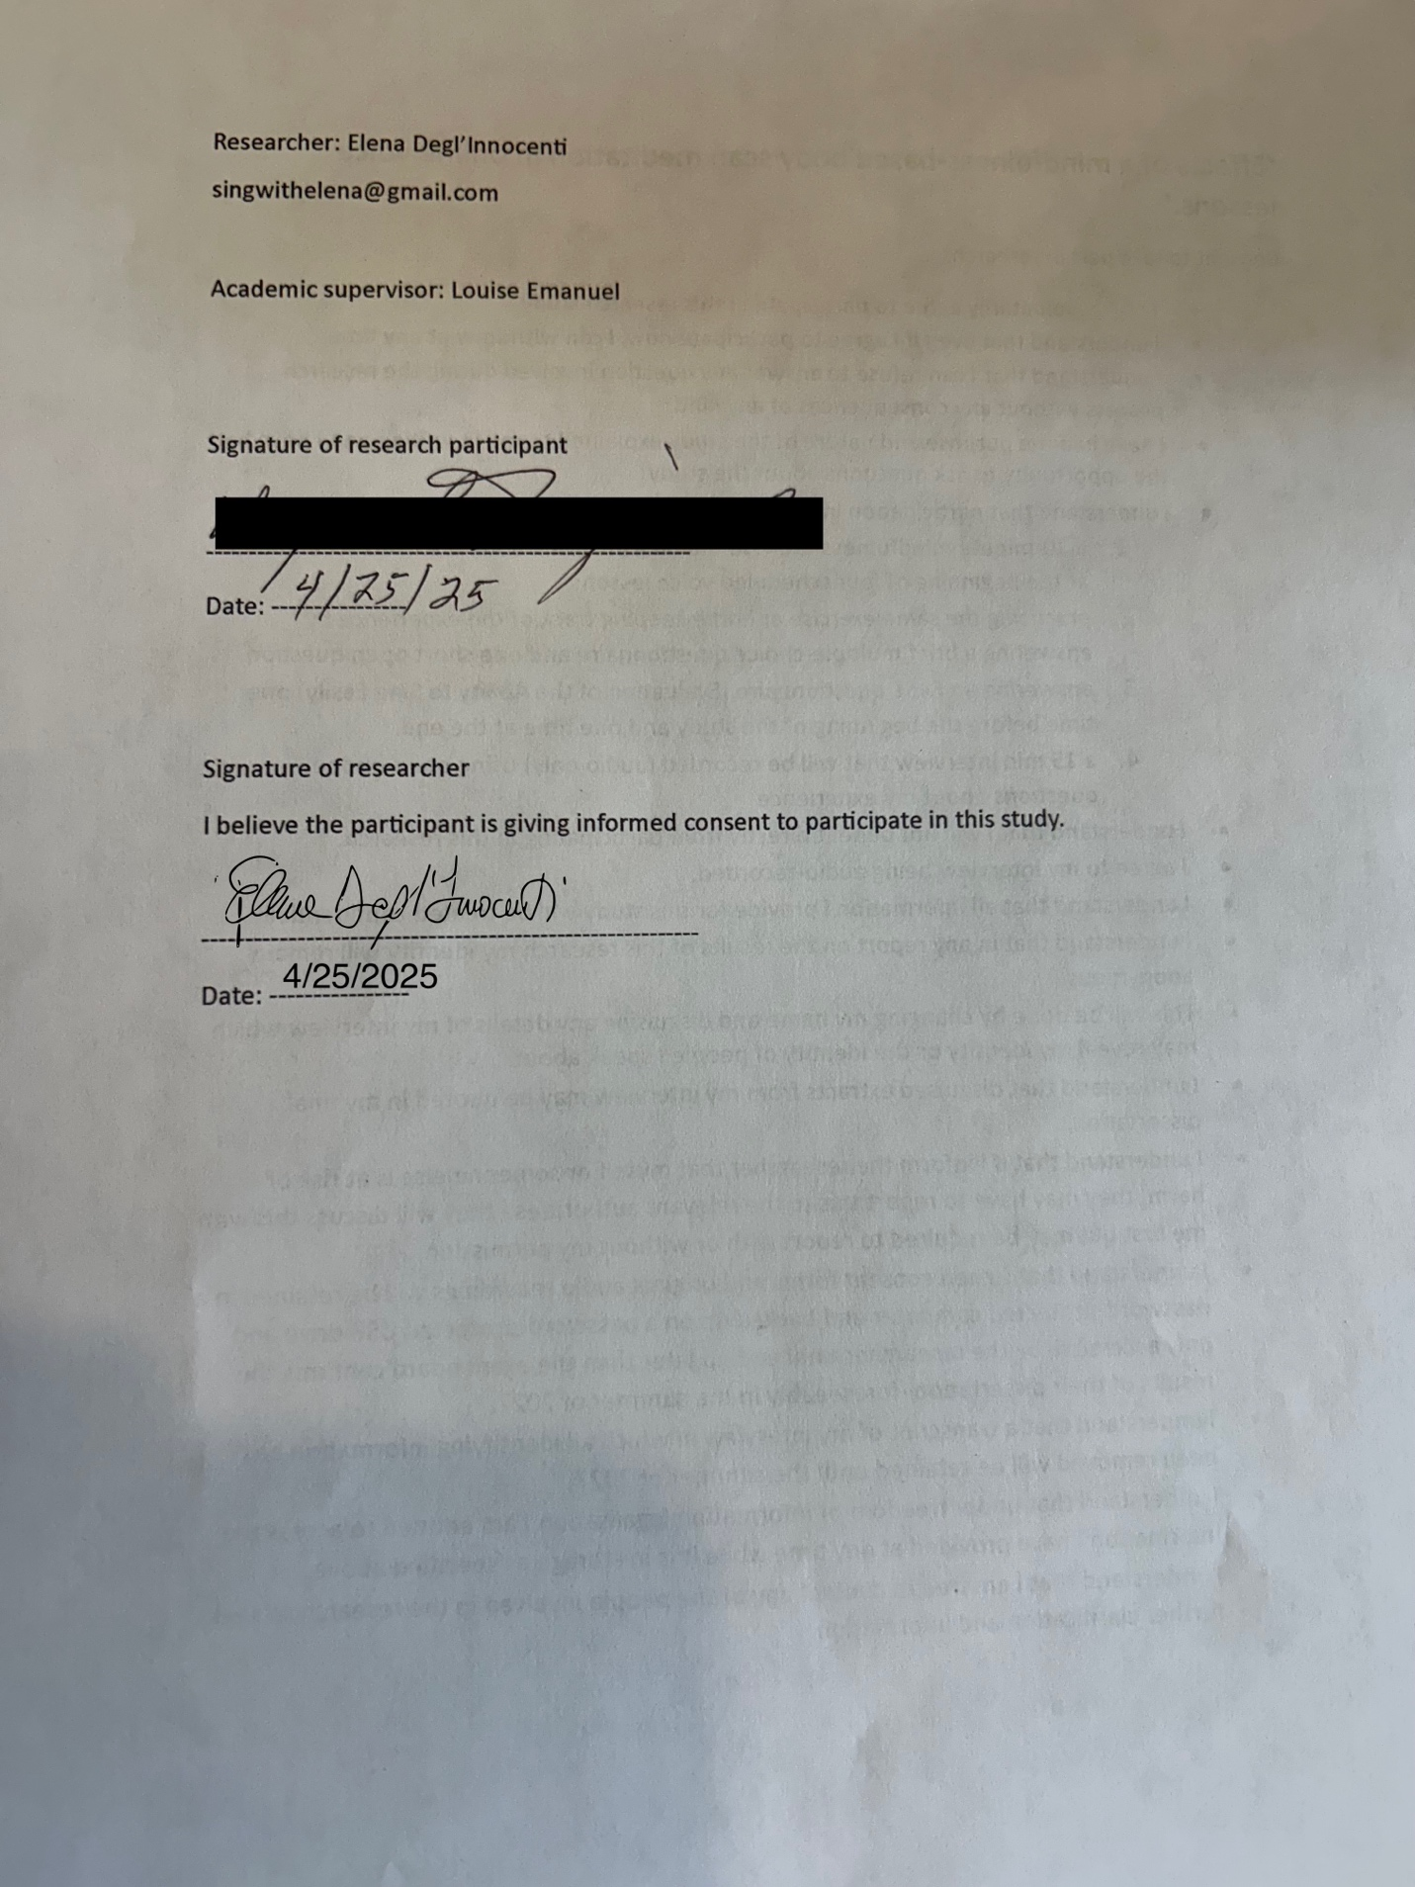

APPENDIX 18 Body Scan Meditation Track Link

https://youtu.be/m_wxkvUHoog

