

Cover page:
UWTSD BIRMINGHAM CAMPUS
Developing Innovation and Creativity for Business Advantage
BMSW6102
M I Malik
1810158
Lecturer name: Dr Charles Vincent

Content page:
Cover page: 1
Content page: 2
Introduction: 3
The innovative product or service proposition: 3
Post lockdown customer needs: 3
Potential buyers: 4
Selling point: 4
Product name: 4
A unique selling proposition: 4
Competitors: 5
E-commerce business setup: 5
Perfect name for business and product: 6
Domain name: 6
Register your domain: 6
Business licence or permits: 6
Choose correct ecommerce solution: 6
Build & design your website: 7
Financing, staff, equipment and supplies: 7
Payments: 7
Marketing, promote and launch: 7
Target customers: 8
Segmentation process: 8
Marketing mix and 4Ps: 9
Conclusion: 10
References: 11

Introduction:
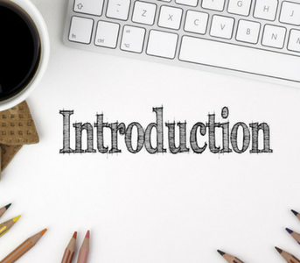
Meeting customer demands or needs in COVID19 is one of the major challenge in any organisation to achieve success, in present age you can see most companies offer extra benefits and services to their customers and do their best to meet their needs as it is easy to make customers but it is very hard to retain them for long period of time considering all other competitive business offering same services or products but at cheaper rates in the market.
Due to this pandemic and its uncertainty about future now customers way of thinking has been changed and now they are expecting more than before (Ashfaq et al,. 2019), so most companies are thinking about new ideas, innovations or services which can meet all the customer needs now and even after this pandemic is over, so to meet all customer requirements and demands we need new innovation in the form of a service or product which can be sold either online or through single point of sale, considering the idea of new innovation which can be useful after this pandemic I have been thinking about a lot of different ideas but finally I came up with an idea which can befit customers not only now but it can also continue to help users after this pandemic.
The innovative product or service proposition:
After a lot of thinking about different ideas about new innovation which can help customers after covid19, I came up with an outstanding idea of a product which will be a reusable drinking water bottle which will change drink safe logo from blue to red if detect any kind of virus, bacteria, germ or any sort of contamination in water, it will be fully tested and approved by the UK health and safety department and it will be completely safe to drink water from this bottle as long as it doesn’t change colour but in case if it does simply add provided tiny safety tablet in water shake it well and dispose the water safely and it will be ready to reuse, there is no need to wash the bottle again as it will be fully cleaned, the cost of one bottle will be 50p including 100 safety tablets and I will sell it for £1.00p, additional tablets can be sold as 100 for 0.50p buyer will pay for the postage, a chines company called Beijing Enterprises will produce these bottles and tablets for me and delivery to UK will be free.
Post lockdown customer needs:
During this pandemic time people are scared to go out and even when they need to drink water most people like to avoid buying water from outside considering they might have some virus inside or on top of bottle which can be very harmful for them, as due to this present situation most people need some king of safety requirement which can bring their trust back so they need something they can use everywhere and drink water with their old fearless feelings, so this bottle will be the perfect solution for them as even they buy water from outside they can put that water into this bottle and check if this water is safe to drink as globally more than 485000 people dies every year with drinking contaminated water (Pal et al,. 2018), so this product will be helping users not only on a small scale but it will also help to reduce people drinking contaminated water globally.
Potential buyers:
This product can be sold to general public at national and international level, as according to a report 1 in 3 people globally still don’t have access to clean drinking water (Chellaney, 2013), so I will do my best to keep the selling price of this product as low as possible so globally everyone should be able to afford to buy this product as from start my customers will be general public.
Selling point:
From start I will be selling my product on Ebay as this is one of the best selling platform where you can sell your product without any complications, through selling Ebay you don’t need to worry about taking direct payments from customers or PCI-DSS compliance issues, as Ebay take care of everything and the charge is around 13% of total price, once my product get famous I will start selling on Amazon as well, Amazon is another great platform where you can sell your product globally and they look after all payments.
Product description:
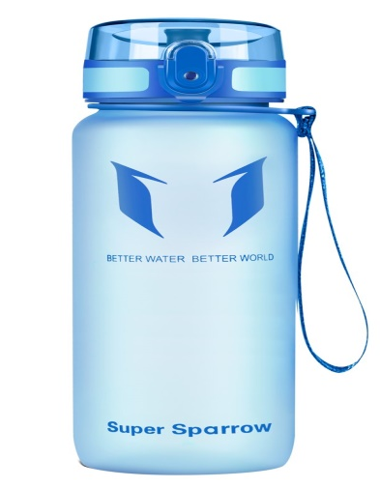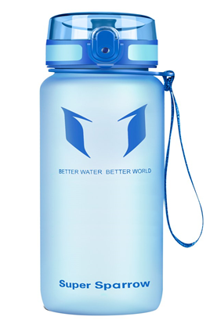
DRINK SAFE
DRINK SAFE
I will be selling my product under the name of Drink Safe so I will register a company which will be online company called Drink Safe and will only sell online to customers, I will observe my sale for few months and if doing well I will make a professional website for my online company which will have a buying link where you will have option for either pay through bank cards, PayPal or you can be redirected to Ebay or Amazon to buy product through them and also make payment through them.
A unique selling proposition:
A unique selling proposition, more commonly referred to as a USP, is the one thing that makes your product better than the competition. It’s a specific benefit that makes your product stand out when compared to other products in your market.
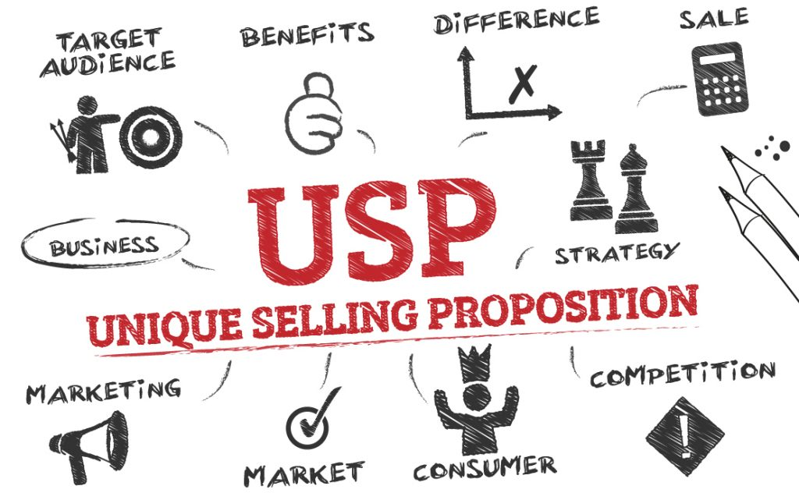
To make my product unique and better than others I will consider every aspect of new business strategy as a strong USP can make your business stand out in the market and a weak USP can do opposite so it is highly important to check all risk factors involved, do full market research (Miller, Henthorne, 2007), customer value is another important issue to consider, group discussion, check who your present compotators are and you also need to consider your direct and indirect or hidden comparators, when considering USP you also need to consider product suitability and product life cycle as these are one of the main points to consider when introducing new product in the market as you have to make sure product is fully sustainable as you don’t want to sell something which will cause harm to environment, society or any other stakeholder, when introducing new product from design to disposal you have to go through a lot of different process such as manufacturing, transportation, use etc., so you have to make sure your product is meeting all these requirements and that will make your product unique sellable and different from others as one of the main reason new products are getting failed in the market is no research.
Competitors:
After my research from different search engines I find out at present I don’t have any competitors for this product but once this product will get famous then a lot of different competitors may steel my idea and will start selling the same product with different name which I am well aware of and to overcome this issue I will be consider a upgrade plan which will improve my product features and functions.
Ecommerce business setup:
Due to present pandemic situation ecommerce businesses have shown incredible growth in past two years and it will even grow more after COVID 19 is over as now more people are using smartphone and internet, most people like to shop online rather than traveling to shops as this is more convenient for them to receive their products or services while sitting in their own home comfort, so this sudden change has increased a huge demand for online business.
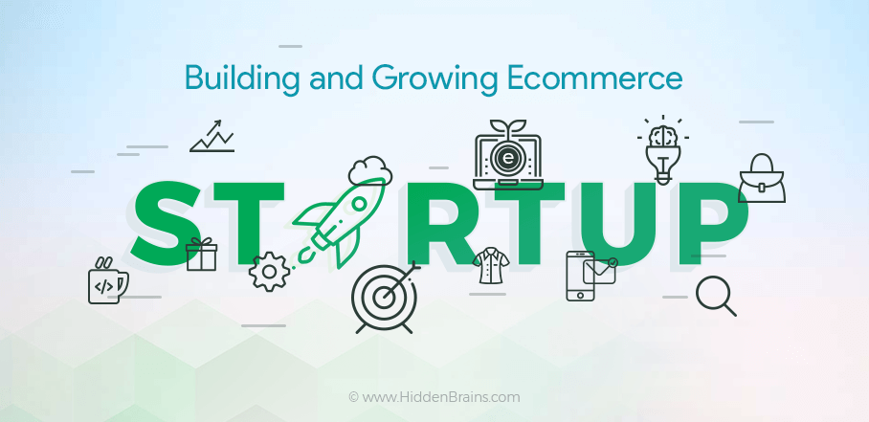
Starting an ecommerce business is very tough work with many stages and choices that need to come together at the correct time, you really need to spend a lot of your time to lay the correct groundwork and once your ecommerce business is established correctly, it is very simple to handle and is also very profitable too (Rodgers et al,. 2002).
To establish successful ecommerce business where I can sell my product easily I have to consider the following steps.

Perfect name for business and product:
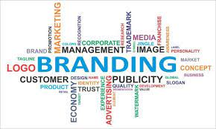
My product and business name has to be unique where people can attract towards it easily, it should be simple and sweet so people can remember it easily
Domain Name:
After selecting my product and business name I will be moving to another step which is selecting domain name for my business, this has to be simple short and unique as this will identify your business website, In most cases your business name is your domain name but sometime it is very difficult to get same domain name as your business then you need to choose an URL address that is related to your business, your domain name has to be easy to remember so people can easily remember it and can come back to your website without any hesitation.
Register your Domain:
After securing my business domain name I will register it with Godaddy, Bigrock, etc., there will be yearly charge for this service, when registering your domain name you have to give or enter your details like name, email, address, phone number etc., after successfully registration you will get confirmation email so to register this you don’t need any massive paperwork it is very simple and easy process which you can do yourself.
Business licence or permits:
To run my ecommerce business I will be applying for online sale required licence or permits, in most cases you don’t really needs permit or licence to run an online business as this really depend on what are you going to sell, but In near future I will be defiantly thinking to registering my business with HMRC for VAT purpose as when your business makes more than £85000 per year you defiantly need to register your business for VAT.

Choose correct ecommerce solution:
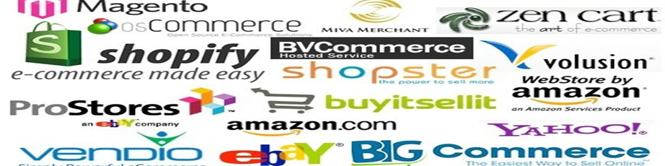
There are multiple ecommerce platforms available in the present market and most of them offering fairly the same services, features and functions, most popular ecommerce platforms are Shopify, BigCommerce, Volusion, etc., these platforms manages all the products, groups, checkout procedure, and other features involved.
Build & design your website:
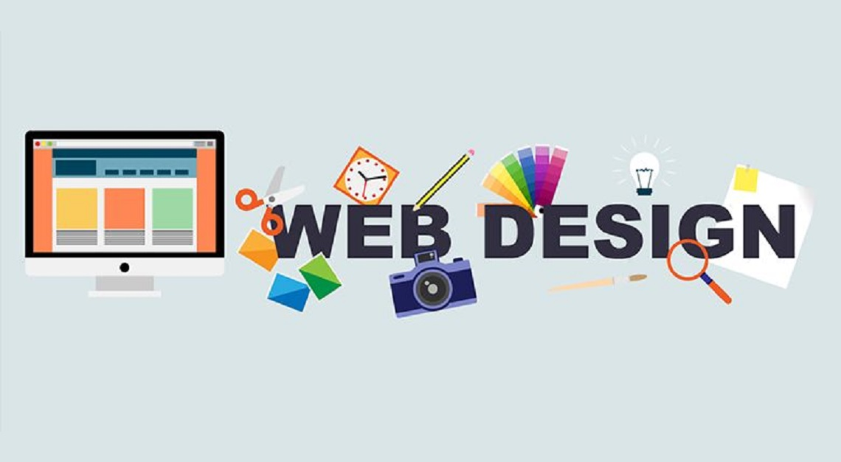
Your website design has to be perfect, simple, friendly, easy to understand, appealing to customers with great photographs inside defining your product, explaining why your product is unique and why should people buy this (Brown, 2020), I will be hiring a professional web design company like 7 Cloud Tech, Lounge Lizard, Upwork, etc. to design my business website, it will support all latest brewers, Android devices and IPhones, it will also Include terms and conditions, shipping and returns pages.
Financing, staff, equipment and supplies:
For my business to run online I don’t need any staff as I can handle everything myself, I will be buying a laptop and printer and some other necessary equipment and supplies and to finance all this and my product I will be using my personal savings.
Payments:
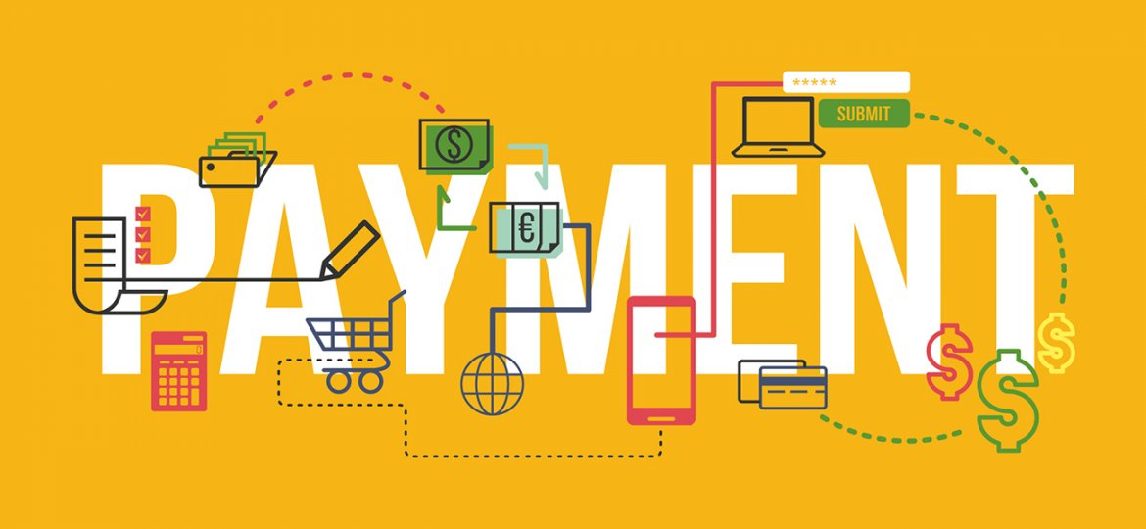
On my website I will be using transfer link to Ebay and Amazon so if customer prefer they can buy through them but in near future I will also have option to pay through PayPal and bank cards, which will be fully PCI-DSS compliance.
Marketing, promote and launch:
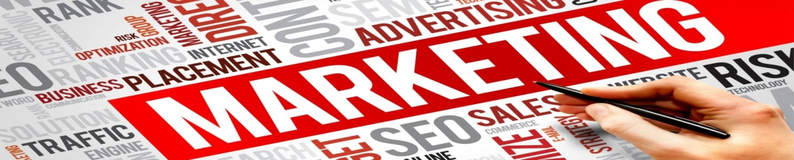
Before launching my product I will do complete market research considering product life cycle issues, arrange some prelaunch promotions, give 1000 free samples to random people and ask for feedback which will give me an idea how many people are going to buy my product, I will promote product via Social media, I will set up a Facebook page, Twitter account and also will advertise on different search engines and due to this people will be aware of my product and interested customers will be waiting for it to be launched (DiMarco, 2006), I will also promote my product on local radio stations as this is another best way to advertise your product where everyone can listen about your product.
Target customers:
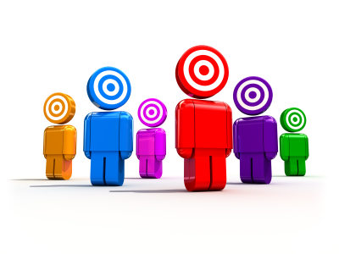
My target customers will be general public around the world as present pandemic situation has made people around the world so much scared so now even after this pandemic is over people would like to keep themselves safe as much as possible and will take every possible precaution which can protect them from catching dangerous viruses or germs so my product will be the best solution for them as every single human in the world drink water and when they will be getting this opportunity where they can drink safe water so they will defiantly take advantage of this product.
Segmentation process:
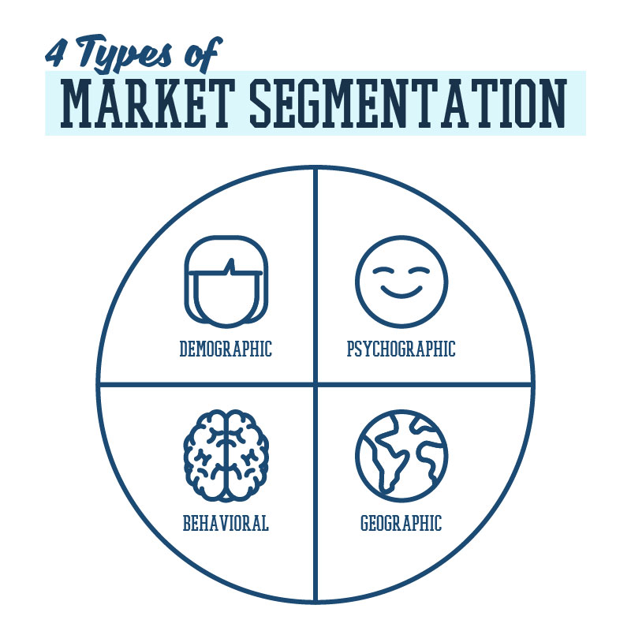
To target my customers I will also use segmentation process which will help me to understand and choose the most profitable group of people to focus on (Dibb, 1998), as by using this process I will be choosing group of people who are really interested in my product, to get the correct idea I will be considering four types of segmentations.
Demographic Segmentation:
This type of segmentation split people into groups considering their age, sex, marital status, family size, occupation, education level, income, race, nationality and religion, demographic segmentation can help you to narrow down your market even more and one advantage of this kind of segmentation is that the information is relatively easily accessible and low cost to obtain.
Geographic Segmentation:
This type of segmentation split your market according to your customer locations, it is very simple but very beneficial segmentation as by knowing customer location you can understand their needs more clearly and this will also help you to decide what to advertise in a specific area.
Psychographic Segmentation:
This is same as demographic segmentation but it work differently as by using this segmentation you can easily understand your customer motives, preferences and needs and by understanding this you can make content that meet their needs e.g. traits, interests, beliefs, values, attitudes and lifestyles.
Behavioral Segmentation:
By using this segmentation you can divide your customers through their behaviours as you can see how much time they spend on your webpage or how much interest they are showing on your product e.g. online shopping habits, action taken on website, usage rate, loyalty etc.
Marketing mix and 4Ps:
The Marketing mix was originally coined by academic Neil H. Borden in the late 1940s, it is a tool which can help you to avoid mistakes when you launching a new product to the market as there are so many different factors to consider when launching a new service or product, one small mistake can destroy whole project so you have to be extra careful when considering your market options for you new product (Goi, 2009), It is designed to meet the company’s marketing objectives by providing customers with value at all stages and it can be used for businesses of all sizes, the marketing mix is usually made up of four variables referred to as the four Ps of marketing which are as below.
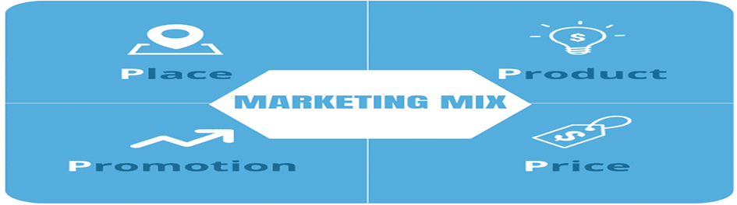
Product:
The product you offering to customers have to be perfect as you must understand and meet all of your customer needs and demands as if your product doesn’t meet customer demands then it will fail in the market.
Place:
Considering online sale it is very important that where and how you will advertise and position your product as your business is internet base so you need to make your website appealing to customers where they can get attracted by looking at your product and website design.
Price:
As customers are always looking for value for money so this is very important that your price is correct where you are making enough profit and also offering cheaper rates then your competitors.
Promotion:
It is highly recommended that you promote your product correctly as one mistake can destroy the image of your product so it is very important to spend some extra time on this as this is the base of your business.

Conclusion:
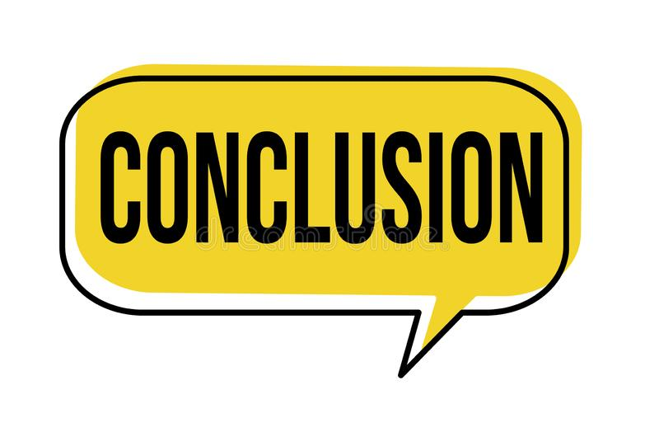
Considering present and post pandemic situation it is highly vital that people need something which can secure their future life so the product I made is the perfect solution for them as by using this bottle they can clearly see they are drinking safe water and this will protect them from dangerous viruses, germs and bacteria and this will also make them aware if their water is contaminated so this product will not only meet their needs but it will also give them benefit of two services from one product (Bayus, Shane, 2008), considering the number of whole word population still drinking contaminated water this product will be life saver for them.

References:
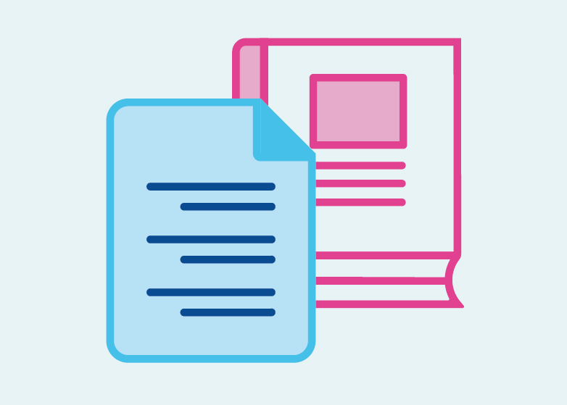
Ashfaq, M., Yun, J., Waheed, A., Khan, M.S. and Farrukh, M., 2019. Customers’ expectation, satisfaction, and repurchase intention of used products online: Empirical evidence from China. Sage Open, 9(2), p.2158244019846212.
Bayus, B.L. and Shane, S., 2008. Understanding customer needs. Handbook of Technology and Innovation Management, pp.115-142.
Brown, J., 2020. How To Design The Website Of Your Dreams. Pardox Journal, 1(1).
Chellaney, B., 2013. Water, peace, and war: Confronting the global water crisis. Rowman & Littlefield.
Dibb, S., 1998. Market segmentation: strategies for success. Marketing Intelligence & Planning.
DiMarco, J., 2006. Launch and Promotion. In Web Portfolio Design and Applications (pp. 208-212). IGI Global.
Goi, C.L., 2009. A review of marketing mix: 4Ps or more. International journal of marketing studies, 1(1), pp.2-15.
Miller, M.M. and Henthorne, T.L., 2007. In search of competitive advantage in Caribbean tourism websites: Revisiting the unique selling proposition. Journal of Travel & Tourism Marketing, 21(2-3), pp.49-62.
Pal, M., Ayele, Y., Hadush, M., Panigrahi, S. and Jadhav, V.J., 2018. Public health hazards due to unsafe drinking water. Air Water Borne Dis, 7(1000138), p.2.
Rodgers, J.A., Yen, D.C. and Chou, D.C., 2002. Developing e‐business; a strategic approach. Information management & computer security.

