HUMAN RESOURCE MANAGEMENT PART 2

COURSE : MBA General management
MODULE CODE : LCMB7000
ASSIGNMENT TITLE : 2
STUDENT NO : 2130892
LECTURER : Dr Gladius kulothungan

CONTENTS

Si No | Title | Page No
1 | Introduction | 3
2 | Company Background | 3
3 | Human Resource Strategies  • HR strategies develop and deploy in compensation • HR strategies develop and deploy in HR effectiveness measurement • HR strategies develop and deploy in employee retention | 3-9
4 | Conclusion | 9
5 | Recommendations | 9
6 | References | 10-11

INTRODUCTION
The practice of acquiring, employing, assigning, and supervising personnel is known as human resource management (HRM) (Mathis et al., 2016a). Human resource management plays a crucial role in every organization. Without competent human resources management, businesses are unlikely to attract and retain top talent, grow and advance their operations, and sustain a positive, inclusive organizational climate (Arvanitis, Seliger, and Stucki, 2016). The work here analyses the issues of HRM and IHRM in various organizations that will enable one to manage the design and implementation, policies, procedures, etc. to attain their goal and objectives.
COMPANY BACKGROUND
Peter Kelly established Softcat, a Marlow-based supplier of IT infrastructure, in 1993. In addition to an Irish office in Dublin, they have institutions in the UK in Bristol, London, Manchester, Leeds, Marlow, Southampton, Birmingham, and Glasgow. The entity is a component of the FTSE 250 Index and is listed on the London Stock Exchange. The company mainly provides cyber security solutions. In the UK and Ireland, Softcat is a top supplier of technological solutions and services to organizations across the public and private sectors. Investment management, business information, and analysis, teamwork, commodities procurement, data center, end-user computation and portability, security and networking software licensing, and Information Technology services are all things they offer. The company has a revenue of 1156. 7 million pounds with an operating income of 119.4 million pounds. The total number of employees in the company is 1681 as of 2021. In November 2015, this company underwent an IPO on the London Stock Exchange. The business was elevated to the FTSE 250 Index in March 2016. Hellawell became chairperson after leaving his position as CEO in March 2018. Hellawell was succeeded as CEO on April 1st, 2018 by Graeme Watt.
HUMAN RESOURCE STRATEGIES
A people-centric approach to addressing a firm's crucial problems is summarised in the Human resource strategy. This strategy shows the prominence of hiring, talent acquisition, remuneration, performance management, or company culture and necessitates HR engagement throughoudeployes in t strategic planning (Dass and Parker, 2017). To make sure that the company's human resources procedures are in line with the aim of the organization, it is significant to have a human resources strategy.
Human Resource procedures can help to improve workers’ output, have a good effect on learning, and improves a company's success in general (Noe, 2017).
HR strategies develop and deploy in compensation
The entire amount of cash and non-monetary benefits that provide to an individual in return for the job they perform for the company is known as compensation (Milkovich, Newman, and Milkovich, 2014). It's often one of the greatest costs for institutions that employ people. Compensation goes beyond a worker's usual paycheck. It also comprises a great range of additional pay and perks (Singh and Loncar, 2010). With the role of human resource manager in Softcat company, there is an effective compensation developed and deployed in the company for all the workers so that there will be an effective remuneration and compensation that positively affects the work of the people with better commitment. Since, adjusted wages, payments for overtime work, allowances, vacation, paid leaves, etc. are provided to the employees in the company which are the various compensation packages. Overall the teams or groups’ commitment and satisfaction will improve in the company so that we will be able to attain the goals and objectives (Yamoah, 2013).
This kind of compensation package will further improve the job satisfaction of the people and hence they can improve it in the future. Apart from their performance, the company’s output can also be raised with this kind of effective compensation system (Rasmi, Amrullah, and Sumardi, 2017). However, employee loyalty can be attained if the company provides valueadded compensation to the correct place in the Softcat company. All the employees will get regular payments and they will not be satisfied with this so the company must provide certain kinds of extra payments to the employees for their overtime work and allowances (Lu et al., 2016). These overtime payments or extra allowances provided to them will give more satisfaction and a certain kind of recognition will be appreciated and improve the morale of the people working there. Not only the satisfaction is improved there, but better motivation is also provided to the workers (Osabiya, 2015). One major thing is that the company must treat everyone equally and Softcat is doing it, where there should not be any kind of discrimination or distractions, and this process in Softcat will create an interest among the employees to work more in the company and will feel a sense of belongingness.
Theories of compensation
The theory associated with compensation is expectancy and reinforcement. According to the reinforcement theory, a behavior that results in a fulfilling experience is likely to occur again. The conclusion for compensation is that good worker productivity coupled with financial compensation will increase the likelihood of subsequent job performance. The workers will do certain jobs where they will get rewards from the top managers in a company. The major features of this theory consist of expectancy, instrumentality, and rewards.
Expectancy- this is anticipation the employees or team members have on the organization which is based on their job and performance in the company. so that the skills for the people, availability and proper use of resources, etc. are the various supports needed for the workers in the company and are the things they anticipate to get from the company (Chopra, 2019). People in the company believe that they will get all kinds of support for their work from the top managers and other stakeholders. This kind of expectation for the workers will help them to work more satisfactorily and brings a commitment to their work.
Instrumentality- this phase is the mentality of the people working in the company where they think that if they work in a better manner they will be treated and valued y all the top managers in the company. this shows the integration between the work and outcomes. The major role played here is human resource management because there will be a kind of respect, trust, etc. toward them and if they work in a better manner they will be rewarded by this personnel. Clarity, accountability, and transparency must be there among all the managers so that they can consider the work and performance done by the people and decide about the recognition, reward, and appreciation.
Valence- the reward or the outcome received by the people in the organization is valence and is based on their performance. People cannot anticipate the valence in the company because it is not equal to the work they did in the organization (Carruthers, 2018). All employees are different in the organization based on their abilities, skills, etc. So the bonus, recognition, promotion, etc. also depend on all these factors and may vary. Here more role is for the HR manager where he needs to value all the individuals based on their abilities.
Relevance of this strategy with Softcat company
This theory applies to the company but more than that they can adopt the Vrooms theory of expectancy in the company so that the company will be able to enhance more output than they already have. In this theory, people will raise their efforts and performance in the company so that the output can be increased more. More competition is faced by the technology companies and by adopting this theory they will be able to raise their competition. The top managers in Softcat can give more preference to the relation with the employees so that better cooperation can be enhanced and the effort will be more on work.
When this kind of employee engagement is there in Softcat company there can be high performance in the organization. By adopting these theories and strategies the company can redesign its plan so that it can attain better performance in the company with better success. By combining the factors of the expectancy theory employee motivation and commitment to the organization can be established and better compensation packages can also be provided. These all factors bring a feeling of belongingness to the company by the employees.
So one of the best strategies the Softcat company can adopt on the compensation is that the compensation provided to the team or employees in the company by the HR managers is that the wages and other allowances must be based on their performance and productivity in the company without any discrimination. This will improve the employee morale and eagerness to work more.
HR strategies develop and deploy in HR effectiveness measurement
Softcat company can find out the HR effectiveness so that the various decisions in the company can be adopted smoothly. for example, the evaluation of effective HR strategies is needed in the company. As the human resource manager, there is a need to find various human resource measures technique that helps in the actual performance and growth of the company which can be analyzed and determined properly (Mathis et al., 2016b). Various strategies there like a balanced scorecard system, HR matrix, and benchmarking can be adopted or applied in the company that gives efficiency and effectiveness to various kinds of human resource strategies in the company.
Matrics for measuring human resource effectiveness
With the help of the scorecard method, Softcat can access its efficiency and effectiveness in all the approaches related to human resources (Keyes, 2016). With the proper use of this matrix, the company can determine various initiatives for the successful attainment of growth and goals. There will be strong and better internal clarity and transparency within the business and at last, external transparency and accountability are to be executed that help in attaining the effectiveness of the human resources (Lueg and Vu, 2015).
The balance scorecard matrix in the company is relevant to the company here where the company has its goal, mission, vision, etc. for a long period (Akkermans and van Oorschot, 2018). Accountability, clarity, or transparency is to be maintained in the business or among the team members. these features will enable the people to work effectively in the company and also will be helpful to the HR managers so that they will be able to evaluate effectively all the human resource policies and other related initiatives (Appelbaum et al., 2017). These effects in the company will make people a part of the company and when their opinions are ideas are considered the team members will be valued in the company and all the work that they do will be appreciated. Appreciation and recognition create a sense of belongingness to the company among the employees or team members (Blatt and Camden, 2017). As an example, Microsoft is an international technology company that has better human resource effectiveness practices so that the company can attain all its goals and needs.
Overall, the Softcat company can adopt the balanced scorecard method for the effectiveness of their human resource because with this strategy there will be accountability, transparency, and clarity in all the work they do. This strategy will enable the Softcat company to access all its policies and other new initiatives.
HR strategies develop and deploy in employee retention
Employee retention is the capacity of an organization to retain its staff using appropriate procedures and tactics where one can stop the best talent from quitting whether the turnover rate is high or low (Cloutier et al., 2015). Various employee retention strategies the companies can adopt are hiring the right people with better empowerment. The managers in the company must believe that the present staff are the major assets of the company and believe them in all the factors (Gadekar, 2012). To understand the position and performance of the employees there must be a feedback system and after that, there must be a recognition and appreciation system which helps to sustain high morality in the organization. Apart from all these factors, the company must create a better working environment so that the employees can work in a satisfied manner and retain in the organization.
One of the best examples of this strategy used was Apple’s industry to retain their employees so that they improved and sustained their staff rate by 28%(Cattermole, 2019). Some other examples are CISCO, LG, and DLF where they used certain strategies to retain the employees in the company and are hiring the best and avoiding the rest, they conducted staff orientation programs For the new employees and provide a flexible place to work. They make a learning skill and advancement program to make their career and look for major triggers in their work. When they find something as an error an early warning detection system is also maintained (Sharma and Shukla, 2020).
The employee retention strategies adopted by the company will motivate the employees to be there in the company itself. There will be performance appraisal, motivation, employee feedback, appreciation, a better working environment, etc. (Ramlall, 2004) will be there for the employees in the company. This will enable the people to have more satisfaction and morale in the company. The incentives and other benefits received by the people will help to raise productivity with better quality of work (Cancelliere et al., 2011). Relationships with customers are more likely to be enhanced by the engaged workers, and groups that have had time to come together also typically provide outcomes. These all factors will bring a sense of belonging to the employees in the organization.
Practical application of various models of HRM and IHRM
In the Softcat company, the process of employee retention can be done using the below retention process

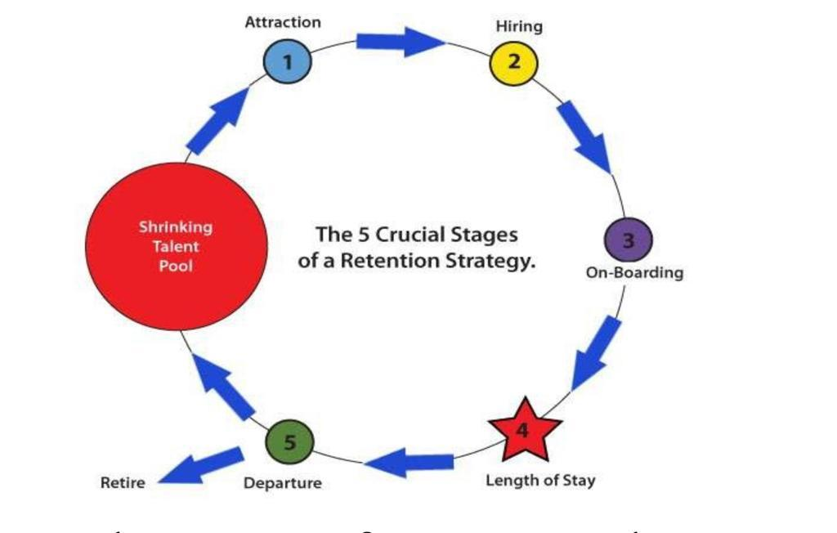
In the case of HRM and IHRM practices, an HR manager is attracting employees by providing all the needed facilities to the people after hiring. During all their terms in the company, all the benefits are given that satisfy the employees till their retirement time. This will help the company to retain the workers for a long period. Apple is a company that provides better work culture which is transparent in nature, supports employees, and gives empowerment to all their employees for their growth and development. Employees are satisfied in these fields of their work so that employees are retained and sustained in the companies.
To retain the employees in the organization the best adopted or deployed strategy Softcat can take is understanding the needs of the people and giving them more training and motivation. This will help the employees or team members to work freely in the company with better productivity. So that they can be retained for a long period. They can also provide certain incentives and allowances in the company for the employees to sustain them with better growth and development.
CONCLUSION
The report explains the Human Resource Management and other practices of Softcat company. The report explains the HR strategies that have been adopted in compensation, Hr effectiveness measurement, and staff retention. This has also shown how the strategies make the team or group members’ values, appreciated and create a sense of belonging to the company. some recommendations for the company in the coming years are also discussed.
RECOMMENDATIONS
• All the factors within the company must be harmonized while looking over all the internal and external plans.
• The company must provide compensation and other benefits to all the employees in the company without a break in it. This will enable the people to have more satisfaction in the company.
• More communication with better clarity and transperancy must be there and is to be strictly followed by the top management to all human resources in the organization.
• If the employees in the company are not adapted to many of its factors better training ad development should be provided and monitoring must be there from the top management.
• A feedback system after mentoring must be provided to them regularly so that they can understand their weakness and work on them.

REFERENCES
Akkermans, H.A., and van Oorschot, K.E. (2018) ‘Relevance assumed: a case study of balanced scorecard development using system dynamics, in System dynamics. Springer, pp. 107–132.
Appelbaum, D. et al. (2017) ‘Impact of business analytics and enterprise systems on managerial accounting’, International Journal of Accounting Information Systems, 25, pp. 29– 44.
Arvanitis, S., Seliger, F. and Stucki, T. (2016) ‘The relative importance of human resource management practices for innovation’, Economics of Innovation and New Technology, 25(8), pp. 769–800.
Blatt, R. and Camden, C.T. (2017) ‘Positive relationships and cultivating community, in Exploring positive relationships at work. Psychology Press, pp. 243–264.
Cancelliere, C. et al. (2011) ‘Are workplace health promotion programs effective at improving presenteeism in workers? A systematic review and best evidence synthesis of the literature, BMC public health, 11(1), pp. 1–11.
Carruthers, P. (2018) ‘Valence and value’, Philosophy and Phenomenological Research, 97(3), pp. 658–680.
Cattermole, G. (2019) ‘Developing the employee lifecycle to keep top talent’, Strategic HR review [Preprint].
Chopra, K. (2019) ‘Indian shopper motivation to use artificial intelligence: Generating Vroom’s expectancy theory of motivation using grounded theory approach, International Journal of Retail & Distribution Management [Preprint].
Cloutier, O. et al. (2015) ‘The importance of developing strategies for employee retention.’, Journal of Leadership, Accountability & Ethics, 12(2).
Dass, P. and Parker, B. (2017) ‘Strategies for managing human resource diversity: From resistance to learning, in International Human Resource Management. Routledge, pp. 375– 387.
Gadekar, S.S. (2012) ‘Managing intangible assets: measurement of human capital in manufacturing sector’, Journal of Commerce and Management Thought, 3(1), pp. 39–50.
Keyes, J. (2016) Implementing the IT balanced scorecard: Aligning IT with corporate strategy. Auerbach Publications.
Lu, L. et al. (2016) ‘Work engagement, job satisfaction, and turnover intentions: A comparison between supervisors and line-level employees’, International Journal of Contemporary Hospitality Management [Preprint].
Lueg, R. and Vu, L. (2015) ‘Success factors in Balanced Scorecard implementations–A literature review’, Management revue, pp. 306–327.
Mathis, R.L. et al. (2016a) Human resource management. Cengage Learning.
Mathis, R.L. et al. (2016b) Human resource management. Cengage Learning.
Milkovich, G.T., Newman, J.M. and Milkovich, C. (2014) Compensation. McGraw-Hill/Irwin Nova Iorque.
Noe, R.A. (2017) Fundamentals of human resource management. Boston, Mass. McGraw-Hill.
Osabiya, B.J. (2015) ‘The effect of employeesâ€TM motivation on organizational performance, Journal of public administration and policy research, 7(4), pp. 62–75.
Ramlall, S. (2004) ‘A review of employee motivation theories and their implications for employee retention within organizations’, Journal of American academy of business, 5(1/2), pp. 52–63.
Rasmi, R., Amrullah, A. and Sumardi, S. (2017) ‘COMPENSATION AND MOTIVATION EFFECT TO EMPLOYEES’JOB SATISFACTION’, Hasanuddin Economics and Business Review, 1(2), pp. 162–167.
Sharma, H. and Shukla, S. (2020) ‘Role of Predictive Analytics in Employee Retention: Corporate Cases’.
Singh, P. and Loncar, N. (2010) ‘Pay satisfaction, job satisfaction and turnover intent, Relations industrielles/industrial relations, 65(3), pp. 470–490.
Yamoah, E.E. (2013) ‘Relationship between compensation and employee productivity, Singaporean Journal of Business, Economics and Management Studies, 51(1115), pp. 1–5.

