UNIVERSITY OF WALES TRINITY ST. DAVID
CertHE Skills for the Workplace
Professional Career Development

Lecturer: Soban Sadiq

Oksana Mrsic (2131895)

Table of Contents
Introduction: 2
Reflection on the interview role played using Gibbs Model: 3
Life Timeline 5
Personal Swot Analysis: 6
Self-evaluation review, self-motivation and learning style: 6
Smart objective table: 7
Personal Development Plan: 8
Conclusion: 8
References: 9
‌Appendix: 10

Introduction:
My job path as a dental hygienist/therapist has been an intriguing trip full of opportunities for learning and difficulties. After finishing school, I decided to pursue a profession in dental hygiene because I have always had a strong interest in oral health. I enrolled in a dental hygiene program and studied the foundations of oral hygiene at Kings College. I gained real-world experience while in school via clinical rotations, which contributed to building a firm dental hygiene foundation. After graduating in 2016, I could use my academic knowledge and talents when I got my first job as a dental hygienist/therapist. With professional development classes and seminars, I have broadened my skill set throughout the years and kept up with the most recent developments in the industry. Using the reflective cycle as a framework, I have had the opportunity to reflect on my professional growth objective and progress so far. I began by reflecting on my experiences and determining my strong points and opportunities for development. I examined these encounters and determined what I had learned. This assisted me in determining the areas where I needed to concentrate my efforts to advance my abilities and knowledge. I made a strategy to further my job growth after considering my experiences. This included establishing specific objectives, participating in professional development programs, and looking for mentoring from seasoned experts. My work as a dental hygienist/therapist has been a great and happy adventure. I have pinpointed areas for improvement and created a strategy to meet my professional objectives via reflection and the reflective cycle. I'm eager to advance in my position as a dental hygienist/therapist and learn new things.

Reflection on the interview role played using Gibbs Model:
Stage of cycle
Description of the event | I played both the interviewer and the interviewee during the role-playing exercise. I prepared a list of inquiries for the interviewee on their prior employment history, educational background, and character traits. I had to judge the interviewee's professionalism, communication abilities, and aptitude for the job. I had to demonstrate my knowledge and abilities about dental hygiene and treatment while providing clear, concise answers to the interview questions.
Feelings | I was initially apprehensive as the interviewer because I wanted to ask the appropriate questions and conduct the interview professionally. As the interview continued, I gained confidence and maintained a pleasant yet professional demeanour. Participating in the simulated job interview was enlightening for me. I was anxious throughout the interview since I knew my knowledge and communication abilities would be judged. I made an effort to remain composed and on task, and I was pleased with myself for providing clear and certain answers to the questions. It helped me better grasp the interview process and the necessary skills for job interview success. I gained a lot of knowledge through the job interview role play, one of which was the need for preparedness. Before the interview, I learned about the business and the job I was applying for. Also, I rehearsed my delivery and prepared responses to typical interview questions. Because of my preparation, I communicated my abilities and experiences throughout the interview with clarity and confidence. I also discovered the value of active listening through role-playing. I made certain to pay close attention to the interviewer's inquiries and provide intelligent responses. I also made a point of keeping eye contact and expressing my excitement for the job.
Evaluation | I also saw that I might have supported my answers to interview questions with more specific examples. Even though I had prepared responses to frequently asked interview questions, I should have used concrete examples from my prior experiences to illustrate my abilities better. I will provide more specific instances in the future to back up my statements during job interviews. The mock job interview was an excellent learning opportunity for me. It aided in my comprehension of the interview procedure and the abilities necessary to be successful in a job interview. I am more certain of my capacity to succeed in my next job interviews after analysing my performance and recognizing my areas for growth.
Analysis | I recognise that there is always an opportunity for development in my performance upon reflection. I must continue to hone my communication skills, both as an interviewer and an interviewee, and acquire the ability to give and receive effective feedback. I must also improve my body language and nonverbal indicators to enhance my professionalism and confidence during interviews
Conclusion | As a dental hygienist/therapist, I found the role-playing exercise beneficial for my professional development. It allowed me to hone my communication skills, assess my assets and shortcomings, and acquire new interviewing techniques. I intend to continue practicing and refining my interview skills to become a more self-assured and competent dental professional.
Action plan | I intend to conduct and participate in simulated interviews with coworkers and mentors. With this, I can communicate more effectively and boost my self-assurance. I can pinpoint my weak areas and get feedback from others to help me perform better by replicating real-world events. I will concentrate on enhancing my body language and nonverbal signals during job interviews. My body language plays a significant role in how others perceive me, and by focusing on my posture, eye contact, and facial expressions, I can appear more confident and professional. I will evaluate my performance and make necessary modifications after practicing in front of a mirror or recording myself. I will research current industry trends, best practices, and typical interview queries to better prepare for future job interviews. By keeping abreast of the most recent advancements in my field, I can demonstrate my expertise and dedication to the profession, helping me stick out among other candidates. I will actively seek feedback from colleagues or mentors on my interviewing skills and performance. By soliciting advice and constructive criticism, I can identify areas for improvement and modify my approach accordingly.

Life Timeline
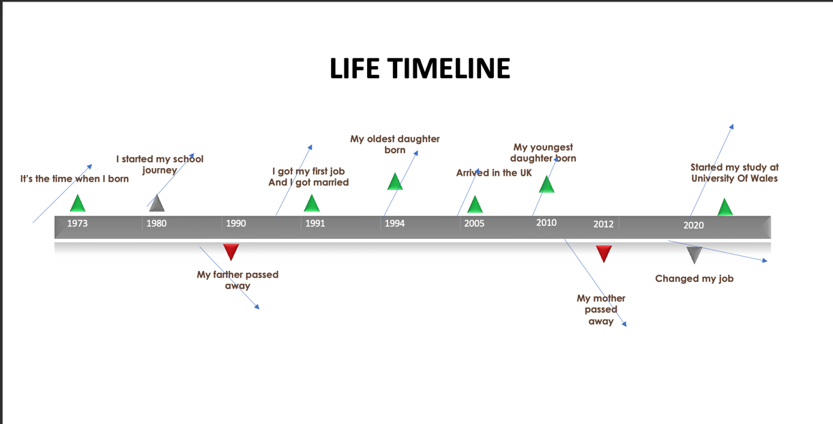

Personal Swot Analysis:
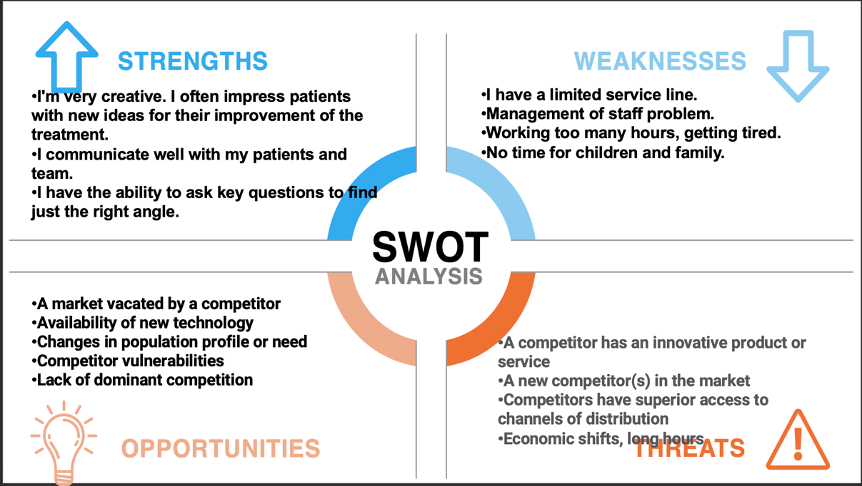

Self-evaluation review, self-motivation and learning style:
I have a variety of abilities that are crucial to my job as a dental hygienist/therapist. I've succeeded in my work and provided patients with the finest treatment possible because of these talents. Being a dental hygienist/therapist, empathy is among my most valuable qualities. It enables me to comprehend my patients' requirements and give them the consideration and care they need. They can confide in me to give them the confidence and support they need during their dental sessions since I can relate to their worries. This has facilitated the development of trust and enduring connections with my patients. Self-awareness is another talent that is crucial to my job. I make sure my patients are safe and happy in my capacity as a dental hygienist/therapist. To provide the greatest care possible, I must be conscious of my feelings and behaviours. Observing my body language, tone of voice, and nonverbal signs while engaging with my patients falls under this category. Digital proficiency is a talent that has grown significantly in dentistry. Dental hygienists and therapists are now expected to be skilled users of digital technologies, including electronic health records, digital X-rays, and other software. I can utilise these technologies successfully, which has helped us simplify our practice and provide our patients with better treatment.
I also possess teamwork abilities. I collaborate closely with dentists, dental assistants, and administrative personnel. I can collaborate with my co-workers to deliver the best possible treatment for our patients via excellent communication. This entails working collaboratively on treatment plans, debating patient issues, and ensuring that our office works efficiently. In my capacity as a dental hygienist/therapist, relationship-building is another talent I have. To make my patients feel relaxed and at ease throughout their sessions, I can establish lasting connections with them. While long-lasting connections and trust are necessary for delivering high-quality treatment, this has aided in developing these qualities with my patients.
My position as a dental hygienist/therapist requires me to have communication skills. This entails speaking and non-speaking, listening intently, and attending to the patient's requirements. I must evaluate my patients' oral health requirements and create individualised treatment strategies for each (Neugebauer and Evans-Brain, 2016). Making informed judgments needs the capacity for information analysis and critical thinking abilities. While at work, I'm on the lookout and highly focused. Detail-oriented work is crucial in the dentistry sector. I must ensure that all operations are carried out precisely and quickly and that all patient records are comprehensive and up to date. I have developed time management skills because I respect time. Dental visits may be time-sensitive, so it's critical to manage time well to ensure patients get the treatment they need promptly. To guarantee that all processes are carried out swiftly and successfully, I can set priorities and manage my time well. I have a variety of abilities that are crucial to my job. I have flourished in my work and provided my patients with the best treatment possible because these abilities include empathy, self-awareness, digital competence, team cooperation, and relationship development. I can continue to build and hone these abilities to provide excellent care and make informed decisions.

Smart objective table:
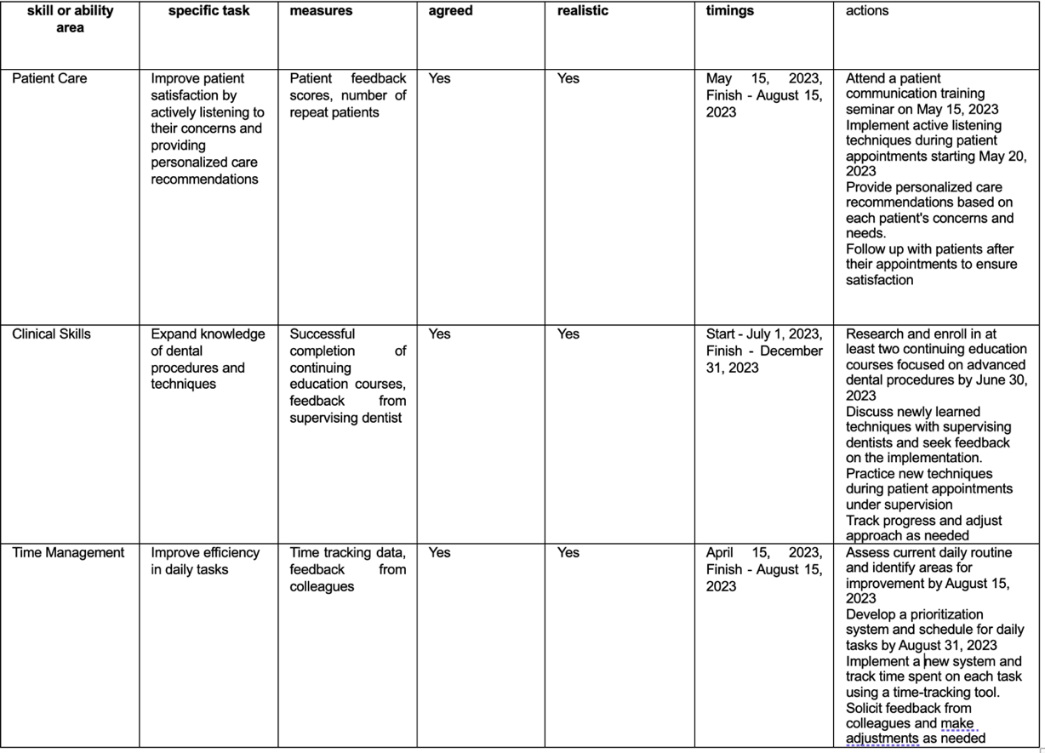

Personal Development Plan:
Researching and identifying particular areas I need to improve steps in developing my dental technology abilities. This will require examining recent technical dentistry improvements and identifying areas where I need more skills (Neugebauer and Evans-Brain, 2016). For instance, I must increase my understanding and proficiency using intraoral scanners or CBCT.
I want to attend workshops and seminars that concentrate on these topics after I have determined the areas that need development. These seminars and workshops will provide practical instruction and let me learn from subject-matter specialists. To learn more about their experiences with this technology, I will also get the chance to network with other dental experts.
I want to take part in online training courses and dental technology-focused training programs in addition to attending workshops and seminars. I'll be able to study when I want and at my speed thanks to this. Online courses are a more accessible alternative for continuing education since they may be more economical than physical workshops and seminars (Cottrell, 2021).
I want to integrate these technologies into my routine practice after I have mastered and am knowledgeable in them. Doing this will better serve my patients and keep up with professional developments. For instance, I may employ an intraoral scanner to enhance patient diagnosis and treatment planning.
Lastly, I will need feedback from patients to assess my progress and propose areas for future development. This will assist me in identifying the strengths and weaknesses of my dental technology-related abilities and modifying my training and development plan as necessary. I am convinced that I will be able to develop and improve my dental technology abilities by adhering to this methodical procedure. This will help me to offer better treatment for my patients and remain current with the newest developments in the profession.

Conclusion:
The skill set I presently have and how it relates to my chosen vocation as a dental hygienist was emphasised in the reflective report on my career development plan. After identifying a skill gap in this area, I also determined that I needed to design a step-by-step plan for acquiring the dental technology skills I needed. The role-playing job interview experience I had and what I learned from it was further covered in the report. At job interviews, I understood the importance of being prepared, listening carefully, and providing concrete examples. Body language and giving more specific examples to back up my statements were two more areas where I saw improvement needs. Based on my evaluation, I keep constantly looking for possibilities for professional growth (Cottrell, 2021), such as going to workshops and seminars, taking online courses, and integrating new technology into my everyday practice. I will also work on my body language and interviewing techniques to convey greater professionalism and confidence during job interviews. I can advance and succeed in my chosen dental hygienist job if I take this strategy.

References:

Cottrell, S. (2021). Skills for Success : Personal Development and Employability. London: Macmillan Education Uk.

‌Morgan, P. (2017). Business student’s guide to study and employability. Los Angeles: Sage.

Neugebauer, J. and Evans-Brain, J. (2016). Employability. SAGE.

Smile, P. (2013). Guide to Becoming A Dental Hygienist - Dental Hygienist Course UK. [online]
Perfect Smile. Available at: https://www.perfectsmile-dental.com/news/guide-becoming-dental-hygienist-uk/ [Accessed 14 Apr. 2023].
Tarrant, P. (2013). Reflective practice and professional development. Los Angeles: Sage.

‌Appendix:

Questions I have been asked by my interviewer:

1. What credentials do you have that make you a good dental hygienist?
2. How do you handle scared or anxious patients?
3. Do you prefer to work independently or as a team?
4. Are you comfortable working with patients of any age?
5. Has a patient ever gotten angry or upset at you? What did you do?






