

BA(Hons) Business Management

Student Name: Desislava Kutak
Student Number: 2030540
Module: Management Economics A1 (LCBB5003)
Lecturer Name: Dr Taye Osadiya

Table of Contents
Introduction 3
Chosen product and chosen business 3
Reason to choose the product 3
Demand and market equilibrium 5
Price of substitutes 5
Price of complements 6
Consumer Income 7
Consumer tastes & preferences 8
Consumer expectations of price 8
Demographics 9
Price Elasticity of Demand 9
Substitution Effects: Luxury vs. Necessity 10
Probable pricing policy 10
Conclusion 11
Reference 12
Bibliography 15

Introduction
According to Palepu et al. (2020) Financial or economic management in various business situations are important factors to consider before investing in any business related activities. Every business organisation assesses the current demand of the market associated with some product and develops their own substitute that can fulfil the demand of the consumers that are present in the market (Kembauw et al., 2020). In order to understand the necessity of selecting any certain product, existing published data regarding the sales of the product need to be effectively evaluated by the researcher and appropriate charts and graphs need to be incorporated within the research in order to make sure that the evaluations are effectively supported. Understanding the price of substitute products and its impact on the market demand among the consumers, the consumer income price of the complements consumer preferences that taste their expectations from the company regarding the price management demographic analysis and substitution effectiveness on the company pricing policy need to be effectively evaluated (Tien, 2019). The following report discusses the various dimensions that have been mentioned in this above sentence accordingly with special reference to the company Cadbury and their product Dairy Milk which has been one of the most influential and famous products across the world.

Chosen product and chosen business
The business that has been chosen to address the current issue of Cadbury company who mainly operates from the United Kingdom and host products are famous for ensuring maximum preferences from their consumers. The product that has been chosen is the most favourite product sold by the organisation under the name of Cadbury Dairy Milk. Dairy Milk itself has a lot of sister products under the similar brand name yet this current report typically concentrates on the main Cadbury Dairy Milk chocolate bar for evaluating the concern of the study effectively (Cadbury, 2022).

Reason to choose the product
The main reason for choosing the specific company is that every detailed information regarding their annual reports are given in the company website and relevant statistical information can also be taken from various reliable sources. Other reasons for taking this company into consideration include the renowned nature of the company being most renowned among the larger group of consumers in the market and their preference regarding the product to be one of the most available confectionery items that fulfil their craving for milk Chocolate in a market. There are more than other instances that can be useful to show why this specific product has been chosen to be most useful among the consumer group present in the market as it has the potential capability to influence potential competitions in the market regarding producing the similar products from multiple other companies (Ernestleewenbin, 2015). There are a lot of companies that have developed similar products following the Cadbury Dairy Milk in order to provide similar experience in a test birth of their selected consumer groups and concentrate about their nature of being addicted to consumption of chocolate. Due to these different reasons there has been a significant number of competitors in the market who are interested in creating similar products in the market and selling them to the same consumer. The product has been chosen in order to respond to an increasing threat of substitute companies creating similar products by analysing the target group of Cadbury in order to ensure they have an impact on the sales of the company as well as the demand of this specific brand in the market (Lewis, 2021).

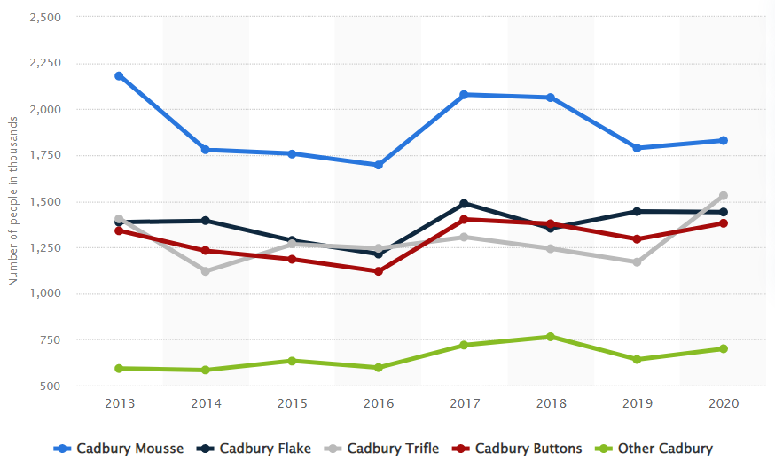
Figure 1: Dessert and topping brands of Cadbury ranked by number of users in Great Britain from 2013 to 2020 (source: Department, 2022b)

Demand and market equilibrium
Understand me the demand and market equilibrium are important ingredients for Cadbury in order to ensure that the demand and supply factors in the market are appropriately equalised. The equilibrium price can be understood as a balance between the demand and supply factors of any product reduced by a certain company in the market. The changes of equilibrium price typically depends on shift or movement in demand or supply or both. Market equilibrium can be described as a point which is an intersecting joint between the supply and demand curve (Devine and Bertsch, 2022). The following section describes multiple areas associated with demand and market equilibrium with providing special statistical information and graphical representation of Cadbury.

Price of substitutes
They are a lot of substitute products that threaten the existence and growth of Cadbury all together. As this product has been increasingly famous in a larger market where the consumers are a lot of organisations who are intending to take control over that specific consumer market by promoting substitute products of their own company that are similar to Cadbury in appearance but not in exact test. It is only obvious that there will be no company that can produce Cadbury products such as Dairy Milk in exact same way as the flavour will not match but the main thing that need critical consideration is that the product Dairy Milk is famous for its nature of being a comparatively cheaper product that provide their consumers with a great experience of test at a lower price (Lewis, 2021). This opportunity is used by the substitute product producers in the market as a day provides similar looking products to the consumers in the same price range which is acting as a substitute of the product for Cadbury. The price of substitutes do not generally increase as they intend to provide a similar experience to the consumers in order to increase their sales hence decrease their substitute price and gain more consumer attention. Although due to the increase substitute products in the market the companies hardly facing any competition as the consumers are most faithful and loyal towards the products created by the company and also the company continuously developed their product to make it more diversified and also keep the previously existing products in the market for increasing their expansion over the consumer segment effectively (Cadbury, 2021). The pricing could have created a problem for Cadbury to decrease their existing sales rate yet the pricing strategy and their diversified range of product to use multiple strategies for different market segments has helped the company to remain free from the threats of such competitions of substitute product prices in the market.
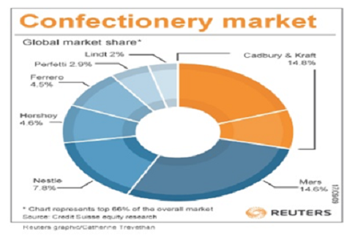
Figure 2: Factors affecting Supply and Demand of Cadbury Products ( Source: Consult, 2019)

Price of complements
The price of complement in your substitute goods that shift towards the demand curve is a serious matter of concern for every organisation. Complementary products are defined as products that are created by the main company or substitute companies in order to fulfil the demand of the consumers in the market (Ruiz et al., 2020). Complementary products are also defined as those products that have negative cost price elasticity of the demand. In simple terms whenever the price of the complementary product rises in the market it automatically decreases the demand for the actual product, resulting in declining the price and demand of the actual product in the market drastically. It is easily understandable that the impact of substitute and complementary products has drastic consequences for the sales rate of any organisation in the market. Whenever the price of the complementary products increases it automatically leaves an impression among the consumers that the actual product has increased their price and that results in decreasing the demand or preference of that original product in the market drastically leading the organisation to decrease their price for maintaining their sales margin elevated. Similar can be observed in the case of Cadbury Dairy Milk if other companies provide similar products or complementary products in the market (Madugba et al., 2021).
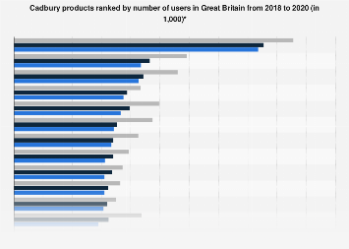
Figure 3: Cadbury products ranked by number of users in Great Britain from 2018 to 2020 (in 1,000) (Source: Department, 2022)

Consumer Income
Consumer income plays a great role in helping an organisation to retain their actual. In the case of the company Cadbury primary level operating in the UK it is imperative to analyse the disposable income of the median household in the country. During 2021 at the end of the financial year it was observed that the median household income was 31400 British pounds which can be useful for describing that and average cities in the United Kingdom are able to purchase the Cadbury Dairy Milk product without facing complexities in their daily income or compromising their other essential purchases (Croal, 2022). In 2022 it was observed that the income had increased by nearly 2000 British pounds that signifies that the average population in the United Kingdom can be effective towards impacting the development of capability of their consumers (Clark, 2022).
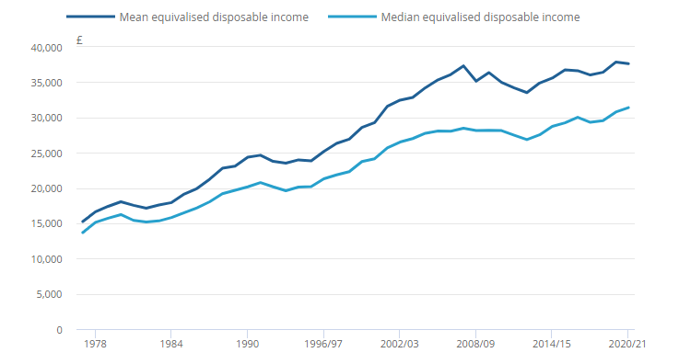
Figure 4: Median income increased during the 10-year period leading up to financial year ending 2021 (Source: Croal, 2022)

Consumer tastes & preferences
Consumer taste and preference are important ingredients that decide the production of Cadbury in the market. The preference of Cadbury consumers has an impact in developing their products continuously and is also influential on providing them with a beneficial upper hand regarding the ability to impress the existing consumer segment effectively. Statistical observations have shown the brand value of Cadbury have increased in 2022 due to the preference of the consumers. The brand value of the company was around 5.73 billion US dollars during 2022 whereas it was only 3.87 million US dollar in 2018 (Department, 2022c). It signifies that the consumers are preparing the products of the company and deciding to increase the demand in the market.

Consumer expectations of price
Consumer expectation regarding the price of the product always changes with the changing preference of their taste. Expectations of the consumers regarding decreasing the price of Cadbury products can be seen in various third world countries whereas in the first one countries the consumers do not expect the company to decrease their price and make the product more cheap. For Cadbury Dairy Milk the range of pricing strategy they use to sell the different sister products under the similar brand name is significant to observe as it has the capability to impact on the consumer mentality belonging to every economical layer of the society.
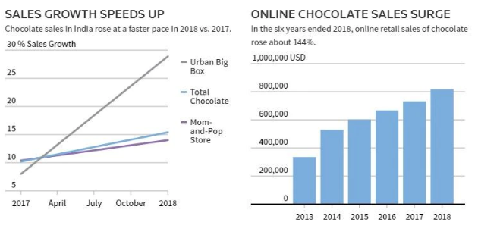
Figure 5: Rural India loves chocolate, Dairy Milk top choice ( Source: India Today, 2019)

Demographics
Number of consumers has definitely been increasing for Cadbury that can be observed by the increasing brand value of the brand that has increased by nearly two billion US dollars in the last 3 years. This signifies the significant increase in the number of consumers for the company.

Price Elasticity of Demand
The elasticity of price in demand can be termed as the percentage change in the demanded quantity of the product or service divided by the certain amount of percentage change in the price. Hence there are two determining factors that decides the price elasticity of Cadbury Dairy Milk that are the changing percentage in the demanded quantity of dairy milk in the market and the change in the price of the similar product (Beck and Lein, 2020).

Substitution Effects: Luxury vs. Necessity
From the point of view of the consumers that are involved with purchasing the products provided by Cadbury in the market this product is a luxury product that is only purchased by the consumer whenever there is a necessity of fulfilling a chocolate craving. Cadbury is associated with providing a lot of products using multiple pricing strategies for each of their products and the brand Dairy Milk has multiple products under their brand name that equally signifies the importance of the product by the company significantly (Dragone and Vanin, 2022). The product is only purchased by the consumers whenever there is a necessity of fulfilling their satisfaction regarding eating milk chocolate. It is categorised under the luxury product which is the reason and the substitution effect of the product increases the demand of the product in the market. The demand of the brand in the market is significantly increasing as the young generation is being more and more affected and drawn towards purchasing the animal products due to a major reason that the company concentrates on promoting the product specified to every occasion in multiple countries. Due to its nature being diversified in nature in India alone they are separate Cadbury Dairy Milk products for Valentine's Day, Christmas Diwali or Bhai Duj purpose (Meena, 2020).
Due to the increased diversity in this brand and its nature of being an increasingly popular product among the consumers it is easy to understand why it is being more elastic in nature when it comes to measuring demand of the product. This product is obviously more elastic compared to any other brand line or product line of the company due to its nature of providing a mode diversified pricing policy yet recent studies has shown that the significant decrease in the product quality of the Dairy Milk products that can be bought in a comparatively cheap price is affecting the growth of the company significantly (Kasirye et al., 2020). Using a different pricing strategy can be useful for Cadbury to retain stability of the increasing demand of their consumers in the developing countries. The reason to state this fact is that Cadbury has been considerably delivering poor quality of product line in the developing countries especially in the specific region where the product of the company can be bought in significantly less amount.

Probable pricing policy
Cadbury's currently using different pricing policies for all of their products in the market and in the dynamic line of their products alone there are a lot of modifications that can be done. Currently the organisation has been focused on using premium pricing strategy for their high end product of Dairy Milk line whereas using an economy pricing policies for their cheaper product launched in the market. The organisation needs to develop their premium pricing policy in order to remove the increasing threat of substitute products in the market that are affecting the demand of the Cadbury products increasingly (Keller, 2017). This increasing demand of the product in the market among the consumers is encouraging the similar companies to provide similar and complementary products in the market in front of their consumers which is directly affecting the sales margin of the company negatively. Apart from the set of the substitute products it is also a recognisable factor for the company to identify the decreasing level of their quality of product is also impacting on the consumers mindset to choose other products over Cadbury and make necessary quality development strategies to improve their product (Uggla, 2017). The company can use a penetrating pricing strategy and develop a new line of products at a cheap price that can affect both lower groups of consumers and fill their craving for chocolate.

Conclusion
In conclusion it can be stated that considering the demand of a certain product produced by large companies in the world is a major factor that increases the potential capability of similar organisations to produce substitute and complementary products in the market. This increased number of substitute products in the market results in decreasing demand of the similar product in the market which ultimately decreases the possibilities of the organisation to make maximum profit from the target market. The demand is the key to ensure profit and by effectively analysing the impact of the substitute and complementary product in the market Cadbury can make an effective pricing strategy that can help them to overcome the competition in the market.

Reference
Beck, G.W. and Lein, S.M., (2020). Price elasticities and demand-side real rigidities in micro data and in macro models. Journal of Monetary Economics, 115, pp.200-212.
Cadbury (2021) Cadbury Dairy Milk, Cadbury. Available at: https://www.cadbury.co.uk/products/cadbury-dairy-milk-11294 (Accessed: December 21, 2022).
Cadbury (2022) Our products, Cadbury. Available at: https://www.cadbury.co.uk/products (Accessed: December 21, 2022).
Clark, D. (2022) Topic: Earnings and wages in the UK, Statista. Available at: https://www.statista.com/topics/3850/wages-and-salaries-in-the-uk/#topicHeader__wrapper (Accessed: December 21, 2022).
Consult, T. (2019) Factors affecting supply and demand of Cadbury Products, Thesismind. Available at: https://thesismind.com/supply-and-demand/ (Accessed: December 21, 2022).
Croal, P. (2022) Average household income, UK: Financial year ending 2021, Average household income, UK - Office for National Statistics. Office for National Statistics. Available at: https://www.ons.gov.uk/peoplepopulationandcommunity/personalandhouseholdfinances/incomeandwealth/bulletins/householddisposableincomeandinequality/financialyearending2021 (Accessed: December 21, 2022).
Department, S.R. (2022a) Cadbury: Leading products in the UK 2018-2020survey, Statista. Available at: https://www.statista.com/statistics/312031/cadbury-leading-products-in-the-uk/ (Accessed: December 21, 2022).
Department, S.R. (2022b) Leading Cadbury Dessert Brands in the UK 2013-2020, Statista. Available at: https://www.statista.com/statistics/303887/leading-cadbury-s-desserts-and-toppings-in-the-uk/ (Accessed: December 21, 2022).
Department, S.R. (2022c) Cadbury Brand Value 2022, Statista. Available at: https://www.statista.com/statistics/1337772/cadbury-brand-value/ (Accessed: December 21, 2022).
Devine, M.T. and Bertsch, V., (2022). The role of demand response in mitigating market power: A quantitative analysis using a stochastic market equilibrium model. OR Spectrum, pp.1-43.
Dragone, D. and Vanin, P., (2022). Substitution effects in intertemporal problems. American Economic Journal: Microeconomics, 14(3), pp.791-809.
Ernestleewenbin (2015) Cadbury, Microeconomics. Available at: https://taylorsmicroeconomics.wordpress.com/2013/10/24/cadbury-microeconomics-individual-assignment/ (Accessed: December 21, 2022).
India Today (2019) Rural India loves chocolate, Dairy Milk Top Choice, India Today. India Today. Available at: https://www.indiatoday.in/business/story/chocolate-sales-in-rural-india-dairy-milk-1574884-2019-07-29 (Accessed: December 21, 2022).
Kasirye, F., Radwan, H. and Kreya, M., (2020). Assessing the 2014 Cadbury controversy through the Theory of Planned Behavior.
Keller, K.L., (2017). Managing the growth tradeoff: Challenges and opportunities in luxury branding. Advances in luxury brand management, pp.179-198.
Kembauw, E., Munawar, A., Purwanto, M.R., Budiasih, Y. and Utami, Y., (2020). Strategies of Financial Management Quality Control in Business. TEST Engineering & Management, 82, pp.16256-16266.
Lewis, A. (2021) These Cadbury facts have made us rethink everything we thought we knew about chocolate, Delish. Delish. Available at: https://www.delish.com/uk/food-news/a36969555/cadbury-facts/ (Accessed: December 21, 2022).
Madugba, J.U., Howell, K.E., Nwanji, T.I., Faye, S., Egbide, B.C. and Eluyela, D.F., (2021). Audit committee quality and financial reporting in deposit money banks in Nigeria. Asian Economic and Financial Review, 11(2), pp.104-117.
Meena, M., (2020). An Organization Study Report Of Cadbury India Pvt Ltd (Doctoral dissertation, CMR Institute of Technology. Bangalore).
Palepu, K.G., Healy, P.M., Wright, S., Bradbury, M. and Coulton, J., (2020). Business analysis and valuation: Using financial statements. Cengage AU.
Ruiz, F.J., Athey, S. and Blei, D.M., (2020). Shopper: A probabilistic model of consumer choice with substitutes and complements. The Annals of Applied Statistics, 14(1), pp.1-27.
Tien, N.H., (2019). International economics, business and management strategy. Dehli: Academic Publications.
Uggla, H., (2017). The price of luxury. IUP Journal of Brand Management, 14(2).

Bibliography
- Figure 1: Dessert and topping brands of Cadbury ranked by number of users in Great Britain from 2013 to 2020
- Figure 2: Factors affecting Supply and Demand of Cadbury Products
- Figure 3: Cadbury products ranked by number of users in Great Britain from 2018 to 2020 (in 1,000)
- Figure 4: Median income increased during the 10-year period leading up to financial year ending 2021
- Figure 5: Rural India loves chocolate, Dairy Milk top choice

