Target 1 | I am going to complete additional proofreading of my work to ensure absolute accuracy of spelling and clarity of expression.
Target 2 | I am going to further develop my critical thinking by further familiarising myself with various pedagogies and learning theories and comparing their ideas.
Target 3 | I am going to continue engaging with a wide range of relevant literature using a wider range of sources and writers.

Part B: How a school develops one aspect of its SDP: a report that critically reflects on the actions, impact and evidence base.

Within Part B of this assignment, I will be analysing the practice of my most recent placement school and its school development target to facilitate the professional development of all staff ([Placement School], 2019). As part of this process, I will be focusing on how this target was formed, addressed, and measured in terms of its impact on students and other stakeholders.

The placement school I am basing this assignment on is a community primary school located within the county of Swansea, designed to cater to students aged 3-11 ([Placement School], 2020). Only being built less than fifteen years ago, the school is specifically designed to act as a community hub providing services such as a local library and several community rooms ([Placement School], 2018). Unfortunately, the most recent figures indicate that around 94% of children live in the top 50% most deprived areas with free-school meals being at 22.7% ([Placement School], 2018). However, the school has demonstrated great resilience in terms of coping with the Covid-19 pandemic, enabling the continued learning of students and student-teachers despite lockdown learning being enforced. As such I will be discussing the strategies implemented during the pandemic as part of my comprehensive analysis of the school’s effort to achieve its targets.

In order to evaluate the success of my placement school’s development targets and actions we first need to break down the school development plan process into its key principles. As outlined by the Welsh Government, the process of creating a school development plan “is a disciplined process involving honest self-evaluation using qualitative and quantitative data” (2014, p.2).
As we reflect, we are actively and persistently examining our experiences, critically breaking down the thinking and actions of ourselves and others (Lay and McGuire, 2009). When reflecting on the experiences of children, educators often utilise the Mosaic approach, viewing children as social actors and experts in their own lives (Kelly, 2013). When reflecting on our own or other’s practice, as educators, we experience a similar cycle to that of the overall school development plan starting with reflection, planning, action then reflection again. However often we utilise specific methods to collect information on our teaching practice such as lesson study. This technique allows a teacher to see learning experienced from the perspectives of their students, giving more awareness to their needs while also encouraging increased collaboration between staff (Lee, 2008). But even if the collection of information or expertise is a collaborative effort, usually the responsibility of reflecting on and updating teaching expertise is left to the individual.

When creating a school development plan, school staff members are reflecting and planning as a collective in partnership with stakeholders. Thus, the second key principle of the school development plan process is the utilisation of social and learning networks within the school and learning community. This principle is supported by the pedagogical principles of Urie Bronfenbrenner and his ecological systems theory despite looking from a school development perspective rather than the students’. As part of his theory of ecological systems, Bronfenbrenner envisaged that children interacted and developed within different layers of influence such as the microsystem and the mesosystem (Gilbert, Rose, and Richards, 2015). The mesosystem can be described as the institutional level of interactions between the home and school, making a child’s education dependent not only on the teacher but also on the parent or guardian (Benjamin, 2015).

When we apply these concepts to school development planning, we can infer that maintaining positive and free conversation with stakeholders such as parents and carers is essential. Not only do both stakeholders, families, and teachers, directly influence the development of children, how successfully they interact and communicate with each other can shape the development of students. This idea can be extended to how staff interact with each other or how schools collaborate with organisations outside of the local community.

It could be argued that the idea of ecological systems puts unnecessary expectations on students to constantly experience efficient development. It could induce further stress especially if you consider the impact of enforced home learning experiences due to homework, which many practitioners had deemed to lack any positive impact on the learner. However, this is an over exaggeration of Bronfenbrenner’s pedagogical principles as a child’s development is not linear. Even Piaget, viewing development as building blocks of experience, believed that cognitive development required progressive reorganisation of mental processes (Mcloed, 2018).

When evaluating the school development plan created by my placement school, we also need to have a strong sense of what professional development of all staff means for the school. According to ‘Yr Athrofa’ (2018), professional learning includes engaging in formal and informal learning in order to stimulate thinking and ensure professional knowledge is up to date. Additionally, the effective professional development journey should contribute to improvements in outcomes for students, teaching, and school leadership (Jones, Pugh, and Taylor, 2018). Examples in Finland have demonstrated that successful teachers should have some degree of agency over their pedagogical approaches, with a focus on research, social interaction, and specialist subjects (Lee and Richings, 2018). Unfortunately, the degree of freedom over professional development especially when linked to research is dependent on the motivations of the school and availability of staff.

As professional development covers a wide spectrum of ideas and opportunities, part of the school development plan needs to specify what staff need to focus on.

One option is to focus specifically on subject knowledge, as teachers cannot teach topics, they themselves do not understand, yet this doesn’t necessarily require an academic qualification (Aloisi et al, 2014). According to Jerome Bruner however, the focus should not be general subject knowledge but knowing how to support students through a process or topic of learning. This is otherwise known as scaffolding where supported learning enables learners to accomplish tasks and develop understandings of new concepts and environments (Mallett, 2013). It could be said that scaffolding fits within the same ethos of Lev Vygotsky and his zone of proximal development. Vygotsky describes this zone as being supported through previous learning, instruction, and interaction with more capable others (Barnes, 2018). Both Vygotsky and Bruner encourage the idea of creating a learning environment that encourages children to gradually be able to solve problems by themselves through appropiate support and the exploration of concrete learning materials (Bowman, Burns, and Donovan, 2001; McLeod, 2019).

Another avenue to focus development on is curriculum design. According to the curriculum for Wales (Welsh Government, 2020) rather than separating key skills such as literacy and numeracy, they should be embedded across the curriculum. It is therefore the responsibility of all practitioners to reinforce these skills across their teaching, not just for specialist practitioners (Welsh Government, 2020). This idea is mirrored by Professor Donaldson (2015) where he suggests moving away from a subject based curriculum to an areas of learning approach. However, although it is important to ensure consistency across the school in terms of how the curriculum is executed, this area of professional development still comes back to practitioners needing up to date subject knowledge.

Interestingly within the main school development plan (Appendix ?), my placement school has chosen to centre most of their professional development actions around pupil well-being and additional learning needs. More specifically securing support for students with English as an additional language and those who might be suffering from trauma or other more serious emotional needs.

In order to successfully carry out these professional learning actions, the school should have properly worked through the process of school reflection and planning. It first requires the school to have a clear vision of what attributes they wish to embody. My placement school has three main aspirations including building a positive community, integrating a broad curriculum, and providing worthwhile learning opportunities ([Placement School], 2019). Based around these aspirations, the school can then start moving through each stage of the school development planning cycle (Appendix 2), starting with self-evaluation.

When a school is self-evaluating, as mentioned previously, it is crucial to utilise the qualitative and quantitative data available. For my placement school, qualitative data is usually sourced from the general observations of learning or more specifically collected from stakeholders directly through governors’ meetings and student feedback. Working with stakeholders to create a school-development plan is commonly known as co-production. Unfortunately, not everyone is willing to engage with aspects of the school such as this. So, leaders need to remain sensitive and non-judgemental, keeping in mind that the most disadvantaged children have the most to gain from home-school partnerships (Welsh Government, 2016).

Collecting quantitative data can be completed through methods such as assessment results, surveys, and classroom observations, and even educational research evidence (Schildkamp, 2019). Unfortunately, although this is an example of good practice, some practitioners may feel disconnected from the process or singled out over a specific statistic from their classroom.

That is why my placement school emphasises that going through the process of school development plan cycle is a part of enabling the school to become a learning organisation. According to the Welsh Government there are around seven key elements that make up a school-based learning organisation. The most relevant to the process of the school development plan being: “Promoting team learning and collaboration among all staff” (Welsh Government, 2018, p. 5). We can see that my placement school took this government recommendation seriously when working through this school development process. Not only because they were able to organise specific training opportunities for practitioners, but because one of their key action points is: “to ensure staff are engaging with the schools as learning organisations” (Appendix 2).

As evidenced by the actions outlined in the school development plan, a significant number of students demonstrated more extreme emotional needs. This training is all the more relevant as schools continue to deal with the effects of the pandemic and recover from extended lockdown learning. Within the school 17% of students were identified as having English as an additional language [Placement School], 2018).

In order to properly execute the plans mapped out by the school development planning document, all the key elements must be finalised This includes details such as indicating the time period of completion for certain actions, how progress will be reported back to stakeholders, and if opportunities for staff training are needed (Smith, 2002). As seen in Appendix 1, my placement school has specifically outlined the measurable milestones, time scale, responsible personal in charge and the resources needed for the action point.

The measurable milestones are especially important as they allow for both the school and outside observers such as me to evaluate the success of school development priorities and their action points. Unfortunately, as we can see from the timescale mentioned in appendix 1, the learning context drastically changed in the year 2020. Thus, making other priorities impossible to work towards. However, by looking at Appendix 3, we can infer that the school’s ability to self-evaluate and collaborate with stakeholders was so strong they were able to simplify the original school development plan.

This time there is a much larger focus on subject knowledge surrounding the different areas of learning and experience. However, staff are encouraged to pursue their own interest in other professional areas of development and research. Fortunately, the Appendix 3 development plan was designed to only be used during lockdown learning. However, the learning experiences and individual training will still carry over into classroom practice.

After self-evaluation, strategic planning and taking action comes reviewing the impact of the priority and its actions. Unfortunately, although my placement school has seemed quite successful with all other stages of the school development planning process, it is exceedingly difficult to judge the success of its planning. This is because there is very little information about the training and learning experiences of staff to compare the measurable milestones to. It could be argued that the pandemic limited the communication between staff members. But as seen in Appendix 3, all the school changed was the professional learning focus.

I would strongly suggest that as part of future school development plans, a system should be created to share professional training and expertise within the school. Not only would this enable staff members who are limited in availability to still progress in their teaching, but it would also collect evidence to compare to when self-evaluating professional progress.

The only evidence they have so far collected is results from a Welsh Government school learning organisations survey which did not provide many details except confirming that staff were engaging in professional development. By utilising an online sharing platform or a collective professional learning drive, there would be many possibilities to collect qualitative and quantitative data. For example, you could analyse what percentage has shared a professional learning experience or notes from a training experience, then who utilised these notes. If a collection of staff took interest in a particular topic of development such as digital competency, the school could record the lessons learnt from the experience and how they influence to the development of students.

To conclude I have greatly enjoyed breaking down the thought processes and actions of my placement school. When reflecting on the school development plan process carried out by my placement school, I feel that they have been successful in developing a cohesive plan to assist staff members in their professional development. They have clearly outlined the financing, staff and specialists required to successfully complete each action. However, I would argue that there is a lack of effort to share professional practice. Although meetings are regularly held to discuss school development and teaching practice, especially during lockdown learning, there does not seem to be any internal sharing of expertise.

To summarise, my placement school created a successful school development plan which was organised and clearly thought out to the extent that it was easily simplified when the learning context unexpectantly changed. They achieved this my communicating clearly to stakeholders such as parents and governors on their plans, creating collaborative opportunities when needed. The specific development target to facilitate the professional development of all staff was well justified. I especially appreciated the decision to uplift the professional skills of all staff members, allowing for students to benefit across their learning experience. One area that I think could further be improved is the sharing of expertise, especially from those who are able to attend professional learning courses or conferences.

As part of the process to complete this assignment, I was able to learn much about how schools actively and continuously improve the learning experience of students. Although I am familiar with this process as an individual practitioner, I was not fully aware of the amount of careful co-ordination a large-scale process like this required between school leaders and stakeholders. I look forward to taking part in future school development planning and general school improvement in my future teaching practice.
(Total Word Count 2471)

Part B References:

[Placement School] (2018) Self Evaluation Report 2018-19. Internal Report – [Placement School] Unpublished.

[Placement School] (2019) School Development Plan 2019-22. Internal Report – [Placement School] Unpublished.

[Placement School] (2020) Covid-19 School Development Plan. Internal Report – [Placement School] Unpublished.

[Placement School] (2020) Headteacher's Message. Available at: http://stthomascommunityprimary.wales/ (Accessed: 20th February 2021)

Aloisi, C et al. (2014) What makes great teaching? Review of the Underpinning Research. Available at: https://www.suttontrust.com/wp-content/uploads/2014/10/What-Makes-Great-Teaching-REPORT.pdf (Accessed: 31st March 2021)

Barnes, J. (2018) Applying Cross-curricular Approaches Creatively. Oxon: Routledge.

Benjamin, D, M. (2015) ‘Teacher and Parental Influence on Childhood Learning Outcomes’. Degree of Doctor of Philosophy Education, Walden University. Available at: https://scholarworks.waldenu.edu/cgi/viewcontent.cgi?article=2777&context=dissertations (Accessed: 22nd November 2020).
Bowman, B.T., Burns, M, S., and Donovan, M.S. (2001) Eager to learn. USA: National Academy Press.

Donaldson, G (2015) Successful Futures: Independent Review of Curriculum and Assessment Arrangements in Wales. Cardiff: Crown Copyright.

Gilbert, L., Rose, J., and Richards, L, V. (2015) Health and Well-being in Early Childhood. London: SAGE.

Jones, C., Pugh, B., and Taylor, L. (2018) Welsh Government Contract Area 8 of the National Model for Professional Learning: The Individual Professional Learning Journey. Available at: https://pure.southwales.ac.uk/files/3112441/Revised_report_including_WG_amendments.docx (Accessed: 7th March 2021).

Kelly, B. (2013) ‘Exploring a methodology with young children: Reflections on using the Mosaic and Ecocultural approaches’, Australasian Journal of Early Childhood, 38(1), pp. 35-40. DOI: 10.1177/183693911303800107

Lay, K. and McGuire, L. (2009) ‘Building a Lens for Critical Reflection and Reflexivity in Social Work Education’, Social Work Education, 29(5), pp. 539-550. DOI: 10.1080/02615470903159125

Lee, C. and Richings, L. (2018) Area 1: An Overview of Evidence for the National Approach to Professional Learning in Education. Welsh Government, Cardiff.

Lee, K, F, J. (2008) ‘A Hong Kong case of lesson study: benefits and concerns’, Teaching and Teacher Education, 24(5), pp. 1115-1124.

Mallett, J. (2013) ‘The exploration of the implementation of talk for writing in a year 4 class’, Education, 41(1), pp. 23-31. DOI: 10.1080/03004279.2012.710096

McLeod, S. A. (2019) Bruner - learning theory in education. Available at: https://www.simplypsychology.org/bruner.html (Accessed: 31st March 2021).

McLoed, S, A. (2018) Jean Piaget’s theory of cognitive development. Available at: https://www.simplypsychology.org/piaget.html (Accessed: May 1st).
Schildkamp, K. (2019) ‘Data-based decision-making for school improvement: Research insights and gaps’, Educational Research, 61(3), pp. 257-273. DOI: 10.1080/00131881.2019.1625716

Smith, R. (2002) Creating the Effective Primary School: a guide for school leaders and teachers. London: RoutledgeFalmer

Welsh Government (2014) School Development Plans. Cardiff: Crown Copyright

Welsh Government (2016) Theme 1: leadership for a self-improving system. Cardiff: Crown Copyright

Welsh Government (2018) Schools in Wales as learning organisations. Available at: https://hwb.gov.wales/api/storage/f87e720f-8568-4a60-9383-55e20b9a1bb7/schools-in-wales-as-learning-organisations.pdf (Accessed: 7th May 2021)

Welsh Government (2020) Curriculum for Wales guidance. Cardiff: Crown Copyright.

Yr Athrofa (2018) The National Approach to Professional Learning in Wales: Evidence base. Available at: https://athrofa.cymru/wp-content/uploads/2019/04/UWTSD-strategic-context-22.10.18.pdf (Accessed: 7th May 2021)

Appendices:
- School development planning cycle (Welsh Government, 2014, p. 7)
- School Development Plan (2019-2022) Priority 3 ([Placement School], 2019)
- Covid-19 School Development Plan Priority 3 [Placement School], 2020)

Appendix 1

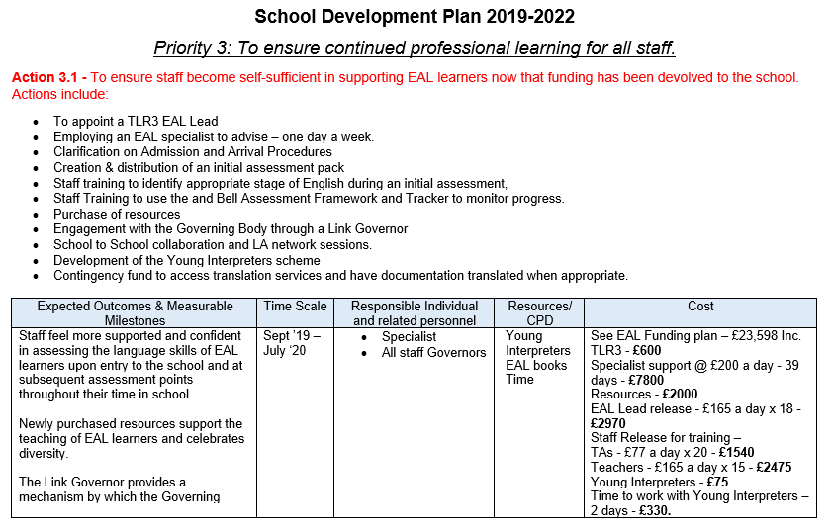

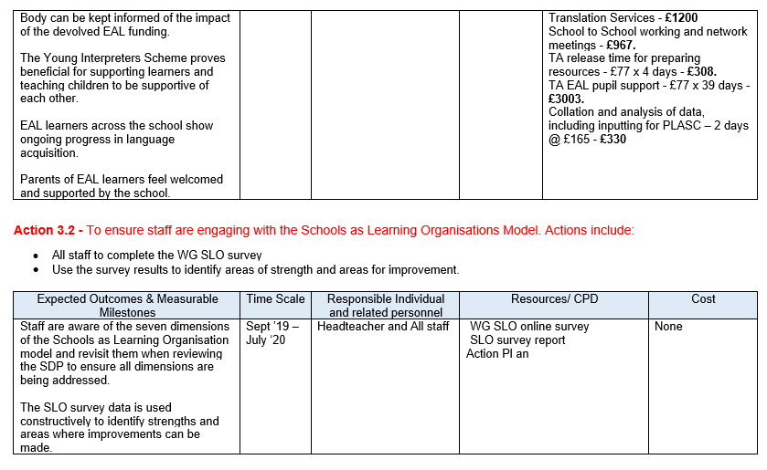

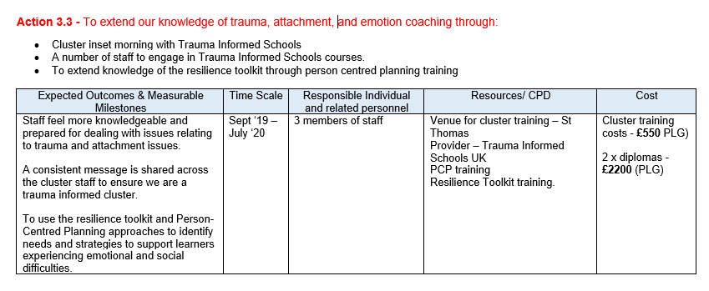

Appendix 2

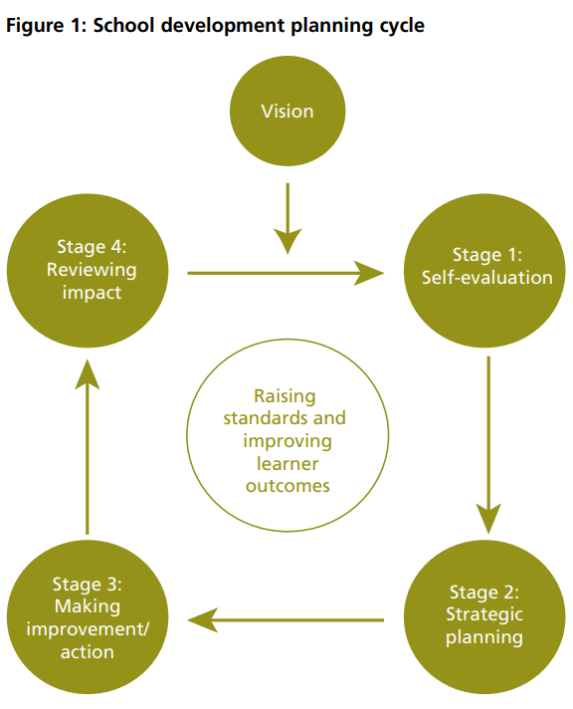

Appendix 3



