Sabine Denis, SI 1708972
MA in Ecology and Spirituality
August 2018

Module 4 – Western Esoterism
Was Aleister Crowley the ‘wickedest man alive’ or a prophet of the new aeon? Illustrate your answer with reference to the texts and techniques of Thelema.

Aleister Crowley, the wickedest man alive or a prophet of the new aeon?

Introduction,
Throughout Western history, there have been secret spiritual movements that have been considered as profane, or even retarded, by both the religious and scientific establishments. The common term for these movements is “occultism” (hidden or secret in Latin), although the official academic term is “Western Esoterism” (Partridge, C. 2005). Occultism haunts the public imagination, and its known figures, such as like the ill-famed Aleister Crowley, have stirred the popular freight with rumours of child sacrifice, violent sex orgies, psychedelic drug abuse, and other horrors. The purpose of this paper is neither to defame Aleister Crowley by adding fuel to his already flamboyant reputation, nor to eulogise him by denying the excesses he has been accused of. Many of the mixed feelings about Aleister Crowley are the result of his self-promotion as a “beast” and I refer to his autobiography and numerous biographies for a colourful description of his notorious live. Crowley’s charismatic personality is tightly bound to the development of his theory and praxis. I will therefore summarise his career in one paragraph, based on John Symond’s biography “The Beast 666. The Life of Aleister Crowley” (1997).

Edward Alexander Crowley was born in puritanical Victorian England (1875), in a strict protestant family (Symonds 1997). After his father’s death, he rebelled, changed his name to the Gaelic Aleister and turned to occultism, in a relentless search for self-realisation. Crowley joined the Hermetic Order of the Golden Daw, the most influential occult group of that period (Gilbert 2015: 241). He was initiated to magical art and rituals but was expelled from the lodge due to him publicising its highly secret rites. He then explored a variety of eastern religions and mysticisms. It was in Egypt, on his honeymoon, that a Holy Guardian Angel dictated to him “The Book of Law”, the basis for his religion called “Thelema” (Urban 2003: 143). This book was to be the revelation of a New Aeon of which Crowley in his persona of “The Beast 666” was to be the prophet. He founded a community in Sicily, in the Abbey of Thelema. The members of the community participated in drugs parties and practiced sex magic in all forms. One might think that with such an attractive lifestyle he would have many friends, however Aleister managed throughout his life to alienate almost everyone, from the prudish Victorian protestant society to his wife, his multiple mistresses and lovers, his mountaineering friends, mentors and colleagues in the occult world. He died alone, in penniless obscurity, in 1947.

To answer the question of whether Aleister Crowley was the wickedest man alive or a prophet of the new aeon, I need to go beyond the public figure of “The Beast” to ascertain the relevance of his Religious Philosophy of Thelema in contemporary culture and spiritual movements. I will more specifically focus on Crowley as a mystic and as an occultist.

1. Thelema: Aleister Crowley, the Prophet

“The word of the Law is THELEMA” (Crowley 1909, AL I 39)

In April 1904, the Guardian Angel Aiwass dictated the Liber AL vel Legis or The Book of the Law (abbreviated as AL) to Crowley and revealed his spiritual philosophy Thelema, a Greek word for “will”. The monk François Rabelais had coined the term Thelema in the 16th century, in a story about a community that lived without rules and laws, simply according to free will and pleasure (Urban 2003: 143). According to Crowley, the new religion Thelema was destined to supplant Christianity. The Law of Thelema can be summarized in the following three aphorisms:

- Do what thou wilt shall be the whole of the Law (Crowley 1909, AL I 40)

The central doctrine of Aleister’s new religion is that every man and woman has a unique hidden essence (Djurdjvic 2008: 8). This essence is the Higher Self and can be discovered through rituals and praxis. Crowley identified the Higher Self with the True Will. It is every person’s duty to “search for and carry out his or her true purpose in life, in other words, to do one’s Will” (Djurdjvic 2008: 2). Contrary to what could be believed, “Do what thou wilt” is not a free license for debauchery and is not the same as “Do what thou like”. It involves a form of personal development and is not limited to purely hedonistic tendencies. The notion of “will” calls for the discovery of the Higher Self in relation to the cosmos (Djurdjvic 2008:9). On the other hand, in the effort of self-realisation, there is absolute liberty, without regard for the moral or religious codes.

- Every man and every woman is a star (Crowley 1909, AL I 3)

To Crowley, the law of Thelema is the answer to all problems: since each of us is unique, there are no two identical wills and there can be no conflict of wills, unless one of the parties is not aware of his/her True Will (Bogdan 2015: 296). Each Star stays in its own orbit. Hence, there is no need for righteous standards of “right” or “wrong”: “Ethics is balderdash” says Crowley in his own commentary on the Book of Law (1954). A Thelemite does not have to consider the “rightness” of his actions, but only needs to focus on the harmony of those actions with his True Will (Morgan 2011: 164). This has been nuanced after his death, by adding the Golden Rule and stipulating that the dictation “Thou thy will” includes an obligation to allow everybody else the freedom to do their wills unhindered by you (Hessle 2007: 7).

- Love is the Law, love under will (Crowley 1909, AL I 57)

While the will remains the law, the nature of that will is love. But this love is a byproduct of the will and does not supersede it. If a contradiction should arise in any crisis, it is the will that will always prevail (Hessle 2007:11).

Crowley’s position on religion is ambiguous. He invokes a number of Gods in the course of his life, with prevalence of Egyptian Gods reigns during his time at the Golden Dawn and in the literature of Thelema (Djurdjevic 2008: 4). But he ultimately eschewed the idea of “Gods”, declaring instead that “there is no God but man” (Crowley 1909, AL II 23). In any way, he did not want his Thelema, with teachings which are more descriptive than proscriptive, to become an ultimate religious dogma: "It all depends on your own acceptance of this new law, and you are not asked to believe anything, nor to accept a string of foolish fables beneath the intellectual level of a Bushman and the moral level of a drug-fiend. All you have to do is to be yourself, to do your will, and to rejoice." (Crowley, The Book of Liberty, nd).

2. Magick : Aleister Crowley, the Occultist

“Magick is the Science and Art of causing Change to occur in conformity with Will. … Every intentional act is a Magickal act.” (Crowley 1930: 134)

Like any good prophet before him, Aleister Crowley was asked by the different Egyptian Gods in the Thelema to go on and teach the new Law (Morgan 2011: 166). He was ordered to promulgate the Law to all of humanity, with the stipulation that each individual had to pass through various “ordeals” to prove their rejection of the old law and to bring them to know their true will. He therefore invented a series of practices, which he called “Magick”, spelled with a “k”, to distinguish it from the spells and divination practices of “lower” magic (Bogdan 2015: 296).
It concerned an eclectic and personal combination of spiritual rituals drawn from Western magical traditions like those of the Hermetic Order of the Golden Dawn, and Indian sources of meditation and yoga. To this, Crowley added the power of sexuality as a source of magic as well as drama and performance (Urban 2003:148). He merged it all into “dramatic rituals” with performance, music, dances and sex to liberate ecstasy and prove the validity of the Thelemic principles. Thelemites had to undergo those various magical rituals that were designed not only to cause transformation in the outside world but more so within the practitioner himself (Harvey 1997: 88). In Crowley’s view, science and religion had failed and Magick was the third manner, a combination of the method of science and the aim of religion (Bogdan 2015: 297). He was inspired by the renewed interest in magic during the Renaissance period, with the discovery of the writings of Hermes Trismegistus, the archetype of the “Magus”. This found echo in a second revival wave for occultism that flourished in England from the late 1800s until the 1920s and was Crowley’s milieu (Hanegraaff 2013: 33).

Crowley defined Magick as the act of causing change according to will. This definition is very broad, especially since Crowley added that “any intentional act is a magickal act”. However, Crowley’s focus was not on gaining power over the outside world through this magical practice, rather aiming at inner development of the Magician himself (Hanegraaff 2003: 106). The goal was the spiritual self-realisation of the Magician and his followers, in line with the “True Will” or, in modern terms, personal development.

- "Sex is the main expression of the Nature of a person; great natures are sexually strong; and the health of any person will depend upon the freedom of that function" (Crowley 1909, AL II 12)

Crowley was a practitioner of Left-Hand Magick, derived from the Tantric traditions of India and a strand of the Western esoteric tradition that interprets alchemical symbols in sexual terms (Harvey, G. 1997: 97). He had learned the rituals in The Ordo Templi Orientis and he viewed orgasms as being the openings through which magical intent could be channeled. He took the concept much further than his predecessor, Paschal Beverly Randolph (1825-1875), and did not limit sexual intercourse to marital relationships but included sex with prostitutes, masturbation and homosexual intercourse (Urban 2015: 566). By making sexual acts the ultimate keys to his Magick, Crowley turned his back to the entire social-moral world which he lived in (Urban 2003:149). Aleister Crowley referred to masturbation jokingly as “child sacrifice” and boasted that he made this particular sacrifice on an average about 150 times per year (Crowley 1930: 217). Eventually, the rumors about the Thelemic sex orgies, drugs parties and the systematic experimentation with every conceivable form of transgression in the puritan Victorian age let to the epithet “the wickedest man on earth”. It was the headline in 1923 in the John Bull Magazine, a popular British Weekly, because of the rumours of “practices which no normal person could conceive of, much less describe” rumoured to be conducted by him (Urban 2003: 161).

Conclusion: Aleister Crowley: A wicked Trickster-Prophet

To answer the question of whether Aleister Crowley was the most wicked man on earth or a prophet of the new aeon, we need to know what his influence today is to see whether a new aeon had started (Jones 2017). Indeed, Aleister Crowley had announced a new era, the aeon of Horus, characterised by individuality and freedom (Djurdjevic 2008:3), following the aeon of Isis (matriarchy) and aeon of Osisris (patriarchy).

The aeon did not start immediately and the impact of Crowley’s work was not instantaneous. Only several decades after his death did Crowley’s teaching gain influence in the New Age movement, with posthumous assistance from pop musicians, like the Beatles and David Bowie. I believe he would have loved that. He finally gained the recognition he searched for his entire life and his message of free will, love and sexual liberation found echo in the sixties (Bogdan 2015: 301). His teachings influenced the founders of new religious movements like Wicca (Gerald Gardner), Chaos Magic (Austin Osman Spare) and Scientology (Ron Hubbard) and he became one of the most influential figures in the revival of magic at the turn of the new millennium (Hutton 1999: 171). He was also one of the first to bridge Eastern spirituality and Western Esotorism, opening the gates to the discovery of a whole series of new spiritual movements. Only recently has Crowley been dignified with academic attention, especially in the field of Western Esoterism (Hutton, R.1999:171). “Crowley is not only a fascinating figure worthy of attention by scholars of religion, but he is also of profound importance for the understanding of modern Western spirituality and culture as a whole” (Urban, 2003: 139).

Above all, Aleister Crowley was a trickster. Western modernity knows very little tricksters and Crowley is one of the few exceptions. According to anthropologist Paul Radin “The trickster is a picaresque hero, a being with voracious appetites, particularly for food and sex, who in the course of trying to satisfy his hungers plays tricks with social and natural law” (Wallace 1957: 180). He is at the same time a creator and destroyer and does not care for good or evil. The trickster embodies “the primeval generativity and diffractive ingenuity of things” (Akomolafa 2017: 441). He is a means to keep the world awake and sharp (Hyde 2017: 16). They function as catalysts in traditional societies and bring about transformation by crossing the boundaries and violating taboos (Kripal 2014: 123). Because they work outside the rules, they manage to change them, exactly like Aleister Crowley’s defiance of the Victorian morale. The world is in need of more tricksters like Crowley: in spite of, or rather thanks to, their disruptive behaviour, they create new cultures. Do you think it is a coincidence that Crowley’s Thoth Tarrot card of the Magus, number 17, is a representation of Mercury, the archetype of the trickster (Crow 2008)?

My conclusion is that he may have been the wickedest man in the world, however, he was also a prophet of the New Age aeon. Crowley himself predicted his own influence when he wrote: “1000 years from now, the world will be sitting in the sunset of Crowlianity.” We may not be sitting in the “sunset of Crowlianity” yet, but as a true trickster of our modern and postmodern society, he has opened the doors of perception for the “spiritual but not religious” generation.

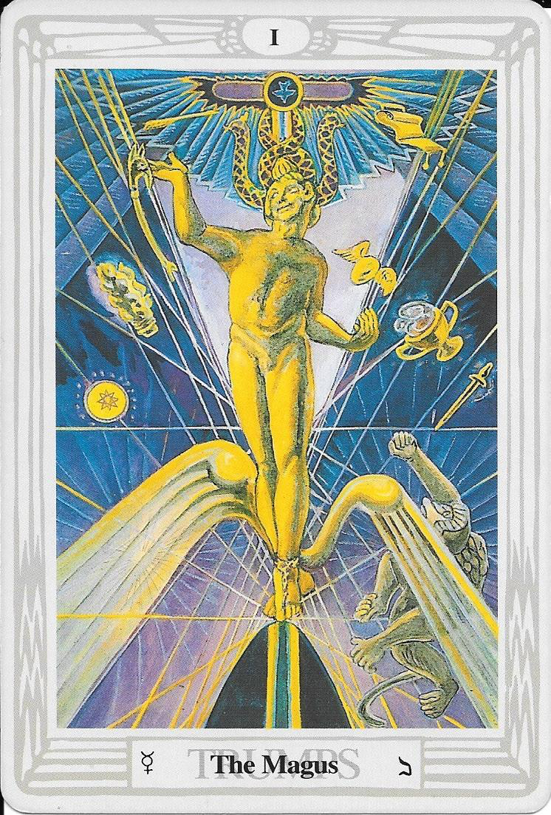
To end this paper in true Aleister Crowley style, I will finish it, with a wink, with one of his quotes: “Holy, Holy, Holy are these Truths that I uttered, knowing them to be falsehoods?” (Crowley 1952)

Reference List

Akomolafe, B. 2017. These Wilds Beyond Our Fences. Letters to my daughter on humanity’s search for home. Berkeley: North Atlantic Books.

Bogdan, H. 2015. Aleister Crowley, A Prophet for the Modern Age. In Partridge C. (ed) The Occult World. Oxfordshire: Routledge.

Crow, J. 2008. The Bhikkhu and the Magus: Exploring Allan Bennett’s Influence on Aleister Crowley. Cesnur International conference 2008, London (Available from http://www.cesnur.org/2008/london_cyberpro.htm)

Crowley, A. 1973. Magick: edited, annoted and introduced by Symonds and Grant. London: Routledge & Kegan Paul

Crowley A. 1954. The Law is for All: The Authorized Popular Commentary on Liber AL sub figura CCXX, The Book of the Law. Wilkinson, L. and Beta, H. (eds). New Falcon: Tempe.

Crowley, A. 1952. The Book of Lies, which is also falsely called Breaks. New York: Weiser.

Crowley, A. 1930. Magick in Theory and Practice: Liber Samekh. Paris: Lecram Press.

Crowley, A. 1909. The Book of the Law, Liber AL vel Legis. Available from https://hermetic.com/legis/index.

Crowley, A. nd. The Book of Liberty. Available from http://www.thelema.org/publications/books/Ethics.pdf

Djurdjevic G. 2008. The Birth of the new Aeon: Magick and Mysticism of Thelema from the Perspective of Postmodern A/Theology. Cesnur International conference 2008, London (Available from http://www.cesnur.org/2008/london_cyberpro.htm)

Gilbert, R.A. 2015. The Hermetic Order of the Golden Dawn. In Partridge C. (ed) The Occult World. Oxfordshire: Routledge

Hanegraaff, W. 2013. Western Esotericism. A Guide for the Perplexed. London: Bloomsbury Academic.

Harvey, G. 2015. Contemporary Paganism and The Occult. In Partridge C. (ed) The Occult World. Oxfordshire: Routledge

Hessle, E. 2007. The Ethics of Thelema. An essay examining the ethical implications of the Law of Thelema, and a criticism of some common misconceptions of the same. Privately Published. (Available from: http://www.erwinhessle.com/writings/pdfs/The_Ethics_of_Thelema.pdf)

Hutton, R. 1999. The Triumph of the Moon. A History of Modern Pagan Witchcraft. Oxford: Oxford University Press.

Humphries, G. And Vayne J. 2004. Chaos Magick. Oxford: Mandrake.

Hyde, L. 2017. Trickster Makes This Workd: How Disruptive Imagination Creates Culture. London: Canongate

Jones, R. 2017. In the Shadow of the Beast: The Impact of Aleister Crowley on New Religious Movements and Contemporary Culture. Georgia State University, (Online: http://scholarworks.gsu.edu/rs_theses/46)

Kripal, J. 2014. Comparing Religions. Oxford: Wiley Blackwell.

Morgan, M. 2011. The Heart of Thelema: Morality, Amorality, and Immorality
in Aleister Crowley’s Thelemic Cult in The Pomegranate 13(2): 163–183
(Online: doi: 10.1558/pome.v13i2.163).

Partridge, C. 2015. The Occult World. Oxfordshire: Routledge

Sausman, J. 2007. Science, Drugs and Occultism: Aleister Crowley, Henry Maudsley and the Late-nineteenth Century Degeneration Theories. Journal of Literature and Science 1(1): 40-54. (Available from http://www.literatureandscience.org/issues/JLS_1_1/JLS_vol_1_no_1_sausman.pdf)

Symonds, J. 1997. The Beast 666. The Life of Aleister Crowley. London: Pindar Press.

Urban, H. 2003. Unleashing the Beast: Aleister Crowley, Tantra and Sex Magic in late Victorian England. Esoterica: The Journal of Esoteric 5: 138-92. Available from http://www.esoteric.msu.edu/VolumeV/Unleashing_the_Beast.htm.

Urban H. 2015. Sex Magic. In Partridge C. (ed) The Occult World. Oxfordshire: Routledge

