  Significance of the global team in effective problem solving | Contemporary Challenges: Making a Difference  Assignment 2  MARIA ISABELLE ROCKERFELLER (2244735)

Content Page
Section 1 – Notes relating to the Presentation (Including the link to the presentation) ………………………………………………………………………………………………………………….Pg.2
Section 2 – Reflection on the process Using Gibbs Reflective Cycle……..…………………………Pg.6
References……………………………………………………………………………………………………………………Pg.10
Appendix………………………………………………………………………………………………………………………Pg.11

Section 1 – Notes on the Presentation
4.0 Recognising individual differences and the role of emotional intelligence in the management of conflict.
People differ in many ways, bringing their own personalities, values, emotions, and moods to the workplace. When new employees join an organisation, their permanent or erratic qualities have an impact on how they act and function. Additionally, when hiring new employees, businesses anticipate that they will possess a particular set of talents, prowess, personality, and values. Therefore, it's critical to comprehend the unique traits that influence employee behaviour at work.
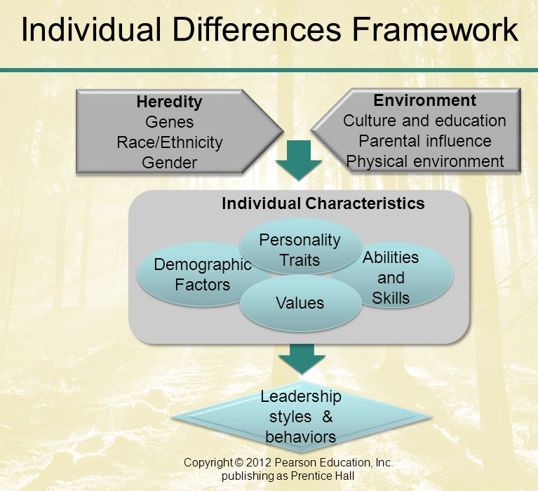
Figure 4.1 Individual Differences Framework
Note. The framework shows elements of individual differences.

It's important to remember that, even though genes play a big role in how different people are, they also work with external factors to shape traits and behaviours. The nature vs. nurture debate shows how genetic traits and environmental factors like upbringing, society, and life experiences work together. Also, epigenetics, which is the study of how external factors can change how genes are expressed, adds another layer of complexity to how genes and individual differences work together (CDC, 2022). Genetics is the basis for knowing how people are different and for appreciating the variety of human traits and behaviours. But it's important to remember that genes aren't the only thing that makes us who we are. Our surroundings and the choices we make also have a big impact on who we are.

Next is the evaluation of the environment in terms of culture and education, parental influence, and physical environment. While genetics shape who we are, the environment affects how those qualities are displayed and how people interact with the world.
Evaluating the environment in the individual differences framework is important because it helps us understand how outside factors interact with genetic traits to affect behaviour, development, and results. By looking at how the environment affects people, we can learn more about the complex connection between nature and nurture. This helps us come up with effective interventions, policies, and strategies that help people grow in a good way and solve problems in society.

Moving on to the individual characteristics. Understanding individual characteristics in the individual differences’ framework helps us understand and recognise each person's unique qualities. Studying these distinctions helps us understand human behaviour, cognition, and personality, allowing us to design approaches, interventions, and interactions to promote personal growth, effective communication, and harmonious relationships.

Lastly, is the leadership styles and behaviours as the possible outcome from the development of individual characteristics. Leadership styles and behaviours can be identified after the development of individual characteristics. It must be understood in the individual differences framework since effective leadership is not one-size-fits-all. Different qualities, communication styles, and motivations affect leadership styles. We can cultivate leaders' talents, establish more inclusive and flexible leadership methods, and create settings that maximise collaboration, innovation, and organisational success by recognising these differences.

How does individual differences affect ethics? – There exists a correlation between the ethical conduct of individuals and their personal ideals, personality traits, and perceptual tendencies. Individuals who prioritise economic well-being are more likely to engage in immoral behaviour. The presence of an external locus of control is likewise associated with immoral decision-making. There is a tendency for individuals to overestimate their own ethicality, which might serve as an obstacle to engaging in ethical behaviour. Culture exerts a significant impact on various aspects of human existence, including values, personality traits, perceptions, attitudes, and work behaviours. Hence, a comprehensive comprehension of individual differences necessitates a meticulous consideration of the cultural surroundings.

Why should global leaders embrace individual differences? – In order to effectively embrace the role of a global leader, leaders must cultivate an attitude of embracing diversity with a sense of inquisitiveness and understanding, with the aim of fostering mutual advantages and development (Kelly-Radford, 2015). Imagine a scenario where a training room of interns from a multination corporation with 10 over nationalities presented: Indians, Chinese, French, Germans, etc. The ability to find the person most different form yourself to start a conversation is difficult for people as no one is comfortable enough to do so or assumed to be “less than” as being different in society causes hesitation for approach. As for global leaders they should consider on such elements, for instance, to avoid missing out global opportunities to reach out to those in need, engaging with the global edge and the willingness to learn in the cultural context and ability to approach things (Kelly-Radford, 2015).

As for the role of emotional intelligence in the management of conflict, among other things, conflict can result from divergent viewpoints, values, and opinions. Emotional intelligence, or the capacity to identify and control one's own emotions as well as those of others, is a prerequisite for effective conflict resolution. Particularly in the business environment, where disagreements are unavoidable, emotional intelligence is essential to conflict resolution.

How does emotional intelligence play a role in conflict management? – Active listening is crucial to emotional intelligence in conflict resolution. It requires undivided attention to the other person without interrupting or disregarding them. Showing real interest in the other person's feelings and views builds trust, respect, and rapport. It also helps you understand the root causes of the disagreement and find common ground to settle it. Active listening takes patience, openness, and empathy for the other person. These abilities can assist resolve workplace conflicts and preserve healthy relationships (Sharma, 2023)

Empathy is also required to connect with others and understand their feelings and viewpoints. It demands active listening, deferring judgement, and acknowledging feelings. Empathy helps people create trust and rapport, which is crucial to dispute resolution (Sharma, 2023). Empathy can help you resolve disagreements by creating a favourable environment. Empathy can also improve dispute resolution communication and understanding.

Conflict resolution requires the building of trust, which emotional intelligence can help build. Showing empathy and creating rapport with the other person builds trust. Emotional intelligence is essential for conflict resolution since active listening and acknowledging others' emotions develop trust. Communication that is honest and straightforward can also build trust. It's crucial to be open to a win-win solution to build trust. Emotional intelligence builds trust and fosters openness and honesty, which can help resolve conflicts. Therefore, while dealing with disagreement, create trust first (Sharma, 2023).

In the realm of conflict management, leaders who possess a high level of emotional intelligence (EI) demonstrate the capacity to effectively mitigate heightened tensions, foster constructive discourse, and identify resolutions that are advantageous to all parties involved. Individuals in this context possess the capacity to proficiently regulate their own emotions, so mitigating the potential influence of personal biases on their decision-making processes and minimising the escalation of conflicts. In the realm of leadership effectiveness, scholarly investigations have demonstrated that emotional intelligence (EI) plays a pivotal role as a prognosticator of achievement (Babatunde et al., 2023). Leaders that possess a high level of emotional intelligence (EI) are more inclined to engender trust among their subordinates, effectively communicate with them, and drive them to perform at their best. Additionally, they exhibit a higher level of adaptability towards change, possess superior stress management skills, and demonstrate the ability to make judgements that effectively address the interests of many stakeholders. Organisations that place a high emphasis on fostering the growth of emotional intelligence (EI) inside their leaders and staff may see notable advantages, such as enhanced communication, less conflict, and increased levels of engagement and productivity.

**Link of presentation to be inserted**

Section 2 – Reflection
In this section, shows on how me as the team member reflect towards the discussion and presentation of my teammates and I throughout our journey towards getting an effective outcome. The framework that we work upon reflecting is the Gibbs Reflective Cycle.

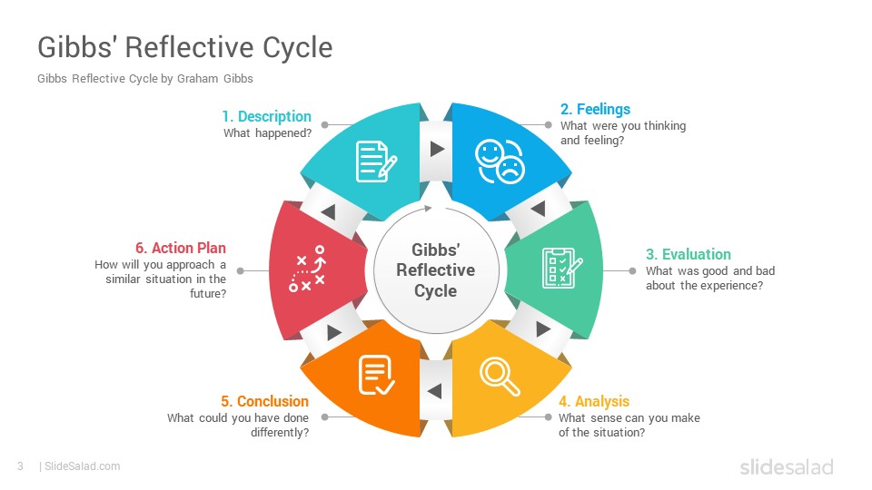
Figure 2.1 The Gibbs’ Reflective Cycle

Note. The graphic above refers to the Gibbs Reflective Process framework in a form of a sequence (The University of Edinburgh, 2020).

The purpose of this reflection process is to gather such insights and feedback based on the team’s presentation and participation based on our issue where society continues to throw away huge amounts of single use plastics in significance of the global team in effective problem solving.

Description:
I believe the collected perspectives provides such incredible value. Throughout the experience, as individuals from different background areas of business, ethnicities, and skills the environment was filled with such curiosity and interactions remotely. We started off by introducing of how plastic pollution has been affecting the environment with comparison from the present to the future and even shared statistics about the majority of countries supporting global rules to end plastic pollution. This served as a powerful opening to capture everyone’s attention and highlight the urgency of finding effective solutions.

Feelings:
Transitioning into the empathising the situation. We shared some stories of how plastic pollution was harming the environment especially such specific groups (consumers, people, flora, and fauna. The balance of biodiversity is a vital element to preserve and maintain the human and animal race. Empathising reflects our connection to the natural world and our common obligation to preserve and look after the planet and all of its inhabitants. We may work towards a more enduring and peaceful coexistence between people and the environment by encouraging empathy. My emotions fluctuated during the discussion from being excited about the collaborative approach and worried about producing effective solutions.

Evaluation
Upon reflection, under the evaluation stage I realized that we had been contributing to the problem by not being mindful of our plastic consumption and disposal habits. As for some of us, we often used single-use plastic items without considering their long-term impact on the environment. This experience made us realize the urgency of the plastic pollution crisis and the need for individual actions to address it. The experience within the diverse team enriched the brainstorming process however the drawback was that it was occasionally difficult to coordinate schedules and different opinions that caused delays and frustration.

Analysis
Moving on towards the analysis, the root causes could possibly be such factors which are the single-use culture which contributes towards the significant use of plastic waste, consumer behaviour where it leads individuals perform improper disposal and excessive consumption and even lack of proper waste management referring to plastic ending up in natural environments or oceans. Hence, an eco-friendly environment must be the created outcome. This emphasised the value of encouraging open dialogue, attentive listening, and respect for all points of view. The experience also demonstrated the necessity for realistic solutions that are adapted to the particular demands and restrictions of the community in question.

Conclusion
Throughout the collaborative journey as a team, it is concluded that the addressing issue of plastic solution, we have gained valuable insights to be that transformed our perspectives and culture on teamwork and environmental stewardship it effectively addresses the issue clearly with the requirement of the collaborative efforts from the team with such diversity. The key lessons that I have learned are community engagement to amplify the impact of our efforts and to raise awareness while taking such action so that a behavioural change of individuals contributes to the solution. However, what I could have done or stated differently is to embrace constructive dialogue such as the multisectoral approach (MSA). It refers to an integrated, cooperative process with various sectors work together to address challenging issues and interconnected PHC (Primary Health Care) objectives like universal health coverage (UHC) and the Sustainable Development Goals (SDGs) (Improvingphc, 2022).
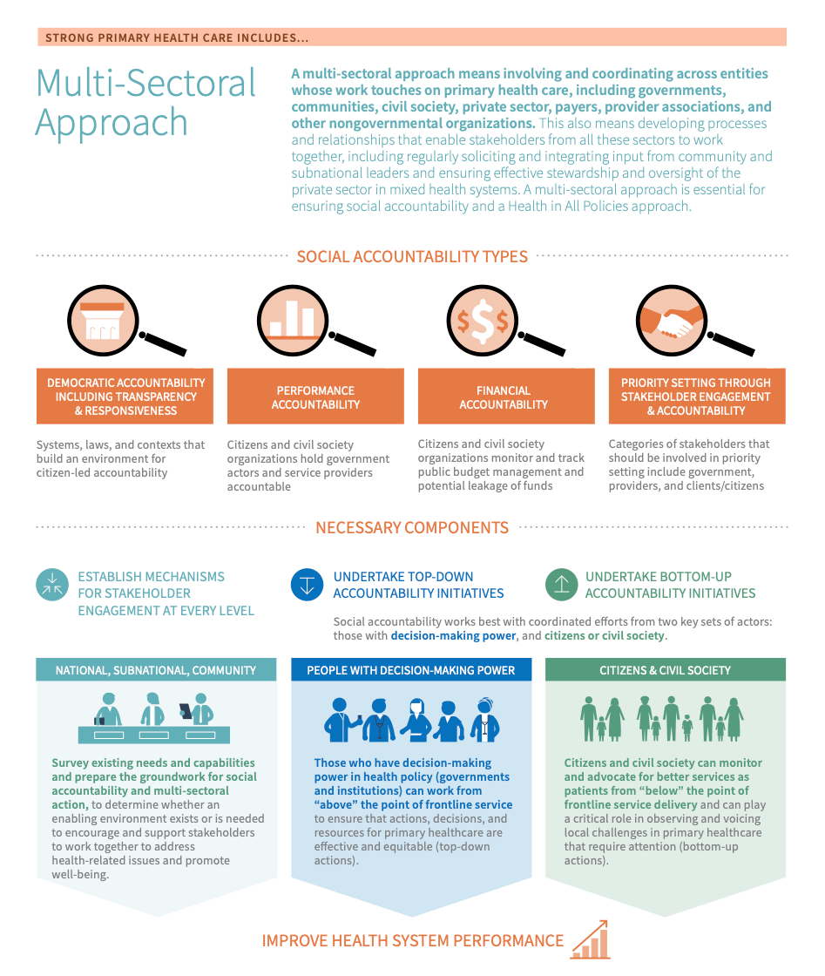
Figure 2.2 Multi-Sectoral Approach

Note. Infographic shows the functions of the multi-sectoral approach (Improvingphc, 2022).

Action plan
Throughout the journey with my team, with the experiences and insights gained from addressing the issue as a team, I believe we are all leaders in a way. As for me, I would like to develop an action plan that focuses on advocacy, education, and collaboration. Firstly, is to keep updated on world news to enhance my understanding better of the issues. Secondly, is to collaborate with multiple stakeholders such as businesses, community members, etc. With utilizing emotional intelligence, it comes handy as I am able to craft an impactful message towards the audience while inspire action. Considering into participating workshops, clean-up events, etc are ways to foster widespread involvement. As for policy advocacy while engaging with the policy makers it helps to strive for greater systematic change and stricter regulations.

References
CDC. (2022, August 15). What is Epigenetics? Centers for Disease Control and Prevention. https://www.cdc.gov/genomics/disease/epigenetics.htm
‌ Kelly-Radford, L. (2015, April 20). Global Leaders Embrace Difference. Chief Learning Officer - CLO Media. https://www.chieflearningofficer.com/2015/04/20/global-leaders-embrace-difference/
‌Sharma, D. (2023, May 14). 5 Effective Ways to Use Emotional Intelligence in Conflict Resolution - Risely. Risely. https://www.risely.me/emotional-intelligence-in-conflict-resolution/
‌Babatunde, F., Haruna, S., & Adeshina Omotayo. (2023, March). Emotional Intelligence in Conflict Management and Leadership Effectiveness in Organizations. ResearchGate; Edupedia Publications. https://www.researchgate.net/publication/369538702_Emotional_Intelligence_in_Conflict_Management_and_Leadership_Effectiveness_in_Organizations
‌ MindTools | Home. (2023). Mindtools.com. https://www.mindtools.com/ano9qiu/gibbs-reflective-cycle
‌ The University of Edinburgh. (2020, November 11). Gibbs’ Reflective Cycle. The University of Edinburgh. https://www.ed.ac.uk/reflection/reflectors-toolkit/reflecting-on-experience/gibbs-reflective-cycle
‌Improvingphc. (2022). Multi-Sectoral Approach | PHCPI. Improvingphc.org. https://www.improvingphc.org/improvement-strategies/governance/multi-sectoral-approach
‌
**References to be added more until 10 sources**

Appendix: Team Contributions to Addressing Plastic Pollution

**Screenshot of presentation to be attached**

Each team member brought their own specialties, knowledge, and contributions to the joint initiative designed to fight plastic pollution in a neighbourhood. The team's diversity allowed for a well-rounded strategy to address the intricate problem of plastic pollution. A summary of each individual contribution is given below:
TASKS | MEMBERS | CONTRIBUTIONS
- Wicked problems the challenges difficult or impossible problems where the affecting variables are not known or quantifiable.  - Design thinking to investigate, define, propose, and evaluate problem solutions | IZZATI NADHRAH BINTI AL MALEK (2244736) | - Conducted in-depth research on plastic usage globally.  - Provided statistics and insights of regarding how plastic pollution is becoming worse in terms of comparison of the past and future.  - Suggested how leaders should recognise the problem using the Gibbs Reflective Cycle to make an effective outcome.
- Decision making frameworks and techniques | SHIVARNI NAIR A/P GUNASEGARAN (2226207) | - Conducted in-depth research methods and framework to utilize towards plastic pollution while it is suitable for global leaders (ERP initiatives, ban and regulatory measures, circular economy strategies)  - Differentiated each framework and techniques.  - Ensured the decision-making stage outcomes the best choice and collaboration.
- Recognising individual differences and the role of emotional intelligence in the management of conflict | MARIA ISABELLE ROCKERFELLER (2244735) | - Researched elements to understand individual differences.  - Identified gaps that addresses the individuals’ differences and affects towards ethics.  - Analysed emotional intelligence during the discussion while identifying the importance of utilizing it towards conflict management.
- The role of diplomacy, persuasion, and negotiation in effective collaboration | PRIYANKKA SIVAPERUMAL (2244738) | - Raise the important roles of a leader portrays to make an effective collaboration.  - Evaluated how each role contributed to the team’s success.  - Conducted in depth researched on ethical persuasion
- The significance of interdisciplinary thinking in finding effective solutions to problems | YUMNA AFZAL AHMAD  (2244741) | - Clearly defined comparisons of shared methods  - Stated the advantages and disadvantages of interdisciplinary thinking.  - Raise a concern on factors that brings difficulty in interdisciplinary thinking
7.0 The role of ethics in identifying  solutions  8.0 Collective decision-making process | NUR INSYIRAH BINTI JOHAN ARIFFIN (2226216) | - Investigating the relationship between interdisciplinary thinking and collective decision making  - Stated how does collective decision-making address issues in the global world.

