DIGITAL SKILLS AND RESEARCH METHODS
IMPACT OF VIRTUAL LEARNING ENVIRONMENT
STUDENT NAME: ALEXANDRU-MARIAN BALSANU
STUDENT ID: 1713839
PROFESSOR:OLUSOYI ASHAYE

Table of Contents
Introduction 3
Primary Research 3
Virtual learning environment help in the improvement of student technical skill 3
Immediate feedback helps in raising the learning outcome of student 4
Learning with VLE help students for improving the inclusivity 6
VLE provide flexibility and comfort for gaining academic knowledge 7
VLE help in the improvement of student technical skill 8
Secondary Research 9
Impact of VLE on student engagement satisfaction retention and recall 9
Influence of virtual learning environment over student performance 10
The impact over students activity in virtual learning environment over the final grade 11
The virtual learning environment provides comfort and flexibility to the student. 12
Conclusion 13
Reference List 14
Appendices: 16
Appendix 1: Questionnaire 16

Introduction
The virtual learning environment is generally one of the web-based software that is designed for facilitating the teaching and learning activities. Therefore, students and teachers can use it for the competition of tasks with determining location and time, which additional help for discussing the lesson. The empirical evidence to suggest the use of a virtual learning environment that, provides a significant impact on the shipment student by entering in the independent student for increasing the motivation and studies. The study will provide enough for the student to have a good view of the study impact. It gives a better effect on the learning environment of students according to the recommendation of the tutor.

Primary Research

Virtual learning environment help in the improvement of student technical skill
Virtual learning environment helps improve the teaching. The teacher can generally use various trusted online resources and apps for enhancing the study traditionally and also keep the students engaged (Barany, 2019). Moreover, online and generally required technical skill for getting success and also help in getting the ability to creating new documents and additional using the word processing program with the help of VLE software. Moreover, the technology used language students for stimulated encouragement and experience for improving decision-making skills.
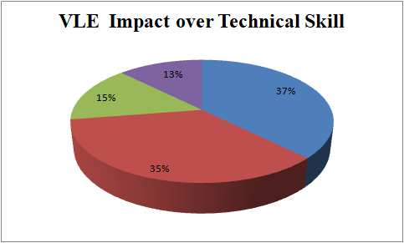
Fig: Virtual learning environment helps in improvement of student technical skill
(Source: Self-created)

Immediate feedback helps in raising the learning outcome of student
Providing immediate feedback my tutor generally helps in gaining appropriate knowledge information by the student over their weaknesses and addition it doesn't work for understanding about the games that are required to be fulfilled for achieving academic success. Therefore, it additionally ensures the pressure study that can be improved with the help of prompting the enquiry. However, feedback is constructive for enhancing the self-confidence of students and an additional benefit for increasing their self-awareness and enthusiasm over academic success (Shah et al. 2019).
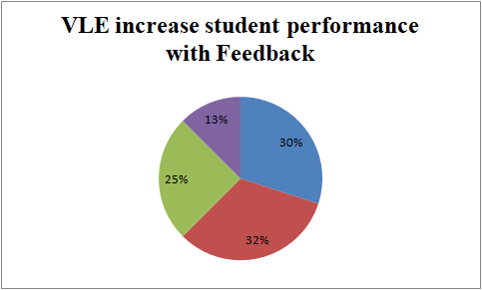
Fig: Virtual learning environment helps in improvement of student technical skill
(Source: Self-created)
VLE help for student in accessing and learning of digital service for the future benefit
Virtual learning environments generally contain various tools that help students learn different subjects. Therefore, students can usually access them really with the help of a login system. With VLE Students completing projects and homework from home and also result in lowering the chances of missing lessons. It also determines one of the self-paced benefits and learning opportunities for students. It will help students improve their academic skills by attending online courses. It additionally benefits students for learning and traditional methods and different outcomes following the destruction rate over online learning.
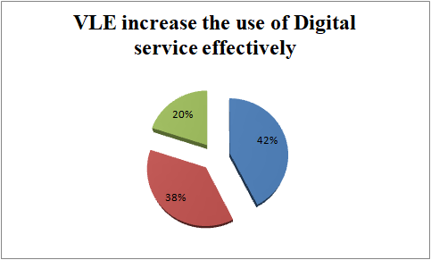
Fig: VLE help for student in accessing and learning of digital service for the future benefit
(Source: Self-created)

Learning with VLE help students for improving the inclusivity
They are learning with the help of a journal and hence students for gaining appropriate feedback for increasing the academic weakness and additional motivation for improving the work. It quickly creates an inclusive environment that helps students learn with proper understanding and awareness over a specific topic. Extra help in determining the convenience that is required for student learning with classroom visit and the real mode usually provide a better pathway for improving the understanding of the academic environment with digital technology (Tabatabai, 2020).
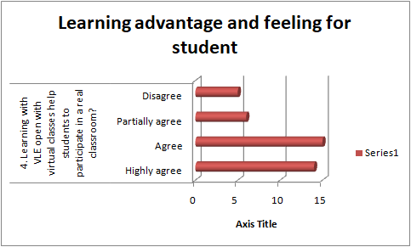
Fig: Learning with VLE help students for improving the inclusivity
(Source: Self-created)

VLE provide flexibility and comfort for gaining academic knowledge
Online education helps students for gaining appropriate knowledge and also increases the opportunity for improving the lifestyle. Therefore, it also provides better access for students for getting fit to education without missing classes. Moreover, online training usually makes it more convenient for students living in rural areas or students concerned with disabilities. However, the grave usually provided information about the flexibility and comfort provided to students is relatively high and additionally includes the opportunity for contacting higher education.
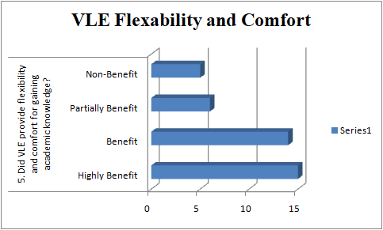
Fig: VLE Provide flexibility and comfort for gaining academic knowledge
(Source: Self-created)

VLE help in the improvement of student technical skill
By using a virtual learning environment, the student learns different technical terms and use devices for the classes. Show me the time going students of virtual learning classes develop and become more efficient with digital applications and software. With the technological advancing society, knowledge about digital applications and virtual terms will help in the student for later life also (Shahzad et al. 2020) Adequate knowledge in the digital world, and proper application can depict a positive impact in students' career.
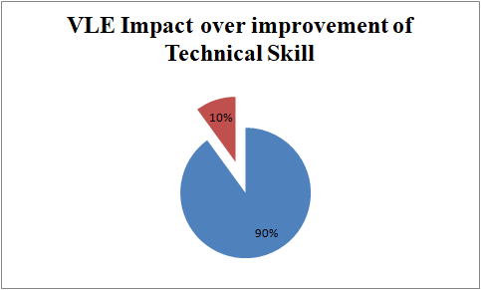
Fig: VLE help in the improvement of technical skill
(Source: Self-created)

Secondary Research

Impact of VLE on student engagement satisfaction retention and recall
The virtual learning environment is determined as the progress of students according to the passive to the active learner. The active learner generally promotes critical thinking and is also essential for transfer in their knowledge acquired from the classroom with clinical settings. Moreover, the randomized control trial was conducted with students attending a teaching station according to radiation therapy. Moreover, both of the sessions are identical except the VLE. The anonymous questionnaire is distributed for talking about the participant and also getting appropriate knowledge. The VLE is significant for improving the satisfaction and engagement of students. As an example: Therefore, the critical finding analysis help in gaining necessary information about the role of VLE, which is generally important for student for gaining appropriate knowledge about the study skills. Moreover, it helps teacher for attaining classes and additionally providing a pathway for academic success (Herrera Mosquera, 2017).
Therefore, the virtual environment also provides information regarding the engagement, student satisfaction and recalling. The bachelor usually provided great result towards the promotion and support of formal education and also that according to the curriculum of prospective innovation. Therefore, it gives a paramount role for supporting the learner over informal and formal contact with innovative strategies. Retention of students is also one of the critical issues at higher educational institutions according to the perception of learning about the virtual machines and that are driving machines for detecting the student risk at early stages. Therefore, the elements help provide better instruction to tutor regarding the production of final courses and also help in providing feedback according to the grades of students.
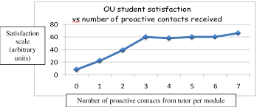
Fig: Impact of VLEL on student engagement satisfaction retention and recall
(Source: Herrera Mosquera, 2017)

Influence of virtual learning environment over student performance
The Virtual Learning Environment is generally consolidated with the educational institution. Therefore, it does not seem irrelevant about the challenges that students face regarding their academic performance. There are a variety of variables that influence students for increasing their performance and also making a virtual environment for determining the possibility and also influence as a better learning process. Therefore, VLE provides identification about the focus required by knowing the importance of students accessing the virtual learning environment by building a proper relationship between the academic indicator and student performance. The implementation of VLE at higher education institutions help to justify the concert for accessing the influence of student performance (Varajali, 2016).
Therefore, it is essential for consolidating the environment that implies contextualization for using this environment regarding the former learning and teaching process. The education system is based on the web, which is the reason for increasing the number at schools and universities. Therefore, the learning environment is based on the technology and the digital resources we are a student or required to follow the virtual environment activity which traditional interaction with the continuous communication process. Moreover, building the relationship between the reconstruction and construction process of knowledge also helps inform good attitudes a bit with the framework that informs over educational methods. The use of VLE quickly determines the contest that implies over technology and main potentially over the learning feature. Virtual learning environments generally provide better support to the additional study benefit of students and teachers to communicate over online platforms for developing and understanding the analytical skills required for student performance.
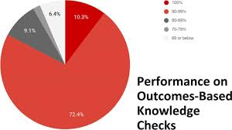
Fig: Influence of virtual learning environment over student performance
(Source: Varajali, 2016)

The impact over student’s activity in virtual learning environment over the final grade
In a virtual learning environment, which is a typical online classroom, it provides necessary education courses to the learners for students within their houses. With a detailed study of research work done, a fact came upon that VLE is more essential and useful for instruction-based learning styles. For the determination of grades and finding the variation between degree programs and predicting student’s final grade potential can also be done with the help of VLE. However, in traditional classrooms, face to face interaction turned out more useful for the students. Still, in recent times the availability of classes at any time and lack of cost promote the virtual learning environment in education systems (Moore et al. 2019). Virtual learning environments also help students to safeguard their life in pandemic situations like COVID-19 outbreak. Infectious diseases can easily outbreak in classrooms as they are physically contacted with each other; VLE can easily handle the problem by providing necessary classes with a physically isolated connection between students and teacher. Computerized data and information about student help in teachers for quickly determining their grades and progress of individuals during their courses.


Fig: The impact over student’s activity in virtual learning environment over the final grade
(Source: Moore et al. 2019)

The virtual learning environment provides comfort and flexibility to the student.
The virtual learning environment is beneficial for both teacher and students. For the students, the virtual learning environment provides an opportunity to learn new skills and knowledge within their rooms, avoiding the issues regarding travelling and arranging classrooms. A VLE student can engage themselves with education while remaining in their comfort zone and having a relaxing study time. Students also can access their classrooms for anywhere at any time of the clock, which generally increases the interest of students in the classrooms and helps in not bunking the class (Chaim et al. 2018)
Requirements of effective time management cannot be denied in a student's life. Virtual learning environments help students manage their time with an adequate strategy and help them to grow punctuality in their personal life. Virtual learning is also beneficial for the Teachers as they can handle a massive number of students within a class. Immediate feedback and resolving them from both sides of the teacher and students can be quickly done with the help of VLE. Managing the time virtual learning can also be cost-saving for the students as they do not have to travel or move from their land. This system brings flexibility and comfort in students' lives and helps them to concentrate on their studies with adequate knowledge.

Fig: Virtual learning environment provide comfort and flexibility to the student
(Source: Chaim et al. 2018)

Conclusion
The virtual learning environment general student and additional e provide various opportunities for learning appropriate with the help of digital service. The assessment helps in focusing on the relationship between the student performance and virtual learning environment. The study easily profiles identification about the impact of real student performance with the help of both primary and secondary research. The assessment provided the title about the importance of really regarding the interpretation of students and accessing degrees.

Reference List
Barany, A., 2019, October. Examining the Impact of Virtual City Planning on High School Students’ Identity Exploration. In Advances in Quantitative Ethnography: First International Conference, ICQE 2019, Madison, WI, USA, October 20–22, 2019, Proceedings (Vol. 1112, p. 199). Springer Nature.
Barany, A., 2019, October. Examining the Impact of Virtual City Planning on High School Students’ Identity Exploration. In Advances in Quantitative Ethnography: First International Conference, ICQE 2019, Madison, WI, USA, October 20–22, 2019, Proceedings (Vol. 1112, p. 199). Springer Nature.
Chaim, O., Muschard, B., Cazarini, E. and Rozenfeld, H., 2018. Insertion of sustainability performance indicators in an industry 4.0 virtual learning environment. Procedia Manufacturing, 21, pp.446-453.
Herrera Mosquera, L., 2017. Impact of implementing a virtual learning environment (VLE) in the EFL classroom. Íkala, Revista de Lenguaje y Cultura, 22(3), pp.479-498.
McMaster, E., Moore, T., Onstott, D., Weathers, A. and Herrington, A., 2019, November. The Impact of Virtual Immersion in the E-Learning Environment. In E-Learn: World Conference on E-Learning in Corporate, Government, Healthcare, and Higher Education (pp. 668-672). Association for the Advancement of Computing in Education (AACE).
Moore, T., Weathers, A., Onstott, D., McMaster, E. and Herrington, A., 2019. The Impact of Virtual Immersion in the E-Learning Environment.
Shah, M., Foster, A., Talafian, H. and Barany, A., 2019, October. Examining the Impact of Virtual City Planning on High School Students’ Identity Exploration. In International Conference on Quantitative Ethnography (pp. 199-210). Springer, Cham.
Shahzad, S.K., Hussain, J., Sadaf, N., Sarwat, S., Ghani, U. and Saleem, R., 2020. Impact of Virtual Teaching on ESL Learners' Attitudes under COVID-19 Circumstances at Post Graduate Level in Pakistan. English Language Teaching, 13(9), pp.1-9.
Tabatabai, S., 2020. COVID-19 impact and virtual medical education. Journal of Advances in Medical Education & Professionalism, 8(3), pp.140-143.
Váraljai, M., 2016, October. Establish innovative learning environment by virtual lab concept: An exploratory research in higher education. In 2016 7th IEEE International Conference on Cognitive Infocommunications (CogInfoCom) (pp. 000373-000378). IEEE.

Appendices:

Appendix 1: Questionnaire

- Did the virtual learning environment help in improving the technical skills of students?

Highly agree | Agree | Partially agree | Disagree
15 | 14 | 6 | 5

- Did the immediate feedback provided by the tutor will help in raising the outcome over the student learning environment?

Highly agree | Agree | Partially agree | Disagree
12 | 13 | 10 | 5

- Did VLE help in improving the accessibility of digital service effectively? Did the use of digital service provide future benefit?

Improvement over accessing | Provide future benefit | No idea
17 | 15 | 8

- Learning with VLE open with virtual classes help students to participate in a real classroom?

Highly agree | Agree | Partially agree | Disagree
14 | 15 | 6 | 5

- Did VLE provide flexibility and comfort for gaining academic knowledge?

Highly Benefit | Benefit | Partially Benefit | Non-Benefit
15 | 14 | 6 | 5

- Did VLE help in the improvement of student technical skill?

Yes | No
36 | 4

