Fundamental accounting

Stundet name: Claudia Dumitrita Dumitriu Ignat
Stundet number: 1818426
Module title: Accounting Fundamentals LCBB4001
Lecturer’s name: Rexon Nting

Table of Contents
Introduction 3
Financial Statement 3
Task 1 3
Task 2 8
Task 3 12
Task 4 17
Conclusion 21
Reference: 22

Introduction

Accounting means a set of principles and techniques regarding the registration in the double part of the asset.
Accounting appears from the need to respond informationally and decisively to the problem of the management of movements of economic values ??autonomous on individuals or legal entities as the case may be.
Accounting is the basis of any successful financial activity, which any entrepreneur should understand and take care that its principles are implemented in a fair, professional manner, without errors of calculation or evidence. Otherwise, they can lead to bankruptcy!
Accounting has no borders. Its theoretical, scientific and practical limits are endless both in terms of understanding economic phenomena and in how they are systematized, processed and presented, so you can never claim to know everything about it.

Financial Statement

Task 1
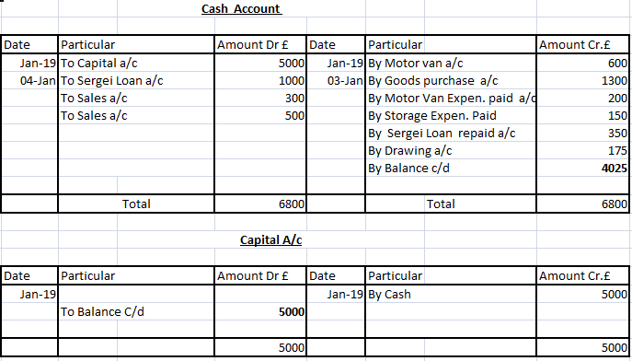

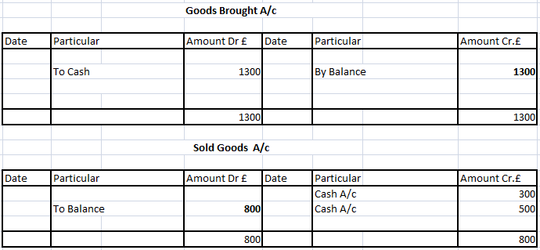

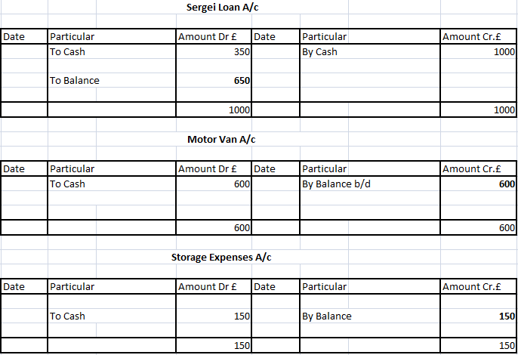

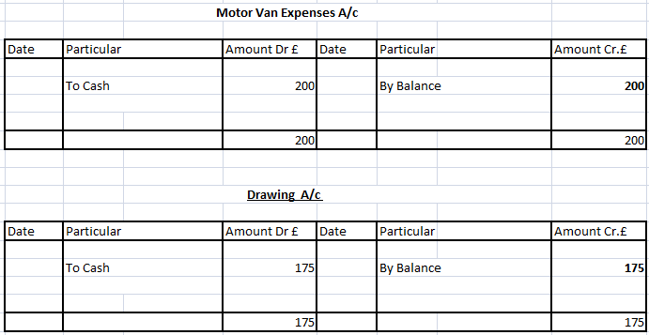

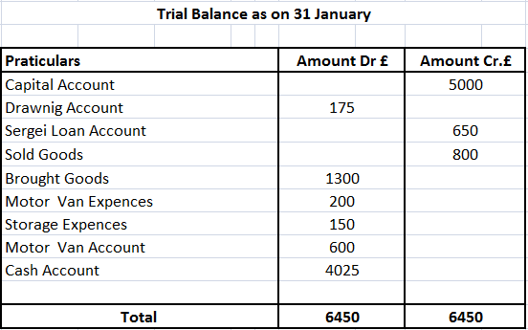

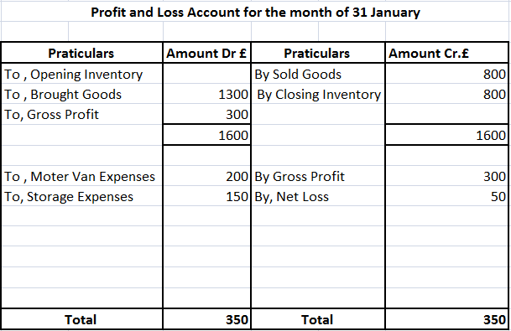

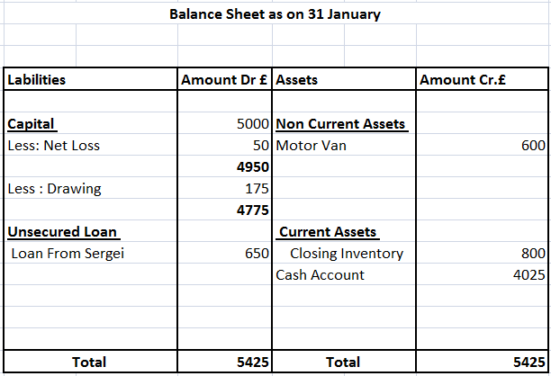

Task 2

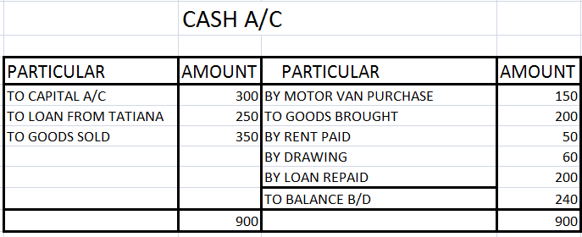

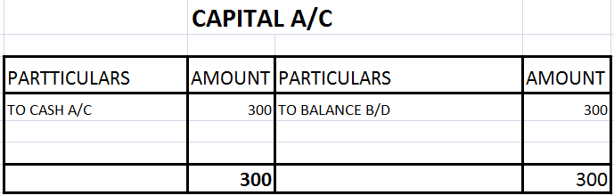

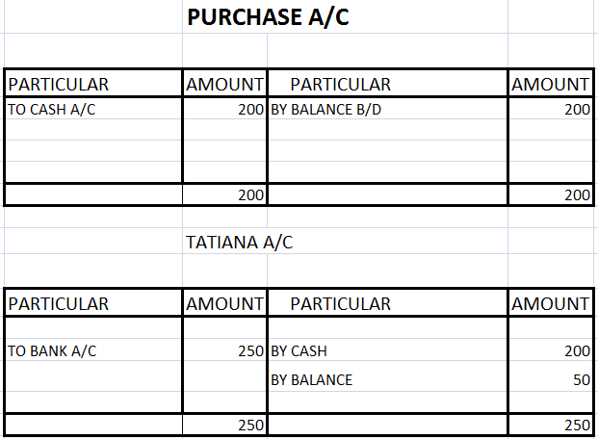

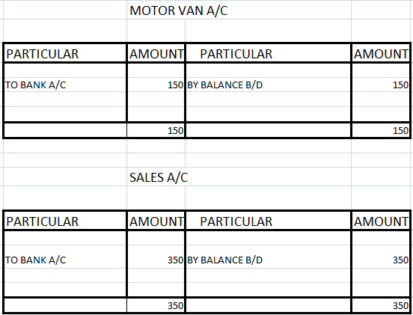

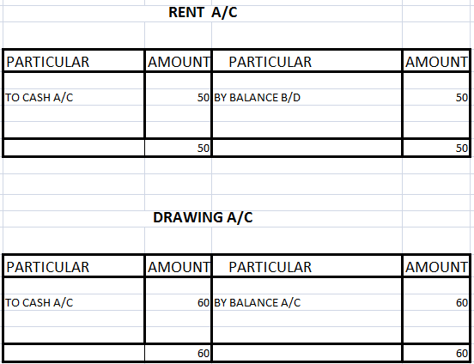

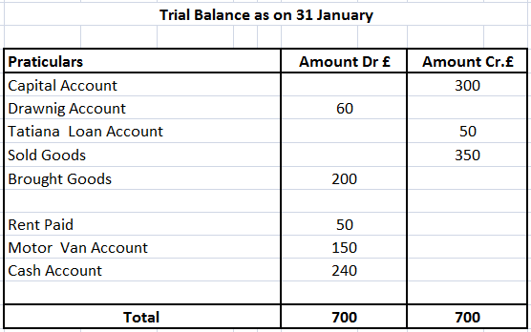

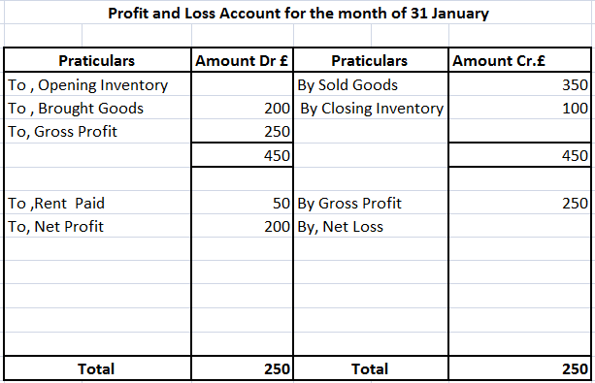

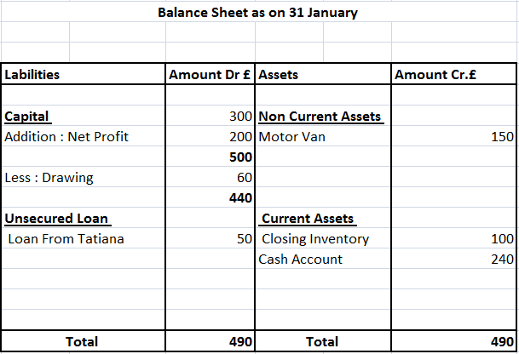

Task 3

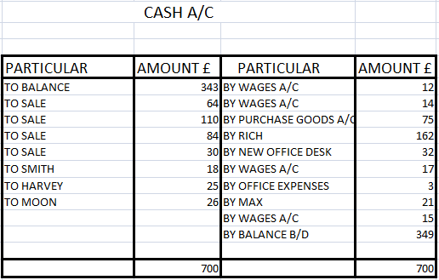

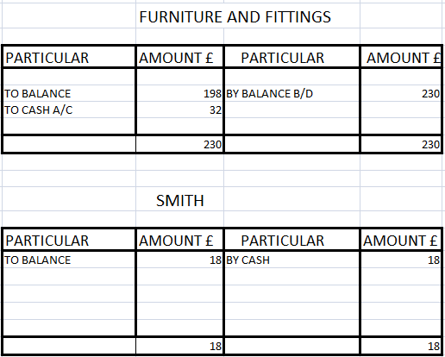

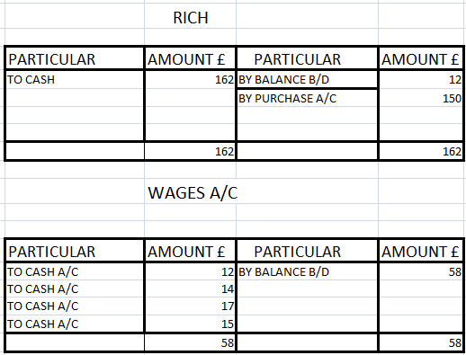

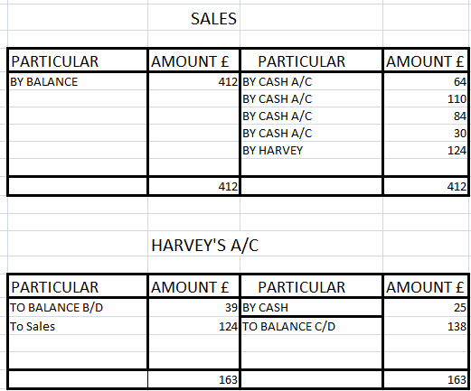

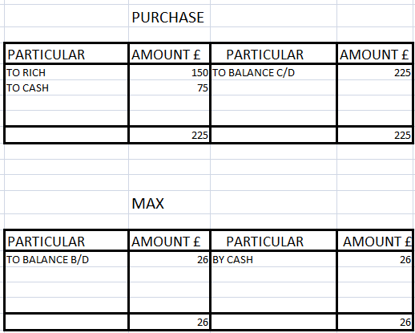

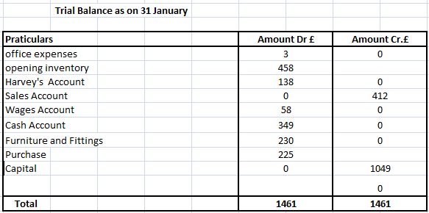

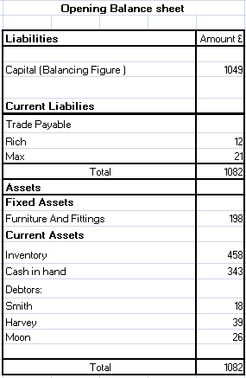

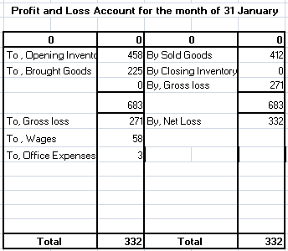

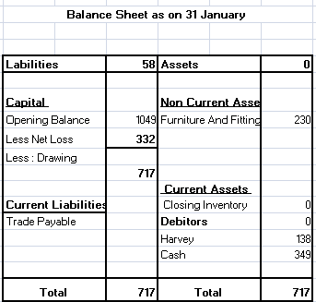

Task 4

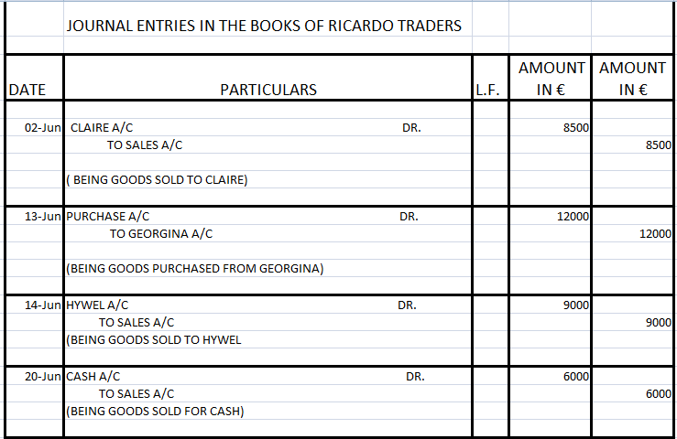

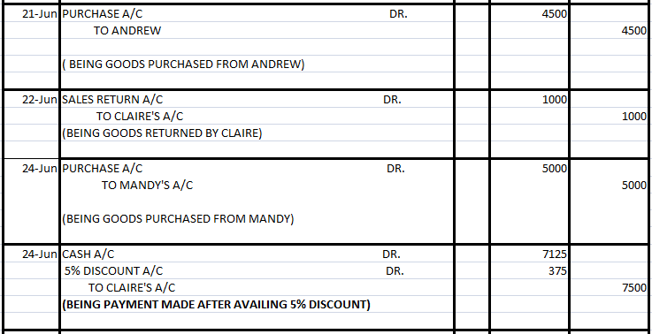

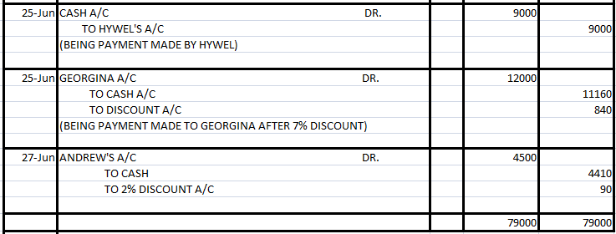

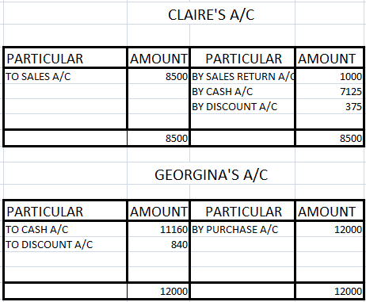

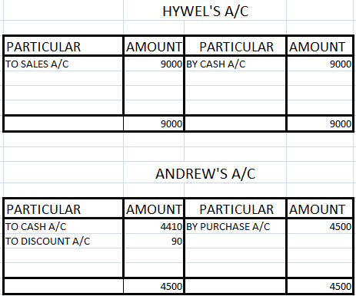

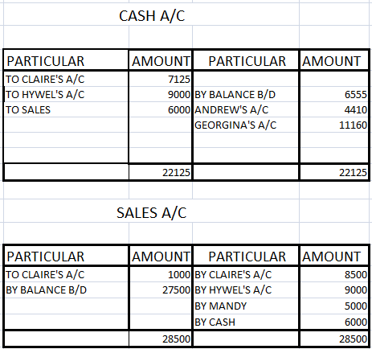

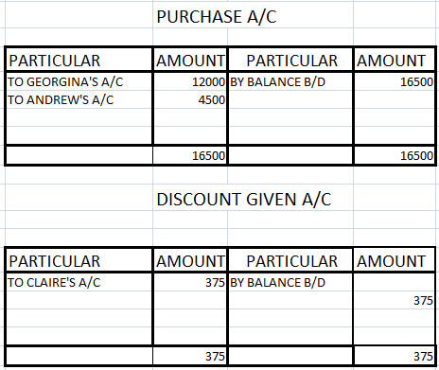

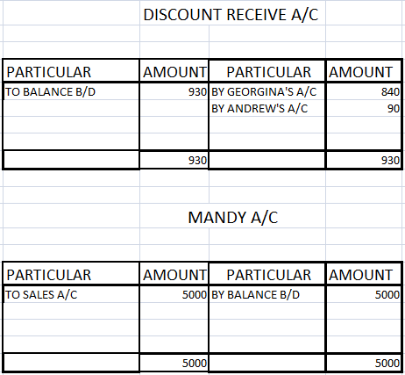

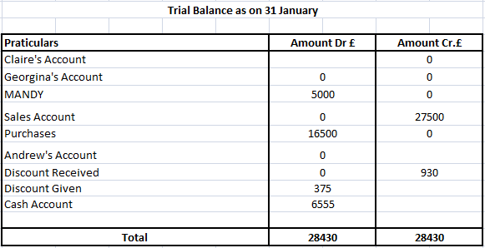

Conclusion

At the end of this assestment, we can see that accounting is the base of a business, we learned tecniques and methods of cost accounting.

Reference List

Brief, R.P., 1965. Nineteenth century accounting error. Journal of Accounting Research, pp.12-31.

Dearden, J., 1978. Cost accounting comes to service industries. Harvard business review, 56(5), pp.132-140.

DRURY, C.M., 2013. Management and cost accounting. Springer.

Garner, S.P., 1947. Historical development of cost accounting. The Accounting Review, 22(4), pp.385-389.

Graves, J.H., 1971. Commission on accounting principles. Journal of Accountancy (pre-1986), 131(000005), p.61.

Wygal, D.E. and Stout, D.E., 1989. Incorporating writing techniques in the accounting classroom: Experience in financial, managerial and cost courses. Journal of accounting education, 7(2), pp.245-252.

