Table of Contents
1. Introduction 3
2. Database Design 4
2.1 Normalisation and Design Decisions 5
3. Database Implementation 5
3.1 Relational Schema, Integrity Constraints, and Normalisation (3NF) 5
3.2 Sample Data Insertion for Design Validation 6
3.3 Audit Tables to Support Accountability and Traceability 7
3.4 Indexing Strategy Aligned with Query 7
3.5 Triggers for Automated Auditing Mechanisms 8
3.6 Stored Procedures and Transaction Control 8
3.7 Essential Queries Supporting Operational Design Validation 9
4. Conclusion 10
5. References: 11

1. Introduction

The Campus Club Management System (CCMS) was designed and implemented as a relational database solution to support the university’s Students’ Union in the structured administration of clubs and societies. Current practices rely on paper-based records and disconnected spreadsheets, resulting in fragmented storage and limited integration across memberships, events, communications, and participation data. This operating model constrains data integrity, complicates retrieval, and reduces the reliability of engagement reporting required for institutional planning and decision making.
Accordingly, CCMS introduces a unified relational schema engineered to enforce referential integrity via primary and foreign key constraints, reduce redundancy through Third Normal Form (3NF), and support controlled data operations through transaction-managed stored procedures. The report documents the design rationale and the implementation workflow, including integrity constraints, audit mechanisms supporting traceability, and performance-oriented indexing decisions.

2. Database Design

The database design applies a relational model to represent the entities, attributes, and relationships required to manage clubs, memberships, events, communications, and engagement. The design is documented through an Entity Relationship Diagram (ERD), presented in Figure 1, which defines primary keys, foreign keys, and integrity constraints.

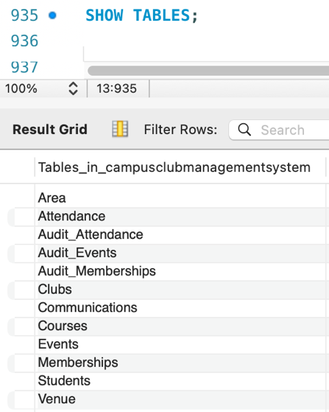
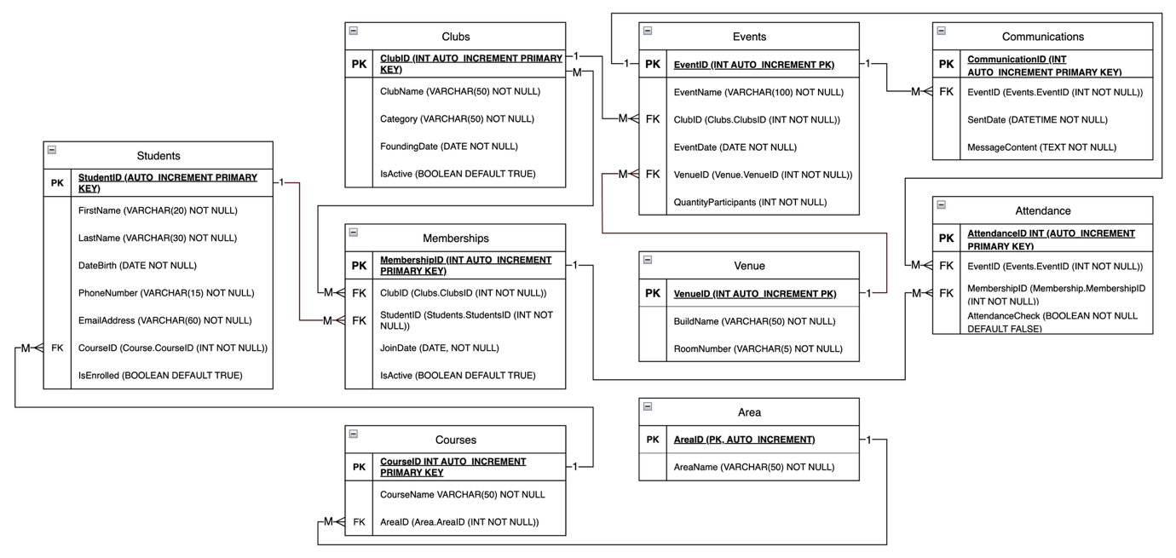
Figure 1. Entity Relationship Diagram (ERD) for the Campus Club Management System (CCMS). [1]

For terminological consistency, ERD entities are discussed in their implemented relational representation, with relationships enforced through primary and foreign key constraints.
The Students table stores core student data, including enrolment status, and each record is linked to a single academic programme through CourseID, enforcing a one-to-many relationship between the Courses table and the Students table. The Courses table and the Area table are separated to preserve Third Normal Form (3NF) and to enable consistent reporting aggregation. Programme and discipline descriptors are maintained through CourseID references rather than duplicated attributes within the Students table, thereby reducing redundancy and limiting update, insertion, and deletion anomalies. The resulting structure maintains consistent academic categorisation and supports analytical aggregation of membership and participation by programme and discipline through foreign key joins, where the Area table classifies the Courses table and the Courses table is referenced by the Students table [2], [3].
The Clubs table stores society records, including category, founding date, and active status. The Events table references the Clubs table through ClubID, supporting a one-to-many relationship in which each club may be associated with multiple event records. Event records store operational attributes including EventDate, a venue reference, and QuantityParticipants to represent capacity constraints. The Venue table isolates location attributes to prevent repeated building and room values across event records and to support maintainable venue-related reporting [2], [3].
The Memberships table resolves the many-to-many relationship between the Students table and the Clubs table and stores JoinDate and membership status to support longitudinal tracking. A uniqueness constraint on (StudentID, ClubID) prevents duplicate membership records. The Attendance table resolves the many-to-many relationship between the Memberships table and the Events table, enabling attendance to be recorded per membership per event. A composite uniqueness constraint on (EventID, MembershipID) prevents duplicate attendance entries and supports reliable engagement metrics. The Communications table stores event-linked messages through EventID, maintaining auditable, traceable communication records without duplicating message content within student data.

2.1 Normalisation and Design Decisions
The schema is normalised to 3NF. Each table represents a single subject area, all non-key attributes depend fully on the primary key, and transitive dependencies are avoided. This structure reduces redundancy, prevents insertion and update anomalies, and supports consistent reporting.
Many-to-many relationships are resolved through associative tables rather than multi-valued attributes, which improves scalability and ensures that membership and attendance tracking can be extended without structural redesign. Primary keys and foreign keys are applied systematically to enforce referential integrity, thereby supporting reliable joins across both operational and analytical queries.

3. Database Implementation

3.1 Relational Schema, Integrity Constraints, and Normalisation (3NF)
The CCMS solution adopts a relational schema because the scenario requires structured storage of student records, club records, event records, and participation records with clearly defined relationships and enforceable integrity rules. Relational modelling supports data integrity through primary key and foreign key constraints, ensuring that each entity instance is uniquely identified and that inter-table relationships remain valid. This approach supports the CCMS requirement to centralise operations and minimise inconsistent or duplicated records. Foundational database literature emphasises that well designed relational schemas reduce redundancy and strengthen integrity when relationships are represented using keys and constraints [2], [3].
Within the implementation, integrity constraints are enforced through primary keys, foreign keys, and uniqueness constraints.

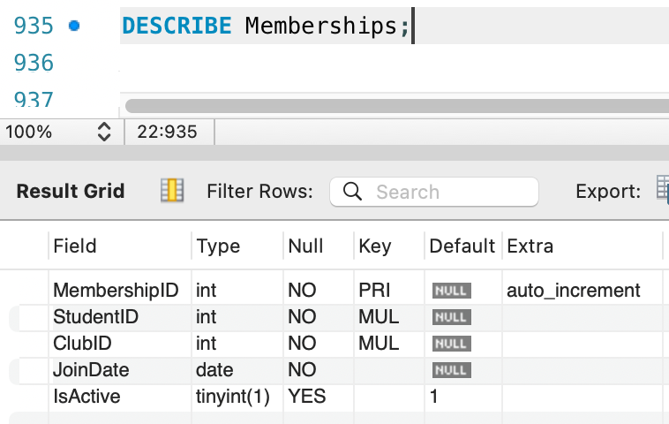

For example, the UNIQUE constraint on (StudentID, ClubID) in the Memberships table prevents duplicate memberships for the same student and club, whereas the UNIQUE constraint on (EventID, MembershipID) in the Attendance table prevents the same membership from being recorded more than once for a given event. These constraints align with database design principles that favour declarative constraint enforcement by the DBMS, rather than reliance on application layer validation [2], [3].
The schema is designed to remain consistent with Third Normal Form. Core descriptive attributes are stored once within their corresponding tables, including student attributes in the Students table, club attributes in the Clubs table, and venue attributes in the Venue table. Associative tables are used to resolve many-to-many relationships, including the Memberships table linking the Students table to the Clubs table, and the Attendance table linking membership participation to the Events table. Normalisation theory supports this structure because it reduces update anomalies and prevents inconsistent duplication of attributes across multiple tables [2], [3].

3.2 Sample Data Insertion for Design Validation
Representative sample data are inserted into the implemented schema to validate correct operation of table definitions and integrity constraints. Test data population constitutes a standard validation step in database development because it verifies referential integrity across foreign key relationships, confirms that declarative constraints reject invalid inserts, and demonstrates expected behaviour under typical operational workloads. In relational database systems, controlled test datasets support verification that implemented relationships and constraints correspond to domain rules, including student records associated with the Courses table via CourseID and membership records in the Memberships table referencing existing records in the Students table and the Clubs table [2], [3].

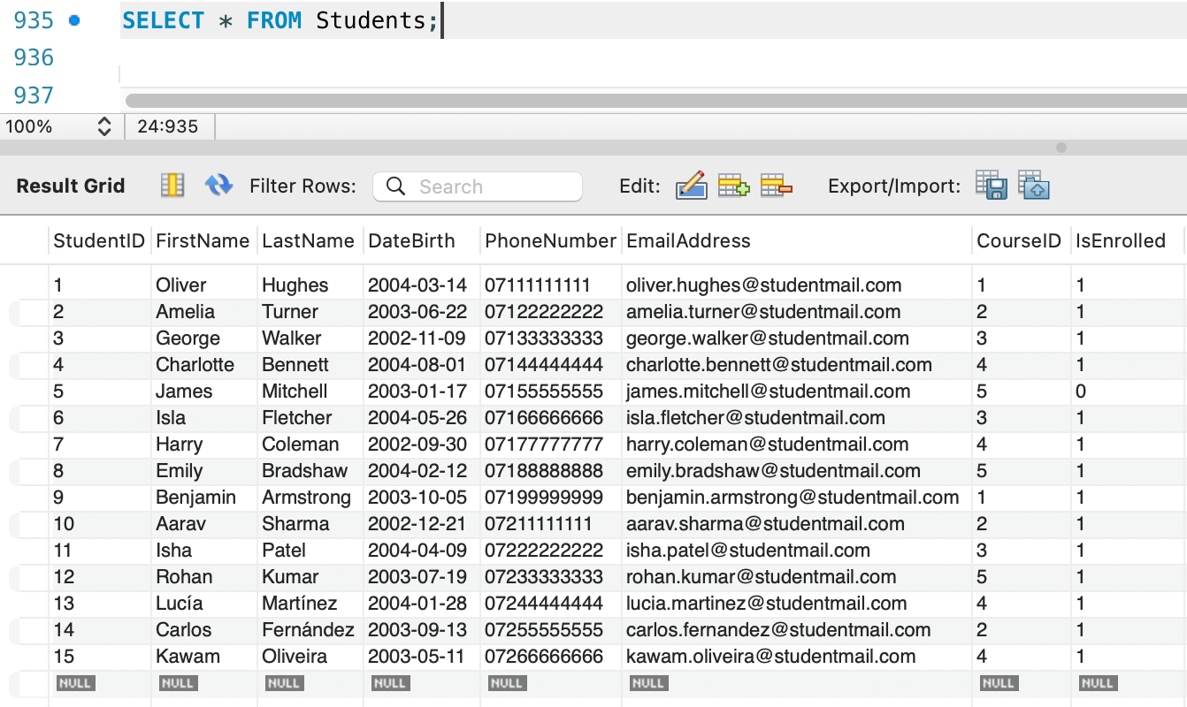

3.3 Audit Tables to Support Accountability and Traceability
To strengthen traceability and governance, the CCMS implementation introduces a separate audit layer that records modifications applied to the Memberships table, the Attendance table, and the Events table. This audit layer preserves a persistent history of INSERT, UPDATE, and DELETE activity. Database systems theory identifies audit logging and historical traceability as governance mechanisms that enable subsequent verification of operational data correctness and support inspection during review, dispute resolution, or compliance-oriented analysis [2]. Each audit table records action type, relevant identifiers, OLD and NEW values, timestamp metadata, and actor attribution, thereby separating transactional data from historical change records [2].

3.4 Indexing Strategy Aligned with Query
In the implementation, query performance is treated as a design concern rather than a post-deployment adjustment. For that reason, the script defines a set of secondary indexes targeting columns that dominate join predicates and selection conditions during routine operational workloads. The indexed attributes include Students.CourseID, Memberships.StudentID, Memberships.ClubID, and Events.ClubID in combination with Events.EventDate, in addition to the join attributes that support access paths through the Attendance table and the Communications table. In relational DBMS execution, secondary indexes reduce the search space considered by the optimiser, thereby lowering input and output cost for selective retrieval operations and join processing. Database performance literature explains that balanced-tree index organisations improve retrieval and join efficiency by reducing the number of page accesses required to locate qualifying tuples and to support efficient join access paths [2]. At the DBMS level, the approach is implemented using MySQL support for explicit index definition via CREATE INDEX, which enables predictable optimisation of access paths without introducing dependency on application-layer query restructuring [4].

3.5 Triggers for Automated Auditing Mechanisms
Following the introduction of audit tables, CCMS applies trigger-based automation to ensure that audit logging is executed consistently whenever data modification operations occur. In relational DBMS environments, triggers represent a native mechanism for embedding event-driven logic within the database engine, enabling predefined actions to be executed automatically in response to INSERT, UPDATE, and DELETE operations [2].
Within the MySQL environment, triggers are defined through the CREATE TRIGGER statement and may be configured to execute AFTER data modification events. This execution timing is appropriate for audit requirements because it captures the final persisted state of the affected records, supporting accurate representation of operational changes. In CCMS, this implementation supports traceability by recording modifications affecting the Memberships table, Attendance table, and Events table, thereby preserving a structured history of changes that can be inspected for accountability and verification purposes [5].

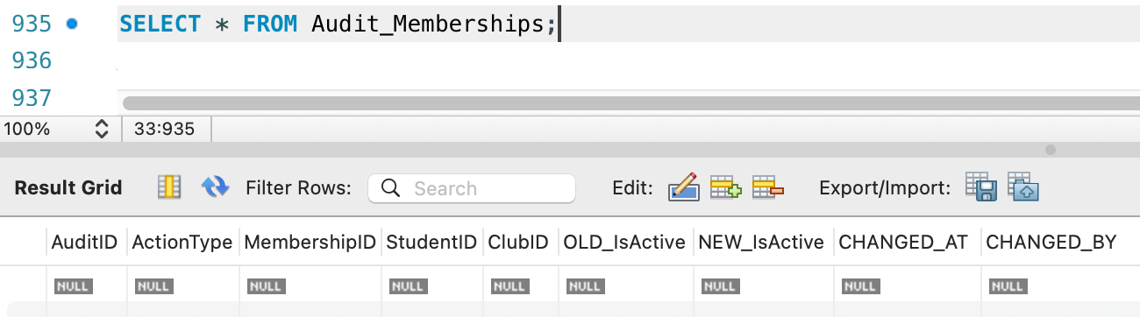

3.6 Stored Procedures and Transaction Control
The implemented solution uses stored procedures to centralise CRUD operations and to enforce consistent business logic at the database layer. Stored procedures reduce duplicated logic and support uniform application of validation rules across insert, update, and delete operations. Database literature supports encapsulation of repetitive operations within the DBMS because this approach improves maintainability and reduces the risk of inconsistent rule enforcement across multiple application entry points [2], [3].
Explicit transaction control is also applied through the use of START TRANSACTION, COMMIT, and ROLLBACK to guarantee atomicity and consistency for multi-step operations. Transaction theory establishes that COMMIT makes a unit of work durable, whereas ROLLBACK restores the database to a previous consistent state when validation fails or when a constraint violation is detected. This prevents partial execution outcomes from leaving the database in an inconsistent state, which remains essential in multi-user operational environments [2], [3].
Conditional commit and rollback logic is implemented in procedures including Procedure_Create_Membership and Procedure_Create_Attendance, where validation checks confirm that the student record remains enrolled and that the membership record remains active prior to the insertion of dependent records. When validation conditions are not satisfied, ROLLBACK ensures that no invalid membership or attendance tuple persisted. MySQL defines transactional control statements that support explicit transaction boundaries and conditional rollback behaviour within stored program logic [6].
Procedure definition and parameterised execution are supported in MySQL through the CREATE PROCEDURE statement, which enables consistent CRUD execution with conditional statements and embedded transaction control, thereby satisfying the requirement to justify commit or rollback outcomes under defined business rules [7].

3.7 Essential Queries Supporting Operational Design Validation
The implemented script includes a set of essential queries that demonstrate functional alignment between the relational schema and the operational requirements of the Students’ Union. These queries include retrieval of active clubs, extraction of membership lists per club, identification of scheduled events per club, generation of attendance lists per event, inspection of event linked communications, and aggregation of engagement metrics per academic course.
From a database design perspective, execution of these queries provides workload-oriented validation of the entity relationships and associative tables, confirming that the implemented primary and foreign key structure supports the required access paths. Moreover, the query set demonstrates that reporting outputs can be produced through relational joins across normalised tables, without reliance on redundant attribute duplication or non-normalised storage. Database design literature recognises query-driven validation as a necessary verification step, since it confirms that the schema supports required retrieval patterns while preserving integrity constraints and consistency guarantees [2], [3].

4. Conclusion

The Campus Club Management System (CCMS) provides a relational database solution that addresses the Students’ Union requirement for centralised club administration, improved data integrity, and reliable engagement analysis. The implemented schema supports membership management, event organisation, attendance recording, and communication traceability within a single integrated structure.
The design applies established relational principles, including Third Normal Form (3NF), explicit constraint enforcement, and resolution of many-to-many relationships through associative tables. Audit tables, triggers, and transaction-managed stored procedures strengthen governance by preserving change history and enforcing atomic commit and rollback behaviour under defined business rules.
Query performance is supported through a workload-oriented indexing strategy that improves join efficiency and predicate filtering for routine operational retrieval and reporting. Overall, the implementation satisfies the scenario requirements and provides an extensible foundation for further analytical and reporting enhancements.

5. References:

[1] K. Oliveira, “Entity Relationship Diagram (ERD) for the Campus Club Management System (CCMS),” Unpublished diagram, Jan. 2026.

[2] A. Silberschatz, H. F. Korth, and S. Sudarshan, “Database System Concepts”, db-book.com, 7th Edition, McGraw Hill, Mar. 2019. [Online]. Available: https://db-book.com/slides-dir/index.html [Accessed: Jan. 14, 2026]

[3] R. Elmasri and S. B. Navathe, “Fundamentals of Database Systems”, Pearson Education, Jun. 25, 2015. [Online]. Available: https://github.com/suman2020/Car_Rental_System/blob/main/Fundamentals-of-Database-Systems-Pearson-2015-Ramez-Elmasri-Shamkant-B.-Navathe.pdf [Accessed: Jan. 14, 2026]

[4] Oracle, “15.1.15 CREATE INDEX Statement”, MySQL 8.0 Reference Manual. [Online]. Available: https://dev.mysql.com/doc/refman/8.0/en/create-index.html [Accessed: 14 Jan. 2026]

[5] Oracle, “15.1.22 CREATE TRIGGER Statement”, MySQL 8.0 Reference Manual. [Online]. Available: https://dev.mysql.com/doc/refman/8.0/en/create-trigger.html [Accessed: 14 Jan. 2026]

[6] Oracle, “15.3.1 START TRANSACTION, COMMIT, and ROLLBACK Statements”, MySQL 8.0 Reference Manual. [Online]. Available: https://dev.mysql.com/doc/refman/8.0/en/commit.html [Accessed: 14 Jan. 2026]

[7] Oracle, “15.1.17 CREATE PROCEDURE and CREATE FUNCTION Statements”, MySQL 8.0 Reference Manual. [Online]. Available: https://dev.mysql.com/doc/refman/8.0/en/create-procedure.html. [Accessed: 14 Jan. 2026]
Google Translate, private communication, Jan. 2026. [Accessed: Jan. 14, 2026].
OpenAI’s ChatGPT, private communication, Jan. 2026. [Accessed: Jan. 14, 2026].

