

Student Name :- Rinkal Kishan Parekh
Student I’D :- 2110585
Module name :- ROLE OF HUMAN RESOURCE MANAGER TO ENHANCE EMPLOYEE SKILL AND PRODUCTIVITY OF THE COMPANY (HUMAN RESOURCE MANAGEMENT)

Module code :- LCMB7020_LON
Lecturer name:- Mushfiqur Rahman

Acknowledgment
I am grateful to my professors who have allowed me to conduct this research as without their support and guidance I was not able to complete this study accurately. I am grateful to my fellow students at my university who have shared their precious views on the research topic and the inclusion of their views has enriched this research. The collaborative effort of the university staff has helped me to carry out research with high flexibility. I am highly indebted to my tutors who allowed me to improve my research and writing skills by conducting this research.

Thank you,

__________________________

Abstract
The aim of this research is to find the role of an HR manager to increase the productivity and skills of employees of an organisation. HR managers can play an important role in increasing the satisfaction level of the workforce by providing incentives and bonuses on the basis of individual performance. Cultural diversity in the workforce is one of the main factors which have resulted in complexities in the operations of HRM. The technical efficiency of HR managers has resulted in issues in the training process of employees engaged in international companies.
The research methods are an important part of the research that provides the techniques with principles taken by the researcher for data collection, analysis, and evaluation. In this research “positivism research philosophy”, Inductive approaches, “exploratory research design”, and quantitative strategy has been considered. This research has been conducted with the help of survey data along with 15 close-ended questions that have been collected through Google Forms. The methodology section of this research has mainly focused on the primary data to make this research more realistic.
The findings of this research has reflected that educational benefits provided in skill enhancement of the workforce can be marked as the main factor which can increase the retention rate of employees. Training the workforce can develop the ability of strategic thinking which can play a vital role in increasing organisational productivity. Moreover, companies can improve the management process of organisational stakeholders by providing training to the workers. Disruptions in execution can be prevented by companies in an effective manner by taking into account training the workforce. Re-engagement of the present staff can have a positive impact on the retention of the organisational workforce of companies.
It can be concluded that a high focus of HRM on using automation tools can make the work environment better. Along with this, frequent communication with employees can enable firms to resolve internal conflicts in an effective manner. In addition, improvement in organisational culture can be beneficial for firms in retaining the best talents. Compensation packages to employees can be useful to motivate them in functioning.

Table of Contents
CHAPTER 1: INTRODUCTION 9
1.1 Introduction 9
1.2 Research background 9
1.3 Rationale 12
1.4 Problem Statement 13
1.5 Aim and research objectives 13
1.6 Research questions 14
1.7 Methodology 14
1.8 Synopsis of chapters 14
1.9 Summary 15
CHAPTER 2: LITERATURE REVIEW 16
2.1 Introduction 16
2.2 Concept of Variables 16
2.2.1 Independent variable: “Role of Human Resource Manager” 16
2.2.2 Dependent variable: “Employee Skill and Productivity” 17
2.3 The improvement of effectiveness and efficiency in the workplace through human resource management tactics and techniques. 18
2.4 The enhancement of productivity and performance through the proactive involvement of human resource leaders. 20
2.5 HRM's current policies for retaining employees in the workplace. 21
2.6 Situational Factors of HRM 23
2.7 Stakeholder interest for involving employees 24
2.8 Theories and models 24
2.8.1 Strategic Contingency Theory 24
2.8.2 Organizational Lifecycle Theory 25
2.8.3 The Warwick Model 26
2.9 Conceptual Framework 28
2.10 Literature gap 28
2.11 Summary 29
CHAPTER 3: RESEARCH METHODOLOGY 30
3.1 Introduction 30
3.2 Research Onion 30
3.3 Research philosophy 31
3.4 Research approach 32
3.5 Research design 33
3.6 Research Strategy 34
3.7 Data sampling 35
3.8 Data collection methods 36
3.9 Data analysis 36
3.10 Ethical consideration 36
3.11 Summary 37
CHAPTER 4: FINDINGS AND ANALYSIS 38
4.1 Introduction 38
4.2 Findings 38
4.3 Analysis 50
4.4 Summary 64
CHAPTER 5: CONCLUSION AND RECOMMENDATION 65
5.1 Introduction 65
5.2 Conclusion 65
5.3 Linking with research objectives 67
5.4 Research limitation 68
5.5 Future scope of the study 68
5.6 Recommendation 68
References 70
Appendices 80
Appendix 1: Survey questionnaires 80

List of figures
Figure 1.1: Skills required by HR managers in increasing productivity by training workers 10
Figure 1.2: Share of firms focused on increasing headcounts of human resources 11
Figure 1.3: Share of strategies adopted by global firms in enhancing skills of the organisational workforce 12
Figure 1.4: Score of engagement of the workforce in international firms 13
Figure 1.5: Synopsis of chapters 15
Figure 2.1: Role of HRM 16
Figure 2.2: 7 practices of HRM 19
Figure 2.3: Employee retention plan 22
Figure 2.4: Situational factors 23
Figure 2.5: Strategic Contingency Theory 25
Figure 2.6: Organizational Lifecycle Theory 26
Figure 2.7: Warwick Model 27
Figure 2.8: Conceptual framework 28
Figure 3.1: Research Onion 31
Figure 3.2: Research Philosophy 32
Figure 3.3: Research approach 33
Figure 3.4: Research design 34
Figure 3.5: Research strategy 35
Figure 4.1: Response of sample group on age 38
Figure 4.2: Response of sample group on sex 39
Figure 4.3: Response of sample group on work experience 39
Figure 4.4: Response of sample group on support to the workers by HR management 40
Figure 4.5: Response of sample group on skill enhancement of workforce by HR managers 41
Figure 4.6: Response of sample group on security to the workforce by HR managers 41
Figure 4.7: Response of sample group on compensation based on performance 42
Figure 4.8: Response of sample group on information flow in their companies 43
Figure 4.9: Response of sample group on tracking of progression report by HR 44
Figure 4.10: Response of sample group on appreciation of high performance by HR 45
Figure 4.11: Response of sample group on the positivity of work environment 46
Figure 4.12: Response of sample group on skill enhancement in increasing the level of job satisfaction 47
Figure 4.13: Response of the sample group on the relationship between workforce skill development and retention of the workforce 48
Figure 4.14: Response of sample group on skill enhancement of employees in providing the competitive advantage of companies 49
Figure 4.15: Response of the sample group on the role of skill enhancement in increasing job quality and brand value 49
Figure 4.16: Key benefits of skill development of the workforce 51
Figure 4.17: Vital factors of skill development of the workforce 52
Figure 4.18: Types of training and skill development of employees 53
Figure 4.19: Major steps of training and skill development of employees 54
Figure 4.20: Crucial components of talent management of firms 55
Figure 4.21: Processes of talent management of companies 56
Figure 4.22: Vital factors of HRM in companies 57
Figure 4.23: Most important components of HRM in companies 58
Figure 4.24: Indicators of effectiveness of HRM in companies 59
Figure 4.25: Key determinants of organisational culture in companies 60
Figure 4.26: Key determinants of employee retention in companies 61
Figure 4.27: Types of workforce turnover and employee retention 62
Figure 4.28: Major benefits of employee retention in companies 63
Figure 4.29: Most effective strategies for retention of organisational workforce 64

CHAPTER 1: INTRODUCTION

1.1 Introduction
The introduction chapter of this research discusses the background of the enhancement process of the skills of the organisational workforce in companies by effective management of human resources. In addition, the rationale of the research has been discussed in this chapter along with the major objectives of this study. Moreover, the problem statements of the research and research questions have been described in the introduction chapter.

1.2 Research background
Design and analysis of jobs are done by the executives engaged in companies in the management of human resources and this can be marked as one of the most vital parts of conveying the job responsibilities to the organisational workforce. As illustrated by Ozkeser (2019), managers of organisational human resources companies have an important role in maximising productivity by selecting the most suitable individualson the basis of research. For example, the performance of Unilever in managing human resources has reflected that consideration of the diverse opinions of the engaged workers can lead to high motivation to them and this, in turn, can ensure higher productivity for the company (Unilever, 2022). HR managers of Unilever are focused on prioritising the requirements of employees as a part of skill development programs (Unilever, 2022). It has been analysed that 34% of large-scale global organisations have focused on increasing headcount in data analytics for human resources (Statista, 2022). For the same case, it can be found that 10% of the small-scale firms have emphasised increasing headcount in data analytics in HRM (Statista, 2022). A high focus of the large scale and small-scale companies in increasing headcount in HRM reflects an increasing importance of HRM in enhancing the skills of the workforce.
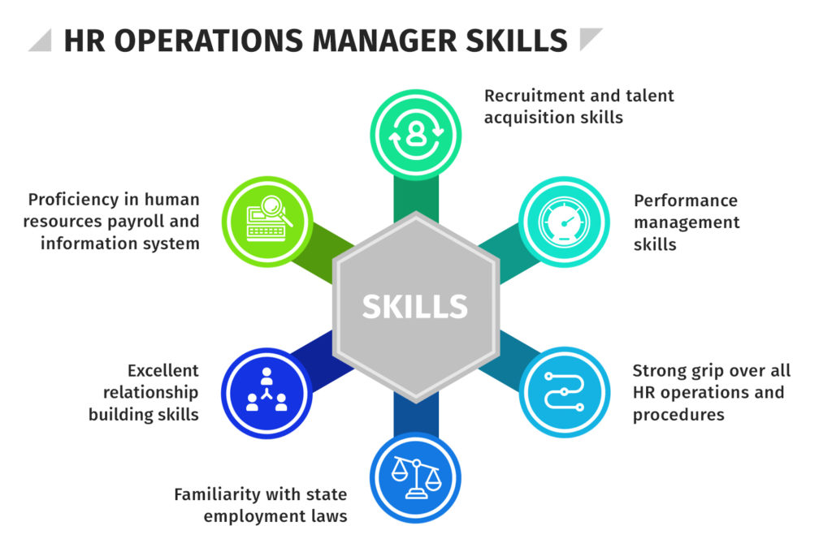

Figure 1.1: Skills required by HR managers in increasing productivity by training workers
(Source: Learner)
In order to enhance the skills of individual workers, managers of human resources have played a vital role in identifying the personality traits of individuals. As stated by Liboniet al. (2019), the main interests of the stakeholders can be made clear to the workforce by executives of human resources and this can be marked as one of the most effective processes to increase organisational productivity. Moreover, from the performance of the majority of the reputed global companies it has been found that in order to convey the administrative duties to the employees, executives engaged in human resources have shown a high level of efficiency and this in turn increased the overall productivity of companies. Motivating the workforce by providing incentives and bonuses can effectively increase the productivity of the employees. 16% of the large-scale international firms have emphasised improving the information technology infrastructure of HRM by increasing headcounts (Statista, 2022). The obtained data have indicated that improvement in the infrastructure of HRM is closely related to the performance of the engaged employees.
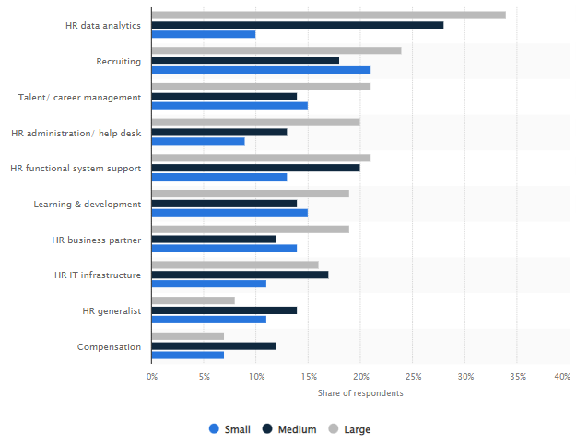

Figure 1.2: Share of firms focused on increasing headcounts of human resources
(Source: Statista, 2022)
Performance of global companies in HRM has shown that in career management 21% of the large-scale organisations have focused on increasing headcount in HRM (Statista, 2022). As per the view of Arslan et al. (2022), consideration of the educational background of individuals along with psychological factors can have a huge impact on the process of skill development of the workforce. The productivity of workers can be increased to a great extent by eliminating the conflicting ideas by executives of human resources which in turn can increase the organisational productivity of firms. It has been analysed that managers of human resources have played a vital role in training the engaged organisational workforce of companies which is one of the key factors in enhancing the professional skills of employees. As mentioned by Lee and Szkudlarek (2021), executives engaged in HRM play a crucial role in providing company-specific information to the engaged employees and this is one of the most vital parts of skill development. At the same time, HR managers play an important role in identifying and resolving the challenges faced by the employees in firms which is a key factor in increasing organisational productivity.

1.3 Rationale
It has been identified that executives engaged in the management of human resources in training the employees due to inefficiency in handling technical tools. As demonstrated by Gigauri (2020), diversity of the organisational workforce is one of the main barriers that HR managers have faced in execution and this, in turn, has resulted in an obstacle to the enhancement of individual performance of the workforce. Therefore, detailed research on HRM practices of global companies can identify the root causes of the emerging challenges faced by managers and recommend effective solutions to overcome those issues. 6% of the professionals in human resources have selected to provide incentives to older workers as a part of upskilling the relatively young workforce (Statista, 2022).
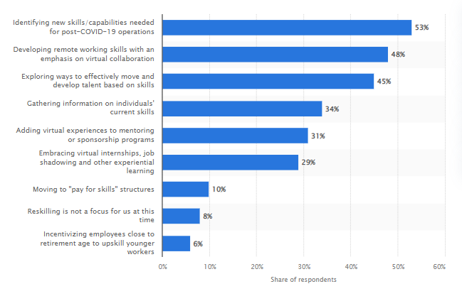

Figure 1.3: Share of strategies adopted by global firms in enhancing skills of the organisational workforce
(Source: Statista, 2022)
On the other hand, 53% of the professionals have emphasised the identification of unique skills among the engaged employees which can play a vital role in increasing the productivity of the firms (Statista, 2022). In addition, skills of remote working have been given a high priority by 48% of HR professionals (Statista, 2022). Moreover, a huge segment of HR professionals has faced issues in the maintenance of the regulations imposed by the government for workers and in this case, detailed research can be effective in suggesting reformative remedies for HR managers. As illustrated by Chanana (2021), organisational conflicts due to the cultural and linguistic diversity of the engaged employees can be marked as the issues faced by managers of HRM which in turn adversely affected the skill development of employees. Moreover, detailed research on HRM can allow the executives to effectively overcome the issues faced by them due to changes in organisational leadership, the merger of firms, and the adoption of advanced technical tools.

1.4 Problem Statement
From the overall organisational performance of the international market players, it has been analysed that a huge segment of HR managers has faced challenges due to changes in leadership. As depicted by Aguinis and Burgi-Tian (2021), a lack of respect for cultural diversity has resulted in a lack of motivation in companies which must be given a high priority by the HR managers. Moreover, issues in communicating with engaged employees have led to complexities in improving the skills of the organisational workforce. It has been identified that the score of engagement of the workers has reduced from 68% in 2020 to 65% in 2021 and this can be marked as one of the other issues faced by HR managers (Statista, 2022).
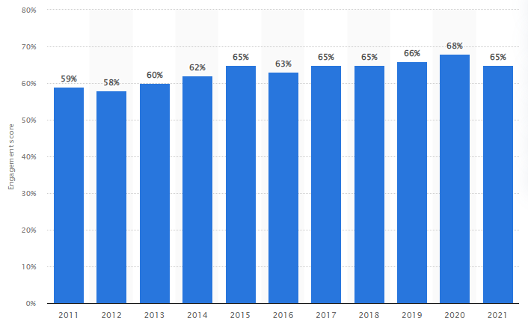

Figure 1.4: Score of engagement of the workforce in international firms
(Source: Statista, 2022)

1.5 Aim and research objectives
Aim
The key aim of this research is to find the role of HR manager to increase productivity and skill of employees of an organisation.
Research objectives
The main objectives of this research are
- To analyse the methods followed in the management of human resources in enhancing the key skills of the organisational workforce
- To evaluate the main impacts of strategies of HRM on performance and productivity level
Of workers
- To identify the present policies used in HRM to retain the existing workforce of companies in global aspects

1.6 Research questions
Discussions of this research are based on the following questions
RQ1: What are the methods followed in the management of human resources in enhancing the key skills of the organisational workforce?
RQ2: What are the main impacts of strategies of HRM on performance and productivity levels?
RQ3: What are the present policies used in HRM to retain the existing workforce of companies in global aspects?

1.7 Methodology
A descriptive design has been adopted by this research in data collection which can be effective in explaining the findings of the previous literature. Along with this, a quantitative approach has been followed by this research along with a sample survey in order to take into account the opinions of individuals on the role of HRM in the skill development of employees. In this case, random sampling has been done by selecting a sample population of 30 individuals.

1.8 Synopsis of chapters
Discussions of this research can be divided into five chapters and in the introduction chapter, the main aim with the objectives of the study have been described. In the literature review, findings from the previous literature have been explained with the application of theories. In the methodology chapter method of research information collection and analysis has been explained. In the findings chapter, results obtained from the conducted sample survey have been described with a detailed discussion. In the concluding chapter, the main summary has been given along with recommendations for improvement.
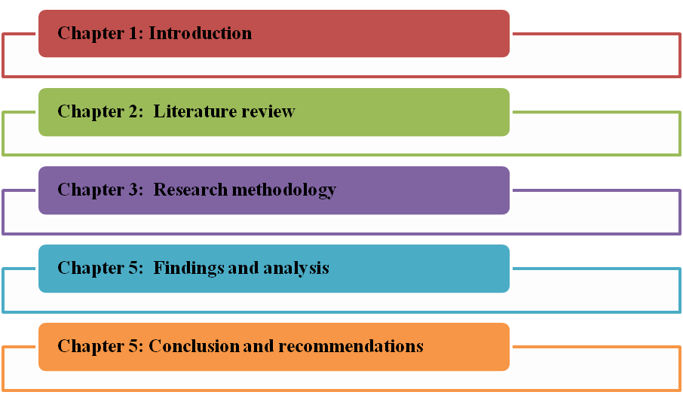

Figure 1.5: Synopsis of chapters
(Source: Learner)

1.9 Summary
From the analysis of the introduction chapter it can be summarised that cultural diversity among the engaged workforce of global companies has resulted in complexities and this in turn prevented HR managers from increasing productivity. In addition, the lack of technical skills of HR managers has resulted in issues in training that need to be mitigated with high importance.

CHAPTER 2: LITERATURE REVIEW

2.1 Introduction
The purpose of this literature review is to examine the situational factors and stakeholder interest that have an effect on HRM and employee skill enhancement. This analysis will also identify the current shortcomings in research related to this topic. By gaining knowledge about the impact of these situational factors and stakeholder interest, organizations can design and execute HRM strategies that effectively promote employee skill development, leading to better organizational outcomes.

2.2 Concept of Variables

2.2.1 “Role of Human Resource Manager”
The function of a “Human Resource Manager (HRM)” within a company involves the tasks and obligations assigned to the individual accountable for overseeing the “organization's human resources” operations. As per the view of Tien, and Nhi, (2019), these operations can encompass recruiting and choosing personnel, coaching and growing employees, overseeing performance, managing worker relationships, regulating benefits and compensation, and ensuring adherence to labor laws and regulations. The principal goal of the HRM is to acquire, maintain, and keep top-performing individuals, maintain favorable worker connections, enforce compliance with labor laws, develop and educate employees, and handle compensation and benefits. The HRM is pivotal in fostering and maintaining a constructive workplace culture and contributes to the overall success of the organization.


Figure 2.1: Role of HRM
(Source: Chieduet al. 2022)
The Human Resource Manager (HRM) at Unilever, a large multinational company, holds a crucial position in ensuring the effective operation of the organization and its 400-person workforce (Cuandraet al. 2022).
The field of HRM encompasses a broad spectrum of tasks, including the hiring process, enhancement of employee skills, overseeing performance evaluation, maintaining employee relations, managing employee benefits, and ensuring adherence to labor regulations.
A primary focus for the HRM is to “attract, retain, and engage top talent” by implementing strategies that appeal to employees, such as offering appealing compensation and benefits, fostering a positive work environment, and providing opportunities for growth.
The HRM also plays a crucial role in maintaining positive employee relations and resolving conflicts, as well as ensuring compliance with labor laws and regulations such as the “Equal Employment Opportunity Commission” and the “Fair Labor Standards Act” (Ferraris et al. 2019).
The HRM is also involved in employee development and training, including identifying areas for improvement, implementing training programs, and evaluating their effectiveness.
Finally, the HRM is responsible for compensation and benefits administration, including creating and managing benefits packages, conducting job evaluations, and overseeing employee salary and benefits negotiations.

2.2.2 “Employee Skill and Productivity”
The term "Employee skill and productivity" pertains to the competencies and output rate of a single worker within the workplace. Skills refer to the understanding and proficiency a worker holds in their area of expertise, and productivity refers to the quantity and standard of the work they generate. As enlightened by Nahar, and Zayed, (2019), the employee's skills and productivity are crucial elements for the success of an organization, as they have a direct impact on the workforce's efficiency and effectiveness. Enhancing employee skills and productivity through education, improvement programs, and similar efforts can result in heightened productivity, enhanced competitiveness, and an overall flourishing of the organization.

Unilever places great importance on the employee skill and productivity of its workforce. The company recognizes that the success of the organization is directly linked to the skills and productivity of its employees.
As enlightened by Alsubieiet al. (2021), the company has implemented various initiatives aimed at improving employee skills and productivity, including employee training and development programs. These programs focus on offering employees with the required “knowledge and skills” to obtain their jobs constructively and efficiently. Additionally, the company provides opportunities for employees to pursue professional development and advance their careers, which helps to improve their skills and overall job performance.
Unilever also prioritizes performance management and evaluates the productivity of its employees regularly. Employees receive regular feedback on their performance, and the company works with them to develop action plans to address any shortcomings and improve their productivity (Jeni, and Al-Amin, 2021).
Unilever also recognizes the significance of fostering a constructive workplace atmosphere, which is key to promoting employee morale and engagement. Unilever fosters a supportive workplace culture that values diversity, inclusion, and employee well-being. This helps to keep employees motivated and productive, and contributes to the overall success of the company.
Another important aspect of Unilever's approach to employee skill and productivity is its commitment to compliance with labor laws and regulations. As per the view of Karim et al. (2019), Unilever provides certainty that all employees are treated fairly and equitably, and that working conditions are safe and healthy. This helps to create a positive work environment and contributes to employee satisfaction and productivity.
Moreover, it has been depicted that Unilever places a strong emphasis on employee skill and productivity, and recognizes that a skilled and productive workforce is critical to the success of the company. Through its various initiatives, the company works to continuously improve the skills and productivity of its employees, and contributes to the overall success and competitiveness of the organization.

2.3 The improvement of effectiveness and efficiency in the workplace through human resource management tactics and techniques.
HRM is an integral part of any organization, serving as a critical driving force in promoting work efficiency and efficacy. The purpose of HRM is to expertly manage the human resources of Unilever, maximizing the skills and capabilities of each worker while ensuring they align with the “objectives as well as goals” of the organization. To attain this goal, HRM implements several tactics and techniques to uplift employee abilities, output, and results.
One way HRM can boost worker performance is by offering training and growth opportunities. According to Ozkeser, (2019), through consistent training programs and workshops, employees can acquire new knowledge and expertise, enabling them to broaden their skill set and raise their overall work performance. Additionally, HRM can introduce performance management systems that offer routine feedback, coaching, and recognition to employees. This enables employees to understand their strong and weak points, inspiring them to concentrate on areas requiring improvement.
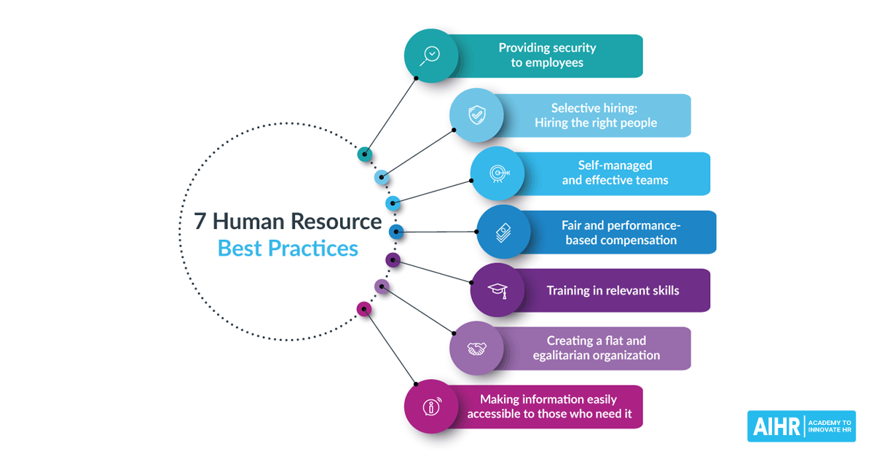

Figure 2.2: 7 practices of HRM
(Source: Azizi et al. 2021)
Another tactic employed by HRM to enhance work efficiency and efficacy is by building a positive work environment. This can be realized through clear communication, teamwork, and employee engagement initiatives. As illustrated by Jumady, and Lilla (2021), by fostering a supportive and collaborative atmosphere, employees are more likely to feel valued and motivated, leading to enhanced productivity and job satisfaction. Furthermore, HRM can implement “flexible work” opportunities such as “remote work or adjustable hours”, allowing employees to better balance their professional and personal lives.
Compensation and benefits administration is also a crucial part of HRM that can impact worker performance and satisfaction (Elrehailet al. 2019). By offering just and competitive compensation packages and benefits, HRM can attract and retain top talent while also encouraging employees to perform at their peak potential. HRM can also evaluate job requirements, frequently assess compensation packages, and negotiate salaries and benefits on behalf of employees.
Lastly, “HRM” is reliable for securing “compliance” with “labor laws and regulations”, safeguarding the “rights of employees” and avoiding potential legal issues for the company. This can include implementing workplace safety measures, enforcing anti-discrimination policies, and efficiently managing labor relations (Amrutha, and Geetha, 2020). It has been shed light on the fact that HRM is a vital aspect of promoting work efficiency and efficiency. By utilizing tactics and techniques such as training and development, a positive work environment, compensation and benefits administration, and compliance with labor laws, HRM can improve employee skills, productivity, and performance, leading to elevated competitiveness and overall success for the organization.

2.4 The enhancement of productivity and performance through the proactive involvement of human resource leaders.
As the stewards of the organization's workforce, HR leaders have a unique chance to make a proactive impact on productivity and performance. Through their active engagement and leadership, HR leaders can create a positive influence on the workforce and foster a culture of continuous improvement that drives organizational success.
As per the view of Tong et al. (2021), one effective way for HR leaders to improve productivity and performance is through savvy talent management. By attracting and retaining top-notch employees, HR leaders can cultivate a workforce that is not only competent but also motivated and engaged. This can be achieved through a series of measures, such as streamlining sourcing, selection, and onboarding processes, as well as through employee engagement programs and performance feedback systems. Moreover, HR leaders play a significant role in supporting employee development and career growth, ensuring that workers possess the necessary skills and knowledge to excel in their roles.
Another important aspect of HR leadership is cultivating a positive workplace environment (Masudet al. 2019). By fostering a supportive, inclusive, and respectful atmosphere, HR leaders can boost employee engagement and motivation, leading to enhanced productivity and performance. This can be achieved through open communication, teamwork-building activities, and employee recognition initiatives, as well as by addressing any workplace issues that may be impacting employee morale. Furthermore, HR leaders play a key role in administering compensation and benefits programs. As highlighted by Stanley et al. (2022), by providing fair and competitive compensation packages and benefits, HR leaders can attract and retain top talent while also motivating employees to perform to their full potential. They can conduct job evaluations, review compensation packages regularly, and negotiate salaries and benefits on behalf of employees, ensuring that the workforce is fairly compensated for their efforts.
Finally, HR leaders are also responsible for ensuring compliance with labor laws and regulations, protecting the rights of employees while avoiding potential legal issues for the organization. This involves implementing workplace safety measures, enforcing anti-discrimination policies, and effectively managing labor relations (Kirchoff, and Falasca, 2022). It has been elaborated that HR leaders have a valuable opportunity to drive improvement in productivity and performance through their proactive involvement and leadership. By focusing on talent management, a positive work environment, compensation and benefits administration, and compliance with labor laws, HR leaders can cultivate a workforce that is motivated, engaged, and aligned with organizational objectives.

2.5 HRM's current policies for retaining employees in the workplace.
The high cost of employee turnover and the difficulties associated with hiring and training new employees have made employee retention a top priority for many organizations. As a result, HRM has developed a range of strategies aimed at retaining employees in the workplace.
According to John-Eke, and Eke, (2020), one of the most effective strategies for retaining employees is by offering competitive compensation and benefits packages. Organizations that provide their employees with fair and attractive compensation and benefits packages are more likely to retain their workforce. This includes offering competitive salaries, health insurance, retirement benefits, and other incentives, such as bonuses and paid time off. Additionally, organizations can also provide non-monetary benefits, such as flexible work arrangements and opportunities for professional development, which can also play a role in employee retention.
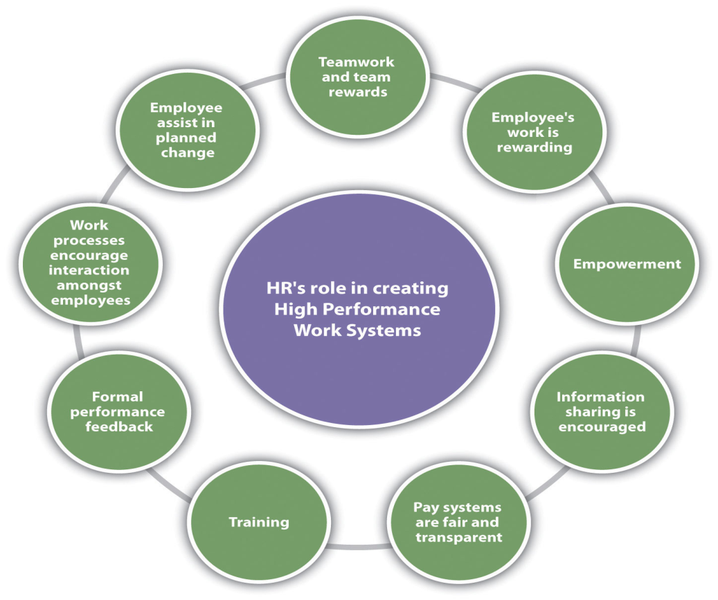

Figure 2.3: Employee retention plan
(Source: Halidet al. 2020)
Another important strategy for retaining employees is to create a positive and supportive work environment. This involves promoting an atmosphere that is inclusive, respectful, and supportive of all employees, regardless of their background or experience (Rizvi, and Garg, 2022). HRM can achieve this through effective communication, teamwork, and employee engagement programs, as well as by addressing any workplace issues that may be impacting employee morale. HRM can also retain employees by providing opportunities for professional development and career progression. As elaborated by Sadiq et al. (2022), by offering training and development programs and workshops, HRM can help employees acquire new skills and knowledge, allowing them to expand their abilities and improve their overall performance. Moreover, HRM can develop “performance management systems” that provide “regular feedback, coaching, and recognition to employees”. This helps employees understand their strengths and weaknesses, encouraging them to focus on areas that need improvement.
Another effective strategy for retaining employees is by engaging them in meaningful work. This involves providing employees with challenging and meaningful tasks and projects that align with their interests and strengths. As illustrated by Mahajan, (2020), when employees feel that their work is meaningful and has a purpose, they are more likely to be motivated and engaged, leading to improved productivity and job satisfaction. Furthermore, HRM can also provide opportunities for employees to take on leadership roles and responsibilities, allowing them to build their skills and gain valuable experience.
Finally, HRM can retain employees by ensuring that they are treated fairly and equitably. This includes implementing anti-discrimination policies and practices, addressing any workplace harassment or bullying, and promoting a culture of inclusiveness and respect (Stahl et al. 2020). Additionally, HRM can also ensure that the workplace is safe and healthy, by implementing workplace safety measures and addressing any health and safety concerns.

2.6 Situational Factors of HRM
External and internal circumstances that affect the implementation of HRM practices and their efficacy in enhancing employee competencies and productivity are referred to as situational factors. A few of the situational factors that have an effect on HRM are:
Organization size and composition: The magnitude and arrangement of Unilever can influence how HRM practices are executed and the resources available for employee ability progression (Rahdiyantaet al. 2019).
Organizational culture: The Company’s culture can influence the level of support for employee education and advancement, as well as the expectations for worker performance.
Economic and market trends: Economic and market trends can impact the resources available for employee ability progression and the demand for certain skills.
Technological advancements: The utilization of technology and automation can affect the skills required for success in Unilever and the need for employee training and development.
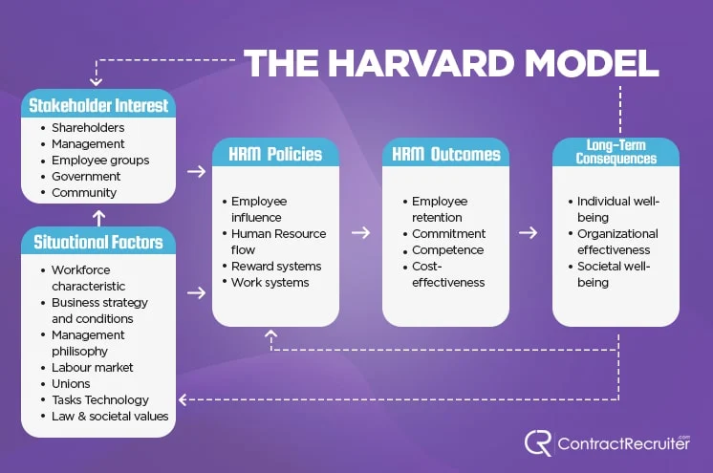

Figure 2.4: Situational factors
(Source: Huoet al. 2020)
Competitive landscape: Competition for skilled employees can impact the need for employee training and development, as well as the resources available for such programs (Al Doghanet al. 2019).
Regulatory framework: Government regulations can affect the types of HRM practices that are legally permitted and the resources available for employee ability progression.
These situational factors must be taken into account when formulating and executing HRM strategies aimed at enhancing employee skills and performance. By grasping the impact of situational factors, HR managers can tailor their HRM practices to meet the specific needs of their organization and improve the effectiveness of their efforts to cultivate employee abilities.

2.7 Stakeholder interest for involving employees
Stakeholders are groups or individuals who have an interest in the success of an organization, including employees. Involving employees in HRM is crucial as it enhances employee involvement, drive, and job satisfaction. Engaging employees in the formation and implementation of HRM practices makes them feel appreciated and creates a sense of ownership in the organization's aims and plans (Blanco‐Gonzalez et al. 2020).
Involving employees in HRM also leads to better communication and teamwork, making HRM practices more effective. Employees can provide valuable feedback and suggestions on HR policies and processes, and identify areas for improvement.
Furthermore, involving employees in HRM ensures that HR policies and processes align with the requirements and expectations of the workforce. This leads to increased support and commitment from employees towards the organization's goals and improves the overall impact of HRM in developing employee skills and performance (Waheed, and Yang, 2019). Overall, including employees in HRM is beneficial for all stakeholders, as it results in improved employee engagement, motivation, and performance, and contributes to organizational success and competitiveness.

2.8 Theories and models

2.8.1 Strategic Contingency Theory
Strategic Contingency Theory in HRM holds that there isn't a one-size-fits-all solution for managing human resources and that the best HR strategies should be tailored to match the unique context, situation, structure, and environment of an organization. The theory focuses thevalue of assigning HR practices with the “organization's overall strategy” and structure, taking into consideration the distinct characteristics of each organization (Safari, and Saleh, 2020).
For instance, in a centralized organization, decisions are typically made at the top and HR strategies must be uniform and consistent across the organization. On the other hand, in a decentralized organization, HR practices must be more flexible and responsive to the differing needs of different departments and divisions.
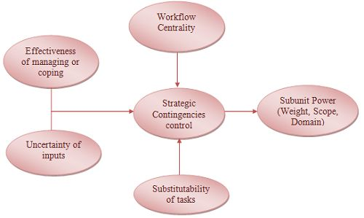

Figure 2.5: Strategic Contingency Theory
(Source: Shonhadji, and Maulidi, 2022)
The "fit" concept is a crucial aspect of “Strategic Contingency Theory”,encountering that HR practices must be associated with the “organization's context, goals, and strategy” to be effective (Nwachukwu, and Vu, 2020). For instance, in a rapidly growing organization, HR may prioritize recruiting and onboarding to ensure a steady supply of talented employees, whereas in a stable organization, HR may focus more on employee retention and development. Moreover, it has been stated that Strategic Contingency Theory posits that HR strategies must be customized to match the unique needs and context of each organisation and that effective HR management requires a thorough understanding of the organisation's strategy, structure, and environment.

2.8.2 Organizational Lifecycle Theory
Organizational Lifecycle Theory is a management viewpoint that considers organizations to develop through various phases of growth, and asserts that HR policies must adjust as the organization evolves. According to this theory, organizations usually experience four phases: inception, expansion, stability, and decline.
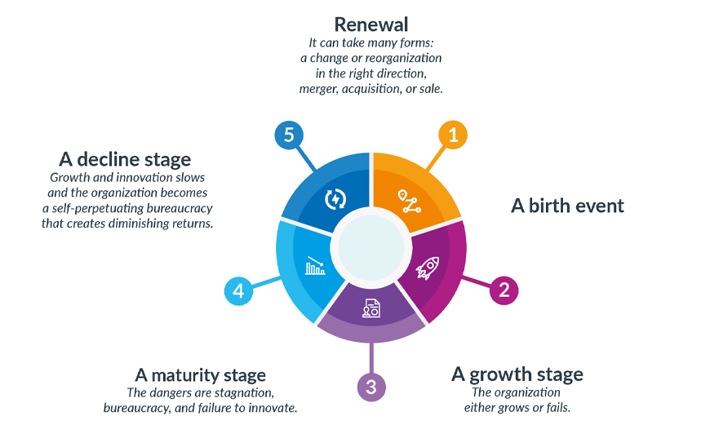

Figure 2.6: Organizational Lifecycle Theory
(Source: Primcet al. 2020)
At the inception phase, HR focuses tend to centre on recruiting and retaining skilled personnel, and HR approaches may be adaptable and customized to fulfil the demands of individual workers. During the expansion phase, HR policies may become more organized and standardized as the organization grows, with an emphasis on constructing and preserving a competent workforce (Bretoset al. 2020).
In the stability phase, HR strategies may concentrate on preserving the current state, with a focus on education and improvement programs aimed at enhancing employee abilities and productivity. Finally, during the decline phase, HR strategies may center on cutting costs and reducing the size of the workforce. The Organizational Life Cycle Theory highlights the significance of HR policies adjusting and transforming in response to the ever-changing requirements of the organization (Roscoe et al. 2020). By comprehending the different phases of Unilever’s lifecycle, HR leaders can better prepare to respond to the shifting demands of their workforce.

2.8.3 The Warwick Model
The Warwick Model is a Human Resource Management framework that concentrates on the collaboration between HR strategies and practices, employee outlooks and actions, and organizational results. It argues that effective HRM can boost employee skills and performance by affecting their attitudes and actions.
The model comprises four parts: HR strategy, HR practices, employee attitudes, and organizational results. The HR strategy lays down the overall path for HR policies and practices and must align with the organization's objectives and culture. As enlightened by Koushedeet al. (2019), HR practices, including recruitment, training, and performance assessment, are then carried out to support the HR strategy.
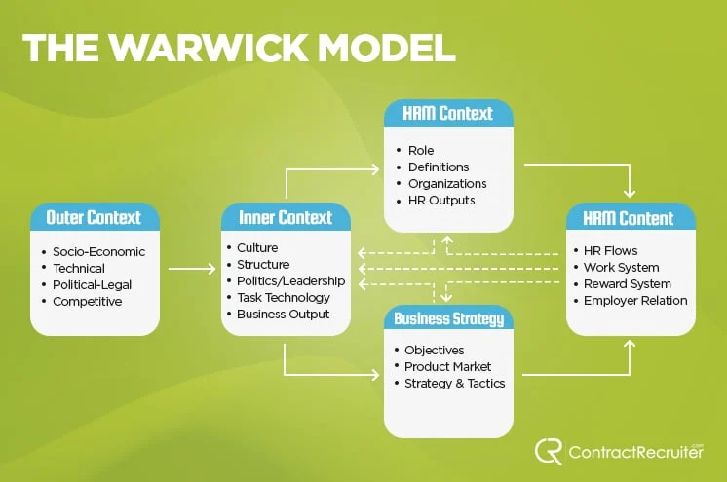

Figure 2.7: Warwick Model
(Source: Thygesenet al. 2021)
Employee attitudes, such as job satisfaction and motivation, are then impacted by the HR practices and can have a direct effect on employee skills and performance. Lastly, the influences of HR practices on “employee attitudes and behaviours” can result in improved organizational outcomes, including elevated productivity, reduced staff turnover, and higher customer satisfaction levels.
The Warwick Model highlights the significance of a comprehensive and integrated HR strategy and the need for HR policies and practices to align with the “organization's goals and culture” in order to have the greatest impact on employee skills and performance.

2.9 Conceptual Framework
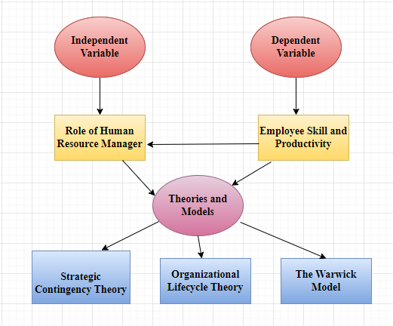

Figure 2.8: Conceptual framework
(Source: Self-created)

2.10 Literature gap
Critical literature has been presented in the literature review section in order to establish the objectives of the research regarding the role of HR managers to enhance the skills and productivity of employees, and different gaps have been identified. Limited research has been found, that discussed the HR manager’s role to enhance the skills and productivity of employees rather discussed leadership’s contribution in this aspect. Different literature focused on to related flexibility of HR, employee competencies, adaptability of leaders, and job satisfaction to employee performance, however, the relation of employee performance to the training, and other different strategies and measures taken by HR manager is discussed in limited literature.While there have been many studies that have explored the impact of HRM practices on various “organizational outcomes”, such as employee satisfaction and performance, there is still much to be learned about the specific mechanisms through which HRM practices can contribute to employee skill development and improvement (Black et al. 2019).
One area in which there is a notable literature gap is in the examination of the impact of situational drivers on the connection between “HRM and employee skill and improvement”. While it is widely acknowledged that situational factors, such as organizational culture, market conditions, and technology, can impact HRM practices and their effectiveness, there has been limited research that has specifically examined the impact of these factors on employee skill development and improvement (Masudet al. 2019).
Another area in which there is a literature gap is in the examination of the impact of involving employees in HRM on employee skill and improvement. While there is some research that suggests that involving employees in HRM can lead to improved employee engagement and job satisfaction, there is limited research that has specifically explored the impact of involving employees in HRM on employee skill development and improvement (Sheng et al. 2020).
Additionally, there is limited research that has explored the impact of different HRM practices, such as “training and development programs, performance management”, and recruitment and selection practices, on employee skill development and improvement. There is also limited research that has examined the impact of HRM practices at different stages of the organizational lifecycle, such as “start-up, growth, maturity, and decline”.
To address these literature gaps, there is a need for more research that specifically examines the relationship between HRM and employee skill and improvement, and that takes into account the impact of situational factors and the involvement of employees in HRM practices.

2.11 Summary
The literature review focuses on the various factors that impact the implementation and effectiveness of HRM practices in developing employee skills and performance. The review highlights the importance of considering situational factors, such as “organizational size, culture, and economic conditions”, in the development and implementation of HRM strategies. It also emphasizes the value of involving employees in HRM practices, as it can improve “employee engagement”, motivation, and “job satisfaction”, as well as increase the effectiveness of HRM practices. The review highlights the need for further research to fully understand the interplay between these factors and the impact they have on HRM practices and employee skills and performance.

CHAPTER 3: RESEARCH METHODOLOGY

3.1 Introduction
The research methodology chapter helps to understand the research data collection techniques and identify significant roles of the research onion in this study. This chapter also conducts a detailed analysis of data collection techniques and data analysis processes that help to build research outlines. On the other hand, this chapter also helps to understand the research timeline and critically evaluate the research design that gathers more data from different sources. Based on this chapter, critically evaluates the data sampling process for focusing on research philosophy and research approaches. Apart from this knowledge, Research onion can evaluate the research strategies that are implemented in the research outcomes.

3.2 Research Onion
Research onion is the framework of research methodology that describes research strategy and research techniques for effective research methods. On the other hand, research onion also helps to provide detailed information regarding research philosophy, research approaches and research design that creates an appropriate timeline for the research study (Newman and Gough, 2020). Research onion can also increase knowledge regarding research data collection methods to enhance appropriate research data sampling. On the other hand, research onion can evaluate the appropriate research strategy that impacts the research completion activity. Apart from the research onion, it is understood that research onion can increasingly gather more data that increase understanding of the data analysis process.
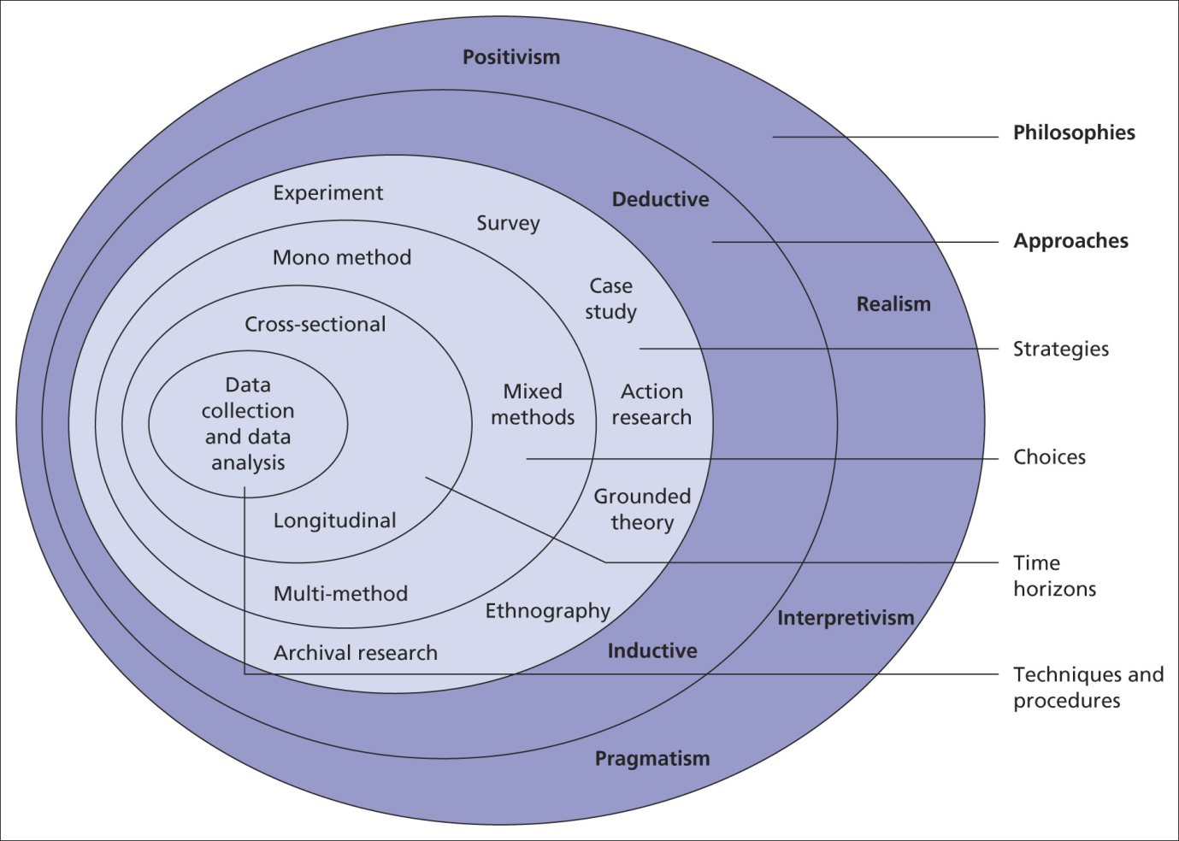

Figure 3.1: Research Onion
(Source: Saunderet al. 2007)

3.3 Research philosophy
Research onion helps to identify the research philosophy for increasing systematic research that helps to provide credible information in this research study. Research philosophy helps to involve authentic research information by evaluating cognitive thinking. Important four research philosophies are Realism, positivism, pragmatism, and interpretivism. Apart from this research philosophy research can provide authentic research information that helps in the data collection process (Mishra and Alok, 2022). This research study mainly followed the Positivism research philosophy that provides cognitive research knowledge for data interpretation. Based on this philosophy researcher can evaluate the quantitative data collection process and explain different principles of research concepts. On the other hand, positivist research philosophy can provide theoretical information about a research study that is estimated to strategy reduce the data sampling methods.
Based on this research philosophy, positivism can increase statistical hypotheses that are implemented in further study. Positivism research philosophy can illustrate the overview of the research objectives that measure the research study to interpret data collection knowledge. This philosophy can help to observe the appropriate elements for data collection techniques in this research study (Bairagi and Munot, 2019). Positivism research philosophy also provides ontological details of research study that is involved in quantifiable data analysis. On the other hand, this philosophy can increase business decades to evaluate the research objectives.
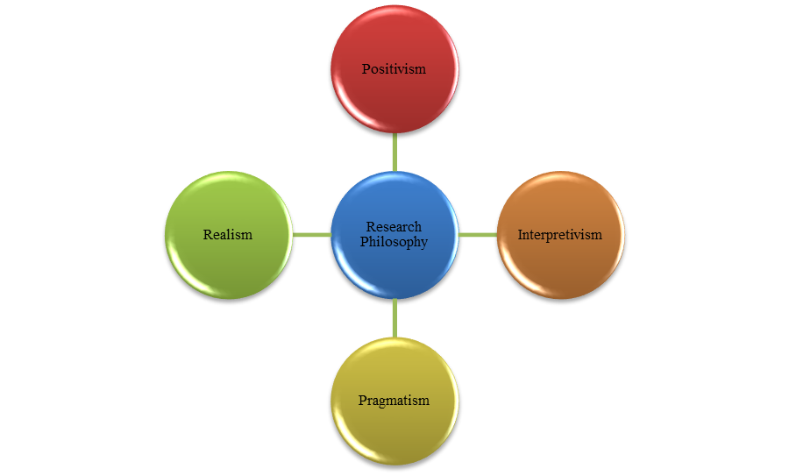

Figure 3.2: Research Philosophy
(Source: Self-Created)

3.4 Research approach
Research approaches help to illustrate the data-gathering methods and proper planning for research completing the evaluation. Research approaches also change the research thoughts and cognitive thoughts for research significance. Based on the research approaches, researchers can increase knowledge regarding research formation. Two types of research approaches showed mainly Inductive and Deductive approaches for increasing conformational activities to emerge the research study (Babii, 2020). This research study mainly followed inductive research approaches to increasing pattern theoretical evaluation. Inductive research approaches also develop the confirmation research data that gather theoretical information. Inductive research approaches help to provide sufficient information about the research study and conduct empirical cognitive structure.



Figure 3.3: Research approach
(Source:Self-Created)
Inductive research approaches can help to formulate the research experiences and research questions that help to identify the social structure to explore the business structure and the researcher can exist the data gathering observations that generate sets of data. On the other hand, Inductive research approaches can be improving the research cognitive thinking and explore the research significance for evaluating the empirical generalisations (Al-Ababneh, 2020). Based on these approaches, researchers can change the knowledge about HR roles in employees' skills. Apart from these research approaches, researchers can explore the social structure of this research study and help to gather more data for research experiences.

3.5 Research design
Research design can help to determine the research framework for utilising the research methodology. On the other hand, research design also provides the data collection methods to evaluate the relevant framework. Four types of research design are Descriptive, exploratory, and explanatory research design. This research study mainly followed an exploratory research design that helps to increase knowledge regarding research issues and change the data collection process by the relevant system (Babii, 2020). Exploratory research design helps to gather more relevant data for identifying the research flexibilities. Based on this research design researcher can provide to find out the horizontal research progress. Apart from this research design, it is understood that exploratory design can provide a ground framework for data collection techniques that implement the research progress at a low cost.
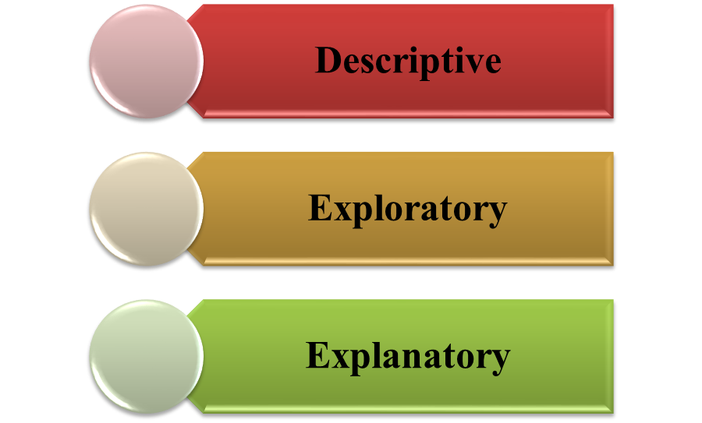

Figure 3.4: Research design
(Source: Self-Created)
According to this research design, researchers can evaluate the most appropriate research techniques to determine the research variables and help to progress the research study. Research design changes the understanding of the relevant research information and determines the research data collection techniques for completing research variables (Thomas, 2021). On the other hand, exploratory research design changes the knowledge about research information and provides a horizontal framework for research flexibility.

3.6 Research Strategy
Research strategy is another stage of a research onion and research strategy can help to determine the research process for significant outcomes. Two Types of research strategy are shown mainly a Quantitative primary data collection process and another secondary qualitative data collection method. Based on this knowledge, researchers mainly followed a primary quantitative research strategy for this study (Al-Ababneh, 2020). A quantitative research strategy helps to provide theoretical information regarding research topics and achieve proper understanding to enhance research findings. On the other hand, this strategy can evaluate the previous research knowledge and previous research results that are implemented in this research study.
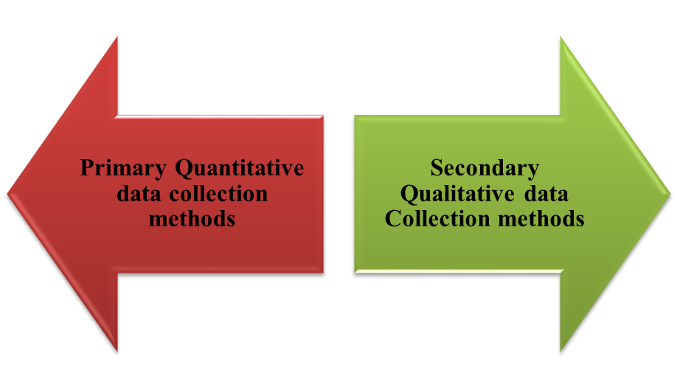

Figure 3.5: Research strategy
(Source: Self-Created)
A quantitative research strategy also changes the data collection process and enhances the proper theoretical data by collecting previous research studies. Based on this research design, researchers can evaluate a broad range of data sampling and enhance knowledge about research problems. On the other hand, a quantitative research strategy also increases knowledge regarding HR roles in employees' skill development to build research objectives and change collection processes (Greening, 2019). Apart from this research strategy, research can demonstrate the data analysing process for completing the proper percentage of theoretical research information.

3.7 Data sampling
Data sampling is the process of data collection technique and selecting representative sources of information in quantitative ways. Data sampling is the set of data that measures effective information regarding HR roles in employees' skills development that increases sampling size. A large sampling size can help to determine the research objectives for completing this research. On the other hand, data sampling helps to enhance the theoretical concept of the research topic and helps to cluster more data determination (Zawacki-Richter et al. 2020). In this research work, random sampling method has been selected in order to maintain the research bias and diversity. For processing the research work, 30 samples has been selected randomly from the large population size.

3.8 Data collection methods
Data collection methods help to understand about research data type and this research study mainly followed the primary quantitative data collection process by survey-based techniques and collecting more data from individual responses. In this data collection process mainly 30 participants are performing and enhancing knowledge about HR roles in employees' skills development. On the other hand, survey data collection techniques can help to increase data flexibility for conducting the appropriate research data (Babii, 2020). Based on these data collection techniques, survey-based primary data also help to improve research findings for increasing research flexibility in conducting research methods. Apart from this study, the data collection techniques also help to determine the research flexibility and fulfil research objectives that mainly included 30 responses.
Survey-based data collection techniques also provide the most significant data for individual knowledge about HR roles to collect more data collection responses. On the other hand, secondary data collection also identifies the existing information that maintains the quantitative data collection process (Al-Ababneh, 2020). These data collection processes also enhance the individual knowledge about representative more convenient data that impact the research outcomes. Total 15 survey close ended questions has been prepared which are circulated thorugh Google form among 30 participants. All these 30 responses has been collected for further analysis purpose to analyse research objectives and questions.

3.9 Data analysis
According to data collection techniques, it is to analyse the individual thoughts and knowledge that analyse the data for research findings. On the other hand, gathering data also analyses the statistical data for a research study to consider individual responses. Apart from this quantitative data collection process, 30 responses are collected that analyse the research significance for research outcomes (Thomas, 2021). Based on the data analysing process, determining the responses that help to understand the knowledge about HR roles in employment skills. Google survey form has been generated for collection of the survey responses and different graph would be prepared for the analysis purpose.

3.10 Ethical consideration
This research study conducts a secondary survey data collection process that significantly elucidates the research information. On the other hand, survey-based data can evaluate the individual data to protect the Data Protection Act, 2018 which is also followed by the researcher. Based on this research study, ethical considerations were also followed to manage the proper citation of the research study. The secondary survey data collection process used in this study significantly clarifies the research data. In order to ensure that the research study was properly cited, ethical considerations were also taken into account. Along with that, all the collected data has been stored in the university database under an encrypted passcode to ensure protection of data and ignore data breaching.

3.11 Summary
This chapter can also help to understand the appropriate data that evaluate in this research methodology. Based on this research onion also helps to describe appropriate research approaches and philosophy that help to cognitive thinking of individuals. On the other hand, Secondary survey-based data collection processes also help to evaluate the research findings. In contrast, this chapter also aids in comprehending the research timeline and providing a critical evaluation of the research design, which collects additional data from a variety of sources. Analyzes the data sampling procedure in light of the research philosophy and methods discussed in this chapter. In addition, Research Onion is able to evaluate the research strategies used to produce the research results.

CHAPTER 4: FINDINGS AND ANALYSIS

4.1 Introduction
Findings and analysis chapter of this research analyses the opinions of the selected sample population for the survey. Along with this, thematic analysis has been done in this chapter in order to describe the key factors which have affected the management of organisational human resources of companies. This chapter has emphasised on reflecting the importance of the management of organisational human resources in the skill enhancement of employees. In addition, the relationship between effective HRM practices and the level of productivity of the organisational workforce has been explained in the thematic analysis section of this chapter. Moreover, current HRM policies of firms have been discussed in this chapter which have been used in the retention of the organisational workforce.

4.2 Findings
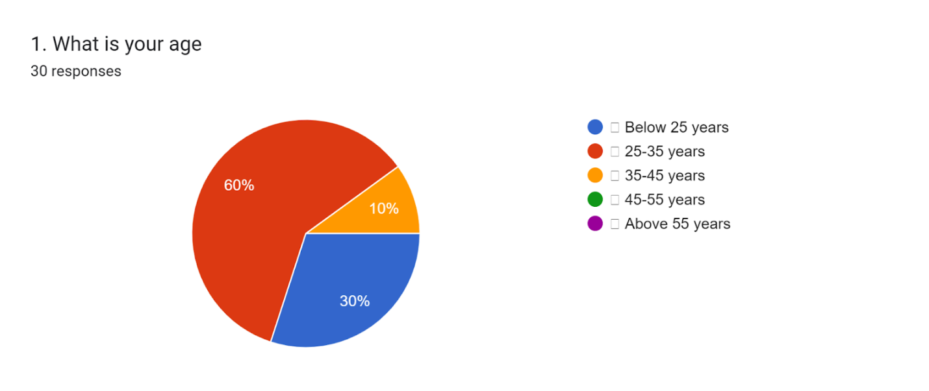

Figure 4.1: Response of sample group on age
(Source: Google form)
Results of the conducted survey have reflected the majority of the selected individuals from the age group 25-35 years and in this, the share is 60%. On the other hand, 30% of the sample population belongs to the age group below 25 years.
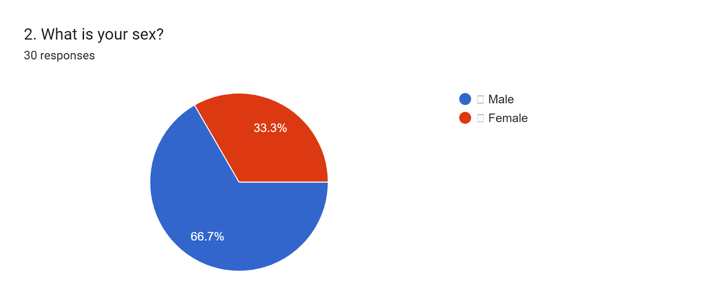

Figure 4.2: Response of sample group on sex
(Source: Google form)
Results of the conducted survey have indicated that the majority of the sample population are male and the share of the male is 66.7% whereas the share of females is 33.3%. The lack of participation of the female workforce in companies is one of the main findings of this survey which must be given high importance by HR managers.
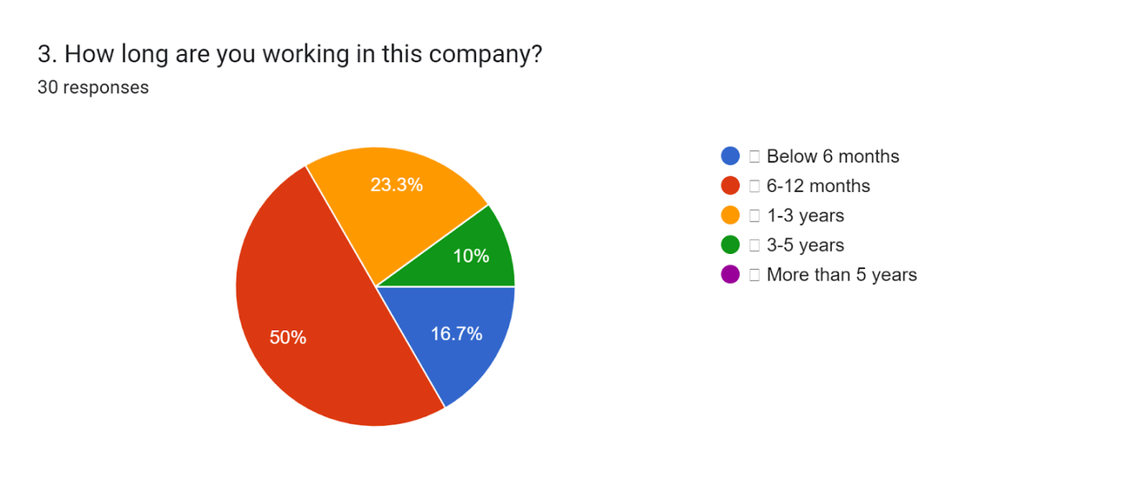

Figure 4.3: Response of sample group on work experience
(Source: Google form)
50% of the respondents have stated that they are engaged in their companies for more than 6-12 months. 23.3% of the respondents have stated that they are engaged in their organisations for 1-3 years. The obtained data have reflected that the retention rate of the workforce is low in most companies which need to be improved by adopting effective HRM policies.
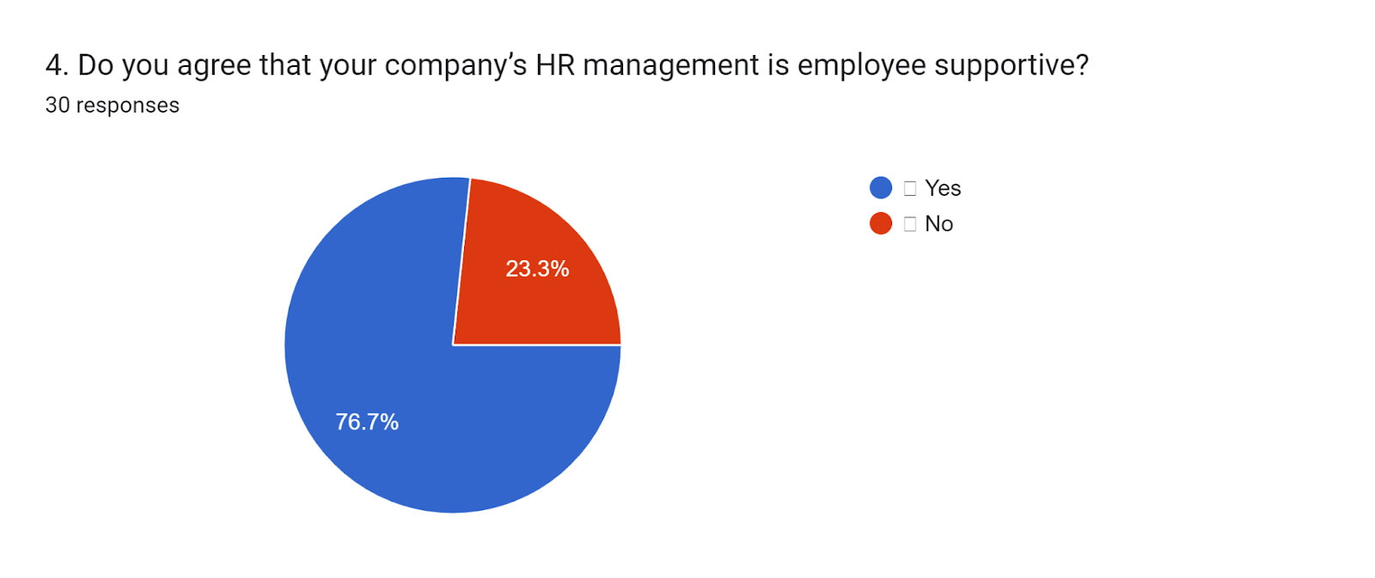

Figure 4.4: Response of sample group on support to the workers by HR management
(Source: Google form)
76.7% of the total sample population have stated that the HR management of their companies is highly supportive of the workforce. On the other hand, 23.3% of the sample population have stated their negative opinion in this case. It has been found that in planning the career of the workforce HR managers can play a vital role. As mentioned by Ozkeser (2019), career success in the workforce is one of the vital factors in which HR managers can play an important role. In addition, in achieving the career objectives of individuals, HR managers can play a vital role. Along with these, managers of human resources play a crucial role in providing support by identifying the main strengths with the major weaknesses of individual workers. Moreover, managers of HRM can play an important role in continuing the education of the workforce by supporting them.
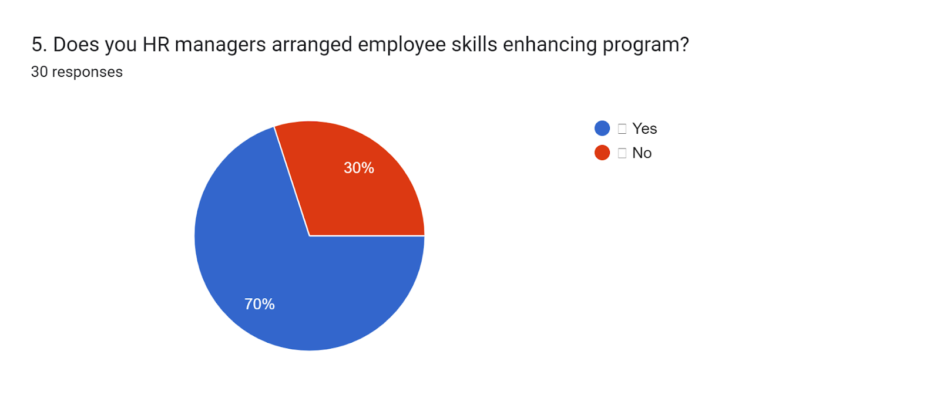

Figure 4.5: Response of sample group on skill enhancement of workforce by HR managers
(Source: Google form)
70% of the sample population have agreed that skill enhancement programs are arranged by their companies and in this case, 30% of the sample population have stated their negative response. From the performance of the profit-earning firms, it has been identified that the role of HR managers is highly important in providing technical training to engaged organisational employees who can be essential in increasing organisational productivity. As demonstrated by Cooper et al. (2019), the management of consumer relationships can be marked as one of the most vital functions of companies on which HR managers can provide guidance to the workforce to a great extent by arranging programs for employee skill development. Along with these, training on quality maintenance can be the other factor on which training is provided to the engaged employees by HR managers. Moreover, the management of organisational stakeholders is the other factor in which HR managers can guide the workforce by arranging programs for skill development.
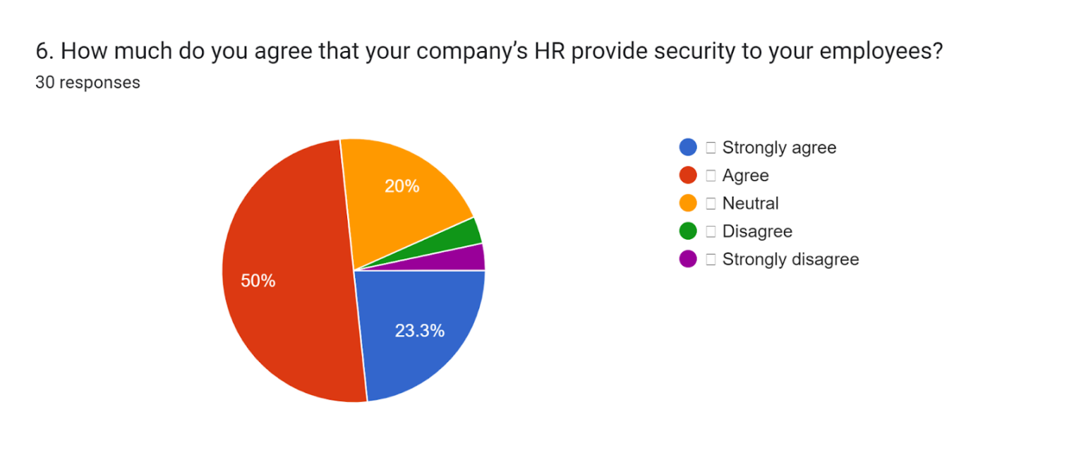

Figure 4.6: Response of sample group on security to the workforce by HR managers
(Source: Google form)
50% of the survey respondents have agreed that the HRM of their companies provides security to them. Along with this, 23.3% of the respondents strongly agreed with this case. It has been analysed that the role of HR managers is high in providing security to the organisational workforce. As mentioned by Fenech et al. (2019), ensuring the protection of the engaged workforce in risky workplaces is one of the main responsibilities of the managers engaged in HRM. In this case, the prevention of health hazards and accidents are the important factors on which the managers of HRM need to be focused. In the implementation of the techniques of hazard control, HR managers must give a high level of effort. On the other hand, policies of HRM must be designed by managers by taking into account the prevention of accidents in workplaces.
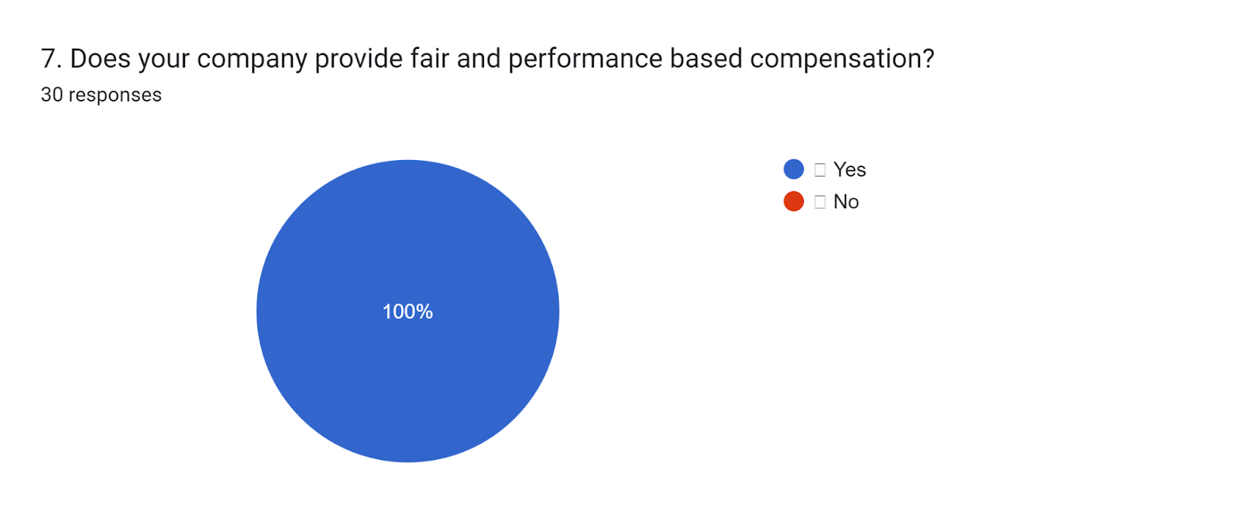

Figure 4.7: Response of sample group on compensation based on performance
(Source: Google form)
All of the selected groups of the sample population have stated that compensation is given by their companies to the workforce on the basis of their performance. Rewarding is one of the best procedures to encourage the workforce and in increasing the effort and engagement of employees, rewards and incentives play an important role. As opined by Sitopuet al. (2021), the reduction of attrition rate can be marked as one of the main responsibilities of HR managers which must be given a high priority in retaining the best performers. In this case, biases can have an adverse impact on the overall organisational performance of firms. Recognition of the workforce effort is a factor that can be highly related to rewarding the workers. The flexibility of the payment process is the other factor of HRM that must be given a high priority by the managers in providing rewards to the employees.
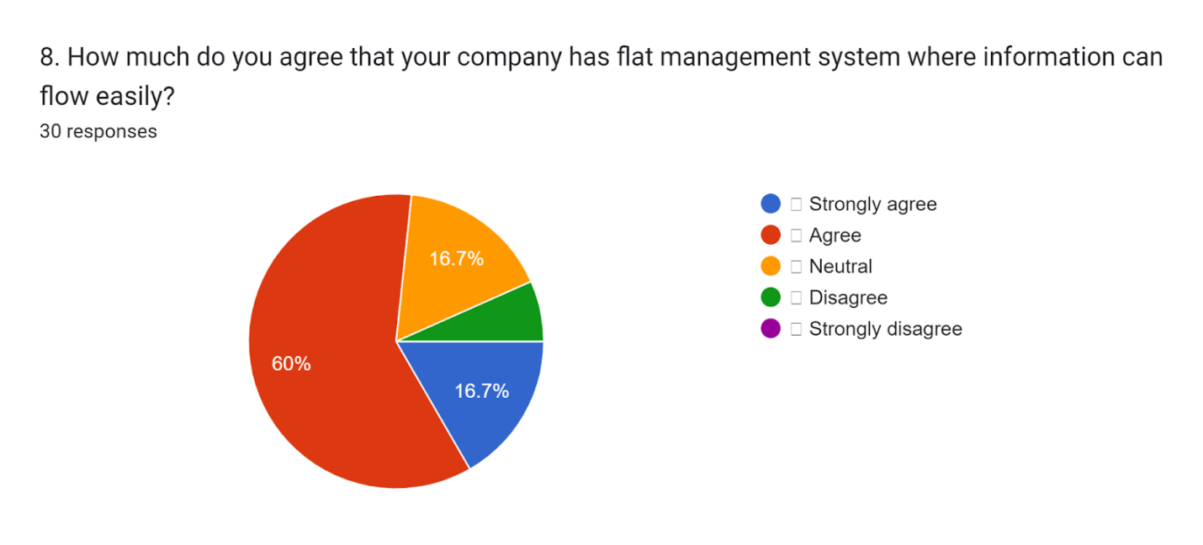

Figure 4.8: Response of sample group on information flow in their companies
(Source: Google form)
60% of the sample population of the conducted survey have agreed that information flow in their companies is effectively managed as a part of HRM. In this case, 16.7% of the sample population strongly agreed with this survey statement. Managers engaged in HRM play a vital role in creating an open communication culture within the organisation which can have a positive impact on overall organisational performance. As demonstrated by Budhwaret al. (2022), transparency in execution is one of the main responsibilities of HRM which must be given high importance in retaining the workforce. Along with these, an effective flow of organisational information can allow the managers to keep the workforce informed regarding the decision-making process of the companies. It has been found that the introduction of an open-door policy of information flow can enhance the team performance of the projects to a great extent. In addition, an improvement in the information flow can result in improved access of the workforce to the tools used in business.
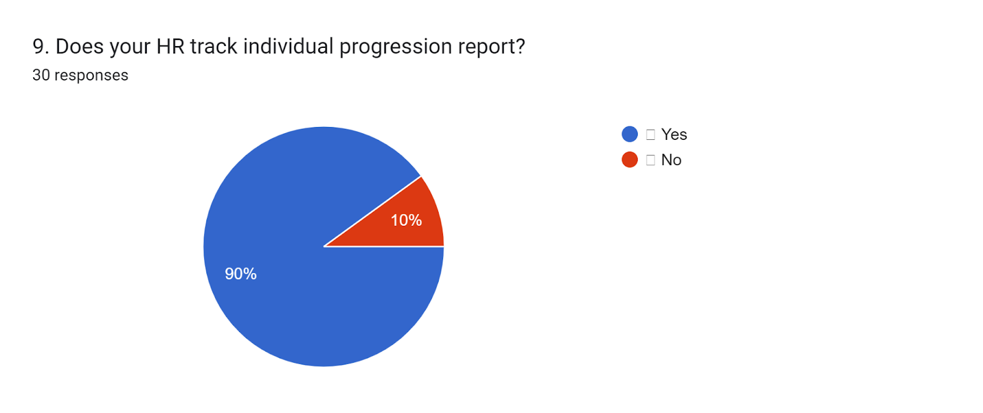

Figure 4.9: Response of sample group on tracking of progression report by HR
(Source: Google form)
90% of the selected sample population have agreed that the progression reports of employees are effectively tracked by the HR managers in their companies and in this case, 10% of the respondents have stated their negative view. Identification of the plans along with organisation and objectives of communication are the major factors that are evaluated by the HR managers in the performance appraisal of the workforce. As per the view of Parry and Battista (2019), the feasibility of objective achievement can be marked as one of the most useful methods of performance evaluation of the workforce engaged in the execution of companies. Progression reports are created by the HR managers by taking into accountthe validation of the major objectives. On the other hand, tangible goals along with intangible aspects are reviewed by the HR managers in the creation of progression reports for individual workers. In addition, interpersonal skills along with a commitment to the workforce are reviewed by the executives engaged in HRM as a part of the creation of a progression report.
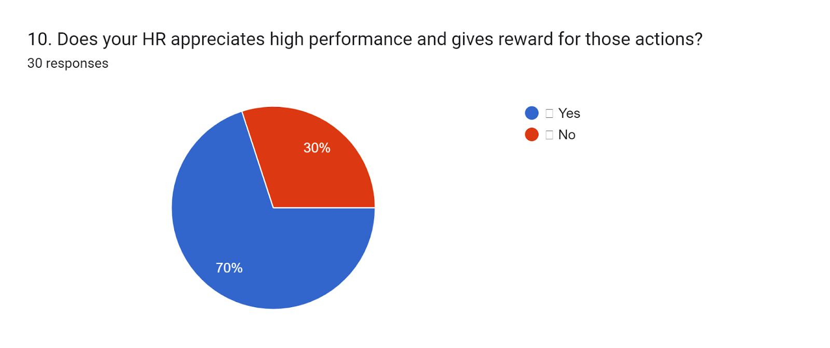

Figure 4.10: Response of sample group on appreciation of high performance by HR
(Source: Google form)
70% of the survey population has stated that high performance of the workforce is appreciated by rewards in their companies by HRM. On the other hand, 30% of the respondents have given a negative view of this case. In order to reduce the stress level of engaged employees, the importance of rewarding workers is high. As opined by Fenech et al. (2019), the investment of firms in the rewarding workforce can lead to an increase in employee satisfaction rate. At the same time, an increased effort of the workers due to rewards can result in a higher loyalty of consumers. An improvement in team culture can be observed in the companies as a direct impact of providing incentives to the workforce. Encouragement of friendly competition is one of the positive impacts of rewarding the organisational workforce which in turn can lead to an increase in the overall productivity of companies. The creation of positivity in the worksites can be marked as one of the main positive impacts of rewarding the workforce by HRM.
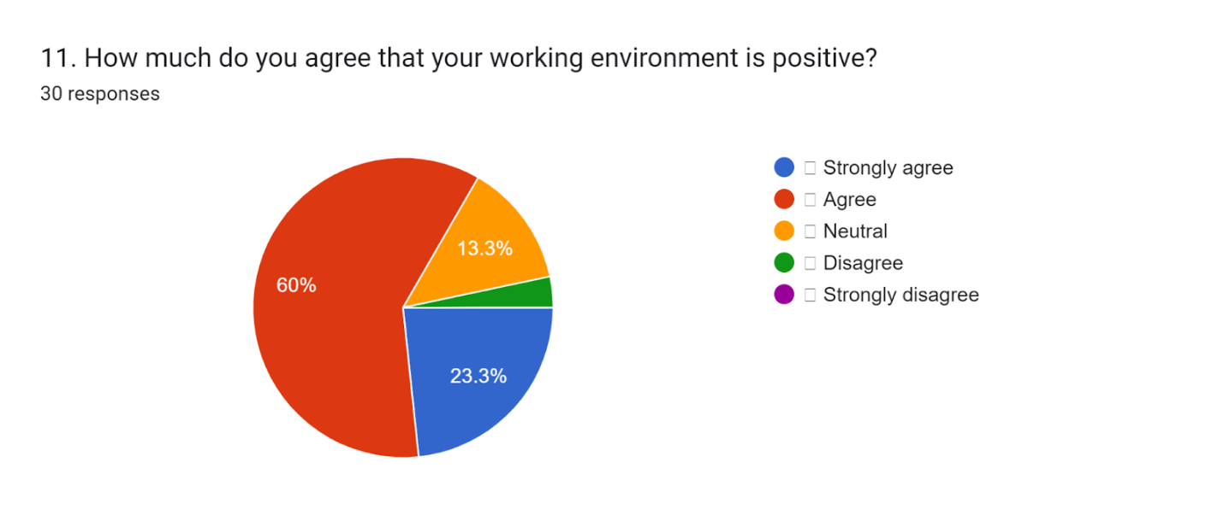

Figure 4.11: Response of sample group on the positivity of work environment
(Source: Google form)
From the results of the conducted sample survey, it has been found that 60% of the sample population have agreed that the working environment is highly positive in their companies. Along with this, Motivation 23.3% strongly agreed with this fact and 13.3% stated their neutral view in this case. Along with appreciation are the main determinants of positivity in the organisational workplaces. As mentioned by Choi (2020), the creation of positivity in the workplace can lead to an increase in the enthusiasm of workers which in turn can result in an increase in the efficiency of employees. Moreover, the facilitation of learning opportunities must be given a high level of priority by the HR managers, and maintenance of this factor can be effective in the creation of positivity in organisational workplaces. The culture of organisational workplaces can be marked as one of the most effective ways to increase positivity in companies. Additionally, the work environment must be made highly comfortable by the firms as part of the creation of positivity in the companies.
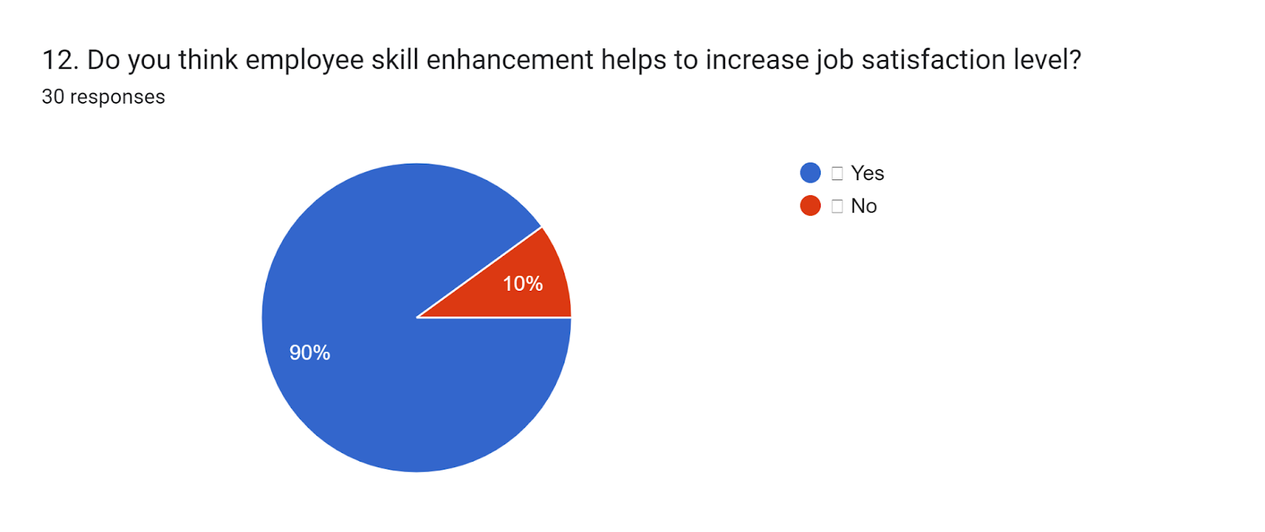

Figure 4.12: Response of sample group on skill enhancement in increasing the level of job satisfaction
(Source: Google form)
The majority of the sample population has stated that skill development in the workforce can lead to high job satisfaction and the percentage share, in this case, is 90%. On the other hand, 10% of the sample group rejected the view. Enhancement of professional skills can be marked as one of the most effective ways to increase the productivity of the workforce. As suggested by Toropovaet al. (2021), reflective learning has been found as one of the most effective ways for the professional skill development of workers. Along with these, learning advanced technical tools is one of the vital parts of the enhancement of professional skills. Enhancement of professional skills of employees can lead to efficiency levels which can ensure performance appraisal. On the other hand, performance appraisal can result in a higher satisfaction level in the workforce. The satisfaction level of the workforce has been found as the key determinant of employee retention in profit-earning companies.
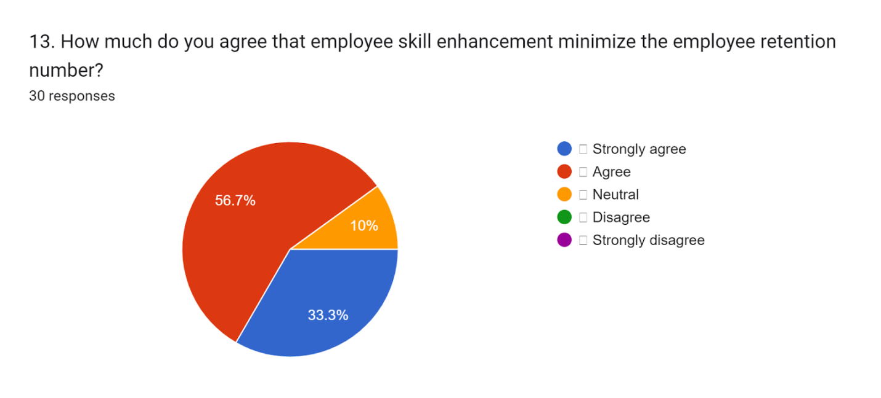

Figure 4.13: Response of the sample group on the relationship between workforce skill development and retention of the workforce
(Source: Google form)
Response of the sample population has reflected that 56.7% of the selected individuals have agreed that enhancement of skills of the workforce can minimise employee retention. 33.3% of the selected individuals strongly agreed in this case and on the other hand, 10% of the sample population remained neutral this case. Facilities provided by companies to develop professional skills among employees can be viewed as an opportunity for the workforce who can play a significant role in increasing the retention rate. As depicted by Singh (2019), succession planning for the workforce can be created by companies in an effective manner by adopting effective HRM policies which can have an important role in increasing the rate of retention of the organisational employees.
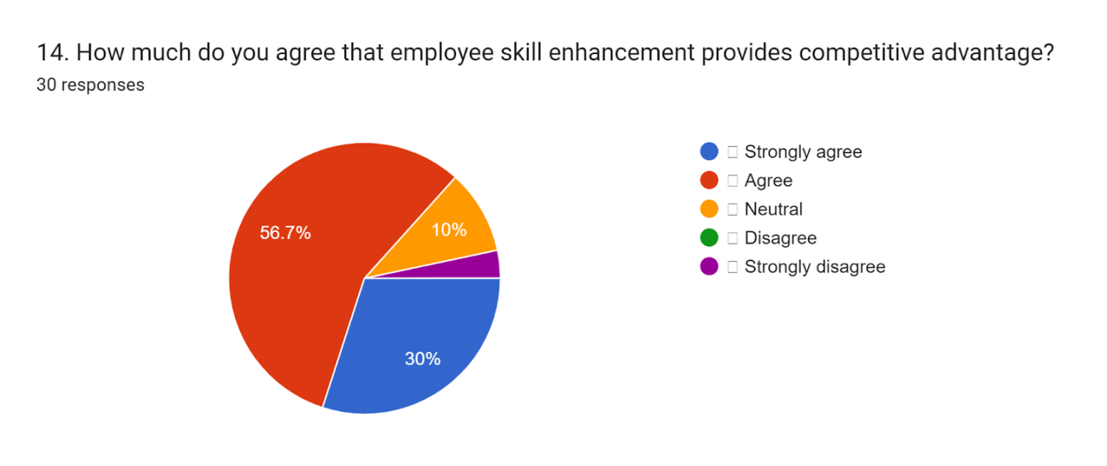

Figure 4.14: Response of sample group on skill enhancement of employees in providing the competitive advantage of companies
(Source: Google form)
56.7% of the selected sample population have agreed that skill enhancement of the workforce can play a vital role in the competitive advantage of companies. In addition, 30% of the survey respondents strongly agreed with this case whereas 10% of them stated their neutral opinion. It has been analysed that developmental programs can have a huge positive impact on the competitive advantages of firms. As commented by Mihardjoet al. (2020), mitigation of emerging challenges can be effectively done by firms by focusing on the enhancement of the skills of the engaged workforce. Along with these, the achievement of sustainable competitive advantage by the companies can be marked as the positive impact of skill enhancement of employees. Moreover, a higher rate of workforce retention can be achieved by companies by enhancing the skills of the organisational employees which is one of the main pillars of the competitive advantage of companies. At the same time, skill enhancement of the workforce can lead to higher promotion opportunities which in turn can lead to higher retention of employees due to a high level of satisfaction.
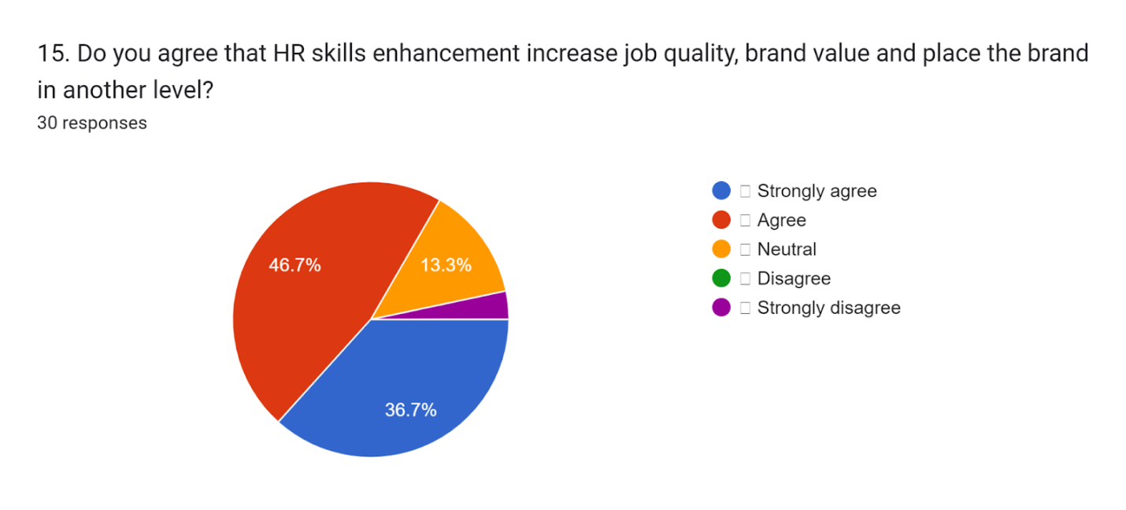

Figure 4.15: Response of the sample group on the role of skill enhancement in increasing job quality and brand value
(Source: Google form)
46.7% of the total survey respondents have agreed that enhancement of workforce skills can lead to an improvement in the brand value of companies and 36.7% of the respondents have strongly agreed in this case. 13.3% of the total sample population have stated their neutral opinion in this case. Consistent delivery of accurate performance can be considered one of the main positive impacts of skill enhancement on the organisational workforce. As mentioned by Niatiet al. (2021), conveying reliable messages from companies to clients can be done by organisations by enhancing employee skills with high importance. Along with these, reality checks by the workforce can be the other positive impact of enhancement of employee skills in companies and this can have an important role in improving brand value in business. Application of creative ideas in execution can be done by the organisational workforce by providing training for them and this, in turn, can play a crucial role in improving the brand value of companies.

4.3 Analysis
Theme 1:Training is one of the most important factors of HRM practices which has played a vital role in skill enhancement of the workforce
It has been found that a reduction in workforce turnover is one of the main positive impacts of skill development of the workforce through training. As per the view of Dash et al. (2019), a reduction in layoff can be marked as one of the main positive factors which can be attained by the firms by training the workforce. Training the workforce can lead to a reduction of complexities in the execution of the engaged employees and this in turn can lead to an increase in the overall productivity of firms. In addition, training the workers can allow profit-earning organisations to enable their workforce to consider the business priorities in an effective manner. At the same time, training the employees can allow the firms to increase morale among them which can be marked as the other positive impact in this case. Additionally, the maintenance of skills inventories by companies has resulted in a higher rate of organisational profitability. As demonstrated by Johnson et al. (2020), training the organisational employees can lead to an increased engagement of the workforce which can be marked as one of its main advantages of it. An increased engagement of organisational employees is one of the main pillars of increasing firms' productivity.
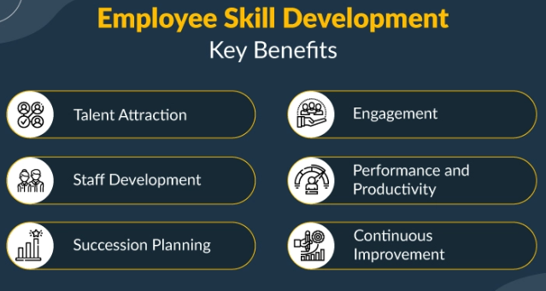

Figure 4.16: Key benefits of skill development of the workforce
(Source: Learner)
On the other hand, the perception of citizens of the countries can be improved by the firms to a great extent by providing training to the workers. As illustrated by Manzoor et al. (2019), the understanding of the employees regarding technical tools can be improved to a great extent by providing training to them. Along with these, it has been analysed that improvement in the technical efficiency of the workforce can result in increased output for the companies. Moreover, the time management of the organisational workforce can be improved to a great extent by providing training to them. It has been found that efficient time management by the workforce can lead to an increase in the output of the companies which in turn can lead to an increase in the profitability rate of companies. Training the workforce regarding time management can streamline the production process which is the other vital factor for increasing profitability rate. As demonstrated by Mihardjoet al. (2020), the functionality of the project teams can be improved to a great extent by focusing on training the workforce companies. Training the workforce can allow companies to carry out vital operations in a cohesive manner.
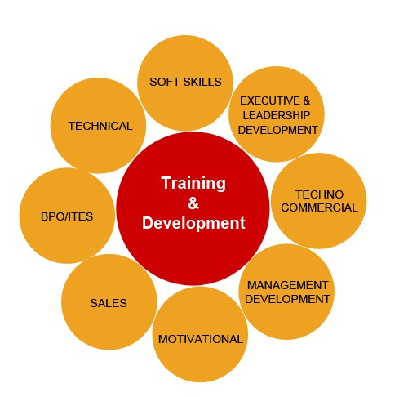

Figure 4.17: Vital factors of skill development of the workforce
(Source: Learner)
Identification of the skill gaps can be effectively done by workers by providing training to them. As per the view of Mohiuddin et al. (2022), the communication skills of the workers can be improved to a great extent by providing training to the companies. On the other hand, training the workforce of companies can show a high level of effectiveness in conflict management which can be marked as one of the main pillars of increased organisational productivity. Training the workforce can be marked as one of the most effective ways to maintain equity with diversity among the organisational workforce and this in turn can allow the firms to motivate the workforce in an effective manner. It has been analysed that training the workforce can lead to increased trust among the workforce and this in turn can lead to an improvement in collaboration in the companies. As demonstrated by Anwar and Abdullah (2021), conflicts among the organisational workforce can be resolved in an effective manner by companies by training the workforce. It has been observed that training workers can lead to an increase in the competitive advantage of firms.
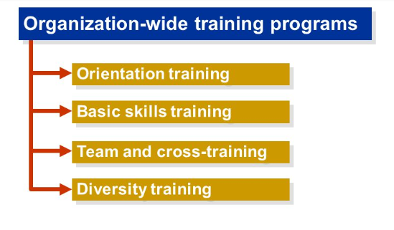

Figure 4.18: Types of training and skill development of employees
(Source: Learner)
Rapid changes in the business environment can be adopted by workers by providing training to their firms. As suggested by Karim et al. (2019), training can enable the employees engaged in production to identify the main demands of the valuable consumers which in turn can lead to an increase in productivity. In addition, strategies adopted by competitors can be analysed by the organisational workforce by providing training to them. Along with these, ongoing consumption trends can be identified by the organisational workers in an effective manner by training them. Effective generation of talent pipelines can be marked as one of the key advantages of training the workforce that the companies can derive. Succession planning of firms can be carried out with a high level of accuracy by training the workforce firms. As opined by Sheeba and Christopher (2020), the enhancement of organisational management is one of the main positive impacts of training the workforce.
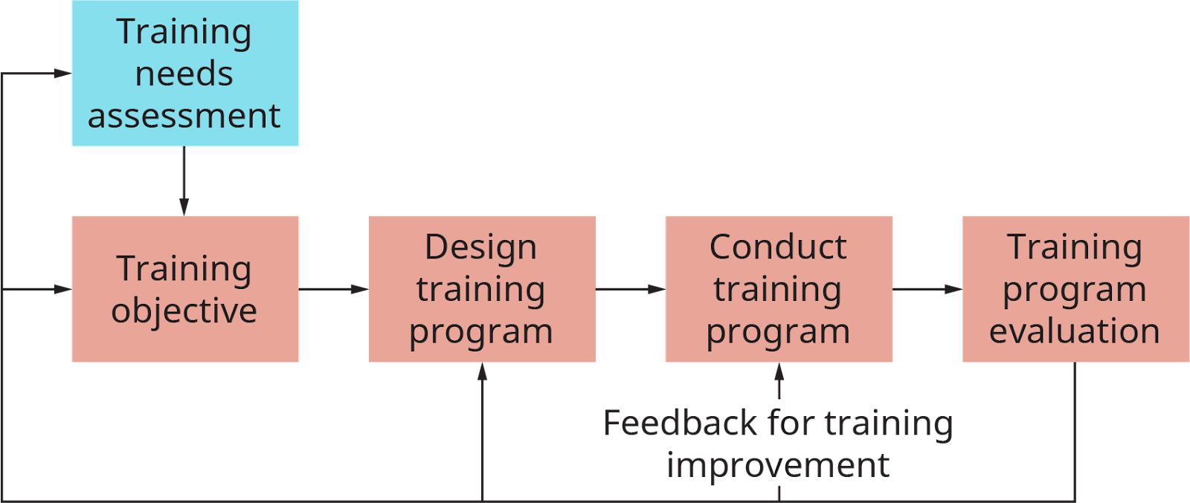

Figure 4.19: Major steps of training and skill development of employees
(Source: Learner)
Theme 2: The productivity level of the workforce along with the organisational performance of companies can be improved by adopting effective HRM policies
Training can be considered one of the most vital factors to increase institutional knowledge among engaged workers. As depicted by Anwar and Abdullah (2021), a reduction in the cost of operation can be marked as the major benefit of adopting effective HRM policies in companies. Companies can increase job security among the engaged workforce by providing training to them which in turn can lead to an increase in productivity. A development program is one of the most crucial parts of effective HRM policies of companies which can have a huge positive impact on reducing human errors in production. It has been identified that the usage of advanced tools such as the application of robotics along with automation is a vital part of production in this present era. Effective HRM policies of companies can allow the workforce to increase their understanding of handling these tools. As commented by Signoretti and Sacchetti (2020), sustainability maintenance can be considered a vital part of the trade execution of companies in the present era. Effective policies of HRM can enable the organisational workforce of companies to maintain sustainability in production in an effective manner and this in turn can lead to a significant improvement in the reputations of firms.
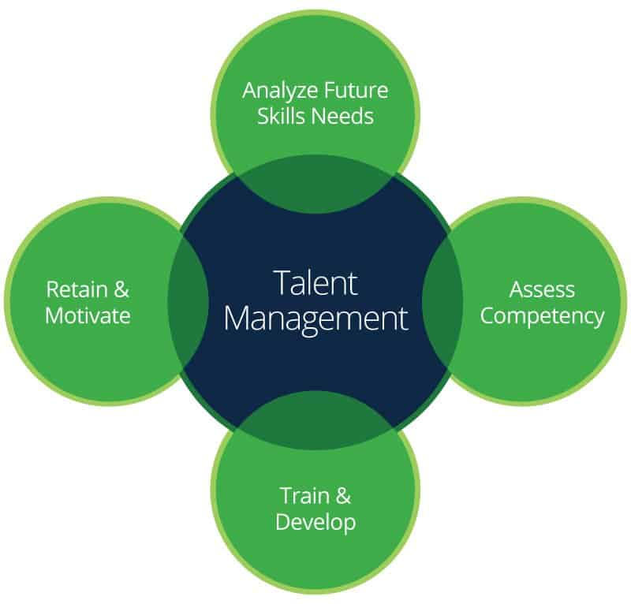

Figure 4.20: Crucial components of talent management of firms
(Source: Learner)
Personalisation of strategies can be carried out by companies by adopting effective policies of HRM. As stated by Budhwaret al. (2022), an increase in the satisfaction level of engaged employees can be marked as the positive impact of adopting effective HRM policies. It has been observed that customer services of companies can play a vital role in satisfying the requirements of consumers and in this case adoption of proper HRM policies can result in an improvement in customer retention rate. Safety in the work sites of companies can be maintained in an efficient manner by focusing on the improvement of HRM policies.
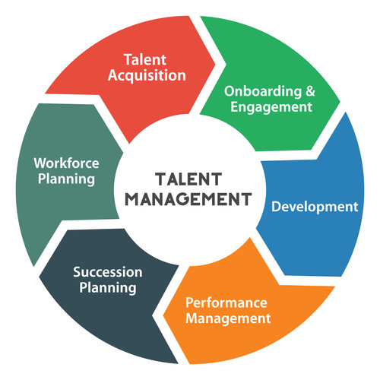

Figure 4.21: Processes of talent management of companies
(Source: Learner)
The adoption of effective HRM policies by companies plays a crucial role in maintaining work ethics in the execution of firms. In addition, it has been found that instructor-led training in the workforce can be highly effective in increasing the productivity of workers. Along with this, technology-based virtual training for employees can be marked as an important process of training. The level of comfort of the engaged workforce can be increased by adopting and focusing on the improvement of HRM policies of firms. As opined by Margherita and Bua (2021), a high comfort level of workers can result in a high level of productivity which is one of the key determinants of the profitability rate of firms. In addition, the balance between the personal lives of workers and professional life can be improved by focusing on effective policies of HRM. The career ladder in companies can be made clearer for employees by adopting effective HRM strategies. On the other hand, a clear understanding of the career ladder in companies can lead to higher retention of existing talents. Moreover, work options can be made highly flexible by adopting effective HRM strategies which is one of the key elements of increasing organisational productivity.
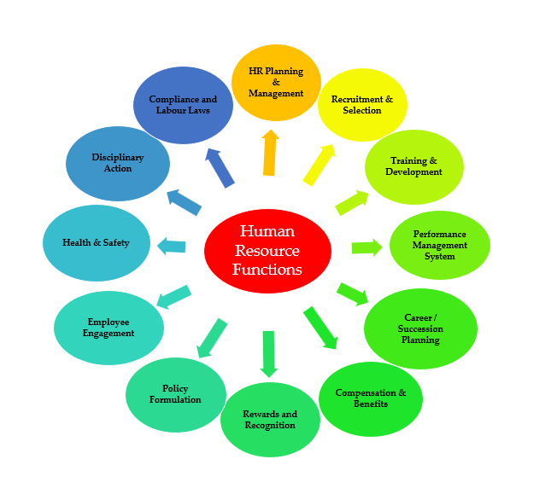

Figure 4.22: Vital factors of HRM in companies
(Source: Learner)
Surveys among the engaged workforce can be effective in the identification of demands and requirements of them. As demonstrated by Adekoya et al. (2019), reduction in environmental stress can be marked as one of the main positive impacts of improving work flexibility which can be achieved by adopting effective HRM strategies in firms. In addition, a reduction in environmental stress can allow the workforce to concentrate more on the given tasks of projects. Communication with the employees engaged in remote work can be considered one of the vital parts of reducing human errors in projects which can be achieved by adopting effective HRM policies. In this case, the assessment program of the workforce is one of the most effective ways to identify the skill gaps of workers. Along with these, navigation of transition must be given a high level of importance by the HR managers engaged in companies. As commented by Lu et al. (2022), the usage of the tools of artificial intelligence can show a high level of effectiveness in improving the overall organisational performance of firms. At the same time, the prevention of usage of the outdated tools can have a positive impact on the productivity levels of firms which can be marked as one of the most effective strategies for HRM.
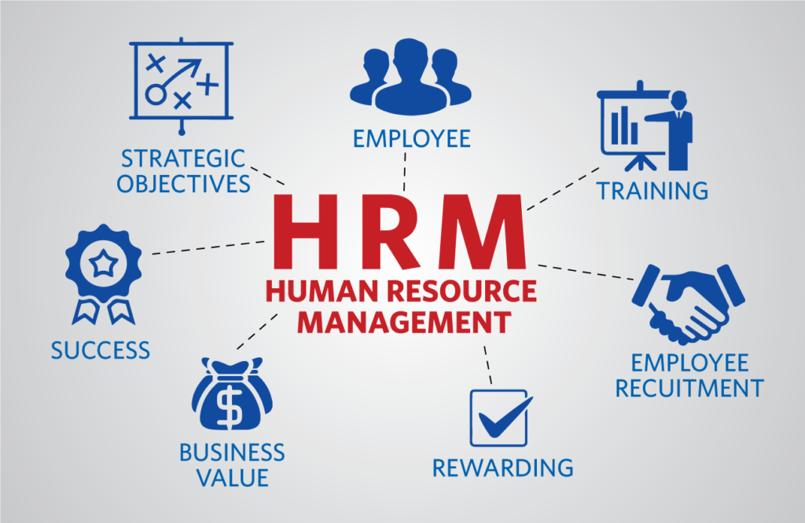

Figure 4.23: Most important components of HRM in companies
(Source: Learner)
It has been identified that budget constraints of companies and projects can be one of the main obstacles to the implementation of effective HRM strategies which can have a negative impact on the overall financial performance of companies. As suggested by Dastmalchianet al. (2020), the upgradation of software tools used in HRM needs to be given a high priority by companies in execution which can allow the managers to effectively evaluate the overall performance of individual workers. The collection of resources for the skilling of the workforce is the other vital component of the implementation of HRM strategies which must be carried out with a high level of importance. In addition, online courses for upskilling the organisational workforce are one of the other effective strategies of HRM that companies need to be taken into account with high importance. Firms must emphasise supporting the workforce for their creative decisions in execution and this can be the other effective strategy for the management of human resources. As stated by Al-Qudahet al. (2020), encouragement of innovative decisions in the workforce can lead to a significant increase in the overall productivity of companies. In addition, companies can reduce the cost of production by allowing employees to take innovative decisions in execution.
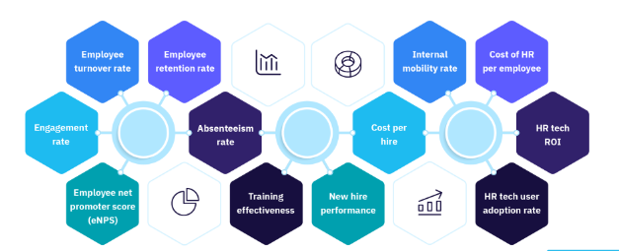

Figure 4.24: Indicators of effectiveness of HRM in companies
(Source: Learner)
The importance of creative decision-making in the workforce is high in increasing the volume of sales in companies. As mentioned by Amrutha and Geetha (2021), incentives for workers based on their creative performance can lead to an increase in the revenue-earning of companies. It has been found that the incorporation of organisational guidelines plays a vital role in maximising the organisational profit of companies. At the same time, the incorporation of organisational rules must be given a high level of priority by firms in the HRM policies. Moreover, effective designing of the policies of HRM can show a high level of effectiveness in completing the most important tasks within the determined deadlines. In this case, it is suggested to the firms focus on providing severance advantages to engaged organisational employees as a part of the improvement in organisational performance. As illustrated by Talib et al. (2020), career transition services by the management of human resources can lead to an increase in the satisfaction rate of engaged workers. Along with these, the structuring of the workforce must be carried out by the HRM of firms with high accuracy.
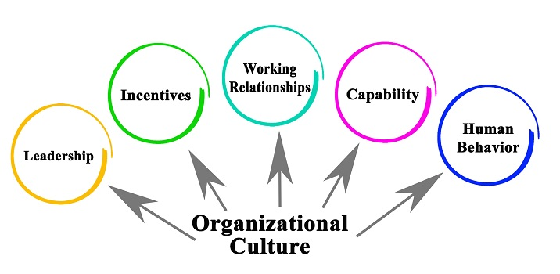

Figure 4.25: Key determinants of organisational culture in companies
(Source: Learner)
Theme 3: Effective designing of the HRM policies can allow the firms to retain existing workers in an effective manner
Onboarding along with orientation can be marked as a vital part of HRM policies which can allow the firms to retain the existing workforce in an effective manner. As mentioned by Malik et al. (2022), companies must focus on explaining the organisational culture to the new workers as a part of the management of organisational human resources. In addition, support to the workforce through training can show a high level of effectiveness in the retention of employees. In this case, it is suggested to the firms focus on onboarding checklists with a high level of importance. Along with these, mentorship programs can allow firms to retain their most valuable and skilled talents in an effective manner. As per the view of Rana and Sharma (2019), mentorship programs need to be given high importance in the case of remote working as a part of the retention of the workforce. Moreover, the firms must be focused on sharing knowledge with the new workers by the existing experienced workforce, and maintenance of these factors of HRM can lead to higher efficiency in retaining the best workers in execution. On the other hand, limits to mentorship opportunities can have an adverse impact on the performance of the companies in retaining the valuable workforce.
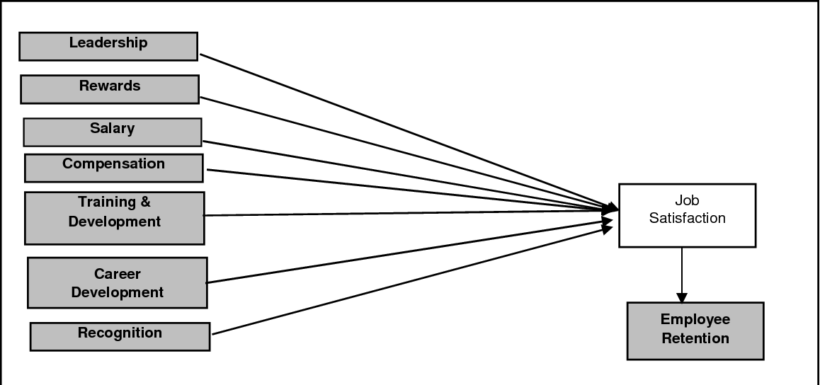

Figure 4.26: Key determinants of employee retention in companies
(Source: Learner)
Workforce compensation is the other factor that can allow companies to effectively retain the existing workforce in HRM. As demonstrated by Tang (2020), competitive compensation to the organisational workforce can motivate the organisational employees to a great extent which is one of the key factors to increase overall productivity. In addition, the benefits of healthcare can be marked as the other effective way by which the workforce of companies can be retained in an efficient manner by the managers of human resources. Along with these, perks to the organisational employees can allow companies to increase employee morale and retention of the workforce can be effectively done by companies by following this strategy. As mentioned by Abdeldayem and Aldulaimi (2020), the flexibility of work schedules is one of the important elements which must be given a high priority by the managers of human resources in retention of the existing employees. In addition, wellness offerings by firms to the workforce can have a significant positive impact on increasing the retention rate of workers.
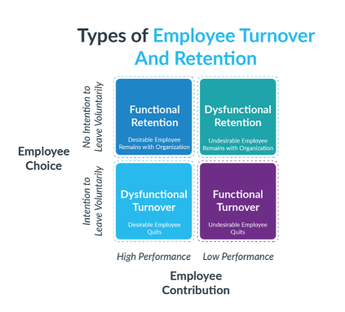

Figure 4.27: Types of workforce turnover and employee retention
(Source: Learner)
Conditions of mental health of the workforce must be given a high priority by the companies as a part of retention of the organisational workforce. As depicted by Collins et al. (2022), prioritisation of the well-being of organisational employees can have a positive impact on workforce retention in HRM. Along with these, programs for the management of workforce stress can allow companies to effectively retain the best employees. Retirement planning services are the other factor that must be given a high priority by companies in HRM and effective maintenance of this factor can lead to an increase in the workforce retention rate. It has been found that a huge segment of reputed global companies has introduced fitness classes for the physical well-being of employees which has made a significant positive impact on the retention of workers. As mentioned by Atkinson et al. (2022), workplace communication must be highly improved by companies in order to identify the factors of dissatisfaction among employees. In this case, issues and difficulties faced by employees must be resolved at a fast pace as a part of workforce retention. Moreover, proactive connection with the engaged workforce can have a huge positive impact on employee retention of companies.
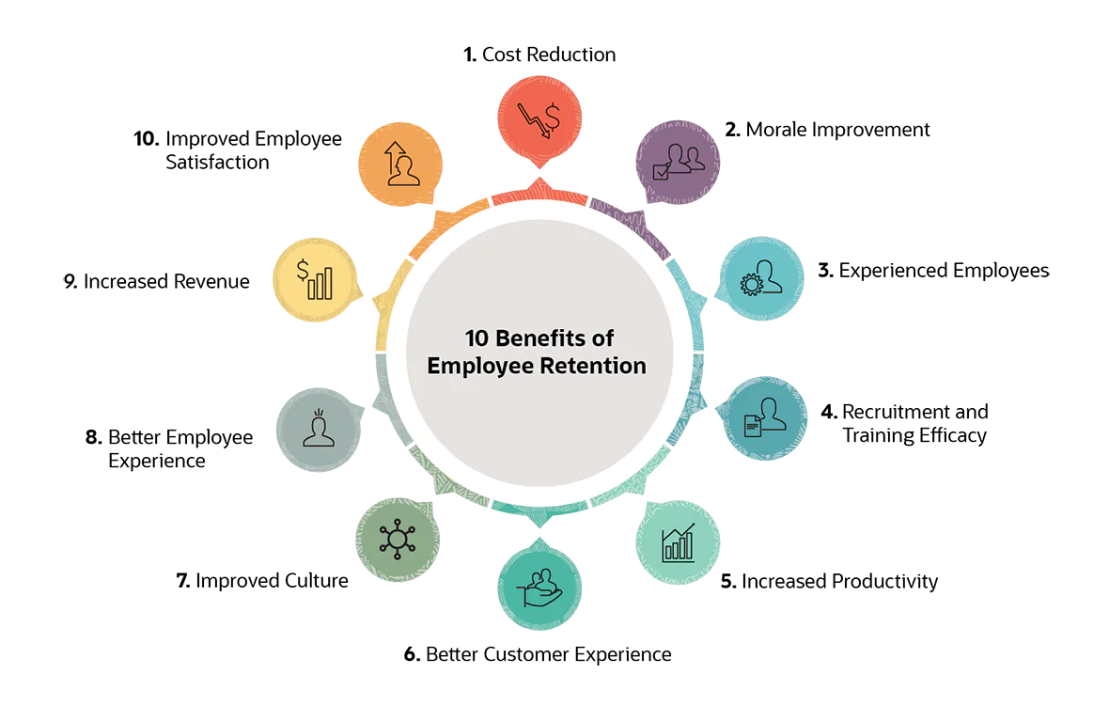

Figure 4.28: Major benefits of employee retention in companies
(Source: Learner)
In order to improve the sense of employees' workload, frequent and transparent communication with employees can play a crucial role. As commented by Mukhutyet al. (2022), feedback to engaged employees can be marked as one of the most vital factors which can play a vital role in motivating employees. On the other hand, feedback can be seen as one of the most effective processes for self-evaluation of the workers and this in turn can result in higher productivity of companies. At the same time, organisational objectives for the long term must be made clear to the workforce as a part of employee retention. In addition, potential scenarios for career advancement are another vital element that needs to be taken into consideration by firms in HRM. As per the view of Sheikh et al. (2019), the creation of a realistic plan for organisational goal achievement can allow firms to retain their best talents in an easier manner. Improvement in workforce competencies by upskilling can have a positive impact on the process of employee retention at firms. Prioritisation of organisational investment for the betterment and professional development of organisational employees can lead to the efficiency of the companies in retaining workers.
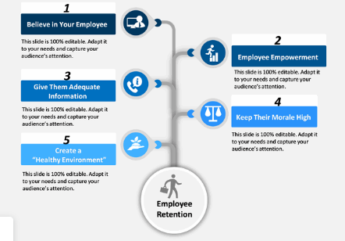

Figure 4.29: Most effective strategies for retention of organisational workforce
(Source: Learner)
Organisational leadership is one of the most vital factors which can have a huge influence on employee retention in firms. As illustrated by Akther and Tariq (2020), an autocratic type of organisational leadership can have an adverse impact on the performance of firms in retaining employees. In addition, the presence of the systems of formal rewards on the overall productivity and efficiency of workers is an important component of HRM that can influence employee retention in companies to a great extent. The democratic style of organisational leadership takes into account the opinions of the engaged workforce of companies which can lead to the effectiveness of the firms in employee retention. Moreover, vacation time of the workforce needs to be given high importance by HRM of companies and this can show a high effectiveness of companies in retaining the best talents.

4.4 Summary
From the discussion of findings and analysis chapter of this research, it has been found that training the organisational workforce can play a vital role in increasing the organisational productivity of companies which in turn can lead to a higher rate of profitability in business. Along with these, the efficiency of the employees can be a vital determinant of the satisfaction level of valuable consumers of companies. In addition, the satisfaction level of the workforce can be increased to a great extent by taking into consideration their individual opinions of them in the decision-making process. Incentives to the organisational workforce can lead to motivation to them and this in turn can ensure a higher effort by the employees.

CHAPTER 5: CONCLUSION AND RECOMMENDATION

5.1 Introduction
The conclusion and recommendation chapter of this research describe the key findings on the role of management of human resources in firms in the skill development of employees and increase of organisational productivity. Along with this linking with the main research objectives has been done in this chapter along with the major limitations of this study. Moreover, the future scope of research on this topic along with effective recommendations for the improvement of HRM operations for firms has been discussed in this chapter.

5.2 Conclusion
From the main analysis of this research it can be concluded that in the analysis and designing of jobs, the teams of management of human resources play a vital role in the profit earning organisations. Along with these, the main responsibilities of jobs can be conveyed by the HR executives to the engaged workers of companies. It has been found that the most suitable workers are selected by the HR executives of companies in the projects and this can be marked as one of the most important responsibilities of HRM. In order to motivate the organisational employees, diverse opinions of them need to be considered with a high level of importance by the decision-makers. On the other hand, the high importance of the personal income of employees can lead to an increase in the overall productivity of firms. Additionally, high importance to the major requirements of the organisational employees can lead to an empowerment of the workforce which in turn can result in an improvement in organisational reputation in competitive market scenarios. In the development of the essential skills required in production, the executives engaged in HRM play a vital role in firms.
It has been summarised that the identification of personality traits can be one of the most vital functions of the executives engaged in the HRM of the firms. Moreover, HR managers can effectively convey the factors of key interests of the organisational stakeholders to the employees involved in operations and this can be considered one of the key success factors in increasing the productivity of companies. Along with these, HR managers of companies play a vital role in conveying the major administrative duties to the workforce. It has been summarised that a high focus of firms on providing incentives to employees can motivate them to a great extent and this in turn can lead to an increased effort and engagement of the workforce in operations. The infrastructure of technical factors of companies is one of the main factors in which HRM plays a vital role in maintenance. At the same time, an improvement in HRM infrastructure can have a positive impact on workforce performance in profit-earning organisations. In the development of professional skills of engaged employees, educational background is an element that needs to be taken into account by HRM with high importance.
Psychological elements of the engaged employees can be considered as the other crucial factor which must be considered with a high priority by the HR managers. It has been found that internal organisational conflicts must be eliminated by HR managers as a part of increasing productivity. Moreover, in the improvement of project coordination, the effective resolution of internal organisational conflicts can play a crucial role. Company-specific data is the other important factor that needs to be shared with the employees by the managers engaged in HRM. Along with these, executives engaged in HRM can play an important role in the identification of the main challenges faced by the organisational workforce. At the same time, HR executives play an important role in suggesting remedies to employees facing challenges in operations. Moreover, the inefficiency of employees in operating advanced technical tools can be marked as the obstacles faced by a huge segment of companies which can be resolved by introducing training programs. In addition, diversity is the other important element that needs to be maintained by the HR managers in the companies, and maintenance of this element can lead to an improvement in the company's reputation.
Maintenance of government regulations has been identified as one of the main issues faced by the executives engaged in HRM of firms. It has been identified that the presence of linguistic diversity among the organisational employees can lead to an increased challenge in the management of human resources in profit-earning firms. Moreover, a sudden change in the leading authority of companies can have a negative impact on the management process of organisational human resources in companies. Additionally, the merger of companies can lead to an increase in challenges in the management process of human resources in firms. The sudden introduction of advanced technical tools can increase challenges in the HRM process in profit-earning companies and in this case, workshops and programs for skill development can have a positive impact on the performance of firms. Disrespect for cultural factors needs to be prevented by the managers engaged in HRM in companies and following this strategy companies can increase the employee retention rate to a great extent.
It has been identified in a lot of cases, the executives engaged in HRM have faced challenges in the communication process with the organisational workforce and the introduction of training programs can show a high level of effectiveness in this case. The engagement score of the workers can be considered an important factor that must be given a high priority in the operations of HRM. It can be summarised that personal bias can be one of the negative factors which can prevent managers of HRM from effectively functioning. A critical review of the performance of individual workers can play a vital role in the identification of the inefficiency and skill-shortage of the workforce. At the same time, the safety of the worksites must be given a high level of priority by the HR managers and this can have a huge impact on employee satisfaction of companies. Enforcement of compliance with employment regulations can be marked as one of the most vital responsibilities of HR managers.

5.3 Linking with research objectives
Objective 1
Discussions of the literature review and findings and analysis chapters have reflected that management of human resources plays a vital role in the promotion of work efficiency of the engaged employees of companies. As depicted by Hamid et al. (2022), maximisation of the capabilities of employees can be considered one of the most important objectives of HRM. In addition, consistent training for the employees can have a huge positive impact on the individual output level of the engaged workforce. Routine feedback has been identified as a vital part of the management system of individual performance. Identification of the personal weak points of the workforce can be effectively carried out by the HR managers which is one of the key factors of productivity increase. The positivity of workplaces can have a huge influence on the individual productivity level of the engaged workforce. Compensation packages to the organisational employees can lead to effective motivation for them and this, in turn, can increase the overall productivity of the companies. Thus, from the discussions of the literature review and findings and analysis, it can be summarised that objective 1 of the research has been achieved.
Objective 2
Analysis of the literature review and findings and analysis chapters have indicated that organisational leaders of companies can have a huge influence on the process of management of human resources in firms. As illustrated by Kim and Kim (2021), the active engagement of the employees can lead to a betterment of the quality of goods and services produced by firms. In addition, it has been identified that continuous improvement culture can allow the workforce engaged in operations to enhance their professional skills. At the same time, streamlining sourcing can be marked as one of the most crucial factors which can have a significant role in carrying out the operations of HRM with high accuracy. Thus, from the discussions of the literature review and findings and analysis, it can be summarised that objective 2 of the research has been achieved.
Objective 3
Discussion of the literature review chapter and findings and analysis section of this research has shown that retention of an engaged workforce is one of the most important priorities of companies in HRM. As suggested by Amjad et al. (2021), competitive compensation for organisational employees can lead to the efficiency of companies in retaining them. At the same time, retirement benefits are another factor that must be provided to the workforce as a part of workforce retention. In addition, work arrangements need to be made flexible as it can allow the firms to retain top-performing employees. High support for engaged employees can have a huge positive impact on retaining their firms. Engagement of the top-performing talents in meaningful tasks can lead to the higher efficiency of companies in retaining the workforce. Thus, from the discussions of the literature review and findings and analysis, it can be summarised that objective 3 of the research has been achieved.

5.4 Research limitation
The research could have collected more numerical data from the websites of the reputed companies regarding their HRM process and the lack of numerical information has been identified as one of the main limitations of this study. The research could have included challenges faced by specific companies in the management of human resources. The research could have discussed the applications of the tools of artificial intelligence and automation techniques in a detailed manner. Consideration of emerging trends in the international market would have enriched the contents of this research. Moreover, the lack of discussion on legal factors related to HRM can be marked as one of the other limitations of this research.

5.5 Future scope of the study
In future research on this topic, the more numerical information on the performance of companies on HRM can be included. Moreover, future studies can explore the relationship between leadership traits and the retention rate of the workforce in firms. Along with these, future research can emphasise the regulatory frameworks of nations which can be useful for companies in the management of organisational human resources. Key reasons for dissatisfaction among the organisational workforce can be discussed in future research. The relationship between HRM and stakeholder management of companies is the other factor that can be described in future research in a detailed manner.

5.6 Recommendation
Improvement in communication
An improvement in internal organisational communication can be marked as one of the most crucial factors which must be taken into account by profit-earning organisations as a part of the improvement in HRM. As depicted by Prayogiet al. (2019), communication with employees can enable companies to engage skilled workers in tasks that are suitable for them. Effective communication with employees can be the key determinant of keeping a working environment highly pleasant.
A high focus on internal organisational culture
Equality must be maintained by the HR executives of the company in providing benefits and incentives to the workforce. As suggested by Cooke et al. (2019), the prevention of diversity on the basis of gender can be marked as one of the core responsibilities of HRM in companies. Transparency is the other crucial element in this case, which needs to be maintained by the HR managers with high importance. The importance of collaboration in teamwork can lead to an improvement in the organisational culture of firms. At the same time, employee recognition must be made frequent as a part of the improvement in organisational culture. In addition, scheduling of work is the other factor of HRM that must be carried out with high importance by firms as a part of the improvement in organisational culture.
Adoption of advanced technical tools in the management of human resources
Technical tools such as the applications of artificial intelligence and automation can allow firms to analyse employee data in an effective manner. As demonstrated by Stepanova et al. (2021), resume screening can be done in an efficient manner by AI tools in the selection process of companies. Moreover, in conveying the administrative duties of the engaged organisational workforce, automation tools can show high effectiveness in the HRM of companies. Along with these, performance evaluation of workers can be efficiently carried out in HRM by using automation tools.

References
Abdeldayem, M.M. and Aldulaimi, S.H., 2020. Trends and opportunities of artificial intelligence in human resource management: Aspirations for public sector in Bahrain. International Journal of Scientific and Technology Research, 9(1), pp.3867-3871.
Adekoya, O.D., Jimoh, I., Okorie, G. and Olajide, M., 2019. Significance of employee engagement and individual well-being on organisational performance in Nigeria. International Journal of Science and Management Studies, 2(5), pp.35-47.
Aguinis, H. and Burgi-Tian, J., 2021. Talent management challenges during COVID-19 and beyond: Performance management to the rescue. BRQ Business Research Quarterly, 24(3), pp.233-240.
Akther, S. and Tariq, J., 2020. The impact of effective training on employee retention: A study in private banks of Bangladesh. Journal of Economics and Business, 3(1).
Al Doghan, M.A., Bhatti, M.A. and Juhari, A.S., 2019. Do psychological diversity climate, HRM practices, and personality traits (big five) influence multicultural workforce job satisfaction and performance? Current scenario, literature gap, and future research directions. Sage Open, 9(2), p.2158244019851578.
Al-Ababneh, M.M., 2020. Linking ontology, epistemology and research methodology. Science & Philosophy, 8(1), pp.75-91.
Al-Qudah, S., Obeidat, A.M. and Shrouf, H., 2020. The impact of strategic human resources planning on the organizational performance of public shareholding companies in Jordan. Problems and Perspectives in Management, 18(1), p.219.
Alsubiei, S., Reynolds, K. and Mohammad, A., 2021. THE IMPACT OF EMPLOYEE MOTIVATION ON ORGANISATIONAL OUTPUT–A CASE STUDY ON UNILEVER ARABIA. PalArch's Journal of Archaeology of Egypt/Egyptology, 18(14), pp.731-741.
Amjad, F., Abbas, W., Zia-UR-Rehman, M., Baig, S.A., Hashim, M., Khan, A. and Rehman, H.U., 2021. Effect of green human resource management practices on organizational sustainability: the mediating role of environmental and employee performance. Environmental Science and Pollution Research, 28, pp.28191-28206.
Amrutha, V.N. and Geetha, S.N., 2020. A systematic review on green human resource management: Implications for social sustainability. Journal of Cleaner Production, 247, p.119131.
Amrutha, V.N. and Geetha, S.N., 2021. Linking organizational green training and voluntary workplace green behavior: Mediating role of green supporting climate and employees’ green satisfaction. Journal of Cleaner Production, 290, p.125876.
Anwar, G. and Abdullah, N.N., 2021. The impact of Human resource management practice on Organizational performance. International journal of Engineering, Business and Management (IJEBM), 5.
Anwar, G. and Abdullah, N.N., 2021. The impact of Human resource management practice on Organizational performance. International journal of Engineering, Business and Management (IJEBM), 5.
Arslan, A., Cooper, C., Khan, Z., Golgeci, I. and Ali, I., 2022. Artificial intelligence and human workers interaction at team level: a conceptual assessment of the challenges and potential HRM strategies. International Journal of Manpower, 43(1), pp.75-88.
Atkinson, C., Lupton, B., Kynighou, A. and Antcliff, V., 2022. Small firms, owner managers and (strategic?) human resource management. Human Resource Management Journal, 32(2), pp.449-469.
Azizi, M.R., Atlasi, R., Ziapour, A., Abbas, J. and Naemi, R., 2021. Innovative human resource management strategies during the COVID-19 pandemic: A systematic narrative review approach. Heliyon, 7(6), p.e07233.
Babii, A., 2020. Important aspects of the experimental research methodology. ВісникТернопільськогонаціональноготехнічногоуніверситету, 97(1), pp.77-87.
Bairagi, V. and Munot, M.V. eds., 2019. Research methodology: A practical and scientific approach. CRC Press.
Black, M.H., Mahdi, S., Milbourn, B., Thompson, C., D'Angelo, A., Ström, E., Falkmer, M., Falkmer, T., Lerner, M., Halladay, A. and Gerber, A., 2019. Perspectives of key stakeholders on employment of autistic adults across the United States, Australia, and Sweden. Autism Research, 12(11), pp.1648-1662.
Blanco‐Gonzalez, A., Diéz‐Martín, F., Cachón‐Rodríguez, G. and Prado‐Román, C., 2020. Contribution of social responsibility to the work involvement of employees. Corporate Social Responsibility and Environmental Management, 27(6), pp.2588-2598.
Bretos, I., Errasti, A. and Marcuello, C., 2020. Is there life after degeneration? The organizational life cycle of cooperatives under a ‘grow‐or‐die’dichotomy. Annals of Public and Cooperative Economics, 91(3), pp.435-458.
Budhwar, P., Malik, A., De Silva, M.T. and Thevisuthan, P., 2022. Artificial intelligence–challenges and opportunities for international HRM: a review and research agenda. The InTernaTIonal Journal of human resource managemenT, 33(6), pp.1065-1097.
Budhwar, P., Malik, A., De Silva, M.T. and Thevisuthan, P., 2022. Artificial intelligence–challenges and opportunities for international HRM: a review and research agenda. The InTernaTIonal Journal of human resource managemenT, 33(6), pp.1065-1097.
Chanana, N., 2021. Employee engagement practices during COVID‐19 lockdown. Journal of public affairs, 21(4), p.e2508.
Chiedu, C.K., Choi, S.L. and Ashar, H.B., 2022. The relationship among job satisfaction, oreganizational commitment and employees’ turnover at unilever corporation in Nigeria. European Journal of Multidisciplinary Studies, 7(1), pp.62-83.
Choi, J., 2020. The mediating effect of positive psychological capital between autonomous work environment and self-directed behavior: evidence from South Korea. Human Resource Development International, 23(1), pp.46-65.
Collins, F.J., Bagshaw, K.B. and Okpara, E.N., 2022. Training and Employee Effectiveness in GSM Telecommunication Firms in Rivers State. Management Sciences.
Cooke, D.T., Olive, J., Godoy, L., Preventza, O., Mathisen, D.J. and Prager, R.L., 2019. The importance of a diverse specialty: introducing the STS workforce on diversity and inclusion. The Annals of Thoracic Surgery, 108(4), pp.1000-1005.
Cooper, B., Wang, J., Bartram, T. and Cooke, F.L., 2019. Well‐being‐oriented human resource management practices and employee performance in the Chinese banking sector: The role of social climate and resilience. Human Resource Management, 58(1), pp.85-97.
Cuandra, F., Christina, C., Alfinda, F. and Eurico, E., 2022. Analysis of The Implementation of Operational Management at PT Unilever Indonesia Tbk Before, During, and After The Pandemi. American Journal of Current Education and Humanities, 1(2), pp.64-74.
Dash, D., Farooq, R., Panda, J.S. and Sandhyavani, K.V., 2019. Internet of Things (IoT): The New Paradigm of HRM and Skill Development in the Fourth Industrial Revolution (Industry 4.0). IUP Journal of Information Technology, 15(4).
Dastmalchian, A., Bacon, N., McNeil, N., Steinke, C., Blyton, P., Satish Kumar, M., Bayraktar, S., Auer-Rizzi, W., Bodla, A.A., Cotton, R. and Craig, T., 2020. High-performance work systems and organizational performance across societal cultures. Journal of International Business Studies, 51, pp.353-388.
Elrehail, H., Harazneh, I., Abuhjeeleh, M., Alzghoul, A., Alnajdawi, S. and Ibrahim, H.M.H., 2019. Employee satisfaction, human resource management practices and competitive advantage: The case of Northern Cyprus. European Journal of Management and Business Economics, 29(2), pp.125-149.
Fenech, R., Baguant, P. and Ivanov, D., 2019. The changing role of human resource management in an era of digital transformation. Journal of Management Information & Decision Sciences, 22(2).
Fenech, R., Baguant, P. and Ivanov, D., 2019. The changing role of human resource management in an era of digital transformation. Journal of Management Information & Decision Sciences, 22(2).
Ferraris, A., Erhardt, N. and Bresciani, S., 2019. Ambidextrous work in smart city project alliances: unpacking the role of human resource management systems. The International Journal of Human Resource Management, 30(4), pp.680-701.
Gigauri, I., 2020. Challenges HR managers facing due to COVID-19 and overcoming strategies: perspectives from Georgia. Archives of Business Review, 8(11).
Greening, N., 2019. Phenomenological research methodology. Scientific Research Journal, 7(5), pp.88-92.
Halid, H., Yusoff, Y.M. and Somu, H., 2020, May. The relationship between digital human resource management and organizational performance. In First ASEAN Business, Environment, and Technology Symposium (ABEATS 2019) (pp. 96-99). Atlantis Press.
Hamid, Z., Muzamil, M. and Shah, S.A., 2022. Strategic human resource management. In Research Anthology on Human Resource Practices for the Modern Workforce (pp. 1-16). IGI Global.
Huo, W., Li, X., Zheng, M., Liu, Y. and Yan, J., 2020. Commitment to human resource management of the top management team for green creativity. Sustainability, 12(3), p.1008.
Jeni, F.A. and Al-Amin, M., 2021. The impact of training and development on employee performance and productivity: An Empirical Study on Private Bank of Noakhali Region in Bangladesh. South Asian Journal of Social Studies and Economics, 9(2), pp.1-18.
John-Eke, E.C. and Eke, J.K., 2020. Strategic planning and crisis management styles in organizations: A review of related literature. Journal of Strategic Management, 5(1), pp.36-46.
Johnson, K.R., Ennis-Cole, D. and Bonhamgregory, M., 2020. Workplace success strategies for employees with autism spectrum disorder: A new frontier for human resource development. Human Resource Development Review, 19(2), pp.122-151.
Jumady, E. and Lilla, L., 2021. Antecedent and Consequence the Human Resources Management Factors on Civil Servant Performance. Golden Ratio of Human Resource Management, 1(2), pp.104-116.
Karim, M.M., Choudhury, M.M. and Latif, W.B., 2019. The impact of training and development on employees’ performance: an analysis of quantitative data. Noble International Journal of Business and Management Research, 3(2), pp.25-33.
Karim, M.M., Choudhury, M.M. and Latif, W.B., 2019. The impact of training and development on employees’ performance: an analysis of quantitative data. Noble International Journal of Business and Management Research, 3(2), pp.25-33.
Kim, M. and Kim, J., 2021. Corporate social responsibility, employee engagement, well-being and the task performance of frontline employees. Management Decision, 59(8), pp.2040-2056.
Kirchoff, J.F. and Falasca, M., 2022. Environmental differentiation from a supply chain practice view perspective. International Journal of Production Economics, 244, p.108365.
Koushede, V., Lasgaard, M., Hinrichsen, C., Meilstrup, C., Nielsen, L., Rayce, S.B., Torres-Sahli, M., Gudmundsdottir, D.G., Stewart-Brown, S. and Santini, Z.I., 2019. Measuring mental well-being in Denmark: Validation of the original and short version of the Warwick-Edinburgh mental well-being scale (WEMWBS and SWEMWBS) and cross-cultural comparison across four European settings. Psychiatry research, 271, pp.502-509.
Lee, E.S. and Szkudlarek, B., 2021. Refugee employment support: The HRM–CSR nexus and stakeholder co‐dependency. Human Resource Management Journal, 31(4), pp.936-955.
Liboni, L.B., Cezarino, L.O., Jabbour, C.J.C., Oliveira, B.G. and Stefanelli, N.O., 2019. Smart industry and the pathways to HRM 4.0: implications for SCM. Supply Chain Management: An International Journal.
Lu, Y., Zhang, M.M., Yang, M.M. and Wang, Y., 2022. Sustainable human resource management practices, employee resilience, and employee outcomes: Toward common good values. Human Resource Management.
Mahajan, V., 2020. Exploring talent management strategies adopted by organizations. Journal of Exclusive Management Science, 9(9), pp.1-11.
Malik, A., Budhwar, P., Patel, C. and Srikanth, N.R., 2022. May the bots be with you! Delivering HR cost-effectiveness and individualised employee experiences in an MNE. The International Journal of Human Resource Management, 33(6), pp.1148-1178.
Manzoor, F., Wei, L., Bányai, T., Nurunnabi, M. and Subhan, Q.A., 2019. An examination of sustainable HRM practices on job performance: An application of training as a moderator. Sustainability, 11(8), p.2263.
Margherita, E.G. and Bua, I., 2021. The role of human resource practices for the development of Operator 4.0 in Industry 4.0 organisations: a literature review and a research agenda. Businesses, 1(1), pp.18-33.
Masud, M.A.K., Rashid, M.H.U., Khan, T., Bae, S.M. and Kim, J.D., 2019. Organizational strategy and corporate social responsibility: The mediating effect of triple bottom line. International journal of environmental research and public health, 16(22), p.4559.
Mihardjo, L.W., Jermsittiparsert, K., Ahmed, U., Chankoson, T. and Iqbal Hussain, H., 2020. Impact of key HR practices (human capital, training and rewards) on service recovery performance with mediating role of employee commitment of the Takaful industry of the Southeast Asian region. Education+ Training, 63(1), pp.1-21.
Mihardjo, L.W., Jermsittiparsert, K., Ahmed, U., Chankoson, T. and Iqbal Hussain, H., 2020. Impact of key HR practices (human capital, training and rewards) on service recovery performance with mediating role of employee commitment of the Takaful industry of the Southeast Asian region. Education+ Training, 63(1), pp.1-21.
Mishra, S.B. and Alok, S., 2022. Handbook of research methodology.
Mohiuddin, M., Hosseini, E., Faradonbeh, S.B. and Sabokro, M., 2022. Achieving human resource management sustainability in universities. International Journal of Environmental Research and Public Health, 19(2), p.928.
Mukherjee, S.P., 2019. A guide to research methodology: An overview of research problems, tasks and methods. CRC Press.
Mukhuty, S., Upadhyay, A. and Rothwell, H., 2022. Strategic sustainable development of Industry 4.0 through the lens of social responsibility: The role of human resource practices. Business Strategy and the Environment, 31(5), pp.2068-2081.
Nahar, S. and Zayed, N.M., 2019. An Analysis of the Impact of Remuneration on Employee Motivation: A Case Study on Unilever, Bangladesh. International Journal of Family Business & Management, 3(2), pp.1-5.
Newman, M. and Gough, D., 2020. Systematic reviews in educational research: Methodology, perspectives and application. Systematic reviews in educational research: Methodology, perspectives and application, pp.3-22.
Niati, D.R., Siregar, Z.M.E. and Prayoga, Y., 2021. The effect of training on work performance and career development: the role of motivation as intervening variable. Budapest International Research and Critics Institute (BIRCI-Journal): Humanities and Social Sciences, 4(2), pp.2385-2393.
Nwachukwu, C. and Vu, H.M., 2020. Strategic flexibility, strategic leadership and business sustainability nexus. International Journal of Business Environment, 11(2), pp.125-143.
Ozkeser, B., 2019. Impact of training on employee motivation in human resources management. Procedia Computer Science, 158, pp.802-810.
Ozkeser, B., 2019. Impact of training on employee motivation in human resources management. Procedia Computer Science, 158, pp.802-810.
Ozkeser, B., 2019. Impact of training on employee motivation in human resources management. Procedia Computer Science, 158, pp.802-810.
Pandey, P. and Pandey, M.M., 2021. Research methodology tools and techniques. Bridge Center.
Parry, E. and Battista, V., 2019. The impact of emerging technologies on work: a review of the evidence and implications for the human resource function. Emerald Open Research, 1(5), p.5.
Patel, M. and Patel, N., 2019. Exploring Research Methodology. International Journal of Research and Review, 6(3), pp.48-55.
Prayogi, M.A., Lesmana, M.T. and Siregar, L.H., 2019, August. The influence of communication and work discipline to employee performance. In First International Conference on Administration Science (ICAS 2019) (pp. 423-426). Atlantis Press.
Primc, K., Kalar, B., Slabe-Erker, R., Dominko, M. and Ogorevc, M., 2020. Circular economy configuration indicators in organizational life cycle theory. Ecological Indicators, 116, p.106532.
Rahdiyanta, D., Nurhadiyanto, D. and Munadi, S., 2019. The Effects of Situational Factors in the Implementation of Work-Based Learning Model on Vocational Education in Indonesia. International Journal of Instruction, 12(3), pp.307-324.
Rana, G. and Sharma, R., 2019. Emerging human resource management practices in Industry 4.0. Strategic HR Review.
Rizvi, Y.S. and Garg, R., 2022. Environmental sustainability performance: a study of the role of green human resource management and other green internal intellectual capital components. International Journal of Business and Systems Research, 16(1), pp.65-105.
Roscoe, S., Eckstein, D., Blome, C. and Goellner, M., 2020. Determining how internal and external process connectivity affect supply chain agility: a life-cycle theory perspective. Production planning & control, 31(1), pp.78-91.
Sadiq, M., Riaz, A., Sajid, M., Shafiq, R. and Pasha, A.T., 2022. IMPACT OF DUAL ORIENTED HR PRACTICES ON EMPLOYEE PERFORMANCE: MEDIATION ROLE OF JOB COMPETENCE AND JOB INSECURITY. PalArch's Journal of Archaeology of Egypt/Egyptology, 19(2), pp.655-675.
Safari, A. and Saleh, A.S., 2020. Key determinants of SMEs’ export performance: a resource-based view and contingency theory approach using potential mediators. Journal of Business & Industrial Marketing, 35(4), pp.635-654.
Säfsten, K. and Gustavsson, M., 2020. Research methodology: for engineers and other problem-solvers.
Saunders, M., Lewis, P.H.I.L.I.P. and Thornhill, A.D.R.I.A.N., 2007. Research methods. Business Students 4th edition Pearson Education Limited, England, 6(3), pp.1-268.
Sheeba, M.J. and Christopher, P.B., 2020. Exploring the role of training and development in creating innovative work behaviors and accomplishing non-routine cognitive jobs for organizational effectiveness. Journal of Critical Reviews, 7(4), pp.263-267.
Sheikh, W.A.H.I.D.U.L., Islam, M.S. and Rahman, F.A.R.H.A.N.A., 2019. Implementing Green Human Resource Management: Cost-Effective Strategies and Tools. Journal of Entrepreneurship Organization Management, 8, p.264.
Sheng, J., Zhou, W. and Zhu, B., 2020. The coordination of stakeholder interests in environmental regulation: Lessons from China’s environmental regulation policies from the perspective of the evolutionary game theory. Journal of Cleaner Production, 249, p.119385.
Shonhadji, N. and Maulidi, A., 2022. Is it suitable for your local governments? A contingency theory-based analysis on the use of internal control in thwarting white-collar crime. Journal of financial crime, 29(2), pp.770-786.
Signoretti, A. and Sacchetti, S., 2020. Lean HRM practices in work integration social enterprises: Moving towards social lean production. Evidence from Italian case studies. Annals of Public and Cooperative Economics, 91(4), pp.545-563.
Singh, D., 2019. A literature review on employee retention with focus on recent trends. International Journal of Scientific Research in Science and Technology, 6(1), pp.425-431.
Sitopu, Y.B., Sitinjak, K.A. and Marpaung, F.K., 2021. The Influence of Motivation, Work Discipline, and Compensation on Employee Performance. Golden Ratio of Human Resource Management, 1(2), pp.72-83.
Stahl, G.K., Brewster, C.J., Collings, D.G. and Hajro, A., 2020. Enhancing the role of human resource management in corporate sustainability and social responsibility: A multi-stakeholder, multidimensional approach to HRM. Human Resource Management Review, 30(3), p.100708.
Stanley, A.O., Ovie, E.A., Ughovero, B.A. and Ijoyah, C.T., 2022. Sustainable Production Strategy and Product Availability: A Study of Unilever Nigeria PLC. LAFIA JOURNAL OF ECONOMICS AND MANAGEMENT SCIENCES, 7, pp.44-65.
Statista, 2022. Engagement score of employees worldwide from 2011 to 2021. Available at: https://www.statista.com/statistics/699977/global-employee-engagement/.[Accessed on: 7th February, 2023]
Statista, 2022. Human resources professionals strategies to accelerate employees' skill development worldwide 2021. Available at: https://www.statista.com/statistics/1235402/hr-professionals-plans-to-accelerate-skill-development/.[Accessed on: 7th February, 2023]
Statista, 2022. Share of organizations worldwide who expect to increase their human resources headcount in 2019, by role and organization size. Available at: https://www.statista.com/statistics/1040411/expected-hr-staffing-changes-worldwide/. [Accessed on: 7th February, 2023]
Stepanova, A., Weaver, A., Lahey, J., Alexander, G. and Hammond, T., 2021. Hiring CS graduates: What we learned from employers. ACM Transactions on Computing Education (TOCE), 22(1), pp.1-20.
Talib, F., Asjad, M., Attri, R., Siddiquee, A.N. and Khan, Z.A., 2020. A road map for the implementation of integrated JIT-lean practices in Indian manufacturing industries using the best-worst method approach. Journal of Industrial and Production Engineering, 37(6), pp.275-291.
Tang, J.J., 2020. Psychological capital and entrepreneurship sustainability. Frontiers in Psychology, 11, p.866.
Thomas, C.G., 2021. Research methodology and scientific writing. Thrissur: Springer.
Thygesen, L.C., Møller, S.P., Ersbøll, A.K., Santini, Z.I., Nielsen, M.B.D., Grønbæk, M.K. and Ekholm, O., 2021. Decreasing mental well-being during the COVID-19 pandemic: A longitudinal study among Danes before and during the pandemic. Journal of psychiatric research, 144, pp.151-157.
Tien, N.H. and Nhi, D.T.Y., 2019. Comparative Analysis of Knowledge Management Software Application at E&Y and Unilever Vietnam. International journal of multidisciplinary research and development, 6(10), pp.22-27.
Tong, S., Jia, N., Luo, X. and Fang, Z., 2021. The Janus face of artificial intelligence feedback: Deployment versus disclosure effects on employee performance. Strategic Management Journal, 42(9), pp.1600-1631.
Toropova, A., Myrberg, E. and Johansson, S., 2021. Teacher job satisfaction: the importance of school working conditions and teacher characteristics. Educational review, 73(1), pp.71-97.
Unilever, 2022. Strategy and goals. Available at: https://www.unilever.com/planet-and-society/future-of-work/strategy-and-goals/. [Accessed on: 7th February, 2023]
Waheed, A. and Yang, J., 2019. Effect of corporate social responsibility disclosure on firms' sales performance: A perspective of stakeholder engagement and theory. Corporate Social Responsibility and Environmental Management, 26(3), pp.559-566.
Zawacki-Richter, O., Kerres, M., Bedenlier, S., Bond, M. and Buntins, K., 2020. Systematic reviews in educational research: Methodology, perspectives and application (p. 161). Springer Nature.

Appendices

Appendix 1: Survey questionnaires
Part A: Demographic questions
1. Your age
- Below 25 years
- 25-35 years
- 35-45 years
- 45-55 years
- Above 55 years
2. Sex
- Male
- Female
3. How long are you working in this company?
- Below 6 months
- 6-12 months
- 1-3 years
- 3-5 years
- More than 5 years
Part B: Objective based questions
1. Do you agree that your company’s HR management is employee supportive?
- Yes
- No
2. Does you HR managers arranged employee skills enhancing program?
- Yes
- No
3. How much do you agree that your company’s HR provide security to your employees?
- Strongly agree
- Agree
- Neutral
- Disagree
- Strongly disagree
4. Does your company provide fair and performance based compensation?
- Yes
- No
5. How much do you agree that your company has flat management system where information can flow easily?
- Strongly agree
- Agree
- Neutral
- Disagree
- Strongly disagree
6. Does your HR track individual progression report?
- Yes
- No
7. Does your HR appreciates high performance and gives reward for those actions?
- Yes
- No
8. How much do you agree that your working environment is positive?
- Strongly agree
- Agree
- Neutral
- Disagree
- Strongly disagree
9. Do you think employee skill enhancement helps to increase job satisfaction level?
- Yes
- No
10. How much do you agree that employee skill enhancement minimize the employee retention number?
- Strongly agree
- Agree
- Neutral
- Disagree
- Strongly disagree
11. How much do you agree that employee skill enhancement provides competitive advantage?
- Strongly agree
- Agree
- Neutral
- Disagree
- Strongly disagree
12. Do you agree that HR skills enhancement increase job quality, brand value and place the brand in another level?
- Strongly agree
- Agree
- Neutral
- Disagree
- Strongly disagree

