Aled Charles – P151860

Can Oppressive Governments be Portrayed Positively in Games

Contents.
- Introduction.
- Portrayal.
- Design.
- Justification.
- Conclusion.
- References.

The three keywords of this dissertation proposal shall be the following:
- Portrayal
- Design
- Justification
The three images that will be followed are:
The UNSC.
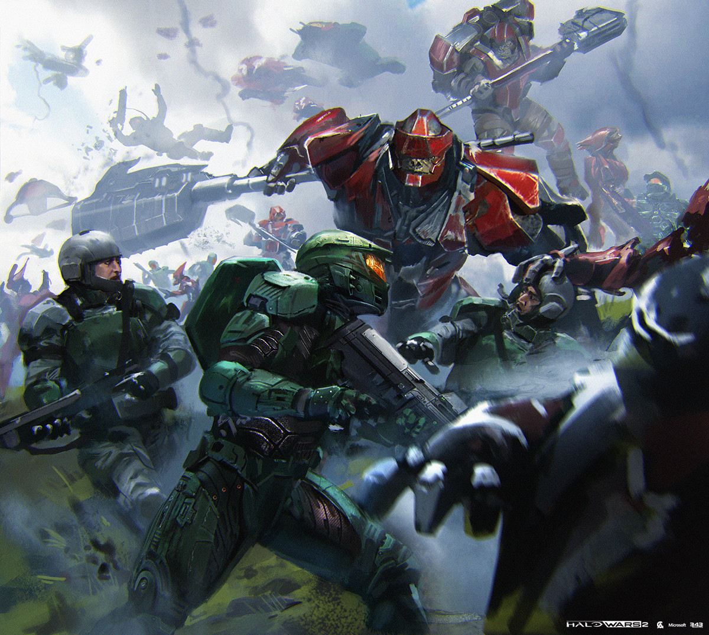

The Imperium of Man.
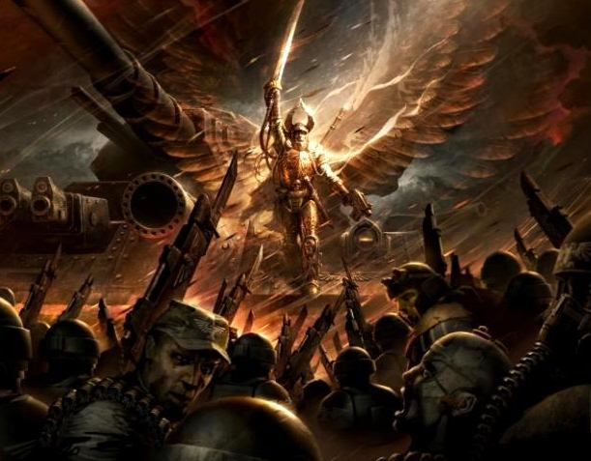
Caesars Legion.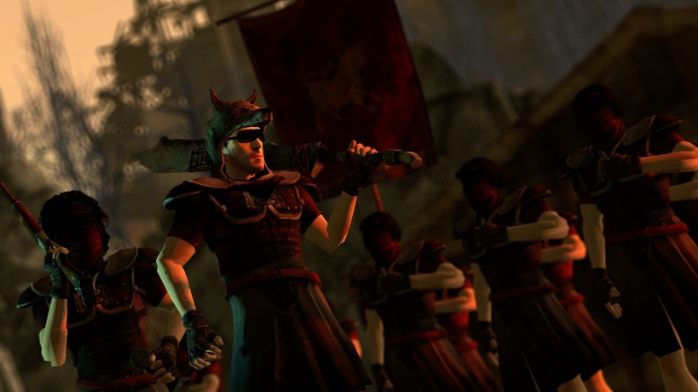

Introduction
Throughout history many of the morally corrupt nations that existed were oppressive governments, nations which more often than not went against the will of their people to cause atrocities of varying nature through history, although most oppressive governments (as is the case with Stalin’s Soviet Russia and Hitler’s Germany) are now confined to the pages of history they are still common in another form and that being popular media such as games.
The reason that games are chosen the form of media as opposed to film or music is that games often allow the person to choose their own allegiances when choosing a faction and as such said faction would have to be three dimensional in its portrayal, a well written faction would be able to show the player both the good and bad sides of a faction’s character which could send the player into a dilemma as to which faction to play as.
As there are so many different portrayals of such governments in media only three examples will be presented in this dissertation proposal as it will help keep the work concentrated and the three factions presented will have varying degrees of negativity. The three factions are:
- UNSC (Halo Setting) – Portrayal wise the best when it comes to karma.
- Imperium of Man (Warhammer 40,000 Setting) – In the middle of the road in its portrayal.
- Caesars Legion (Fallout Setting) – Portrayal Wise the worst when it comes to karma.
Portrayal.
There are big differences in which how the following the governments are portrayed to the player.
UNSC
The UNSC (United Nations Space Command) are perhaps easiest to sympathise with of the three factions that will be presented in this dissertation proposal, the UNSC from the Halo universe is the most positively portrayed not only through design but also by the fans of the Halo games, almost every person that has played the Halo games recognises the UNSC as the “good” faction. In-game the UNSC is portrayed as a highly militaristic organisation, the story behind this is that after decades of waging war against a genocidal Alien faction known as the Covenant, humanity is forced into allowing the military (the UNSC) to govern everything, this in theory was meant to boost Humanities military recourses and give it a better chance to fight off the Alien Covenant at the price of the common citizen having to live in a much more regimented and authoritative regime which has caused insurrectionist movements on some of the UNSC’s outer colonies. Although these actions would make the UNSC seem like an authoritative government to us today it is justified within its universe as the only way that Humanity could survive in this hostile universe.

Imperium of Man
Perhaps the greyest of the three factions the Imperium of Man is portrayed as a highly brutal and authoritative government where most of its citizens live in “Hive Cities” where the population numbers anywhere from a few to over a hundred billion, most of these people then work in one of the worlds many factories in a similar fashion to the Victorians during the Industrial Revolution, most of the population zealously worship the Imperium’s leader known as the “God Emperor of Mankind” with several entire worlds (known as shrine worlds) dedicated to constructing gigantic shrines and cathedrals for worshiping the Imperium’s leader. The Imperium of Man has been constantly waging war for 10,000 years either on rebels and “heretics” from within or on external threats such as aliens or “Daemons”.
While the fans of the universe are conflicted as to whether the Imperium is good or bad for Humanity as a whole they also accept that it is the best chance of survival for Humanity as a species, to gain sympathy from its players the Imperium is set within the Warhammer 40,000 universe which is a setting so hostile that the people who play this game cant help but sympathise with the Imperium in some way even if they play another faction in game, in addition the Imperium of Man is also populated solely by Humans which in addition to the previous point also uses the player subconscious emotions to naturally sympathise with its own species.
Caesars Legion
Of the tree factions this is the most openly evil factions that are being presented. Caesars Legion is a faction from the Post-Apocalyptic Fallout games, the faction known as Caesars Legion begun as a simple tribe from the American State Arizona, this tribe was lead by a man whose true name is lost to history, this man had an obsession with history with particular interest regarding the Roman Empire and in an effort to try and recreate the glory of Rome had started to conquer/destroy its surrounding tribes, Caesar has attempted to copy the Roman Empire to the letter with vanquished enemies being used as slaves and in some cases crucified as was Caesars interpretation of the Roman Empire, in addition to this any male children from the Legion’s slaves are immediately conscripted into the Legion’s military while the female children immediately become the new generation of slaves (while this is not shown in game it is mentioned by many of Caesar’s Legionaries several times), this in Caesars mind meant that while half his Legion was waging war the other half would be in the camp maintaining equipment and brining up the next generation of slaves/soldiers. The reason that Caesars Legion has such a miserable outlook is that in their minds democracy was what started the Great War (this was the event that turned the world into a Post-Apocalyptic wasteland) and that in the harsh Post-Apocalyptic wasteland only governments such as Caesars Legion could survive.
In comparison to the other two factions that are being presented it is much more difficult to find anything positive about this faction, as opposed to ensuring humanities survival and playing on the players subconscious this is a Government that fights other human factions and claims their lands by right of conquest. But there are those that sympathise with this faction, this is more due to a person’s outlook as after doing more research on the faction a person would find that while Caesars Legion wages brutal wars against its enemies it will then rebuild the area that they have conquered and govern the area with such efficiency that crime becomes almost unheard of (although granted that this is mostly due to the harsh punishments that the Legion are prepared to inflict), while the Legion also comes off as group of bloodthirsty savages to an outside observer if the player decides to learn more about them they would find that the Legion also has a large belief in their own version of honour. As mentioned whether a person can sympathise with this faction is totally up to the individual.
Design
UNSC
The United Nations Space Command was heavily designed to look similar to the modern western military (particularly that of the United States) which to a western audience would help the player sympathise with this faction, the ordinary foot soldier of the UNSC (mostly the marines) were heavily modelled after the Colonial Marines in James Cameron’s Aliens, as the first Halo video game was released quite close to the September 11th attacks these design choices were mostly done on purpose in the hope that a mostly (at the time) American would find it easier to sympathise with a faction that would look similar in design to the United States military.
Imperium of Man
The Imperium of Man has taken designs from several different sources but are universally portrayed as being very religious (this part of the design being highly inspired by the Medieval church) and in other parts being very militarised with its troops taking designs from a large number of historical factions such as the WW2 faction the Wehrmacht (the Armageddon Steel Legion) or Peter the Great’s Cossacks (the Vostroyan First Born), with these design choices in mind many of Warhammer’s fans have begun to jokingly refer to the Imperium as “Catholic Nazis” after its two defining characteristics.
Caesars Legion
As opposed to the futuristic look of the above two factions the post-apocalyptic Caesars Legion takes heavy inspiration from the Roman Legions (as the faction’s name would imply) albeit a much less organised look to it, the form of government that Caesar rules is almost an exact copy of ancient Rome although with a few exceptions such as having great hatred for any intoxicating or narcotic supplies, another difference that the Legion has with ancient Rome is that while Rome had some degree of democracy such with the senate Caesars Legion is entirely ruled by Caesar himself with little to no democracy in play.
Justification
UNSC
When it comes to the authoritative government that the UNSC forced upon its populace it itself feels less of a dictatorship and more as the shield and saviour of humanity defending its survival against the genocidal Alien Covenant and it is indeed mentioned several times in Halo lore that without the UNSC and its militaristic way of governance humanity would have been wiped out as a species. Although when it is quite easy to look at the UNSC in a very positive light (as most of the fans do) in the lore the UNSC can be portrayed as a much more aggrieve ruler even looking at disgruntled colonists in the Outer Rim worlds of the UNSC as insurrectionists and terrorists.
Imperium of Man
The Imperium of Man is a government that rules over one million inhabitable planets in the Milky Way Galaxy with a population speculated to be in the quadrillions, from its capital Holy Terra (Earth) the Imperium wages war a constant against extra-terrestrial races even going so far as to commit species genocide or destroying entire world to further its goals whist forcing its ordinary citizens to either work most hours of the day inside large factories or are conscripted into the Imperial Guard (or Astra Militarum humanity’s military). The Imperium of Man feels justified in its actions as like the UNSC it sees itself as humanities last bastion and in most cases the Imperium is right in this regard, most of the Imperium’s enemies are themselves genocidal bloodthirsty who would like nothing more than to destroy Humanity once and for all and for over ten thousand years Humanity has survived and remained the dominant race in the galaxy thanks to the governance of the Imperium.
Caesars Legion
Caesars Legion tend to follow more authoritative ideals in its government as through their historical interactions with other factions most democratic tribes and nations have been revealed to be corrupt or militarily weak in comparison to themselves, this has thus influenced the Legion to centre all of its governance around one incorruptible figure (which is ironic considering that Caesars Legion try to emulate Ancient Rome in every way and yet totally ignore Rome’s democratic centres such as the Senate), this way they see themselves as less of a brutal military and more incorruptible force brining “civilisation” to the many tribes of the Fallout Universe.
Conclusion
While in many forms of media it is quite common to have an Authoritative government be an antagonist, this could be due to said government’s oppressive policies or warlike nature. While there are examples in fiction where if well written it is easily possible to have such a government be the protagonist faction due to either the setting they’re in or through the justification for said governments actions, in other examples it is possible to have antagonist factions where through some similarities with the players some people may find themselves sympathising with said faction which can make for an interesting social experiment.

References:
Literary Sources:
- Orr, E.S., Ross, C. and Orr, R.R., 2012. Trait and symptom differences between factions in online gaming: The vulnerable side of evil. Computers in Human Behavior, 28(2), pp.739-743.
- Çakar, U. and Alakavuklar, O.N., 2014. Dystopian Future View as a Narrative of Inherent Entropy of Organizations. In Chaos, Complexity and Leadership 2012 (pp. 539-543). Springer, Dordrecht.
- Jones, S.E., 2008. The meaning of video games: Gaming and textual strategies. Routledge.
- Carlzon, A., 2017. Pragmatic Understanding through Dialogue and Choice:: How Role-playing Games like Fallout: New Vegas Promote Pragmatic Understanding.
- McFarlane, A., 2012. Halo and Philosophy: Intellect Evolved. Foundation, 42(116), p.98.
- Baumgartner, R., Future there is only War «. Warhammer 40,000, Transmedial Ludology, and the Issues of Change and Stasis in Transmedial Storyworlds.
- Schulzke, M., 2009. Moral decision making in fallout. Game Studies, 9(2).
- Hergenrader, T., 2011, June. Gaming, world building, and narrative: Using role-playing games to teach fiction writing. In Proceedings of the 7th international conference on Games+ Learning+ Society Conference (pp. 103-108). ETC Press.
- Schell, J., 2014. The Art of Game Design: A book of lenses. AK Peters/CRC Press.
- Paul, C.A. and Wysocki, C., 2017. Subconscious Bias and The Curious Case of Free-to-Play.
- Rigby, S. and Ryan, R.M., 2011. Glued to games: How video games draw us in and hold us spellbound: How video games draw us in and hold us spellbound. ABC-CLIO.
- Freeman, D., 2004. Creating emotion in games: The craft and art of emotioneering™. Computers in Entertainment (CIE), 2(3), pp.15-15.
Image Sources:
Halo UNSC:
343 Industries, (2017) Loading Screen Roster Brawl [ONLINE]. Available at: https://cdna.artstation.com/p/assets/images/images/005/175/036/large/kunrong-yap-ui-feloadingscreen-roster-brawl-240616.jpg?1489050132
Imperium of Man:
Sir Soundwave, (2014), LordSolarMacharius [ONLINE]. Available at: http://i0.kym-cdn.com/photos/images/original/000/692/225/7a1.jpg [Accessed 18 April 2018]
Caesars Legion:
SauceNAO, (2016), 1466036891489.jpg [ONLINE]. Available at: https://img.fireden.net/v/image/1466/03/1466036891489.jpg [Accessed 18 April 2018].

