International Business Communication
Student name:Elena Oniga
Student number:1905210
Assessment title:Assessment 1
Lectures name:Chizoba Esio-Bassey

Table of Content
Introduction 2
Discussion 3
Introduction to the selected developing country 3
Theories of international and intercultural communication in the selected country 3
Critical discussion of cultural sensitivity 4
Conclusion 6
Reference 7

Introduction
The fundamental aim of this study is to look into the different aspects of international business and the relation of communication with it. International business is the way of doing business where multiple countries remain involved and the spreading of the business is done through the inclusion of the characteristics of the respective countries. It is important to note that international business is a concept that takes multiple issues with it and if the whole scenario can be evaluated from the inclusive point of view then it can be seen that the countries where the factory of the concerned farm is decided to be built, may appear culturally different from the native country of the company. Hence, it becomes important to acknowledge and accept the culture and habits of the people of the country. Here comes the concept of inclusivity and it is also mentioned that communication is also a component that develops with the help of inclusive aspects of international business. The authority of the business farm is expected to make and build communication with the people of the country so that the work atmosphere becomes easy for the workers and the productivity of the worker's increases. The study focuses on the description of the developed country along with the application of the theories of internalism and the intercultural communication that happens during the establishment of the branch of the company. The matter of cultural sensitivity is also a part of the discussion whereas the cultural limitations of the taken foreign countries could also be discussed. The proper implementation of the communication strategies and the evaluation of them would also take place in the discussion of the topic.

Discussion

Introduction to the selected developing country
There are various developing countries in the world and here in this study, India would be taken as the developing country where the UK based country wants to establish their branch of the firm. A developing country is a country that has not fully developed yet but has crossed the line below which a country can be referred to as an underdeveloped country. Earlier India used to depend on the agricultural sector but after the inclusion of the second five-year plan in 1952 industrialization was emphasized (Makhmudov, 2020). At that time various big industries were established in India and that was the push that India needed the adaptation to rapid industrialization. However, in 1991 when a new economic policy was granted in India the door to privatization and globalization was opened. For that permission was given to the foreign country to establish their farms in India.
If the culture of India is talked about then it can be said that India belongs to the continent of Asia which is way different from Europe and the country of the UK. Hence, the cultural difference would create a barrier to the establishment of farms in India. India is a hugely populated country and therefore it can be said that its labour-centric industries are more acceptable. The financial condition of India is way different from the UK and the per capita income of India is also lower than the countries of Europe, specifically the UK. So, the establishment of a firm in India would make the UK face many challenges (Steinfatt, and Millette, 2019). Hindi is the dominant language in India and many regional languages are also given importance. The characteristics, needs and productivity of people are also different in India. So, it can be said that India is culturally different from the UK and the decision of the UK based company to open their branch in India would accuse them of facing certain limitations which they have to critically evaluate.

Theories of international and intercultural communication in the selected country
Multiple theories of intercultural communication justify and denote the pros and cons of establishing a factory of a UK based company in a developing country like India. The below-listed theories can be included in this.
- Hofstede’s approach- Hofstede's approach to intercultural communication focuses on the behaviour of the people of the respective country and discusses cross-cultural communication (Rubtsova, 2019). The cultural change of a country indeed comes with the changing behaviour of the citizens of that particular country hence it can be said that from the perspective of Hofstede if the behaviour of the people of India can be observed closely then their needs, expectation, and demands would be recognised which would help the company to make the business more developed in India.
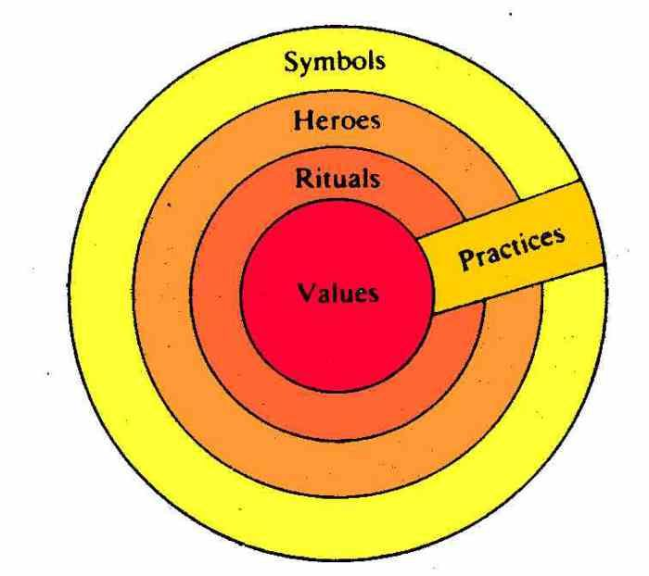
Figure 1: Hofstede’s approach to interculturalism
(Source- Crewe, 2022)
- Samovar’s approach- Samovar’s intercultural theoryis based on the interpretations of the stories and narratives that are heard through the communication that is made with the local people of the country. India is indeed a culturally rich country and some ample stories and myths can be heard if one stays there for a long time. The faith, belief and mental condition of the people are connected with the myths and beliefs. Hence, the theory helps in deciphering the nature of the people of the country.
- Janet's approach- Jandt’sapproach is the one in which not only the culture of the developing country would be looked into but the culture of other countries like the UK would also be evaluated and a comparative study would be made between the two countries with which the intercultural differences are understood more smoothly (God et al., 2020).
- Dialectical approach- There are six dichotomies through which the intercultural differences between two countries can be detected. These are like- personal vs contextual, cultural vs individual, static vs dynamic etc (Baker, 2018). The dialectical approach is connected with the reduction of dilemma and it also helps in getting a proper idea about a subject because here two different aspects of the country are evaluated. In India, the culture and scenario of the past are way different from the present hence this approach helps cope with the cultural differences between UK and India.

Critical discussion of cultural sensitivity
Cultural sensitivity is how the different aspects of other cultures are identified. It is also referred to as the knowledge, inclusion and understanding of the culture and heritage of other countries to cope with the changing scenarios. International business is a way of spreading business in different countries and different countries indeed possess different cultures (Dasih et al., 2020). The different cultures would also include differences in religion, language, characteristics and demands. Here the UK based company wants to make a factory in a developing country like India and the cultural difference between these two countries can create challenges in the development of the established factory. The UK based country is expected to look into the matter of cultural sensitivity with the help of various tools.
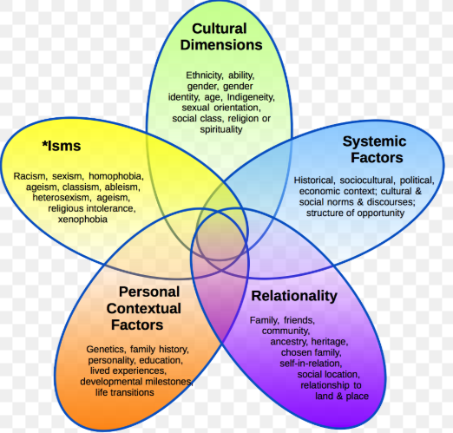
Figure 2: Cultural sensitivity
(Source- Academia, 2020)
- Communication
Communication with local people is a way of generating cultural sensitivity. Cultural sensitivity includes the knowledge and awareness about the culture of the other country and the history, characteristics, nature and knowledge regarding a country can be known from the local people and the best way to know about all these is the communication that is initiated among the local people. It is noticeable that language is one of the key factors when it comes to communicating with the local people (Jhaiyanuntana et al., 2020). It is mentionable that UK and India are culturally different so the languages are also different hence the first step of cultural sensitivity is to get to know the language through which communication can be initiated.
- Rejecting ethnocentrism
Ethnocentrism is the state in which a person judges other cultures depending based on their culture and in that way the concept of cultural sensitivity does not occur. The rejection of ethnocentrism denotes that the Persians are not ready to accept the perks of the other cultures and in that way, the positive sides of a culture can not be noticed. Hence to know the cultural aspects of India, the UK needs to remove ethnocentrism from themselves and look into Indian culture more profoundly (Handford et al., 2020). For example- the festivals of India are different from the UK and if the people from the UK consider the festivals inferior to theirs then the understanding of Indian culture would never happen.
Discussion and analysis of different communication barrier experience by the foreign business
There are various communication styles of the different organisations in the foreign business. This study has focused on the different aspects of international business and the communication strategy related to it. It is important to note that international business is a concept that takes multiple issues with it and if the whole scenario can be evaluated from the inclusive point of view then it can be seen that the countries where the factory of the concerned farm is decided to be built, may appear culturally different from the native country of the company. Hence, it becomes important to acknowledge and accept the culture and habits of the people of the country (Tetteh, et al., 2021). Here comes the concept of inclusivity and it is also mentioned that communication is also a component that develops with the help of inclusive aspects of international business. The authority of the business farm is expected to make and build communication with the people of the country so that the work atmosphere becomes easy for the workers and the productivity of the worker's increases. The study focuses on the description of the developed country along with the application of the theories of internalism and the intercultural communication that happens during the establishment of the branch of the company. The matter of cultural sensitivity is also a part of the discussion whereas the cultural limitations of the taken foreign countries could also be discussed. There are various problems which can be mitigated by the proper implementation of theoretical framework and strategic activities from the end of the management of the international organisations coming from the developed countries.
The barriers of international communication skills are:
Linguistic barrier
The different countries are inhabiting different languages. The business development of different countries sometimes faces the linguistic variety in order to talk to the other diploma maths of other countries because of this language barrier. Sometimes the diplomats are not able to convey their opinion to the diplomats of international business coming from other countries because of the annoyingness of the language of that person. Though English is the International language and everyone should know it if they are conducting any international business , underdeveloped countries are not aware of it in a large way. That is why they often take the help of the interpreters but they are not at all always able to communicate and mitigate all the barriers to find the solution of this problem.
Cultural barriers
It is often observed that at the time of international business that the different types of business people are coming to the other country for business activities are not able to cook up with the culture of the new country (Kitenge, and Lahiri, 2021). This situation happens because of the difference of culture which can be judged as a cultural barrier and it is not good for the organisation because the cultural pediasure can be foreign trade and commerce of the underdeveloped countries.
Climatic change
When international businessmen go from one country to another country for the purpose of business, they are often faced with a huge climatic change which sometimes is not capable of coping up (Kitenge, and Lahiri, 2021). These types of changes are often derogatory for the health issues of the persons going to the different countries and that is the reason why international businessmen sometimes return to their native land because of huge climatic changes and suffering from health problems. This can be also considered as a challenge towards international business.
Legal barriers
The international businessmen have to follow some law and order of the native countries where they are conducting their business. It is observed sometimes that the people are not able to understand the law in the very beginning of their business ventures to the foreign land. It's sometimes associated with the disobedience of law and order of the particular country which is not the growth and development of the business. The international business people should follow the law and order of the countries where they are going to expand their business in order to comply with the national rules and regulations otherwise they are business can be penalised.
The appropriate communication strategies and recommendations to enable the company to succeed in developing the communication
Coping of with the cultural change
Increment of the communication strategies
intercultural communication focuses on the behaviour of the people of the respective country and discusses cross-cultural communication (Rubtsova, 2019). The cultural change of a country indeed comes with the changing behaviour of the citizens of that particular country hence it can be said that from the perspective of Hofstede if the behaviour of the people of India can be observed closely then their needs, expectation, and demands would be recognised which would help the company to make the business more developed in India.By implementing the theory of hostate the international communication theory should be incremented. The international business relation will increase more if the communication gap of the different countries will decrease and the people can learn to hopa with the other cultural dimension in a greater way according to the strategy given by Hofstede. The eastern culture always welcomes the other people for group activities and the western culture always visual practices of a business activity which is also explained in this model and according to this strategy all the international business people should learn all the positive features in order to get better results of their communication skills from the different strategy and theoretical implications (Kudo, et al., 2022).
Developing the cultural environment of the countries
On the other hand, international business depends on the cultural development of the different countries. The other countries should focus on the development of the cultural activities of the country in order to draw the tension of the following businessman which will also increase the economy of the country in the Global aspect of economic background.
Helping others with language barrier
The language barrier seriously hampers communication of international business related people and it should be discarded by the help of entrepreneurs in between the business related conversation. Otherwise it will be impossible for the diplomats to talk with each other in regard to the expansion of business activity.

Conclusion
The report aims at the inclusivity of an international company that is based in the UK. The report focuses on the impact that is generated after the UK based company decides to open its branch in a developing country like India. In this report, an introduction is given about the various aspects of international business and the description of the developing country India is also there. Multiple theories decipher the various concepts that are related to the internationalization of a company and the inclusivity of the concerned company. Here in this study the description and inclusion of various theories related to internationalization and interculturalism are discussed. The aspect of cultural sensitivity is also discussed in the report and is evaluated from the perspective of India. Naturally, two culturally different countries like the UK and India would not agree on every point when it comes to building a relationship regarding business. There are relevant examples that support the theories. Also, different strategies of communication are provided in this study so that the selected developing country can be evaluated from the perspective of communication too. At last, a list of recommendations is given in the hope of getting better results. Hence, the study aims at evaluating the different approaches with which the setting up of the firm of a UK based company in a developing country like India is evaluated.

Reference
Baker, W., 2018. English as a lingua franca and intercultural communication. The Routledge Handbook of English as a lingua franca, 25, p.36.
Dasih, I.G.A.R.P., Triguna, I.B.G.Y. and Winaja, I.W., 2019. Intercultural communication is based on ideology, theology and sociology. International journal of linguistics, literature and culture, 5(5), pp.29-35.
God, Y.T. and Zhang, H., 2019. Intercultural challenges, intracultural practices: How Chinese and Australian students understand and experience intercultural communication at an Australian university. Higher Education, 78(2), pp.305-322.
Godwin-Jones, R., 2019. Telecollaboration is an approach to developing intercultural communication competence. Language Learning & Technology.
Handford, M., Van Maele, J., Matous, P. and Maemura, Y., 2019. Which “culture”? A critical analysis of intercultural communication in engineering education. Journal of Engineering Education, 108(2), pp.161-177.
Ilie, O.A., 2019, June. The intercultural competence. Developing effective intercultural communication skills. In International conference Knowledge-based organization (Vol. 25, No. 2, pp. 264-268).
Jhaiyanuntana, A. and Nomnian, S., 2020. Intercultural communication challenges and strategies for the Thai undergraduate hotel interns. PASAA: Journal of Language Teaching and Learning in Thailand, 59, pp.204-235.
Makhmudov, K., 2020. Ways of forming intercultural communication in foreign language teaching. Science and Education, 1(4), pp.84-89.
Rubtsova, A., 2019, March. Socio-linguistic innovations in education: productive implementation of intercultural communication. In IOP Conference Series: Materials Science and Engineering (Vol. 497, No. 1, p. 012059). IOP Publishing.
Steinfatt, T.M. and Millette, D.M., 2019. Intercultural communication. In An integrated approach to communication theory and research (pp. 307-320). Routledge.
Tetteh, M.O., Chan, A.P., Darko, A., Torku, A. and Nani, G., 2021. Critical Barriers to International Construction Joint Ventures Success: Multiexpert Views and Contextual Disparities. Journal of Construction Engineering and Management, 147(8), p.04021081.
Kitenge, E. and Lahiri, S., 2021. Is the Internet bringing down language‐based barriers to international trade?. Review of International Economics.
Shekhar, S. and Kesharwani, A., 2021. ANALYZING THE BARRIERS TO INTERNATIONAL TRADE LOGISTICS FROM INDIAN PERSPECTIVE: AN ISM MODELLING APPROACH. Academy of Marketing Studies Journal, 25(6), pp.1-6.
Kudo, K., Isobe, N., Ueda, S., Tomimatsu, S., Moriyama, T. and Shimizu, S., 2022. Barriers to International Telemedicine Conferencing: A Survey of the National University Hospital Council of Japan. Telemedicine and e-Health, 28(3), pp.433-439.

