Student Name: Juliette Zelleke
P Number: 1706524
Programme of Study: Design Crafts
Module: Ways of perceiving (ADAD4010)
Tutor: Julia Lockheart
Word count: 1,406

Over the centuries, artefacts and objects have found their way into the western world and have been ‘exhibited’ in several museums. These objects tend to be curated in a particular style with the objects organised by type rather than origin. Most objects are poorly described, with lack of what the object or artefact was meant for and its cultural significance. Most of the cultures that are being represented in these objects are still alive and thriving while some unfortunately have been lost; with it, the beauty, meaning and cultural complexity of some of these said objects. There are many arguments that these objects should be returned to their rightful homes from which they were taken. However I do not fully agree with this statement. Some artefacts have become fragile with time and it might be too dangerous to transport them across the world without damaging them. In the midst of the artefacts are in large accessible cities that are often visited such as Paris or London, there is no better place to give them life again. But I do believe that there are far better ways of exhibiting them in a clear and interesting way without washing or misinterpreted the meaning behind these pieces.

‘Primitivism- A belief in the value of what is simple and unsophisticated, expressed as a philosophy of life or through art or literature.’ (Oxford Dictionaries | English, 2019) Throughout history curtain art pieces and sculptures have been considered as Primitive. I personally believe that they are unpolished and unfiltered not meant to please everyone. My opening piece would be Joyousness by Paul Gauguin.
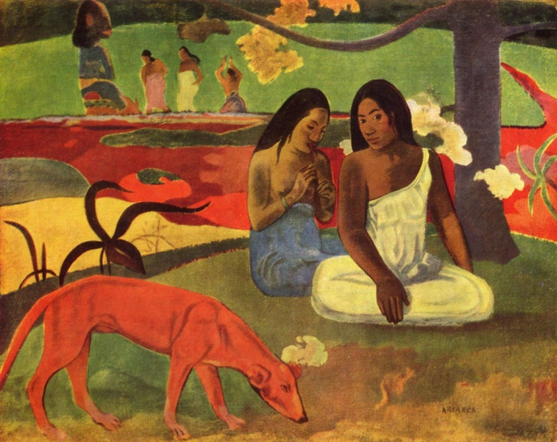
Figure 1: Joyousness by Paul Gauguin, Musee D'orsay, Paris, France

Gauguin gave up his family and life to live in Tahiti in 1891, where people thought that is art work had changed into a more savage style of painting. Joyousness was considered primitive because it broke away from the French impressionist art work that he was known for. The painting depicts two Tahitian women bathing next to a running red river that had been tinted in this colour due the red clay, this would have displeased a lot of people as they would have preferred the river to be more ‘natural coloured’, such as blue. After his death the paintings that he had made in Tahiti became immensely popular and are now considered masterpieces. I think that it is an excellent opening piece as it introduces the viewers to the theme of ‘primitivism’ or what may be believed as primitivism and art from other places.

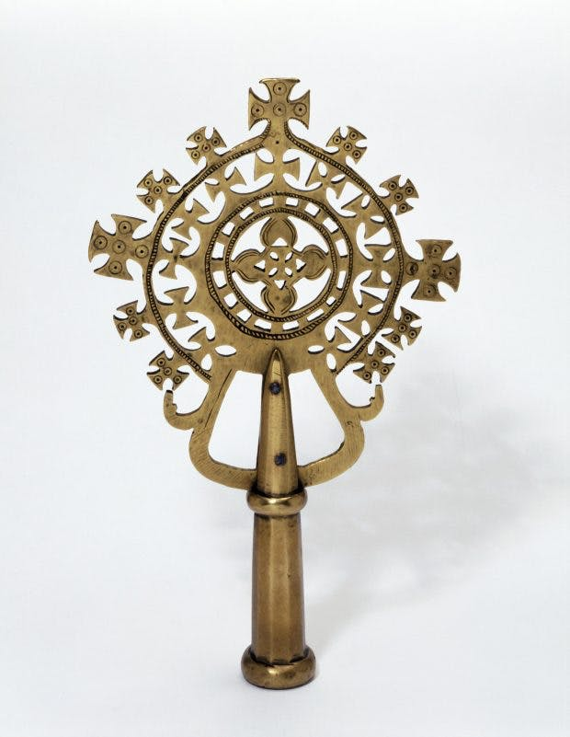
Figure 2: Processional cross (before 1868), Ethiopia. Victoria and Albert Museum, London

Ethiopia is known for its vast designs and interpretations of the cross. In fact there is no other symbol more present in the culture than the cross. Each cross is different depending on region, church and spiritual significant such as the twelve apostles, Holy trinity and the five wounds of Jesus. Wood and metal are the most common materials used to make the crosses but there can be some make from precious metals such as silver and gold, although they are less common. There are three types of crosses. ‘The ‘processional’ crosses are mounted on a long staff and carried by priests during religious ceremonies.’ (Gnisci, 2019) These crosses are the largest and have the most intercut design and are carried along in precessions during festivals. “Hand’ crosses are smaller than the processional ones, and have, instead of a shaft, a narrow solid handle ending in a base plate or cube.’ (Gnisci, 2019) These are also carried by priests and usual have a more simple design. They are usual held by priests at the head of processions or used for blessings. The final cross is the neck cross. Emperor Zara Yaqob ordered all Christians to wear a cross; this was so the Christians were able to identify each other easily as well as the crosses they would have also had tattoos.

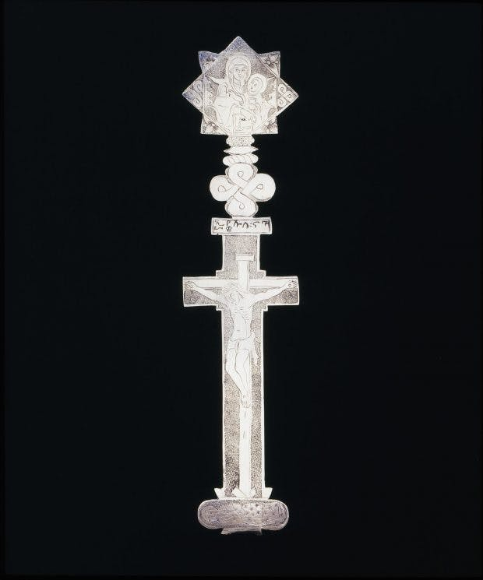
Figure 3: Hand cross, (18th century), Ethiopia. Victoria and Albert Museum, London

For my second piece I would like to have a wall full with a variety of frames. Mounted within these frames I would have a single Ethiopian cross. I want to viewer to see the vast variety of Ethiopian crosses to see the different sizes, materials, shapes and designs; to feel the overwhelming presents and craftsmanship that goes into each and every cross. This jewellery is a significant part of the Ethiopian culture and is still being practiced today.

Following the wall of crosses, I would be honoured to exhibit some of the ‘Treasures of Magdala’ which were stolen by British soldiers from Ethiopia after the battle of 1868. Among these treasurers where an 18-carat gold crown, some Christian scriptures and 300 sacred manuscripts as well as some of Emperor Tewodors II’s personal belongings. (The Independent, 2019) Most of these items are being shown in museums across the United Kingdom, however some items have been returned, such as the hair of Emperor Tewodros II. However it is not enough for the Ethiopian people, culture and history. Many of the items that were looted are steeped in religious significance and were taken from the priests that did not recognize Tewodors as their emperor. ‘In the heat of this discussion, the significance of the objects themselves has been largely overlooked.’ (Gnisci, 2019) These objects are more than just beautiful piece of art. For the Ethiopian people it is their past, future and present, these sacred artefacts are missed by the nation and should be returned to their home as they will be well taken care of. Some pieces that are being exhibited in the United Kingdom are quite common in Ethiopia such as some presentational crosses and would benefit more if they were exhibited in the United Kingdom. On the other hand, some pieces like the crown would now benefit from being in its country of origin, as it is steeped in spiritual and cultural significance and the county.
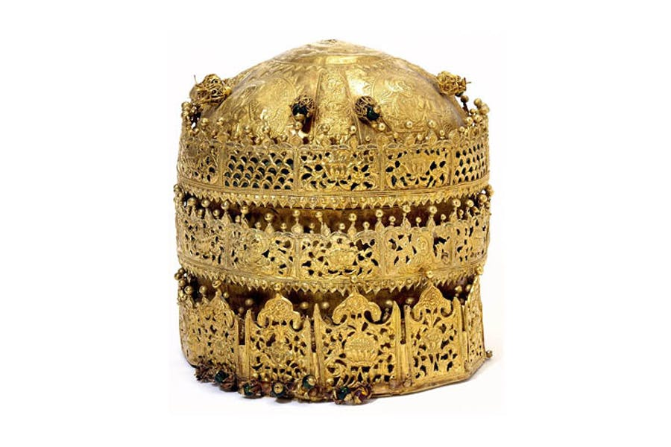
Figure 4: Crown, probably made in Gondar, Ethiopia, around 1740. Victoria and Albert Museum, London

The manuscripts and painting taken during the raid would be mounded elegantly on the other walls, as well has the cloths that were found. They would have enough spaces in-between them so that the artefacts would be undisturbed by one another. In the centre of the room the crown and other jewels standing strong as they had once before.
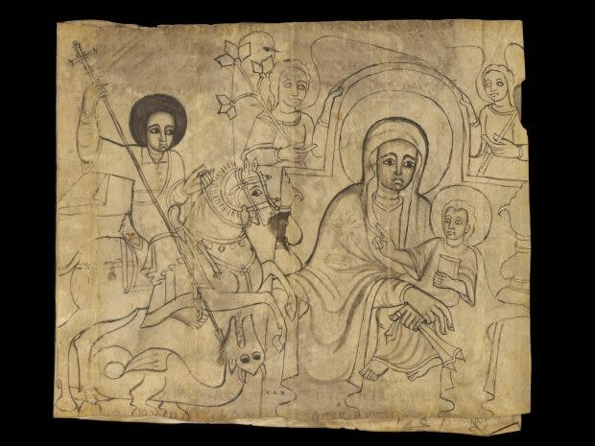
Figure 5: St George and the Dragon, the Virgin and Child, (18th century), Ethiopia. Victoria and Albert Museum, London

In light of all this, there are several places working with some locals of where the artefacts originated from. For example some Maasai tribesmen went to the University Of Oxford’s Pitt Rivers Museum where they saw a bracelet that originated from their tribe clustered together with other similar artefacts. The bracelet in question is an Orkatar, which is something that cannot be given or sold. It symbolises the death of a father and it is a form of inheritance that passes down the generations. Some of the main questions that were asked where whose was it? How did it end up here? After this revelation the museum is trying to ‘reclaim the narrative’ of these objects, and are working with the tribes men to restore the objects and give them life once more. I think that this is a step in the right direction. We cannot change the past but we can redeem the mistakes that were made. By working together on projects like these the artefacts are no longer lost in a complicated history. (Wall, 2019)
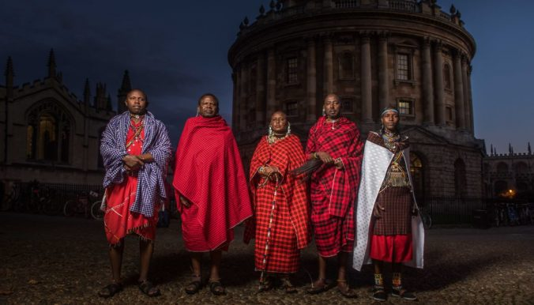
Figure 6: Maasai committee, Museum of Oxford Pitt Rivers

In conclusion, my goal is to show people that history is important and owning up to what has been done is important too. These objects may have been taken a long time ago but the places that they were taken were rich in culture and representation. Something as simple as a bracelet may mean nothing to someone, but to another it means the world. I want to show these objects and represent and respect the history and pain that they went through. This subject is a rather large subject and I was limited myself to cultures that I know and are from. Gauguin’s painting shows his home away from home and his third world view. Having grown up surrounded by a mixture of cultures, I believe that I too can relate to this work. The Ethiopian crosses and stolen treasure is a part of my history and I thought it was important to include it, to not forget what had happened. Seeing and reading the participation with the Maasai was also important as I grew up seeing their craftsmanship first hand. I would like the viewer to see, understand these pieces, for what they are. To know that when they leave they have had the full story.

Bibliography

Huichawaii.org. (2019). [online] Available at: https://www.huichawaii.org/assets/evangelatou_maria_ahs_2013.pdf [Accessed 6 May 2019].
The Independent. (2019). Ethiopia demands stolen crown back. [online] Available at: https://www.independent.co.uk/news/uk/this-britain/ethiopia-demands-stolen-crown-back-1031229.html [Accessed 6 May 2019].
Gnisci, J. (2019). The Maqdala treasures | Apollo Magazine. [online] Apollo Magazine. Available at: https://www.apollo-magazine.com/the-looted-ethiopian-artefacts-that-ended-up-in-uk-museums/ [Accessed 6 May 2019].
Oxford Dictionaries | English. (2019). primitivism | Definition of primitivism in English by Oxford Dictionaries. [online] Available at: https://en.oxforddictionaries.com/definition/primitivism [Accessed 6 May 2019].
Zehabesha.com. (2019). THE LAST DAY OF EMPEROR TEWODROS II’s LIFE AND THE LOOT OF MAGDALA | Zehabesha – Latest Ethiopian News Provider. [online] Available at: https://www.zehabesha.com/the-last-day-of-emperor-tewodros-iis-life-and-the-loot-of-magdala-2/ [Accessed 6 May 2019].
Southworld.net. (2019). The variety of Ethiopian crosses - News & views from emerging countries. [online] Available at: https://www.southworld.net/the-variety-of-ethiopian-crosses/ [Accessed 6 May 2019].
Wall, A. (2019). Maasai Community Members Work to Decolonize Oxford’s Pitt Rivers Museum. [online] Museum Studies at Tufts University. Available at: http://sites.tufts.edu/museumstudents/2018/12/04/maasai-community-members-work-to-decolonize-oxfords-pitt-rivers-museum/ [Accessed 6 May 2019].

