  Component One: Student Journal (learning log) 750 words +/- 10%  Contribution to Overall Module Assessment: 25% | Student No: | Nicusor Florin Mistode 2246469
 | Module Title: | Operating Hotel Facilities
 | Module Code: | BMIH4006
 | Lecturer: | Lisa-Marie Bassler
Introduction
Based on the view of Bridger, (2018), the housekeeping department within the hotel is a crucial department for ensuring organisational productivity. Continuing in the same vein, Cottrell, (2019) has stated that the development of knowledge regarding housekeeping is essential and is achievable through study (Cottrell, 2019). This is because; the housekeeping department ensures the quality of hotel rooms and attracts new customers within the hotel. During my placement, I worked as a room cleaner in the housekeeping department of Ibis Northampton Hotel and I have experienced both positive and negative incidents at the time of working. Along with the room cleaning, I have served to the guests also and this was my most positive experience.
Gibbs reflective model
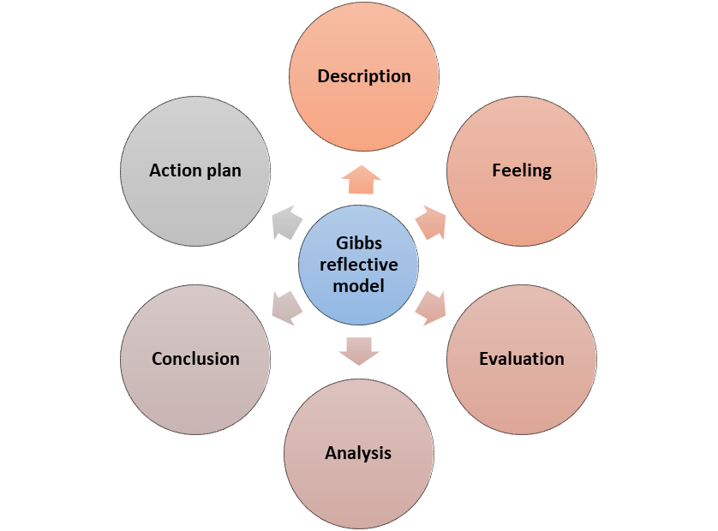
Figure 1: Gibb’s model
(Source: Self-developed)

Description
I worked in the housekeeping department at IBIS Northampton Center where I was responsible for several tasks including cleaning, fulfilling guest requirements and overall presentations of rooms. During my placement in the housekeeping department, I was trained by the management of the hotel to accelerate my knowledge and skills associated with housekeeping services. I also address the customer's point of view as well as the policies and procedures of the hotel for maintaining effective performance to raise market growth. My ability to fulfil guest's needs and cleaning allowed me to meet the satisfaction level of the guest. Being a representative in the housekeeping department, maintaining cleanliness and orderliness were the utmost things for gaining the attention of consumers. Minor improvements and expected changes in the housekeeping department could raise guest satisfaction (Garrido-Moreno et al., 2021).
Feelings
Based on my placement experience, I can say that I have learnt professionalism from my job, and I have got training from my seniors to achieve success effectively. Emotional intelligence is crucial in any work to ensure own emotions as well as to understand the emotions of others (Ivanov et al., 2020, p.533). Furthermore, professionalism is the core part of enhancing the quality of work (Mullins and Dossor, 2013). According to my feelings, room cleaning is one of the most critical work of the housekeeping department of a hotel. At first, I was frustrated as I could not ensure the quality of work and subsequently, I have overcome challenges. It has provided me with an experience regarding the effectiveness of performance. I have realised that professional is the most important to achieve success within a specific job role. Based on developing professionalism I have enhanced my quality work in room cleaning as well as guest service. In this case, I have learnt the process of managing time is most important in guest service. As depicted by Leiter and Bakker, (2010), the housekeeping department focuses on the quality of hotel rooms for enhancing the hotel ratings (Wang, 2020). Hence, I believe that the housekeeping department is essential to ensure organisational productivity within the hotel.
Evaluation
In the housekeeping department, I have an intensive knowledge of providing quality services addressing the demands of guests. My experiences in this department assisted me in maintaining seamless services as per the changing needs of them. During my placement in the housekeeping department, I possessed a wider knowledge of communication and time management skills. My effective communication skills assisted me in understanding the thoughts of the guests and conveying accurate information regarding services. On the other hand, I have weaknesses in problem-solving skills and critical thinking skills and thus, sometimes I fail to solve complex issues of guests' queries in the housekeeping department. In this context, I need to work on improving my problem-solving skills for solving client's issues.
Analysis
My placement experience allowed me to develop a deep understanding of the housekeeping department's role in guest satisfaction. I understand that the housekeeping of the department's pivot role is vital to providing satisfaction to the customers. In terms of departmental operational tasks, I learned about proper procedures for cleanliness and managing guests within the hotel. I work to supply the product from one area to another and sometimes I clean the room, prompt to respond to the guest's request. The overall success of the hotel is automatically enhanced when it maintains a sustainable approach for its customers (Raghubalan and Raghubalan, 2016). Effective teamwork for preparing a creative presentation of rooms helped me to learn about various innovative ways (Vatan and Dogan, 2021, p.100775).
Conclusion
Based on the above discussion, the customer-based approach is an effective tool for developing the customer service level. In the housekeeping department, I have identified that competency level is the most important matter to enhance the effectiveness of performance. Communication and behaviour skills also enhance the engagement level of the customers. Professional behaviour and solving the queries of the customer are also important factors in the housekeeping department and that is why I also must improve my problem-solving skills and time management skills. I believe that problem-solving and time management skills are crucial to consider in the case of enhancing professionalism as well as competency level.
Action plan
Objective | Specific | Measurable | Achievable | Relevant | Time-bound
Time management skill | I would focus on providing the quality of service to the customers | I would focus on the goal setting to ensure my performances | I would take help from my teachers and professor to achieve the skill | It would provide me with a better career opportunity in the future. | It would take 2 months.
Problem-solving skill | I would solve the quarries of the consumers | I would like to attend a test and examination to measure my performance | I would take help from my team members to achieve the skill | It would help me to develop my professional career for a better future. | It would take 4 months to achieve the skill

Component Two: Health and Safety Guide
Contribution to Overall Module Assessment: 25%
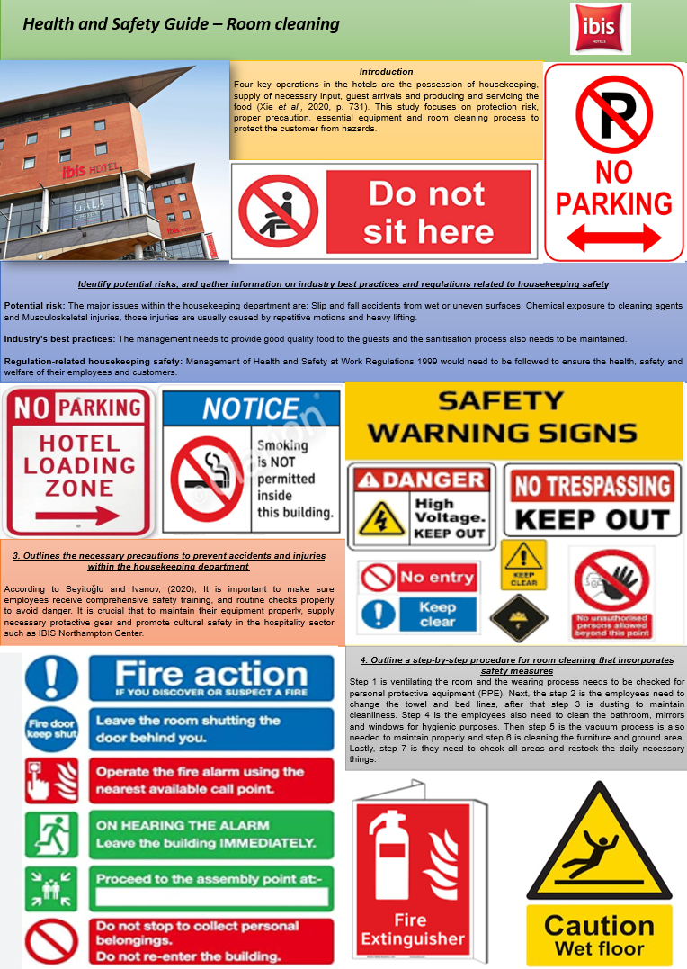
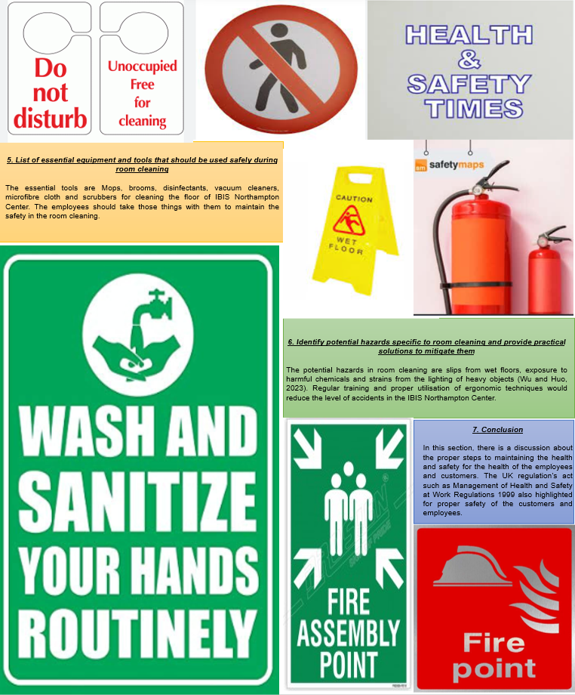

Reference List

Component 1
Bridger, E. 2018 Employee engagement: a practical introduction. 2nd ed. HR Fundamentals. London: CIPD and Kogan Page.
Cottrell, S. 2019 The Study Skills Handbook. 5th ed. London: Red Globe Press.
Garrido-Moreno, A., Garcia-Morales, V.J. and Martin-Rojas, R., 2021. Going beyond the curve: Strategic measures to recover hotel activity in times of COVID-19. International Journal of Hospitality Management, 96, p.102928. https://www.tandfonline.com/doi/abs/10.1080/09669582.2021.1910829
Ivanov, S., Seyitoğlu, F. and Markova, M., 2020. Hotel managers’ perceptions towards the use of robots: a mixed-methods approach. Information Technology & Tourism, 22, pp.505-535. https://link.springer.com/content/pdf/10.1007/s40558-020-00187-x.pdf
Leiter, M. P. and Bakker, A. B. 2010 Work Engagement : A Handbook of Essential Theory and Research. Hove [England]: Psychology Press.
Mullins, L. and Dossor, P. 2013 Hospitality Management and Organisational Behaviour. 5th ed. Harlow: Pearson.
Raghubalan, G. and Raghubalan, S. 2016 Hotel Housekeeping - Operations And Management. 3rd ed. India: Oxford University Press.
Vatan, A. and Dogan, S., 2021. What do hotel employees think about service robots? A qualitative study in Turkey. Tourism Management Perspectives, 37, p.100775. https://www.sciencedirect.com/science/article/pii/S2211973620301422
Wang, C.J., 2020. Managing emotional labor for service quality: A cross-level analysis among hotel employees. International Journal of Hospitality Management, 88, p.102396. https://www.sciencedirect.com/science/article/pii/S0278431919300684

Component 2
Seyitoğlu, F. and Ivanov, S., 2020. A conceptual framework of the service delivery system design for hospitality firms in the (post-) viral world: The role of service robots. International Journal of Hospitality Management, 91, p.102661. https://www.ncbi.nlm.nih.gov/pmc/articles/PMC7492062/
Wu, X. and Huo, Y., 2023. Impact of the introduction of service robots on consumer satisfaction: Empirical evidence from hotels. Technological Forecasting and Social Change, 194, p.122718.https://www.sciencedirect.com/science/article/pii/S0040162523004031
Xie, C., Zhang, J., Chen, Y., Morrison, A.M. and Lin, Z., 2020. Measuring hotel employee perceived job risk: dimensions and scale development. International Journal of Contemporary Hospitality Management, 32(2), pp.730-748. http://gala.gre.ac.uk/id/eprint/28888/1/28888%20MORRISON_Measuring_Hotel_Employee_Perceived_Job_Risk_2020.pdf

