[Date]25/3/2022
Nelly Nyaundi Myles (1710690)
UNIVERSITY OF WALES TRIINITY ST DAVID

L
BMSW Leading and Implementing Workplace ChangeBMSW6103 6103
Executive summary

“To be the most highly valued business by: the customers we serve, the communities in which we operate, our loyal and committed colleagues and of course, our shareholders” Tesco”s Mission Statement.

In recent times Tesco had to adapt to the increased development in Technology . The changes made where in the use of digital technology , Artificial intelligence, self-checkouts, checkout sensors. The paper explores reasons for the changes ,the process of the change and the role of organisational leadership additionally it analyses and evaluates the structure and impact of culture in Tesco. Finally It highlights the importance of organizational capability in implementing change and the renewed interest of the emergence of change agent.

The method used for the research is through online journals , books, websites, (secondary sources) the findings show that Tesco has had planned and unplanned changes acerated by the recent pandemic Covid -19 , and increased use of technology by customers . leadership played an important role in the change . The impact of the change as resulted to complex issues in leadership and culture .over the years a lot of research on the role of business concepts and models have been used to structure and monitor change effectively.

Change is complex and often paradoxical organisational change need to be systematic, Few studies have been made on the type of technology and training to embrace in the retail sector as changes are revolving rapidly. . customer relationship management (CRM) few attempts have been made to establish the full extent of Return on investment (ROI) on technology , Technology has disrupted the CRM systems threating loyalty.

Table of Contents
2.1 background of tesco 3
About Tesco 3
THE CURRENT MARKET POSITION 4
2.2 Reason for the change 6
change models used in tesco during the change 6
PLANNING 6
IMPLEMENTATION 7
benefits of using change models 7
2.3 leadership management of complex areas 8
2.4. leadership in relation to change 11
2.5 TESCO CULTURE 12
changes in the culture based on the ‘change 12
2.5 change agents 14
3.0 conclusion 15
4.0 recommendation 16

1.introduction
The purpose of the report is to discuss technological changes made by Tesco to increase competitive advantage ,and to retain customers. The report looks at the importance of organisation capability to enable change analysing the complex leadership concepts relating to change, it analyses and evaluates the relationship between organisational culture and the impact on change . The report seeks to identify the change drivers, models that are used to enable change and there benefits the role of change agents and finally exploring additional need of the organisation. Tesco agrees that embracing technology is now a necessity.

2.1 Background of Tesco

Tesco is a global British grocery and general products company based in Welwyn Garden City, England. It was founded by Jack Cohen in 1919 from a market stall and has successfully grown to the world’s third-largest retailer in terms of gross revenues and the ninth-largest in terms of net revenues. (Kantar, 2021). It operates in seven countries across Europe, the United States, and Asia. . Despite the massive expansion and going global ,Tesco failed to take off in China due to late entry after rivals Wal- mart which were able to get better and cheaper store locations (Hopkins, 2015) Tesco also pulled out of the United States the failure was also due to timing . The new venture launched in 2007 just after consumer spending trends went into a sharp decline. (Heffernan, 2013)

OVERVIEW OF THE PRODUCTS AND SERVICES

Tesco’s main revenue is from grocery and retail. It also has other product lines and services such as insurance, banking, mobile network, savings and even Petrol.

Tesco corporate treasury services plc incorporated on 30 July, 2013. The Issuer operates under the Companies Act 2006.It operates different formats which are Tesco Extra and Tesco “Express” . The difference between these stores essentially are that “Tesco Extra” are bigger and have a wide range of products. Tesco “Express” on the other hand are smaller convenience style shops usually set up close of to offices and areas where commuters have quick access. Tesco Express stores typically tend to be higher in prices on some items and open longer hours on certain days such as Sunday and bank Holidays.

THE CURRENT MARKET POSITION

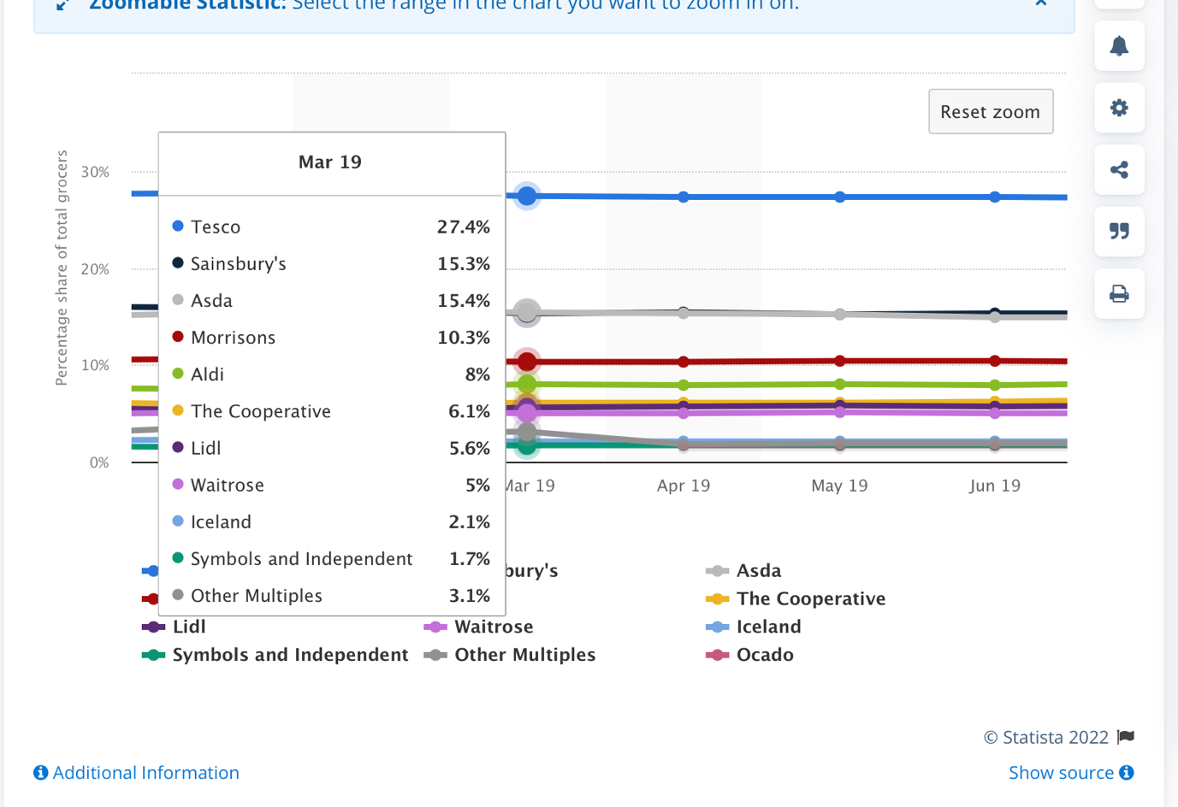

Tesco is the UK retail leader i
The share price as at 28th January 2022 is 302.75

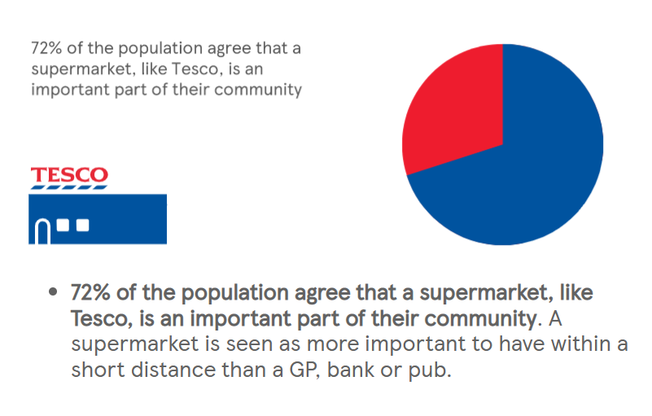
The FTSE 100 supermarket giant saw its share rise by 0.2% to 27.4% in February 2021, the first rise since December 2016 as it saw monthly sales jump 13.2%, according to market researcher( Kantar. 2020)Compared to rival discount stores Aldi and Lidl 7.5% and 7.9% . This has largely been caused by panic buying customers largely due to the pandemic. An overall of 215.2 billion grocery splurge . Due to inflation consumer trends have changed to discount stores like Lidl and Aldi .Resulting to price wars but considering the recourse base value (RBV) of Tesco it has managed to improve its competitive advantage by investing in technology and building capabilities with improved customer engagement and retention through social media , AI. and online .sales making them immune to treats.
Also the increase can be explained with the technological changes Tesco has implemented the constant improvement and introduction of product lines and services and using the BCG matrix the change can be emulated to the question marks quickly changing into stars increasing cash flow.
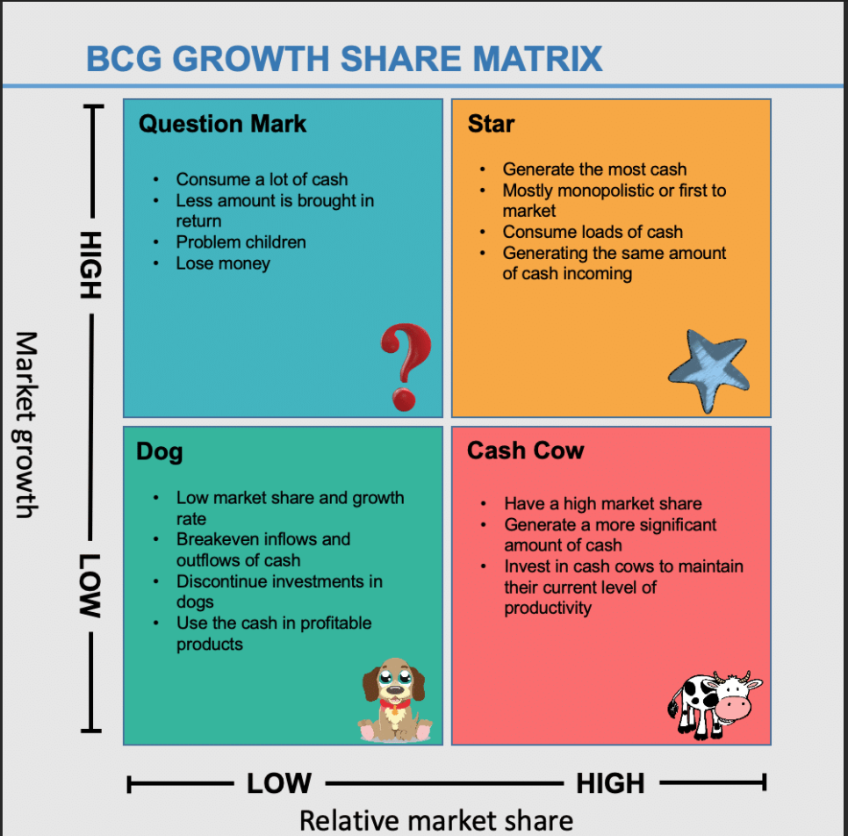
(Bing.com, 2022)

2.2 Reason for the change

Tesco has made changes influenced by both Macro and Micro Environmental

firstly is to access and control, social , political economic and technological threats with the aim of reducing organisational exposure to risk across all touch points. Secondly is adhering to the mission and vision statement which affects the culture and leadership associated with internal environment. Thirdly is the complexity of the consumer shopping trends According to McKinsey research and salesforce research 88%of customers now expect companies to accelerate digital initiatives fourthly is competition from different market forces and finally the reason to increase organisation capability and competitive advantage

The influences of change within the organisation

The change influenced change across different departments especially the
Customer service Department – use of self-checkouts outs , chat bots , AI. Heat sensors to reduce ques and increase customer experience
Human Resource Department – shortages of staff, due to covid – 19 and Brexit , recruitment, upskilling, Tesco to keep its 13,000 temporary staff due to increased staff absence caused by the omicron variant (Wright, 2022) and redeployment of staff

CHANGE MODELS USED IN TESCO DURING THE CHANGE

PLANNING

- Iron triangle , evaluating Time cost and quality

- PESTLE tool acronym of Political, Economic, Social, Technological, Legal and Environmental factors in Appendices
- SWOT analysis Acronym for Strengths ,Weakness, Opportunities and Threats as detailed in Appendices 2 Another tool that can establish organisation capability
- POTTERS FIVE FORCES - this enables the organisation to identify any competition in the market and change accordingly this model was created by professor Michael Porter in 1979
- VRIO analysis which stands for the valuable, Rare, Inimitable and organisational focus shows that the core competencies (Jugdev, 2005) of Tesco are the huge market portfolio, brand, marketing , and technology establishing resource base both tangible and intangible, This is the internal analysis (Morris, 2019) and the resource based view (RBV)
- LEWINS FORCE FIELD – identifying the resistance forces
- STAKE HOLDER ANALYSIS - is a key part of formulating an organisation's strategy. A stakeholder is a group or individual, who has an interest in what the organisation does, or an expectation of the organisation. It is important that an organisation understands the needs of the different stakeholders. (KAPLAN FINANCIAL KNOWLEDGE BANK, 2012)

IMPLEMENTATION

BALANCE SCORE CARD - The balanced scorecard acts as a structured report that measures the performance of company management. The management team can be evaluated against Key Performance Indicators (KPIs) (Corporate Finance Institute, 2019)

Gantt chart to monitor progress and time lines

Kolb’s Learning Cycle

change comes learning /retraining tools that leaders can use to increase capabilities of teams and individuals By encouraging the use of Kolb’s learning cycle (1984) it states that /’learning is a process where knowledge is created through a transformation of experience. As this could be a personal experience and unique to every individual collecting and processing feedback should be key. The experiences of the staff if denied could be seen as oppressive leadership which would give negative outcomes. Having a platform to air their views and experience will be beneficial overall.

Impact analysis tool
Impact Analysis is a technique designed to unearth the "unexpected" negative effects of a change on an organization.(Mindtools.com, 2017) It is a braining storming technique for braining high level areas and affected elements.
the fast paced business environment the tool requires capturing the structuring of the change and ensuring that they are managed well the advantage of this tool it can be useful for smaller decisions and used at a desk level or larger decisions conducted in different functional teams .

BENEFITS OF USING CHANGE MODELS

- guiding principle to underpin the problem in complex areas
- improve the organisations ability to change avoid failures increasing the chances of success
- improves capitalisation of organisation capabilities help underpin the nature of the change required and capitalising organisations capabilities(Harvard Business Review, 2004)
- Monitors progress
- Total quality management
- Customer data analysis

2.3 leadership management of complex areas
“Courage is what it takes to stand up and speak; courage is also what it takes to sit down and listen.” Winston Churchill.

leaders were engaged with the strategic planning of the change which involves
- supportive coalition – communication with all stakeholders within and out of the organisation
- culture Audit – to clarify that the culture of the organisation would enable the change and is conducive.
- implementation planning – that is looking at factors that will be need on the process i.e. budget, plans, teams, prior to the implementation.
- organisation capability Audit to verify if the firm has enough resources to carry out the change efforts i.e. qualified staff, time to allocate for training
- strategic planning budget – the amount the organisation is able to put aside for the project. Cost , time and quality (the iron triangle)
- performance and management link – this are systems to measure progress . like project management software, that facilitates , plan ,collaboration, execution and delivery with feedback. And accurate reports
The complex area identified was in Human Resource Department(HRD|). Complexity is the degree of difficulty of implementing the task compared to other tasks previously performed, generally the complexity is riskier. That stems from high levels of uncertainty and minimal organisational experience(Patzak and Rattay 2012). Mitchell (2014) .

Technology evolving rapidly and continuously required that Staff need to be upskilled, and to enable this a skill audit had to be taken to identify the gaps .Several authors state that the involvement of top managers plays a critical role in strategic implementation success (Bergen 1982; Smith and Kafron 1996). However managers find it difficult to deliver the bad news in cases of redeployment ,or choosing staff for priority training. Top managers had to get involved in recruiting external trainers who can identify the right person for the skills this left less burden to the line managers. The leadership helped in structuring and communicating the progress of the change. another complex issue is creating harmony between machine and humans in the workplace with minimal disruption. Leaders were not able to hinder this complex issues completely and caused complaints as seen below.

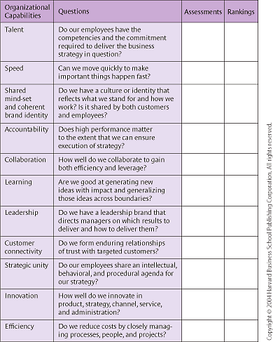

(Barratt‐Pugh, Bahn and Gakere, 2013)

Individual | organisational
Individual functional experience  - Technical expertise | Organisation’s core competence’s  Technical e.g managing risks
Leadership ability  - Communication, vision | Organisations capability  Culture,innovation and speeD

2.4. leadership in relation to change

“LEAdership produces change . That is its primary function” john P.Kotter

With today’s ever-changing and competitive environment, one approach leaders can take to create a competitive advantage is to foster an organizational climate that encourages and supports change and creativity These leaders are concerned about the transformation of both the organization and the individuals within it, and to that end influence their followers to transcend their own self-interests for the good of the group by raising their commitment to the importance of the organization’s vision. It involves binding employees around a common purpose. These leaders act “as change drivers, actively involved in creating an environment and culture that foster change and growth leadership involves two roles: an instrumental role in which the leader has the knowledge to design the change and a charismatic role in which the leader has strong interpersonal skills. (Graetz, 2000) . Bass work (1985 ) categorized leaders into three types: transformational, transactional, and laissez-faire.

At the employee level, an effective transformational leader changes the values, beliefs, and attitudes of followers (Podsakoff et al. 1990).Graetz also argued that An effective transformational leader is able to foster a psychological climate that embraces readiness for change. laissez-faire leaders are detri-mental to these organizations’ efforts toward revitalization and change. laissez-faire leaders provide no support and no direction to their employees. These leaders do not create a psychological climate that encourages new ideas and suggestions. In fact, (Hetland et al., 2011)argued that laissez-faire leaders “who neglect their duties are in fact likely to create a climate of uncertainty, confusion, and frustration, in which learning and creativity will be difficult, if not impossible” . Thus it can be hypothesized that laissez-faire leadership will be negatively related to psychological climate for organizational change, Nevertheless Transactional leadership was not related with any of the psychological climate of change. A transactional leader is one who works within the existing organizational culture and may be more risk averse than a transformational leader and thus will not be as likely to support employee creativity which can lead to resistance to change if the bottom up approach is not implemented. Consequently transactional leadership has some positive attributes to change but significantly less than Transformational leadership. The impact of technology; hard skill needs and then soft skill needs at three levels (entry, supervisory and senior management). (Woods, Doherty and Stephens, 2021) The more significant quality is emotion intelligence and being visionary. The need of hybrid leaders is becoming essential. Retail is becoming a more attractive sector to work in. This is primarily due to the growing influence of technology, which is replacing mundane tasks with a dynamic and inter- active environment. This development may help the retailer to attract and retain talent . finally he role of leadership is increasing capabilities both of the individual and the organisation.

t

2.5 TESCO CULTURE
“In most organisational change efforts , it is much easier to draw on the strengths of the culture than to overcome the constraints by changing the future “..Edgar schein

. According Edgar Shien Organizational culture consists of three parts: artifacts, espoused values, and underlying assumptions. When trying to implement change this parts can explain the resistance, irrational behaviour, and fear . on the other hand it is a powerful force that motivate individual effort or damage morale.
Tesco does not display a dominate culture model it has fragments of other models due to its size and geographical operations as a multinational company dealing with cultural diversity. With moving environment the culture had to change to fit the competitive market. |A strong model that resonates with

hofstede

A Dutch social psychologist Geert Hofstede was fascinated by the consequences of cultural differences for international communication and management, Hofstede developed a six-dimensional framework for discerning the phenomenon of cultural difference. His framework finds numerous practical applications in fields like international business negotiations, global marketing,. The model is applicable in Tesco’s frame work

HANDY ORGANISATIONAL CULTURE

handy model of organisational culture, developed by Charles handy (1999)and Roger Harrison (1972) and is mainly how the power is distributed in an organisation and specific levels of cooperation with the bottom up approach the employees have a say in operations and the top to bottom approach only specific group make decisions (tools hero, 2022)The model also classifies organisational cultures into four major types:
The power culture, The role culture, The task culture, and The person or support culture. None of the four types can claim to be better or superior; they are each suited to different types of circumstances. including different types of personalities.

Role culture
Tesco is a highly structured environment where clear systems . This culture shares a number of factors in common with Weber’s description of the ‘ideal-type’ bureaucracy. In the organisation level Tesco has different subsidiaries with a band of management at the top

Employees are almost always judged solely on how well they meet their targets and there are procedures in place. This makes the work dependable and there is less stress however this can create automatons that simply follow rules ,hindering creativity .

Task culture
Task culture ask culture depends on teamwork to produce results. Groups, project teams or task forces are formed for a specific purpose and can be re-formed, abandoned or continued. The organisation can respond rapidly since each group of contains all the decision-making powers an example of this is Tesco “Red Door” initiative.

changes in the culture based on the ‘change

- Work place culture
- Complexity and diversity of consumers behaviour due to increased use of
technology
- Need to increase organisation capability through training
- Challenges in customer and staff loyalty due to increased knowledge.
- Increased customer experience in store due to faster ques
- Consumer awareness

the impact of culture on the change process within organisations

One of the major impact of the culture change is “burnout” Burnout” refers to “a loss of enthusiasm for work, negative feelings and cynical attitudes and low sense of personal accomplishment” (Maslach and Leiter, 2008), Staff shortages, causing work overload .This resulted to poor performance which was reflected customers reviews . (in, 2022)
Much of the disruption was are result in changes to job roles and to the tasks performed by individuals rather than job losses.as in the case of “jacks “closure " (News, 2022) Tesco promised relocation of staff. Technology necessitate the provision of new hard skills but, importantly, reinforced the necessity for soft skills . New job roles that were previously not in retail have been created Cyber security ,Data analysis, and software development. Are some of the examples. However the challenge is ,this are highly sort out skills and are also needed in other sectors subsequently lead to staff shortages. Upskilling the internal staff comes with a dilemma of which skill to embrace.
.
Work place culture changed .Creativity, teamwork, decision making, and innovation are all enhanced by a strong workplace culture .Employees had to work from home loneliness and isolation are some of the impact of technology .

Use of technology meant that keeping customer loyalty was difficulty due to easy access to caparison sites increasing competition. Staff were also able to migrate to other jobs .

Customers are no longer tied to 9-5 working hours 24/7 shopping whenever, has been extremely helpful and convenient with free deliver, online sales , greater choice and opportunity for price comparison subsequently this has moved the customer away from the high street known as the” great retail brick and mortar apocalypse” (Supply and Demand Chain Executive, 2018)
Dealing with frustrated customers increased customer complaints in Dublin Tesco had to close part of its branch when customers refused to abide to the social distancing rules and being nasty to staff. (Berry, 2020)

2.5 change agents

Change agents can be defined as a leader charged with understanding the change, establishing just how it will affect the team, and communicating that information to everyone, to ensure they’re all happy to go on the journey together. However Klein (1976) describe change agents as "undeserving victims of the irrational and dysfunctional responses of change recipients" ,Internal change agents seek to determine strategies to facilitate the change process; whereas the change recipient endeavours to determine how the change will directly affect them.

Tesco has been in constant change and used internal and external change agents in form of different teams leads and departments heads in the organisation ,to explore commonalities and differences across departments in their view of the desired change .
some of the departments listed below:

- Training and development
- Total Quality management
- Customer service
- Human resource Department

The role of the agents were to work through departments to decimate good practice ,corporate value for corporate cohesion using different strategies to manage the change. The advantage of this is that internal agents have extensive experience in the company's processes and technologies already ,and using them is a cost effective approach .however this causes “”burnout because of additional work bestowed to the managers. employing external agents have been know not to be desirable as too many new faces, and the change agents begin to lose vital credibility with line managers and staff. Also it takes longer to build strong relationships needed for the role(McKinsey & Company, 2017)however a positive aspect is , External agents are not involved with internal politics, they also come with better skill and knowledge and are objective to change the challenge is making strong relationship appropriate for change can be slow (McKinsey & Company, 2017)

.

3.0 CONCULSION

The results of the analysis has yielded interesting findings Tesco’s Technology change was due to |Micro and Macro environmental factors. The factors have affected stakeholders . The analysis and concepts of models used in the change help in mitigating threats and managing risks and also tracking progress, likewise, there is strong evidence that leadership is crucial in the change process . Thus ,Transformation leadership style and qualities were required for the change additionally the leader has to be visionary and have emotional intelligence However, there were challenging complex areas that needed Top management and use of external agents. External agents are preferred especially in complex issues like delivering bad news. The complex areas were mainly due to the impact of culture change and the need of new skills . Further need in building resilience and increase organisation and individual capability has been identified .

4.0 recommendation

Area of development to improve change planning and implementation | Actions to be taken  i.e. training | Priority  Low/medium/high  Explain decision | Support and development  Internal or external | Review  dates | Other  comments
Resilience and stress coping | Counselling and coaching | High  To reduce stress and anxiety causing resistance and absenteeism | external | 28/3/2022 | Source consultant
Digitalised leaders | Training &  recruiting | High  increase  competence | Internal and  external | 29/3/2022 | Yearly
Customer engagement | Resolve complaints and take feedback | High  To safe guard brand name and | Internal  Customer service | daily | Weekly meetings
Compliance | training | High  To update operations legal requirement | external | Periodically | Review immediately after change occurs.
Change agents | training | High  Improving skill sets | external | 28/3/2022 | annually

APPENDICE 1

POLITICAL
ON 31ST January 2019, the UK announced the withdrawal from the European Union with an extensions. Brexit finally happened in in 31st Jan 2020. After lengthy negotiations. The political change affected Tesco in numerous ways.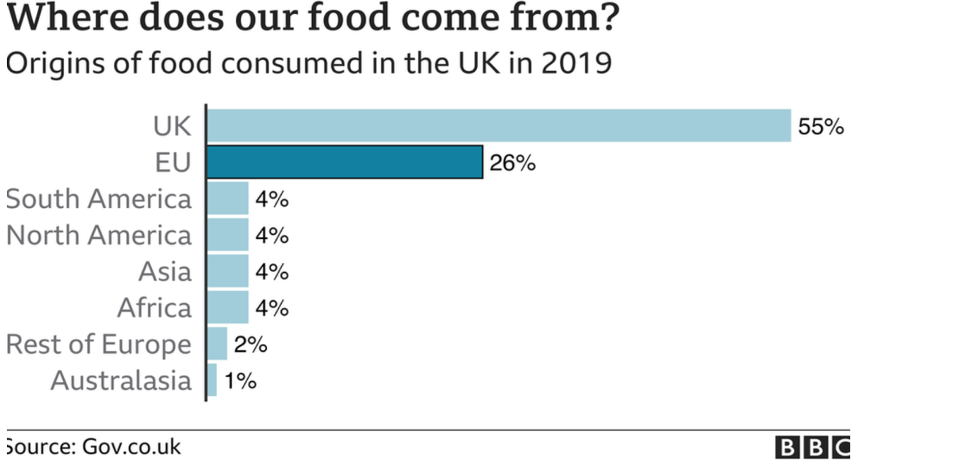
26%of food comes from the Eu . Brexit had an effect on food prices and also additional customs paperwork (News, 2020a)
The conflict in Ukraine is driving energy prices higher ,petrol
ECONOMIC
Inflation in the UK is rising with prices rising from month to month. In the last 12 months prices rose by 5.5 % (News, 2022b) The average pay is not keeping up affecting sales. Also competitive wages due to staff shortage due to Brexit could mean Tesco have to increase wages to keep staff especially lorry drivers affect cost effective strategy.
Increase interested rates twice by the bank of England in the last three
Months. Rising grocery prices causing a lot of panic to families (Badger, 2022)

SOCIAL
Consumer buying trends have changed which in return has made Tesco invest more online presence and social media platforms like Facebook, Instagram for more customer engagement. Animal right campaigns, vegan products, panic buying through covid.

TECHNOLOGICAL
There has been investment in technological investment such as
Drone trial in Scotland , Self-checkouts scan and go being very popular during the pandemic this has helped reduce the spread of the disease and also create mored suitable customer experience.

LEGAL

Brexit has resulted in more paper work , to comply with international law
Laws have been made to protect the consumer like changing prices clearly labelling products this caused a closure in one of Tesco shops in Dublin .
Change in government policies like monitoring and adressing age and gender bias to maintain its reputation.

ENVIROMENTAL
Climate change, Tesco is committed to reducing the carbon footprint of goods and minimizing plastic use and waste in the shop by being more conscience (tesco,2021)
Tesco SWOT Analysis

Strength  - Customer focused  - Online shopping, provides ease to those that cant travel to store  - Training and partnering with employees. Provides sense of worth and loyalty to organisation  - Advanced technology usage eg scan and go, mobile payment app and system that count products automatically for the customer.  - Leading grocery store in the UK with a revenue of £57.8billion in fiscal year 2021 (Tesco annual report)  - Diversified geographically. Tesco has several stores in other countries compared to the other retail stores in UK | Weakness  - High costs in logistics and operations to keep up with competitors  - Unfair treatment of suppliers. They have been in the news for several years for mistreating their suppliers. In one occasion not paying and even offering less deals  - Due to the mistreatment, this has led to negative publicity. In June 2020, Tesco’s shareholders voted against a greedy decision to inflate the bonuses paid to a departing chief executive by $1.98 million to over $2.8 million.
Opportunities  - Due to health risk, more cashless stores have been created. Tesco opened their first and are due to open more cashless stores  - Price matching- Tesco launched Aldi price match on hundreds of items In attempt to avoid loss in market share to Aldi  - New one hour delivery options. Over 100 stores in UK now offer one hour delivery | Threats  - Covid-19- this complicated supply and transport due to the government restriction during the pandemic  - Brexit- Britain no longer in the European Union, therefore increase in costs  - Rivals such as Aldi, Lidl and ALDI have been the main competitors for Tesco in terms of price

Change models

Appendice 2 TESCO SWOT ANALYSIS
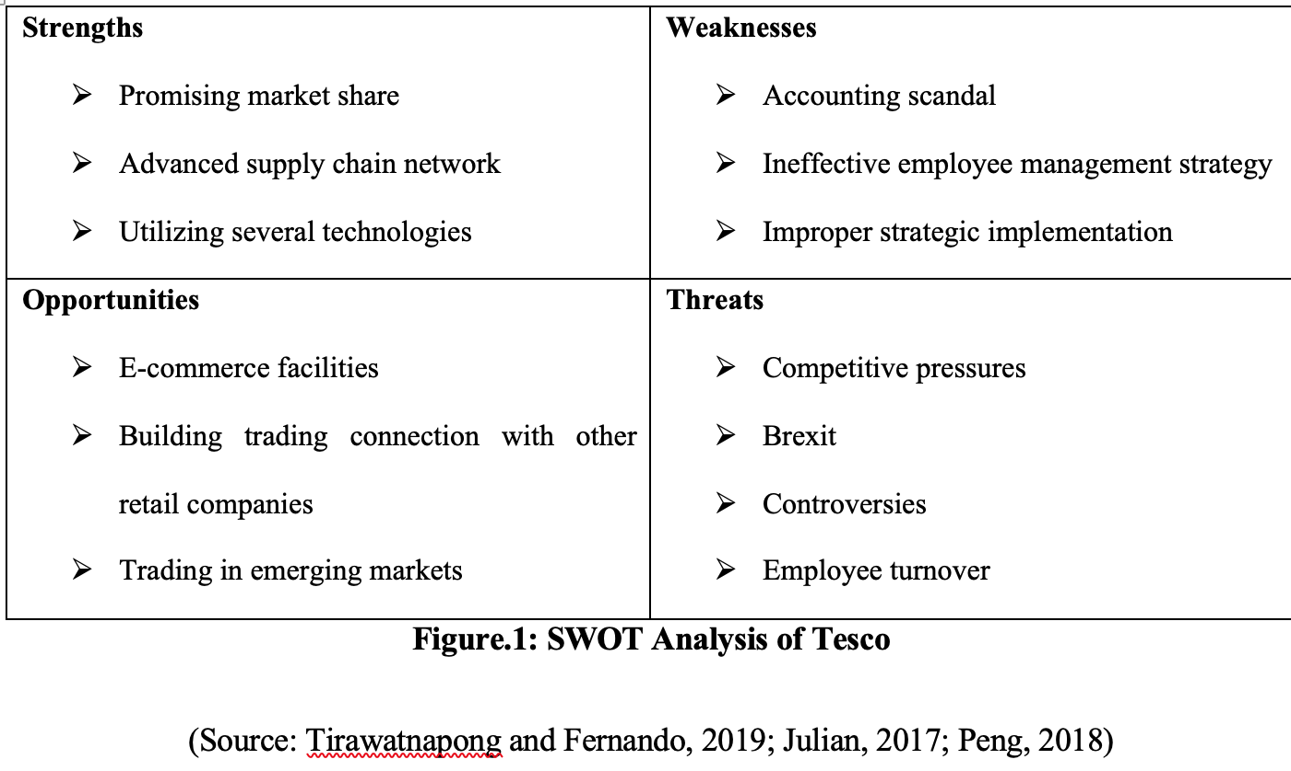
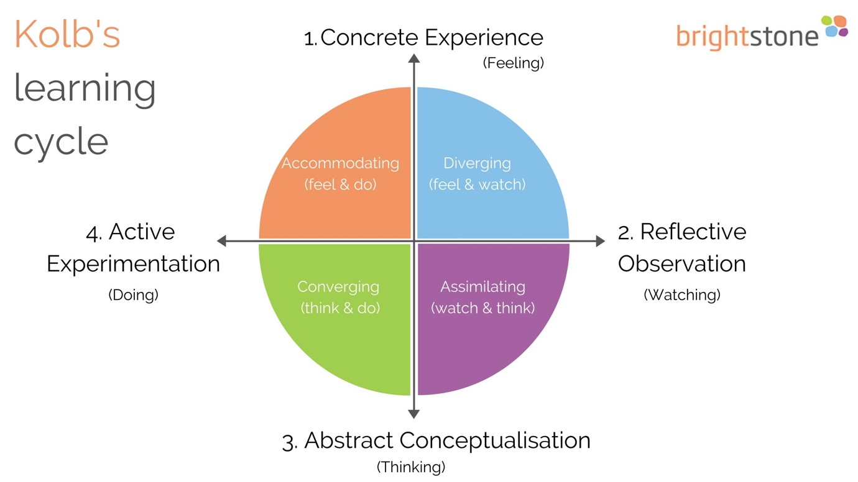

driving force | restricting force
- competition  - customer demands  - new entrants  - Technology | - organisational capability  - pestle factors  - market instability  - economic factors/fear of losing jobs bottom up approach used to reduce resistance

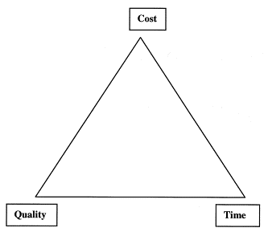
The Iron Triangle.

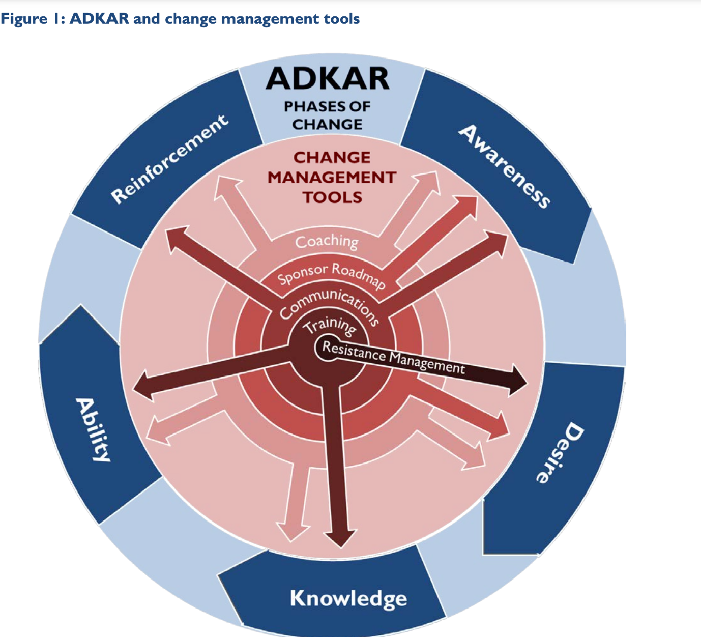
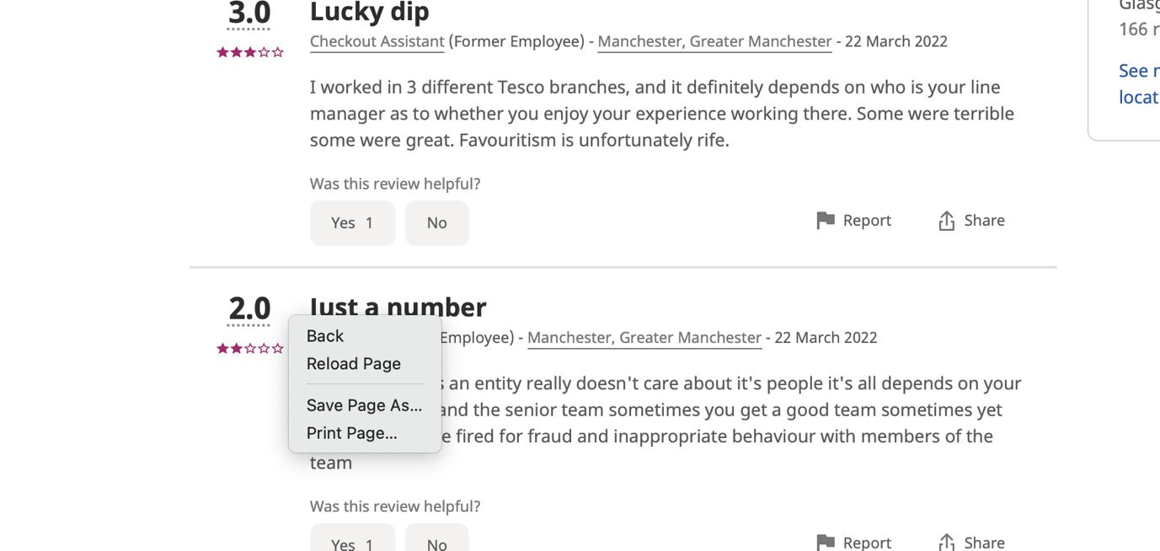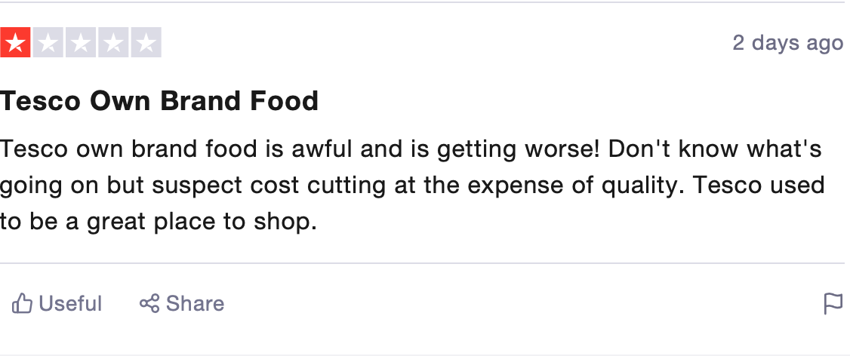

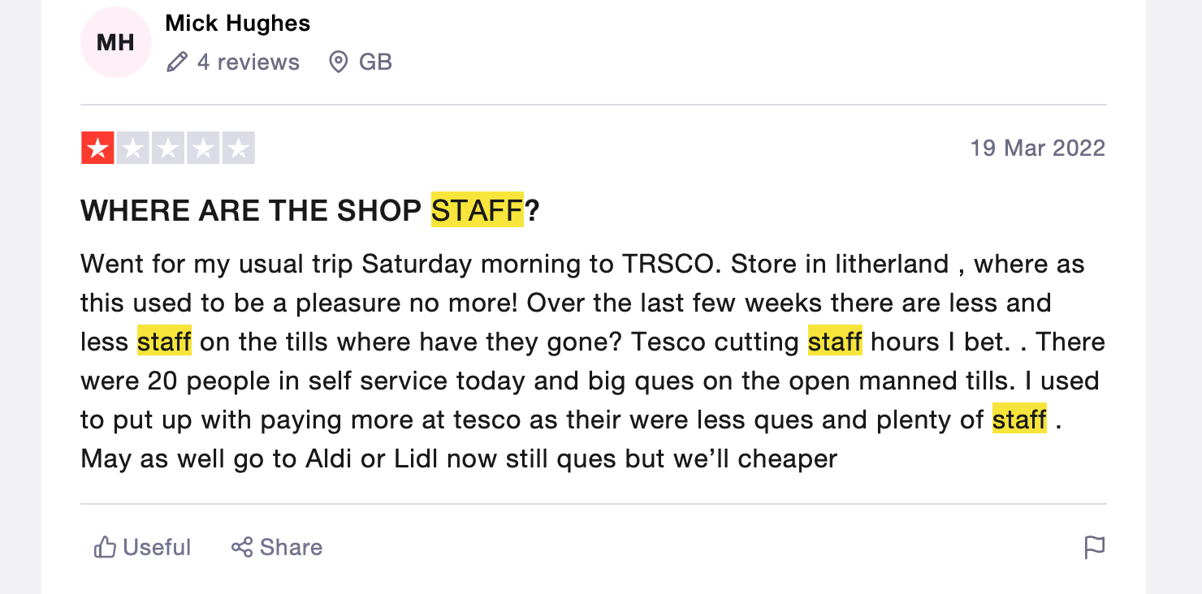

Reference list
Barker, M. (2021). Tesco sees strong online growth but stresses need to ‘plan for all eventualities’ – Marketing Week. [online] Marketing Week. Available at: https://www.marketingweek.com/tesco-sees-strong-online-growth-but-is-planning-for-all-eventualities/ [Accessed 30 Jan. 2022].
Bloom, N., Bunn, P., Chen, S., Mizen, P., Smietanka, P. and Thwaites, G. (2019). Brexit Is Already Affecting UK Businesses — Here’s How. [online] Harvard Business Review. Available at: https://hbr.org/2019/03/brexit-is-already-affecting-uk-businesses-heres-how> [Accessed 30 Jan. 2022].
Butler, S. and Farrell, S. (2014). Tesco must change culture and reinvent brand, new boss tells employees. [online] the Guardian. Available at: https://www.theguardian.com/business/2014/sep/26/tesco-must-change-culture-reinvent-brand [Accessed 30 Jan. 2022].
Charged Retail Tech news (2020). Tesco will trial drone deliveries from October - Latest Retail Technology News From Across The Globe - Charged. [online] Latest Retail Technology News From Across The Globe - Charged. Available at: https://www.chargedretail.co.uk/2020/09/10/tesco-will-trial-drone-deliveries-from-october/ [Accessed 30 Jan. 2022].
Connelly, M. (2022). The Kurt Lewin Model Of Change. [online] Change Management Coach. Available at: https://www.change-management-coach.com/kurt_lewin.html [Accessed 30 Jan. 2022].
De Kervenoael, R., Hallsworth, A. and Clarke, I. (2006). Macro-level change and micro level effects: A twenty-year perspective on changing grocery shopping behaviour in Britain. Journal of Retailing and Consumer Services, [online] 13(6), pp.381–392. Available at: https://www.sciencedirect.com/science/article/pii/S0969698906000130 [Accessed 28 Jan. 2022].
Edie Newsroom (2020). Tesco to help customers visualise the environmental impact of their shopping. [online] edie.net. Available at: https://www.edie.net/news/7/Tesco-to-help-customers-visualise-the-environmental-impact-of-their-shopping/ [Accessed 1 Feb. 2022].
Field, C. (2017). Tesco Labs: the drive for new technology - Retail Connections. [online] Retail Connections. Available at: https://www.retailconnections.co.uk/articles/tesco-labs-drive-new-technology-2/#:~:text=Tesco%20Labs%3A%20the%20drive%20for%20new%20technology%201,...%204%20Ecosystems.%20...%205%20Voice%20control.%20 [Accessed 30 Jan. 2022].
Fleming, M. (2020). Tesco on how Covid-19 helped it to ‘really be at its best’. [online] Marketing Week. Available at: https://www.marketingweek.com/tesco-covid-19-brand-be-at-best/ [Accessed 30 Jan. 2022].
Insider Intelligence (2016). Consumer-generated content helps drive online sales. [online] Business Insider. Available at: https://www.businessinsider.com/consumer-generated-content-helps-drive-online-sales-2016-5?IR=T [Accessed 30 Jan. 2022].
investor in the people (2019). 6 Traits of a Successful Change Agent. [online] Investors in People. Available at: https://www.investorsinpeople.com/knowledge/successful-change-agent/ [Accessed 12 Jan. 2022].
Javid, M. (2018). how does technology affect Tesco. [online] prezi.com. Available at: https://prezi.com/dij8g0peegyp/how-does-technology-affect-tesco/ [Accessed 30 Jan. 2022].
Kantar, R. (2012). Ten Reasons People Resist Change. [online] Harvard Business Review. Available at: https://hbr.org/2012/09/ten-reasons-people-resist-chang [Accessed 30 Jan. 2022].
KAPLAN FINANCIAL KNOWLEDGE BANK (2012). Stakeholder analysis. [online] Default. Available at: https://kfknowledgebank.kaplan.co.uk/business-strategy/stakeholder-analysis [Accessed 7 Apr. 2022].
McKinsey & Company (2017a). The change agent challenge. [online] McKinsey & Company. Available at: https://www.mckinsey.com/business-functions/operations/our-insights/the-change-agent-challenge [Accessed 12 Jan. 2022].
McKinsey & Company (2017b). The change agent challenge. [online] McKinsey & Company. Available at: https://www.mckinsey.com/business-functions/operations/our-insights/the-change-agent-challenge [Accessed 31 Mar. 2022].
McKinsey & Company (2017c). The change agent challenge. [online] McKinsey & Company. Available at: https://www.mckinsey.com/business-functions/operations/our-insights/the-change-agent-challenge [Accessed 31 Mar. 2022].
Mindtools (2020). Porter’s Five Forces - The Framework Explained: Analyzing Competitiveness Using Michael Porter’s Strategic Model. [online] Mindtools.com. Available at: https://www.mindtools.com/pages/article/newTMC_08.htm [Accessed 30 Jan. 2022].
Morris, J. (2019). VRIO Analysis. [online] Oregonstate.education. Available at: https://open.oregonstate.education/strategicmanagement/chapter/4-vrio-analysis/ [Accessed 7 Apr. 2022].
Nazir, S. (2022). Tesco posts rise in vegan food sales during Veganuary - Retail Gazette. [online] Retailgazette.co.uk. Available at: https://www.retailgazette.co.uk/blog/2022/01/tesco-posts-rise-in-vegan-food-sales-during-veganuary/ [Accessed 30 Jan. 2022].
News, B. (2018). Tesco trials shopping without tills. [online] BBC News. Available at: https://www.bbc.co.uk/news/business-44654797 [Accessed 30 Jan. 2022].
News, B. (2021). Tesco opens its first checkout-free store. [online] BBC News. Available at: https://www.bbc.co.uk/news/business-58951984?at_medium=RSS&at_campaign=KARANGA [Accessed 30 Jan. 2022].
Peterson, L. (2018). Building Resilience Through Mentoring - Lesley Petersen Consulting. Lesley Petersen Consulting. [online] 3 Apr. Available at: https://petersen.consulting/building-resilience-through-mentoring [Accessed 9 Dec. 2021].
Plus500 (2022). Tesco | TSCO-L CFDs | Plus500. [online] Plus500.com. Available at: https://www.plus500.com/en/Instruments/TSCO-L?ncc=true&id=1408&tags=bi_sr+110314565_cpi+UKSearchStocks_cp+1219358568139355_agi+Stocks.Tesco_agn+tesco+shares_ks+kwd-76210039208368%3aloc-188_tid+be_mt+c_de+o_nt+_ext+69174_loc+UURL&=%d7%90&msclkid=dfa1139d8c3711d376c07269aa001245&utm_source=bing&utm_medium=cpc&utm_campaign=UKSearchStocks&utm_term=tesco+shares&utm_content=Stocks.Tesco [Accessed 28 Jan. 2022].
Pratap, A. (2017). Microenvironmental factors affecting business - notesmatic. [online] notesmatic. Available at: https://notesmatic.com/microenvironmental-factors-affecting-business/#:~:text=Micro-Environmental%20Factors%20in%20Business%201%20Customers%3A%20Customers%20are,21%20st%20century%20needs%20a%20strong%20brand%20image. [Accessed 31 Jan. 2022].
Richardson, D. (2022). Is Tesco Clubcard Pay+ any good? – Which? News. [online] Which? News. Available at: https://www.which.co.uk/news/2022/01/tesco-bank-rolls-out-tesco-clubcard-pay-for-all-customers-is-it-worth-trying/ [Accessed 30 Jan. 2022].
Roubler (2020). Roubler. [online] Roubler UK. Available at: https://roubler.com/uk/resources/blog/category/innovation-technology/ [Accessed 31 Jan. 2022].
Statista (2017). Great Britain: Grocery market share 2017-2021 | Statista. [online] Statista. Available at: https://www.statista.com/statistics/280208/grocery-market-share-in-the-united-kingdom-uk/ [Accessed 30 Jan. 2022].
Stevens, B. (2021). Tesco opens its first checkout-free store. [online] BBC News. Available at: https://www.bbc.co.uk/news/business-58951984?at_medium=RSS&at_campaign=KARANGA [Accessed 30 Jan. 2022].
Tesco (2019). COVID-19 UPDATE AND PRELIMINARY RESULTS 2019/20. [online] Tesco PLC. Available at: https://www.tescoplc.com/news/2020/preliminary-results-announcement-2020/ [Accessed 30 Jan. 2022].
Tesco (2022). COP26. [online] Tesco PLC. Available at: https://www.tescoplc.com/cop26/ [Accessed 28 Jan. 2022].
tesco (2018). Tesco. [online] Instagram.com. Available at: https://www.instagram.com/tescofood/?hl=en [Accessed 30 Jan. 2022].
tesco (2021). youtube tesco tech - Bing video. [online] Bing.com. Available at: https://www.bing.com/videos/search?q=youtube+tesco+tech&docid=608013729753936624&mid=9FC46905C8D057C0D3449FC46905C8D057C0D344&view=detail&FORM=VIRE [Accessed 30 Jan. 2022].
warrilow (2019). Where Kotter’s 8 Steps Gets it Wrong. [online] Strategies-for-managing-change.com. Available at: https://www.strategies-for-managing-change.com/where-kotters-8-steps-gets-it-wrong.html [Accessed 30 Jan. 2022].
Woods, R., Doherty, O. and Stephens, S. (2021). Technology driven change in the retail sector: Implications for higher education. Industry and Higher Education, [online] p.095042222110091. Available at: https://journals.sagepub.com/doi/10.1177/09504222211009180.

