

Module name: Changemakers: Building your Personal Brand for Sustainable Employment
Module number: (BMHP5015_BIRM)
Student name: Melania Ciornei
Student number: 2329516
Lecturer name: Tsiwani Khumalo

PORTFOLIO

Table of content

Task 1: Personal Brand .............................................................................................. 3
Task 2: Network Map Rationale ................................................................................. 4
Task 3: Blog – Anxiety in Teenagers .......................................................................... 5
Task 4: NHS Equality, Diversity and Inclusion ………………………........................... 7
Task 5: Letter to Yourself ........................................................................................... 9
Task 6: Gantt Chart .................................................................................................. 10
Task 7: Making Changes ...........................................................................................11
Task 8: Self-Reflection ............................................................................................. 12
References ............................................................................................................... 13

Task 1
Personal Brand
My employment goal is to become an Occupational Therapist working within the health and social care sector in community or clinical settings. My personal brand reflects how I present myself professionally and the value I offer to employers in caring roles. Personal branding involves strategically communicating skills, values and professional identity (Gander, 2014).
Currently, my personal brand is centred on reliability, professionalism and a commitment to learning. I demonstrate organisation, reflective practice and ethical awareness, which are essential in health and social care. Through academic coursework and independent study, I have developed research, analytical and time-management skills, strengthening my understanding of supporting young people’s mental health (Fitzgerald, 2020).
However, my personal brand remains academically focused and lacks practical experience in clinical settings. This creates a gap between my current skills and employer expectations, particularly in communication and relationship-building.
My target audience includes health and social care employers, placement providers and recruiters. To develop my personal brand, I will update my LinkedIn profile to clearly present my skills and goals and seek volunteering or placement opportunities to gain practical experience.
These actions will strengthen my professional identity and improve my readiness for employment.

Task 2
Network Map Rationale
My current network can be described as a hybrid structure reflecting different spheres of my life, including career, social relationships, personal support and community engagement. The network map illustrates relationships influencing my personal and professional development. Within this network, I have a strong bonding network mainly consisting of family members and friends who provide emotional support and stability. These relationships represent forms of social capital supporting trust and resilience within my immediate environment (Coleman, 1990; Putnam et al., 1993).
However, my bridging and linking social capital remain underdeveloped because many of my connections are concentrated within familiar educational and social environments, limiting access to wider professional opportunities (Claridge, 2020). Although I interact with classmates, lecturers and work colleagues, these relationships are often related to coursework or work responsibilities rather than strategically developed professional connections. As a result, my network lacks structural diversity, which may limit access to wider professional communities (Cullen-Lester and Pryor, 2025).
Bridging and linking ties provide access to knowledge and career opportunities beyond one's existing social group (Usha and Ferzana, 2009). To strengthen my network, I aim to develop relationships with lecturers and employers within the health and social care sector. Expanding these connections will support my future career as an Occupational Therapist (Phillips and Ellinas, 2014).
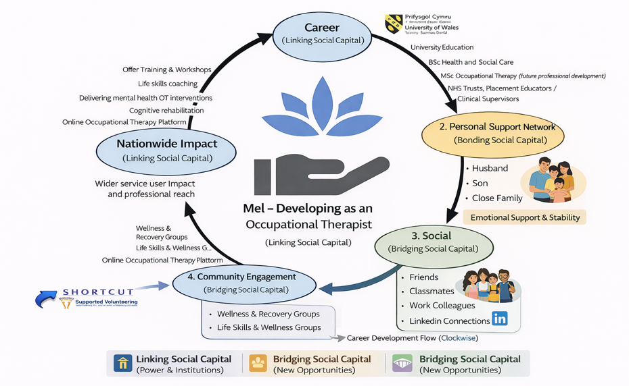
Figure 1. Personal/Professional Network Map Supporting Occupational Therapist Development

Task 3
Blog: Anxiety in Teenagers, a guide for parents.
Anxiety is one of the most common mental health challenges affecting teenagers today, and many parents and carers feel unsure how to recognise signs or respond. Adolescence is a period of emotional and social change, increasing vulnerability to anxiety. Research shows anxiety disorders often begin during adolescence and can continue into adulthood if not identified early (Merikangas et al., 2010). This blog aims to raise awareness of teenage anxiety and provide guidance to support families.
Understanding Teenage Anxiety
In the UK, 1 in 6 children and young people aged 7–16 have a probable mental health disorder, with anxiety among the most common conditions (NHS Digital, 2023). Globally, about 7% of adolescents experience an anxiety disorder (World Health Organization, 2021). While occasional worry is a normal part of growing up, persistent anxiety can affect wellbeing, academic performance and daily life (Mental Health Foundation, 2022).
Teenagers face pressures including academic expectations, peer relationships and social media. These factors are illustrated in the fishbone diagram below, highlighting academic, social and digital influences contributing to teenage anxiety. Online comparison and fear of failure can intensify stress (Wang et al., 2023). Anxiety may present as withdrawal, irritability or physical symptoms such as headaches, stomach aches or sleep difficulties.
How Can Parents and Carers Help?
Behavioural changes or school avoidance indicate distress. Creating a safe, non-judgemental space where teenagers feel heard is essential. Maintaining routines, encouraging sleep and setting boundaries around social media can support wellbeing. If anxiety significantly affects daily life, support from a GP may be necessary (Radez et al., 2022).
Conclusion
Early recognition, open communication and support can improve outcomes. By staying informed and supportive, parents and carers can help young people build resilience and healthier coping strategies. Nevertheless, because general strategies may assist in coping with anxiety, personal needs might also differ, and, therefore, the need to provide individual professional assistance cannot be underestimated.

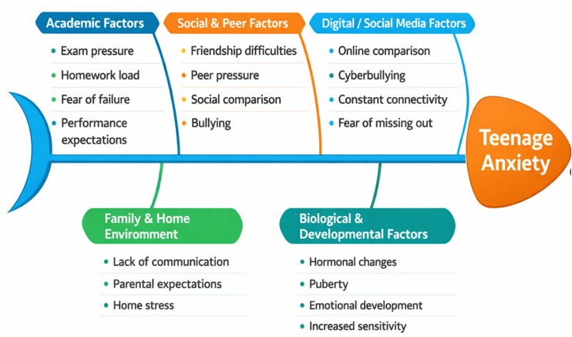Figure 2. Fishbone Diagram, Contributing Factors to Teenage Anxiety

Task 4
NHS Equality, Diversity and Inclusion
1. What is the primary goal of the NHS Equality, Diversity, and Inclusion Improvement Plan?
The NHS Equality, Diversity and Inclusion (EDI) Improvement Plan aims to create a fair and inclusive workplace where staff feel respected regardless of background. It aims to improve staff experience and reduce workforce inequalities (NHS England, 2023).
2. How does the NHS EDI Improvement Plan propose to tackle the gender pay gap?
The plan tackles the gender pay gap using transparent pay data, targeted action plans and fair recruitment and promotion processes to support women’s progression into senior roles (NHS England, 2023).
3. What is meant by the term ‘intersectionality’ as used in the NHS EDI Improvement Plan?
Intersectionality describes how different aspects of identity, such as race, gender and disability, overlap and create experiences of discrimination or disadvantage (Crenshaw, 1989).
4. Why is it important for the NHS to create a psychologically safe work environment?
Psychological safety allows staff to speak up and share concerns without fear. This supports wellbeing, learning and better patient care (Edmondson, 2019).
5.How does the NHS EDI Improvement Plan suggest improving the experience of internationally recruited staff?
The plan proposes improving induction, pastoral support and training so internationally recruited staff are supported and treated fairly (NHS England, 2023).
6. What role does leadership play in advancing EDI objectives according to the NHS Improvement Plan?
Leadership should set clear EDI goals, monitor workforce data and promote inclusive workplace cultures across NHS organisations (NHS Leadership Academy, 2021).
7. Identify one way the NHS EDI Improvement Plan aims to reduce health inequalities within the workforce.
One strategy to reduce workforce inequalities is analysing recruitment, pay and promotion data across protected characteristics and implementing targeted actions (NHS England, 2023).
8. Why does the NHS EDI Improvement Plan emphasise the importance of collecting and analysing data on protected characteristics?
Collecting workforce data helps organisations identify discrimination patterns and make evidence-based decisions to improve equality outcomes (NHS Workforce Race Equality Standard, 2022).
9. Explain how flexible working policies can contribute to equality and inclusion in the NHS workforce.
Flexible working policies support staff with caring responsibilities or disabilities, improving inclusion, wellbeing and retention (NHS People Plan, 2020).
10. What is one strategy mentioned in the NHS EDI Improvement Plan to combat bullying and harassment in the workplace?
The plan aims to reduce bullying and harassment by improving reporting systems and analysing staff survey data to strengthen accountability (NHS England, 2023).

Task 5
Letter to yourself
Melania Ciornei
12 Success Road
Manchester
M13 9PL
United Kingdom
25 March 2026

Dear Younger, Me,
I know that 2021 was one of the most difficult and painful periods of your life. Losing both your father and your sister in the same week felt overwhelming and almost impossible to process. One of the hardest moments was having to tell your mother, who had just buried her husband, that she had also lost her daughter. At the same time, you were raising your child as a single parent while continuing to work full time. The emotional pressure and responsibility you carried during that time were enormous.
I also know that you sometimes feel guilt when you think about your sister. You wonder if you could have done more for her, especially if she had told you she was ill. These feelings are a natural part of grief because when we lose someone we love, we often search for answers or ways we could have changed the outcome. However, it is important to remember that you cared deeply for your sister and would have supported her if you had known what she was going through.
Looking back now, you showed incredible resilience and emotional strength. Even while grieving, you continued to support your family and care for your child. This experience has helped develop your empathy and emotional intelligence, allowing you to better understand the struggles that others may face.
Although that time was filled with sadness, it has also shaped the compassionate and resilient person you are becoming today.
With love,
Mel
Task 6
GANTT Chart
The Gantt chart illustrates the planned timeline of academic and professional activities required to achieve my long-term career goal of becoming an Occupational Therapist. The first stage focuses on completing Level 5 coursework between May 2025 and March 2026, which depends on the successful completion of Level 4 modules. During this period, I am also undertaking voluntary work at Princess Royal Hospital from July 2025 to June 2026. This experience provides exposure to healthcare environments and helps develop professional skills such as communication, teamwork, and patient support. The next phase involves completing Level 6 modules between May 2026 and January 2027 while conducting dissertation research and writing from October 2026 to April 2027. These activities represent key academic requirements for completing my Bachelor of Science (Honours) degree. During this stage, I will also prepare and submit my application for the MSc Occupational Therapy (Pre-registration) programme.
Graduation in May 2027 represents an important milestone. Following this, I plan to complete the MSc programme between September 2027 and June 2029, including clinical placements. The final milestone is beginning my career as an Occupational Therapist in July 2029.
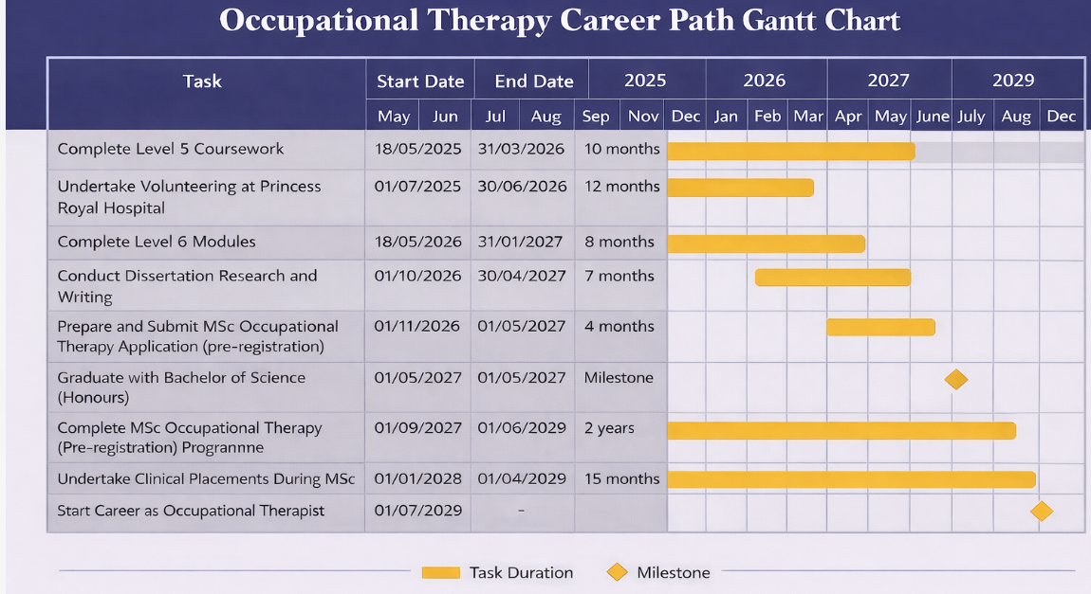
Figure 3. Gantt Chart Illustrating the Planned Career Path Towards Becoming an Occupational Therapist
Task 7: Making Changes
Report: Implementing a Staff Wellbeing Support Programme
As the manager of a care home, I plan to introduce a staff wellbeing support programme. Care home staff often experience high workloads, stress and burnout, which can negatively affect staff morale, and the quality of care provided to residents. Supporting staff wellbeing is therefore essential for maintaining effective health and social care services (NHS England, 2023).
Planning the Change
The first step is identifying the problem and setting clear objectives to improve staff wellbeing. Project management approaches suggest that change should begin with defining goals and planning activities before implementation (Simon and Murray-Webster, 2018). The programme will include regular staff wellbeing meetings, access to mental health support and flexible shift options where possible. A timeline will be developed to monitor progress and evaluate the effectiveness of the programme.
Skills Required
Leadership and communication skills are essential to explain the purpose of the programme and encourage staff participation. Time management and organisational skills will also be important to ensure the change is implemented efficiently and consistently (Cameron and Green, 2019).
Barriers and Solutions
Possible barriers include staff shortages, limited time and reluctance from staff to discuss wellbeing concerns. These barriers can be reduced by involving staff in decision-making, providing confidential support services and ensuring managers regularly check in with employees.
Conclusion
Introducing a staff wellbeing support programme can reduce burnout and improve job satisfaction. With effective leadership and planning, the change can enhance staff wellbeing and improve the quality of care provided to residents.

Task 8
Self-Reflection: Reflection Using Gibbs’ Reflective Cycle
Using Gibbs’ Reflective Cycle (1988), I have reflected on what I learned during this module and how it has developed my professional skills. Reflective practice is important in health and social care because it encourages professionals to analyse experiences and improve future practice (Gibbs, 1988; Bulman and Schutz, 2019).
Description
During this module I learned about employability, personal branding, networking, project management and reflective practice. I also completed activities related to goal setting and communication, which helped me understand the importance of planning my career development.
Feelings
At the beginning of the module I felt uncertain about how to present myself professionally and how to plan my career development. As the module progressed, I became more confident in recognising my strengths and identifying areas for improvement through reflective learning (Gibbs, 1988).
Evaluation
One positive aspect of the module was learning how reflective practice supports professional growth and continuous learning. However, I initially found reflective writing challenging because it required deeper analysis rather than simply describing experiences.
Analysis
Through reflection I realised that developing skills such as communication, teamwork and time management is essential in health and social care. Reflective practice also helps professionals evaluate behaviour and improve the quality of care provided (Schön, 1983).
Conclusion and Action Plan
Overall, this module has increased my self-awareness and understanding of professional development. In future practice, I plan to continue using reflective practice to evaluate my experiences, improve my communication skills and support my ongoing professional learning.

References List
Bulman, C. and Schutz, S. (2019) Reflective practice in nursing. 6th edn. Oxford: Wiley Blackwell.
Cameron, E. and Green, M. (2019) Making sense of change management: A complete guide to the models, tools and techniques of organizational change. 5th edn. London: Kogan Page.
Claridge, T. (2020) Social capital research. Available at: https://www.socialcapitalresearch.com (Accessed: 17 March 2026).
Coleman, J.S. (1990) Foundations of social theory. Cambridge, MA: Harvard University Press.
Crenshaw, K. (1989) ‘Demarginalizing the intersection of race and sex: A Black feminist critique of antidiscrimination doctrine, feminist theory and antiracist politics’, University of Chicago Legal Forum, 1989(1), pp. 139–167.
Cullen-Lester, K. and Pryor, M. (2025) The social capital of leaders: Networks and relationships in organisations. London: Routledge.
Edmondson, A.C. (2019) The fearless organization: Creating psychological safety in the workplace for learning, innovation, and growth. Hoboken: John Wiley & Sons.
Fitzgerald, C. (2020) Supporting mental health in health and social care. London: Routledge.
Gander, M. (2014) ‘Personal branding and employability’, Journal of Brand Management, 21(3), pp. 192–199.
Gibbs, G. (1988) Learning by doing: A guide to teaching and learning methods. Oxford: Oxford Polytechnic.
Merikangas, K.R. et al. (2010) ‘Lifetime prevalence of mental disorders in U.S. adolescents: Results from the National Comorbidity Survey Replication – Adolescent Supplement (NCS-A)’, Journal of the American Academy of Child & Adolescent Psychiatry, 49(10), pp. 980–989.
Mental Health Foundation (2022) Children and young people’s mental health statistics. London: Mental Health Foundation.
NHS Digital (2023) Mental health of children and young people in England. London: NHS Digital.
NHS England (2023) NHS equality, diversity and inclusion improvement plan. London: NHS England.
NHS Leadership Academy (2021) Developing inclusive leadership in the NHS. London: NHS Leadership Academy.
NHS People Plan (2020) We are the NHS: People plan for 2020/21. London: NHS England.
NHS Workforce Race Equality Standard (2022) Workforce race equality standard report. London: NHS England.
Phillips, N. and Ellinas, C. (2014) ‘Understanding the role of networks in organisations’, Organization Studies, 35(4), pp. 479–501.
Putnam, R.D., Leonardi, R. and Nanetti, R. (1993) Making democracy work: Civic traditions in modern Italy. Princeton: Princeton University Press.
Radez, J. et al. (2022) ‘Why do children and adolescents with mental health problems not seek help? A systematic review of barriers to accessing professional help’, European Child & Adolescent Psychiatry, 31(1), pp. 1–22.
Schön, D. (1983) The reflective practitioner: How professionals think in action. New York: Basic Books.
Simon, P. and Murray-Webster, R. (2018) Making sense of project management: A structured approach to managing projects. London: Routledge.
Usha, C. and Ferzana, H. (2009) ‘Social capital and networking in professional environments’, Journal of Management Development, 28(6), pp. 512–526.
Wang, P.S. et al. (2023) ‘Use of mental health services for anxiety, mood, and substance disorders’, The Lancet Psychiatry, 10(3), pp. 195–204.
World Health Organization (2021) Mental health atlas 2020. Geneva: World Health Organization.

