Materials and Processing report - Max Oliver (2218428)
Rubber Properties
Introduction
In this report we will be discussing and testing the properties of rubber using the scientific method. This will include Maximum Tensile Strength and the Youngs Modulus of rubber. Rubber is a polymer which can be found in nature (Rubber trees) or synthesised in a lab or industrial environment. Rubber is extremely versatile and is used for many different tasks all over the world from cable insulation to car tyres to erasers, rubber is extremely versatile. It has a very high friction coefficient which means that it can get a good grip on many surfaces. Rubber loosens slightly when it is heated and can melt and becomes brittle when subjected to cold temperatures. Rubber is also very elastic and when expanded it tries to contract to the original state. We are going to use this property of rubber to test its Youngs Modulus and Tensile strength by using weights to stretch some elastic bands.
Experiment:
Kit list-
-An elastic band (5mm width 1mm thickness)
-A metal rule
-A load bearing carabiner
-1.5ft of climbing rope
-10kg of 0.4kg masses including a mass holder
-6ft of string
-A 30cm ruler
-A load bearing stand 2m off the floor
-A roll of Sellotape
Method
First we looped the rope through the carabiner and tied the rope to the stand and knotted the rope at the top so the carabiner hung below. Next we loop our elastic band through the carabiner. On the stand we taped the meter rule so that the tip of the rule was lined up with the top of the elastic band which was draped over the bottom ledge of the carabiner. We made sure the metre rule pointed straight down parallel to the rope, carabiner and band. Now we used our ruler to measure the thickness and width of the elastic band and recorded these values. We created a table with columns to record Mass added, Total Mass, Length and stretch. Every time we add weight we record each of these variables. First we took a recording with no mass to get the original length and area of the band and then we added masses in increments of 0.4kg at a time onto the mass holder which itself weighs 0.5kg. We continued repeatedly adding weight and recording our results until our band snapped. Note eventually our lengths of band extended past our rule and we had to use both rulers together in order to record accurate length. Also before any extra mass is added we tied the string to the mass holder and then tied both ends of the string to our stand with 0.6m of slack either side, this was so when the band snapped and our weights dropped the string help the masses and prevented and damage to the equipment.
Results

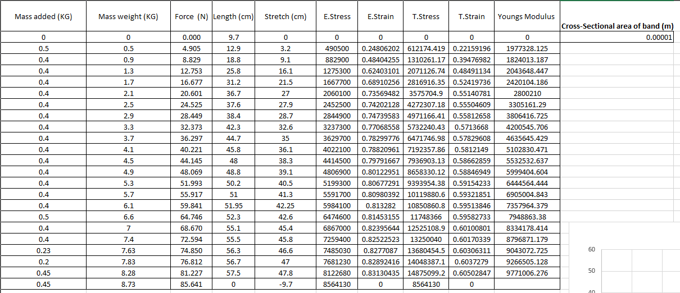

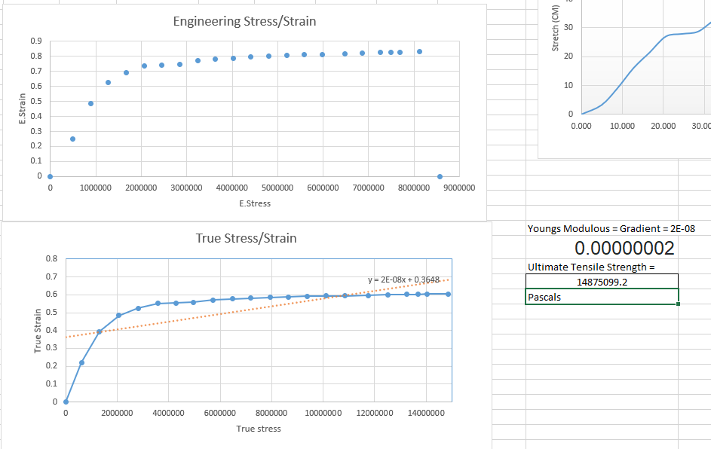

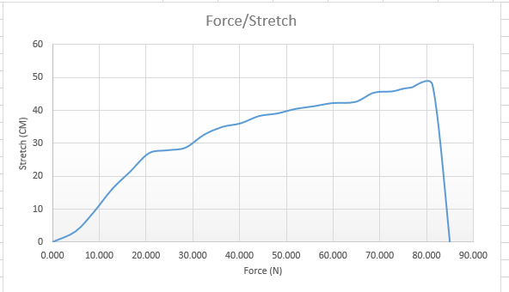

Analysis
Equations used,
E.stress = Force/Area
E.Strain = Stretch/Original Length
T.stress = E.stress*(1+E.strain)
T.strain = ln(1+E.strain)
Youngs Modulus = Gradient of T.stess/strain graph
Our Stress and strain increased steadily as mass was added and the force increased up until just over 80N where our rubber snapped and we met our Ultimate tensile strength. Long before this however we reached the Elastic and Plastic limits of the rubber band. We can see this by looking at both of the stress and strain graphs. Initially the curve has a large gradient which softens out and decreases exponentially around 2000000 Pascals. We can use this drop off in gradient to see that even if the masses were removed the band would no longer be able to retake its original shape. To get the young’s Modulus we plotted a trend line on the True Stress/Strain graph and by plotting the linear equation for this line we can find the gradient which is equal to the Young’s Modulus. Our result for Y.M was 2*10^-8. To find the Ultimate Tensile Strength we found our last value for T.stess before our band snapped which was around 14.8*10^7 pascals.
Discussion
Our result for Young’s Modulus was significantly lower than the average for soft rubber. This could be due to a fault in our value recording or calculations. Our value for ultimate tensile strength was similar to the average for soft rubber which is around 16*10^7 pascals. 14.8/16 * 100 = 92.5% accuracy.
In order to increase the accuracy of our results given more time we could use upto 5 rubber bands and then take an average of all the results to increase accuracy. We could also increase the mass in smaller and smaller increments in order to get a much more accurate picture of how the rubber responds to the force as well as a better value for UTS. Both of these methods would take a significantly longer amount of time then was used for testing.
Conclusion
To conclude, our experiment produced useful results which game us an accurate value for UTS within 10% however an inaccuracy in plotting the data or one or more of the equations used caused a value for Youngs Modulus which was incorrect by a significant magnitude. This experiment could be improved endlessly with time as money by increasing the sample size.
Acknowledgements
Thanks to Dewi Miller for assistance in setting up the experiment and help with recording results.

