• The title of the essay – How to engage employees (Generation Ys or Generation Zs) throughout the employee lifecycle?
• Zenab Ismail Ashoor ,2211703
• Personnel Resourcing and Development. BMIH5005
• lecturer’s name: Helen Lee

To engage potential Generation Y employees also known as millennials, is to understand their, needs, wants and desires. This role falls on the human resource department of a hotel and will use the employee life cycle to determine if there is talent recognised and manage employee numbers. With new technological advancement that impacts all economic sectors, brings a change in all sectors on how work is done and is often referred to as the fourth industrial revolution (Rotatori, Lee and Sleeva, 2020).
This essay will exam the evolution of the generation Y employees lifecycle and how they interact with the changing hotel industry. To understand the findings, Marriot Hotel is selected for this research and an analysis in how the company maintained its standards, as well as its employees. Marriot Hotel has maintained its relevance in the hospitality industry since it first opened its doors to lodging in 1957 (Marriot International, n.d.).
“Human Resource Management is defined as a strategic and coherent approach to the management of an organisation’s most valued assets –the people working there who individually and collectively contribute to the achievement of its objectives.” (Armstrong and Taylor, 2020, p.763).
Human resource management is primarily a collection of policies that is put in place to manage work and the people employed to do the job. Although Human resource management covers a wide variety of roles such as, recruitment, selection, training, performance management amongst others, this makes it universally hard to agree on a singular generic definition of human resource manage (Beardwell and Thompson, 2017). One of the methods human resource management uses at the recruitment stage is employee life cycle which gives the recruiter a guide to follow during the process (Verlinden, 2021). By following the guide, it allows the recruiter to spot potential talent that is missed, fill internal vacancies, resolve job satisfaction, and retain existing employees.
The image below will show the process and stages that human resource management follow to achieve the desired outcome and anticipate any variables during recruitment.
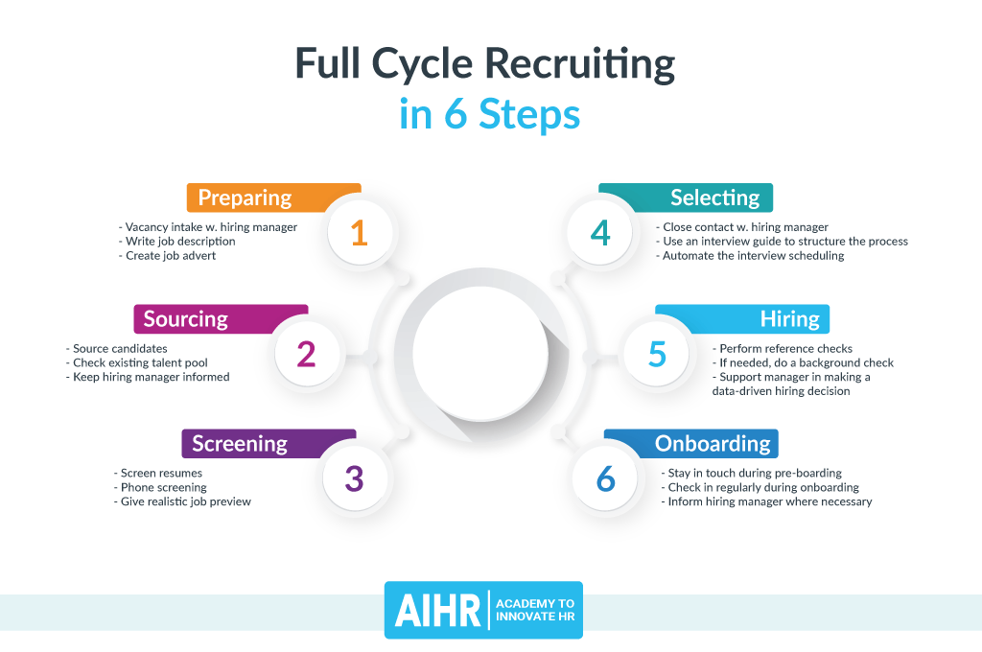(Verlinden, 2021)

6 Stages of work cycle recruitment:
1.preparing: -This the stage where job and role is analysed and any preferred skills or qualifications for role is outlined. Then a job description is prepared with any task requirements that is needed ready to be put out on company website or third-party recruitment agencies is used like Indeed, Totaljobs ect.
2.Sourcing: - At this stage is when recruiters actively search for potential candidates through third party agencies like Indeed, Totaljobs and invited to apply for role. Existing employees are looked at in detail to see if they are the right candidates and fit for role.
3.Screening: - This is when recruiters analyse applicants for role through their CV’s that they have submitted. While also screening CVs for desired skills or qualifications, they also use phone interviews to give realistic job expectations.
4.Selecting: - This is the final CV screening where emphasis is on desired skills or qualifications that is needed and desired characteristics. As applicants received their first interview during screening process, this enabled recruiter to pick up desired characteristics that is needed. All applicants that have been selected will be sent their interview schedules and what is to expect at this stage.
5.Hiring: - At this stage when references that has been provided are checked, paperwork filled and checked like applicants’ identification paperwork satisfies company requirements etc. If background check has been done if needed, work history satisfactory and finally passing all information on to manager to double check.
6.Onboarding: -This is the final stage where new employees are familiarised with company, understand their roles and what their responsibilities are. Any training that is needed booked or completed and that new employees have someone familiar to contact if needing any assistance or information.

Employee life cycle as shown below works in the same way as the 6-cycle recruiting but has 5 added stages implemented to benefit the company and employees. This method helps monitor the progress of each employee in the company with the aim of providing a positive experience while working there and after they decide to leave the company (Verlinden, 2020). By following this method, it will give the company a better understanding of their employees for example if they need extra support, further training, promotion etc. In return this gives the company the answers as to what motivators their employees respond positively as this will boost productivity and performance.
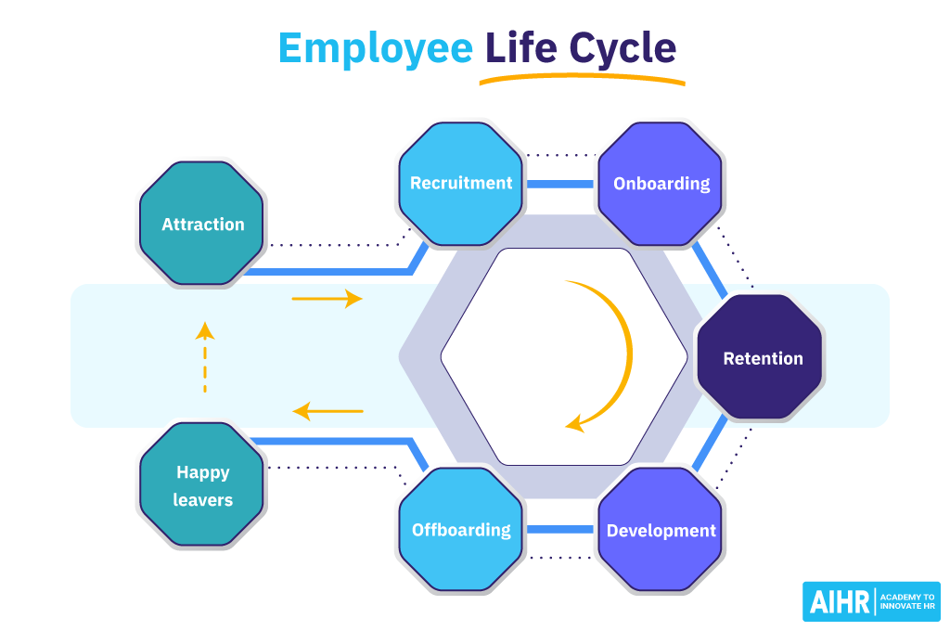(Verlinden, 2020)
The added stages of employee life cycle will be explained below and what each step entails.
1.Attraction: - This is what entices potential employees and what attracts them to the company in the first place. This could be that it is a big company offers more benefits than others like sick pay, ideal working hours, free meals, free parking space, work culture etc. Also, how the brand and company communicates to its targeted audience, marketing strategy that is used, this could be through social media. Examples could be Facebook, Instagram, company websites as this will determine the type of people applying for the job vacancies. After covid 19, performance, number-based attitudes will not go well with employees as they look for a sense of belonging more than anything they have a new look on life (De Smet et al., 2021).
2.Retention: - This is how companies try and retain employees who wish or have expressed their desire to leave the company. This gives the company a stage to rectify any issues employee may have. Examples could be work life balance so employee may need to reduce their hours or amend them, missed talent, and may need promotion if company can financially be able to oblige, work cultures that need improving (Koziol and Mikos, 2019). This is the stage where employers try and give them something or reason to stay.
3.Development: - This is where career development is encouraged, and training is provided for different roles and skills acquired as a result, employees do not feel stagnant. This can be highlighted through company surveys conducted internally completed by all employees, or through appraisals. Career opportunities encouraged through meetings etc. By investing in their work force careers and skills may highlight the evolution of talent (Crane and Hartwell, 2019).
4.Offboarding: - At this stage when employees hand in their resignation and work their notice period .This also gives employer to ask why they are leaving ,work culture , team and management relationships .This will give company something to work with to make sure future employees do not have the same experience .At the same time it will give the company on areas that have improved or is most liked by employees.
5.Happy leaver: - This is the final stage for a leaving employee as at this stage the aim is to make sure employee has a positive memory and experience both leaving and during their work. As this may not be the last time the company may see them, they might return to work. Later, in life (Schiemann, 2019) Ensure all refences needed contact is given, goodbye email and a way to stay in touch for the future. This is essential as the employee will spread positive image to their friends and family so word of mouth will give company resource opportunity.
Human resource management is a strategic organisation with the sole aim to achieve its goals, which branch out in many department (Boon, Hartog and Lepak, 2019). The department covers compensation if any accidents should occur through the relevant channels. Redundancy is also handled through the department as they help put all relevant paper work in place for tax reasons .Another area is wellbeing engagement which has become high in demand by employees and has pushed employers to unknown territories due to the impact covid 19 has had on human health (Carnevale and Hatak, 2020).Pandemic has had a devastating impact on hospitality as all establishments were forced to close, loss of jobs , income and when they where allowed to open major staff shortage as staff did not return ,effected business negatively .With many employees struggling with long covid the hospitality industry which already struggled to retain staff now have another problem ,attracting potential employees .Do to lack of support , wellbeing wise ,financially and not valued by company many employees did not return and decided to work in different sectors .This type of job migration would not happen if something was in place in organisations so that they would have been better equipped .Employees have reacted different to their jobs as the pandemic has brought about not only physical ailments but psychological and social changes that have changed their views on everything (Mihalache and Mihalache, 2021).

Generation Y born between 1990-2000s is a large group of individuals with different age ranges but have common characteristics and travel behaviours. This generation although in different stages of their lives, careers share common values and behaviours due to their shared past as they are born just as technology picked up. The two life changing events that all Generation Y share is the birth of internet and smartphones (Ketter, 2020). Due to this shared experience that shaped their values and behaviours, this generation appreciate experience over possessions, tech natives, well connected, have a major social media presence and an attitude that is live in the present moment (Ketter, 2020).Although generation y have adapted well to technological development and they are also environmentally conscious as and aware of today’s easy accessibility , convince life negatively impact the environment (Činjarević, Kožo and Berberović, 2019).Generation y value work life balance as they grew up watching their parents (baby boomers )work long and stressful jobs often with no career progress which has shaped their views on working life (Gaidhani, Arora and Sharma, 2023).This generation make a dedicated work force who are not motivated by money but value working for a company that cares about society (Frye et al., 2019).They like to be up to date with all information , world news, company information let it be the one they work for or buying from (Littera Scripta , 2019). Also, this generation will leave a company easier than the other generations as they Value transparency and autonomy in work environment as they grew up during globalization (Jung, Jung and Yoon, 2021). It is essential that companies understand their work force as their past shapes and values their life today, they are not easily swayed and if recognised will be loyal employees. Each generation were born at a time of change, economically, politically etc, thus if not looked at individually and treated the same will see high employee turnover (Luger, Hofer and Floh, 2021).
The future of human resource management is uncertain with new technology emerging such as Artificial intelligence, digital convenience, social trends that may influence how human resource management is conducted and may cause grey arears ethically. However Human resource management evolution through changing times is evident that it will still be needed in the future (Vrontis et al., 2021).

Reference list
Armstrong, M. and Taylor, S. (2020). Armstrong’s handbook of strategic human resource management : improve business performance through strategic people management. New York: Kogan Page, p.763.
Baum, T., Cardenas Rubio, J. and Congreve, E. (2023). ReWAGE Evidence Paper: Work, Wages and Employment in the UK’s Hospitality Sector. [online] University of Strathclyde. Coventry, UK: university of Strathclyde Glasgow. Available at: https://pureportal.strath.ac.uk/en/publications/rewage-evidence-paper-work-wages-and-employment-in-the-uks-hospit [Accessed 23 Oct. 2023].
Beardwell, J. and Thompson, A. (2017). Human Resource Management : a Contemporary Approach. 8th ed. [online] Harlow: Pearson. Available at: https://ebookcentral.proquest.com/lib/trinity/reader.action?docID=5185647 [Accessed 22 Oct. 2023].
Boon, C., Hartog, D.N.D. and Lepak, D.P. (2019). A systematic review of human resource management systems and their measurement. Journal of Management, [online] 45(6), pp.2498–2537. doi:https://doi.org/10.1177/0149206318818718.
Carnevale, J.B. and Hatak, I. (2020). Employee Adjustment and well-being in the Era of COVID-19: Implications for Human Resource Management. Journal of Business Research, [online] 116(116), pp.183–187. Available at: https://www.sciencedirect.com/science/article/pii/S0148296320303301 [Accessed 23 Oct. 2023].
Činjarević, M., Kožo, A. and Berberović, D. (2019). Sharing is Caring, and Millennials Do Care: Collaborative Consumption through the Eyes of Internet Generation. South East European Journal of Economics and Business, [online] 14(1), pp.49–60. doi:https://doi.org/10.2478/jeb-2019-0003.
Crane, B. and Hartwell, C.J. (2019). Global talent management: A life cycle view of the interaction between human and social capital. Journal of World Business, [online] 54(2), pp.82–92. doi:https://doi.org/10.1016/j.jwb.2018.11.002.
De Smet, A., Dowling, B., Mugayar-Baldocchi, M. and Schaninger, B. (2021). ‘Great Attrition’ or ‘Great Attraction’? The choice is yours - ProQuest. [online] www.proquest.com. Available at: https://www.proquest.com/openview/d5d8bac592a6b5fbbd46ef0d6452378f/1?pq-origsite=gscholar&cbl=30375 [Accessed 23 Oct. 2023].
Frye, W.D., Kang, S., Huh, C. and Lee, M.J. (MJ) (2019). What factors influence Generation Y’s employee retention in the hospitality industry?: An internal marketing approach. International Journal of Hospitality Management, [online] 85(102352), p.102352. doi:https://doi.org/10.1016/j.ijhm.2019.102352.
Gaidhani, S., Arora , Dr.L. and Sharma, B.K. (2023). UNDERSTANDING THE ATTITUDE OF GENERATION Z TOWARDS WORKPLACE. [online] 9(2249-7455). Available at: https://www.researchgate.net/profile/Bhuvanesh-Sharma-3/publication/331346456_UNDERSTANDING_THE_ATTITUDE_OF_GENERATION_Z_TOWARDS_WORKPLACE/links/5c751d22458515831f7025d7/UNDERSTANDING-THE-ATTITUDE-OF-GENERATION-Z-TOWARDS-WORKPLACE.pdf [Accessed 23 Oct. 2023].
Jung, H.S., Jung, Y.S. and Yoon, H.H. (2021). COVID-19: The effects of job insecurity on the job engagement and turnover intent of deluxe hotel employees and the moderating role of generational characteristics. International Journal of Hospitality Management, [online] 92(102703), p.102703. doi:https://doi.org/10.1016/j.ijhm.2020.102703.
Ketter, E. (2020). Millennial travel: tourism micro-trends of European Generation Y. Millennial Travel: tourism micro-trends of European Generation Y, [online] 7(2055-5911), p.192. Available at: https://www.emerald.com/insight/content/doi/10.1108/JTF-10-2019-0106/full/html [Accessed 22 Oct. 2023].
Koziol, W. and Mikos, A. (2019). The measurement of human capital as an alternative method of job evaluation for purposes of remuneration. Central European Journal of Operations Research, [online] 28(0), pp.pages589-599. doi:https://doi.org/10.1007/s10100-019-00629-w.
Littera Scripta (2019). LITTERA SCRIPTA Economics M Management Corporate Finance Finance and Valuation. Selected aspects of risk management in Polish and Slovak SMEs , [online] 12(2). doi:https://doi.org/10.36708/Littera_Scripta2019/2/0.
Luger, M., Hofer, K.M. and Floh, A. (2021). Support for corporate social responsibility among generation Y consumers in advanced versus emerging markets. International Business Review, [online] 31(2), p.101903. doi:https://doi.org/10.1016/j.ibusrev.2021.101903.
Macke, J. and Genari, D. (2019). Systematic literature review on sustainable human resource management. Journal of Cleaner Production, [online] 208(0959-6526), pp.806–815. doi:https://doi.org/10.1016/j.jclepro.2018.10.091.
Marriot International (n.d.). Our Story. [online] www.marriott.com. Available at: https://www.marriott.com/about/culture-and-values/history.mi#:~:text=1957- [Accessed 22 Oct. 2023].
Mihalache, M. and Mihalache, O.R. (2021). How workplace support for the COVID ‐19 pandemic and personality traits affect changes in employees’ affective commitment to the organization and job‐related well‐being. Human Resource Management, [online] 61(3). doi:https://doi.org/10.1002/hrm.22082.
Rao, M.S. (2020). Book Review: Reinventing the Organization: How Companies Can Deliver Radically Greater Value in Fast-Changing Markets. Journal of Values-Based Leadership, [online] 13(1). doi:https://doi.org/10.22543/0733.131.1307.
Schiemann, W.A. (2019). From talent management to talent optimization. Journal of World Business, [online] 49(2), pp.281–288. doi:https://doi.org/10.1016/j.jwb.2013.11.012.
Verlinden, N. (2020). The Employee Life Cycle: 19 Tips to Get it Right. [online] AIHR. Available at: https://www.aihr.com/blog/employee-life-cycle/ [Accessed 23 Oct. 2023].
Verlinden, N. (2021). Full Cycle Recruiting: All You Need to Know. [online] AIHR. Available at: https://www.aihr.com/blog/full-cycle-recruiting/ [Accessed 22 Oct. 2023].
Vrontis, D., Christofi, M., Pereira, V., Tarba, S., Makrides, A. and Trichina, E. (2021). Artificial intelligence, robotics, advanced technologies and human resource management: a systematic review. The International Journal of Human Resource Management, [online] 33(6), pp.1–30. doi:https://doi.org/10.1080/09585192.2020.1871398.

