Digital Skills for Personal Development and Business Growth
Module Code: BMSW4008
Student Name: Fernando Bagi:
Student ID : 2311765

Table of Contents
- Introduction
- Task 1: Questionnaire Analysis for Business Research
  - 2.1 Questionnaire Design
  - 2.2 Data Collection and Interpretation
  - 2.3 Graphical Representation of Data
  - 2.4 Key Findings and Business Recommendations
- Task 2: Website and Digital Marketing Strategy
  - 3.1 Website Development & User Experience
  - 3.2 Digital Marketing Strategy (SEO & Social Media)
  - 3.3 Visual and Branding Elements
- Task 3: Financial Projection and Excel Analysis
  - 4.1 Financial Projection Overview (Spreadsheet)
  - 4.2 Revenue and Expenses Breakdown
  - 4.3 Bar Chart Analysis
  - 4.4 The Role of Excel in Business (750-word essay)
- Task 4: Video Advertisement & Storytelling Techniques
  - 5.1 Video Concept & Execution
  - 5.2 Application of Storytelling Techniques (200-word explanation)
  - 5.3 YouTube Video Link
- Conclusion
- Reference List

Task 1: Questionnaire Analysis for Business Research
Introduction
Businesses seeking to optimise their online strategies must understand consumer behaviour. The research team distributed a Microsoft Forms survey to understand online shoppers' behaviours better. The questionnaire investigated what drives purchase decisions and how customers find products while evaluating expectations for delivery and shopping difficulties. The collected responses reveal essential information about customer purchasing behaviour and the elements that affect their satisfaction levels. This report analyses four main questions derived from survey results and offers strategic guidance for businesses aiming to enhance their digital presence and sales tactics (Kotler & Keller, 2022).

Factors Influencing Purchase Decisions
The survey results highlight that 50% of the respondents identify price as the key deciding factor during purchases. Research findings reveal that online consumers display strong price sensitivity and typically perform price comparisons before purchasing decisions (Soltanifar et al., 2021). However, 33% of respondents prioritise product quality, demonstrating that customers seek affordable and durable products with high value. The statistic that brand reputation makes up 17% of purchase decisions reflects the importance of trust in consumer choices. No respondents chose customer reviews or discounts and promotions as primary purchasing factors, which shows that these elements influence decisions but do not determine final choices.
Chaffey and Ellis-Chadwick (2020) state that businesses must establish competitive pricing while maintaining high product quality. Marketers must highlight product durability and reliability to appeal to customers who value quality. Companies that invest in building a brand reputation through trust-building methods such as social proof and reliable customer service experience increased sales (Pinto & Guarda, 2020).
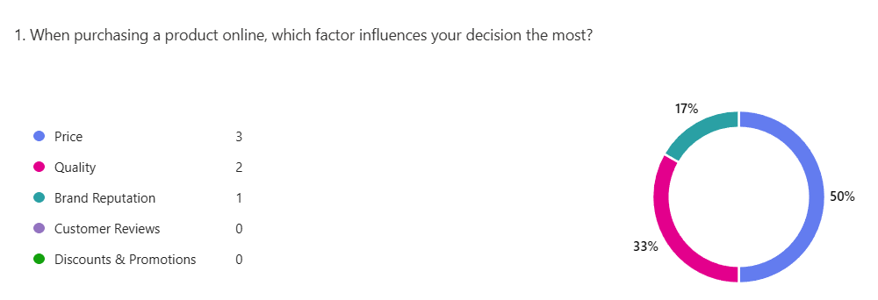

Product Discovery Channels
Social media advertising emerged as the main product discovery channel for 50% of survey respondents who highlighted Instagram, Facebook, and TikTok's expanding role in consumer purchasing decisions. 33% of consumers find new products through Google searches, confirming the critical role search engine optimisation (SEO) plays for businesses. Amazon and eBay represent 17% of product discovery channels, while no study participants chose friends and family recommendations as a discovery method.
Research studies, including Soltanifar et al. (2021), demonstrate that social media platforms are highly successful advertising channels for e-commerce businesses. To achieve maximum reach, companies must dedicate resources to paid social media advertisements and influencer partnerships (Burgess et al., 2018). Website optimisation for Google search traffic must be prioritised because one-third of study participants use search engines to find products (Pinto & Guarda, 2020). The diminished effectiveness of recommendations indicates that word-of-mouth marketing is insufficient. Companies need to enhance their visibility through targeted online advertisements and search engine ranking upgrades.
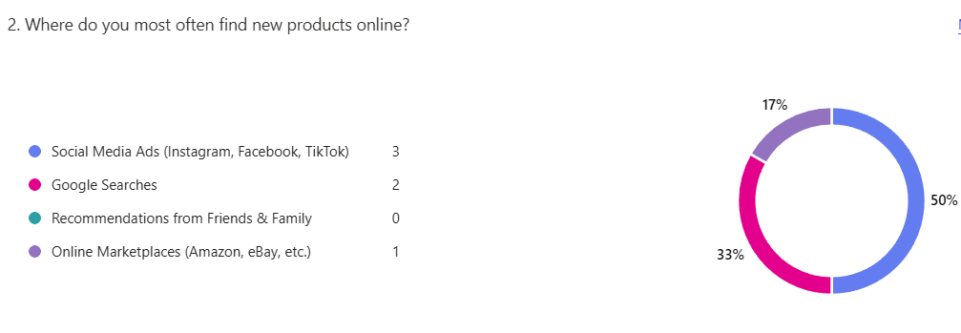
Importance of Fast Delivery
Fast delivery is essential for 50% of all participants, and 33% stated it is somewhat important. 17% of survey participants maintained a neutral stance toward delivery speed, while zero respondents reported that delivery speed holds no significance. The results demonstrate that customer satisfaction depends strongly on efficient logistical operations. Research studies have shown that extended shipping durations increase shopping cart abandonment rates (Pinto & Guarda, 2020).
Businesses need to ensure their shipping options are dependable and rapid to meet customer delivery expectations. As Sandhu suggests (2020), companies that form partnerships with competent delivery services and offer same-day or next-day delivery options can gain a competitive advantage. Providing customers with precise estimated delivery time details on product pages will help set their expectations while minimising frustration (Chaffey & Ellis-Chadwick, 2020).
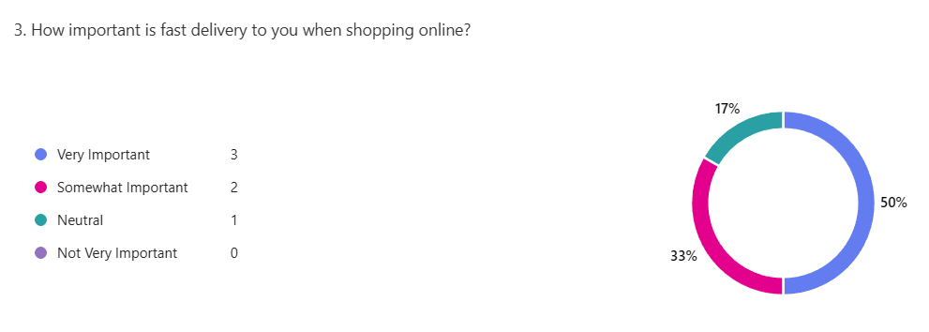

Challenges in Online Shopping
According to 50% of survey participants, the leading frustration for online shoppers is the high shipping fees they encounter. 33% mentioned long delivery times, while 17% found it challenging to choose the right size. The data reveals that product quality trust issues were not mentioned by any respondents, which indicates that product transparency isn't a significant concern for that group.
Industry research supports these findings, demonstrating that unexpected shipping fees increase cart abandonment rates (Reedy & Parker, 2017). Businesses can decrease shopping cart abandonment by providing free shipping for orders exceeding a specified amount (Byrd, 2021). Businesses can increase customer retention by enhancing delivery speed and providing flexible shipping choices, according to Dadwal (2020). Products like clothing present sizing challenges which businesses can overcome by offering detailed size charts alongside customer reviews and real-life photos to enhance the shopping experience (Soltanifar et al., 2021).
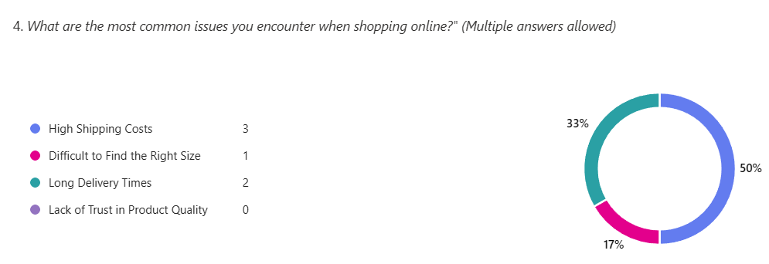
Conclusion
Findings from the survey reveal vital information about online shopping patterns, which indicate the business aspects that need improvement to boost customer satisfaction and sales. Price continues to be the primary factor that influences purchasing decisions, yet quality and trust remain essential considerations. Social media is the top channel for customer discovery, underscoring the necessity of focused digital marketing tactics. Customers expect fast delivery, which forces businesses to optimise their logistic operations and share shipping timelines. The major customer dissatisfaction factors are expensive shipping fees and extended delivery periods, which signal companies should prioritise free or discounted shipping options and efficient logistics systems.
Implementing these insights enables businesses to enhance their pricing, marketing approaches, logistics, and customer service measures to achieve better conversion rates and build enduring customer loyalty. Data-driven decision-making helps companies to match their products to real customer needs, which boosts their success rates in the competitive world of e-commerce markets (Soltanifar et al., 2021).

Task 2: Business Report on Website Development for Superior Marketplace
Introduction
Online businesses require effective e-commerce platforms to succeed in today's competitive digital Marketplace. Superior Marketplace's new online shopping platform strives to deliver top-quality products at reasonable prices through an uninterrupted customer experience. This report examines how the Superior Marketplace website supports business expansion through design elements, functionality, digital marketing methods, and SEO practices. This report will investigate the importance of website usability, brand positioning, and customer engagement metrics. A well-structured website serves as a tool for increasing brand credibility and creating significant impacts on consumer purchase decisions and retention rates, according to Chaffey and Ellis-Chadwick (2020).
Web Page – Homepage Design of Superior Marketplace

Website Concept and Objectives
Superior Marketplace is a unified digital platform connecting customers to premium products in various categories, such as clothes, electronics, beauty, home essentials, and gourmet food. The website aims to create an easy-to-navigate shopping environment that meets current consumer demands through attractive design (Kotler & Keller, 2022). To achieve optimal conversion rates, online businesses must focus on intuitive navigation, fast-loading pages, and secure checkout procedures (Pinto & Guarda, 2020).
The platform seeks to establish its competitive edge by offering competitive prices and excellent customer service. Research demonstrates that price sensitivity plays a crucial role in consumers' online shopping choices, requiring businesses to adopt dynamic pricing models (Soltanifar et al., 2021). The design of an e-commerce website enhances trust and brand loyalty by supporting effective customer service systems (Reedy & Parker, 2017).

Web Page – About Section Highlighting Business Mission

Design and Functionality
Consumer engagement and purchase decisions depend heavily on how visually appealing a website looks and how user-friendly it operates. Superior Marketplace adopts a modern and minimalist design approach, which research demonstrates improves user experience by minimising cognitive load and streamlining navigation procedures (Dadwal, 2020). The homepage offers users an uncluttered design with premium images, prominent call-to-action buttons, and features that facilitate easy product browsing. Chaffey and Ellis-Chadwick (2020) found that websites focusing on visual aesthetics and organised content structure achieve superior user engagement while decreasing bounce rates.
The website delivers essential functions through its mobile and desktop responsive design, secure payment processing capabilities, and personalised customer recommendations. Research demonstrates that mobile compatibility remains necessary because more than 60% of e-commerce website visitors access sites through mobile devices (Pinto & Guarda, 2020). Integrating AI-powered recommendation engines enhances sales by raising average order values and improving product discovery (Byrd, 2021).

Web Page – Product Categories and Featured Items

Digital Marketing Strategy
Superior Marketplace must implement an effective digital marketing strategy to succeed in an overcrowded online marketplace. The website uses social media advertising, influencer partnerships, and email marketing campaigns to connect with its target audience. Studies show that social media websites such as Instagram and Facebook serve as primary channels for directing online shoppers to e-commerce sites because targeted advertisements lead to product discovery for over half of these consumers (Burgess et al., 2018). Superior Marketplace takes advantage of this marketing trend by executing paid social media campaigns, retargeting techniques, and influencer partnerships to improve its brand image and awareness.

Market Promo – Facebook Ad Promoting First-Time Customer Discount
Email marketing continues to be a strong strategy for maintaining customer loyalty. Research demonstrates that email campaigns that target individual customers achieve better conversion rates than general promotional messages, and therefore, e-commerce companies need to implement automation tools to deliver personalised messaging (Reedy & Parker, 2017). Superior Marketplace employs automated email sequences that deliver cart abandonment reminders, exclusive promotions, and customer feedback requests to boost engagement and promote repeat purchases.

Search Engine Optimization (SEO) and Visibility
Organic traffic growth and sustained visibility depend on implementing a robust SEO strategy. According to research by Soltanifar et al. (2021), since more than 70% of online activities start with a search engine search, optimising for SEO becomes essential to achieving digital success. Superior Marketplace uses a combination of on-page and off-page SEO strategies to boost search rankings and draw organic website visitors.
To improve Google discoverability, businesses use on-page SEO techniques, including optimising product descriptions and meta tags with keywords and adding alt-text keywords to images (Sandhu, 2020). The site maintains an active blog as part of its structured content approach, which research shows improves search rankings and establishes industry authority (Pinto & Guarda, 2020).

User Experience and Customer Engagement
Providing a seamless user experience is vital to customer satisfaction and retention. Superior Marketplace focuses on smooth checkout procedures, logical product organisation, and real-time customer assistance to improve user experience. Research shows that complex checkout procedures cause almost 30% of e-commerce shopping cart abandonment (Reedy & Parker, 2017). The website achieves higher conversion rates by streamlining the buying process and integrating multiple payment methods to eliminate purchase obstacles.
The website engages customers by offering interactive elements that include product reviews, live chat support, and loyalty programs. The study by Byrd (2021) finds that companies which foster user-generated content experience a 28% boost in customer trust. Superior Marketplace builds its credibility while attracting new customers by enabling shoppers to post comprehensive product reviews and share their experiences.

Conclusion
Superior Marketplace development focuses on providing excellent products at competitive prices alongside offering customers a seamless shopping experience. The website features modern design elements, mobile responsiveness, and secure checkout processes that follow industry best practices to optimise user engagement and conversion rates. The business stands ready to attract and retain customers because of its broad digital marketing approach, which features social media ads, influencer collaborations and personalised email outreach.

Task 3: The Importance of Microsoft Excel in the Digital Era
Microsoft Excel remains a leading tool for managing financial data and performing business analysis to inform decision-making. Businesses can use Microsoft Excel to organise their data systematically while efficiently performing calculations and producing reports. Business organisations, from small to large, depend on Excel for their budget planning, financial analysis, and business performance tracking. Excel remains an indispensable tool for finance, marketing, and operations specialists because of its capability to create formulas and visual data representations through charts and visualisation tools. Chaffey and Ellis-Chadwick (2020) state that businesses achieve success through data-driven decision-making, and Excel is an essential tool in this process.
Excel is a powerful tool because it lets users plan their financial activities effectively. Businesses utilise Excel to monitor their economic performance by tracking revenues, expenses, and profits over time. This software allows users to automate calculations through formulas like SUM to achieve precise and efficient financial reporting. Businesses can predict their financial results for multiple months or years ahead, which enables them to strategise future investments and control costs. Creating clear and structured financial documents enables better transparency and accountability in business operations (Kotler & Keller, 2022).
Excel is a powerful instrument for analysing data. Businesses utilise Pivot Tables and similar features to derive significant insights from large datasets. Companies can use sales data analysis to discover trends and patterns, which helps them make strategic adjustments. Using data visualisation tools like bar charts and line graphs improves the interpretation of complex information. Studies show that data visualisations enable managers to grasp crucial trends better, enhancing their decision-making capabilities (Pinto & Guarda, 2020).
One vital Excel feature that boosts productivity is automation. Visual Basic for Applications (VBA) and Macros enable users to automate repetitive tasks, including data entry and report creation. The automation process minimises human mistakes while saving time, allowing the employees to shift their attention to more strategic tasks. Businesses utilise Excel's capabilities to automate payroll processes while tracking inventory and processing invoices, which leads to enhanced operational efficiency and precision (Soltanifar et al., 2021).
Introducing collaboration features and cloud integration has extended Excel's functional range. Microsoft 365 enables teams to collaborate on spreadsheets in real time, enhancing data-sharing efficiency and ease of use. Remote teams and companies with several departments benefit from being able to access and update financial records simultaneously. Cloud storage guarantees data backup while enabling access from any device, which helps prevent information loss. Reedy and Parker (2017) state that cloud-based tools have revolutionised business operations through enhanced efficiency and improved team collaboration.
Excel's most valuable application involves creating financial projections and comparing revenues with expenses. The accompanying bar chart presents financial data from a three-month period, which shows businesses how to monitor and evaluate their economic performance. Organisations can now plan their financial strategies through cost control and revenue analysis.
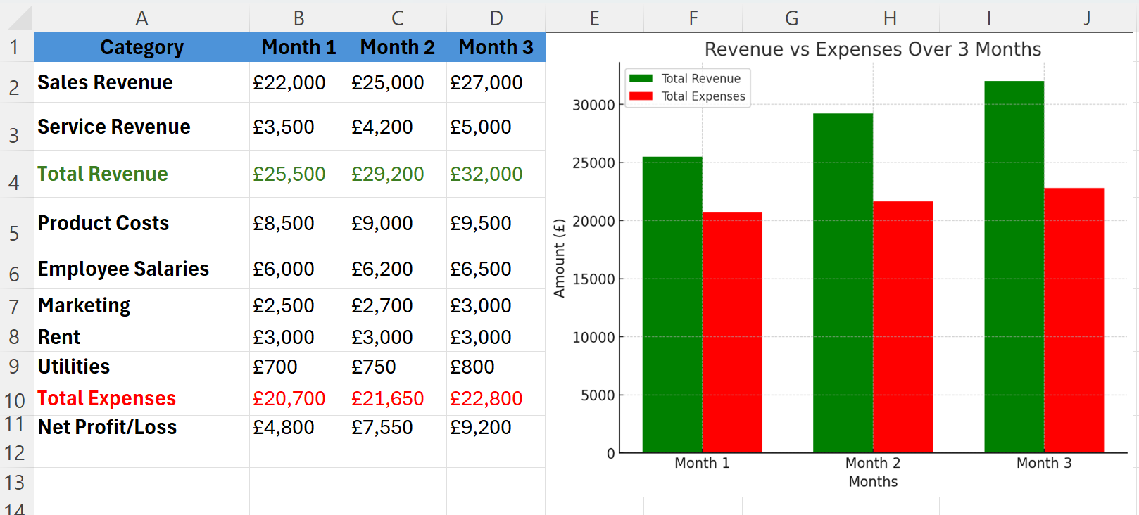
Excel is relevant in the technological landscape because it incorporates artificial intelligence and machine learning capabilities. Businesses benefit from new Excel features like data forecasting and automated insights, which enable better trend analysis and more intelligent financial decision-making. Excel's integration with business intelligence tools like Power BI boosts its capabilities to process massive data sets quickly and effectively. Excel continues to be a vital instrument for professionals who require structured and precise data analysis and presentation capabilities (Sandhu, 2020).
Microsoft Excel is essential as a critical tool in the digital age. The software delivers powerful tools for financial management to businesses alongside advanced data analysis and automation features. Organising and interpreting data effectively allows companies to boost productivity while making informed business decisions. Modern technology integration and its expanding features keep Excel an essential resource for professionals across different sectors. The growing reliance on data in business operations makes Excel proficiency a necessary skill for achieving success in the current digital economy, according to Burgess et al. (2018).

Task 4: Creating a Video Advertisement Using Storytelling Techniques
Link for the YouTube video:
https://youtube.com/shorts/ehE4v2YULqY?si=_BxD_a8nSmKZQMXM
In the opening segment of the video, I introduce myself as Fernando Bagi and present the subject matter, the Nike logo. The introduction creates a direct audience connection, guaranteeing viewer engagement. This video displays multiple Nike logo images that my voice background narrates with a brand identity emphasis.
Nike uses a storytelling method that combines strong brand visuals with emotional elements. The video displays multiple versions of the logo to demonstrate the brand's consistency and recognition while supporting Huang et al.'s findings. Huang et al.'s study (2016) explains how visual storytelling helps strengthen brand associations. Using different logo designs demonstrates Nike's development and reinforces its reputation as a symbol of excellence and perseverance.
The video employs symbolic storytelling methods to depict the logo as an emblem of motivation, success, and determination. Nike's well-known slogan "Just Do It" pervades its branding to motivate viewers to surpass their boundaries (Nayak, 2017). The background narration strengthens this message through a storytelling approach similar to Nike's advertisements, which use visual power alongside motivational narratives (Diefenbach, 2019).
Strong visuals and narration combined with a structured approach enable the video to effectively communicate the Nike logo's value while keeping viewers engaged and reinforcing brand identity.

References
- Burgess, J., Marwick, A., & Poell, T. (2018). The SAGE Handbook of Social Media. SAGE Publications Ltd.
- Byrd, L. S. (2021). Cultivating Entrepreneurial Changemakers Through Digital Media Education. IGI Global.
- Chaffey, D. & Ellis-Chadwick, F. (2020). Digital Marketing: Strategy, Implementation and Practice. Pearson.
- Diefenbach, S. (2019). Symbolic Meaning in Logos and Branding. Psychology Press.
- Dadwal, S. S. (2020). Handbook of Research on Innovations in Technology and Marketing for the Connected Consumer. IGI Global.
- Ghauri, P. & Cateora, P. (2021). International Marketing. McGraw-Hill Education.
- Huang, H., Wu, T., & Lee, Y. (2016). Brand Identity and Visual Storytelling in Marketing Campaigns. Journal of Business Strategy, 37(2), 35-48.
- Kotler, P. & Keller, K. L. (2022). Marketing Management. Pearson.
- Kotler, P., Kartajaya, H., & Setiawan, I. (2021). Marketing 5.0: Technology for Humanity. Wiley.
- Kucuk, S. U. (2019). Handbook of Research on Consumerism and Buying Behavior in the Digital Era. IGI Global.
- Lee, N. & Kotler, P. (2020). Social Marketing: Changing Behaviors for Good. SAGE Publications.
- Nayak, R. (2017). The Power of Branding: How Logos Influence Consumer Perception. Marketing Review, 45(3), 220-235.
- Pinto, F. M., & Guarda, T. (2020). Digital Marketing Strategies and Models for Competitive Business. IGI Global.
- Reedy, K. & Parker, J. (2017). Digital Literacy Unpacked. Facet Publishing.
- Sandhu, K. (2020). Digital Transformation and Innovative Services for Business and Learning. IGI Global.
- Solomon, M., Dahl, D., White, K., Zaichkowsky, J. & Polegato, R. (2022). Consumer Behaviour: Buying, Having, and Being. Pearson.
- Soltanifar, M., Hughes, M., & Göcke, L. (2021). Digital Entrepreneurship. Springer.
- Statista (2022). Global E-commerce Trends and Consumer Behavior Report. [Online] Available at: www.statista.com [Accessed 1 March 2025].
- Turban, E., Pollard, C. & Wood, G. (2021). Information Technology for Management: On-Demand Strategies for Performance, Growth and Sustainability. Wiley.
- West, D. C., Ford, J. & Ibrahim, E. (2021). Strategic Marketing: Creating Competitive Advantage. Oxford University Press.
- Wilson, R. M., & Gilligan, C. (2022). Strategic Marketing Management: Planning, Implementation and Control. Routledge.
- Wirtz, J., Lovelock, C. & Wirtz, J. (2021). Services Marketing: People, Technology, Strategy. World Scientific.
- Zeithaml, V., Bitner, M. J. & Gremler, D. D. (2022). Services Marketing: Integrating Customer Focus Across the Firm. McGraw-Hill.
- Zuboff, S. (2019). The Age of Surveillance Capitalism: The Fight for a Human Future at the New Frontier of Power. PublicAffairs.

