75% Marketing Assignment : Rolls Royce

By Vijaypal Godara

Name :- Vijaypal Godara

Student Number:- 2130310

Module :- LCMB7001

Lecturer:- Tushara Balendran

Course:- Master In Business Administration

Submission Date :- 09/09/2022
Table of Contents
Introduction 2
Company Background 2
Communication 3
Shannon and Weaver Communication model 3
Promotional Strategies 3
Online Promotional Strategies 3
Offline Promotional Strategies 4
Brand Equity 5
Keller's Brand Equity Model 5
Stages of Customer Journey 7
Initial awakening 7
Dreaming and research 8
Decision making 8
Purchase and use 8
Loyalty 8
Critical Analysis of Customer Journey Map 9
Customers' Touchpoints 9
Product 10
Packaging 10
Price 10
Place 10
Promotion 11
People 11
Total Engagement Model 11
There are three tiers in this model. 12
Conclusion 12
References 14

Introduction
Customer touchpoints are the various ways in which organisations can interact with customers. This can be through phone calls, emails, or face-to-face meetings. A customer touchpoint is any contact between a potential or existing customer and the company. Touchpoints can be in person, such as when a customer walks into a store or over the phone when a customer calls a company's department. Touchpoints can also occur on social media platforms such as Facebook and Twitter. Companies post updates about their products or services to engage with users who may later become customers. To maintain the good performance of the business, customer touchpoint is considered crucial.
This report has presented the comprehensive marketing strategies of Rolls Royce, a world-famous luxury car company. The marketing strategy discussed in the report has discussed Integrated market communication, promotional strategies, brand equity, customer journey, customer touchpoint and many other things to maintain the company's performance.

Company Background
Rolls Royce is a car company that has been around for over 100 years and has had some challenging times during its history. Rolls Royce was founded in 1904 by Frederick Henry Royce and Charles Stewart Rolls (Yusuf et al. 2004).
In 1905, their first car was produced, called the 'Silver Ghost'. It was a success because it could go up to 60 mph at a time when other cars could only reach 20 mph. In 1907, the 'Twenty' model came out, with 20 horsepower per cylinder instead of 12 like earlier models did; this made it faster than any other car (Botticelli, 1997). Later on, as technology improved, so did engine power: By 1914, Daimler Hire started hiring 20hp cars for £4 per day plus petrol cost (£160 today).
In 1906, the two men partnered to market Royce's new cars in England. These cars were originally called Royces but were changed to Rolls-Royce after Rolls was killed in an airplane accident. The partnership lasted until 1933.
In 1970 Rolls Royce was losing money due to excess capacity on its assembly lines following sales growth that had outpaced production increases. The company also faced loss-making contracts with its largest customer, Boeing Aircraft Corporation (BAC), which had been awarded by BAC's predecessor companies, Lockheed Corporation (LCC) and Douglas Aircraft Corporation (DAC) (Young and Hussey, 1977).

Communication

Shannon and Weaver Communication model
The Shannon and Weaver Communication Model of Rolls Royce is a simple diagram model of communication that has been used in engineering, computer science, mathematics and linguistics. It gives an easy understanding of how information flows between different departments within a company or organisation (Bachmair, 1991).
The main idea behind this model is to show how information can be transmitted from one entity to another. This is done using three sets of elements which are referred to as: messages, encoders (or transmission channel) and decoders (or receiver). Messages are what is being sent from one party to another via a medium; encoders modify or encode these messages before they are sent through the medium while decoders decode them at the other end.
Integrated Marketing Communication
Integrated Marketing Communication (IMC) is a marketing process that integrates the four elements of marketing communications: advertising, sales promotion, public relations and personal selling.
IMC is not a new concept. It has been around for more than 100 years and it's still relevant today because it has proven to be effective in building brands through customer engagement and loyalty (Kitchen, and Burgmann, 2010). However, IMC can be challenging to implement because it requires collaboration between multiple departments and external stakeholders such as suppliers or distributors.
Integrated marketing communication is the concept that all forms of marketing communication should be integrated and coordinated. The aim is to create a consistent message which can be adapted for different media and target audiences (Finne and Grönroos, 2013).
The IMC pyramid shows how different types of messages, advertising appeals and target audiences can be combined to create a comprehensive, integrated campaign.

Promotional Strategies

Online Promotional Strategies
Social Media
Social media is a powerful platform for promoting the brand and promoting products. It's also a great way to interact with customers, build trust and loyalty, and create an emotional connection between the brand and the consumer (Smith, 2013).
Rolls Royce has found success in using social media to promote its luxury cars by focusing on creating high-quality content that engages its audience.
SEO Marketing/Search Engine Optimization
In order for people to find out more about the company, they need somewhere where they can go and read all about what the brand does, as well as get in contact with the brand if they wish to. This could be done by simply putting up posters around town or handing out flyers, but these days, most people use search engines such as Google when looking for something specific, so where better place than this?
The online world is a vast place to promote the brand, and Rolls Royce has mastered it well (Do Quang, 2017). It is important for the brand to understand the changing trends in this digital world since they can help the brand in reaching out to more customers.

Offline Promotional Strategies
There are two types of offline promotion channels that the brand will be able to utilise for the business, either mass media or niche.
Mass media is the first of the two options; these are channels like television, the radio, and print media. This can be a great way to promote the product or service because it reaches a large number of people, but it can also be very expensive and time-consuming (Azimovna, 2021). This type of promotion is best used when the brand wants to reach a wide audience without having a specific target market in mind because if the brand is trying to find customers for just one certain product, then going with a niche would work better for the brand because it targets a more specific segment of people that might be interested in what the brand has to offer them as opposed from trying advertising everywhere hoping someone might see it by mistake.
Rolls-Royce has been using a variety of offline promotional strategies to engage its customers, such as
- Advertising through billboards and TV commercials.
- Hosting exclusive events for high-end clients (Zook, and Smith, 2016). For example, they have hosted an event in Miami where they invited their top clients and gave them a chance to drive around in some of their cars while listening to music from artists like Kanye West and Jay Z. They also provide VIP access backstage at concerts as well as other entertainment venues around the world such as Michael Jackson's estate which is located in Los Angeles California where guests can experience what it would feel like being inside one of these cars or even driving one themselves!

Brand Equity
Brand equity is a measure of the value of a brand. It is defined as "the differential effect that a brand has on customer's perceptions, behaviours, and ultimately financial results". The three components of brand equity are brand awareness (how many people know the brand), loyalty (how committed are they to the brand), and associations (what do they think about it). Brand equity can be calculated using the following formula (Morgan, 1999):

Brand Equity = Perceived Quality - Perceived Value for Price + Relative Market Share Advantage – Inter-Brand Competition – Other Factors.

In the case of Rolls-Royce, the brand identity is a combination of its logo and corporate colours. The Rolls Royce logo is a simple crest that consists of a RR monogram, the company name and the year of incorporation. The RR monogram was designed by Charles Royce (founder) in 1906 and has been used as a symbol for this luxury car manufacturer (Mackay et al. 1998).
The company's official colour code consists of two shades: midnight blue and claret red. It was adopted in 1910 to represent their cars – these are also two shades found on most models.

Keller's Brand Equity Model
Keller's brand equity model provides a structured approach to building strong brands. It consists of four major components: brand salience, brand performance, brand imagery, and brand judgement (Olson, 2017).
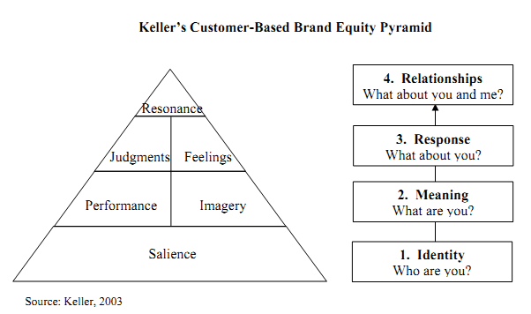
1. Brand Salience:
Brand salience is the degree to which a brand is in the minds of consumers. It's important to note that brand salience is distinct from awareness, which refers to how well-known a brand is overall.
Brand salience can be measured by asking consumers to recall the brand when prompted with images or words related to that category (for example, asking them whether they can remember any brands associated with sports cars) (Kang, 2022). This method has been used successfully in many different industries—for instance; researchers found that BMW was significantly more likely than MINI Cooper or Buick Regal Blue when asked about which colours were associated with cars.
2. Brand Performance:
Brand performance is the degree to which a brand's products and services meet the expectations of its customers. In Keller's model, brand performance is measured by using customer satisfaction surveys. The concept of brand performance can be defined as a function of the following (Kirca et al. 2020):
- Brand's ability to deliver on promises
- Customer expectations
3. Brand Imagery:
Brand imagery is the way consumers perceive a brand. It includes all the cognitive, affective and behavioural responses that consumers have to a brand (Otubanjo and Adegbile, 2019).
It can be described as:
- The totality of feelings, thoughts and ideas that each customer has about Rolls Royce cars in general.
- The image that a customer forms of Rolls Royce cars as a result of his or her experience with them, including what they look like, how they perform and so on.
4. Brand Judgement
Brand judgement is the ability of a consumer to make a judgement about the quality of the brand. It is based on feelings, perceptions and knowledge. Brand judgement is an important aspect of this model because it makes up for two-thirds of Keller's brand equity framework (Kolbl et al. 2020).

Stages of Customer Journey
A customer journey is important for understanding how customers interact with a brand. It helps marketers understand what customers think and feel at each stage of the process, giving them a better chance of engaging with them in meaningful ways.
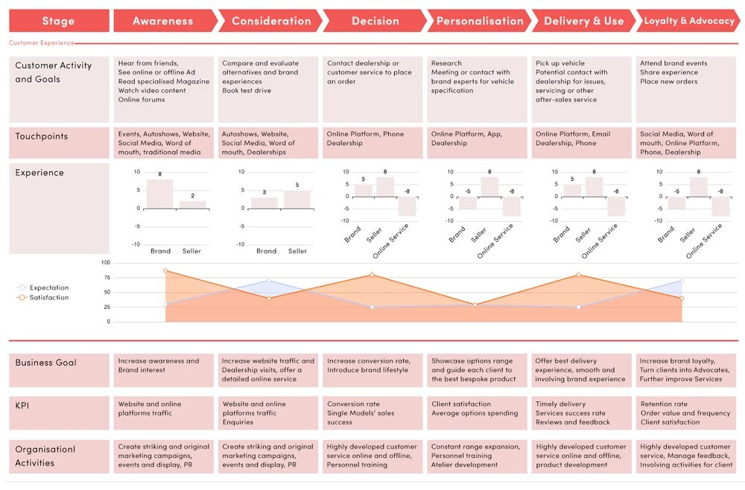
Source: Luxury Automotive Customer Journey toward 2030: What’s next? [online]

Initial awakening
The initial awakening stage is the first step in the customer journey, and it's where the brand can establish a relationship with the customers.
The main goal of this stage is to get customers interested enough in the brand so that they'll be more likely to buy from the company or recommend the company to others (Hu, 2016). This means creating content that targets their pain points and offers solutions, building relationships with influencers who can spread word of mouth about the products or services, finding ways to engage with potential customers (such as through social media), and offering incentives such as discounts or free trials on products so they'll give them a chance before committing themselves financially.

Dreaming and research
Once the brand has a clear idea of the customer journey, the brand can begin to think about how the brand will get the customers to dream and research.
The process of dreaming is often hard for companies to understand because it involves creating something that is not tangible or real. But in the case of Rolls Royce, they needed to help their customers dream about what would be possible once they had purchased one of their items (Keiningham et al. 2020)—a car or plane, for example.

Decision making
The "Discover" section on the Rolls-Royce website is a powerful tool. This includes pages such as "Explore" and "Learn." These sections aim to help customers understand what they can expect from their experience with Rolls-Royce. Customers are looking for more information about pricing, availability and product specifications. They also want reviews from others who have purchased vehicles from the company before them to know what to expect when it comes time for their purchase decision (Tueanrat et al. 2021).

Purchase and use
Rolls Royce is a luxury brand, and the customer expects a certain level of service. Customer wants to know that they are valued and appreciated, not just as customers but also as individuals. They want to feel like they are part of the Rolls Royce family. For this to happen, Rolls Royce needs to make sure their employees have the right attitude towards their customers at every stage of their journey with the brand (Demmers et al. 2020).

Loyalty
Loyalty is the final stage of the customer journey, and any business needs to keep customers in this stage as long as possible. In this stage, the customers are happy with the product or service and have become repeat buyers. Importantly, they also recommend the brand to others.

Critical Analysis of Customer Journey Map
Rolls Royce offers its customers a variety of products and services that are designed with the utmost care and precision. Each product requires extensive research, design and testing before it is launched into the market. This ensures that each product meets all standards set by Rolls Royce for quality assurance purposes so as not to disappoint their customers in any way possible. As a result, customers are more likely to have a positive experience with the product and will be more likely to recommend Rolls Royce products to others.
The customer journey map of Rolls Royce is not getting the whole story. The company needs to improve its visualisation, as well as address the lack of whole story. In addition, there are some fault in customer journey map of Rolls Royce which can be corrected in future.
Rolls Royce needs to understand that a good map is not only about matching data with users, but also making sure the whole story gets told through it—this means addressing prescriptive views and assumptions around what customers need and want from your product or service.The company needs to make sure that the customer journey map is not just about analysing what users do, but also why they do it. This will help identify gaps in the journey, which can then be filled through follow up research or simply by redesigning the product itself. In conclusion, the customer journey map of Rolls Royce is not as successful as it could be. There are many things which they need to improve in their customer journey map. The main reason behind this failure is that they have not visualized the process properly and have presented it in a prescriptive way.

Customers' Touchpoints
The brand can think of customer touchpoints as "touching" the customers through all sorts of channels: website, store experience, phone call, etc. The more touch points the brand use, the harder it gets to keep each one perfect because there's no way the brand can be everywhere at once (Keiningham et al. 2020).

Product
The product is a core touch point for customers. The product should be unique, innovative and consistent with the brand image. It should be easy to use and maintain, reliable and durable.

Packaging
Packaging is an important touch point for customers as well. It should be attractive, useful, durable, long-lasting, and easy to open.

Price
The customer's price expectation determines whether they will buy the product. The customer expects to pay a premium price for the product if the brand has a premium brand like Rolls-Royce. However, if the brand sells more mass-market products, the products must be cost-effective and affordable.
It is also important to consider the competition when setting the prices. If no competitors are offering similar products or services within close proximity to them, then this may allow the brand to set high prices for the services or goods; however, if there are competing companies in the same market area as this, then it may be best practice not to charge excessive amounts for items because customers may shop around for cheaper alternatives instead of purchasing from the brand (Bolton et al. 2018)

Place
The place is where the customer gets the product. It can be a store, a website, an app or a call centre. The place is where they buy it. But the place may not be where the brand gets it; it might get it in the home or at work, depending on what kind of service the brand uses.

Promotion
Promotion is a key touchpoint in the customer experience, an area many businesses neglect. Promotion is communicating information about the company and its products to people who may or may not be interested in buying from the brand. It can include advertising (which includes TV commercials, radio ads, print ads, billboards and other types), public relations (press releases and media appearances), sales promotion (free samples or coupons), direct marketing (email campaigns) and personal selling (salespeople knocking on doors).

People
The customer touchpoints of Rolls Royce include (Ponsignon et al. 2017):
- Customer service is the first point during a person's journey with the brand. This involves responding to customer inquiries and complaints.
- The customer experience is how customers think about their experiences with the company or product. The goal is to ensure every customer has a positive experience when interacting with the brand.
- Customer satisfaction involves asking questions about how satisfied people are with their interactions with the business or product.
- Customer loyalty refers to how strongly people feel toward the brand compared to others in its category (for example, cars). It also includes whether they would recommend it and other factors like the likelihood of repeat purchases or re-purchasing from the brand if given a chance in future situations (like having another problem). This can be measured by surveys asking customers what products they buy most often and why they choose them over competitors' versions of those same types of products available on the market today.

Total Engagement Model
Rolls-Royce has been around for over 100 years, but it's still trying to reach out to new customers. In fact, in order to grow its customer base, Rolls-Royce developed a new model called Total Engagement Model. This model is designed as a way to attract the next generation of affluent people (Ehret, and Wirtz, 2019). The company wants its customers to be able to customise their trips and experiences based on their needs and interests. The company wants to expand its traditional base of business-jet owners by attracting the next generation of affluent people who are interested in becoming members.
The Total Engagement Model consists of three tiers:
- Full Ownership (Rolls-Royce branded)
- Aspirational Ownership (the desire to own)
- Ownership Experience (access to Rolls Royce products and services)

There are three tiers in this model.
The tiers in the RO model are as follows (Jefferies and Barnard, 2018):
- Tier 1 – Engagement of the hearts and minds of employees. This is where the brand creates an environment that is conducive to employee happiness and satisfaction, which leads to higher engagement and productivity.
- Tier 2 – Engagement of emotions. Once the brand has the employees engaged in their jobs, the brand can begin to engage them emotionally by creating an atmosphere where they are connected through company social events, community outreach programs and more. These activities foster trust among coworkers and allow them to feel like they're part of something bigger than themselves—something that makes them proud to work for Rolls-Royce.
- Tier 3–Engagement with technology/tools available, e.g., HR systems etc.

Conclusion
The report has presented various points on which Rolls Royce should focus in order to enhance its marketing strategy.
Rolls Royce is a car company that has been around for over 100 years. Today, Rolls Royce is one of the world's most successful luxury automobile companies. Having a rich history allowed the company to establish a good brand image in the eyes of the customers. However, the company should also focus on various points such as its communication with customers, promotional strategies, customer touchpoints, stages of the customer journey, customer journey map and total engagement model.
The touchpoints of Rolls Royce are important for two reasons: firstly, because they give insight into what customers want; secondly, because they allow the company to create new opportunities for engagement with customers. Furthermore, Rolls Royce has a unique engagement model to help them connect with their community. They have embraced the idea of creating a total engagement experience across many different channels. By focusing on the mentioned points, the report has discussed that the company can significantly improve its sales and customer retention.

References
Azimovna, M.S., (2021). Extended Foreign Experience in Implementing Marketing Strategies. International Journal of Development and Public Policy, 1(5), pp.14-17.
Bachmair, B., (1991). From the motor-car to television: cultural-historical arguments on the meaning of mobility for communication. Media, Culture & Society, 13(4), pp.521-533.
Bolton, R.N., McColl-Kennedy, J.R., Cheung, L., Gallan, A., Orsingher, C., Witell, L. and Zaki, M., (2018). Customer experience challenges: bringing together digital, physical and social realms. Journal of Service Management, 29(5), pp.776-808.
Botticelli, P., (1997). Rolls-Royce: How a legend was made. The American Scholar, 66(4), pp.501-512.
Demmers, J., Weltevreden, J.W. and van Dolen, W.M., (2020). Consumer engagement with brand posts on social media in consecutive stages of the customer journey. International Journal of Electronic Commerce, 24(1), pp.53-77.
Do Quang, H., (2017). Marketing SWOT Analysis of Rolls-Royce Motor Cars (Doctoral dissertation, Empire State College).
Ehret, M. and Wirtz, J., (2019). Sharing uncertainty across organizations: service capital and customer engagement for realizing nonownership value. In Handbook of Research on Customer Engagement. Edward Elgar Publishing.
Finne, Å. and Grönroos, C., (2013). Rethinking marketing communication: From integrated marketing communication to relationship communication. In The Evolution of Integrated Marketing Communications (pp. 113-130). Routledge.
Hu, Y., (2016). Seeing industrial services through experience lens-Revealing a customer experience map to design for an experiential service in B2B context.
Jefferies, M. and Barnard, K., (2018). Rolls-Royce University Technology Centres: Relationships Matter. In Strategic Industry-University Partnerships (pp. 81-103). Elsevier.
Kang, I., Koo, J., Han, J.H. and Yoo, S., (2022). Millennial consumers perceptions on luxury goods: capturing antecedents for brand resonance in the emerging market context. Journal of International Consumer Marketing, 34(2), pp.214-230.
Keiningham, T., Aksoy, L., Bruce, H.L., Cadet, F., Clennell, N., Hodgkinson, I.R. and Kearney, T., (2020). Customer experience driven business model innovation. Journal of Business Research, 116, pp.431-440.
Keller, K.L., (2003). Brand synthesis: The multidimensionality of brand knowledge. Journal of consumer research, 29(4), pp.595-600.
Kirca, A.H., Randhawa, P., Talay, M.B. and Akdeniz, M.B., (2020). The interactive effects of product and brand portfolio strategies on brand performance: Longitudinal evidence from the US automotive industry. International Journal of Research in Marketing, 37(2), pp.421-439.
Kitchen, P.J. and Burgmann, I., (2010). Integrated marketing communication. Wiley international encyclopedia of marketing.
Kolbl, Ž., Diamantopoulos, A., Arslanagic-Kalajdzic, M. and Zabkar, V., (2020). Do brand warmth and brand competence add value to consumers? A stereotyping perspective. Journal of Business Research, 118, pp.346-362.
Mackay, M.M., Romaniuk, J. and Sharp, B., (1998). A classification of brand equity research endeavours. Journal of Brand Management, 5(6), pp.415-429.
Morgan, R.P., (1999). A consumer-oriented framework of brand equity and loyalty. International Journal of Market Research, 42(1), p.65.
Olson, E.L., (2017). Will songs be written about autonomous cars? The implications of self-driving vehicle technology on consumer brand equity and relationships. International Journal of Technology Marketing, 12(1), p.23.
Otubanjo, O. and Adegbile, O.E., (2019). The Corporate Heritage Brand Development Process: A New Institutional Theory Approach. IUP Journal of Brand Management, 16(1).
Ponsignon, F., Durrieu, F. and Bouzdine-Chameeva, T., (2017). Customer experience design: a case study in the cultural sector. Journal of Service Management.
Smith, D.J., (2013). Power-by-the-hour: the role of technology in reshaping business strategy at Rolls-Royce. Technology analysis & strategic management, 25(8), pp.987-1007.
Tueanrat, Y., Papagiannidis, S. and Alamanos, E., (2021). Going on a journey: A review of the customer journey literature. Journal of Business Research, 125, pp.336-353.
Young, R. and Hussey, D.E., (1977). Corporate planning at Rolls-Royce Motors Limited. Long Range Planning, 10(2), pp.2-12.
Yusuf, Y., Gunasekaran, A. and Abthorpe, M.S., (2004). Enterprise information systems project implementation:: A case study of ERP in Rolls-Royce. International journal of production economics, 87(3), pp.251-266.
Zook, Z. and Smith, P.R., (2016). Marketing communications: offline and online integration, engagement and analytics. Kogan Page Publishers.
Bello, R.D. (n.d.). Luxury Automotive Customer Journey toward 2030: What’s next? [online] RccDB Cars - Automotive | Business | Research. Available at: https://www.rccdbcars.com/automotive-blog/luxury-automotive-customer-journey-toward-2030-whats-next [Accessed 9 Sep. 2022].
‌

